The Narcissism Epidemic Evaluation
Fen Shields
The Work – Part 1 of 2
This project seemed to be named after The Narcissism Epidemic: Living in the Age of Entitlement by Jean M. Twenge and W. Keith Campbell, so this seemed like a natural starting point for my research. I found that Twenge and Campbell believed there were five main causes for the rise of narcissism in America and these were: a focus on self-admiration, child-centered parenting, celebrity glorification and media encouragement, the promotion of attention-seeking on the internet, and easy credit. They also managed to name eight examples of society’s “grandiose fantasy” including phony genius students through grade inflation and phony feelings of children being special through self-esteem focused parenting and education. The book also focused on an idea that self-esteem is based on success and therefore should not come before it. There were studies and statistics featured to support the idea of rising levels of narcissism. For example, in 2006, 51% of 18-25 year olds said that “becoming famous” was an important goal for their generation. There were also links to materialism showing that on average, the more materialistic a person was, the more depressed they were. However, I believe that they should have looked at the possibility that materialism could be an attempt made by the depressed to make themselves feel better. I also found myself seeing problems with the statement “Even people who simply aspire to have more money suffer from poor mental health…” as they could be struggling with mental health as a result of struggling to get by because they are poor.
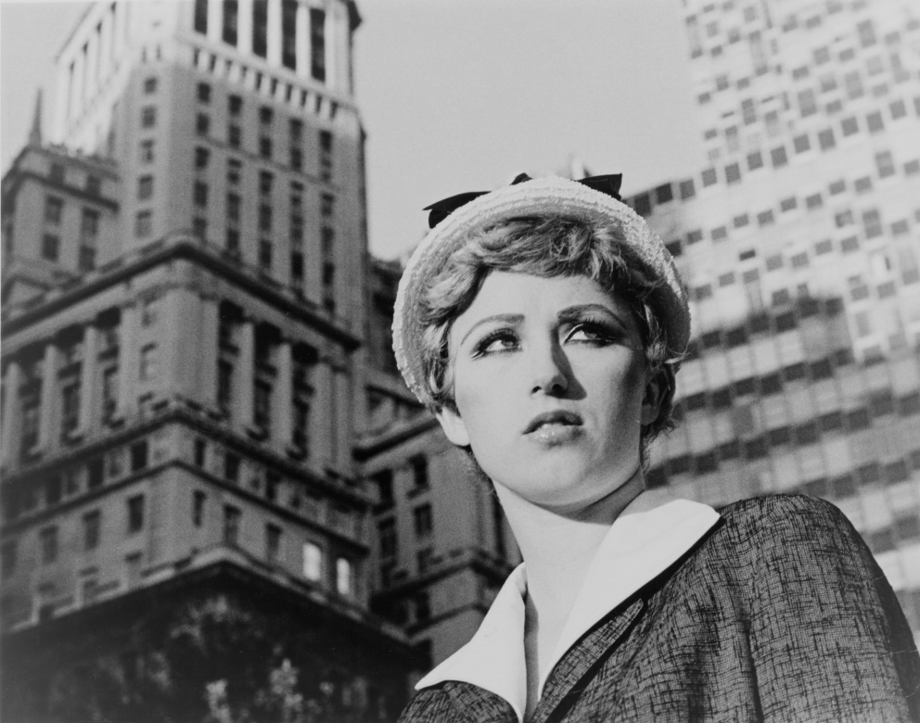
I then decided to look at Cindy Sherman as she was listed as an example and I am already familiar with her work. I understand that the mere fact that her practice is based primarily around self portraiture is narcissistic but I also feel that themes of narcissism run deeper than that in her work.

Figure 1: Still From an Untitled Film, Cindy Sherman, 1977-1980
The above image is perhaps one of her most well-known and is from a set where she dressed as generic female film characters. Many things about this image can be linked to narcissism such as using herself as a model, an apparent comparison of herself to a movie star, the flattering lighting, makeup and dress. Also, photographers tend to base their practices around what they know, see or feel. One could suggest that she sees herself as a movie star and that’s why she spent three whole years creating a set where she can embody or become this. As much as I enjoy Sherman’s work, I was unsure that this was the story of narcissism that I wanted to tell. Therefore, I made the decision to formulate my concept before I looked at more artists.
I decided pretty quickly that narcissistic characteristics didn’t interest me nearly as much as Narcissistic Personality Disorder (NPD). I recalled from previous reading I had done that this was very similar to psychopathy which is an area I’m very interested in. I decided to go back through books I had previously read on this subject, starting with Is There a Psycho in Your Life by Kerry Daynes and Jessica Fellows as I remember it being the most informative. They split Bob Hare’s PCL-R (psychopath checklist) into “lifestyle” and “personality traits” sections. They spoke of an “overlap with diagnostic criteria” for psychopathy with other personality disorders, particularly NPD. They even went as far to say that “…psychopaths and narcissists can therefore be thought of as close cousins.” Daynes and Fellows then listed a nine point checklist for narcissism. They also informed us that there are more psychopaths in the business world than in the criminal population and that psychopathy has no cure. It was then discussed how psychopaths see people as pawns, patrons or patsies. Pawns have something the psychopath wants, patrons are those in positions of power and patsies are people they can step on to get what they want. It was also shown that they are not startled by loud noises, they are good at lying, they have an inability to learn from punishment and they are cold, callous, controlling and narcissistic. The book also quotes Martha Stout whom is the author od The Sociopath Next Door about how psychopaths often have brief but intense hobbies or projects. The book even explained the “laws of friendship” and how psychopaths break all of them. Dynes and Fellows also include a study about how autism and psychopathy are both linked to abnormal amygdala functioning.
I then followed up this research with going back through The Psychopath Test by Jon Ronson. It is a much more pleasant read than the last book, includes the same information but told through a narrative which makes it much longer. There are also parts which demonstrate the key role narcissism plays in psychopathy for example, the business man he interviewed who claimed not to be narcissistic while standing under a huge oil painting of himself. After going through these books I began to think that psychopathy was too much of a tangent from rising levels of narcissism so returned to researching Narcissistic Personality Disorder.
I found a summary of the symptoms of NPD on helpguide.org but discovered a more comprehensive list on mayoclinic.org and it occurred to me that NPD, at it’s heart, was a need for control. I then went back through the symptom list and managed to link them all to a need for control:
- Self-importance
They believe they are important because they believe they are in control
- Entitlement / require admiration
They think that they deserve the world because they think they control it
- Expect to be seen as superior
I control you therefore I am superior to you
- Exaggerate achievements
To validate delusions of control
- Fantasises about power, success, brilliance, beauty or the perfect mate
They crave the control that power, success and brilliance gives them and see beauty and the perfect mate as ways to achieve power
- Believes they are superior
Because they believe they are in control and that makes them superior
- Belittles others
Because they think they can control them and that makes others inferior and unworthy of respect
- Expects compliance
Because they think they control them so others should follow their orders
- Takes advantage of others
Because they think they control others so they can do what they like
- Won’t recognise the feelings of others
Because they think they are in control therefore they think they are the only one that matters
- Envies others
Because others may have something they need to gain control such as money or a position of power
- Behaves arrogantly
They’re smug because they feel in control
- Must have the best
Because they think they deserve it as they are in control
I then perceived that a possible cause for the rise of narcissism is that narcissists crave control and in society right now, it feels like we have an ever-worsening lack of control. This results in people trying to regain a bit more control and power over their lives. For example: global warming shows us that on a personal level we can’t stop the death of our planet, governments lying an breaking promises show us we don’t have a say in how the country is run, no one can give us a definitive answer as to how Brexit will affect us so our future is unpredictable and out of our control, rising levels of youth unemployment makes us feel like we need to take any job we can get and therefore our career paths are out of our control. This is just to name a few examples. Also, we know that feeling out of control increases levels of anxiety and depression. I believe that it also increases narcissism. To decrease the number of people with poor mental health, the government uses consumerism to make people feel like they have some control. Advertisements show people can have ultimate control over how they look with make-up, clothes, accessories, hair dyes and so much more. They show you can control your home by buying upgrades, refurbishment, home décor. You can control how good you feel by buying vitamins, slimming foods, yoga classes – there are so many more examples. This may be keeping a handle on levels of anxiety or depression, but this worsens narcissism even more. It encourages you to spend money on things to make you feel in control which encourages you to obsess over yourself. It feeds your narcissistic tendencies. To summarise; if you feel out of control then you become narcissistic by seeking control, but if you find control through buying things to ‘improve’ yourself, it means you’re obsessing over yourself and becoming narcissistic.
Deciding to go down the route of consumerism, I started looking at artists who work with consumerism. I began with Daniel Tacchinardi.
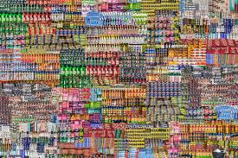
Figure 2: Consumerism – Daniele Tacchinardi
I feel that this image represents consumerism well but on a corporate level. Rising levels of narcissism are because of people buying more not necessarily because of companies creating more.
I wanted to create work about narcissism in older generations because I feel like society looks at the younger people too much when talking about self-obsession. I started out by looking at photographing home décor in my mother’s house because she appears obsessed with her house looking presentable and stylish.
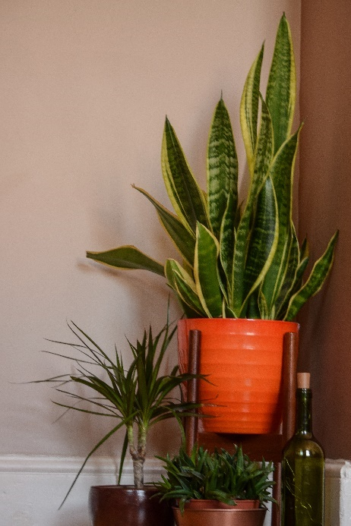
Figure 3: Test Shoot 1
To me, this image looked too much like an advertisement to be considered a negative response to consumerism. In fact, I don’t see it conveying a message of consumerism at all. I had the exact same problem with photographing the garden set up.

Figure 4: Test Shoot 2
Without context, there is no understanding the consumerism behind this image. The garden used to be woodchip until it was converted to stones, This pleased the owner for a bit until she got bored and bought the garden furniture. She was happy for a bit after that too, until she got bored. Then came the wooden picnic table. Then happiness came and got overtaken by boredom at which point the decking was built. The image may have been more successful if there were progress shots taken over months to show the development of the need for more.
After the test shoots were unsuccessful, I began to plan my final shoot. I thought I’d look at the obsession people have with buying more clothes. I had access to photography a three-door closet filled to the brim with clothes. I could have photographed it from the front showing all the clothes but felt that what clothes were inside were not as important as the fact that there was a lot inside. I therefore decided to take a slight angle from the left with all the doors open enough to see that there were clothes inside.
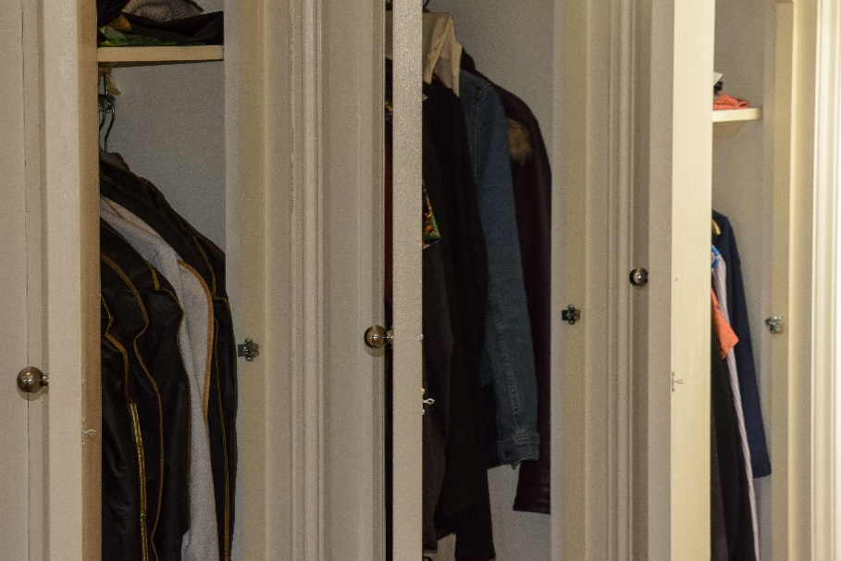
Figure 5: Final Image
I thought it was successful in conveying the message of consumerism and it was a well taken photograph considering the low light and space of the area but it lacked a pleasing aesthetic. If I were to redo this project I would think much more carefully about how aesthetically pleasing the final image is, not just how successful it is at conveying a message. If every image was taken purely to demonstrate an exact point with no regard for art then we’d end up exhibiting stock photos.
When it came to displaying my work in the exhibition I decided to print the same image out three times in a column. This was to suggest that everyone’s closets are the same – filled with so much generic clothing that they can’t possibly need all of it. I displayed it in a white frame on a white wall to keep with the main colour of the image: white. This way, the white walls in the image stretch out and continue on the white walls of the studio. I feel like this way of displaying it helped to convey the message of the image.

The Exhibition – Part 2 of 2
We planned the exhibition by communication through a Facebook Messenger chat. This was very unprofessional of us as in the workplace we would not communicate on social media as it is informal and allows us to be on call 24/7. We should have used email correspondence. On top of this, this chat was being recorded and sent on to the people marking our level of professionalism without our consent or knowledge which was not just unprofessional, but a violation of our privacy.
When it came to selecting rolls, we had a poll where we could all vote for what we wanted to do. The options were: cleaners, bartenders, curators, social media managers, work installers, money collectors and poster makers. I signed myself up for putting up work an after a few people stated how much they really did not want to end up curating, I put myself up for that position as well. Unfortunately, a colleague tried to suggest curation should be done by everyone together. This seemed impractical and making unanimous decisions would be time consuming so it was eventually decided that three of us would take the curation roll.
This colleague then asked that each person only put themselves down for one singular job but I pointed out that it’s better that we cover all bases first and then we can look at cutting down on jobs later but it was important that we had at least one person in each slot to begin with. We ended up with six cleaners, four work installers, three curators, two bartenders, one social media manager who merged this job with the poster creating one, and one money collector.
I then began a discussion about whether we wanted to keep the title or change it and after we talked about it we took a vote. Two people wanted to change the title and everybody else wanted to keep The Narcissism Epidemic.
Next, I helped in a group of us which took down the previous work on the corridor and then stacked the frames round the corner by the office so as to keep them out of the way. I then printed and framed my work, cleaned the frame and helped others frame theirs, put pins in their frames and even helped one person drill brackets into their frame.
As part of the three-person curation team, I helped to curate the whole corridor, taking notes and then created a diagram ensuring that everybody had a space. Everyone also had a say in where they wanted their work to go which was considered during planning. This planned out diagram was then sent to a colleague on the curation committee that didn’t take notes correctly. My colleague then changed the entire exhibition without my knowledge or permission so my contribution was somewhat erased.
I then put my own work up and helped with others too. I took measurements, marked it out, had people hold it while I leveled it and drilled them into the wall. The new layout left an empty gap at the beginning of the exhibition so I asked if we could add something in and a colleague suggested a namelist. This worked very effectively to fill space while keeping the exhibition look professional.
On the night it was quite a rush to finish off. The people in charge of the name tags had only just printed and were still cutting them up so I assisted in hammering them into the walls. I was also trying to help a colleague having technical difficulties to display their work and I also cleared the base room to set up the bar.
We had one major problem however: one person had not printed there work, had not come in, had not responded to any messages and there were rumors that they were dropping out. I left plenty of time for them to show up but at half an hour before the opening, something needed to be done about the big black space. I brought two podiums with paper and pens on and asked a colleague to print a sign indicating that feedback was appreciated then hammered that into the wall. Surprisingly, twenty minutes before the exhibition started, my colleague showed up expecting to print and display their work so I moved the podiums to the very front of the exhibition, removed the notice and got a colleague to paint over the holes where the nails had been, and used double sided tape to stick the notice above the podiums. I then marked out where the images would be put up and nailed the late persons nametag in an appropriate place. The latecomer was still struggling to print so I helped them out but we were only able to print two A4 sheets of paper by the time the exhibition was well under way. I discussed with the group whether it was better to disrupt the exhibition with nailing the paper into the wall or to leave the space blank. A vote was taken and I ended up nailing the paper onto the wall.
Overall I feel like I made a fair contribution to the exhibition and contributed to it’s success.

Bibliography
Books
The Narcissism Epidemic: Living in the Age of Entitlement, Jean M. Twenge and W. Keith Campbell, 2009
Is There a Psycho in Your Life, Kerry Daynes and Jessica Fellows, 2012, London
The Psychopath Test, Jon Ronson, 2012, Croydon
Websites
Narcissistic Personality Disorder, helpguide.org
https://www.helpguide.org/articles/mental-disorders/narcissistic-personality-disorder.htm
Narcissistic Personality Disorder, mayoclinic.org
https://www.mayoclinic.org/diseases-conditions/narcissistic-personality-disorder/symptoms-causes/syc-20366662
Figures
1: Still From an Untitled Film, Cindy Sherman, 1977-1980
2: Consumerism, Daniele Tacchinardi
3: Test Shoot 1 (TNE), Fen Shields
4: Test Shoot 2 (TNE), Fen Shields
5: Final Image (TNE), Fen Shields

