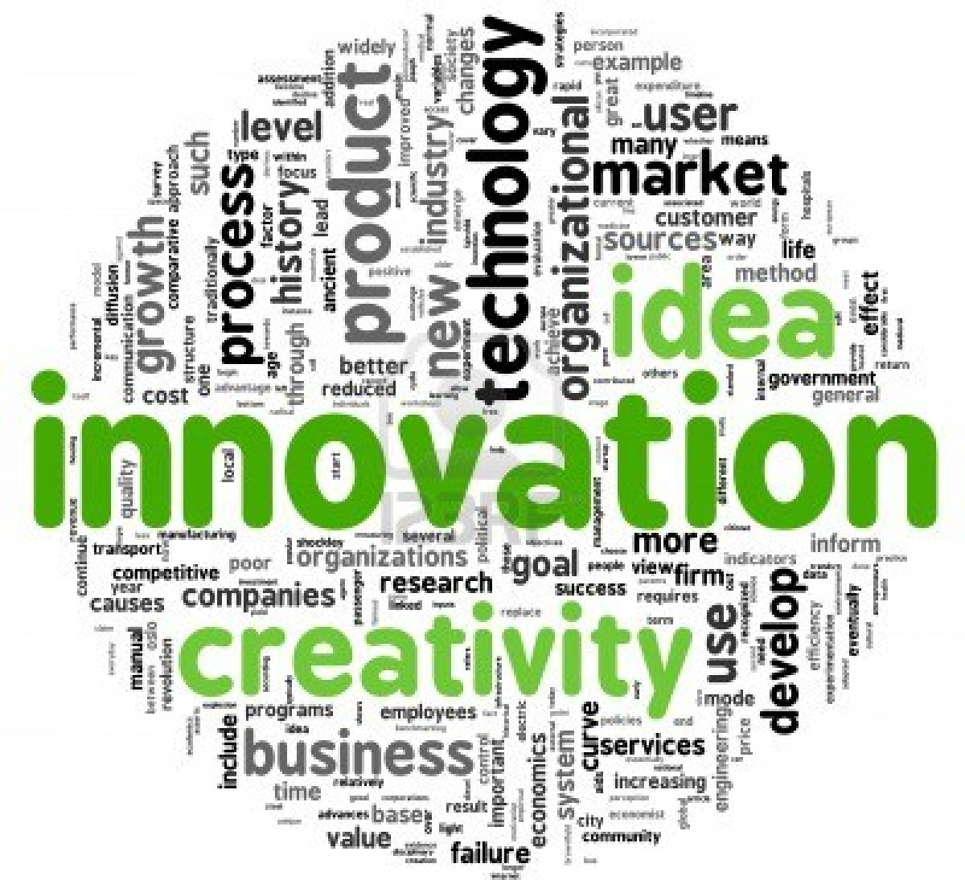

Developing Innovation and Creativity for Business Advantage.
(BMSW6102_SWAN)

Tracey Williams 1905282.
25th March 2022.

Executive Summary.

The basis of this report is discussing how Innovation and Creativity differentiate from each other and evaluate the innovation opportunity of Samsung Galaxy Z Fold 3 smartphone. Research showed this fits into the Incremental Innovation by being an upgraded version of the Galaxy Z Fold 2. And yet, because of the OLED panel making it 25% more power efficient and brand new to the organisation this would also fit into Radical Innovation. Looking into the Creative thinking process this helps to invent, problem-solve, create, and communicate in new ways. Samsung’s process involves employees as well as management and they work together as a whole. The company set up a create lab to give employees the tools, time, and support needed to develop these ideas. Looking at the different innovation models the Open and Closed Innovation model showed advantages and disadvantages, but Samsung’s open innovation proves successful. The Innovation Process Model resulted in it being more reliant on technology and market trends, and customers, suppliers and employees are being ignored resulting in bad representation of the needs of the customer. Looking at the barriers and risks through Lewin’s Force Field Analysis for the forces for and against the innovation opportunity, results were higher for the innovation than against it which proved successful for the opportunity to move forward. Samsung’s leadership style relates to Transformational and yet it could also be associated with a Democratic leadership style. The report showed that Innovation and Creativity are the main drivers for the organisation and comes from the leaders more than the managers.

Contents.
Contents
1.0 Introduction. 4
1.1 What is Creativity and Innovation? 4
2.0 Main Findings. 5
2.1 Overview of the Innovation Opportunity. 5
2.2 Type of Innovation. 5
2.3 The Creativity Thinking Process 5
2.4 Models of Innovation. 6
2.4.1 Open and Closed Innovation. 6
2.4.2 The Innovation Process. 6
2.4.3 4P’s to Innovation. 7
2.5 Assessment of the Effectiveness. 7
2.5.1 Barriers and Risks. 7
2.6 Leadership& Management. 8
3.0 Conclusion. 9
4.0 References. 10
5.0 Appendices. 12
4P’s Innovation Model. 13
13
Lewin’s Force Field Analysis. 13
Task 2 14
Question 1 14
Critically explain how Innovation and Creativity can support business advantage. 14
Question 2. 15
Critically review and evaluate one lecture from the module and reflect on how this has supported your understanding of Innovation and Creativity. 15
References. 16
Question 1 references. 16
Question 2 references. 16

Introduction.

This report was requested on the 10th of January 2022 by the CEO of Samsung and is written by Tracey Williams, Research and Development officer. The discussion will be on Innovation and Creativity and how they differentiate from each other and evaluating an innovative opportunity within an organisation. Looking at how the creativity thinking process can be applied at different levels and analysing models of innovation such as the Innovation Matrix, Open and Closed Innovation, Model of Innovation and 4P’s to Innovation to support the opportunity. Also assessing the effectiveness by using Lewin’s Force Field Analysis to highlight the barriers and risks that the organisation needs to be aware of when implementing the innovation opportunity. The R & d officer will be considering what leadership and management style assisted in the creative idea behind this opportunity. Concluding the report will be looking at whether the innovative opportunity is a success or failure. This report will be submitted on 25th March 2022 and will be researched through resources such as textbooks, internet, journals and articles and these methods will be based on secondary research methods only. The organisation being discussed is Samsung, it is a South Korea based company consisting of many subsidiaries but focusses on mainly electronics from motors, digital tv’s to mobile phones. The organisation is an industry leader in technology and is recognised all over the world and is ranked a top 10 global brand. (Burris, 2020).

1.1 What is Creativity and Innovation?

Innovation is strongly associated with growth. New business is created by new ideas, by the process of creating competitive advantage in what a firm can offer. (Tidd and Bessent, 2018, p. 2). Hunter defines Creativity as “the capability or act of conceiving something original or unusual”. (Hunter, 2013, Chapter 1,). Amabile et al defines creativity “as the production of novel and useful ideas in any domain” and innovation as the successful implementation of creative ideas within an organisation”. (Amabile et al, 1996, pp.1154-1184). However, according to Anderson et al “Creativity and Innovation at work are the process, outcomes, and products of attempts to develop and introduce new and improved way of doing things”. (Anderson et al, 2014, pp. 1297-1333).
Peek suggests that Creativity is the first step in identifying that something might be possible in the first place. But innovation is the action of putting things into practical reality, despite challenges and resistance, rather than just contemplating. Creativity and innovation, while closely linked as part of a creation process, are not the same. Creativity isn’t measurable, it’s subjective, while innovation – at its most basic level meaning "new" – is measurable in the sense that an innovation is the creation of something new, whether it be a new product, idea, or method. (Peek, 2021).
And yet Guy Kawasaki looks at innovation as to “Make meaning to change the life of others and to change the world and make it a better place to live in”. The art of innovation (Kawasaki, 2014). Kawasaki suggests that innovators need to be in denial to keep evolving and to make meaning rather than money and good innovation occurs when there are no limitations and move on to the next curve. Having a mantra that the organisation wants to be known for rather than just a mission statement. (Kawasaki, 2014).

2.0 Main Findings.

2.1 Overview of the Innovation Opportunity.
Samsung first introduced foldables in 2011 but after 10 years it was released to the consumers. The innovation was to reassess the smartphone thoroughly and a flexible hinge mechanism was designed to help prevent dust and dirt getting into it. They released Galaxy Z Fold 3 in 2021 and it has a IPX8 water resistance rating and for privacy it has the ingenuity of using the screen without opening the phone. This exceptional drive for innovation has triggered a growing market for foldable devices with Samsung seeing a 150 percent increase in consumers. The company will continue to collaborate with app developers and industry partners to continue the progress of the mobile industry for the future. (Samsung newsroom, 2021).

2.2 Type of Innovation.
Davila et al (2013) suggests that there are three categories of innovation, Incremental, Radical and Semi-radical. The innovation Matrix shows that not all innovations are created equal. Incremental innovation is upgrading existing products and processes, whereas Radical innovation is something brand new not already in existence. Semi-radical innovation involves change to either the business model or the technology but not both. (Davila et al, 2012, Chapter 2.) See appendices.
Looking at Samsung’s Galaxy Z Fold 3 innovation this would fit into the Incremental innovation, the product is an upgraded version of the Galaxy Z Fold 2. However, it could also fit into Radical Innovation as having the first water resistant foldable smartphone with an IPX8 rating and a flexible OLED panel which is 25% more power efficient and the first company to achieve this which makes it brand new to the organisation.

2.3 The Creativity Thinking Process
John Adair suggests that “as a creative thinker you combine ideas or elements that already exist. Creativity is when someone transforms materials at hand into a new creation”. (Adair, 2007, pp. 7-8).
However, Alhalabi suggests that creative thinking helps you invent, problem-solve, create, and communicate in new ways. These processes help to improve creative thinking skills. (Alhalabi, 2021).
According to James Taylor when you think of creativity you think of the arts or music, whereas manufacturing and business is more related to innovation. He suggests a framework 6p’s of creativity, starting with Purpose: why is Samsung creating this? This would be to improve the original product. Personality: understanding how the team do creativity whether they work well together. Process: looking at who can model their product and ideas. Place: their environment in which they work. This would relate to Samsung’s C-lab as explained underneath. Product: what is the product? Which is Samsung Galaxy Z Fold 3 smartphone. Persuasion: being able to persuade someone that the creative idea is worth pursuing is very important. The 6P’s of Creativity (Taylor, 2015).
Samsung’s creativity thinking process doesn’t just involve management but also the employees, the organisation as a whole work together for more creative ideas. The company set up a C-lab (short for creative lab) for workers, to encourage them to create ideas by giving them time, support, and the tools to develop these ideas and with the colleague’s agreement this could result with further development of a new product or service. The lab enables the employees to give 100% commitment to their projects. (Samsung Newsroom, 2016).

2.4 Models of Innovation.

2.4.1 Open and Closed Innovation.

According to Chesbrough “The Closed Innovation paradigm and its associated mind-set toward organisations industrial R&D has led to many important achievements and many commercial successes”. (Chesbrough, 2006, p. 21).
However, Tidd and Bessant states that there are arguments for keeping a closed approach, “there is a value in doing your own R&D and market research because the information collected is then available to be exploited in ways that business can’t control” (Tidd and Bessant, 2018, p. 240).
The Open Innovation is where important ideas come from inside or outside the organisation. This approach puts external ideas and paths on the same level of importance as that of the internal ideas and paths. (Chesbrough, 2006, p. 43). An example of the model in appendices.
Samsung has an open innovation the organisation encourages its research and development team to look for possibilities for open innovation. The organisations champions collaborate with external partners which have successfully derived dozens of start-ups from them. A four-part strategy the company uses for open innovation partnerships, accelerators, acquisitions, and ventures. Samsung collaborates with other tech companies to find new opportunities within its existing product line. (Rodriguez, 2022). Although there can be disadvantages of open innovation, risks of information being leaked that competitor can then have an advantage in the market. Risks of making the wrong choice among the start-ups and sometimes skilled employees can be enticed into competing companies. (Go>Tech, 2021).

2.4.2 The Innovation Process.
Managing the innovation process to provide a good solution for a problem or refreshing a creation involves, searching, selecting, implementing, and capturing value from the innovation. (Tidd and Bessant, 2018, p. 48).
Samsung’s overall innovation process began with a Project Innovation Team (PIT) with the need to have an incubator group to work with every business unit. Below is how it would work in the model innovation process. (Samsung Newsroom, 2013).

Capture. This is where finalisation and the PIT employees together with business units end the product concept.

Implement. This is refining into one concept then developed into a solid business case for the units.
Select. Thinkers and designers analyse the data from the research brainstorming hundreds of ideas that might prove innovation to the task at hand.
However, having a linear process can sometimes be reliant on the technology and market trends, and other sources such as customers, suppliers, public and employees are ignored. Money is spent on R&D but not on the other sources, resulting in bad representation of the needs of the customer. (Luenendonk, 2019).

2.4.3 4P’s to Innovation.

Tidd and Bessant suggest that innovation can take changes in several forms and there are four categories: Product innovation, Process innovation, Position innovation and Paradigm innovation. Mainly referred as the 4P’s to innovation this tool enables businesses to discover what the innovation process can improve and bring to the business. (Tidd and Bessant, 2018, p. 21).

Product Innovation. | Process Innovation. | Position Innovation. | Paradigm Innovation.
Samsung Galaxy Z Fold 3 smartphone. Upgraded form the Z Fold 2. | Creating an extra-large screen with an added S Pen support. | Customer’s request. | A flexible OLED panel called Eco OLED, 25% more power efficient and the first company to achieve this.

The product innovation would go into Incremental because it is an upgraded version of original product, whereas the Process Innovation would go into Radical because it is new to the company. Position would be Incremental because the customers have requested an updated version and finally the Paradigm would be Radical because it is brand new. (See appendices for model). There are some criticisms of the 4P’s model in that there is an unclear transition between Radical and Incremental sometimes they can overlap each other. Also, there is a lack of guidance for further steps. (Biznewske.com, 2022).

2.5 Assessment of the Effectiveness.

2.5.1 Barriers and Risks.
Force Field Analysis was created by Kurt Lewin in the 1940’s. The model is used in businesses for making and communicating go/no-go decisions and is used by analysing the forces for and against change. (Mindtools, 2022).
The model is easy to understand and by enhancing the driving forces and reducing the resisting forces this allows the organisation to present their decision in the most appropriate way to the team. And yet, if key people are ruled out of the analysis the result will probably be inaccurate and differences of opinions could occur, and the model does not show how to proceed if that happens. (Expert Management Program, 2021). Results for Samsung’s innovation showed that forces for change scored higher than forces against so the innovation opportunity can move forward. (See appendices).

2.6 Leadership& Management.

Samsung’s leadership style relates to Transformational; the leaders inspire, encourage, and motivate employees to be innovative and creative by communicating and collaborating and encouraging them to learn, grow and perform to exceptional levels to help in the success of the organisation. Yet, creativity could be associated with a democratic leadership style by using vision to drive and encourage team members to be more innovative and creative through giving them new opportunities to develop new ideas.
The CEO of Samsung stressed “the importance of technology preparation management” this shows the strong will of top management to implement the innovation strategy. Also, that open innovation needs to be encouraged to enable concurrence in the electronic industry. (Jang et al, 2019). This would suggest that there is more focus on innovation and creativity coming from the leaders.
Samsung’s leaderships aim is not simply about the consumption of products but the way the organisation invents, works, and collaborates with its broader ecosystem of industry peers and partners. (Samsung Newsroom, 2017).

3.0 Conclusion.

This report concludes that Innovation and Creativity go together like a team one creates new ideas and the other implements these ideas within the organisation. The Innovation opportunity is Samsung Galaxy Z Fold 3 smartphone this fits into the Incremental Innovation by being an upgraded version of the Galaxy Z Fold 2. And yet, because of the OLED panel making it 25% more power efficient and brand new to the organisation this would also fit into Radical Innovation. Creative thinking process helps to invent, problem-solve, create, and communicate in new ways. Samsung’s process involves employees as well as management and they work together as a whole. The company set up a create lab to give employees the tools, time, and support needed to develop these ideas. The Open and Closed Innovation model showed advantages and disadvantages, but with Samsung’s open innovation it proves to be successful. The Innovation Process Model resulted in it being more reliant on technology and market trends and customers, suppliers and employees being ignored resulting in bad representation of the needs of the customer. The 4P’s to Innovation also showed to have some criticism especially the overlapping of the transition between Radical and Incremental Innovation. Looking at the barriers and risks through Lewin’s Force Field Analysis for the forces for and against the innovation opportunity, results was higher for the innovation than against it which proved successful for it to move forward. The model is easy to understand but if anything was ruled out of the analysis the model does not show how to proceed with it. Samsung’s leadership style relates to Transformational and yet it could also be associated with a Democratic leadership style. The report showed that Innovation and Creativity are the main drivers for the organisation and comes from the leaders more than the managers.

4.0 References.

Adair, J (2009) The Art of Creative Thinking: How to Be Innovative and Develop Great Ideas. London: Kogan Page, Limited.
Alhalabi, R. (2021) Creative Thinking: What is it, Why is it Important, and How to Develop it? Available at: https://www.potential.com/articles/creative-thinking/ (Accessed: 8th March 2022).
AMABILE, T.M., CONTI, R., COON, H., LAZENBY, J. and HERRON, M., 1996. Assessing the work environment for creativity. Academy of Management Journal, 39(5), pp. 1154-1184.
Anderson, N., Potočnik, K. and Zhou, J. (2014) ‘Innovation and Creativity in Organizations: A State-of-the-Science Review, Prospective Commentary, and Guiding Framework’, Journal of Management, 40(5), pp. 1297–1333. doi: 10.1177/0149206314527128.
Biznewske.com, (2022) The 4P’s Innovation Space Model: Product, Process, Position, Paradigm Innovation. Available at: https://biznewske.com/4ps-innovation-space-model/ (Accessed: 21st March 2022).
Burris, M. (2020) The History of Samsung (1938-Present). Available at: https://www.lifewire.com/history-of-samsung-818809 (Accessed: 27th February 2022).
Chesbrough, H. (2006) Open Innovation: The New Imperative for Creating and Profiting from Technology. Boston, MA: Harvard Business School Press.
Davila, T. et al. (2012) Making Innovation Work: How to Manage it, Measure it, and Profit from it. Updated Edition. Available at: https://books.google.co.uk/books?id=F2_S8FFaSKMC&printsec=frontcover&dq=Making+Innovation+Work:+How+to+Manage+It,+Measure+It,+and+Profit+from+It&hl=en&sa=X&ved=0ahUKEwig-pi21PHpAhX7ShUIHcnKCzIQ6wEIKjAA#v=onepage&q=Making%20Innovation%20Work%3A%20How%20to%20Manage%20It%2C%20Measure%20It%2C%20and%20Profit%20from%20It&f=true (Accessed: 6th March 2022).
Expert Program Management. (2021) Force Field Analysis. Available at: https://expertprogrammanagement.com/2021/09/force-field-analysis/ (Accessed: 21st March 2022).
Go>tech Innovation, (2021) Closed Innovation VS Open Innovation. Available at: https://gotechinnovation.com/closed-innovations-vs-open-innovations/ (Accessed: 21st March 2022).
Hunter, G. S. (2013) Out-Think: How Innovative Leaders Drive Exceptional Outcomes. Germany: Wiley.
Jang, S.H., Lee, S.M., Kim, T. et al. Planting and harvesting innovation - an analysis of Samsung Electronics. Int J Qual Innov 5, 7 (2019). https://doi.org/10.1186/s40887-019-0032-x
Kawasaki, G. (2014) The Art of Innovation. [Ted Talk]. Available at: https://www.youtube.com/watch?v=Mtjatz9r-Vc&t=6s (Accessed: 23rd March 2022).

Luenendonk, M. (2019) The Innovation Process: Definition, Models, Tips. Available at: https://www.cleverism.com/innovation-process-definition-models-tips/ (Accessed: 21st March 2022).

Peek, S. (2021) Creativity is Not Innovation (But You Need Both). Available at: https://www.businessnewsdaily.com/6848-creativity-vs-innovation.html#:~:text=Creativity%20is%20the%20novel%20step,resistance%2C%20rather%20than%20just%20contemplating (Accessed: 23rd March 2022).
Rodriguez, J. (2022) 5 Example of Companies that got Open Innovation Challenges Right [blog] Available at: https://www.herox.com/blog/982-5-examples-of-companies-that-got-open-innovation-c (Accessed: 21st March 2022).
Samsung Newsroom. (2021) A Decade: How Samsung Foldables are Defining the Future of Smartphone Innovation. Available at: https://news.samsung.com/global/a-decade-in-the-making-how-samsung-foldables-are-defining-the-future-of-smartphone-innovation (Accessed: 27th February 2022).
Samsung Newsroom. (2016) How Samsung Helps its Internal Innovators to Spread their Wings. Available at: https://news.samsung.com/global/how-samsung-helps-its-internal-innovators-to-spread-their-wings (Accessed: 7th March 2022).
Samsung Newsroom. (2017) [Innovation Feature Part 1] Samsung Changing for the Future. Available at: https://news.samsung.com/global/innovation-feature-part-1-samsung-changing-for-the-future (Accessed: 22nd March 2022).
Samsung Newsroom. (2013) Samsung’s Product Innovation Team: How Ideas Become Streamlined. Available at: https://news.samsung.com/global/samsungs-product-innovation-team-how-ideas-becomes-streamlined (Accessed: 10th March 2022).
Taylor, J. (2015) What is the Difference Between Innovation and Creativity: James Taylor [video]. Available at: https://www.youtube.com/watch?v=TL2d2t2iZkY&t=546s (Accessed: 10th March 2022).
Tidd, J. and Bessent, J. (2018) Managing Innovation. Integrating Technological, Market and Organisational Change. 6th Ed. Hoboken: Wiley.

5.0 Appendices.

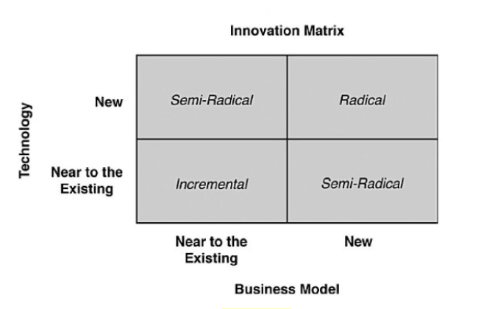
First water resistant foldable.
Upgraded smartphone

Open and Closed Innovation Model.

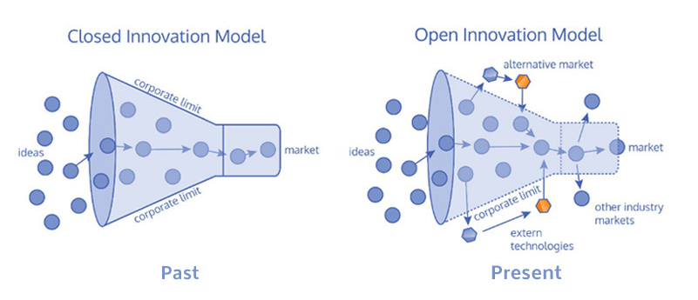

4P’s Innovation Model.
Incremental
Incremental
Radical
Radical

Lewin’s Force Field Analysis.
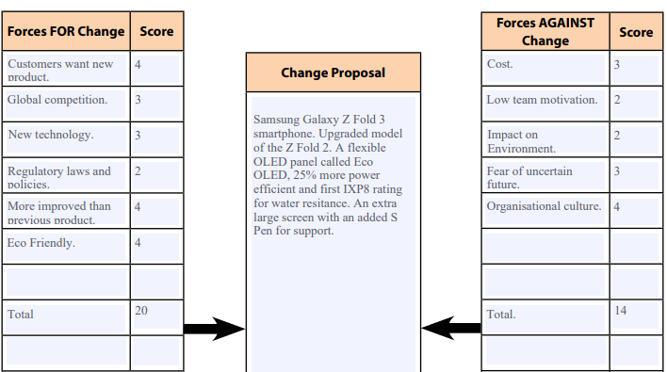

Task 2

Question 1

Critically explain how Innovation and Creativity can support business advantage.
“Innovation enables problem-solving and provides creative insight that allows you to look at things from a different perspective, regardless of whether you are developing a new product. It is one of the critical skills for achieving success”. (Ni Business Info, 2022). Some would argue that businesses that do not innovate have the risk of reduced productivity losing market shares to competitors and key staff and even the risk of going out of business. (Ni Business Info, 2022).
Creativity is an essential element in the business world and most companies can benefit from it. Ravelo states that there are nine surprising advantages of creativity in business. Creativity can help companies create lasting value through innovation it also invites the creation of new and innovative ideas. It allows you to see the customer’s needs from different angles also help in reinforcing the brands. Creativity can attract top talent as well as boosting the productivity and performance of employees. Creative thinking helps solve problems and recognises failures giving opportunity to make improvements. Creativity makes for a more positive workplace and results in higher job satisfaction. (Ravelo, 2021).
All businesses need Creativity and Innovation without the two the company won’t be able to grow beyond the competitors. Showcase unique qualities by showing what makes the business different to others which will make people remember who the business is and what they have to offer. Creativity can help connect more with customers and keep them from going to competitors. (Kappel, 2022).
However, there can be disadvantages of innovation in business, stockholders and investors don’t like change that reduces, so they only see the negative side of the innovation. Some HR departments prefer not to hire people who want to transform the corporate culture. It is hard to choose between the advantages and disadvantages of innovation, but the decisions can show what a good leader looks like in business. (Sherman, 2019).
According to Queens University “Creativity is inherent in all people, but for some, it may lie dormant”. (Queens.edu, 2022). Having creative leaders and managers can inspire employees to problem solve and understand the company’s ideas and goals. In today’s businesses there is an aggressive competitive environment which needs the companies to adapt quickly to all the technological changes. Having a diverse team can inspire new ways for creative solutions. Grouping teams with the same mind set can stall and restrain creative ideas. Rewarding employees for their innovation ideas helps them become more creative. (Queens.edu, 2022).
Comedian John Cleese once said, “If you want Creative workers, give them enough time to play”. This is true in many ways and yet some organisations aren’t doing enough to encourage workers to innovate. Creativity is a performance booster; it encourages collaboration and problem solving that offers the team a share in the outcome. Creating an environment that leaders and teams can engage, exchange ideas, and have team-building exercises, these can have a positive impact on the workforce. (Charpentier, 2022).

Question 2.

Critically review and evaluate one lecture from the module and reflect on how this has supported your understanding of Innovation and Creativity.

Greg Satell (2017) created the Innovation Matrix for leaders to identify a strategy to solve problems by asking two questions ‘How well can we define the problem? And how well can we define the skill domain(s) needed to solve it’? The 4 types are Sustain Innovation, Breakthrough Innovation, Disruptive Innovation and Basic Research. (Satell, 2017). However, the lecturer stated that it was Davila et al (2012) who created the matrix making it hard to find resources for the report. The model was easy to follow but sometimes confusing when some of the types of innovation over lapped.
The lectures for this module are based on activity learning which for me personally it didn’t work. I understand interacting with the students but being online I felt less engaged. The lecture ‘What is Innovation’ consisted of two videos to watch but there wasn’t enough time on the day to watch them. However, when I did watch Guy Kawasaki’s Ted x talk The Art of Innovation, I found it engaging from start to finish especially with his humour which made it more interesting, and I agreed with his thinking that ‘great innovation occurs when you don’t limit yourself and you think to the next curve’. He discussed 10 key points but for me the first two was significant to innovation. Make meaning rather than money to change the world and make mantra rather than a mission statement, state why should it exist? (Kawasaki, 2014).
The second video was Professor Joe Tidd discussing Why innovate? Creating & capturing value. He discusses that innovation is for benefit or value rather than profit or growth and how do they create that value and how might they capture it? (Tidd, 2014). This video lecture I didn’t understand very well because I couldn’t hear what the students were responding to his questions, and he kept saying we will discuss that in the next lecture, or we discussed that in the previous lecture. So, unless you were in the first lecture it wasn’t beneficial to me for my learning.
Another part of the lecture was to read Peter Drucker ‘The Discipline of Innovation’ article. He argues “that most innovative business ideas came from methodically analysing seven areas of opportunity”. Four areas exist within a company these are unexpected occurrence, incongruities, process needs and industry and market changes. Three additional areas exist outside a company these are demographic changes, changes in perception and new knowledge. Innovation requires knowledge, ingenuity, and focus. (Drucker, 2002). I understand the seven areas of opportunity however, I would have preferred to have gone through these in my lecture.
Reflecting on the What is innovation? lecture from the module I feel it was a wasted lecture, the first hour was going over the previous weeks lecture and the recording was about 30 minutes in total. I had to leave early but looking at the recording it didn’t really help because most of it was telling us what to do at home. I could have improved my understanding of this lecture if I had watched the videos sooner and read the article. However, I still prefer to go through my lectures with slides showing exactly what tools and models being discussed.

References.

Question 1 references.
Charpentier, L. (2022) The Importance of Unleashing Creativity and Innovation in your Team. Available at: https://www.forbes.com/sites/forbesbusinesscouncil/2022/02/08/the-importance-of-unleashing-creativity-and-innovation-in-your-team/?sh=8cd220254373 (Accessed: 22nd March 2022).
Kappel, M. (2022) 4 Benefits of Innovation in Business. Available at: https://www.allbusiness.com/4-benefits-innovation-business-111251-1.html (Accessed: 22nd March 2022).
NI Business Info, (2022) Use Innovation to start or grow your business. Available at: https://www.nibusinessinfo.co.uk/content/advantages-innovation#:~:text=Innovation%20enables%20problem%2Dsolving%20and,stay%20ahead%20of%20the%20competition. (Accessed: 22nd March 2022).
Queens University of Charlotte (2022) Importance of Creativity and Innovation in Business. Available at: https://online.queens.edu/resources/article/creativity-and-innovation-in-business/ (Accessed: 22nd March 2022).
Ravelo, L. (2021) 9 Surprising Advantages of Creativity in Business. Available at: https://www.creativitymesh.com/advantages-of-creativity-in-business/ (Accessed: 22nd March 2022).
Sherman, F. (2019) The Advantages and Disadvantages of Innovators. Available at: https://bizfluent.com/info-8471685-advantages-disadvantages-innovators.html (Accessed: 22nd March 2022).

Question 2 references.

Drucker, P.F (2002) The Discipline of Innovation. Available at: https://hbr.org/2002/08/the-discipline-of-innovation (Accessed: 24th March 2022).
Kawasaki, G. (2014) The Art of Innovation. [Ted Talk]. Available at: https://www.youtube.com/watch?v=Mtjatz9r-Vc&t=6s (Accessed: 23rd March 2022).
Satell, G. (2017) The 4 Types of Innovation and The Problems They Solve. Available at: https://hbr.org/2017/06/the-4-types-of-innovation-and-the-problems-they-solve (Accessed: 24th March 2022).
Tidd, J. (2014) Why Innovate? Creating & Capturing Value. [video]. Available at: https://www.youtube.com/watch?v=n9txlwMjcCI&t=10s (Accessed: 24th March 2022).

