Fundamentals of Construction Technology

Assignment: 1

University of Wales Trinity Saint David’s
Student: Ryan Tillman Davies
Student ID: 191404
Course Title: HND Architectural Technology
Email address Ry4ntdavies@gmail.com


Table of Contents
University of Wales Trinity Saint David’s 1
Project Brief 2
Introduction 3
Best Practice for a Site Investigation 3
Site in Question 3
Appendix 1 – Proposed Location of the site (3D View) 4
Appendix 2– Google Earth 3D (North Facing) 4
1. Desktop Study and Archival Research 5
1a. Desktop Study Definition 5
Appendix 3 - Archival Ordnance Survey Map 1:1250 (Swansea Archive Records, Surveyed November 1945 – 1946 Plan 21/6592) 5
1b - Previous Use 5
Appendix 4 – Google Earth 2D (22/11/19) (North Facing) 6
1b. Planning Records of Adjacent Sites 7
Planning Application: 2019/2525/DOC 7
1c. Contamination Report and Findings 7
2. Walkover Survey 8
Appendix 6 – 2D Google Earth Site Location (North Facing) 8
2b - Ground Investigation Recommendations 10
3. Suitable Foundation Design Recommendation 11
3a- Pile Foundation Benefits 11
3b - Pile Foundations Drawbacks 12
Appendix 10 – C.D. Gray Engineering Proposed Costa Coffee Pile Foundations, Heol Ddu, Birchgrove, Swansea (2019) 12
3c – Evaluation of Pile Foundation Methods 13
• 3c (1) - Augered & Continuous Auger Pile Foundations 13
• 3c (2) - Driven Piles 13
• 3c (3) Pile Foundation Method Recommendation 13
4. References 13
4a. Sources 13
4b. Appendixes 14

Project Brief

‘City and County of Swansea have chosen to enter into a joint agreement with Marriot Hotels to create a new restaurant and ice-cream parlour (with manager’s apartment) on Swansea foreshore, in the position indicated. The site is located between County Hall and the Marriot Hotel and is illustrated on the attached images. The building, which is to share parts of the car park of both of the existing adjacent facilities, is to have a GIA (Gross Internal Area) at ground floor level of approximately 300 square metres.’

Introduction
The objective of this report is to describe the history of the proposed site via a desktop study, identify the ground conditions and existing site details and establish any historical contaminants recommendations of the best practice in carrying out the site investigation with appropriate regulations and codes of practices applied.

This report will determine a feasible foundation design for the proposed construction of a new restaurant and ice cream parlour on the Swansea foreshore. Considering the findings of the report and the building regulations.

Best Practice for a Site Investigation
The first recommendation to consider is to follow the structure outlined by the code of practice BS5930 and Approved Document C (Site Preparation and resistance to contaminants and moisture) for an effective site investigation.

• ‘Phase 1: Desk study and field reconnaissance (see Section 2);
• Phase 2: Preliminary investigation;
• Phase 3: Detailed (design) investigation;
• Phase 4: Control investigation’

(Code of Practice for Site Investigations BS5930 (2015)

Site in Question

Appendix 1 – Proposed Location of the site (3D View)
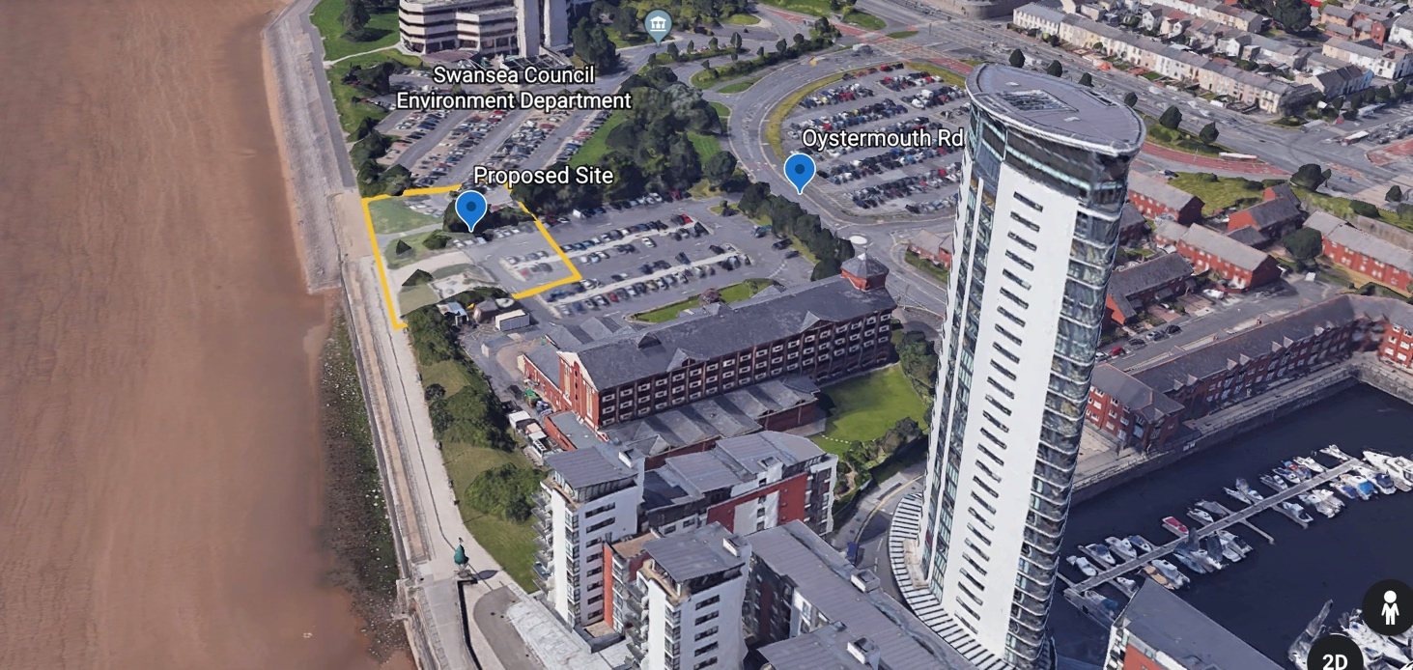

Appendix 2– Google Earth 3D (North Facing)
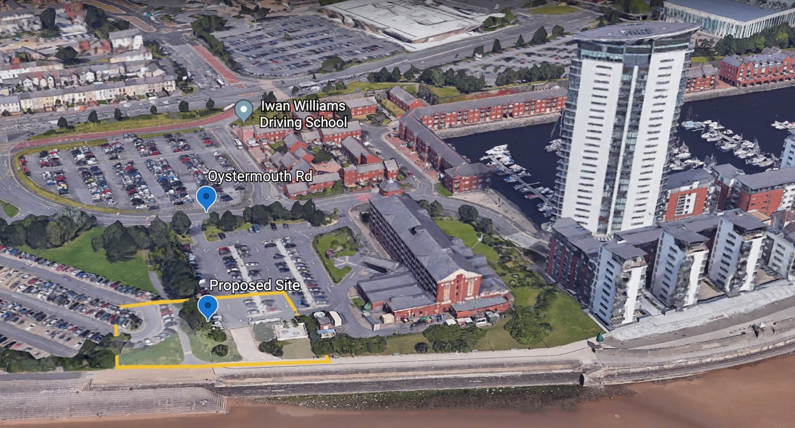

Desktop Study and Archival Research

1a. Desktop Study Definition

‘The desk study should comprise a factual core supplemented by interpretative elements which summarize physical, geoenvironmental and geotechnical aspects in order to aid the formulation of a ground model or a conceptual site model.’

As stated in the Code of Practice for Site Investigations BS5930 (2015), https://geotechnicaldesign.info/download/bs5930-2015.pdf (Accessed November 2019)

Appendix 3 - Archival Ordnance Survey Map 1:1250 (Swansea Archive Records, Surveyed November 1945 – 1946 Plan 21/6592)
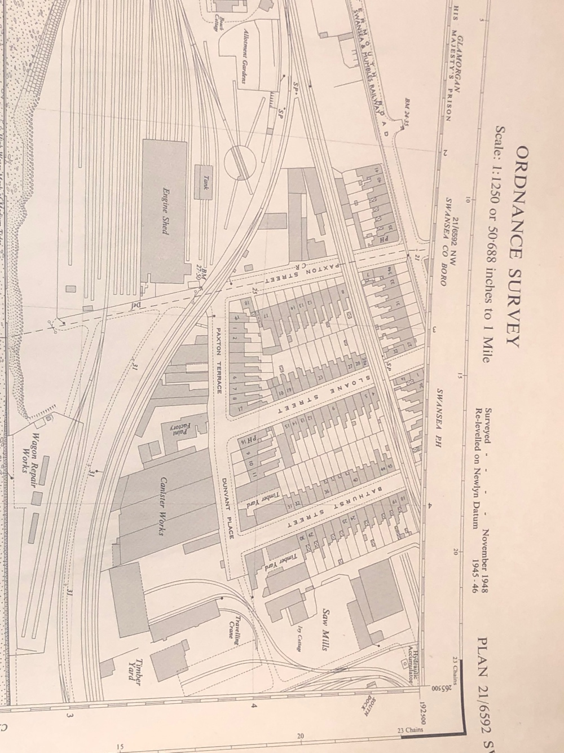

1b - Previous Use
Figure 3 demonstrates the historical background of the proposed site. The previous use of the site illustrated above was a ‘Canister Works’ and ‘Engine Shed’ that suggests that the site ground can pose a risk of contaminated soil from industrial chemicals previously used on the site.

Logically the risk of contamination on site is feasible to prepare a ground investigation and lab study to ensure the safety of workers in accordance with the Health and Safety at Work Act 1974 - Control of Substances Hazardous to Health Regulations and Construction Design and Management Regulations (CDM 2015) to eliminate the hazard to workers. Failure to ensure the safety of workers will be considered negligence, where the principle contractor and designer will be liable in the court of law leaving the company open for prosecution.

Additionally, the site has a history with railways running through the area that would be used to transport goods and people to Carmarthen on the Mumbles track. Potentially during excavation of the site, old railway tracks may be encountered and can present issues such as increased cost of safe excavation and removal. Lead can be a contaminant along with metals within the soil. Considering this, an essential requirement is to assume that the land may contain these industrial contaminants and consider appropriate soil remediation techniques.

Appendix 4 – Google Earth 2D (22/11/19) (North Facing)
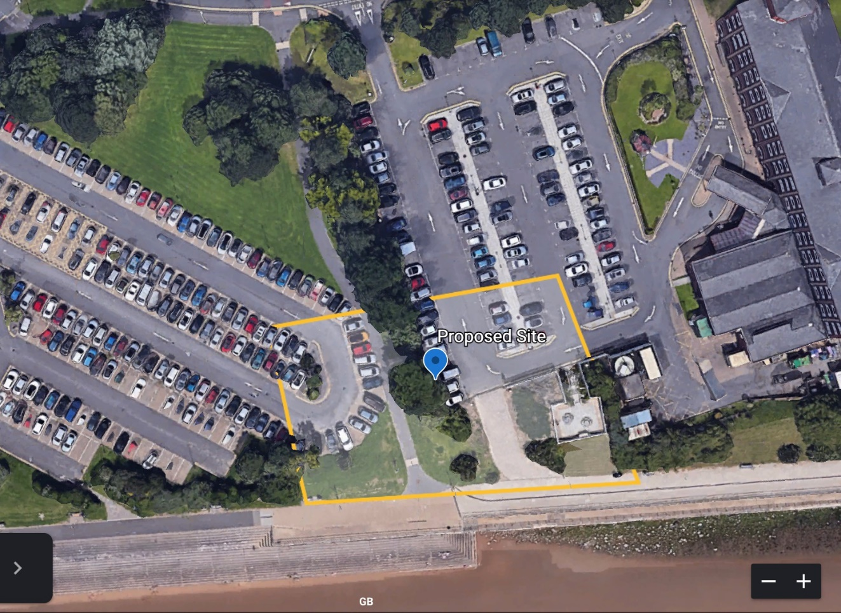

Finally, a recommendation will be to consider the risk that a brown field site can pose to workers on site. Ensure that there are provisions in place to identify any services that are existing in the substructure if compromised will become a hazard to employees such as underground pipe work and electrical cables. To comply with the Health and Safety at Work Act 1974: CDM Regulations 2015, Personal Protective Equipment and training must be supplied to all workers for the appropriate contamination dealt with on site safely, any specialist work shall be subcontracted to competent persons.

Specifically, to the site in question being in Swansea the risk of unexploded bombs from World War II was feasible due to the history of the area. This was investigated in the Swansea Archive where the historian believed that there would be an unlikely risk of unexploded bombs in the area considering the extensive development over the years such as the adjacent Marriot Hotel, it would be more likely to have been discovered and removed.

Building Control will expect evidence of a Coal Mining Authority report for the proposed site is located within an area that is considered within the coal mining areas.

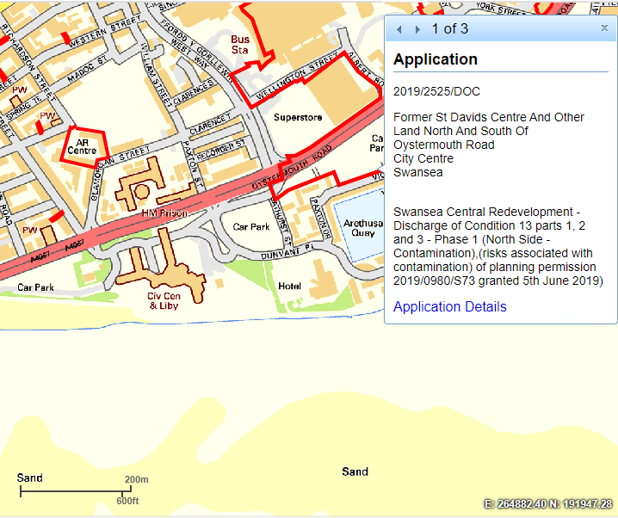
1b. Planning Records of Adjacent Sites

Planning Application: 2019/2525/DOC
Address

‘Former St Davids, Centre And Other Land North And South Of
Oystermouth Road, City Centre, Swansea. Swansea Central

Redevelopment – Discharge of Condition 13 parts 1, 2 and 3 - Phase 1 (North Side - Contamination) (risks associated with contamination) of planning permission 2019/0980/S73 granted 5th June 2019)’

https://property.swansea.gov.uk/online-applications/applicationDetails.do?activeTab=makeComment&keyVal=Q0G9THEVKAR00 (5th of June 2019) (Accessed November 2019)

Appendix 5 – Swansea Town and Planning (5th of June 2019) (Accessed November 2019) https://property.swansea.gov.uk/online-applications/applicationDetails.do?activeTab=makeComment&keyVal=Q0G9THEVKAR00

1c. Contamination Report and Findings
Within the planning application reference 2019/2525 for an adjacent site the document titled Curtins Ltd ‘Hydrocarbon Contamination Letter’ (Issued: 5th of June 2019) (Accessed November 2019) Ltd explains the discovery of the contamination found during the ground investigation.

The report initially identifies ‘granular deposits of sandy gravel to a proven depth of 5.45m’ which was predicted due to the site being located near to the Swansea coast line which the described soil type discovered is proven to contain a low bearing capacity which would be unable to support the loading of the proposed building. The ground water table was discovered at 5.0m and continued to rise to 3.7m. This information will be valuable to predict what to expect during the project’s ground investigation and ultimately the excavation of the foundations.

The investigation encountered a metal object which resulted in the bore hole being abandoned. Which re-enforces the prediction made from the archival research that it is probable that metal obstructions may be found due to the previous industrial usage such as the ‘canister works’ and train line, potentially causing delays on-site from working at the substructure which can indicate additional costs. https://property.swansea.gov.uk/online-applications/applicationDetails.do?activeTab=makeComment&keyVal=Q0G9THEVKAR00 (5th of June 2019) (Accessed November 2019)
Additionally, the letter commented on the ‘Visual and olfactory evidence of hydrocarbon contamination was identified at 5.0 m to 5.45 m bgl in the form of a strong hydrocarbon odour and visible sheen on the soil sample.’ This form of contamination is likely to be discovered on the site in question with the current use being a car-park as identified in the walkover survey makes it probable that fuel has been spilled on the site which is formed of hydrocarbons the lab study conducted found amounts of hydrocarbons up to 880 mg/kg.
The discovery of ‘BTEX (benzene, Toluene, Ethylbenzene and (m,o)Xylene) compounds are also noted within the sample at low to moderate-concentrations.’ Curtins Hydrocarbon Letter (July 2019) (Swansea Planning)’https://property.swansea.gov.uk/online-applications/applicationDetails.do?activeTab=makeComment&keyVal=Q0G9THEVKAR00 (5th of June 2019) (Accessed November 2019)

Walkover Survey

Appendix 6 – 2D Google Earth Site Location (North Facing)
Existing Vegetation and Trees
Carpark (Brown Field Site)
Carpark (Brown Field Site)
Existing Adjacent Building
Water Table/ Coast
Existing Adjacent Building
Site Access
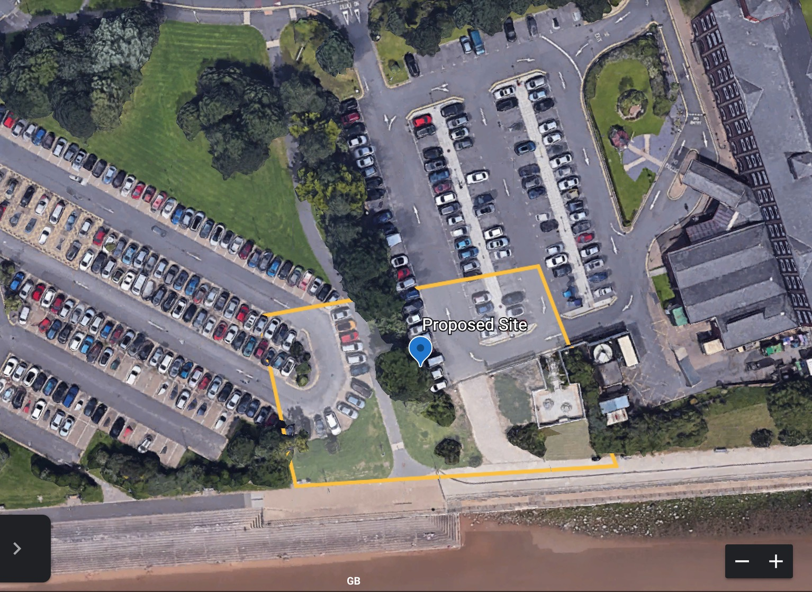

The proposed site is located between the site is located between Swansea County Hall and the Marriot Hotel.

The site will be considered a brown field site as the current use of the land is for car parking and vehicle storage, this can suggest soil contamination from oil and fuel spillage.

Following the Code of Practice for Site Investigations BS5930 (2015) guidance clearly outlines that if the proposed site falls under the category of a brown field site, it can indicate a risk of substances that can be harmful when exposed to life, contaminate other environments or even attack properties found in materials within buildings. Additionally, the guidance identifies that any site can be at risk of naturally existing amounts of arsenic, methane and radon for example that will need to be considered when investigating.
(No Author) (Accessed November 2019) https://geotechnicaldesign.info/download/bs5930-2015.pdf

Appendix 7 – Approved Document C (C1)

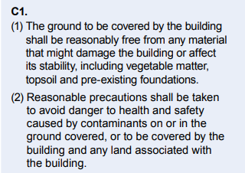
As seen in Appendix 7 – Approved Document C outlines that it is a requirement that the proposed site is reasonably free from contamination and precautions are in place to avoid the existing hazards to effect inhabitants and the proposed structure.

Additionally, the adjacent buildings near the site can suggest that services may be running beneath ground. As illustrated above the presence of trees on the site can impact the foundation design therefore an investigation on the variety of species present to indicate root size and moisture demand of the tree. A planning perspective to confirm that are no protected trees that cannot be demolished or that any protected habitat is being impeded. A recommendation would be to request more information on the existing services from Swansea City and Council and Western Wales and Power Distribution.

2b - Ground Investigation Recommendations
Appendix 8 - Cranfield Soil and Agrifood Institute, Soil Scapes
http://www.landis.org.uk/soilscapes/
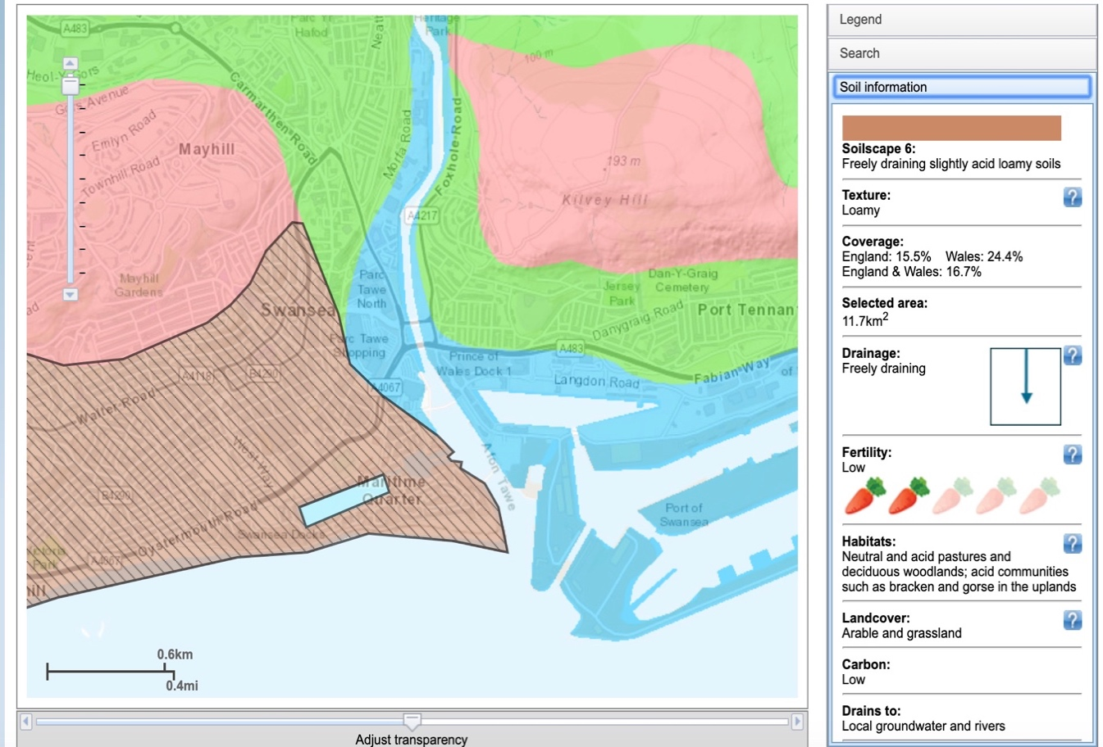
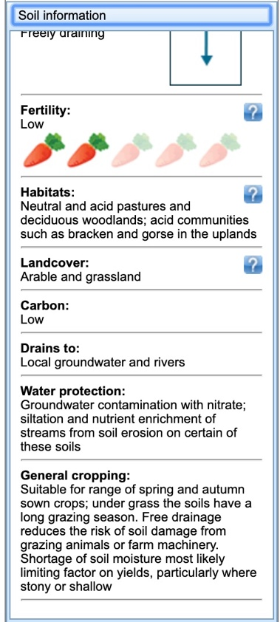

According to Cranfield Soil and Agrifood Institute Soil Scapes in figure 8, the area of which the proposed site is located is considered to be ‘freely draining slightly acid loamy soils’. Acidic presence within the soil demonstrates some form of contamination on site which compared to the archival research can conclude that is stems from the previous industrial use of the ‘Canister Works’ shown in Figure form of contamination on site which compared to the archival research can conclude that is stems from the previous industrial use of the ‘Canister Works’ shown in Figure 4. This would explain the description of the soil being of ‘low fertility’ due to the pH – level being affected by the industrial contamination.

Figure 8 identifies the soil type as freely draining loam soil. The components of ‘loam soil is a proper, healthy balance of sand, silt and clay soil.’https://www.gardeningknowhow.com/garden-how-to/soil-fertilizers/what-is-loam-soil.htm (04/04/18) (Accessed: 03/12/19). This will aid the design of the foundation and drainage system, allowing for locations of soakaways to be allocated and determine the suitable depth required to bypass the effects of clay during subsidence.

The consideration that if the ground type contains clay, with the presence of trees on the existing site shown in figure 3, with the demand of moisture from the trees can potentially cause differential settlement from the subsidence caused from absorption of the moisture in the clay soil will cause the clay to shrink and expand with variations of moisture. A recommended solution to this issue would be to design out the risk and consider a foundation such as a pile foundation that would

Suitable Foundation Design Recommendation

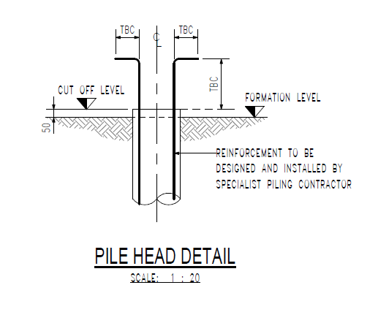
3a- Pile Foundation Benefits
Appendix 8 – C.D. Grey Engineering Proposed Costa Coffee Pile Foundations, Heo, Ddu, Birchgrove, Swansea (2019)
One of the foundation designs that can reach greater depths into the substructure would be a pile foundation.

Appendix 9 – Approved Document A – Structure (A1)
Approved document A – Structure states that:
A1. (1) The building shall be constructed so that the combined dead, imposed and wind loads are sustained and transmitted by it to the ground:’
In consideration that the site is located near the coast this design will be feasible for the proposed works as it would allow the dead and imposed loads to be safely transferred to ground that has better bearing capacity. This design will allow for compliance with the approved document A – Structure as highlighted in the figure 12 presented above.

This foundation design can be prefabricated off-site in a controlled environment which maintains quality of production. Benefits on-site can include increased efficiency in terms of project time management with faster installation on-site, foundation piles can be delivered when required which best utilises site storage.

Pile foundations provide greater compliance with the Health and Safety at Work Act 1974: CDM Regulations 2015 through eliminating the risks for tradesmen that would have worked within a trench during excavating for foundations. Through using driven piles as opposed to excavating soil, this foundation design displaces and compacts the soil. The effect of this method will in turn increase the bearing capacity of the piles. Considering this eliminates the requirement to excavate the soil which can save money on excavation and exporting of soil. Compared to the Deep foundation method that would require an excavation that would be an increased health and safety risk for employees working at substructure level and the excavation can potentially lead to structural issues such as subsidence. (Designing Buildings) (15/05/19)https://www.designingbuildings.co. uk/wiki/Driven_piles

The foundation’s structural capabilities compared to other types of foundations are considerably superior with higher lateral and bending resistances which makes them suitable to resist the elements such as for strong winds on the Swansea bay coast. Furthermore, this method can be considered more sustainable method with reduced wastage from excavation. (Designing Buildings) (15/05/19)https://www.designingbuildings.co. uk/wiki/Driven_piles

3b - Pile Foundations Drawbacks

Appendix 10 – C.D. Gray Engineering Proposed Costa Coffee Pile Foundations, Heol Ddu, Birchgrove, Swansea (2019)
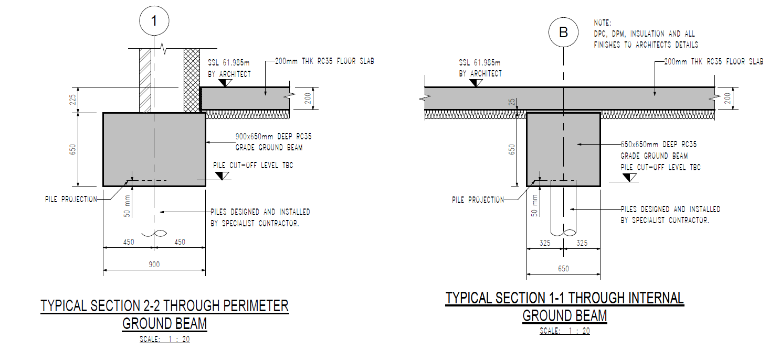
Potential drawbacks of the use of this method of foundation requires careful planning for driving the piles. The installation is of a specialist nature which will demand heavy equipment to install the piles. The requirement of an engineer to design and calculate the foundation is essential to achieve compliance with building control which will result in extra costs at the design stage. During the process of transportation and installation, in order for the concrete to be durable enough to survive the stresses imposed on them the concrete piles will require additional reinforcement through either pre-stressing or precast methods that can be an additional cost to construct the substructure. (Designing Buildings) (15/05/19)https://www.designingbuildings.co. uk/wiki/Driven_piles

In terms of suitability, considerations of adjacent buildings will be of value to understand the effect on the site’s neighbours which may perhaps be affected by the noise and vibration created during installation. Furthermore, the proximity of the proposed foundations to adjacent buildings can make this method unsuitable as the vibrations can cause issues with existing structures in close proximity. (Designing Buildings) (15/05/19)https://www.designingbuildings.co. uk/wiki/Driven_piles

Considering the research made in the report, the decision to use pile foundations for the proposed works can be deemed feasible due to their ability to reach deep distances to deliver dead and imposed loads of the building safely. This depth unmatched by other forms of foundations. The site is not within close proximity of existing structures that warrants an objection to use this method meaning that the proposed pile foundations will have minimal impact to the surrounding area in terms of noise pollution. Finally, the health and safety benefits to workers is also a contributing factor which will increase site safety of the project. (Designing Buildings) (15/05/19)https://www.designingbuildings.co. uk/wiki/Driven_piles

3c – Evaluation of Pile Foundation Methods

3c (1) - Augered & Continuous Auger Pile Foundations
Continuous Auger has similar benefits but is most suitable for unstable or water bearing ground. This method uses more hollow drilling pieces, which is used so that the concrete can be pumped directly to the bottom as the auger is withdrawn. Requires drilling the piles into the ground, which can reach as deep as 24m. An Auger is a rotating shaft with cutting blades, which is introduced to the ground and later replaced with a steel reinforced concrete pile. The least expensive of the methods and apparently, a common method of pile foundations. A benefit is that it produces low vibration and light weight which is a health and safety benefit with less impact for the workers if using a handheld auger in accordance with the Lifting Operations and Lifting Equipment Regulations (LOLER). (Home & Renovating) (16/05/16) https://www.homebuilding.co.uk/foundations-for-difficult-sites/

3c (2) - Driven Piles
This method is suitable for ground conditions that are prone to a high level of moisture content or water bearing capacity which may include contaminated ground. Requires plant such as a hydraulic pile driver which forces the piles into the ground. It has a lower creation of spoil during the installation which can create a cost saving on transport and disposal.). (Home & Renovating) (16/05/16) https://www.homebuilding.co.uk/foundations-for-difficult-sites/

3c (3) Pile Foundation Method Recommendation
Considering the evaluation of the different methods presented. A recommendation would be to decide to use a driven pile method. This will be more suitable for the site with the specification identifying this method to be suitable for contaminated land and high moisture content highlighted to be on the present on the site. Additionally, reduce costs working at the substructure level is an appealing benefit.

References

4a. Sources
The Building Act of 1984
Approved Document A – Structure (Wales)
Approved Document C – Site Preparation and Resistance to Contaminants and Moisture (Wales)

Cranfield Soil and Agrifood Institute, Soil Scapes
http://www.landis.org.uk/soilscapes/

Code of Practice for Site Investigations BS5930 (2015)
https://geotechnicaldesign.info/download/bs5930-2015.pdf

Darcy Larum, (Landscape Designer)
(14/04/18) (Accessed 22/11/19)
’https://www.gardeningknowhow.com/garden-how-to/soil-fertilizers/what-is-loam-soil.htm

Designing Buildings (No Author)
(15/05/19) (Accessed 04/04/19) –https://www.designingbuildings.co. uk/wiki/Driven_piles

Curtins ltd - Pile Foundation Risk Assessment (Issued: 21 August 2019)

Ian Rock Chartered Surveyor, Home & Renovating
(16/05/16) (Accessed 10/12/19) - https://www.homebuilding.co.uk/foundations-for-difficult-sites/

Swansea Town and Planning (5th of June 2019) (Accessed November 2019) https://property.swansea.gov.uk/online-applications/applicationDetails.do?activeTab=makeComment&keyVal=Q0G9THEVKAR00

Taylor & Francis Online (T&F Online)
https://www.tandfonline.com/doi/full/10.1080/23311843.2019.1603418 (Updated: 25/04/19) (Accessed 03/12/19)

4b. Appendixes
Appendix 1 – 3D View Proposed Site, Google Earth

Appendix 2 – Proposed Site North Facing, Google Earth

Appendix 3 – Archival Ordnance Survey Map 1:1250 (Swansea Archive Records, Surveyed
November 1945 – 1946 Plan 21/6592)

Appendix 4 – Proposed Site North Facing, Google Earth

Appendix 5 – Swansea Town and Planning (5th of June 2019) (Accessed November 2019) https://property.swansea.gov.uk/online-applications/applicationDetails.do?activeTab=makeComment&keyVal=Q0G9THEVKAR00

Appendix 6 – Cranfield Soil and Agrifood Institute, Soil Scapes
http://www.landis.org.uk/soilscapes/

Appendix 7 – Approved Document C – Site Preparation and Resistance to Contaminants and Moisture (Wales)

Appendix 8 - Cranfield Soil and Agrifood Institute, Soil Scapes
http://www.landis.org.uk/soilscapes/

Appendix 9 – C.D. Gray Engineering Proposed Costa Coffee Pile Foundations, Heol Ddu, Birchgrove, Swansea (2019)

Appendix 10 - Approved Document A – Structure (Wales)

Appendix 11 - C D Gray C.D. Gray Engineering Proposed Costa Coffee Pile Foundations, Heol Ddu, Birchgrove, Swansea (2019)

