Module Code- BMSK4002

Prepared By:

Sanzina Rahman

Student Number (ID):
1812578
Group 3

Module Name:
Digital Skills and Research Methods

Prepared for:
Mr Balendran Kandasamy

Assignment Task

Task: The effectiveness of the use of modern technologies within the workplace and explore social media as a tool for marketing, information gathering and communication within the workplace, creating own professional online presence to illustrate and evidence this research.

Table of Content:
Page
- Introduction 2
- Type of technology 2
- Pros and Cons of the technology 3
- Web Technology 5
i. Skype
ii.Team Viewer

- Comparison of Skype and Team Viewer 7
- What is Social Media? 8
- Exploring Social Media as tool for marketing 8
- How do social media helping business? 9
- Exploring social media as a tool for communication 9
- Exploring social media as gathering information 10
- My online presences 12
- References 14

Introduction:
In today’s world no one can think of their life without technology. We all are depended on it in a good or bad way. Technology is basically a set of skills and process to produce a product. “Technology is human knowledge which involves tools, materials, and system”-(Ramey Karehka). We use technology everywhere. Almost everything around us is control by different technology. From spaceship to small microwave everything is a blessing of technology. Technology is invented to make our life simpler. It helps us in various ways. From problem identifying to problem solving technology helps us in every single step.

Types of technology:
There are different kinds of technology present in this world:
- Communication Technology- This technology helps us to communicate with each other. For example, in everyday life we use phones, computer, email or texting for communicating with each other.

- Medical Technology: This technology is used for our wellbeing. We use this kind of technology to invent new medicine or to improve our health care system. We use this to diagnose illness, treat disease or to do research of inventing new treatment.

- Information Technology: By using technology we can transfer information with each other. It is a very important tool for any business. Big companies, bank and organizations use this technology to maintain their customer service, security, planning and development.

- Environmental Technology: In today’s world can you imagine you day without a set of television in your living room or radio in your car? In our busy life this technology gives us a scope to escape from this practical life.

- Business Technology: This technology helps a business to function properly. For example in a car factory the machinery to produce a car a parts makes the company to run its business. Cause without the machinery there will be no business. This technology is basically combination of software and hardware. There are companies which does not require machineries instead of that they comply more on software. Either way it helps any company to exist and run efficiently.

- Educational Technology: This technology has vast impact on today’s world. Now- a -day’s online education or e-learning is very popular. It is helping people all over the wold. Any one sitting in any corner of the world can read a same book like you because of this technology. For example using any iPad or kindly you can read hundreds of books and gather knowledge.

Pros and cons of the technology:
The purpose of the invention of any technology is to make our life easier. But if any one misuses of any technology then instead of doing any good it can become harmful for us.

- Pros of Technology:
-Save time – This is the biggest advantage of any technology. For example, introducing a computer in our day to day life has reduced huge chunk of our time. Not only that even in our household, using a microwave, a vacuum cleaner or dish washer has changed our life drastically.
-Increase production: Technology helps business to increase the production by using automated machinery and can save money, time both as well. Now -a -days the machines can produce hundreds unite in a single minute saving hundreds of working minutes.
-Access Information: Technology helps us to collect information from any corner of the world any time we want. It helps business to make decision and make planning for the future as well.
-Medical advantage: From inventing paracetamol to penicillin, technology is a blessing in the medical sector. It opens up million ways to research, invent and apply the new invention to increase our life span and wellbeing.
-Communication Advantage: In business it is essential to keep communication going on. You need to communicate with you supplier, manufacture, distributors and also employee all the time. Technology gives us the advantage of quick communication via phone, text or email. This makes any business well informed and effective.

- Cons of the technology:
-Safety: Any technology if you did not use it properly or if you misuse it on purpose it can cause harm for you. For example, computer was invented to make our like easy but of you use it to operate illegal activities in this case the technology will be blamed because it was the medium to execute those illegal activities.
-Affordability: Technology is expensive. It’s difficult for everyone to be able to get the taste of using technology. All people don’t have the luxury to bear the high cost of the technology.
-Social Disconnection: This is the biggest disadvantage of the technology. Modern science has given us the blessing of technology but taken away our real time connection. For example now a day everybody is glued to their phone, busy checking social media instead of paying any attention to the person sitting next to him.
-Distraction: Technology distracts everyone. Specially, students get affected by this. These things can take their attention away from their study. The same affect can also happens to any employee or employers as well if the person does not know when to put Stop on using technology.

Web Technology:
Web technology is the way for the computer to communicate with each other using mark-up language like, HTML, CSS and other binary codes.

- Describing two web technologies:
1. Skype
2. Team viewer

- Skype:
Skype is an online telecommunication application to make video calls and to chat with other people. It is a free computer program which called skype protocol that provides VoIP (Voice internet protocol) service.
If you have internet connection you can use skype from any corner of the world. It can be used in a computer, laptop, tablet or any smartphone as well. This is a free app. So, there is no charge for any call. Skype has its own specialized software which allows high quality video and audio communication. It has option for contact list, instant messaging and many other features as well. Recently they have lunched the option where people can speak in their own language translated by skype software.

- What can anyone do on skype?

- Calling – Audio video calling, voicemail.
- Messaging – Instant text, video messing.
- Sharing – screen sharing, file transfer and contact sharing.
Anyone can use this to have meeting, interview or group work shop as well. With this anyone can make video call with group of up to 50 people.

Team Viewer:
Team viewer is software which is used to remotely access to another computer to view files, run program or for trouble shooting any problem. Basically it shares your system with other person. It can be used in windows, mac, Linux, chrome, iOS and android as well.
To use this software you need to share your ID and password of team viewer with the other person. SO that he can access you pc. You will be monitoring every single movement of the other user. If there is any file transferring happen, this software will show you file transfer update to maintain the safety standard.
In this app if you want to stop the access of the other users, you just need to close the application, and then the connection will be automatically stopped. For accessing again you have to provide your new password to the other user cause every time the password gets changed for high security purpose.

Compare Skype and Team viewer:

- Video Tutorial – Team viewer has the function of video tutorial but on the other hand Skype doesn’t have this function.
- Free trail – Team viewer provides customer a free trail option whereas Skype doesn’t provide free service.
- Remote access- Team viewer has remote access facility but Skype hasn’t introduced this facility yet.
- Video assistant: In team viewer communication is very effective as you can do the video chatting and also someone can assist you to do any task remotely. For example, if any teacher or project manager wants to help the student or colleague they can easily do that by using this software.
- Audio Quality – Team viewer has poor audio quality but Skype has an advantage in this section. It is well known for its good audio quality.
- Pricing – Skype for business $5 per month/user at the starting. On the other hand Team viewer is free to use for everyone.
- Feature- Team viewer’s has five feature; Chat, Document management, Remote support, Project collaboration, Scheduling. And on skype for business software has 3 features; Chat, VoIP, Conference calling.
- Easily Reachable – With Skye it is much easier to reach a lot of people. Cause almost everyone has heard of it. So, whoever you are looking to find out will be easier to find in Skype. On the other hand team viewer users are mostly official people. That’s why it is difficult to find vast variety of people here.
- Platform- Team viewer works on windows, Linux, iOS and android on the other hand Skype can be use on windows, mac, Linux and it also available on iPhone, android and windows phone.
- Video quality: Skype recommend using 5 users video call at a time to maintain the quality of the video. Team viewer has no issue with video quality.

Social media
Any website which allows users to share their content, opinion, views, and also have the option of interaction and community building can be classified as a social media. Some examples are, Facebook, YouTube, twitter, dig, Myspace, flicker etc.
In the chart below it shown that how many hours’ people spent on social media every day:

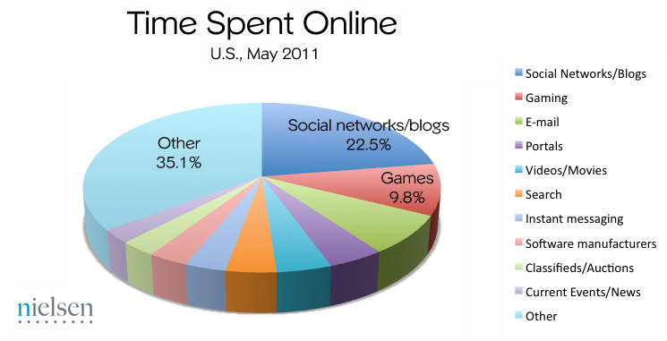[Source: Social Media Report for Q3 2011]

- Exploring social media as a tool for marking:
Social media is an emerging sector of marketing for any business. Using social media anyone can promote their business and reach out to a wide range of customer at the same time. As Jaoker et al. (2009) suggest, “The people formerly known as the audience are now the media”. (p.1). IBMs recent CEO survey reports that 50% of small and mid-size business plan to use social media for marketing in the next three years. (casey,2012).

- How do Social media help in business?

- Generate exposure or visibility. It gives the company or the product an identity.
- Increase in sales.
- It works in consumer to consumer communication by keeping fan pages, promotion, and interaction.
- It saves tons of money in marketing for small and medium size business.
- Helps business achieve competitive advantage. Now one cannot afford to have no presence on the social media whereas your competitor is making a wave with its products on this platform.
- Social network develop the trust that ultimately creates influence among consumers. (safko 2010,84)
- It can be used as a platform for advertisement. From IBM to a local ice cream shop everybody use this platform to promote their product and idea.
- It establishes a direct line with the customers. Now-a-days customers are no longer passive receivers instead they are engaged in the process very much.

- Exploring social media as a tool for communication:
Social media provide different kind of communication platform. For example,
- LinkedIn on identity
- Foursquare on presence
- YouTube on sharing
- Facebook helps to establish exposure and relationship.
Social media enables consumers to gain growing control in their business due to its enhanced communicative features.

Here is “the honeycomb” chart below to understand the functionality of social media in terms of communication:
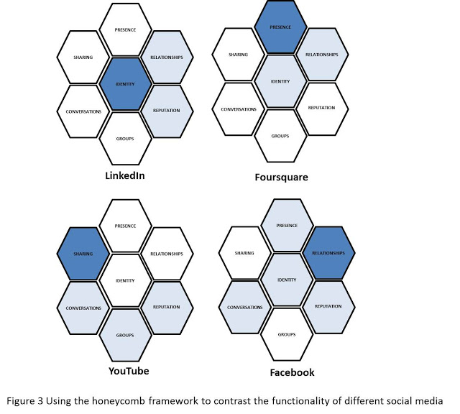

- Exploring social media as a tool for gathering information:
Social media serve both as a tool for searching and producing information.
- Anyone can get Up to date information from here.
- All the information on social media is easy to reach and easy to share as well.
- Social media is more democratic place to get any neutral or unbiased information.
- From here we can gather information on company views, opinion and future plan.
- Social media got over billion users. We can acquire information and insight from others using this platform.

- Many social media platform act like an information source:

- Facebook-From Facebook anyone can get information about people, events, organization, discussion group and forum.
- LinkedIn- It is mostly a professional’s site. From here anyone can acquire information about potential candidate.
- Twitter – This act almost like face book. From here anyone can get news, events and information.
- Slide share- Mostly used by officials and researchers for study purpose. From here we can get presentation, info graphs, and documents.
- Wikipedia- It is well known web service where information is created collaboratively.
Social media can serve both high and low quality information as there is no monitoring and restriction of uploading any information. That’s why it is important to pay attention in evaluating the reliability of information you get from this platform before using it.
Here is a chart of most popular social media sites which can be used for research purpose.

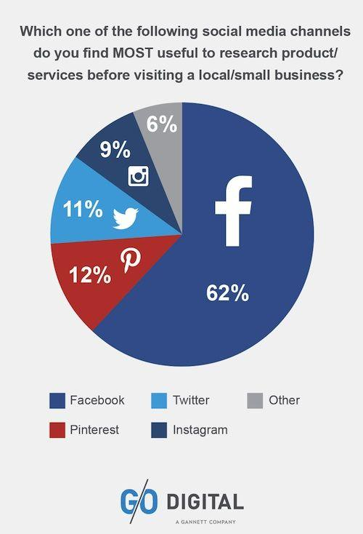

[Source: G/O Digital]

My Online Presence:
In today’s fast changing world there is no escaping from social media, whether you are an individual, start-up, small business or a large corporation. An online presence is a must have requirement.
Below is the proof of my online presence:

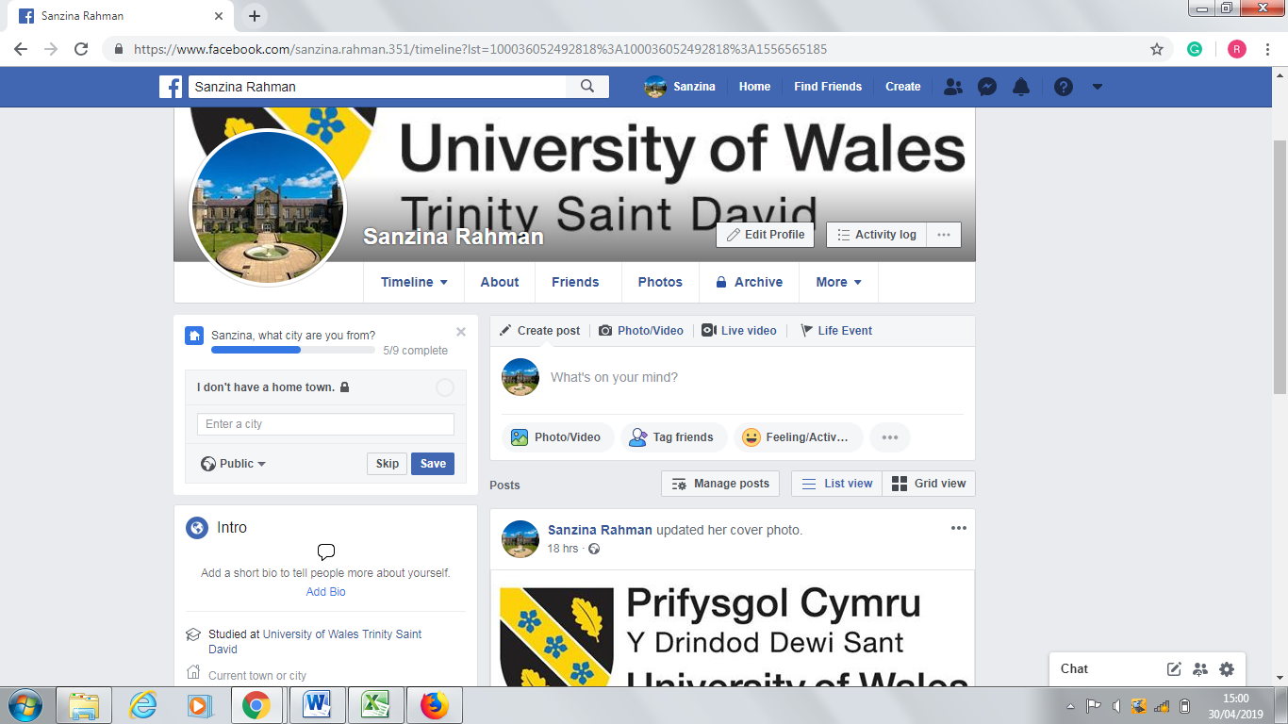
https://www.facebook.com/sanzina.rahman.351/timeline?lst=100036052492818%3A100036052492818%3A1556565185

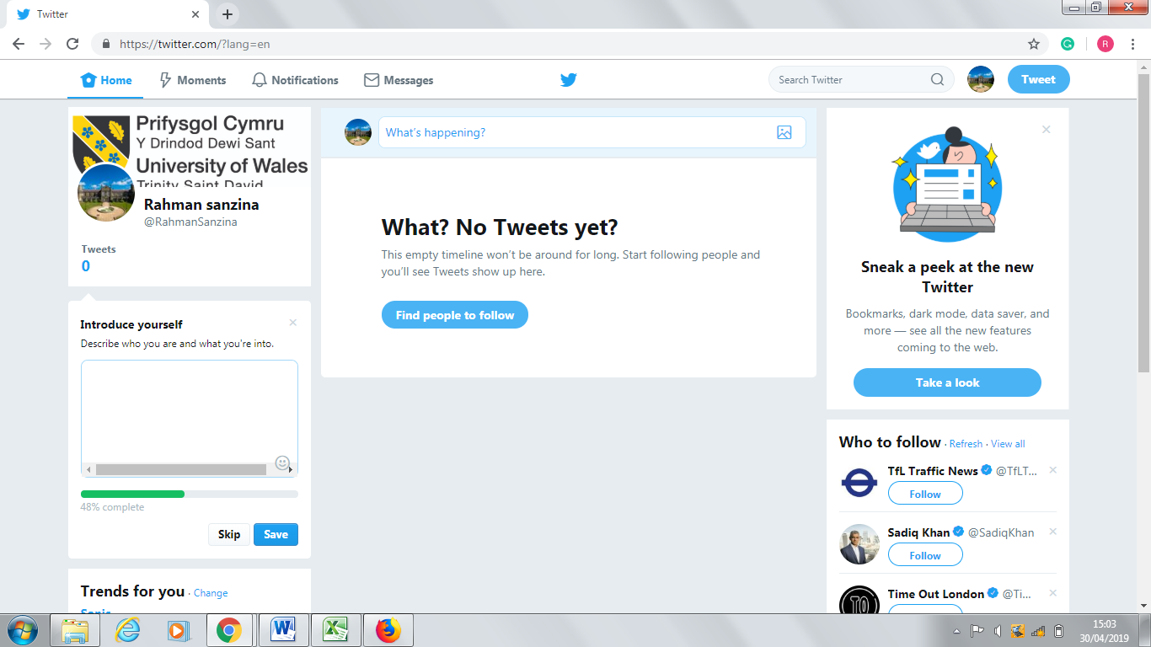
https://twitter.com/?lang=en

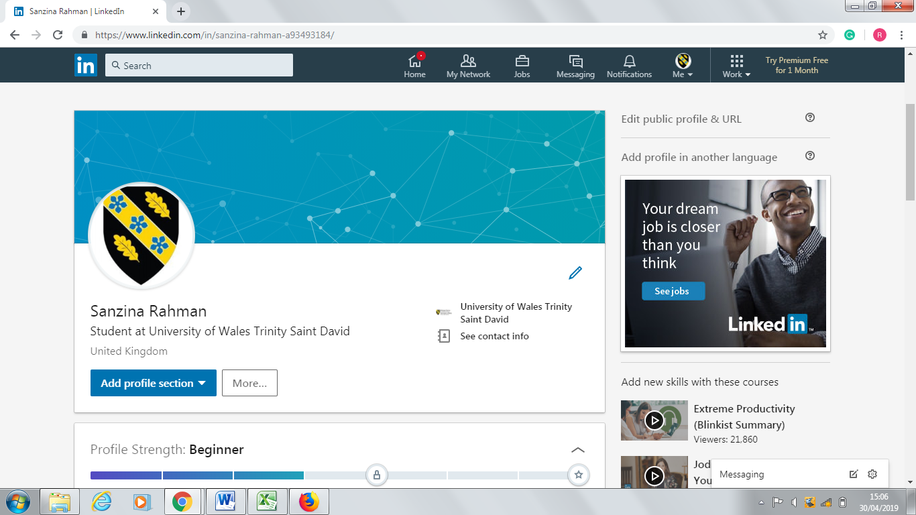
https://www.linkedin.com/in/sanzina-rahman-a93493184/

References:

Porter,Michael E.(1985).”TECHNOLOGY AND COMPETITIVE ADVANTAGE”,Vol.5.Issue:3,pp.60-78.Available at: https://www.emeraldinsight.com/doi/abs/10.1108/eb039075
Ismail,N.(2017).” Modern technology: advantages and disadvantages”.Information Age,London,10 April.Available at: https://www.information-age.com/modern-technology-advantages-disadvantages-123465637/
Ramey,K.(2013).” WHAT IS TECHNOLOGY – MEANING OF TECHNOLOGY AND ITS USE”.Techucation,12 December.Available at: https://www.useoftechnology.com/what-is-technology/
Carleton,B.(2013).Building RealtimeHTML5.Available at: https://lostechies.com/chrismissal/2013/09/03/10-uses-for-realtime-web-technologies/
Foulk,T.(2018).Skype:‘Everything you need to know’.6 April. Available at: https://www.imore.com/skype
Sullivan,Jesica R.(2012).”Skype:An Appropriate Method of Data collection for Qualitative interviews?,”The hilltop review.Vol 6:ISS 1,Article 10.Available at: https://scholarworks.wmich.edu/hilltopreview/vol6/iss1/10/
Zhang,Chystal B.& Lin,Y.(2015).”Exploring interactive communication using social media”.P: 670-693.24july.Available at: https://www.tandfonline.com/doi/citedby/10.1080/02642069.2015.1064396?scroll=top&needAccess=true
Kichanova,V.(2009).The role of Social Media in Research and Development. Available at: https://www.theseus.fi/bitstream/handle/10024/49218/the_role_of_social_media_in_research_and_development.pdf?sequence=1&isAllowed=y
BIA/Kelsey (2012) BIA/Kelsey Forecasts US Social Media Ad Spending to reach $9.8 Billion by 2016, available at: http://www.biakelsey.com/Research-and-Forecasts/Forecasts/ (accessed on 25 June 2012).
Pentina, Iryna & C. Koh, Anthony. (2012). Exploring social media marketing strategies in SMEs. Int. J. of Internet Marketing and Advertising. 7. 292 - 310.Available at: https://www.researchgate.net/publication/264836988_Exploring_social_media_marketing_strategies_in_SMEs
Safko, L. 2010. The Social Media Bible: tactics, tools and strategies for business success, pp.5-9, 84. John Wiley & Sons, Inc. Hoboken, New Jersey.
Tien Wang, Ralph Keng-Jung Yeh, David C. Yen, Mirhanna Gabrielle Sandoya. (2016) Antecedents of emotional attachment of social media users. The Service Industries Journal 36:9-10, pages 438-451.
Mc Gee,M.(2011).” Social Media Report for Q3 2011”.September 19.Available at: http://www.smallbusinesssem.com/wp-content/uploads/2011/09/nielsen-time-online.jpg
Neti,S.(2011).” SOCIAL MEDIA AND ITS ROLE IN MARKETING”.ISSN,Vol 1,Issue 2 July.Available at: https://www.ijecbs.com/July2011/13.pdf
Kietzmann, J.H., Hermkens, K., McCarthy, I.P., & Silvestre, B.S. 2011. Social Media? Get Serious! Understanding the Functional Building Blocks of Social Media. Business Horizons, 54, 241-251.
Safko, L., 2010. The social media bible: tactics, tools, and strategies for business success. John Wiley & Sons.Available at: https://books.google.co.uk/books?hl=en&lr=&id=2c0Yrp1X-o8C&oi=fnd&pg=PR5&dq=safko+the+social+media+bible&ots=VevyW97Kt2&sig=uND4Mk9xJRZjpLO70xSyhRJcLLw#v=onepage&q=safko%20the%20social%20media%20bible&f=false
https://www.facebook.com/sanzina.rahman.351/timeline?lst=100036052492818%3A100036052492818%3A1556565185
https://twitter.com/?lang=en
https://www.linkedin.com/in/sanzina-rahman-a93493184/
http://www.pamelahazelton.com/marketing-biz/shoppers-research-on-facebook-most/

