2D Diffusion Equation Model using the Explicit Finite Difference Method
Computational Methods
Mark Alexander Watson
ACMA6012 Student Number: 2116466

Table of Contents
Contents
Introduction 2
Explicit Finite Difference Form of Constitutive Equation 3
Taylor series expansion 5
Initial Boundary Conditions 10
Validation of Codes 11
In depth analysis of Codes 13
Main Model Limitations 13
Suggested Improvements & Future Recommendations 14
References 14

Introduction
The aims and objectives of this report is to review the Heat equation within a two-dimension space and review the heat adaption within the Aluminium plate, whilst doing so over time. In the progression of this assignment, mathematical modelling and principles will be applied to the Heat equation to transform it into a Linear form. However, it is essential to investigate and consider through validation of the Discretised equation, in conjunction with coding that errors can occur and tolerancing is important in the accuracy of the results.
The equation under examination will be based around the Explicit Finite Difference Method which is used for solving governing partial differential equations within a heat transfer system (CFD, 2024). EFDM’s are used with known values at an existing time step and approximated for values in an additional time step (Hadiyol, 2023). The Heat equation used for the basis of this assignment is of a second order derivative and in its standard form would be difficult and time consuming to solve. Therefore, the Heat equation needs to be converted using Taylor series expansions to a Linear equation, and this discretized equation is used at every Nodal point within the grid applied. It is not practical, and potentially less accurate to calculate each individual node therefore MATLAB software is recommended.
Generally, many uses graphical solutions to gain insight into heat transfer problems that are complex in nature. However due to the limitations in accuracy and consistency of the outcomes they are primarily suited with 2d geometrical problems. Conventional 3 dimensional problems require solving for all X,Y,Z and T axis, the thickness of the Aluminium plate is negligible therefore the study is two- dimensional. Currently numerical solutions are most used to solve such heat equations, this is mainly due to the speed at which it can be solved and provided variables and expressions are clear and accurate enough depending on factors including mesh size and minimal of human errors. Such numerical techniques are used in solving stress analysis, heat transfer and fluid study.
Description of study and two-dimensional representation
The initial temperature of the plate will be 0 degrees, in practical terms heating probes can be attached to the plate and three of the four sides in contact with a cold heat source, the plate will continue to heat up until it has reached equilibrium point and the temperature will rise no more. We can choose a Grid point structure of any size, even so it is imperative to note the finer the grid structure we will be provided with a more accurate temperature map see fig 1.1 (Marotin, 2023). By increasing the special resolution of the solution potentially this can increase the accuracy of the numerical solutions, however this can increase the length of solving time dramatically. These points are known as nodes or cell centroids depending on the method chosen. Therefore, we must derive an equation best suited for this.


Fig 1.1: Drawn example of the aluminium plate split into a coarse and fine grid structure, there are directional references, the arrows depict heat input direction. The the length between each node is ‘h’, which is the user input variable in this assignment.
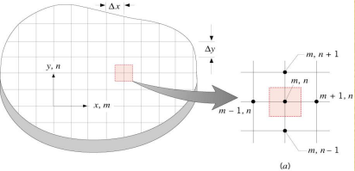

Fig1.2: Example of nodal network and finite difference approximation.
The example in fig() above demonstrates the nodal network and finite difference approximation that is used at numerous discrete points in which the temperature can be determined, in the above example m,n is used as notation, and similarly used + / - for co-ordinates in space (CFD, 2024)

Explicit Finite Difference Form of Constitutive Equation
Heat equation Introduction
The Heat Equation (HE) is one of the most important and fundamental equation across various engineering fields and applications. It is a partial differential equation that describes the distribution of heat through a liquid or a solid (through variance in temperatures) in a particular region over a specific time. For example, the equation anticipates the bodies’ reaction when place in contact with a heat source (conduction) and it may heat up or cool down. In due time the internal heat energy with reach equilibrium points and normalize (Kiharalnjogu, 2009).The heat equation is used to replicate heat transfer and processes, and this gives us a closer look into how objects and fluids may behave when exposed to varying heat temperatures. It helps predict a heated bodies temperature rection when exposed to a cold-water source, and after time will normalize (Kiharanjogu, 2009). Kiharanjogu informs the equation was obtained from Fourier’s Law and conservation of energy. The flow rate of heat energy directly through a surface, corresponds to the negative temperature gradient of the surface.
With uniformity in Density, Specific heat capacity and thermal conductivity considering the system is fully insulated and there are no extra heat sources T satisfies the equation included in two-dimensional form:
- $\frac{∂^{2}T}{dx^{2}}$ +$\frac{∂^{2}T}{dy^{2}}$ + $\frac{∂^{2}T}{dz^{2}}$= $\frac{ρ.Cp}{K}$ . $\frac{∂T}{∂t}$ Three-dimensional Equation
$2.0) \frac{∂^{2}T}{dx^{2}}$ +$\frac{∂^{2}T}{dy^{2}}$ = $\frac{ρ.Cp}{K}$ . $\frac{∂T}{∂t}$ Two dimensional (Croft D.R, 1977)
Heat equation (Croft D.R, 1977)
k = 143 W/m.C (Thermal conductivity Aluminium)
ρ = 2.8 × 103 kg/m3 (Density of Aluminium)
c = 795 J/kg (Specific Heat Capacity of Aluminium
$\frac{∂^{2}T}{dx^{2}}$ = Deviation in temperature in relation to X plane.
$\frac{∂^{2}T}{dy^{2}}$ = Deviation in temperature in relation to Y plane.
$\frac{∂T}{∂t}$ = Deviation in Temperature T with respect to time t.

It is important to identify that heat transfer has both direction and magnitude, and the rate at which heat conduction in a specified direction is comparable to that of the Temperature gradient (Rajesh, 2014) Rajesh also communicates that Heat Conduction (transfer of thermal energy between two interfaces when in contact) is three dimensional. It is also Time dependent, in addition the temperature varies with position along over time, hence:
3.0) T = T (x, y, z, t).
Heat conduction can take place between various physical states such as liquids, gases, and solids although heat transfer and temperature are not of the same nature. Whilst Heat transfer has both direction and magnitude demonstrating that it is indeed a Vector Quantity, therefore requires direction and magnitude at exact points or nodes to provide a solution as part of an equation. Temperature specifically is a measurement of average internal energy within objects (NIST, 2019) in this circumstance a solid Aluminium plate. In closer examination Temperature is physically linked to the ‘vibration of molecules’ within a body, and therefore the greater the temperature the more movement there will be. Temperature Is measured in Kelvin and additionally Celsius (C.Marquand, 1994)
Thermal Diffusivity is a used to describe how well a material allows heat to travel through it, in comparison to thermal conductivity describes how quickly heat will flow from a hot face to a cold face (Mike Gedeon, 2018). Furthermore, the authors state Thermal diffusivity describes how rapidly a chosen material under transient heat conduction comes together to a steady state heat transfer. The thermal diffusivity of a material governs the rate of heat conduction, and in aiding of effective thermal diffusivity, high conductivity is desirable in conjunction with low heat capacity.
4.0) $\frac{1}{∝}= \frac{ρ.Cp}{K}$ ($m^{2}/second$)
A practical example, within Toolmaking a plastic Mould Tool will need to be manufactured using steels that can efficiently conduct heat away from the plastic moulded material within the cavity. Temperature of molten plastic can reach 320°C depending on the material used (Plastikcity, 2024). This aid in removing heat allows for the plastic component to cool down effectively, thus reducing cooling times, it does so in addition through cooling waterways inserted through working faces and plates of the tooling. The higher the materials diffusivity the lower the cycle time (Mike Gedeon, 2018) from injection to fully colling down and setting. Further research into Thermal diffusivity demonstrates that the level of Thermal diffusivity of a material is dependent upon the macrostructure (pores) in addition to the microstructure of the material (defects, impurities and grain boundaries) (Beckstein, 2023) (Education, 2006). Acknowledging the previous statement, shows that tempering of the metal and the manufacturing of the material have a significant effect on Diffusivity.

Taylor series expansion
Taylor series expansion allows for the re-writing of smooth function derivatives into a various number of polynomials. The partial differential equation of the heat equation is lengthy and complex to solve, in using a finite difference method this provides a straightforward conversation into a Linear equation. The following shows how Taylor series can be used and applied to our 2-Dimensional heat equation.
f(x) = $\frac{1}{x}$ , f’(x) = $\frac{1}{x^{2}}$ , f’’(x) = $\frac{2}{x^{2}}$ , f’’’(x) = $\frac{3}{x^{3}}$ , … = $f^{k}$(x) = $\frac{K}{X^{K+1}}$ & similarly $\sum_{n=0}^{∞}{\frac{x^{n}}{n!}}$ ( For Exponentials)
Taylor series expansion process for the 2-Dimensional heat equation
f(x) = f(x0) + f’(x0) ·$\frac{{(x-x0)}^{1}}{1!}$ + f’’(x0) · $\frac{{(x-x0)}^{2}}{2!}$ + f’’’(x0) ·$\frac{{(x-x0)}^{3}}{3!}$ + …
x0 = is the location at which we build our polynomial series on, and for the purpose of this equation we alter by replacing with the letter ‘h’ as this approximates where we are located at out point of interest, altering the above we get:
f (x0 + h) = f (x0) + f’(x0) ·$\frac{{(h)}^{1}}{1!}$ + f’’(x0) · $\frac{{(h)}^{2}}{2!}$ + f’’’(x0) ·$\frac{{(h)}^{3}}{3!}$ + …
The objective now is to approximate f to allow us to find the close value of the function and allow ease of further calculations, we will now make ‘f’ the subject:
f (x0 + h) - f (x0) = + f’(x0) ·$\frac{{(h)}^{1}}{1!}$ + f’’(x0) · $\frac{{(h)}^{2}}{2!}$ + f’’’(x0) ·$\frac{{(h)}^{3}}{3!}$ + …
We can simplify the above slightly:
f (x0 + h) - f (x0) = f’(x0) ·$h$ + f’’(x0) · $\frac{{(h)}^{2}}{2!}$ + f’’’(x0) ·$\frac{{(h)}^{3}}{3!}$ + …
To derive ‘f’ we will need to divide both sides of the equation by ‘h’, now we get:
$\frac{f (x0 + h) - f (x0) }{h}$ = $\frac{f’(x0) · \frac{{(h)}^{1}}{1!} + f’’(x0) · \frac{{(h)}^{2}}{2!} + f’’’(x0) · \frac{{(h)}^{3}}{3!} + …}{h}$
Which now reduces the RHS to the following:
$\frac{f (x0 + h) - f (x0) }{h}$ = f’(x0) + f’’(x0) · $\frac{{(h)}^{1}}{2!}$ + f’’’(x0) ·$\frac{{(h)}^{2}}{3!}$ + …
We can now re-arrange the remaining formula to achieve a first order derivative:

f’(x0) = $\frac{f (x0 + h) - f (x0) }{h}$ + 0(h) ← 0(h) is the error / disturbance term containing remaining offline terms.
Forwards difference Approximation
f’(x0) = $\frac{f (x0 + h) - f (x0) }{h}$ (FDA Which is h > 0)
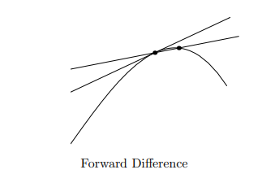

Fig 3: Image demonstrating the forward difference approximation (Gerald, 2022)
The term ‘h’ will need to be a small value, and therefore a larger value will create substantial deviations on graph.
f (x0 - h) = f (x0) - f’(x0) ·$\frac{{(h)}^{1}}{1!}$ + f’’(x0) · $\frac{{(h)}^{2}}{2!}$ - f’’’(x0) ·$\frac{{(h)}^{3}}{3!}$ + …
Subtract ‘f’(x0) to LHS like previous manipulation:
f (x0 - h) - f (x0) = f’(x0) ·$\frac{{(h)}^{1}}{1!}$ + f’’(x0) · $\frac{{(h)}^{2}}{2!}$ - f’’’(x0) ·$\frac{{(h)}^{3}}{3!}$ + …
Now dividing both sides with ‘h’ allows progresses to:

$\frac{f (x0- h) - f (x0)}{h}$ = $\frac{ f’(x0) · \frac{{(h)}^{1}}{1!} + f’’(x0) · \frac{{(h)}^{2}}{2!} - f’’’(x0) · \frac{{(h)}^{3}}{3!} + …}{h}$
Transforms to:
$\frac{f (x0 - h) - f (x0)}{h}$ = f’(x0) + f’’(x0) · $\frac{{(h)}^{1}}{2!}$ - f’’’(x0) ·$\frac{{(h)}^{2}}{3!}$ + …
Re arranging to traditional format:
Backwards difference Approximation
f’(x0) = $\frac{f (x0- h) - f (x0)}{h}$ + ‘0’ ← 0(h) is the error / disturbance term containing remaining offline terms.
The Forwards and backwards Difference approximations demonstrate the discrepancy and errors with the nearest intersection points. Now that we have determined both the forwards and backwards to the first derivative we can subtract or add both for additional approximation further.
f (x0 + h) = f (x0) + f’(x0) ·$\frac{{(h)}^{1}}{1!}$ + f’’(x0) · $\frac{{(h)}^{2}}{2!}$ + f’’’(x0) ·$\frac{{(h)}^{3}}{3!}$ + … (A)
f (x0 - h) = f (x0) - f’(x0) ·$\frac{{(h)}^{1}}{1!}$ + f’’(x0) · $\frac{{(h)}^{2}}{2!}$ - f’’’(x0) ·$\frac{{(h)}^{3}}{3!}$ + … (B)
Subtract ‘B’ from ‘A’:
f (x0 + h) - f (x0 - h) = 2f’(x0) ·$h$ - 2f’’’(x0) ·$\frac{{(h)}^{2}}{3!}$ +2 $f^{5}$(x0) ·$\frac{{(h)}^{5}}{5!}$
Divide by ‘2h’ to get f’ on its own:
$\frac{f (x0 + h) - f (x0 - h) }{2h}$ = $\frac{2f’(x0) · h - 2f’’’(x0) · \frac{{(h)}^{3}}{3!} +2 f^{5}(x0) · \frac{{(h)}^{5}}{5!}}{2h}$
We get:
$\frac{f (x0 + h) - f (x0 - h) }{2h}$ = f’(x0) - f’’’(x0) ·$\frac{{(h)}^{2}}{3!}$ + $f^{5}$(x0) ·$\frac{{(h)}^{4}}{5!}$
Re arrange to standard form:
Central difference Approximation
f’(x0) = $\frac{f (x0 + h) - f (x0 - h) }{2h}$ + ${(0)}^{}$ ← $h^{2}$ is the error / disturbance term terms to the first derivative.

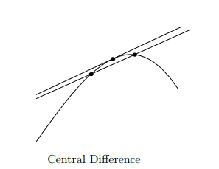

Fig 3.1: Image demonstrating the central difference approximation (Gerald, 2022)

Central difference Approximation to the 2nd order Derivative
Through the addition of forwards and backwards difference approximation we get:

f (x0 + h) = f (x0) + f’(x0) ·$\frac{{(h)}^{1}}{1!}$ + f’’(x0) · $\frac{{(h)}^{2}}{2!}$ + f’’’(x0) ·$\frac{{(h)}^{3}}{3!}$ + … (A)
f (x0 - h) = f (x0) - f’(x0) ·$\frac{{(h)}^{1}}{1!}$ + f’’(x0) · $\frac{{(h)}^{2}}{2!}$ - f’’’(x0) ·$\frac{{(h)}^{3}}{3!}$ + … (B)
We get the following:
f (x0 + h) + f (x0 - h) = 2f (x0) + 2f’’(x0) · $\frac{{(h)}^{2}}{2!}$ + $2f^{4}$(x0) ·$\frac{{(h)}^{4}}{4!}$ +..
Re arranging and cancelling out common factors we get:
f (x0 + h) -2f(x0) + f (x0 - h) = f’’(x0) · $h^{2}$+ $f^{4}$(x0) ·$\frac{{(h)}^{4}}{2!}$ +..
Finally dividing by $h^{2}$ to get f’’ on its own:
$\frac{f (x0 + h) -2f(x0) + f (x0 - h) }{h^{2}}$ = $\frac{f’’(x0) · h^{2} + f^{4}(x0) · \frac{{(h)}^{4}}{2!} +..}{h^{2}}$
Finally, we get:
Central difference Approximation to the 2nd order Derivative
f’’(x0) = $\frac{f (x0 + h) -2f(x0) + f (x0 - h) }{h^{2}}$ +0 ($h^{2})$
(Marotin A. , 2023)
Now we can input our second order derivative and first order derivative approximations into the Heat Equation and conclude our final approximation solution to be used. If we alter some of the factors of the from the above approximations to best suit our node and co-ordinate system for ease of understanding.
$\frac{∂^{2}T}{dx^{2}}$ +$\frac{∂^{2}T}{dy^{2}}$ = $\frac{ρ.Cp}{K}$ . $\frac{∂T}{∂t}$ Two-Dimensional Heat Equation
Firstly, we apply the Central Difference Approximation to the 2nd order derivatives on the LHS.

$\frac{∂^{2}T}{dx^{2}}$ = f’’(x0), $\frac{f (x0 + h) -2f(x0) + f (x0 - h) }{h^{2}}$ = $\frac{TE-2Tp+TW}{h^{2}}$ (For horizontal x plane)

$\frac{∂^{2}T}{dy^{2}}$ = f’’(x0), $\frac{f (x0 + h) -2f(x0) + f (x0 - h) }{h^{2}}$ = $\frac{TE-2Tp+TW}{h^{2}}$ (For vertical y plane)
p =Replaces node location (X0) with point ‘p’
X0 = Current node location on grid structure.
+h/-h = Denotes location of co-ordinates on grid structure (left, right, up, down) That have been replaced by North, East, South, West.
$h^{2}$ = Grid spacing ^2
$\frac{ρ.Cp}{K}$ = $\frac{1}{∝}=$ Thermal Diffusivity
$\frac{∂T}{∂t}$ = f’(X0) = $\frac{f (x0 + h) - f (x0) }{h}$ = $\frac{{Tp}^{t+∆t}- {Tp}^{t}}{∆t}$ Forward difference Approximation (Time domain)
The FDA is used for the first order derivative of the equation (explicitly) when transformed into a Linear equation it provides us with one unknown as seen below. Although the error accumulation maybe larger in comparison to other approximations of choice, In comparison in linear conversion, the BDA when transformed leaves us with multiple of unknowns, that require more time and effort to solve. The final equation is displayed below where each position has been allocated a ^t which affirms the equations relationship to the time space (Marotin A. , 2023).
$\frac{{TE}^{t}- 2{Tp}^{t}+ {TW}^{t}}{h^{2}}$ + $\frac{{TN}^{t}-2{Tp}^{t}+{Ts}^{t}}{h^{2}}$ = $\frac{1}{α}*\frac{{Tp}^{t}- {Tp}^{t}}{△^{t}}$
In order to arrive at a fully Discretized Equation further Factoring and mathematical modelling can be applied to the heat equation in its current form.
Fo (${TE}^{t}+TN^{t}+{TW}^{t}+{TS}^{t}-{4Tp}^{t})+{Tp}^{t}= {Tp}^{t+∆t}$
Where Fo is the Fourier number substituted into the equation, with ${Tp}^{t}$ transferred over to the LHS matching its order. Now to transfer ${Tp}^{t}$within the inside of the brackets we must multiply and divide by the Fo and so we get:
Fo (${TE}^{t}+{TN}^{t}+TW^{t}+TS^{t}+Tp\left(\frac{1}{Fo}-4\right)= {Tp}^{t+△t}$
The final arrangement of formula will take the form of the fully Discretised equation below:
${Tp}^{t+△t}$= Fo (${TE}^{t}+{TN}^{t}+TW^{t}+TS^{t}+Tp\left(4- \frac{1}{Fo}\right)$
For 2-dimensional steady flow heat equations, for a heat problem in a area considered R on the x-y plane with given boundary conditions then this is termed a boundary value problem that is called Dirichlet. This is especially applicable to rectangle formations where one side has an input heat source and the three other sides remain at zero (Kreyszig, 1999)

Initial Boundary Conditions
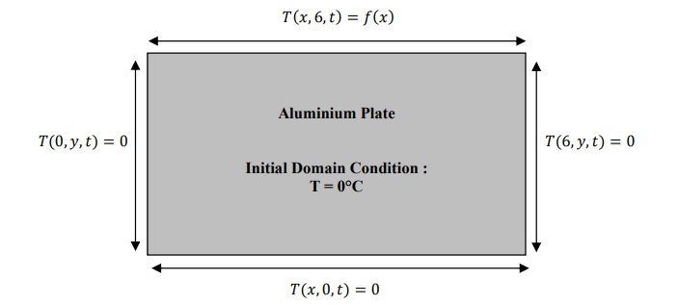
When evaluating an engineering problem, we are required to input the necessary constraints that allow us to evaluate the domain to which the boundary conditions are known. From necessity it is boundary conditions that specify how the system interacts with its external environment (Kiharalnjogu, 2009). Boundary value problems are differential equations and are hugely important in modelling numerous amounts of engineering and mechanics (solids, heat transfer and fluid mechanics) within space.

In viewing the aluminium plate in fig 4.0 above, the dimensions are (0,6) metres on and (0,6) metres on y hence:
- T (x,y,0) = 0 , 0 < x < 6, 0 < y < 6
The Initial temperature of the plate is T = 0°C and the heat source as demonstrated in Fig () will be the inputted variable with time. Below are the constant boundary conditions for the aluminium plate:
Y axis (0,6)
- 𝑇 (0, 𝑦,𝑡) = 0
𝑓𝑜𝑟 0 ≤ 𝑦 ≤ 6 𝑎𝑛𝑑 0 ≤ 𝑡 ≤ 𝑡ℎ𝑒𝑟𝑚𝑎𝑙 𝑒𝑞𝑢𝑖𝑙𝑖𝑏𝑟𝑖𝑢m
- 𝑇 (6, 𝑦,𝑡) = 0
X axis
- T (𝑥, 0,𝑡) = 𝑓(𝑥)
𝑓𝑜𝑟 0 ≤ 𝑥 ≤ 6 𝑎𝑛𝑑 0 ≤ 𝑡 ≤ 𝑡ℎ𝑒𝑟𝑚𝑎𝑙 𝑒𝑞𝑢𝑖𝑙𝑖𝑏𝑟𝑖𝑢m
- 𝑇 (𝑥, 6,𝑡) = 0

Validation of Codes
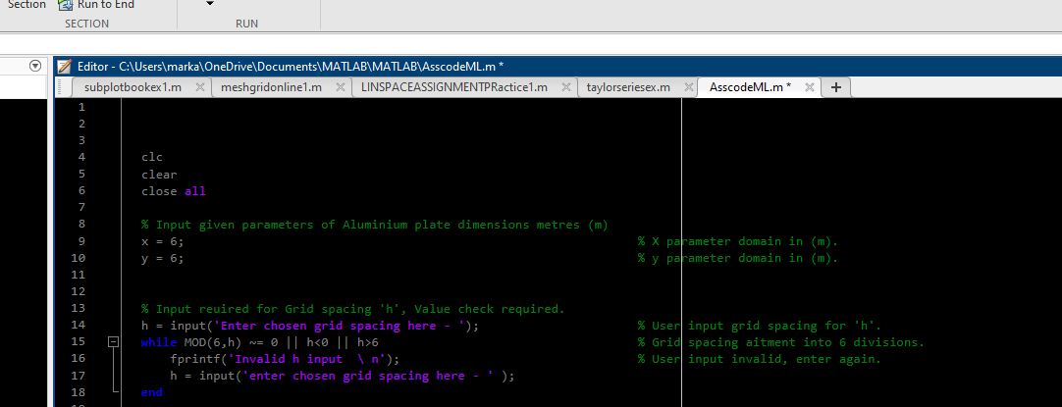
In beginning a coding sequence with the traditional method to provide a clean basis form other recorded code, the first input is the dimensions for the x and y initial domain conditions. They are stated as (𝑥, 𝑦, 0) = 0 0 < 𝑥 < 6 0 < 𝑦 < 6 within the assignment content.
There are two input variables that the user must enter for initializing and running of the code until Thermal equilibrium is established. However, the input variables must adhere to rules, as set in the coding sequences. The step input ‘h’ must fall into and divide into the given dimensions of the plate and matrix that are 0,6 X 0,6. The ‘while’ mod is used for opening statement of code, this is best suited where a specific code is repeated an unknown quantity of times until the condition is met. In failing to meet the condition, the ‘fprintf’ statement will appear, prompting user to re-enter input information that will correlate to stored information (Germain, 2024).
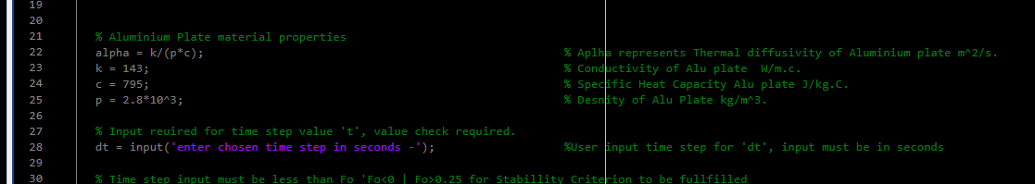
The Aluminium plate properties are an important input of coding, the Thermal Diffusivity which is an important part of the numerical code. The values are provided and are then included as part of the code. The definition and calculation of ‘alpha’ will not change, other than if the material changes.

Additionally, for the other variable which is ‘delta t’ of shortened for code ‘dt’. The input of this variable must fall within the stability criterion ‘Fo’which is ¼.

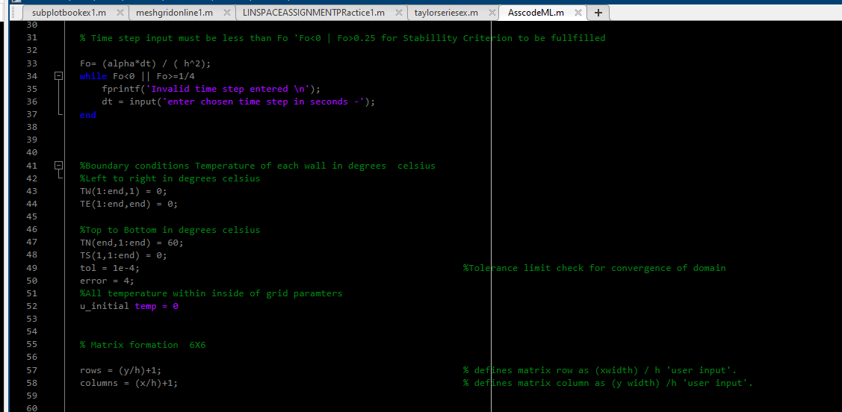

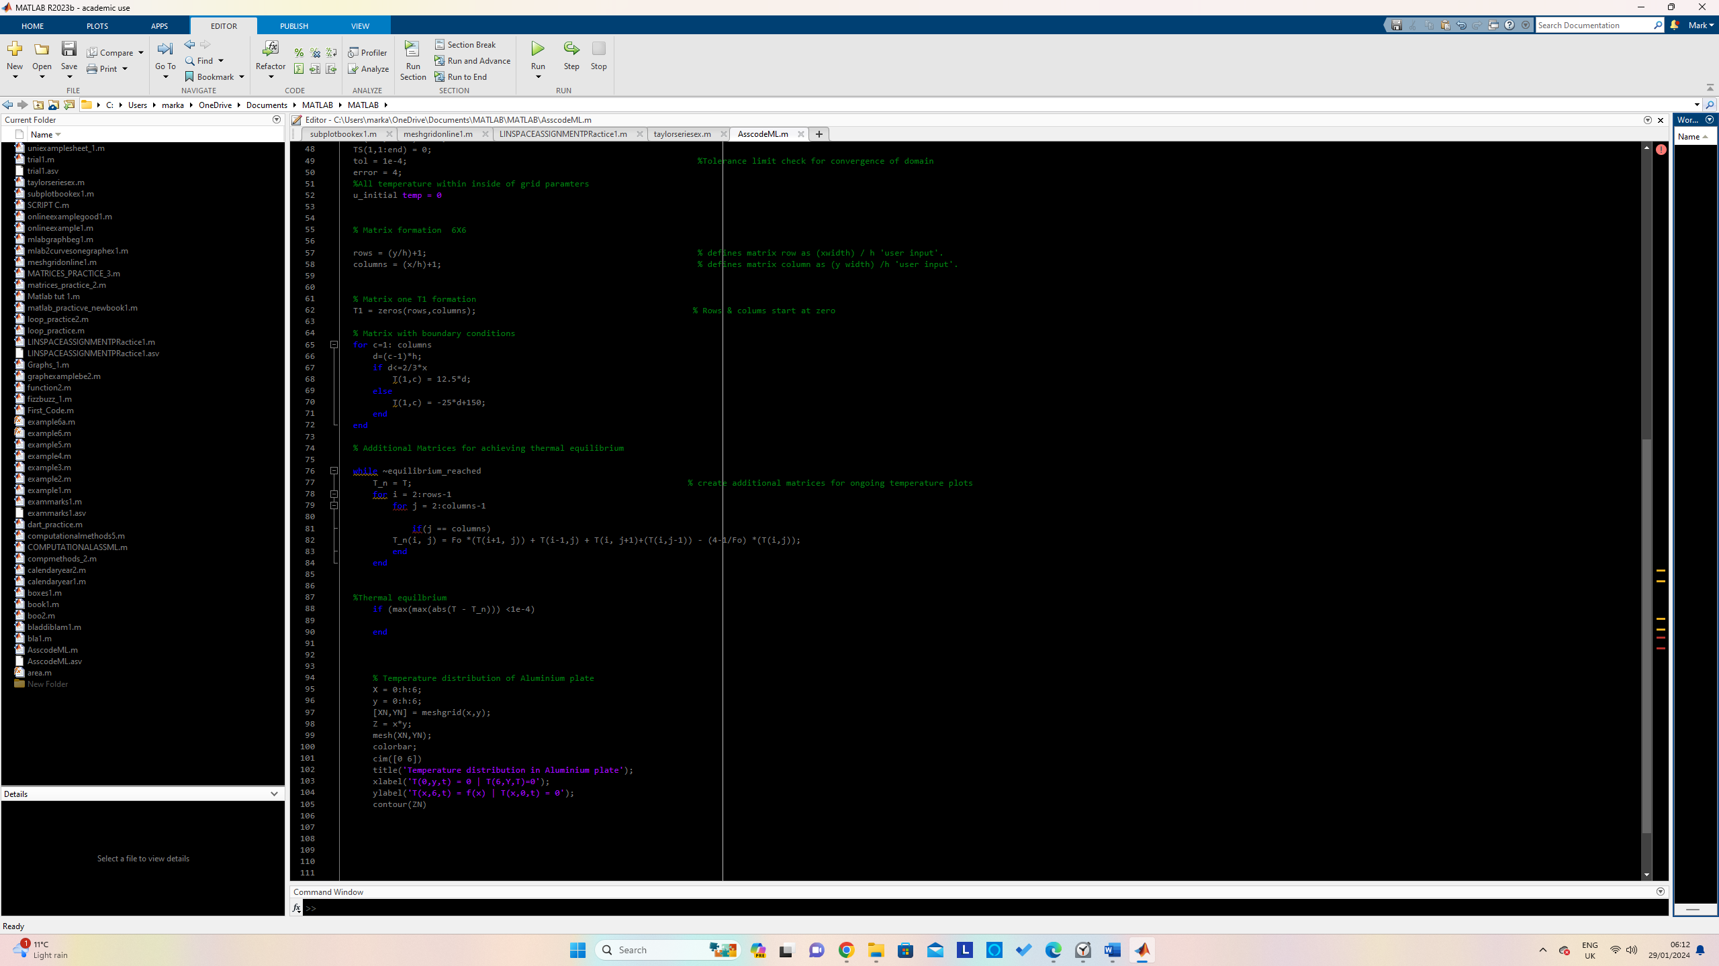
The boundary conditions were inputted by referencing Direction poles that are North, East, South and West. A tolerance was inputted for use in grid parameters that would allow for a range to be applied that should not exceed values.

The constant boundary condition provided where inputted for each reference plane of aluminium plate from 0 > 6 at which thermal Equilibrium was reached at time ‘t’. Also, the details of contour colour chart was inputted, in addition to x and y labelling.

In depth analysis of Codes

Main Model Limitations
In this two-dimensional problem the Von Neumann analysis is applied by use of the Fourier method (Fo number). It is used within the application of linear constant coefficient finite difference formulas in rectangular grid formats (Trefethen, 1994).It is used for ensuing characteristic results in terms of amplification factors that the Fo stability must lie within. Any slight deviations in stability will cause growth and fluctuation errors in final answers of solutions. In conjunction with stability issues, round off errors are an accumulative inconvenience that can arise with computational calculations. Within the realms of this assignment, as ‘h’ value nears zero, that is the mesh size reduces which can aid in approximation. On finite difference methods the FDA is used for simplicity and speed of solving, however for good accuracy the degradation in the convergence of FDA is when value ‘h’ near the value ${10}^{-8}$. Furthermore, a number further away from this demonstrates greater deviation in errors size (.Pacheco, 2022)

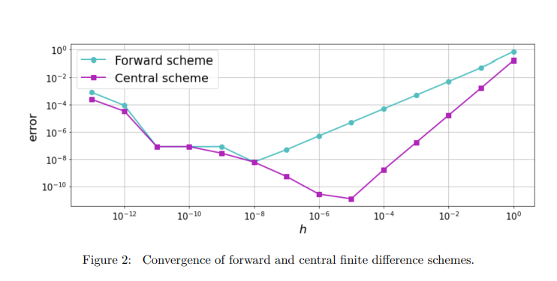

Fig 5.0, Image depicting the error convergence of FDA vs CDA (.Pacheco, 2022).
In approximating mathematical procedures as used in the conversion of the HE into a linear though Taylor series expansion, this increases the chance of Truncation errors. By limiting the infinite terms in the Taylor series, that is only including the equation to the power and factoral ^3, we are indeed reducing the mathematical accuracy by not including all the other terms afterwards.
ε1 = $\frac{true error}{true value} . 100\%$
Fig5.1: Use of the above equation for calculating the relative error percentage.

Suggested Improvements & Future Recommendations

For improved accuracy of results, using different approximation methods whilst including an infinite number of more terms from use of Taylor series will help in the reduction of truncation errors and provide a more precise and true result. Checking the results both numerically via the use of Taylor series expansion linearly and furthermore computationally through MATLAB and comparing errors and closeness of results will certify the validity of the results. The coders’ ability will indefinitely limit the potential of the results, in terms of competency of the programme. Using additional simulation programmes such as ANSYs will also validate and further corroborate results.

References
.Pacheco, D. R. (2022, 9 30). Rounding errors in numerical differentiation. Retrieved 01 27, 2024, from wiki.maths: https://wiki.math.ntnu.no/_media/tma4130/2022h/roundoff_.pdf
Beckstein, F. (2023). Thermal Diffusivity of Metals as a function of grain size. (A. Labratory, Ed.) Retrieved 01 18, 2024, from Netzsch.com: https://analyzing-testing.netzsch.com/_Resources/Persistent/5/8/f/c/58fc80fbc5124b199029f168c1cee66cc1c8a968/AN%20267_Thermal%20Diffusivity%20of%20Metals.pdf
C.Marquand, D. (1994). Thermofluids an integrated apporoach to thermodynamics and fluid mechanics. (Vol. 1). Sussex, Uk: John Wiley and ons. Retrieved 1 5, 2024
CFD, C. (2024, 01 01). Explaining the Finite Dfference Method and Heat transfer. Retrieved 01 05, 2024, from Cadence System analysis: https://resources.system-analysis.cadence.com/blog/msa2022-explaining-the-finite-difference-method-and-heat-transfer#
Croft D.R, L. D. (1977). Heat Transfer Calculations using the Finite Difference Equations. london, uk: Applied Sciences . Retrieved 1 5, 2024
Education, W. (2006). Microstructure. Retrieved 1 21, 2024, from University of Washington: https://depts.washington.edu/matseed/ces_guide/microstructure.htm#:~:text=Example%20Case%20Studies-,Microstructure,%2C%20grains%2C%20and%20grain%20boundary.
Gerald, C. (2022, 08 05). Formulas for numerical differentiation. Retrieved 01 24, 2024, from icn.people.uic.edu: https://lcn.people.uic.edu/classes/che205s17/docs/che205s17_reading_01e.pdf
Germain, J. (2024). The ''While Loop''. (Jim, Editor, Jim, Producer, & Utah University) Retrieved 1 27, 2024, from Welcome to Jim's Computer Science Topics Area: https://users.cs.utah.edu/~germain/PPS/Topics/index.html
Hadiyol, N. (2023, 1 04). What is the difference between an explicit finite difference method and an implicit finite difference method. (Quora ) Retrieved 01 05, 2024, from Quora: https://www.quora.com/What-is-the-difference-between-an-explicit-finite-difference-method-and-an-implicit-finite-difference-method
Kiharalnjogu, S. (2009, 08). Heat Equations and their aplications. School of mathematics, 7,10. Nairobi. Retrieved 01 8, 2024, from http://erepository.uonbi.ac.ke/bitstream/handle/11295/95896/Njogu_Heat%20Equations%20And%20Their%20Applications%20(One%20And%20Two%20Dimension%20Heat%20Equations).pdf?sequence=1
Kiharanjogu, S. (2009). Heat equations and their applications. Masters project, University of Nairobi, School of mathematics, Nairobi. Retrieved 01 22, 2024, from http://erepository.uonbi.ac.ke/bitstream/handle/11295/95896/Njogu_Heat%20Equations%20And%20Their%20Applications%20(One%20And%20Two%20Dimension%20Heat%20Equations).pdf?sequence=1#:~:text=The%20heat%20equation%20is%20used,financial%20mathematics%20for%20thi
Kreyszig, E. (1999). Advanced Engineering Mathematics. In E. Kreyszig, Advanced Engineering Mathematics (8 ed., Vol. 8, pp. 600-602). Columbus, Ohio, USA: Peter Janzow. Retrieved 01 15, 2024
Marotin, A. (2023, 11). Lecture 10. Swansea, South Wales. Retrieved 01 10, 2024
Marotin, A. (2023, 11). Online lecture recording number 10. Teams. Swansea, South wales, Wales. Retrieved 1 10, 2024, from 10 - Computational Methods - 22-11-2023.mp4
Mike Gedeon, A. J. (2018, 03). Thermal diffusivity and Effusivity. Retrieved 01 11, 2024, from Materion.com: https://materion.com/-/media/files/alloy/newsletters/technical-tidbits/issue-no-111-thermal-diffusivity-and-effusivity.pdf
NIST. (2019, 6 5). Kelvin:Thermodynamic Temperature . Retrieved 1 5, 2024, from National Insttute of Standards and Technology : https://www.nist.gov/si-redefinition/kelvin/kelvin-thermodynamic-temperature#:~:text=Thermodynamic%20temperature%2C%20by%20contrast%2C%20is,plus%20contributions%20from%20other%20factors.
Plastikcity. (2024). Plastic material melt & mould temperatures. Plastikcity knowledge base. United kingdom. Retrieved 01 23, 2024, from https://www.plastikcity.co.uk/useful-stuff/material-melt-mould-temperatures
Rajesh. (2014). Cengel_ch02.qXd. In Rajesh, Cengel_ch02.qXd (Vol. 1.6, p. 1). Retrieved 1 6, 2024, from https://cecs.wright.edu/~sthomas/htchapter02.pdf
Trefethen. (1994). Accuracy, Stabillity, and Convergence. Retrieved 01 28, 2024, from people.maths.ox.ac.uk: https://people.maths.ox.ac.uk/trefethen/4all.pdf
UWTSD. (2023, 12). 2D Diffusion Equation model . Electronic assignment . Swansea, South Wales. Retrieved 12 22, 2023, from file:///C:/Users/marka/OneDrive/Desktop/PT%20Computational%20Analysis%20final%20year/ACMA6012_sem2_CW1_2023_24.pdf%20Main%20assignment%20Content%201.pdf

Code print
clc
clear
close all

% Input given parameters of Aluminium plate dimensions metres (m)
x = 6; % X parameter domain (width) in (m).
y = 6; % y parameter domain (height) in (m).

% Input reuired for Grid spacing 'h', Value check required.
h = input('Enter chosen grid spacing here - '); % User input grid spacing for 'h', nodes.
while mod(6,h) ~= 0 || h<0 || h>6 % Grid spacing aitment into 6 divisions.
fprintf('Invalid h input \ n'); % User input invalid, enter again.
h = input('enter chosen grid spacing here - ' );
end

% Aluminium Plate material properties

k = 143; % Conductivity of Alu plate W/m.c.
c = 795; % Specific Heat Capacity Alu plate J/kg.C.
p = 2.8*10^3; % Desnity of Alu Plate kg/m^3.
alpha = k / (p*c); % Aplha represents Thermal diffusivity of Aluminium plate m^2/s.

% Input reuired for time step value 't', value check required.
dt = input('enter chosen time step in seconds -'); %User input time step for 'dt', input must be in seconds

% Time step input must be less than Fo 'Fo<0 | Fo>0.25 for Stabillity Criterion to be fullfilled

Fo= (alpha*dt) / ( h^2);
while Fo<0 || Fo>=1/4
fprintf('Invalid time step entered \n');
dt = input('enter chosen time step in seconds -');
end

%Boundary conditions Temperature of each wall in degrees celsius
%Left to right in degrees celsius
TW(1:end,1) = 0;
TE(1:end,end) = 0;

%Top to Bottom in degrees celsius
TN(end,1:end) = 60;
TS(1,1:end) = 0;
tol = 1e-4; %Tolerance limit check for convergence of domain
error = 4;
%All starting node temperature within inside of grid paramters
uT_initial temp = 0

% Matrix formation 6X6

rows = (y/h)+1; % defines matrix row as (xwidth) / h 'user input'.
columns = (x/h)+1; % defines matrix column as (y width) /h 'user input'.

% Matrix one T1 formation
T1 = zeros(rows,columns); % Rows & colums start at zero

% Matrix with boundary conditions
for c=1: columns
d=(c-1)*h;
if d<=2/3*x
T(1,c) = 12.5*d;
else
T(1,c) = -25*d+150;
end
end

% Additional Matrices for achieving thermal equilibrium

while ~equilibrium_reached
T_n = T; % create additional matrices for ongoing temperature plots
for i = 2:rows-1
for j = 2:columns-1

if(j == columns)
T_n(i, j) = Fo *(T(i+1, j)) + T(i-1,j) + T(i, j+1)+(T(i,j-1)) - (4-1/Fo) *(T(i,j));
end
end

%Thermal equilbrium
if (max(max(abs(T - T_n))) <1e-4)

end

% Temperature distribution of Aluminium plate
X = 0:h:6;
y = 0:h:6;
[XN,YN] = meshgrid(x,y);
Z = x*y;
mesh(XN,YN);
colorbar;
cim([0 6])
title('Temperature distribution in Aluminium plate');
xlabel('T(0,y,t) = 0 | T(6,Y,T)=0');
ylabel('T(x,6,t) = f(x) | T(x,0,t) = 0');
contour(ZN)

