

EMPLOYABILITY SKILLS

JULIA

PETRENCIKOVA
Student number: 2110476

28/11/2021

—

Academic and Employability Skills
(BMSW4001_BIRM)

—

Giridhar Katti



TABLE OF CONTENT
Introduction………………………………...3
Intention…………………………………......3
Time management………………………...4
Definition…………………………..……......4
My experience with time management…5-7
Recommendations………………………….7
Presentation skill…………………………8
Definition………………………………….…8
My experience with presentation skills…..9
Recommendations…………………………9
Digital skills…………………..…………..10
Definition…………………………………..10
My experience…………………………….11
Recommendations………………………..11
Conclusions……………………………….12
References……………………………13-14
Appendices………………………………..15

INTRODUCTION

I would like to call employability skills also skills for success or skills for the future. But why are such skills
important or necessary?

When choosing a university, we decide about our future and our career. Therefore, it’s important to focus
on our strengths and work on our weaknesses. After graduation, it is important to stand out as there are millions of others who are applying for a job we are interested in. How can we stand out? What can make
a difference? We can achieve it by hard work on our employability skills. In this report, I will be focusing
on employability skills close to me and my experience (Cotrell, Stella; 2015).

I will be using Gibb’s reflective cycle.
Source: Author

TIME MANAGEMENT

Time management is one of the most important skills to have in employment. Why is this so important and what are the basics of good time management? As the workload these days increases and the workforce decreases, we must be able to set achievable and effective goals to be successful in our own or someone else’s business and without unnecessary stress.

The best way to manage time is to:
- set a goal
- develop a plan
- measure the outcome

When setting a goal, taking time to plan, and setting priorities rather than going into a project without thinking saves our time.

It’s important to make our goal achievable and realistic, creating space for any contingency rather than setting an unrealistic goal leading to disappointment and the creation of a ‘bad and unreliable name’ for business.

When developing a plan, we need to focus on below:
- tasks to be divided between what could be done, what must be done, and what not need to be done
- begin with a plan for available time and then complete it within that time
- set deadlines
- the most difficult tasks to be planned when energy levels are high
- easier tasks to be planned when energy levels are lower
- know your team and when giving tasks, select the right task for the right person
- when communicating and discussing options, ensure you only discuss what is necessary
- spend time and accurately measure how long is taking a certain activity, this is highly important to develop a realistic and achievable plan
- be open with assigning routine work to someone else who can handle it moving the focus on difficult tasks
- use daily planners, or useful applications, such as Outlook or Microsoft Teams to be able to complete your plan as you will need to communicate with others some details prior to finalising your plan
(Thomack, B.; 2012)

How can you measure the outcome?
When measuring outcomes, I will use my own experience inspired by Gibb’s reflective cycle.
I have been working on several new Warehouse System Rollouts and this kind of project is a good example for me to share my experience.

We started each project with a carefully prepared plan dividing it into three main sections:
- UAT(testing) of the new system
- training of management and operatives on the new system
- GO LIVE and support

Please see below an example of the UAT (testing plan) for Goods In department.
 | Id | Name | Status | Version | User | Checked | Issue Details
Goods In | TC-22660 | 01-01 First Stage Receipt | New | 2.0 | J.P. | Y
Goods In | TC-22629 | 01-02 Goods Receipt | New | 1.0 | J.P. | Y | Show Movements ( Put Away) not showing as (W)
Goods In | TC-22661 | 01-03 Under & Overs | New | 1.0 | J.P. | Y
Goods In | TC-22662 | 01-04 Under received Order Line | New | 1.0 | J.P. | Y
Goods In | TC-22663 | 01-05 Under Received Quantity | New | 1.0 | J.P. | Y
Goods In | TC-22664 | 01-06 Over received Quantity | New | 1.0 | J.P. | Y

Source: Author

In most projects, you will come across an issue. Each issue needs to be logged. This needs to be assigned to a particular department (for example IT). Using Gibb’s cycle in this example:

Source: Author

Once the issues during UAT (testing) have been logged, we can move towards the next phase called training of the management and operatives. When creating such a plan, communication is key. Questions such as a list of operatives, how many operatives can be released per session, and what is the best time for them to be released are essential.

Ensure you ask the managers what skill each operative requires to be trained on. Once all these questions are answered, you can populate a training plan. This plan needs to involve the day and time of each session, the name of the training session, and the names of the operatives. Do not forget to include contingency day in case some of the training did not go as planned. The time and place of the training session must be agreed upon and the plan to be populated so everyone is informed.

Once the training is completed, we can apply Gibb’s cycle and reflect on our experience, for example, operatives did not attend the training session- they need to be added to the contingency plan, but why they did not attend their session? – it is good that we have extra sessions, however, what would happen if too many people have missed training sessions? – analysis lead us to them being off sick, on holidays, or not aware of the training- we have planned them for an extra session- we applied an action plan ( asking managers if someone is long term sick, on holidays prior to the creation of the plan and sending e-mail reminding the future sessions at the end of each day).

In the last phase GO LIVE, the plan is not always predictable as we are unsure, how many issues we will deal with on daily basis, however, this plan consists of the names and shift schedule for those supporting the GO LIVE. When creating such a plan, we need to ensure that, there is always someone available for support.
At the end of the project, we can reflect on all aspects and issues we dealt with and how can we make it better for the future.

I hope my experience will be useful for someone who needs to improve their time management skill.

RECOMMENDATIONS

- Always have a contingency plan
- Before setting time for the task to be completed, spend time to ensure the time set is as accurate as possible
- Communicate with those involved in the plan and listen to those with experience who can give you advice when planning in the area you have a lack the knowledge
- Ensure you have a suitable person for each element of the project
- Ensure everyone is aware of any changes
- Be realistic when setting deadlines
- When coming across any issue, log the issue
- Do not try to blame someone if there is a problem, but learn from it and think how you could make it better next time

PRESENTATION SKILLS

Presentation skills are important as they might be assessed as part of a degree when studying, but more importantly, it is an employability skill. Presentation skills are beneficial when preparing for a job interview.
A short presentation may be required from the employer, but also in certain jobs, it is a daily routine (for example when holding a conference, meeting, teaching, or training).

We will be discussing tips on how to become a good presenter, but also how to create a good presentation on Microsoft PowerPoint. I will then share my experience with presenting.

Here are a few useful tips on how to build your presentation skills:
- your audience needs to be engaged, prepare a few questions to ask after presenting a particular topic
- keep eye contact
- make sure your audience can see you and hear you, but change your pitch to suit the audience
- briefly inform about the content of the presentation at the start
- do not rush through the presentation and pause it if needed
- your body language- maintain good posture, do not put your hands across or in your pockets, do not walk in front of your Microsoft PowerPoint presentation as you might be blocking a view, and remember your gestures can keep the audience entertained
- set the venue prior to presentation and adapt it to suit different audience
- you will be usually given time, and therefore, ensure you do not exceed it (practice before)
- do not speak in monotone to keep your audience interested
(Harrison, J.; Simpson, M.; Harrison, O.; Marin, E.; 2012)

Here are 5 principles on how to create a good presentation using Microsoft PowerPoint:
- make it clear structure (one message per slide), use notes and handouts
- working memory (use pictures, videos, graphs in your presentation)
- size (use a bigger font for important message)
- contrast (apply dark background and light text)
- 6 objects per slide is a maximum
(TEDx Talks, 2014)

I have applied Gibb’s cycle in my experience with presenting. I work as an Operational Trainer, and I am inducting new staff. I have worked in this department for 4 years and presentations are in my weekly schedule.

This is how I have reflected on my presentations:

Source: Author

RECOMMENDATIONS

- from my own experience reading slides without interaction with your audience is a most common mistake when doing presentations
- avoid unnecessary information, make your presentation clear to the audience keeping notes for yourself
- keep eye contact with the audience as this way you can notice if people in the room are interested or if they need a break
- Use videos, graphs, examples to make it memorable
DIGITAL SKILLS

According to Laar, E., Deursen, A., Dijk, J., Haan, J. (p.577, 2017) “Innovation starts with people, making the human capital within the workforce decisive. In a fast-changing knowledge economy, 21st-century digital skills drive organizations' competitiveness and innovation capacity.”

Digital skills are therefore one of the most important employability skills. We use technologies and innovations on daily basis in and out of work. Technology and digital skills make our life easier, but also being advanced means having better chances to be successful at job interviews and be effective in your career.

It is commonly known that older employees have difficulties finding a new job as they are often not advanced or qualified enough in the digital aspect. (Brooke, L. and Taylor, P., 2005).

To develop our career, it is important to develop our digital skills. We work surrounded by technologies, tools, software which are continuously improving and so we must keep up to date to progress in our careers. (Bokek-Cohen, Y., 2017).

Different digital skills are required in different industries. I have created a chart of digital skills required in my job role. Please see below.

These are basic digital skills required in many other job roles.

My example of digital skills method in Gibb’s cycle:

Continuous development is necessary
Source: Author

RECOMMENDATIONS

- be involved in any training and continuously develop your digital skills
- consider a subscription to any technology magazine or other resources to keep informed and to know what is trending as first to share all the news with others
- consider completing further courses for future development
- when learning a new skill, consider the right option ( videos , books, diagrams, lecturer) depending on your learning style

CONCLUSION

We have covered three employability skills in this report. Time management, digital skills, and presentation skills. We must take a positive attitude when learning anything new, even if it is challenging. There is no limit on your training. The more you learn, the easier will things work for you.

Remember if you apply time management skills well, such as setting a goal, developing a plan, and measuring the outcome, it will help you with other employability skills, such as digital skills (for example good time management will allow you to plan your development effectively) or in terms of presentation skills ( for example measuring the time spent by presenting will help you to do your job on time and without stress).

Sometimes we struggle, because of different reasons. Some people may need to learn to say no to achieve their original plan and keep up with it. Others are avoiding technologies and the solution for this may be to find a buddy, admit the importance of technology or invest to gain more knowledge. Finally, nothing happens without giving our energy and effort into what we do. (Caposey, P. J, 2018).

REFERENCES

Bokek-Cohen, Y. (2018). Conceptualizing employees’ digital skills as signals delivered to employers. International Journal of Organization Theory and Behavior, 21(1), 17–27. [Online]. Available at: https://doi.org/10.1108/IJOTB-03-2018-003 (Accessed: 05/12/2021).

Brooke, L. and Taylor, P. (2005), “Older workers and employment: managing age relations”, Aging & Society, Vol. 25 No. 3, pp. 415-429.

Caposey, P. (2018) Manage your time or time will manage you : strategies that work from an educator who’s been there. Alexandria, Virginia: ASCD.

Cottrell, S. (2015) Skills for Success: Personal Development and Employability. E-book [Online]. Available at: https://ebookcentral.proquest.com/lib/trinity/reader.action?docID=4762723 (Accessed: 01/12/2021).

Harrison, J., Simpson, M., Harrison, O. and Martin, E. 2012. Presentation Skills. In: 2012. Study Skills for Criminology, SAGE Study Skills Series, 2nd edn, London: SAGE Publications Ltd. pp. 37-48 Available at: <http://www.doi.org.ezproxy.uwtsd.ac.uk/10.4135/9781446288559.n4> [Accessed 4 Dec 2021].

Laar, E., Deursen, A., Dijk, J., Haan, J. (2017) 'The relation between 21st-century skills and digital skills: A systematic literature review', Computers in Human Behavior, 72 (1), pp. 577 [Online]. Available at: https://doi.org/10.1016/j.chb.2017.03.010 (Accessed: 05/12/2021).

Tedx Talks. (2014). How to avoid death by PowerPoint/David JP Phillips/TedxStockholmSalon. [Online Video].
14 April 2014. Available from: https://www.youtube.com/watch?v=Iwpi1Lm6dFo. [Accessed: 5 December 2021].

Thomack, B. (2012) 'Time Management for Today’s Workplace Demands', Sage Journals, 60 (5), pp. 201-202 [Online]. Available at: https://journals.sagepub.com/doi/pdf/10.1177/216507991206000503 (Accessed: 02/12/2021).

APPENDICES

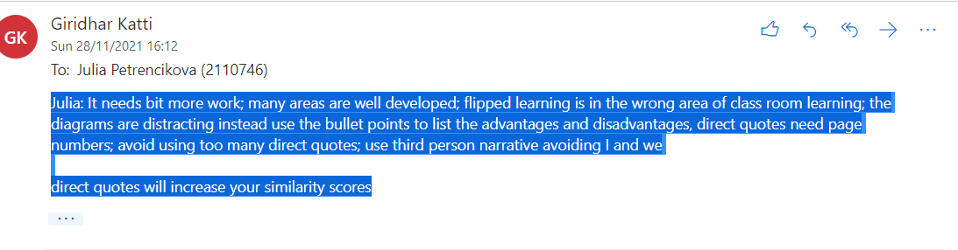
Task 1 Assignment draft (I did not receive the evaluation form)

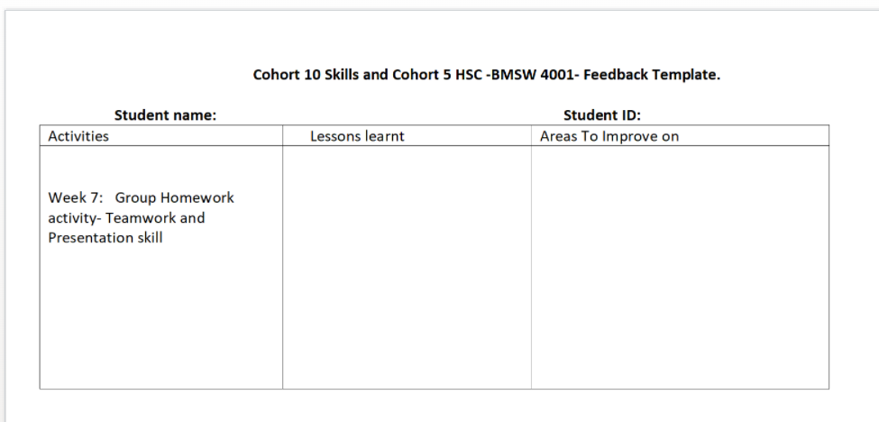
Feedback template(I have completed the presentation, but I could not attend due to an emergency, I am happy to present my slides, when convenient, I have emailed you regarding this, but had no answer).

