Module Code: LCBB5000
Data Handling and Business Intelligence
Assignment Title: Component 2:
Practical: Essay
Student Name: Marius Dinu
Student ID: 2244847

Table of Contents
Section 1 2
Introduction 2
Descriptive statistics 3
Data visualization 5
Correlation Analysis 9
Recommendation 10
Conclusion 10
Section-2 11
a) Advantages and disadvantages of using SPSS 11
b) Meaning and importance of Data Mining Cycle with example 12
References 14

Table Of Figures
Figure i Descriptive statistics 4
Figure ii Price vs. Square Footage of Living Space 7
Figure iii . Price Versus Number of Bedrooms 8
Figure iv Price versus Number of Bathrooms 9
Figure v Price vs. Year Built 10
Figure vi Correlation analysis 11

Section 1

Introduction
The given dataset has information on various properties, including details such as price, square footage of living space (sqft_living), square footage of the lot (sqft_lot), number of bedrooms, number of bathrooms, and the year the house was built. This dataset serves as a basis for the analysis of the factors influencing house prices. Main variables of interest include the price variable as the dependent variable, and the variables which can affect the price, including living space, lot size, count of bedrooms, count of bathrooms, and age of the property based on the year it was built. The report examines the relationship between these variables and house prices in order to ascertain which of the factors most influences property value (Gabauer et al., 2024). The report will try to bring out, from descriptive statistics, data visualization, and correlation analysis, the trends and patterns that best explain the fluctuation in prices. Additionally, these findings will help recommend valuable advice to homebuyers. These recommendations shall help potential buyers understand what to look for when their goal is to be reasonable in their house seeking, seeking cheaper housing, or wanting to invest in a more upscale investment price bracket. At the end, it will all be about empowering homebuyers with data-driven insight to empower them to make a choice of real estate opportunity.

Descriptive statistics
The properties listed in this dataset, several, but the more important variables refer to price, square footage of living space, square footage of the lot, number of bedrooms, and number of bathrooms. In descriptive statistics, these will refer to central tendencies-mean, median, dispersion-standard deviation, and range.
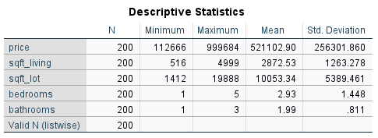
Figure i Descriptive statistics
Price
The average price of the houses is $521,102.90, which indicates the mean selling price for all the houses within the dataset. They vary between $112,666 and $999,684, thereby indicating that the dataset includes both low-cost and high-cost houses. This is also indicated by the standard deviation of $256,301.86, which is fairly large, meaning that even as the selling prices of some of the houses may be in the region of the average, others are far higher or far lower than this. This huge spread is most likely because of the differences in features of the properties that were sold, such as location, size, and condition, which are very influential on price.
Square Footage of Living Space (sqft_living)
It follows, therefore, that the average living space is 2,872.53 sqft, which would suggest that the size of the living area is relatively huge for an average home in this dataset. The living space ranges from 516 sqft to 4,999 sqft, indicating that this dataset includes both small homes and big properties. A high standard deviation of 1,263.28 sqft reflects substantial variation in the magnitude of living space. This would tend to indicate that the larger the house, the higher the selling price, but there is also considerable variability in size that creates price differences.
Lot Square Footage (sqft_lot)
The mean lot size is 10,053.34 sqft, showing that a majority of the properties come with a fairly big lot. Lot sizes range from 1,412 sq ft to 19,888 sq ft; therefore, the lot sizes have a wide range-some may be of small plots of land, while others could possibly make bigger lots.
This large standard deviation of 5,389.46 sqft suggests that the lot sizes vary widely, and hence lots are expected to influence the price of the property in a large way. A home on a larger lot size would fetch a higher amount for sale, while location and type of property are other deciding factors.
Number of Bedrooms
The mean, therefore, is 2.93 bedrooms, and this insinuates that the highest number of the houses included in this dataset have about three bedrooms. The range for bedrooms extends from 1 up to 5 bedrooms. The dataset does currently have smaller properties in addition to bigger homes that would suit families. The moderate standard deviation rate of 1.448 further supports that while the majority of homes fall within a bracket of two to four bedrooms, variability does exist. Fewer properties have only one bedroom and even fewer exceed five bedrooms; thus, the majority of homes are in the middle range.
Number of Bathrooms
The mean number of bathrooms is 1.99, just under two bathrooms per property, which demonstrates the modest size of most homes in this dataset. The range is 1 to 3; most properties have at least one or two bathrooms and a few with three. Considering how low the standard deviation of scattering is, reaching only 0.811, the amount of bathrooms is rather consistent across most properties. This would tend to reflect that most homes probably have one or two bathrooms and fewer homes have more than that.
Interpretation of Results Descriptive statistics
Also show that this set of properties in the data set is very diverse; each has different features. The wide range and high standard deviation of dispersion show that the variable of price contains low- and high-end homes. The sqft_living and sqft_lot are similarly variable; some units are small while others are houses that sit on expansive lots. The number of bedrooms and bathrooms is less variable; the majority of the houses have between 2 and 4 bedrooms and between 1 and 2 bathrooms (Zhao, 2020).

Data visualization
The following visualizations and analysis of data provide significant cues towards the relationship between house price and other factors like a number of bedrooms, number of bathrooms, square footage of living space - sqft_living - and the year the house was built. Now, let's interpret these visualizations in detail:
1. Price vs. Square Footage of Living Space (sqft_living)
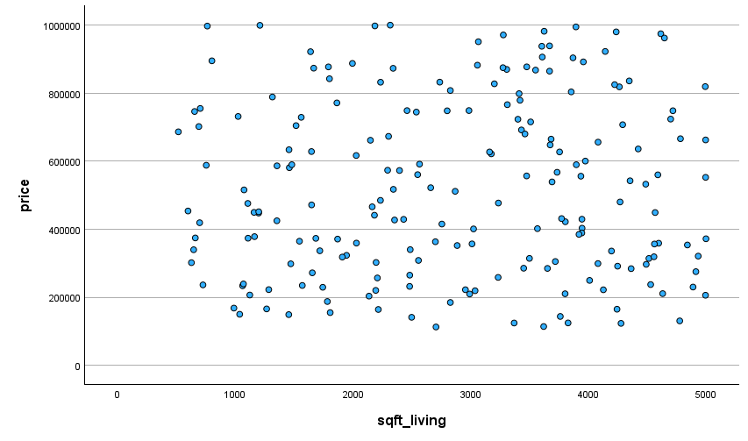
Figure ii Price vs. Square Footage of Living Space
The Price scatterplot against Square Footage of Living Space suggests a relatively good relationship between square footage and price. As might be expected, the larger the house, the higher the sale price will be. Scatterplot data spreads across the x-axis, which represents sqft_living, and the y-axis, which represents price, in such a way that houses with over 3,000 sqft usually fall into the highest price bracket, nearing prices near or upwards of $1,000,000. The scatterplot shows that smaller homes-with sqft_living less than 2,000 sqft-tend to have prices closer to $400,000 or less, while those above 3,500 sqft usually have prices well over $600,000 and at times reach over $800,000. It illustrates that, for similar square footage, the variability of the price is huge.
This may be due to a variety of factors including location, age, and amenities that influence the overall price, but this scatterplot reinforces sqft_living is a major driver in property price.
2. Price Versus Number of Bedrooms
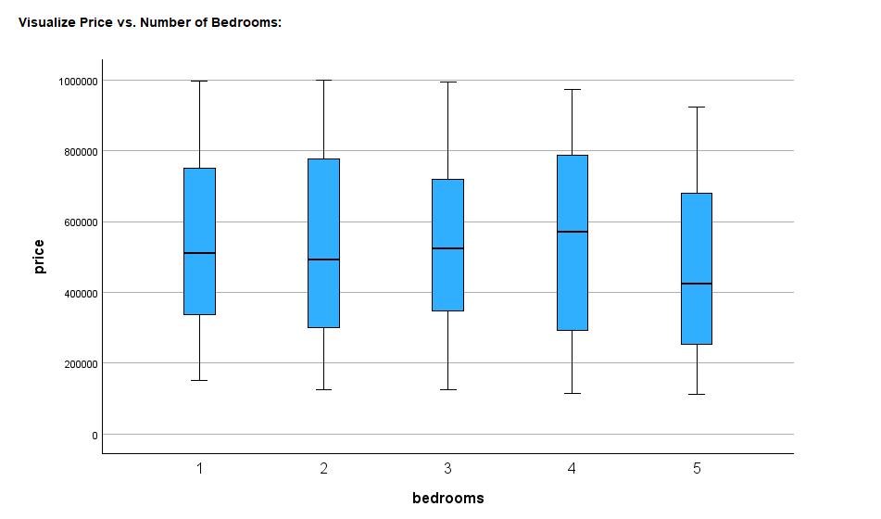
Figure iii . Price Versus Number of Bedrooms
Price vs. Number of Bedrooms: The box plot depicts the distribution of house prices related to the number of bedrooms. For properties with 1-2 bedrooms, the median price is roughly about $400,000, whereas the median prices increase for properties with 4-5 bedrooms, often within a range of $700,000-$800,000. There is indeed some dispersion within the various categories of bedrooms, indicating that while the general trend may be to increase the price with more bedrooms, other factors- such as size of the house or location-may be in play.
One can see that for properties with 1-2 bedrooms, the range in prices is really small, while for 4 or more bedrooms, the range in prices gets bigger, reflecting larger homes or those with more premium features that push up the price. Looking at the boxplot, it can be seen that larger homes, in terms of bedrooms, are more expensive; however, the dispersion in prices for each group of bedrooms is indicative that there are other influencing factors which determine the final price of the house (Guo et al., 2020).
3. Price versus Number of Bathrooms
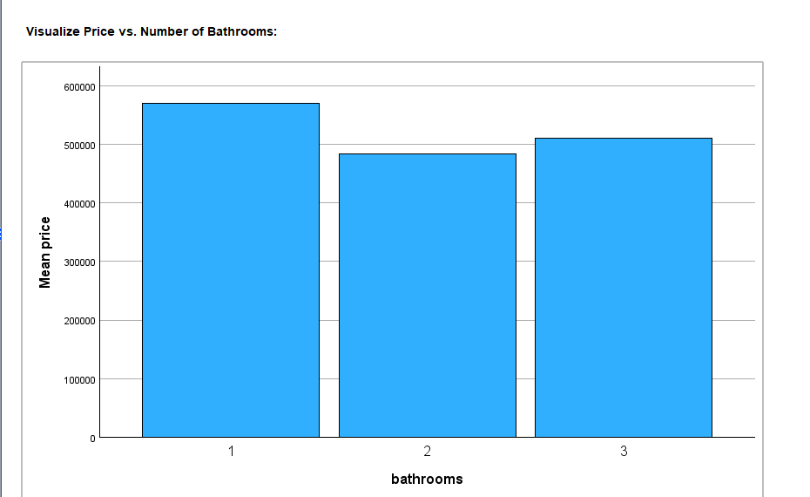
Figure iv Price versus Number of Bathrooms
From the price versus number of bathrooms bar chart, it's clear to see that for houses with 1 bathroom, an average sale price is the highest at about $600,000, as compared to houses with either 2 or 3 bathrooms. In each of these cases, the average sale price is roughly in the neighborhood of $500,000 each. Which could indicate that houses with 1 bathroom could be smaller, older, or cheaper properties, which explains why, on average, they can be more expensive, considering such a fact of having fewer bathrooms. While the homes with 2 or 3 bathrooms are more typical, and their prices are slightly cheaper on average. Although the variation in price, according to the number of bathrooms, is not as pronounced across square footage, the bar chart above shows that bathrooms do contribute to determining property value. It is not as effective in variation as sqft_living, but so far, it contributes to overall price, especially in homes with more than two bathrooms, prices consistently go up.
4. Price vs. Year Built
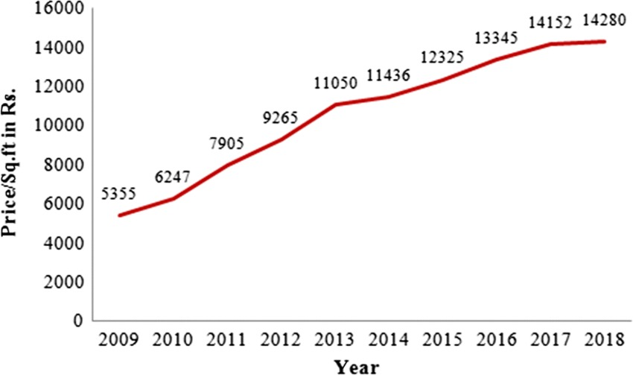
Figure v Price vs. Year Built

The Price per Square Foot vs. Year Built line chart is an indication of steadily increasing prices with time. Within this period, from 2009 to 2018, the price per square foot increased from ₹5,355 to ₹14,280. This uptrend should be indicative of general inflation in the real estate market or increasing demand for properties in newer locations or with more modern amenities. This could also mean that the increased price per square foot reflects larger, more modern homes or homes in better locations-the very factors driving up prices. This steady rise suggests that newer homes, such as those built in the last decade, generally have higher prices per square foot. It could also indicate better construction quality, updated designs, and amenities that appeal to today's buyers. Older homes, representing the earlier years of this basic dataset, would probably lack these modern features and would thus be of lesser value, despite having larger lot sizes (Yan, 2022).

Correlation Analysis
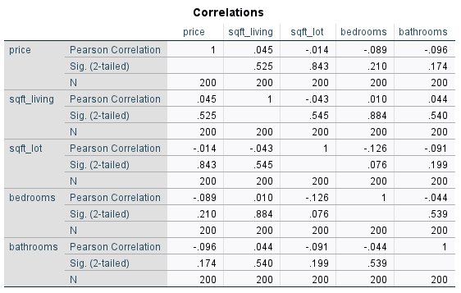
Figure vi Correlation analysis
The correlation, on one hand, looks at the relationship between price and the other variables: sqft_living, sqft_lot, bedrooms, and bathrooms. The Pearson values give a recommendation on the strength and direction of these relationships. The correlation coefficient for price and sqft_living is 0.045 showing a very weak positive correlation. This tells us that, even though there is some relationship between the size of the living space and price, the relationship isn't strong, and may not be very important. The correlation between price and bedrooms is -0.089, showing a very weak negative correlation. This means that in this dataset, number of bedrooms shares a very negligible inverse relation with the prices probably because of large variation in sizes and types of houses. Along the same lines, the correlation of price and bathrooms is -0.096, also showing a weak negative relation. On the other hand, price is correlated with sqft_lot at -0.014, indicating no relation between lot size and house price. However, with a week correlation across the board, it is probably justified that such variables as square footage and bathroom count means very little to house price compared to a house's location or condition (Soltani et al., 2022).

Recommendation
Key Findings and Recommendations for Homebuyers
From these visualizations and correlation analyses could be found a number of key understandings that would explain and identify the factors, which determined the price of a house. The scatterplot of price versus square footage of living space electronically shows a weak positive correlation, meaning larger homes tend to have slightly higher prices but do not strongly relate(Bagheri and Shaykh-Baygloo, 2021). The boxplot of price against the number of bedrooms is suggestive of an increase in the price with an increased number of bedrooms; however, the variation within each category of bedrooms is large. The bar chart for price vs. number of bathrooms is not as indicative, though the price does appear to be somewhat greater for homes with greater numbers of bathrooms. From the correlation matrix, the variables that are poorly correlated with price include sqft_living, bedrooms, and bathrooms; this suggests that these are less influential on price compared to factors like location or property features

Conclusion
It will be possible to find out from the dataset analysis: house price depends on several other factors; square footage of living space, number of bedrooms, and number of bathrooms have only poor correlations. Price is to rise with big-size homes, but these relationships are far from being strong enough to be sole property value determinants. Therefore, homebuyers who are on a tight budget should look for homes that contain fewer bedrooms and bathrooms, whereas when trying to purchase a house at a higher price category, a person should see the size of the living area that is modern. Location and other unmeasured factors are more likely to play a larger role in determining the prices of houses.

Section-2

a) Advantages and disadvantages of using SPSS
In context with business management, it has been determined that SPSS can well be regarded as the most usable statistical software package. However, it has wide application across academia, healthcare, business, and social sciences. It has special features in which a large dataset with complex statistical models is very useful for researchers. Moreover, as with any other tool, this software also entails certain limitations. Therefore, this discussion highlights the pros and cons of SPSS along with practical examples (Shatrı, 2020).
Advantages of SPSS
- User-Friendly Interface: It tends to be probably the biggest strong point about SPSS is how intuitive the GUI environment is. Unlike command-driven statistical software such as R or Python for example enables users to run very complicated analyses using minimal knowledge of programming. For example: a marketing analyst interested in investigating customer satisfaction can easily, using the point-and-click interface provided by SPSS, conduct a regression analysis themselves without having to write a single line of code.
- Comprehensive Statistical Capabilities: SPSS supports a wide range of statistical tests and procedures, including descriptive statistics, t-tests, ANOVA, regression analysis, and non-parametric tests. For instance, SPSS is one of the most well-known computer software programs in healthcare research for analyzing data from patient surveys. Meanwhile, comparing pre- and posttreatment results can be done quite readily with SPSS using paired t-tests.
- Visualization Tools: It has been found that SPSS includes built-in charting tools for developing histograms, scatterplots, and bar charts. However, none of these are as powerful as tools like Tableau but these features are adequate for most statistical reports. For instance, a student writing their dissertation might create box-and-whisker plots to display the distribution of test scores across different groups of students (Rahman and Muktadir, 2021).
Disadvantage
- Cost: In context with the SPSS, it is not cheap; the licensing costs remain high and beyond the reach of many small organizations or perhaps even individual researchers. For example, a very small non-profit doing community health survey work may find it less costly to justify SPSS when alternatives like R are free.
- Limited Customization: On the other hand, SPSS keeps things very user-friendly, it is less flexible than free alternatives like R or Python. For instance, users cannot customize or automate analyses in as much depth. Apart from this, SPSS's limitation might have an impact on the data scientist's choice of Python if he/she wants to integrate some statistical models with machine learning algorithms (Ipsen et al., 2021).
- Steep Learning Curve for Advanced Features: In consideration of SPSS, it is an extremely user-friendly software package in which basic operations are simple, its advanced features, such as writing macros or attempts at complex modelling, take a lot of work to master. For instance, for a business analyst, the difficulties that involve automation of repetitive tasks within SPSS by using Syntax without formal training may be noticeable.

b) Meaning and importance of Data Mining Cycle with example
The Data Mining Cycle is a non-random, iterative process formed for meaningful patterns, trends, and insights from large datasets. It is a series of interdependent steps that ensure consistent, reliable, and result-oriented data analysis. Its major objective is to give raw data meaning by turning it into actionable knowledge for decision-making based on problem-solving in various fields, including business, health, and education. Moreover, the meaning of a problem marks the beginning of the cycle with the identification of an objective or research question. Meanwhile, data collection and preparation involve making sure that the dataset is valid, accurate, and devoid of anomalies. Similarly, this comes data exploration, where analysts explore trends and relationships; model building, using statistical and computational techniques to obtain insight; and evaluation, serving to help verify that the findings are valid and useful. Thus, deployment, putting findings into application in real-world use (Dogan and Birant, 2021).
On the other hand, the Data Mining Cycle may be dynamic and iterative, with stages revisited to either refine results or adapt to new data. Also, this approach makes for an exhaustive analysis process that keeps pace with the growth and complexity of modern datasets. Apart from this, it is a matter of predicting customer behaviour or improving patient outcomes, the cycle is an essential framework for data-driven success.
Importance
In consideration of data management, it plays a crucial role in retrieving valuable information from complex datasets of high volume. Meanwhile, it has numerous advantages, making it an invaluable process for any sector.
- Informed Decision-making: It transforms raw data into actionable insights that will enable organizations to make evidence-based decisions. For example, a company in the retail sector make use of data mining to study trends in purchasing for the optimization of inventory. However, a retailer would therefore ascertain seasonal trends and stock up on merchandise time that sells out at a high rate (Zheng et al., 2024).
- Efficiency and Cost Saving: The cycle lessens errors and redundancies while improving operational efficiency through the systematic analysis of data, therefore saving time and resources. For instance, a logistics company uses data mining to devise the shortest delivery routes. This will conserve fuel and ensure timely delivery. Furthermore, the customers are satisfied effectively.
- Pattern Discovery and Forecasting: The cycle reveals hidden patterns and allows predictive modelling, unveiling the forecast of future trends. For example, healthcare data mining helps to predict patient outcomes. Henceforth, using patient record analysis, hospitals could point out patients likely to suffer due to chronic diseases and enable early intervention with personalized treatment plans.
- Scalability Across Domains: It includes standardized steps in the cycle, like problem definition, data preparation, model building, evaluation, and deployment. Apart from this, it ensures adaptability for diverse applications of marketing to education. Like for example academic institutions use data mining to study student performance and construct custom-made learning with improvements in overall academic performance.

References
Bagheri, B. and Shaykh-Baygloo, R., 2021. Spatial analysis of urban smart growth and its effects on housing price: The case of Isfahan, Iran. Sustainable Cities and Society, 68, p.102769.
Dogan, A. and Birant, D., 2021. Machine learning and data mining in manufacturing. Expert Systems with Applications, 166, p.114060.
Gabauer, D., Gupta, R., Marfatia, H.A. and Miller, S.M., 2024. Estimating US housing price network connectedness: Evidence from dynamic Elastic Net, Lasso, and ridge vector autoregressive models. International Review of Economics & Finance, 89, pp.349-362.
Guo, J.Q., Chiang, S.H., Liu, M., Yang, C.C. and Guo, K.Y., 2020. Can machine learning algorithms associated with text mining from internet data improve housing price prediction performance?. International Journal of Strategic Property Management, 24(5), pp.300-312.
Ipsen, C., van Veldhoven, M., Kirchner, K. and Hansen, J.P., 2021. Six key advantages and disadvantages of working from home in Europe during COVID-19. International journal of environmental research and public health, 18(4), p.1826.
Rahman, A. and Muktadir, M.G., 2021. SPSS: An imperative quantitative data analysis tool for social science research. International Journal of Research and Innovation in Social Science, 5(10), pp.300-302.
Shatrı, Z.G., 2020. Advantages and disadvantages of using ınformation technology in learning process of students. Journal of Turkish Science Education, 17(3), pp.420-428.
Soltani, A., Heydari, M., Aghaei, F. and Pettit, C.J., 2022. Housing price prediction incorporating spatio-temporal dependency into machine learning algorithms. Cities, 131, p.103941.
Yan, Y., 2022. Influencing Factors of Housing Price in New York-analysis: Based on Excel Multi-regression Model.
Zhao, Y., 2020. US housing market during COVID-19: aggregate and distributional evidence.
Zheng, Q., Xu, Y., Liu, H., Shi, B., Wang, J. and Dong, B., 2024. A survey of tax risk detection using data mining techniques. Engineering, 34, pp.43-59.

Appendix -
price | sqft_living | sqft_lot | bedrooms | bathrooms
221958 | 4127 | 16979 | 1 | 3
771155 | 1863 | 17388 | 1 | 1
231932 | 2481 | 1876 | 1 | 2
465838 | 2163 | 5142 | 5 | 3
359178 | 2029 | 16202 | 3 | 1
744167 | 2538 | 7966 | 1 | 1
210268 | 3802 | 8079 | 3 | 3
832180 | 2737 | 8987 | 4 | 2
154886 | 1806 | 7799 | 2 | 2
237337 | 4529 | 5465 | 4 | 2
621430 | 3175 | 18019 | 4 | 1
187498 | 1782 | 14417 | 5 | 1
999159 | 1209 | 19077 | 2 | 1
275203 | 4913 | 9311 | 4 | 1
291335 | 4248 | 18214 | 4 | 2
378167 | 1163 | 15098 | 2 | 3
141090 | 2498 | 6177 | 2 | 1
429365 | 3945 | 15262 | 4 | 1
164820 | 4243 | 9308 | 2 | 2
887201 | 1995 | 6949 | 4 | 3
421879 | 3804 | 2150 | 4 | 3
818315 | 4263 | 2931 | 5 | 2
427069 | 2353 | 10204 | 1 | 2
876997 | 1791 | 19048 | 4 | 3
299041 | 4081 | 2081 | 3 | 1

