Design, conduct and critically evaluate a close-to-practice research project focusing on the model of the transformative teacher in developing practice that has a positive impact on the learner.

Student number: 1902000

Word Count: 4560

Introduction

The following assignment documents the results of a research task that has been designed and conducted with the intent to further professional development and have a positive impact on the participants involved within the research task, using the case study research method. By deepening one’s understanding of the process and purpose of case studies, professional and beneficial development as a research informed practitioner is likely to occur.
It was initially decided to look into learners retention when introduced to new topics and what provision can be put in place to keep their engagement. This theme was chosen, as an essential part of young peoples’ development is embedded in making mistakes (Gabas, Cutler and Schachter 2023); the interpretations learners make reveals to teachers where they can direct their lessons to best support the learning of the class. Learner’s gaps in knowledge will be most frequent when being introduced to new topics as they have not yet had the time to develop the required skills to successfully navigate these new concepts and ideas (Lasmawan and Budiarta 2020) so it is up to the teacher to pick a appropriate teaching strategy for their learners to have the best chance of success. Over the years, researchers have stated that learners are likely to underachieve academically if they view their failure within a topic as something unfixable (Bandura 1997; Blackwell, Trzesniewski and Dweck, 2007). Therefore the teacher must employ provision and a classroom culture that revolves around growth and development.
From this, the proposed research question is as follows:
‘The aim of this research project is to explore the impact of chunking tasks when introducing new topics and its effect on pupil retention.’
The case study took place in a 11-18 secondary school in south Wales. It has around 1,200 pupils, in which 8.5% are eligible for free school meals and 9% are on the special educational needs register (Estyn, 2020).

Literature Review
Chunking new topics into manageable tasks has been a widely used strategy for decades, with seminal works on its advantages being talked about as early Miller’s (1956) research into memory retention, concluding that information chunking would improve learners’ ability to remember information that would otherwise be unmanageable. Over time, this concept has continued to be developed and refined; Sweller’s (1988) cognitive load theory highlights the importance of the teacher being responsible for appropriately managing the often overwhelming load of information presented to learners. By breaking down this information into smaller, more manageable points, it is argued that learners' understanding of the information will be enhanced. Baddeley (1999) has further developed this theory, emphasising the limitations of human memory and how it does not respond well to continuous cognitive overload, therefore the chunking of information is vital to improving memory performance. With the gradual implementation of technology within schools, Mayer and Merno (2003) discuss the importance of reducing the cognitive burden multiple information outlets impose on learners through the breaking down of information and task size. This compilation of research spans over almost 50 years, surviving multiple major societal shifts. The current explorations into this topic still align with the aforementioned researchers’ conclusions; a study that compared the reading comprehension results of learners after the implementation of cognitive load theory, which showed significant improvement in learner performance (Abejuela et al., 2023). The use of task chunking has been reinforced further as an effective teaching strategy in Annga et al.'s (2023) research, which concludes that cognitive load theory in conjunction with short video clips can help young people process information more successfully and improve their learning outcomes. With 70 years worth of research from both peer reviewed academic journals and books, cognitive load theory can be considered a successfully tried and reliable theory, therefore suggesting that the practical solutions provided from it (e.g. chunking information and tasks) is a reliable and justifiable teaching style to trial throughout this research task.
It has been established that information/task chunking and cognitive load theory are deeply embedded within pedagogical psychology. However, cognitive load theory has been met with disapproval by some authors. Researchers have criticised the theory as being too overly simplified, failing to acknowledge the emotions, relationships, and the motivation of the learners in the class (Leppink, 2020). Everyday occurrences, key stages, and even where the lesson sits in the day can alter the moods and behaviours of the learners; the author has argued that these variables are not considered within the strategies, rendering the theory unrealistic and difficult to apply to real-life contexts. Other researchers have suggested that the theory is too individualistic (Kirschner et al., 2018), overlooking the importance of collaborative learning, which is an important part in the development of young people and their academic success (Salvin, 2014). This particular viewpoint argues that the methods that cognitive load theory presents as solutions focus too much on the individual learner and not the whole class. They suggest that teachers must adopt a teaching strategy that allows for the class to have a collaborative learning experience.
Although valid and worth considering, the shortcomings presented are not unique to cognitive load theory, as the majority of educational theories will receive these same criticisms. Therefore, as it only appears to suffer from it is reasonable to suggest that this theory is reliable to base the justifications of this case study on.
However, it is also important to consider that there are other possible provisions to introduce a new topic to a group of learners that does not explicitly involve active chunking of information. Some researchers, such as Meyer and Land (2003) have suggested similar provisions when faced with delivering new topics, but have focused more on the concept of creating models to restructure information. These models get students to break down and simplify the information presented to them independently, rather than it being embedded into the lesson plan of the teacher. The authors of this paper argue that learners cannot eliminate preconceived misconceptions about new topics unless they explore and evaluate the topic themselves in terms that they understand. A similar concept has been proposed by Cheeseman et al. (2016); they believe that teachers should guide and clarify when learners are self-regulating the breaking down of new topics, rather than doing it for them. Although these concepts have the potential to be effective in learners taking responsibility for their own learning, the process of every learner independently re-formatting information at the beginning of every new topic in an already busy curriculum is unrealistic. Other authors have suggested that other methods, such using problem based learning, is the most effective way to approach new topics (Allen, Donham and Bernhardt, 2011). They argue that learners are most engaged and motivated when presented with tasks that have a real-life, authentic context to their lives. Although the importance of authentic contexts is well understood in education, some topics which are essential to the scheme of work do not directly translate well to universally real-life situations, therefore adopting this method of teaching would sometimes force the teacher to ‘shoe-horn’ topics into their lessons, thus defeating the objective of making the topic authentic.

Explanation of a Case Study
Case study research is used to explore specific occurrences within its real-life context or setting; because of this it is a favoured methodology within psychology and the social sciences. It uses qualitative research methods that will generally seek to understand complex social relationships, receive insight on individual experiences and ultimately create data which can be presented to further inform the understanding of the researcher to allow them to further develop strategies to improve their field of study.

The case study research approach has been adopted for this assignment as the topics which will be explored are encompassed by complex, variable social situations. This research method is designed to highlight the idiosyncrasies and complexities of the particular case (Stake, 1995) to therefore help the researcher understand the actions and decisions that are made within that particular context. A case study should focus on a specific case and generate results which will shed light on its broader context (Gerring, 2016), contributing to the overall understanding of the research area the particular case is a part of. As a case study is concerned with the real-life context of the phenomena in question (Priya, 2021), the research must be conducted within this context, otherwise the data and findings will be inauthentic to the researchers overall understanding. With this in mind, it can be concluded that the purpose of a case study is to explore a certain phenomena which contains complex idiosyncrasies, develop a understanding of how these idiosyncrasies work within their real-life contexts, and then apply these findings to further develop the understanding of the broader picture the phenomena is a part of.
The advantages of a case study mainly revolve around the fact that the data it collects will be of a qualitative nature. This type of data will be directly informed by the experiences of the subjects involved (Stake and Visse, 2023). As a result, the data presented will be descriptive and contextual to the case which is being explored (Patton 2014). This means that the conclusions drawn from the research will have an authentic context to the progress of the learners’ academic development. Unlike other forms of research, a successful case study can usually answer how and why a certain phenomena has taken place (Simons, 2009) through the exploration of the key factors and instances that occurred during the study. Additionally, as the data generated from the case study is dependent on the context (Flyvbjerg, 2006) of the phenomena in question, the end conclusions will be of more value than research that uses independent contexts, such as non-observed phenomena, as the dependant context will be authentic to real life whereas an independent context relies on drawing conclusions purely form pre-existing research papers and theories, without any authentic exploration. Finally, a case study is flexible in the way it can be approached (Yin, 2014) allowing for a holistic style of data collection, ensuring all individual viewpoints are taken into account.

It is also important to note that there can be certain disadvantages to the use of the case study method. Complications with the reliability amongst the data gathered due to subjectivity and misinterpretations can leave the enquirer with conclusions which do not reflect the authentic experience of the subjects involved (Cole, 2023). As each response will contain a unique and individualistic interpretation (Silverman, 2010), the data collected will be complex to synthesise and draw conclusions from (Rahman, 2017). Another disadvantage concerns the fact that a case study will reflect the exact time and attitudes of the participants involved within the study, therefore resulting in the findings being a snapshot frozen in time (Walker, 2005), while society and social attitudes ever evolve and change.

Research Methods
For this case study, 3 different research methods have been selected:
.Interview
.Observation
.Questionnaire
All 3 of these methods provide unique approaches to uncovering qualitative data, and have been specifically chosen to give the best possible chance of collecting useful and authentic data.

Interviews
Interviews are mainly used in case studies to gather rich, personal insights into specific events (Creswell, 2017) which the researcher could not discover through other means of data collection. The depth and effectiveness of an interview will largely be determined by its structure which can be broken down into 3 categories: structured, semi-structured or unstructured (Merriam, 2009).
The use of non-verbal cues from interviewees can provide information which a written response would fail to communicate (Hussein, 2022); facial expressions, tone of voice and pauses can be key to understanding the participants authentic feelings.
A successfully structured interview will uncover the nuances and contextual factors (Broache, 2022) of the research question as the interviewer will be able to directly address the phenomena via the insights gathered from the participants.
When an interview is poorly structured, it will not only confuse the interviewee, but also leave the enquirer with data that they cannot draw conclusions from. The common mistakes that lead to this outcome include: interviewees not understanding why they are being interviewed to begin with, non-specific questions and ambiguous language (Widner, 2022).
The interview designed for this case study utilises open-ended questions, which allows for the interviewee to respond in an authentic way (Jacob and Furgerson, 2012); they are not bound to ‘yes’ or ‘no’ answers, which closed questions will force them into. Not only will the questions be authentic, thus providing the research with reliable data, but also rich in content, giving a fuller, more in-depth perspective on the topic. As the case study aims to gain as much scope on the topic at hand, expansive, open-ended questions are essential to the interview’s success. Additionally, these style of questions will give the interviewee several different approaches to the questions, thus maximising the chance of uncovering unique and otherwise hidden data which would be unattainable through ‘yes’ or ‘no’ questions.

Observations
The role of observation in this case study is to gather unique insights which will reveal the classroom’s culture (Jackson and Gołwaki, 2019) which would be difficult to measure through text-based data collections.
A successful observation will notice and record real-life, authentic behaviours amongst the participants (Morgan et al., 2017), adding to how invaluable an observation can be when collecting qualitative data.
For an observation to achieve this, the observer must minimise the influence they have over the participants that they are gathering data on (Wieringa, 2014). The more the observer intervenes with the participants, the less likely it is for authentic behaviours to be displayed.
The main disadvantage of observations stems from the liability of the data collected being viewed subjectively through the observers prejudices; the data will not be objective (Farid, 2022) which raises ethical concerns. To avoid this, the observer must minimise their biases by being as separated from the participants activities as possible, as not to allow their personal opinions to impair their judgement of the observed phenomena.
The observation that will be carried out for this case study will be focused on 1 class and the selected learners’ retainment when being introduced to 2 new topics within the chosen lesson (Topic A and Topic B). Both topics will be new to the learners involved with the study and through the observation, the question of whether the learners are more successful within the completion of tasks set for Topic A or B will be recorded.
The observation planned for this case study eliminates any possibilities of bias via familiarity; the scheduled observation will have only input from myself as the enquirer, and not from the usual classroom teacher.

Questionnaires
To construct a successful and effective questionnaire is a time-consuming process (Iwaniec, 2019), however it will provide the researcher with insightful responses to the phenomena that the participants were involved in.
However, questionnaires are liable to run the risk of being misinterpreted (Arundel, 2023) so it is imperative to understand and implement countermeasures for this. Arundel goes on to suggest that this can be achieved through pilot surveys. The use of this style of questionnaire will allow the researcher to work with a fixed set of parameters (Kemna, Kroemer, and Sukhatme, 2018) which will help provide the researcher with reliable and consistent data. This will likely eliminate the potential of misinterpretations, but does run the risk of oversimplifying, thus providing the enquirer with skewed data.
To ensure the success of the questionnaire, the researcher must critically reflect on the precision and quality of their questions; this will provide them with the most reliable set of results.
The questionnaire in this case study was designed to follow a logical sequence of questions with the intention of making the process for participants as simplistic as possible. The questions were written in plain, simple language to further reinforce a straight-forward participant experience. During the construction of this questionnaire, great care was taken to not include any double-barrelled questions; this is because the synthesis of data will be significantly more complex when there are multiple answers within 1 question (Ng, 2006) .

Data Presentation and Analysis Methods
The design and presentation of data is essential to the success and practicality of the research question; effective presentation and analysis will identify patterns and allow researchers to unveil and identify patterns (Dai, Rosenberg and Lawson, 2022). Once these patterns have been identified, the concepts can be difficult to synthesise, so the use of visualisations can aid in the simplification of this process (Gupta, 2019).
The presentation of data within this case study aims to be clear and serve a definitive purpose to the research (Wood and Bolch, 2019). To achieve this, the collected findings from the research methods explored (interview, observations and questionnaires) need to be successfully synthesised and used to generate a set of results which reflect an accurate representation of the participants’ experiences (Ningi, 2022).
The data presented will also be unbiased and neutral (Robinson, 2017). This ensures that the presentation is ethically sound, as this case study aims to enable the reader to draw their own informed decision on the results which should not be influenced by the opinions of the presenter.
The use of two simple pie charts will be utilised within this case study to present the class observation data (fig 1 and fig 2). This method has been chosen as the visuals are easy to read and understand, therefore it will be suitable for conducting an analysis of the data (Pise and Singampalli, 2023). Additionally, the use of this style of chart allows for clear comparisons between the data presented, enabling clear links between participants’ experiences to be analysed.
The first pie chart will represent the data collected relating to the observation of Topic A in the scheduled lesson (fig 1). The second will represent the data collected for the observation of Topic B (fig 2). This data will measure how many learning outcomes the participants hit within each topic.
Along with this information, 2 bar charts will be utilised to present the data gathered from the questionnaire (fig 3 and fig 4). This chart style has been selected because similarly to the pie chart, a bar graph is simple to read and easy to compare and synthesise data from.

Ethical Considerations
What must be considered first when dealing with collecting and presenting the data of children is the receiving of both consent and assent. Consent is collected from the parent or guardian of the child, whereas assent is collected from the child (McMillan, 2022). The consent/assent is essential to the ethical integrity of the case study, and must be collected before any form of research is conducted. This also ensures the correct safeguarding measures are put in place, and that the participants are fully aware of their position and role within the research (Sanders et al., 2023). It is also essential that the children are fully aware that they have the right to withdraw from the research at any given point. Additionally, as a child is not in a position to make decisions about the collecting and presenting of their personal data, a parent must give their consent as they have the right to know and understand how their child’s information will be shared (Gertsman et al., 2020).
After consent and assent is received, the researcher must then censor or redact any information from the case study that could potentially identify the children involved (Korkiamäki and Kaukko, 2023). Additionally, all information collected must stay confidential and only be shared where appropriate (Cohen, Manion, and Morrison, 2017). This not only adheres to ethical and safeguarding regulations, but also ensures the integrity of the participants involved.
All participants involved in this case study were given a document which asked for their assent to be involved with the research with their right to opt out of the research at any given point explicitly stated which they then signed off on. Once their parental consent was recieved and the research was underway, participants were reminded of their right to opt out of being part of the research, including before, during and after their completion of the questionnaire.
It is also important to note that within this case study, any participant data (consent forms, assent forms, interview and class observation findings and questionnaire answers) have been securely transferred and digitally stored in a password protected electronic device. Additionally, any and all information that can personally identify the participants will be removed to ensure complete anonymity. Any physical documentation (signed consent forms) have been stored securely in a locked storage space, which is only accessible by myself. All forms of data, both digital and physical will be promptly deleted/destroyed after this research project is completed and assessed for grading.

Results and Discussion
The results of this case study are as follows:
For topic A, 66.7% of the sampled learners achieved all of the learning outcomes. 16.7% achieved between 3-4 learning outcomes, and 1-2 learning outcomes were achieved by remaining 16.7% the participating learners; no participants failed to hit any learning outcomes (fig 1).
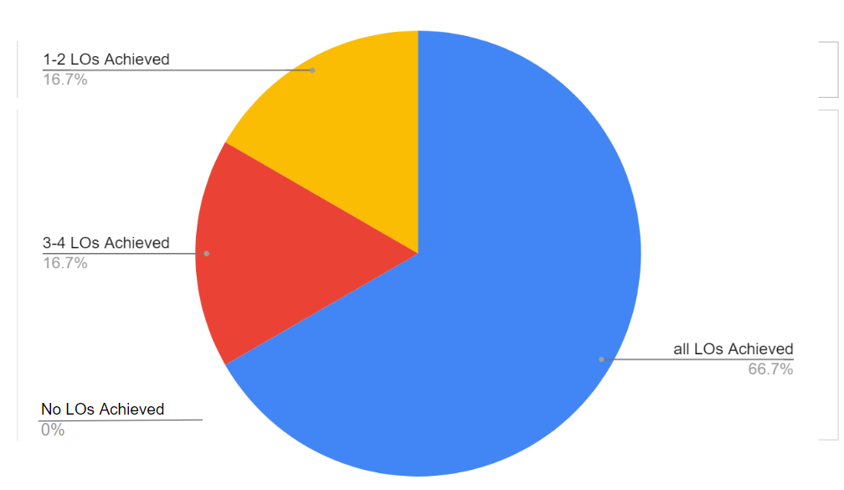
Fig 1

For Topic B, 16.7% of the sampled learners achieved all learning outcomes. An additional 16.7% achieved 3-4 of the learning outcomes, and 50% of the sampled learners achieved between 1-2 of the learning outcomes. The final 16.7% of learners did not achieve any of the set outcomes (fig 2).

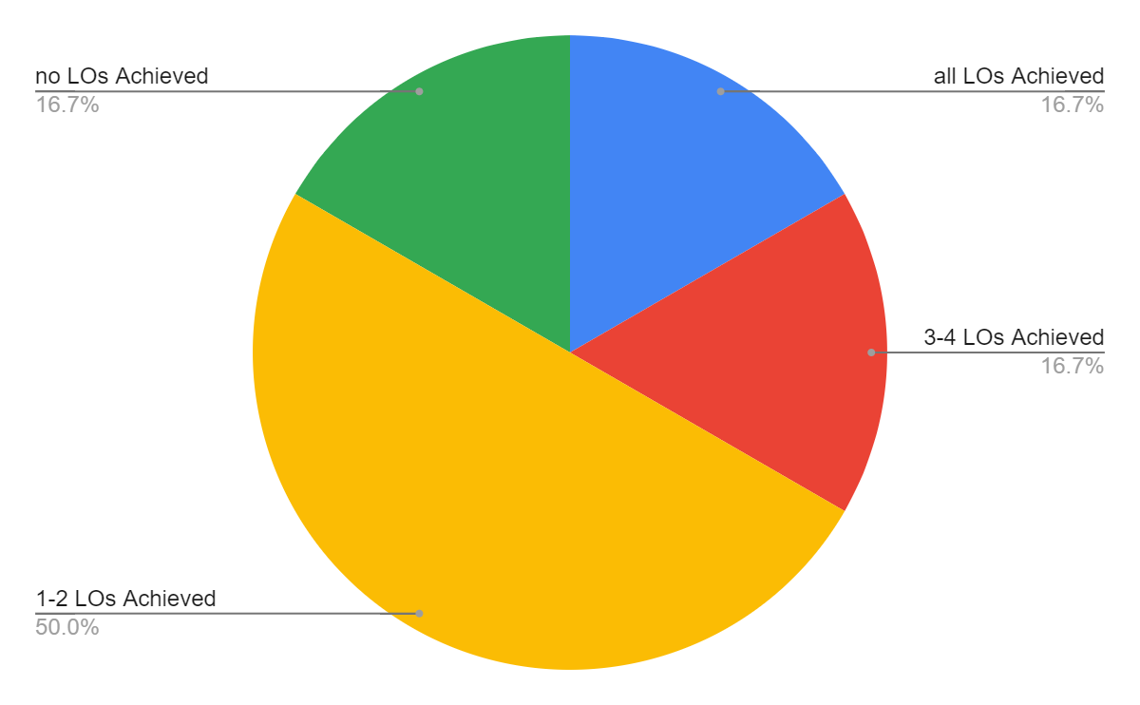
Fig 2

These results from the observation reveal that the participating learners were more successful at excelling in Topic A, and less successful in Topic B.
Topic A featured a thorough break-down of the information needed to understand the new topic, and Topic B had no thorough break-down of information.
From the questionnaire, it has been found that half of the participating learners enjoyed Topic A the most, whereas no participants chose Topic B as most enjoyable; 2 of the participants enjoyed both topics equally, whereas 1 participant found neither enjoyable (fig 3).

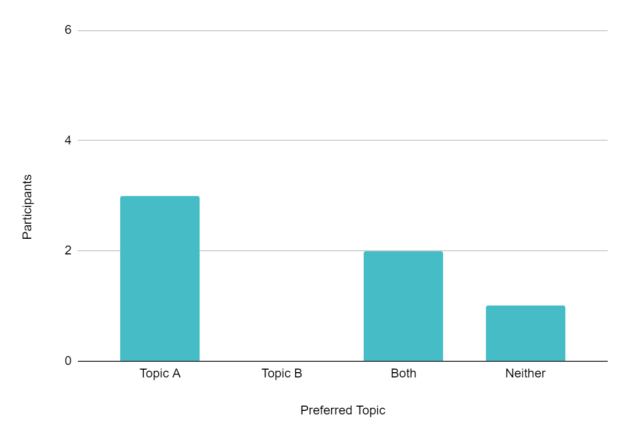
Fig 3

Additionally, half of the participating learners felt little to no confidence in both topics before the lesson in question. 1 participant felt least confident in Topic A before the lesson, 2 felt this about Topic B and 1 participant felt the least confidence in neither of the topics.

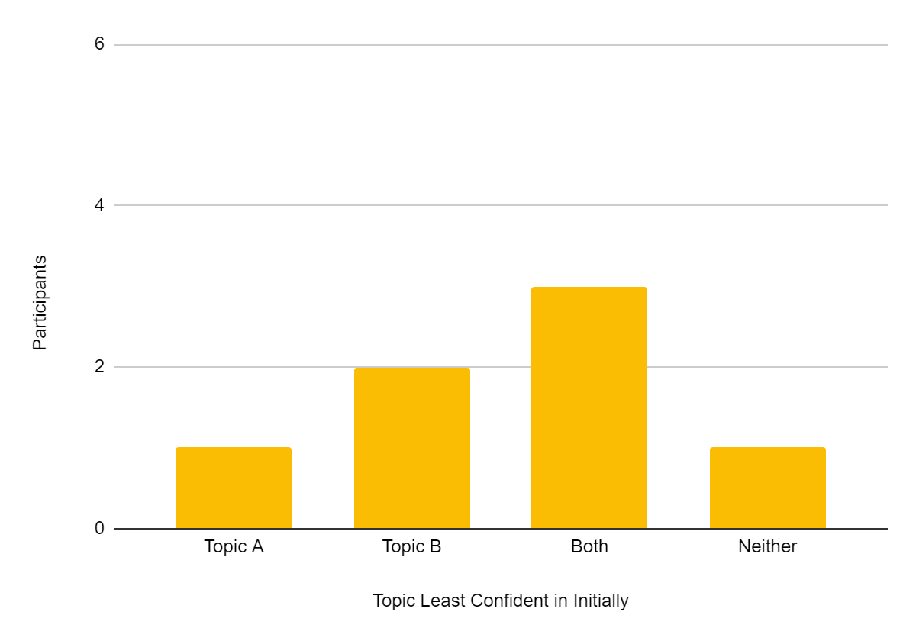
Fig 4

Analysis of Results and Findings
From the results gathered it can be concluded that participating learners were more successful at achieving the set lesson objectives of Topic A, whereas they were less successful at completing Topic B. As Topic A featured thorough task chunking and had all instructions and explanations broken down, it stands to reason that task chunking is more effective at helping learners achieve pre-set learning outcomes than topics that do not utilise task chunking. This correlates with the findings of cognitive load theory, reinforcing the work of Sweller (1988), Baddeley (1999), Abejuela (2023) and Annga (2023); from this class observation, learner’s cognitive load was more manageable when broken down for them.

However, the main aim for this case study was to try to measure the participating learner’s retention and interest in the topic, rather than just learning outcome success. Using the results of the questionnaire and interview, these findings can be used in conjunction with the results of the class observation to determine participant’s retention levels.
Within the interview, the class teacher of the observed class believed that from their experience, learners are more likely to sustain an interest in topics which they fully understand as they feel a sense of security in subjects which they have little to no risk of making mistakes in, and this is best achieved through thorough breakdowns of information when delivering the topic for the firsts time.
This can be reinforced with the results of the questionnaire; half of the participants enjoyed the thoroughly broken down topic more than the topic that was not effectively chunked. This reveals that the participants were more likely to enjoy topics that they know they can achieve in, rather than ones which they have had less success in.
It is also important to note that before the introduction of the topics, the majority of participants felt low in confidence in one or more of the topics; to see half of the participants succeed in Topic A after this further suggests the importance of task-chunking.

Conclusions
The research methods used in this case study allowed for ethical, authentic and well-informed data to be collected on the participants, allowing for the accurate presentation of results.
An interview with the class teacher on their experience with task-chunking provided a professional perspective through a lens of familiarity with the learners in question. This gave the research a credible area to start from, however it must also be acknowledged that the familiarity with the participants could also lead to subconscious biases, which could lead the research into areas of subjectivity. To tackle this, the implementation of an observation was included as it enabled an objective outlook into the topic of interest, which could negate any previous biases from the interview. Additionally, the questionnaire given to the participants gave the case study first hand opinions and viewpoints, which has provided the study with authentic data.
In terms of generalisation of data, due to the limited time in which the study has been conducted within, the results only represent a small selection of learners from one year group. This has somewhat hindered the results as a more varied selection of participants would reveal greater nuances in the presentation of the data; the group that was used in this case study gave data readings that are undeniably more general than what would be considered ideal, but was unavoidable due to time restraints . This has been acknowledged and is addressed fully with suggestions within the recommendations section below.
The completion of this case study has helped in the development of the professional learning teaching standard, as it has contributed to the understanding of how research and data collection can be practically applied to enhance the progress of learners.
Recommendations
To gain a more accurate representation of data, the research period could be carried out over a longer period of time and have a larger number of participants. This could identify if learners retention level is consistent throughout multiple introductory topics, or if it would waiver over time; the richer data would also reveal any idiosyncrasies between particpants. Ideally, this research would start at the beginning of an academic year, and end when the final topic of the year was introduced. This would give the research more depth as it would reveal how the different school terms affect learner’s retention. Additionally, the research would be richer if it involved multiple year groups; from this it could be determined if different year groups respond to task-chunking in different ways.
The results presented in this assignment are only a snapshot of how learners retention is affected by task-chunking when being introduced to new topics; however, this snapshot could be a starting point for further research into the topic. These results would allow for teachers to further develop their practice, as it can be used to personally reflect on the delivery of topics which are new to learners. Additionally, if the research was developed further using the above recommendations, the improvement in learner retention could be expanded to measure other aspects of their learning, such as task understanding or confidence.

Reference List
Abejuela, J., Apundar, M., Berame, M.I., Barcoso, R., Gabisay, C., and Pasay, J. (2023) ‘Chunking Strategy to Improve Students' Reading Comprehension: An Action Research,’ International Journal of Science and Management Studies, 6(1), pp. 100-105.

Allen, D.E., Donham, R.S. and Bernhardt, S.A. (2011) ‘Problem-based learning,’ New Directions for Teaching and Learning, 128(Dec), pp. 21-29.

Angga, N.M., Phieranto C.C, Teio F., Yovan D., Angelica, A. and Putri, F.S. (2022) ‘Chunk Learning Media for Cognitive Load Optimization on Science Learning,’ Seventh International Conference on Informatics and Computing (ICIC), Denpasar, Bali, Indonesia 8-9 Dec. Piscataway, New Jersey: IEEE Publications, pp. 1-6. Available at:https://ieeexplore.ieee.org/document/10006912 (Accessed 18th March 2024)

Arundel, A. (2023). How to Design, Implement, and Analyse a Survey. Cheltenham: Edward Elgar Publishing.

Baddeley, A.D. (1999) ‘Essentials of human memory’, Psychological Review, 106(2), pp. 183-203.

Bandura, A. (1997) Self-Efficacy: The Exercise of Control. New York: W. H. Freeman and Company.

Blackwell L.S., Trzesniewski, K.H. and Dweck, C.S. (2007) ‘Implicit theories of intelligence predict achievement across an adolescent transition: a longitudinal study and an intervention’, Child Development 78(1), pp. 246-263. doi: 10.1111/j.1467-8624.2007.00995.x. PMID: 17328703.

Broache, M.P. (2022) ‘Planning, conducting, and analyzing interviews,’ In Graziano, P.R. and Tosun, J. (eds) Elgar Encyclopedia of European Union Public Policy. Cheltenham: Edward Elgar Publishing, pp. 548-569.

Cheeseman, J., Clarke, D., Roche A., and Walker, N. (2016) ‘Introducing Challenging Tasks: Inviting and Clarifying without Explaining and Demonstrating’, Australian primary mathematics classroom (Australian Association of Mathematics Teachers) 21(3), pp. 3-6. Available at:https://search.informit.org/doi/epdf/10.3316/informit.350316936851015

Cheon, S.H., Reeve, J., Lee, Y. and Lee, J. (2015) ‘Why Autonomy Support and Structure Are Vital for Students' Motivation and Engagement in School: A Self-Determination Theory Perspective’, European Journal of Psychology of Education 69(Jan), pp.43-51. Available at:https://ezproxy.uwtsd.ac.uk/login?url=https://www.sciencedirect.com/science/article/pii/S0742051X17305954/pdfft?isDTMRedir=true

Cohen, L., Manion, L., and Morrison, K. (2017) Research Methods in Education (8th ed.) Oxfordshire: Routledge. https://doi.org/10.4324/9781315456539

Creswell, J.W. (2017) Qualitative Inquiry and Research Design: Choosing Among Five Approaches. 4th edn. Thousand Oaks, CA: Sage Publications.

Dai, T., Rosenberg, J.M., and Lawson, M. (2022) Data Representations and Visualizations in Educational Research. Oxfordshire: Routledge. https://doi.org/10.4324/9781138609877-REE148-1

Deci, E.L. and Ryan, R.M. (2017) Self-Determination Theory: Basic Psychological Needs in Motivation, Development, and Wellness. New York: Guilford Publications.

Dweck, C.S. (2006). Mindset: The new psychology of success. New York: Random House.

Estyn (2020) Inspection Report of [Redacted] School 2020. Available at:https://www.estyn.gov.wales/ (Accessed 27th March 2024)

Farid, S. (2022) ‘Observation,’ in: Islam, M.R., Khan, N.A., Baikady, R. (eds) Principles of Social Research Methodology. Springer: Singapore, pp. 365-375.

Flyvbjerg, B. (2006) ‘Five Misunderstandings About Case-Study Research,’ Qualitative Inquiry, 12(2), pp. 219-245.

Gabas, C., Cutler, L., and Schachter, R.E. (2023) ‘Making Mistakes: Children’s Errors as Opportunities for Emergent Literacy Learning in Early Childhood’, The Reading Teacher, 76(6) pp. 664–672. https://doi.org/10.1002/trtr.217

Gerring, J. (2016) Case Study Research: Principles and Practices. 2nd edn. Cambridge: Cambridge University Press.

Gertsman, S., O’Hearn, K., Gibson, J., and Menon, K. (2020) ‘Parental Understanding of Research Consent Forms in the PICU: A Pilot Study,’ Pediatric Critical Care Medicine, 21(6), pp. 526-534. https://doi.org/10.1097/PCC.0000000000002234

Gredler, M.E. (2012) ‘Understanding Vygotsky for the Classroom: Is It Too Late?’ Educational Psychology Review 24 (March), pp.113–131. https://doi.org/10.1007/s10648-011-9183-6

Gupta, V. (2019) ‘An Analysis of Data Visualization Tools,’ International Journal of Computer Applications, 178(10), pp. 4-7.

Harris, L. (2020) ‘Data protection and confidentiality: challenges for schools in Wales’, Journal of Education Policy, 35(5), pp. 665-679.

Hussein, H. (2022) ‘Interview Method,’ in Islam, M.R., Khan, N.A., Baikady, R. (eds) Principles of Social Research Methodology. Singapore: Springer, pp. 207–219.

Iwaniec, J. (2019) ‘Questionnaires: Implications for effective implementation,’ in McKinley, J. and Rose, H. (eds), The Routledge Handbook of Research Methods in Applied Linguistics. Oxfordshire: Routledge, pp. 224-235.

Jackson, L., and Głowacki, M. (2019). ‘Watching People: Observations,’ in Van den Bulck, H., Puppis, M., Donders, K. and Van Audenhove, L. (eds), The Palgrave Handbook of Methods for Media Policy Research. London: Palgrave Macmillan, pp. 215-231.

Jacob, S. A., and Furgerson, S. P. (2012) ‘Writing Interview Protocols and Conducting Interviews: Tips for Students New to the Field of Qualitative Research,’ The Qualitative Report, 17(42), pp. 1-10.

Kemna, S., Kroemer O. and Sukhatme, G.S. (2018) ‘Pilot Surveys for Adaptive Informative Sampling,’ 2018 IEEE International Conference on Robotics and Automation (ICRA), Brisbane, QLD, Australia 21-25 May. Piscataway, New Jersey: IEEE Publications, pp. 6417-6424. Available at:https://ieeexplore.ieee.org/document/8460488 (Accessed 16th April 2024)

Kirschner, P. A., Sweller, J., Kirschner, F., and Zambrano R., J. (2018) ‘From Cognitive Load Theory to Collaborative Cognitive Load Theory,’ Educational Psychology Review, 13(April), pp. 213-233.

Korkiamäki, R., and Kaukko, M. (2023) ‘Faceless, voiceless child – Ethics of visual anonymity in research with children and young people,’ Childhood, 30(1), pp. 55-70. https://doi.org/10.1177/09075682221126586

Kuhfeld, M., and Tarasawa, B. (2020). ‘The COVID-19 Slide: What Summer Learning Loss Can Tell Us about the Potential Impact of School Closures on Student Academic Achievement’, Educational Researcher 1(April), pp. 1-7. Available at:https://files.eric.ed.gov/fulltext/ED609141.pdf

Lasmawan, I.W., and Budiarta, I.W. (2020) ‘Vygotsky’s Zone Of Proximal Development and The Students’ Progress in Learning (A Heutagogical Bibliographical Review)’, Indonesian Education Journal, 9(4), p. 545.

Leppink, J. (2020) ‘Revisiting cognitive load theory : second thoughts and unaddressed questions,’ Scientia Medica, 30(Jun) pp. 1-8.

Martínez-Huamán, E.L., Quiza Añazco, C., Cuellar Quispe, S., and Gutiérrez-Pérez, B.N. (2023) ‘Teaching with Chunking in Synchronous Classes: The Influence on University Students’ Intrinsic Motivation’, International Journal of Learning, Teaching and Educational Research, 22(2), pp. 377-391. Available at:https://ijlter.org/index.php/ijlter/article/view/6855/pdf (Accessed: 12th March 2024)

Mayer, R.E., and Moreno, R. (2003) ‘Nine ways to reduce cognitive load in multimedia learning,’ Educational Psychologist, 38(1), pp. 43-52.

McMillan, G. (2022) ‘The Parent’s Dilemma: Pediatric Assent in Research,’ Pediatrics Perspectives, 150(3), pp. 1-3.

Merriam, S.B. (2009) Qualitative Research: A Guide to Design and Implementation. San Francisco: Jossey-Bass.

Meyer, R.E., and Land, R. (2003) ‘Threshold Concepts and Troublesome Knowledge: Linkages to Ways of Thinking and Practising within the Disciplines. Enhancing Teaching-Learning Environments in Undergraduate Courses Project,’ Occasional Report, 4(May), pp. 1-14.

Miller, G.A. (1956) ‘The magical number seven, plus or minus two: Some limits on our capacity for processing information’, Psychological Review, 63(2), pp. 81-97.

Morgan, S.J., Pullon, S.R.H., Macdonald, L.M., McKinlay, E.M., and Gray, B.V. (2017). ‘Case Study Observational Research: A Framework for Conducting Case Study Research Where Observation Data Are the Focus,’ Qualitative Health Research, 27(7), pp. 1060-1068.

Moss, L.S. (2017) ‘Collaboration, confidentiality, and care’, Psychological Services 14(4), pp. 443-450.

Ningi, A. I. (2022) ‘Data Presentation in Qualitative Research: The Outcomes of the Pattern of Ideas with the Raw Data,’ International Journal of Qualitative Research, 1(3), pp.196-200. https://doi.org/10.47540/ijqr.v1i3.448

Ng, C. J. (2006) ‘Designing a questionnaire,’ Malaysian Family Physician, 1(1), pp. 32–35.

Patton, M.Q. (2014) Qualitative Research & Evaluation Methods. 4th edn. Thousand Oaks: Sage Publishing.

Pise, A.A. and Singampalli, D.T. (2023) ‘An Introduction to Data Visualisation: An Overview of Visualizing Data,’ in Hiran, K., Hemachandran K., Pise A., and Rabi, B. (eds) Handbook of Research on AI and Knowledge Engineering for Real-Time Business Intelligence. Hershey, PA: IGI Publishing, pp. 34-53.

Priya, A. (2021). ‘Case Study Methodology of Qualitative Research: Key Attributes and Navigating the Conundrums in Its Application’, Sociological Bulletin, 70(1), pp. 94-110.

Rahman, S. (2017) ‘The Advantages and Disadvantages of Using Qualitative and Quantitative Approaches and Methods in Language “Testing and Assessment” Research: A Literature Review’, Journal of Education and Learning, 6(1) pp. 102-112.

Reeve, J. (2016) ‘Autonomy-Supportive Teaching: What It Is, How to Do It’, in Chia Liu, W., Wang, J.C.K. and Ryan, R.M. (eds) Building Autonomous Learners. New York: Springer Publishing, pp.129-152. Available at:https://link.springer.com/book/10.1007/978-981-287-630-0

Robison, W.L. (2017) ‘Ethical Presentations of Data: Tufte and the Morton-Thiokol Engineers,’ in Michelfelder, D., Newberry, B., and Zhu, Q. (eds) Philosophy and Engineering. Philosophy of Engineering and Technology, vol 26. New York: Springer Publishing, pp. 151-162. Available at:https://link.springer.com/chapter/10.1007/978-3-319-45193-0_12#citeas

Sabar, G. and Sabar Ben-Yehoshua, N. (2017) ‘‘I’ll sue you if you publish my wife’s interview’: ethical dilemmas in qualitative research based on life stories,’ Qualitative Research, 17(4), pp. 408-423. https://doi-org.ezproxy.uwtsd.ac.uk/10.1177/1468794116679727v

Sanders, M., Summers, J., Hirneis, V., Hume, S., and McGannon, G. (2023) ‘Consent, assent, and randomized evaluations,’ Policy Press, 19(4), 591–602. https://doi.org/10.1332/174426421X16842419724551

Santhosh, K., Dinesh, N. and Periasamy, P. (2021) ‘Testing Validity and Reliability of the Questionnaire in Soft Skills Research: A Perspective from B-School Alumni,’ International Journal of Entrepreneurship, 25(1), pp. 1-10.

Silverman, D. (2010). Qualitative research. Thousand Oaks: Sage Publishing.

Simons, H. (2009) Case Study Research in Practice. Thousand Oaks, California: Sage Publishing.

Slavin, R.E. (2014) ‘Cooperative learning and academic achievement: Why does groupwork work?,’ Anales de Psicología, 30(3), pp. 785-791.

Smith, A., and Green, B. (2019) ‘Safeguarding and confidentiality in Welsh schools: A review of policies and practices’, Welsh Journal of Education, 21(2), pp. 123-137.

Stake, R. (1995) The Art of Case Study Research. Thousand Oaks, CA: Sage Publishing.

Stake, R. and Visse, M. (2023) ‘Case study research’, in Tierney, R.J., Rizvi, F. and Ercikan, K. (eds) International Encyclopedia of Education. 4th edn. Amsterdam: Elsevier Science, pp. 85-91.

Sweller, J. (1988) ‘Cognitive load during problem solving: Effects on learning’, Cognitive Science, 12(2), pp. 257-285.

Trainor, L.R. and Bundon, A. (2021) ‘Developing the craft: reflexive accounts of doing reflexive thematic analysis’, Qualitative Research in Sport, Exercise and Health, 13(5) pp. 705-726.

Walker, W. (2005) ‘The strengths and weaknesses of research designs involving quantitative measures’, Journal of Research in Nursing, 10(5) pp. 571-582. doi:10.1177/136140960501000505

Welsh Government (2018) Data Protection in Schools: Guidance for Schools in Wales. Cardiff: Welsh Government.

Widner, J. (2022) ‘Descriptive Accuracy in Interview-Based Case Studies’, in J. Widner, M. Woolcock, and D. Ortega Nieto (eds) The Case for Case Studies: Methods and Applications in International Development. Cambridge: Cambridge University Press, pp. 119-141.

Wieringa, R.J. (2014). Observational Case Studies. In: Design Science Methodology for Information Systems and Software Engineering. Berlin: Springer.

Wood, B., and Bolch, C. (2019) ‘Seeing and Understanding Data,’ Embry-Riddle Aeronautical Scholarly Commons, 1(Aug), pp. 1-21.

Yazan, B. (2015) ‘Three Approaches to Case Study Methods in Education: Yin, Merrian, and Stake’, Qualitative Report, 20(2), pp.134-152.

Yin, R.K. (2014). Case Study Research: Design and Methods. 5th edn. Thousand Oaks, CA: Sage Publications.

