

MODULE: CHANGEMAKERS CREATIVITY & VALUE CREATION

Care Connect AI: Transforming Health and Social Care Through Artificial Intelligence Enabled Remote Monitoring for Older Adults with Long-Term Conditions in the United Kingdom

Module Code: BMHP5014

Student Name: Romana Begum Chowdury

Student ID: 2229137

Lecturer Name : Brian Mashumba
Component 2 : Assignment Report

Table of Contents
Poster 3
Written Pitch: CareConnect AI 4
Introduction 4
Background and Justification 4
Description of CareConnect AI Innovation 4
Impact on Patients, Families and Professionals 5
Policy and Legislative Framework 5
Professional Services and Stakeholder Involvement 6
Public Engagement and Community Participation 6
Challenges and Risk Management 6
Conclusion and Call for Adoption 7
References 7

Poster
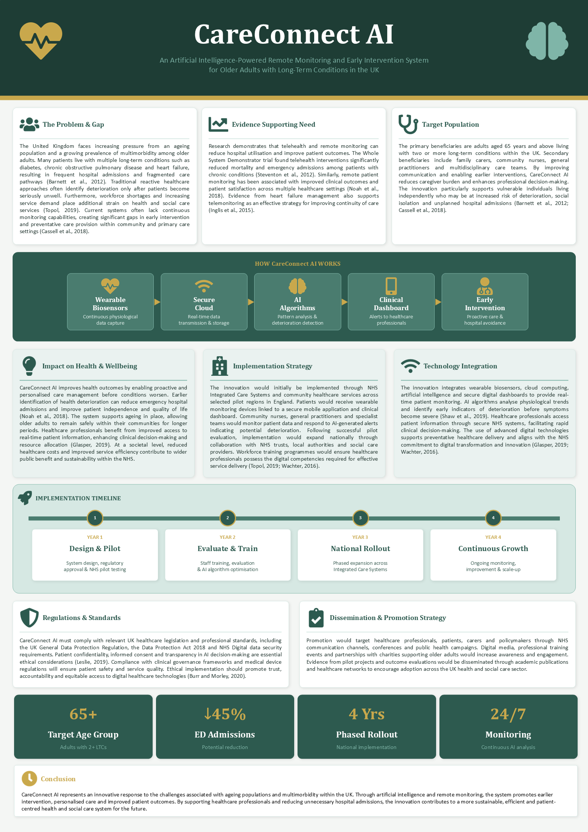

Written Pitch: CareConnect AI

Introduction
CareConnect AI is a remote monitoring system powered by AI to optimise outcomes for older people with multiple long-term conditions in the UK. It integrates wearable sensors, prediction analytics and digital clinical dashboards to provide early warning signs of deterioration and timely interventions. The innovation is relevant to national priorities of digital transformation and preventative care in the NHS (Topol, 2019). This pitch explains the why, how and what CareConnect AI does in integrated health and social care systems.

Background and Justification
There is a large amount of multimorbidity associated with ageing in the UK, which is placing pressure on already overstretched health and social care services. A large number of older people have multiple conditions (such as diabetes, heart and lung disease) and this can result in unscheduled hospital admissions and disjointed care (Barnett et al., 2012). Current reactive models of care don't recognise early signs of deterioration and lead to avoidable complications and costs for the NHS. The evidence reveals that, in chronic disease management (CDM), telehealth and remote monitoring can play a key role in reducing hospital admissions and mortality (Steventon et al., 2012). The uptake in the NHS is however patchy, where workforce constraints and digital capability gaps hamper the implementation (Wachter, 2016). AI-powered solutions like CareConnect AI can tackle these challenges by enabling predictive, preventative and personalised care. This is in line with the NHS Long Term Plan which emphasises moving care out of hospital and using digital innovation to achieve sustainability (Topol, 2019).

Description of CareConnect AI Innovation
CareConnect AI integrates wearable biosensors, a patient-facing mobile application and an NHS clinical dashboard. Physiological data – such as heart rate, oxygen saturation, sleep patterns and mobility indicators – are continuously collected. Using artificial intelligence algorithms, trends are analysed and early signs of deterioration are detected, creating automated alerts for clinicians and carers (Shaw et al., 2019). Healthcare professionals can then step in before things get out of hand, and prevent emergency admissions. The platform will be interoperable with other NHS systems and electronic health records. It facilitates multi-disciplinary working with GPs, community nurses and social care professionals. This not only helps to improve continuity of care but also encourages proactive long-term condition management, boosting clinical efficiency and patient safety.

Impact on Patients, Families and Professionals
CareConnect AI provides the patient with independence, security and better quality of life through continuous monitoring and timely intervention, avoiding the risk of abrupt worsening of health condition (Noah et al., 2018). Families and informal carers experience less burden of care and increased reassurance about patient wellbeing. Healthcare professionals are able to access real-time data, which makes for more accurate healthcare decision-making and less workload when it comes to emergency admissions. Digital monitoring systems are shown to enhance coordination of care and clinical outcomes in chronic disease management (Inglis et al., 2015). The innovation is system level as it enables reduction of pressure on hospitals, optimizing the allocation of resources and facilitating a shift towards community based care. This helps to enhance efficiency and sustainability of the NHS and person-centred care delivery.

Policy and Legislative Framework
CareConnect AI aligns with major policies and regulations in the UK concerning digital health and patient safety. The UK General Data Protection Regulation (UK GDPR) and Data Protection Act 2018 guarantee the safe handling of sensitive patient data. The system also meets NHS Digital standards and security requirements for health technologies. Principles from AI ethics frameworks, such as transparency and accountability and algorithmic decision-making are applied to ethical considerations. The innovation aligns with the vision of the NHS Long Term Plan (2019) – focus on digital transformation and community care. Moreover, the Topol Review (2019) emphasizes the need for workforce readiness and the integration of AI in healthcare. These frameworks provide a secure, ethical and effective way of doing this in UK health and social care settings.

Professional Services and Stakeholder Involvement
This will need NHS trusts, Integrated Care Systems, general practitioners, community nurses and social care providers to work together for successful implementation. There will be clinical governance teams that will take care of safety and quality assurance and digital health experts who will handle system integration. Technology partners help the development and maintenance of AI. Patients and carers are also valuable stakeholders and are involved in user-centred design and feedback processes. A multidisciplinary approach will make CareConnect AI clinically effective, socially acceptable and operationally sustainable across a variety of healthcare settings (Wachter, 2016).

Public Engagement and Community Participation
This will be communicated through NHS awareness campaigns and community outreach programmes and via partnerships with voluntary groups for older people. Educational workshops will be conducted to educate patients and carers to use the wearable devices and mobile applications effectively. Digital inclusion will be ensured by digital inclusion strategies for people with low technological literacy. Engagement also includes gathering feedback from patients to enhance system usability and trust. The participatory approach is consistent with person-centred care and enhances confidence in the community in digital health innovations (Burr and Morley, 2020).

Challenges and Risk Management
Digital exclusion, data privacy issues, algorithmic bias, and healthcare professional resistance to technology are major issues. Another concern is the potential for reliance on AI systems, leading to a decrease in clinical judgment. Such risks will be reduced by educating staff, implementing robust cyber security measures and by communicating clearly about algorithm design. Continuous monitoring and evaluation will assure system accuracy and safety. Adhering to ethical guidelines and regulatory frameworks will also mitigate risks of AI use in healthcare (Leslie, 2019; Shaw et al., 2019).

Conclusion and Call for Adoption
Through a scalable, evidence-based solution, CareConnect AI can enhance the outcomes for older adults with long-term conditions and alleviate strain on NHS services. It combines AI, remote monitoring, and multidisciplinary care, enabling timely intervention and tailored healthcare. The adoption of this innovation is a national health and social care digital health priority and has the potential to revolutionise health and social care provision in the UK (Topol, 2019).

References
Barnett, K., Mercer, S. W., Norbury, M., Watt, G., Wyke, S., & Guthrie, B. (2012). Epidemiology of multimorbidity and implications for health care, research, and medical education: a cross-sectional study. The Lancet, 380(9836), 37-43.
Blease, C., Kaptchuk, T. J., Bernstein, M. H., Mandl, K. D., Halamka, J. D., & DesRoches, C. M. (2019). Artificial intelligence and the future of primary care: exploratory qualitative study of UK general practitioners’ views. Journal of medical Internet research, 21(3), e12802.
Burr, C., & Morley, J. (2020). Empowerment or engagement? Digital health technologies for mental healthcare. In The 2019 yearbook of the digital ethics lab (pp. 67-88). Cham: Springer International Publishing.
Cassell, A., Edwards, D., Harshfield, A., Rhodes, K., Brimicombe, J., Payne, R., & Griffin, S. (2018). The epidemiology of multimorbidity in primary care: a retrospective cohort study. British Journal of General Practice.
Glasper, A. (2019). A long-term plan for embracing digital healthcare technology. British Journal of Nursing, 28(3), 204-205.
Inglis, S. C., Clark, R. A., Dierckx, R., Prieto‐Merino, D., & Cleland, J. G. (2015). Structured telephone support or non‐invasive telemonitoring for patients with heart failure. Cochrane Database of Systematic Reviews, (10).
Leslie, D. (2019). Understanding artificial intelligence ethics and safety. arXiv preprint arXiv:1906.05684.
Noah, B., Keller, M. S., Mosadeghi, S., Stein, L., Johl, S., Delshad, S., ... & Spiegel, B. M. (2018). Impact of remote patient monitoring on clinical outcomes: an updated meta-analysis of randomized controlled trials. NPJ digital medicine, 1(1), 20172.
Shaw, J., Rudzicz, F., Jamieson, T., & Goldfarb, A. (2019). Artificial intelligence and the implementation challenge. Journal of medical Internet research, 21(7), e13659.
Steventon, A., Bardsley, M., Billings, J., Dixon, J., Doll, H., Hirani, S., ... & Newman, S. (2012). Effect of telehealth on use of secondary care and mortality: findings from the Whole System Demonstrator cluster randomised trial. Bmj, 344.
Topol, E. (2019). The topol review. Preparing the healthcare workforce to deliver the digital future, 1-48.
Wachter, R. (2016). Making IT work: harnessing the power of health information technology to improve care in England. London, UK: Department of Health, 1-71.

