
Programme: Master of Business Administration
Module: International Marketing: Principles and Practices
Module Code: LCMB7026
“International Market Entry Strategies and Marketing Mix Analysis of KFC in India and the United Kingdom: A Critical Evaluation and Reflective Study”
Student Name : Manupati Priyanka
Student I’d : 2431447

Table of Contents
Section 1 3
1.1 Brand Overview 3
1.2 Countries Overview: India and the United Kingdom 3
1.3 Comparative PESTEL Analysis: India vs UK 4
1.4 Comparative Analysis of Social Factors: Consumer Behaviour and Culture 6
1.5 Comparative Analysis of STP and International Marketing Mix (7Ps): KFC in India and the UK 8
1.6 International Marketing Mix (7Ps) Strategies: KFC in India and the UK 10
1.7 Considering Cultural and Economic Factors: KFC in India and the UK 12
1.8 Analysis of KFC’s Directional Development Strategy in the UK 12
1.9 Evaluation of Ethical Issues in KFC’s Marketing Mix: India and the UK 13
1.10 Ethical Issues in KFC’s International Marketing 14
1.11 Recommendations for KFC’s International Marketing Strategies 15
Section 2: Reflective Account Using Gibbs’ Reflective Cycle 17
2.1 Description 17
2.2 Feelings 18
2.3 Evaluation 18
2.4 Analysis 19
2.5 Action Plan 19
2.6 Conclusion 19
References 21

Section 1

1.1 Brand Overview
KFC, also known as Kentucky Fried Chicken, is a brand of one of the most iconic and well-known quick-service restaurants in the world. KFC was established in 1952 by a man named Colonel Harland Sanders in the United States, and since that time it has transformed into a giant in the fast-food sector within the entire world. Today, the company has over 32, 000 restaurants in more than 150 countries and territories around the world making it one of the biggest and most geographically distributed fast-food chains in the world (Yum!, 2024).
As a subsidiary of Yum! Brands, KFC is an important brand in the portfolio of the parent organization, and a major source of its sales and profits worldwide. This is because its original Recipe chicken, which is composed of 11 secret herbs and spices, is at the centre of its brand, and it has been expanding its menu to suit local tastes and cultural differences (KFC, 2024).

1.2 Countries Overview: India and the United Kingdom
India Market Overview
KFC was introduced to India market in 1995 and has been continually reducing its footprint in the market in the last 20 years. India is one of the fastest-growing markets of KFC, and the brand has more than 1,000 locations across the country because the consumer demand of quick-service food and urbanisation have increased very fast. Business partners such as Devyani international and Sapphire foods are major stakeholders in the franchise network in India, which portrays high level of localisation and franchising of business growth (Bhushan, 2023).
United Kingdom Market Overview
On the contrary, KFC has been in United Kingdom for a long time, having more than 1,000 stores in United Kingdom and Ireland. It is a mature market with excellent consumer demand of fried chicken, which has led to expansion plans. KFC has declared that it will invest £1.49 billion to launch approximately 500 new stores, renovate current stores and generate thousands of employment opportunities, in a move that reaffirms its faith in the long-term expansion even in the face of economic difficulties (Economic Times, 2025).

1.3 Comparative PESTEL Analysis: India vs UK
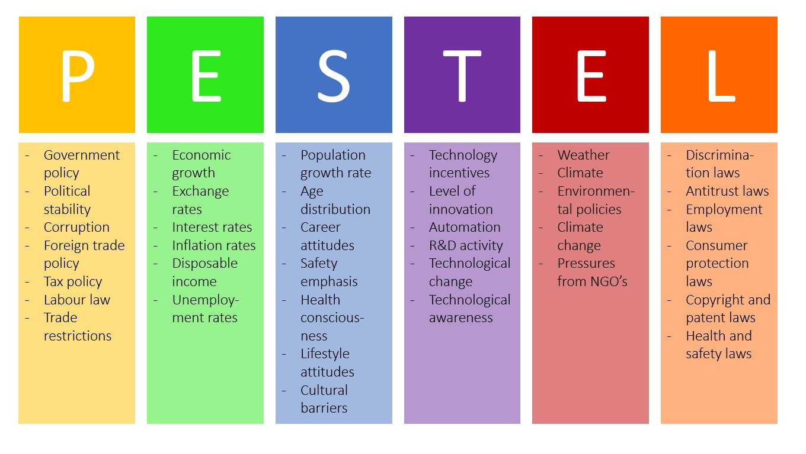
Figure 1: PESTEL Analysis
Source: (de Bruin, 2019)
Political Factors
Policies on liberalisation in India since 1990s have promoted foreign direct investment (FDI) and international entry of quick service restaurants. KFC had ventured into India in 1995 via a franchise system, which provided it with an advantage by the government that opened its policies to international brands venturing in the service industry, to a large degree (Dana, 2021).
Political factors are associated with a pragmatic and controlled environment consisting of full food safety, employment and advertising standards in the UK. An example is the high compliance cost due to stringent hygiene rules and labour laws, which safeguard the rights of consumers and protect the workers.
Economic Factors
The high growth and a growing middle-class population in India makes the country a high-potential market to the quick-service restaurants. Even though per-capita income is still lower compared to Western markets, rising urban incomes and shifting lifestyles favor growth in brands such as KFC (Mukherjee and Navin, 2026).
The UK is a high-income and mature economy, with consumer spending on fast foods high but vulnerable to economic recessions and inflation. Britons are reducing takeaway spending following economic pressures which has halved same-store sales in KFC and other fast food chains (Reuters Staff, 2025b).
Social Factors
The two markets have a major difference in terms of social trends. The Indian population is quite varied and has large vegetarian groups because of cultural beliefs and religious orientations, which demand modification of the menu beyond the usual global product lines. Although KFC India has localised its menu to include rice bowl-based meals and spicier versions to appeal to the locals tastes, consumer attitudes towards fast food also cuts across with issues of health concern and local food traditions that can circumscribe demand beyond the urban youth sector (Chauhan and Shiwang, 2025).
Transparency in sourcing and quality is also in demand in the UK where consumers are becoming more health- and ethically-conscious. When KFC and other chains abandoned a voluntary commitment to poultry welfare, it resulted in mass criticism, which underscored the growing role of social values in animal welfare on brand reputation (Rozemeijer and Wynstra, 2020).
Technological Factors
Use of technology is a major aspect in both markets at varying proportions. The mobile penetration in India is extensive and the digital development is fast, but instead of direct integration of technology in ordering and delivery the intermediation is often facilitated by third parties such as Zomato and Swiggy, and will need varying partnerships and cost model than systems in the UK (Dana, 2021).
In the UK, the modern digitalised system of orders, data analyses and automation of delivery and kitchen processes are part of the competitiveness and improving the customer experience. KFC uses technology like mobile applications and data-oriented marketing as a marketing tool to promote engagement.
Environmental Factors
The KFC environmental policy in India and UK is completely different. KFC in India has already implemented its KFConscious project by establishing eco-conscious restaurants that are energy-efficient, use sustainable materials and divert waste, with a target of 20 such outlets, in line with global ambitions of cutting down greenhouse gases and transitioning to recoverable packaging by 2025 (Yum, 2025).
In the UK, KFC has a zero-waste and net-zero carbon strategy, which it intends to achieve through becoming a fully circular business by 2035 and achieving net-zero emissions by 2040 by partnering to take climate action and run its operations with energy efficiency (KFC, 2022).
Legal Factors
The legal environments make a huge impact on the operations of KFC in India and the UK. KFC in India must also follow the Food safety and standards Act (FSS) 2006 and the food safety and standards regulation associated with it, such as licensing, food quality, labelling and contamination regulation, and these are enforced by the food safety and standards authority of India (FSSAI) to safeguard the health of the population and maintain food safety practices (FSSAI, 2025).
In the UK, KFC must meet highly legal standards related to food quality, labelling and consumer protection laws, legislation on employment and modern slavery that impose high standards of the labour and supply chain (Rozemeijer and Wynstra, 2020).

1.4 Comparative Analysis of Social Factors: Consumer Behaviour and Culture
Eating Out Habits and Lifestyle Trends
India: The emergence of fast food restaurants such as KFC in India is closely associated with the change in lifestyle, urbanisation and changing consumerism. Living in urban areas, young adults and urban families consider eating out to be a part of their social life, celebrations, and a convenient lifestyle, and a substantial population of them eat out every week in the city (RestaurantIndia, 2024).
UK: The consumer behaviour around the fast food Industry in the United Kingdom exhibits continuity and actual transformation. The UK consumers appreciate convenience, especially during lunchtime and fast after-work meals and trends show that consumption of the food-to-go formats will stay high (BBC, 2025).
Cultural Influence on Menu and Preferences
India: Indian culture is a very strong influence on the choice of food, so KFC had to localise its product to suit the regional taste and dietary habits. The menu also frequently incorporates hotter flavour profiles, vegetarian or plant-based preparations in some locations, and seasonal cultural specials due to the multicultural consumer base of India (Chauhan and Shiwang, 2025).
UK: Cultural impacts are different in the UK. Consumers have different tastes in their diets, such as the needs to have halal and vegetarian and more protein-rich food as well as a greater interest in ethically sourced food (Aziz, 2021). To illustrate, although KFC has traditionally performed well because of its iconic fried chicken, consumer attitudes and brand image are influenced by social expectations regarding nutrition, welfare, and sustainability.
Hofstede’s Cultural Dimensions: India vs UK
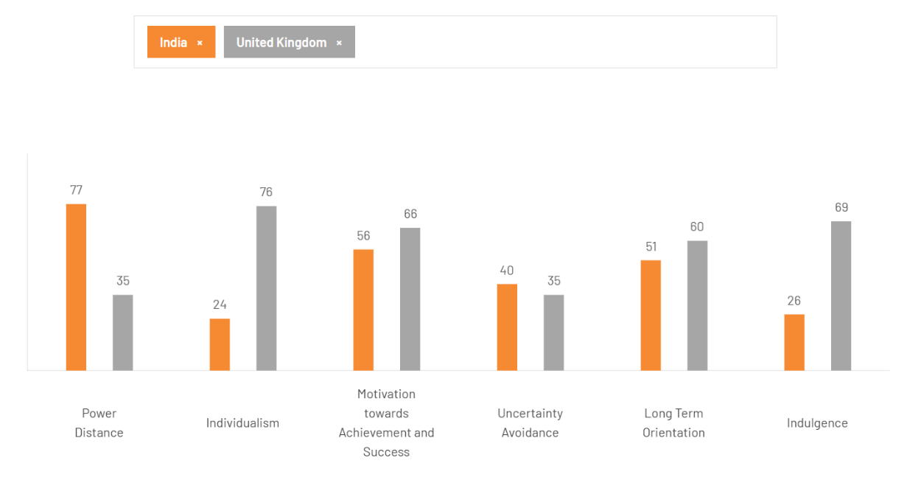
Figure 2: Hofstede’s Cultural Dimensions
Source: (The Culture Factor Group, 2024)
Power Distance (Hierarchy vs. Equality)
The score of India on power distance (77) suggests that the stratification of society and distinct lines of authority are not only tolerated but encourage the normativity of respect towards seniority and top down decision making. In the case of KFC in India, this can be translated to an increased focus on hierarchical communication both internally and externally where managerial decisions are mostly accepted without questioning decisions. A significantly lower score (35) in the UK indicates the cultural value of egalitarian ties and consulting decisions.
Individualism vs. Collectivism
The low individualism score in India (collectivist tendencies) is a direct contrast to the high individualism score in the UK (76-89) where personal choice and achievement are highly valued. KFC in India tends to position itself more on the aspect of the collective values, which is represented in family and group-oriented marketing, as it falls into the collective nature of eating out as a social activity.
Masculinity (Motivation to Success)
Competitiveness is demonstrated in both cultures; however, the UK score is slightly higher which implies that the culture is more focused on success, achievement, and performance. KFC UK can tap into a competitive price strategy and advertising in line with individual performance and aspiration, but KFC India needs to strike a balance between performance message and group identity and cultural pride (BBC, 2025).
Uncertainty Avoidance
Both cultures have moderate levels of tolerance to ambiguity, being fairly flexible. In both markets, KFC would find it easy to innovate and make attempts on new products (ex. localised items in the menu) without fear of opposition.
Long Term Orientation
The long term orientation in India is moderate, indicating that it is patient and future-oriented, thus fitting to the slow expansion of KFC in the emerging cities. UK, slightly lower, shows an even-handed focus on tradition and change, favouring both physical and new products (Aziz, 2021).
Indulgence vs. Restraint
The difference here is dramatic, as India has a low score on indulgence (26) which means that restraint and self-control are more important in Indian consumption, whereas the UK with a high score (69) indicates that the country is more accepting of leisure and enjoyment and social eating (The Culture Factor Group, 2024).

1.5 Comparative Analysis of STP and International Marketing Mix (7Ps): KFC in India and the UK
Segmentation, Targeting and Positioning (STP)
Segmentation
The KFC company in India uses geographical, demographic and lifestyle segmentation as the major segmentations. Its outlets are highly concentrated in urban and semi-urban areas where there is higher disposable income and frequency of eating out; the population density of young working adults and students looking to Western fast food in these areas are high. Age and lifestyle consumption habits are also important in segmentation in UK.
Strategic locations portraying this segmentation would include urban centres, commuter hubs and retail zones. Even though there is little explicit Reuters segmentation data, the high level of investment in the UK (£1.49billion to open and refurbish stores) indicates the segmentation strategy that will target the broad demographic response to a wide range of consumer demographics (Reuters Staff, 2025b).
Demographic Segmentation: In India, KFC mainly focuses on young adults between 18 and 34 years, students as well as working professionals working in urban centres, which match disposable income and frequency of eating-out (Jain, 2020). Families that want to have easy food are also a major segment. KFC targets families, urban commuters, and young adults in the UK by taking advantage of lunch and dinner time.
Psychographic Segmentation: The Indian consumer is an experience, social, and aspirational purchase who is modern and likes to share meals. The UK customers have set the priority to convenience, indulgence, and identification with lifestyle in search of short-term solutions that they should combine with health and ethical issues (Meliha Er Çon and Bennett, 2024).
Targeting
KFC in India focuses on young adults (between approximately 18-34 years), middle and upper middle-class customers who are dining out more frequently, placing orders through apps, or spending time at restaurants. The aspirational taste profiles, and the use of digital, allow this group to form the core customer of the localized product, and festival-based promotions (Brands Pe Charcha, 2026). In the UK, the targeting is still wide but with more focus on the urban commuters, families and the tech-enabled consumers who are using the digital ordering and loyalty programmes (Rozemeijer and Wynstra, 2020).
Positioning
In India, KFC sells itself as an internationally branded but locally Themed and relevant brand (new and modern), combining international quality values and local tastes (local flavours, vegetarian friendly, etc.). This ensures that it is culturally relevant and capitalizes on its iconic brand of Finger Lickin' Good (Chauhan and Shiwang, 2025). KFC in the UK gets to position itself about quality, innovation and cultural relevance. Stress on new products and local relationships (e.g., music festivals), as well as, ambitious creative campaigns, are means of maintaining a culturally entrenched and competitive brand in a saturated QSR market.

1.6 International Marketing Mix (7Ps) Strategies: KFC in India and the UK
Product Strategy
India: KFC product policy in India has focused on localisation in order to fit in the different cultural leanings and consumption habits. Though the main staple of KFC is fried chicken, the menu has added regional ingredients and flavour concepts to suit the local preferences (Chauhan and Shiwang, 2025).
UK: Product strategy in the UK focuses on innovation in core products as opposed to excessive localisation. KFC UK also regularly releases limited-edition products (e.g. new chicken sandwiches) that utilise the established brand equities but address the competition aspects of competitors that include McDonalds and Burger King (Meliha Er Çon and Bennett, 2024).
Price Strategy
India: In India, KFC prices are based on value offering so as to align with the purchasing power of locals and in particular families and youth who are sensitive to price.
UK: The pricing in UK indicates a premium position in accordance with the increased operational costs and brand equity. Prices consider inflation and rise in wages and quality sourcing standards. KFC had a £1.49 billion UK investment plan which indirectly underpins the high pricing strategy to finance growth and renovations (Sweney, 2025).
Place Strategy
India: KFC takes advantage of the rapid market penetration into urban and semi urban markets and effective collaboration with delivery systems to become more accessible. The digital delivery ecosystem (India e.g. third party apps) makes the brand less controlled and lowers the margins with commissions.
UK: Physically in the UK, KFC has a substantial physical presence, with more than 1,000 restaurants and a significant investment strategy to establish and renovate shops, guaranteeing high accessibility in cities and suburbs (Jordan, 2025).
Promotion
India: The localisation and cultural relevancy theme is strongly relayed in the promotional strategy of KFC in India. At the grassroots level, campaigns take advantage of local celebrations, and youth culture, and using social media and food delivery services.
UK: In UK, the campaign is focus on brand heritage, innovation and mainstream media campaigns. KFC supports its presence in UK and Ireland restaurants through a combination of traditional advertising and online channels and seasonal limited-time products to the tune of £1.49 billion investment, meaning that the company is investing heavily in marketing activities in addition to the physical expansion (Economic Times, 2025).
People
India: KFC lays great emphasis on training frontline staff and customer care specifically as booming expansion brings about expansion in terms of workforce (Jain, 2020).
UK: People strategies in the UK are predominantly oriented towards maintaining the standards of the services, and more systematic training and development of the employees that have bigger corporate structure (Meliha Er Çon and Bennett, 2024).
Process
India: In India, process integration is highly dependent on third party delivery solutions (e.g., Swiggy, Zomato), since the latter streamlines the procedure, yet introduces the factor of dependency on third parties.
UK: KFC in the UK prioritizes efficiency with own digital order systems and alliances, enhancing speed and reliability. Standard kitchen operations make sure that all outlets will have uniform standards (Chan et al., 2020).
Physical Evidence
India: Store ambience in India also depends on the location; stores in urban areas tend to exhibit a modern branding experience whereas the smaller towns feature simpler geometries. The quality perception of the customers may be affected by this inconsistency (Jain, 2020).
UK: Physical branding of restaurants in the UK is consistent with the latest interior design, which is an indicator of investment in the customer experience and strengthening the brand that is especially important in high foot traffic urban areas (Sweney, 2025).

1.7 Considering Cultural and Economic Factors: KFC in India and the UK
Cultural Adaptation in Product and Promotion
Cultural factors in India are also very important in influencing the strategy of KFC. Indian food culture consists of strong vegetarian taste and local tastes. Brands does not list detailed menu content, industry reporting on KFC India points to localised product modifications, including spicier versions and vegetarian-friendly options, to attract Indian tastes and honor socio religious stylistic choices. In contrast, in the United Kingdom, cultures focus on convenience, variety, and changing tastes to value and non-performance indulgence. KFC UK pays attention to the innovative limited edition and promotions related to the UK pop culture (Chan et al., 2020).
Economic Conditions and Pricing Strategy
Indian economic environment is characterised by a booming middle income bracket but, reduced purchasing power as compared to the developed markets. The pricing strategy deployed by KFC India will consequently have to be price-focused and competitive to ensure that its volume keeps growing among urban and semi urban consumers who are sensitive to prices (SAJI, 2024). UK economic environment can be described as having more disposable income and is also experiencing inflationary trends and pressure in consumer spending on luxurious goods such as fast foods (Uddin, 2020).

1.8 Analysis of KFC’s Directional Development Strategy in the UK
Strategic Expansion and Investment Focus
The directional development strategy being implemented by KFC in the United Kingdom is characterised by large scale long term investments and focusing on the expansion within the region. Yum Brands KFC intends to spend 1.49 billion dollars (2 billion dollars) on projects in the UK and Ireland within the next five years to enable growth, job creation, and the expansion of outlets, highlighting a strategic emphasis on solidifying market leadership in a developed quick-service restaurant market (Reuters Staff, 2025b). This investment will see a total amount of £466 Million spent on the start-up of approximately 500 new stores and renovations of 200 old stores in the next ten years.
Job Creation and Supply Chain Integration
The other important point in the strategy is the creation of jobs and supply chain investment. The entire investment is approximately £583. million; about 7,000 of this is dedicated to the establishment of over 7,000 new jobs in the KFC business across the UK and Ireland and the supply chain- this is an indication that the company is focused on ensuring the local economies by supporting them as well as advancing its ability to operate at scale (Wise, 2025).
This two-pronged interest in manpower and supply relationships enhances the capabilities of KFC to maintain the quality of its supply and services and tends to bring its larger development aspirations in unhealthy economic conditions where labour and inflationary forces are subjecting consumer behaviours (Jordan, 2025).

1.9 Evaluation of Ethical Issues in KFC’s Marketing Mix: India and the UK
Animal Welfare and Product Sourcing
UK: The key ethical issues of concern, there is the animal welfare issue in the KFC supply chain. At the beginning of 2026, various major restaurant chains, such as KFC, allegedly dropped out of the Better Chicken Commitment (BCC) a voluntary commitment to sell higher-welfare chickens that grow slower and live in better conditions. Animal welfare advocates criticised this move, claiming that the drop in making the pledge is a choice that puts profit over the ethical treatment of animals and that failure to pledge can mislead customers to expect certain welfare standards. The continuity of using fast growing broiler chicken, which is a chicken with known health and welfare problems, is contrary to the idea of ethical sourcing expressed by consumers (Reuters Connect, 2026).
Supply Chain Responsibility and Worker Ethics
UK: In its Modern Slavery Statement, KFC UK recognizes the existence of ethical risks in its supply chain, especially the possibility of forced labour or exploitation based on the use of seasonal and low-paid workers (KFC, 2022a).
India: Ethical marketing also crosses over labour rules. The operator of KFC India, Sapphire Foods, had a one time charge associated with the new labour laws which is an indication of the inception of viable legal and ethical workforce policy modification (Reuters Staff, 2026).
Food Safety and Consumer Transparency
India: In the past, KFC has been subject to food safety and advertisement questions. Even though it is not a new Reuters story, previous cases of Indian states surfaced in which restaurants of international corporations such as KFC were inspected and asserted of misleading menu statements or even possible food safety violations. The authorities of Maharashtra increased the inspections to make sure that consumers are not misled by the description of the products as a sign of ethical expectations that the promotion of fast food products should be precise and secure (Pandya and Praveen Paramasivam, 2024).
Cultural Sensitivity and Local Responsiveness
Although non-unethically, the promotional mix at KFC in India has been forced to consider culturally sensitive content and product formation in relation to food habits and festival behaviour (e.g. consumption of less meat during Hindu festivals), indicating that there must be a respect of consumer values and cultural expectations in promotional strategies (Reuters Staff, 2025a).

1.10 Ethical Issues in KFC’s International Marketing
Ethical Issue in Positioning
In India, advertising of global standards can be against the local variation in tastes or service quality and this can be a deterrent to trust (Chauhan and Shiwang, 2025). In the UK, the focus on decadence and lack of concern about health-related messages can be perceived as an act of unethical conduct when it comes to the wellbeing of consumers (Abeykoon, 2024).
Ethical Issue in Product Marketing
Ethical concerns in product marketing might arise when there is an exaggeration of claims on health, sourcing or quality. As an example, menu writing suggesting high animal welfare standards in the UK, even when industry critics of the practice of slow-growth broilers, may be misleading consumers, which is transparency (Sweney, 2025).
Ethical Issue in Pricing
The pricing practices by KFC may be considered unethical when the company takes advantage of the consumer perceptions (Pandey, 2021). Value-based pricing in India is aimed at affordability but can strain the franchise margins, whereas in the UK higher prices in inflationary times may exclude lower income populations, leading to fairness considerations.
Ethical Issue in Advertising and Promotion
There has to be a balance between advertising campaigns and honesty. During festivals in India, product benefits might be misrepresented by culturally insensitive messaging or false claims. In the UK, offers that encourage indulgence and do not take into consideration the health issues might be subject to ethical criticism, especially in the industry where more people understand nutrition and health (Abeykoon, 2024).

1.11 Recommendations for KFC’s International Marketing Strategies
Direct Export
The benefits of direct export that KFC can apply to India and the UK is mainly the auxiliary products like pre-packed sauces, ready-to-eat snacks, or branded merchandise. Exporting chosen goods at centralised production plants, KFC ensures the quality level and strengthens global brand image without excessive investments (Pandey, 2021). In the UK, premium product line export to supermarkets or online platforms enables KFC to engage consumers who are not necessarily in direct physical restaurants but increase brand reach as well as take advantage of the e-commerce regulations (Young and Bhattacharyya, 2024).
Foreign Direct Investment (FDI)
FDI is essential in the ownership and management of massive operations in strategic areas. India KFC can use FDI to establish flagship stores in its key metropolitan cities such as Mumbai, Delhi, and Bengaluru where it has direct control over the quality of the services, standardisation of menu and efficiency of its operations. FDI in the UK would be able to fund store renovation programs, technological upgrades, and investing in digital infrastructure in ordering and delivery systems (Uddin, 2020).
Joint Ventures
Joint ventures with robust local players (e.g. Sapphire Foods or Devyani International) are advisable in India, due to the complex regulatory environment, cultural peculiarities as well as regional consumer factors. JV partners will offer knowledge of the market, local supply network access and skills in handling government relations. The UK has fewer critical joint venture opportunities since KFC already enjoys sufficient penetration but may attempt co-branded outlets or experimental stores, particularly in areas that address a niche consumer market or digital-first ideas (Jordan, 2025).
OLI Framework Analysis for KFC in India and the UK
Ownership Advantage
KFC boasts of good brand equity, recipes and expertise in operations as part of Yum! Brands. These strengths can give KFC an edge over rivals in a saturated fast-food market in India by playing off international brand awareness, whilst providing domesticized menu choices. Premium positioning, brand loyalty, and product offering innovation is also reinforced by ownership benefits in a mature QSR industry to encourage market leadership in the UK (Chan et al., 2020).
Location Advantage
India is a good business partner because of its potential of growth due to urbanisation, youthful population, growing disposable income and franchised outlets (SAJI, 2024). In contrast, the UK offers a stable, mature market with formed consumer habits towards convenience, online ordering, and quality service.
Internalisation Advantage
KFC officials internalises major operations like the supply chain, employee training, and online order placement to sustain quality and uniformity. Internalisation in India removes supply chain fluctuations in the local market and provides quality of service. In the UK, it enables KFC to run its high-volume operations with ease, adhere to ethical sourcing guidelines, as well as apply innovations into its menu and delivery (Young and Bhattacharyya, 2024).

Section 2: Reflective Account Using Gibbs’ Reflective Cycle
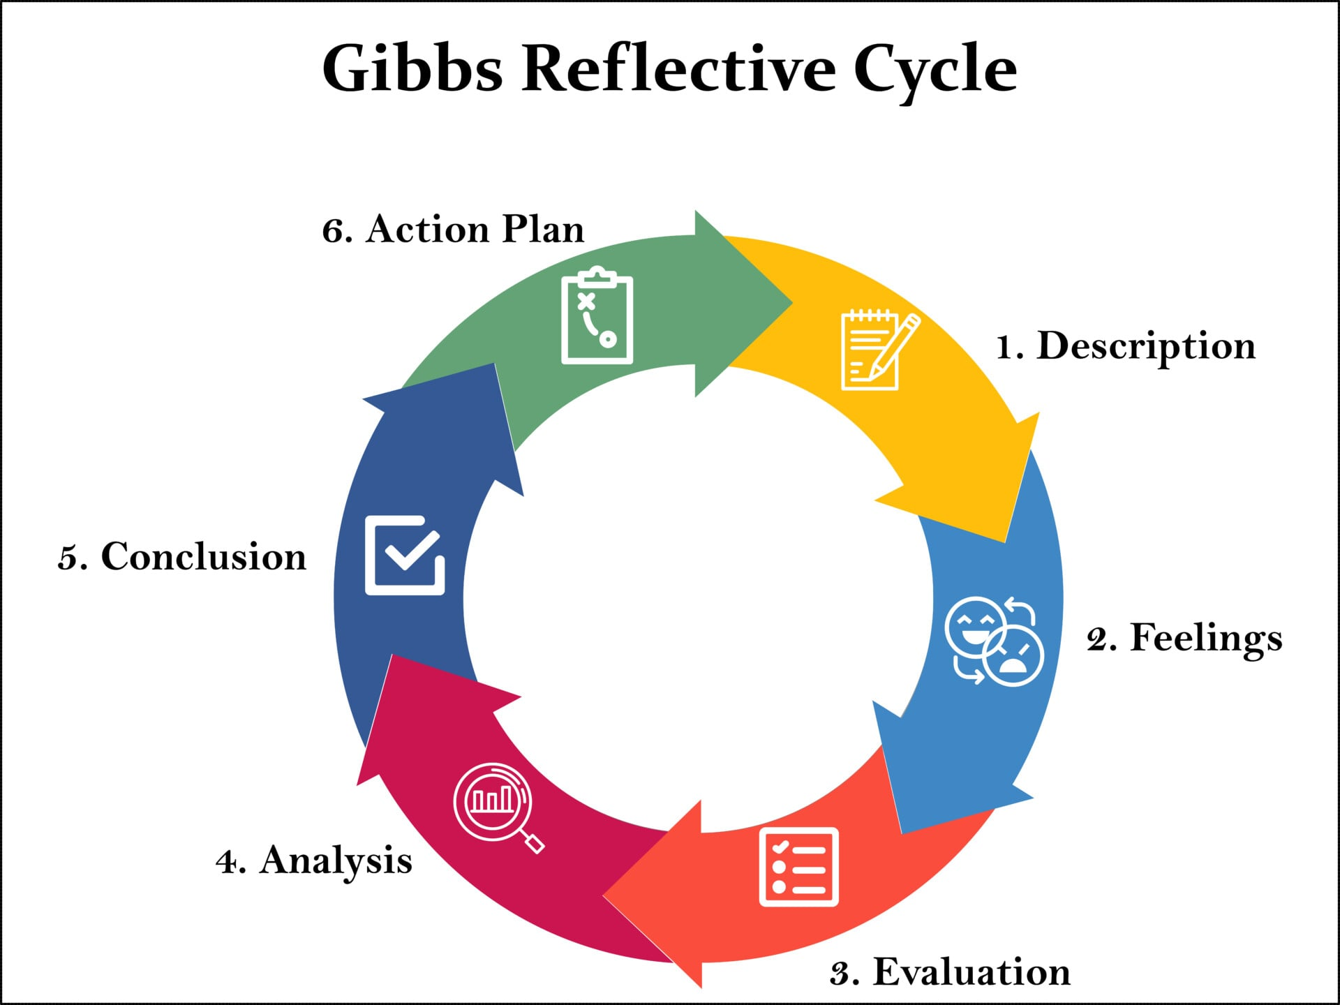
Figure 3: Gibbs’ Reflective Cycle
Source: (McLeod, 2025)
To deliver this reflective account, the Reflective Cycle presented by Gibbs (1988), was used to reflect on my experience of conducting the research, analysing and preparing the international marketing report on KFC in India and the UK. The model by Gibbs consists of six steps, which include Description, Feelings, Evaluation, Analysis, Conclusion, and Action Plan. I have made it my reflection in these steps and the points are discussed in a critical and personal way.

2.1 Description
The assignment involved research and a study of KFC international market entry strategy, STP and 7Ps marketing mix in India and UK. My initial step was to check company annual reports, news stories in the Reuters and official government information to make sure that I referred to authoritative and recent sources. Researching on the product, prices, ad campaigns and distribution of KFC products in the two markets was involved. I also analyzed culture and economics issues using such frameworks as PESTEL or Hofstede cultural dimensions comparing emerging market situation in India and the situation in the UK with the mature market arena (Abeykoon, 2024).
In the course of the research, I organized my work following macro-environmental, consumer behaviour and cultural-analyses, and finally taking a look at KFC and its suggestion to adapt to the marketing mix in each country. I applied OLI framework to evaluate entry strategies, such as direct exporting, FDI, joint venture, and franchising, and considered ethical aspects in marketing, product sourcing, pricing, and advertising.

2.2 Feelings
I was both excited and anxious at the start of the assignment. The emotion to be excited as the analysis of such famous global brand as KFC provided a chance to learn the actual marketing policy in various markets. Fearful, since the task at hand was extensive, and I was required to critically analyze various factors such as cultural adaptation, ethical considerations, and entry strategies, keeping in mind that all information had to be original and pertinent (Aziz, 2021).
At the time when I was undertaking the research, I was satisfied whenever I came across valid sources at Yum! The credibility of my analysis was strengthened by the use of brands annual reports or the articles posted by Reuters. I did get frustrated when information about specific or localised strategies in India or menu adaptations was scarce or sporadic and had to be carefully cross-referenced and checked (Reuters Staff, 2025a). I also found myself being mentally challenged in utilizing such analytical models as PESTEL, the cultural dimensions of Hofstede and STP and the 7Ps marketing mix as they assisted me in deconstructing complex market dynamics in a systematic way.

2.3 Evaluation
Assessment of the research and writing procedure, a number of strengths and weaknesses. One of the strongest points was the use of actual sources that enabled me to offer reliable and truthful insights (Yum, 2025). By relying on KFC/Yum! The analysis of KFC marketing strategies, ethical factors, and market adjustment was all fact-based; I made sure that Brands reports, Reuters news articles, and government data anchored all the facts. Application of analytical frameworks like PESTEL, Hofstede, STP and 7Ps also assisted in developing the report in a systematic manner that enables one to conduct a comparative analysis of both India and the UK.
The other strength was that I was able to critically reflect on the cultural and economic factors concerning the marketing of KFC. An example of this would be my emphasis on localisation in India and premium positioning in the UK, considering the implications of the choices on consumer perception, operational performance, and corporate social responsibility. Also, the three entry strategies direct export, FDI, and joint venture, further enriched the analysis of the directional development strategy of KFC (Yum!, 2024).

2.4 Analysis
Looking back at the whole process of research and writing, I realise that analytical thinking played a key role in deciphering of KFC international marketing strategies in India and the UK. The application of such frameworks as PESTEL, the cultural dimensions outlined by Hofstede, STP, and the 7Ps marketing mix enabled me to analyze both markets systematically, revealing cultural, economic, and regulatory conditions as determinants of market-specific strategy. India, as an illustration, has experienced the power of localisation, adaptation of the menu and joint venture that showed the need to align the global approach to the brand strategy with the preferences of the local consumers.

2.5 Action Plan
As of my reflections, I have formulated an action plan to improve future research and reporting competencies in international marketing. To begin with, I will enhance data gathering methods especially on the emerging market such as India where official or consistent reporting is not available. This entails using local industry reports, government publications, and trusted news outlets to address any gaps without compromising credibility. I shall also be working on triangulating several sources so that the areas of conclusions are led by convergent evidence and not solitary accounts.
Second, I will dedicate more time to critical analysis, instead of descriptive reporting. Although my report was effective in incorporating frameworks, I identified aspects that can be evaluated to a more in-depth level; namely, the ethical implications and cultural adaptation of campaigns and strategies.

2.6 Conclusion
To sum up, the process of researching and analysing the international marketing strategies of KFC in both India and the UK has proved to be highly instructive. The experiences have provided me with a better insight into the issues that surround international marketing such as the fact that there is a balance that needs to be struck between cultural sensitivity, economics, ethics and efficiency in running the business. Applying models such as PESTEL, Hofstede, STP, and the 7Ps enabled me to organize the analysis in a logical order, which makes it possible to conduct the comparison between the emerging and developed markets clearly.
Another concern that was highlighted in the reflection is the role of ethical awareness in international marketing. Analysis of KFC policy towards animal welfare, labour, pricing and advertising illustrated that marketing choice carries wider social connotations, where marketing decisions must be tauthed with corporate values and also the local consumer expectation.

References
Abeykoon, H. (2024). The impact of service quality on customer satisfaction and customer loyalty in multinational fast-food restaurants; A case study based on KFC Liverpool, UK. The International Journal of Business Management and Technology, [online] 8. Available at: https://www.theijbmt.com/archive/0958/2000736615.pdf.
Aziz, M. (2021). Research on KFC Consumer Satisfaction in UK and India. [online] doi:https://doi.org/10.13140/RG.2.2.13936.33288.
BBC (2025). KFC - BBC News. BBC News. [online] Available at: https://www.bbc.co.uk/news/topics/cme28xem31kt.
Bhushan, R. (2023). KFC reaches 1,000 stores in India; to add a lakh jobs. [online] The Economic Times. Available at: https://economictimes.indiatimes.com/industry/cons-products/food/kfc-reaches-1000-stores-in-india-to-add-a-lakh-jobs/articleshow/105777368.cms.
Brands Pe Charcha. (2026). KFC India Marketing Strategy 2025: Localised Menus, Digital Innovation & Engagement - Brands Pe Charcha. [online] Available at: https://brandspecharcha.com/2026/01/13/kfc-india-marketing-strategy-2025.
Chan, C.Y., Kee, D.M.H., Chong, E., Hak, K.K., Yeong, P.H.A., Stephani, S., Sara, H., Chanchal, B., Quttainah, ajdi A., Pandey, R. and Sin, L.G. (2020). The Challenges of Healthy Lifestyle: A Study Case of Kentucky Fried Chicken. International Journal of Tourism and Hospitality in Asia Pasific, [online] 3(2), pp.57–69. doi:https://doi.org/10.32535/ijthap.v3i2.823.
Chauhan, S. and Shiwang (2025). Marketing Strategies of KFC in India. International Journal of Research Publication and Reviews Journal homepage: www.ijrpr.com, [online] 6, pp.10076–10087. Available at: https://ijrpr.com/uploads/V6ISSUE6/IJRPR49003.pdf.
Dana (2021). Organising Entrepreneurship And Msmes Across India. [online] Google Books. Available at: https://books.google.com/books?hl=en&lr=lang_en&id=RvgTEAAAQBAJ&oi=fnd&pg=PR7&dq=Policies+on+liberalisation+in+India+since+1990s+have+promoted+foreign+direct+investment+(FDI)+and+international+entry+of+quick+service+restaurants.+KFC+had+ventured+into+India+in+1995+via+a+franchise+system [Accessed 8 Mar. 2026].
de Bruin, L. (2019). Scanning the environment: PESTEL analysis. [online] B2U - Business-to-you. Available at: https://www.business-to-you.com/scanning-the-environment-pestel-analysis/.
Economic Times (2025). KFC’s £1.49 billion bet on UK and Ireland to create over 7000 jobs Read more at: https://hrme.economictimes.indiatimes.com/news/industry/kfc-invests-149-billion-in-uk-and-ireland-to-generate-over-7000-jobs/121453854. [online] Indiatimes.com. Available at: https://hrme.economictimes.indiatimes.com/news/industry/kfc-invests-149-billion-in-uk-and-ireland-to-generate-over-7000-jobs/121453854.
FSSAI (2025). FSSAI. [online] fssai.gov.in. Available at: https://fssai.gov.in/cms/food-safety-and-standards-regulations.php.
Jain (2020). Customer Satisfaction towards KFC Restaurant chain in Gwalior city-An Analytical Study. [online] Available at: https://www.nssresearchjournal.com/CertEdiDoc/CurrentEdition672e5609-ef09-427c-988b-2951db9842db.pdf#page=71.
Jordan, D. (2025). KFC to create 7,000 jobs in UK and Irish growth plan. BBC News. [online] 27 May. Available at: https://www.bbc.com/news/articles/cy75exp5p6mo.
KFC (2022a). Modern Slavery Statement 2019. [online] www.kfc.co.uk. Available at: https://www.kfc.co.uk/modern-slavery-act.
KFC (2022b). Our Planet – Zero Waste Business by 2035 – KFC UK. [online] www.kfc.co.uk. Available at: https://www.kfc.co.uk/behind-the-bucket/our-planet.
KFC (2024). KFC - KFC Surpasses 30,000 Restaurants Worldwide | KFC. [online] Kfc.com. Available at: https://global.kfc.com/press-releases/kfc-surpasses-30-000-restaurants-worldwide.
McLeod, S. (2025). Gibbs Reflective Cycle. [online] Simply Psychology. Available at: https://www.simplypsychology.org/gibbs-reflective-cycle.html.
Meliha Er Çon and Bennett, R. (2024). Perspectives of Young Adults in The United Kingdom on Fast Food. Ziraat Mühendisliği. [online] Available at: https://www.researchgate.net/publication/386539208_Perspectives_of_Young_Adults_in_The_United_Kingdom_on_Fast_Food.
Mukherjee, H. and Navin, N. (2026). India’s KFC, Pizza Hut operators to merge in $934 million deal. Reuters. [online] 1 Jan. Available at: https://www.reuters.com/world/india/sapphire-foods-devyani-international-merge-create-fast-food-franchisee-giant-2026-01-01/.
Pandey (2021). (PDF) A Case Study of Consumer Satisfaction of Kentucky Fried Chicken. [online] ResearchGate. Available at: https://www.researchgate.net/publication/353431650_A_Case_Study_of_Consumer_Satisfaction_of_Kentucky_Fried_Chicken.
Pandya, D. and Praveen Paramasivam (2024). Indian state to inspect outlets of global fast-food chains after McDonald’s cheese crackdown. Reuters. [online] 27 Feb. Available at: https://www.reuters.com/world/india/indian-state-inspect-global-fast-food-chains-after-mcdonalds-cheese-crackdown-2024-02-27/.
RestaurantIndia (2024). RestaurantIndia. [online] Restaurant India. Available at: https://www.restaurantindia.in/article/eating-out-behavior-of-consumer-segments.6130.
Reuters Connect (2026). UK Fast Food Chains Drop Chicken Welfare Pledge. [online] Reuters Connect. Available at: https://www.reutersconnect.com/item/uk-fast-food-chains-drop-chicken-welfare-pledge/dGFnOnJldXRlcnMuY29tLDIwMjY6bmV3c21sX01UMVpVTUEwMDA3TEFJQlg [Accessed 8 Mar. 2026].
Reuters Staff (2025a). Indian KFC operator Sapphire Foods’ quarterly loss widens on muted fast-food demand. Reuters. [online] 17 Oct. Available at: https://www.reuters.com/world/india/indian-kfc-operator-sapphire-foods-reports-wider-quarterly-loss-2025-10-17/.
Reuters Staff (2025b). KFC to invest $2 billion in UK and Ireland over five years. Reuters. [online] 27 May. Available at: https://www.reuters.com/business/world-at-work/kfc-invest-2-bln-uk-ireland-over-5-years-create-7000-jobs-2025-05-27/.
Reuters Staff (2026). KFC India operator Sapphire Foods slips into loss on one-time labour charge. Reuters. [online] 6 Feb. Available at: https://www.reuters.com/world/india/kfc-india-operator-sapphire-foods-slips-into-loss-one-time-labour-charge-2026-02-06/.
Rozemeijer, F. and Wynstra, F. (2020). KFC UK: Don’t Count Your Chickens Before They Hatch (A). [online] Erasmus University Rotterdam. Available at: https://pure.eur.nl/en/publications/kfc-uk-dont-count-your-chickens-before-they-hatch-a/.
SAJI (2024). A STUDY ON THE INFLUENCE OF MARKETING STRATEGIES OF FOREIGN FAST-FOOD BRANDS IN THE INDIAN MARKET Dissertation Submitted by TANIA SAJI (SB21ACOM044) MERLIN SARA VINOD (SB21ACOM031) NANDANA A NAIR (SB21ACOM032) Under the guidance of Ms. REEMA DOMINIC In partial fulfillment of the requirement for the Degree of BACHELOR OF COMMERCE Nationally Re-Accredited with A++ Grade Affiliated to. [online] Available at: http://117.239.78.102:8080/jspui/bitstream/123456789/4248/1/tania.pdf.
Sweney, M. (2025). KFC plans to invest £1.5bn in UK and Ireland, creating thousands of jobs. [online] the Guardian. Available at: https://www.theguardian.com/business/2025/may/27/kfc-plans-to-invest-15bn-in-uk-and-ireland-creating-thousands-of-jobs.
The Culture Factor Group (2024). The Culture Factor Group. [online] Theculturefactor.com. Available at: https://www.theculturefactor.com/.
Uddin, S.M. (2020). OPERATIONAL STRATEGIES AND MANAGEMENT OF KFC: AN ENQUIRY. [online] ResearchGate. Available at: https://www.researchgate.net/publication/340712732_OPERATIONAL_STRATEGIES_AND_MANAGEMENT_OF_KFC_AN_ENQUIRY.
Wise, A. (2025). KFC to create 7,000 new jobs as it says fried chicken demand stronger than ever. [online] Yahoo Finance. Available at: https://uk.finance.yahoo.com/news/kfc-create-7-000-jobs-101110105.html [Accessed 8 Mar. 2026].
Young, J. and Bhattacharyya, K. (2024). No Chicken at KFC: A Logistics Debacle? [online] SAGE Publications: SAGE Business Cases Originals eBooks. SAGE Publishing. doi:https://doi.org/10.4135/9781071945285.
Yum (2025). Citizenship & Sustainability News. [online] Yum.com. Available at: https://www.yum.com/wps/portal/yumbrands/Yumbrands/news/citizenship-sustainability-news/?fdpgno=1&mid=381531&pgno=21 [Accessed 8 Mar. 2026].
Yum! (2024). KFC. [online] Yum.com. Available at: https://www.yum.com/wps/portal/yumbrands/Yumbrands/company/our-brands/kfc.

