Program: BEng (Hons) Manufacturing Control system Engineering

Student: Adam Hill.

Student Number: 1904039

Date: 12/05/2021

Module: Group Project ACMA5009

Assignment Title: Problem solving and Process Improvements

Assignment No: 1

Lecturer: Richard Sutton





Contents page:

1.0 Introduction ~ Page 3.

2.0 Literature review ~ Pages 4-5.

3.0 Problem Identification ~ Pages 6-7.

4.0 Manufacturing Process ~ Pages 8-9.

5.0 Problem Solving Root Cause Analysis ~ Pages 10-13.
6.0 Data Analysis ~ Pages 14-18.

7.0 Problem Solution ~ Pages 19-25.

8.0 Conclusion ~ Pages 26-28.

9.0 References ~ Page 29.

- Introduction.

This report is a detailed description of the process taken to identify an issue with a manufacturing process in Aston Martin. It covers how the issue is initially identified, using manufacturing systems within Aston Martin. Also, highlighting the severity of the issue and the impact it has on the company. Demonstrating proven root cause analysis methods, which were used to identify the potential factors causing the problem and how to overcome them. Followed by a detailed and comprehensive design proposal, including the different tests which had to be carried out to prove the idea was feasible. Concluding with what phase the new design is regarding the implementation stage.

- Literature Review

As a manufacturing process engineer in the automotive industry, my current role consists of constantly improving the manufacturing process of an Aston Martin DBX. Process improvements can consist of many different factors. Such as, Time saves, improve parts, sequence improvements, ergonomics, manpower required, and footprint consumed. Ultimately, all these factors result in cost savings.

Improving efficiencies within process is also known as lean manufacturing. Lots of studies have been carried out on applying lean principles to business. One proven method is six sigma. “Six Sigma is a method that provides organizations tools to improve the capability of their business processes. This increase in performance and decrease in process variation helps lead to defect reduction and improvement in profits, employee morale, and quality of products or services.” (Quality, 2021) To get the most out of the six sigma method the below principle must be followed;
- “Always focus on the customer
- Understand how work really happens
- Make your processes flow smoothly
- Reduce waste and concentrate on value
- Stop defects through removing variation
- Get buy-in from the team through collaboration
- Make your efforts systematic and scientific”
(Henshall, 2018)

“The Fishbone diagram (also called the Ishikawa diagram) is a tool for identifying the root causes of quality problems. It was named after Kaoru Ishikawa, a Japanese quality control statistician, the man who pioneered the use of this chart in the 1960's” (Juran, 1999)
The Fishbone diagram used in the report was used to try and define the root cause the issue in relating to gap condition between tailgate and rear bumper. “The Fishbone diagram is an analysis tool that provides a systematic way of looking at effects and the causes that create or contribute to those effects. Because of the function of the Fishbone diagram, it may be referred to as a cause-and-effect diagram .” (Watson, 2004)

Another proven method of root cause analysis is the 5 Wh’s. This is a process of breaking a problem down and understanding why it is happening and where the problem truly stems from. “Five is a good rule of thumb. By asking “why” five times, one can usually peel away the layers of symptoms that hide the cause of a problem. But one may also find one needs to ask “why” fewer times, or conversely more.” (Serrat, 2017)

Although referred to as the 5 why method, the root cause can be found in less than five why’s.

Coordinate measurement machines(CMM) were used to obtain data from current parts and assemblies. The use of such machines allows very accurate data to be captured and used to try and pin point what may be causing problem. “During the past few years the measuring capabilities of coordinate measurement machines has become very versatile and widespread. The CMM’s had the ability to efficiently perform very complex measuring tasks.” (Smith, 2016)

One important factor to consider when investigating dimensional issues when assembling a product is tolerance stack up. “Tolerance stack up is often applied to manufactured parts in general to determine the impact of manufacturing processes on the final dimensions of those parts. Tolerances are determined by a variety of methods, from standards such as ISO or ASME, or from the use of geometric dimensioning and tolerancing (GD&T), a method of annotating and marking tolerances on parts, It is important to account for manufacturing variation, as there is no such thing as perfect parts. What's more, those tolerances and variation can greatly affect production costs. “ Says (Reese, 2017)

- Problem Identification

Due to the strong drive to improve overall efficiency within Aston Martin, a cross functional team was developed to try and target the highest hitting quality defects. As a manufacturing engineer, I own a large portion of the manufacturing process. If there is an issue within my area I must act on it and resolve to the best of my ability. Using the systems in Aston Martin to identify these issues. Due to the strong drive to improve overall efficiency within Aston Martin, a cross functional team was developed to try and target the highest hitting quality defects.

A system called FLAGS was used to identify the highest hitting issue within the trim 2 section of the manufacturing process. The results of the identification process are below. The FLAGS system collates all defects and problems which occur over a period of time. The time period can be amended to check for patterns and correlations between problems.

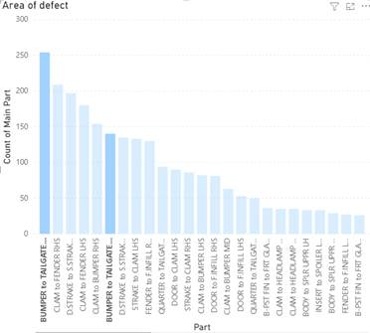
Fig.1, Graph Generated by highlighting the highest scoring defects of the end of line.

As displayed, the highest hitting defect within the trim 2 area is the rear bumper to tailgate gap. Once identified the root cause of the defect had to be found. Naturally, the point of fit was the first place to try and define the root cause.

When investigating the issue further it was apparent that a lot of labor was required to achieve the quality standard. Best case scenario was taking two men roughly 30 minutes labor to achieve a gap within specification (After Point of Fit). This is a process which should be completed during the current 27minute takt. However, the additional labor is required to achieve a good gap condition. Fitting and profiling the rear bumper combine with other process is impossible to achieve within takt.

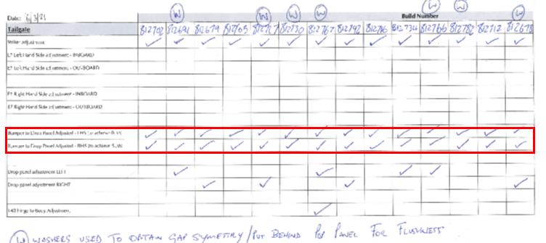
Fig.2, Image of rework sheet highlighting rear bumper rework required.

Fig.2, is an image of a rework sheet which indicates what vehicle were reworked and what rework was carried out. This rework sheet is an example of one day of production. Every vehicle which came off the line required rework on the 06/03/2021 in the form of adjustment to the tailgate and bumper gap. The red box highlights LHS and RHS gap rework.

Current Cost to Business

Based on the 2020 Cost per hour - £48.41

Best Case scenario take 2 techs 30 minutes per car to achieve quality standard. With 80% of cars being reworked.

If breaking down 75UPW(Units per Week) to an even number of vehicles – 15UPD (Units per day)

Technician cost (2 techs) per vehicle - £48.41
Units per Day reworked – 12
Cost per Day – £580.92
Cost per Week - £2,904.60
Yearly Cost (46 Working weeks) – £133,611.60

Once the rework cost was quantified, it highlighted the true cost to the business which this problem was causing.

- Manufacturing Process

The current fit process of the rear bumper requires two men. This is due to the large size of the bumper and the risk of damage when fitting. The two-man fit minimizes the possibility of damage during fitment.

Process Steps
- Fit 4 x adhesive washers on the outer face of the TLS bumper brackets. (These washers dictate the gap between the tailgate and rear bumper quarters)
- Two men obtain bumper from line side trolley.
- Transfer the bumper to the rear end of the vehicle.
- Locate the Centre bracket of the bumper onto the fixings loose fitted to the bumper armature
- Ensure the outer skin of the bumper is placed on inner surface of the TLS bumper bracket
- Locate the outer quarters of the bumper onto the loose fitted fixings on the rear quarter of the vehicle.
- Once locates onto the center and rear quarter fixings hand start 4 x M6 Pan head fixings into the rear Bumper TLS bracket.
- When all fixings have been loose fitted. Start securing the bumper in the correct sequence to the correct torque.

On CAD this design works well. However, due to the variation, capability and tolerance stack up the washer method was not ideal for the current manufacturing set up. Due to the length of time which it takes to fit the bumper it is not possible to add or remove washers to manipulate the gap within spec within the 27-minute takt. Therefore, the bumpers are leaving the point of fit out of spec.

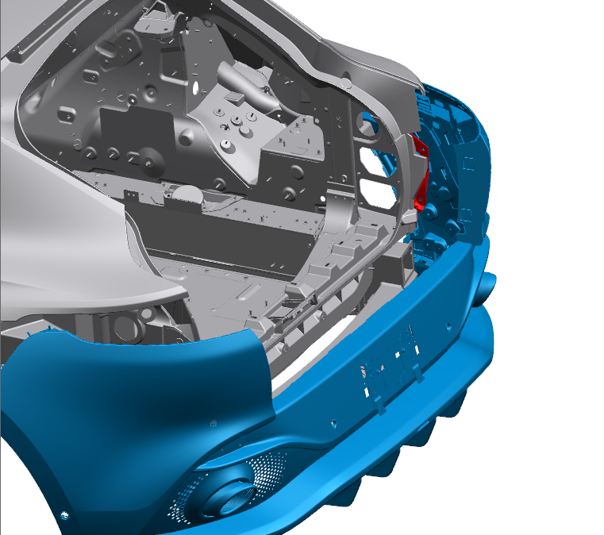
Fig3. Image of Bumper being loaded to Rear of Vehicle.

When looking at how the body is manufactured, large setting fixtures are used to set the body sides to the TUBS (Chassis). These large setting fixtures are very expensive and bespoke to products. Also, they have a capability of achieving high dimensional accuracy when set up correctly. Two out of the three interfaces of the rear bumper are set using the large automated fixtures. However, the bonding of the TLS bracket is a very manual process in comparison to the rest of the body setting methods. Due to the small size of the TLS bracket it was decided that the adhesive application of the TLS was going to be a manual processed unlike the large body sides. The position of the TLS bracket would be set using smaller fixtures which are clamped to the tub.

As you can imagine due to the number of components which build up the entire TUB and body there is potential for a high tolerance stack up and variability in the end product. Especially, the TLS bracket as it is set separately to the rest of the body and the adhesive application is a manual process rather than robotic.

- Problem Solving and Root Cause Analysis

To help identify the reason why the gap conditions were so poor. I used two well-known and proven problem-solving methods to help identify the possible problem causes. One being Ishakawa (Fishbone Diagram) The other being 5 WHYS. Using these methods allowed me to identify any possible factors which may be affecting the final set of the rear bumper.

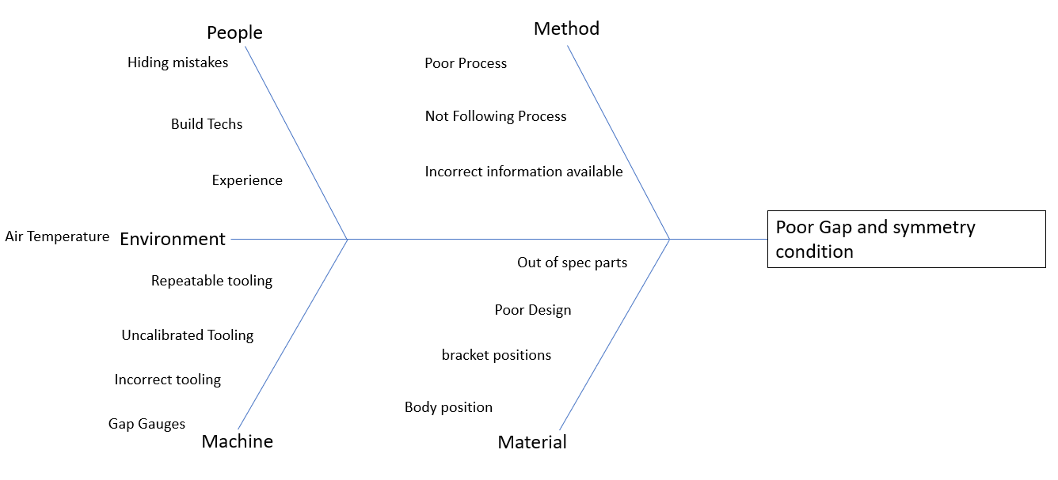
Fig.4. Ishakawa, Fishbone Diagram

Once all possible factors had been identified data could be collected from the metrology lab to help determine which factors truly impacted the poor gap conditions.

  - Ishakawa Analysis

Method

- Process documentation was checked and assessed for flaws. No obvious flaws were detected in process as there was limited adjustment capabilities OK
- Technicians were observed from a distance to ensure process was being followed as stated in process documents. It is best to observe technicians from a distance and
unknown to them to true identify what process they are building to. However, technicians were following correctly. OK
- All relevant process documents were available to technicians on stations. OK

People

- Skills matrix was checked to ensure competent technicians had been building the vehicles showing poor gap conditions. In which all technicians on station were fully trained and very capable of repeatably following the process correctly. OK
- Due to the number of cars showing poor gap condition it was unlikely mistakes were being hidden on every car. N/A

Environment

- The only environment factor which could affect gap condition would be air temperature. However, due to the stable and low temperatures in the assembly hall. The gap conditions of the vehicle would not be affected. N/A

Machine

- The defects related to tailgate to bumper gap are identified end of line and all vehicles defects are collated and documented. Ready for any rework required postproduction line. To ensure quality were calling actual defects out of spec. The gap gauges which were being used were checked by calibrated Vernier calipers to ensure they are accurate and false calls are being made. OK
- Technician tooling was checked to ensure correct tooling was available to complete process correctly. OK
- There is a total of 18 fixings holding the rear bumper to body. All fixings are torqued to 5Nm. Tooling was checked to ensure they were still within calibration dates. OK
- The quality of tooling used to complete the process was high. Tooling purchased for a manufacturing environment must be to a high standard to ensure durability and repeatability. OK

Material
- Bumpers were inspected to ensure they were within design spec. A sample of 30 bumpers were sent to our CMM room for inspection in which all came back within design spec. OK
- Current design is very restricted in terms of adjustment. The only adjustment which the rear bumper has is the method of applying different amounts of washers of 1.5mm thickness to the rear bumper bracket. The more washers added the larger the gap. Firstly, 1.5mm increments is too large to fine tune and compensate for slight errors in the body which have been built into the vehicle in the TUBS facility (Chassis). Also, the bumper must be fully fitted and secure before the results of the washer added can be seen and measured. It takes a total of 6 minutes to fit the rear bumper within a 27-minute TAKT. Therefore, combined with the additional processes which the technicians need to complete there is no time to have more than one attempt to achieve visual standards and correct gap condition. NOK
- Rear bumper bracket also known as TLS bracket was inspected. The TLS bracket which the rear bumper is fixed to is measured daily in the CMM room to ensure Bodyshop are sending good TUBS to final assembly. When the data was captured for TLS bracket it was apparent that there was large variation in TLS position in Y. This would have an immediate impact on Gap condition. NOK

Once the factors highlighted on the ishakawa were investigated it was apparent that two of the factors had a major impact on the gap condition when the rear bumper was fitted.

  - The 5 Why Method

The 5 WHY’s method was used to try and identify the root cause why poor gap condition was present in nearly all vehicles.

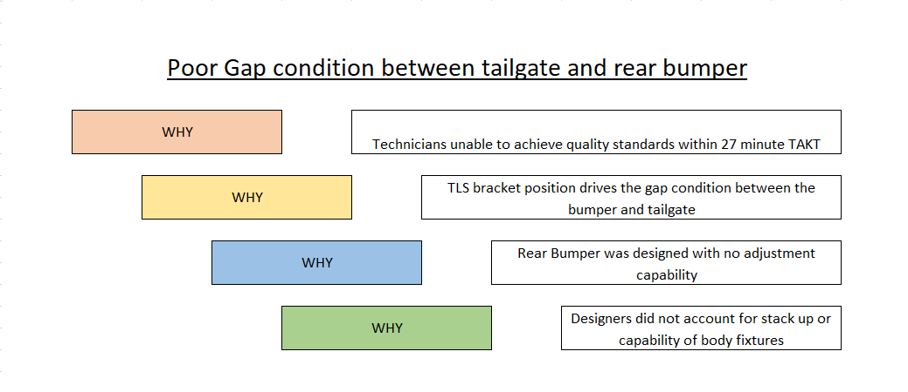
Fig.5, 5 Why Analysis

Although the root cause method is often referred to as the 5 why’s the root cause can be determined sooner than the fifth why. In this case it was determined by the fourth why. Highlighting that the designers did not account for the capability of body shop and potential tolerance stack up from all contributing components and therefore, did not implement any fine adjustment features.

- Data Analysis.

Now the potential root causes had been determined more relevant data could be captured. By identifying the potential factors to why the problem is occurring. It allows better data to be collected. Preventing the relevant date from being diluted by unrelated data.

When referring to the 5 why analysis, the root cause came out as design engineers did not account for manufacturing capabilities of the facility. Therefore, this information was fed back to the design engineers to ensure they account for the capabilities of the facility in which the vehicle will be built in. It is key that information like this is fed back to ensure that lessons are learnt to prevent mistake like this from happening in the future.
In the early stages of manufacturing, during the prototype build phases, this issue was raised to PD. An emergency adjustment method was implemented and is still used today. This is the 1.5mm washers added to the TLS bracket to manipulate the gap between bumper and tailgate. However, with a tolerance of 3mm +-1m and a symmetry of 1mm. The 1.5mm washer adjustment is too large of an adjustment. Also, the method in which of applying and removing washers to suit individual vehicles takes too long and the technicians only have one chance to get it right. If failed on first attempt the defect is passed forward.
Data was collected from the metrology lab to understand the position of all bumper interfaces.

1 – Rear Quarter to Rear Bumper (2 x Fixings LHS and 2 x Fixings RHS)
2- TLS bracket to Rear Bumper (2 x Fixings LHS and 2 x Fixings RHS)
3- Rear Bumper Armature (2 x Central Fixings)
4-Tailpipe Bracket to Body (2 x fixings LHS 2 x Fixings RHS)

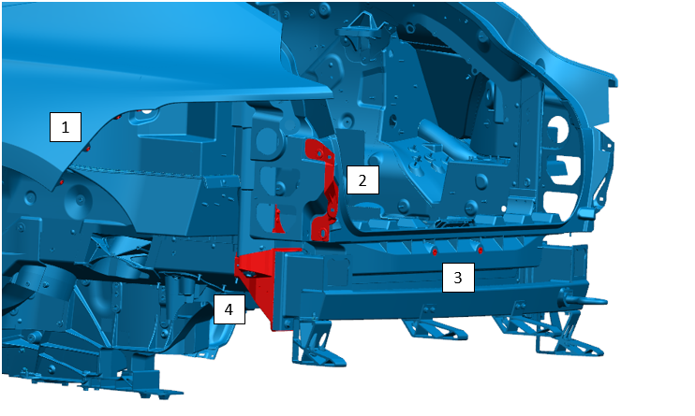
Fig.6, Image of all interfaces between bumper and body
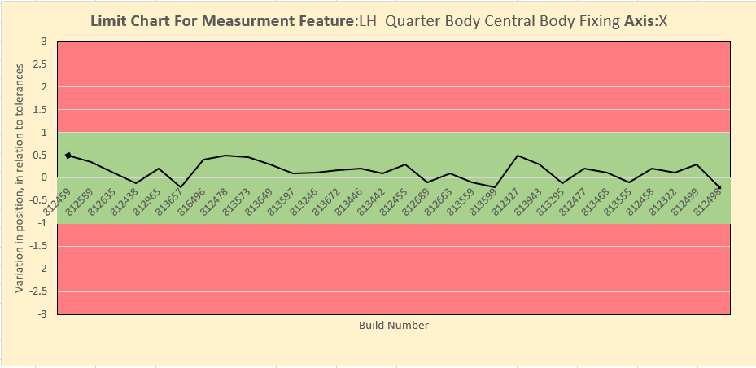

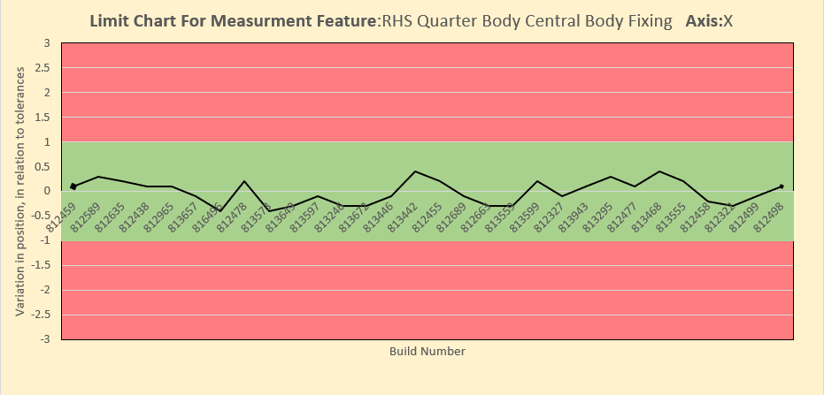
Fig.7, Images of LHS and RHS Body position in X

Position 1 -Fig.5, highlights the joint between bodyside and bumper. This interface has little effect on the gap between tailgate and rear bumper. If the body position was going to cause an effect on the gap it would be out in the Y axis. However, the data shows the body side is in a reasonably stable position. I believe this would be down to the large fixtures used to set the body side to the TUB.

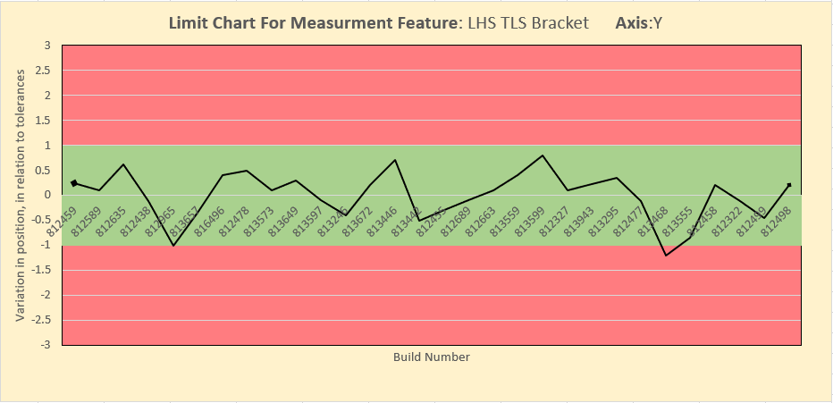

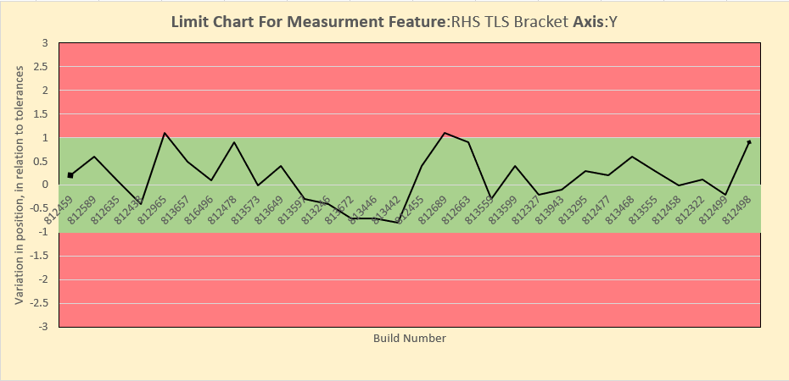
Fig.8, Images of LHS and RHS TLS Bracket positions in “Y”.

Position 2 - Fig.5, The area highlighted position 2 is the TLS bracket. To get the average position of the bracket in “Y” a center point is chosen. Above, are two scatter graphs showing the variation in position in relation to the allowed tolerances. As you can see across the 30 cars checked in the CMM room. The position of the TLS bracket is very unstable with little consistency. Even though 97% of results are within the given tolerance limits. The graphs still represent how unstable the bracket position is and how it could affect the process of setting the gap between rear bumper and tailgate.

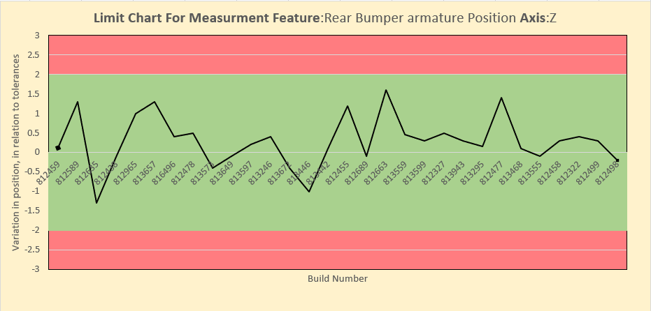

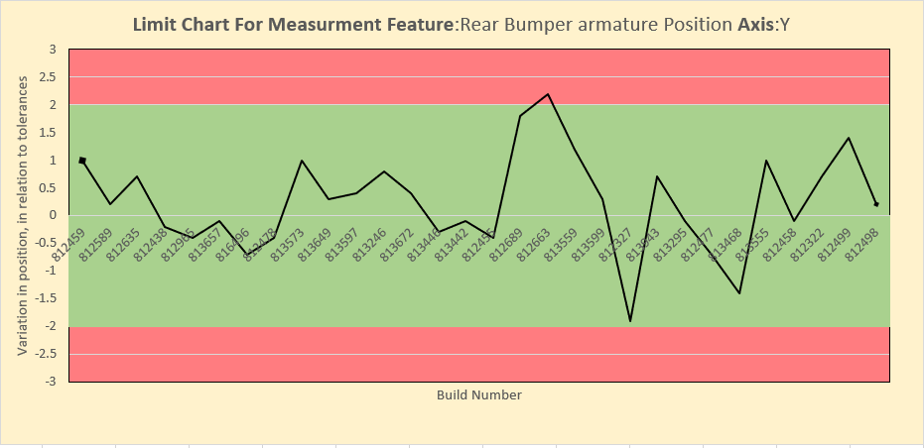
Fig9. Images of Rear Bumper Armature Position in “Y” and “Z”

Position 3 on Fig5. Are the 2 center fixings which secure the bumper to the body. The position of the two riv nuts could affect the gap between bumper and tailgate. However, designers took in account tolerance stack up and integrated oversized square holes which allow the bumper to float up to 4mm in “Y” and “Z”. Therefore, having the ability to compensate for large variations in the Y and Z Axis.

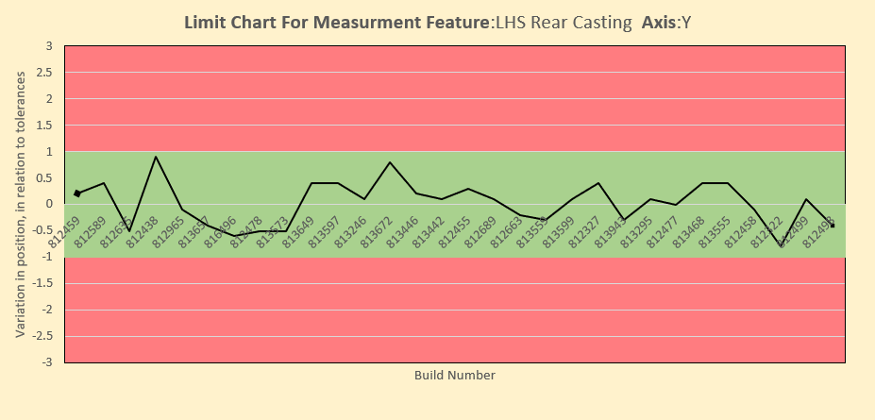

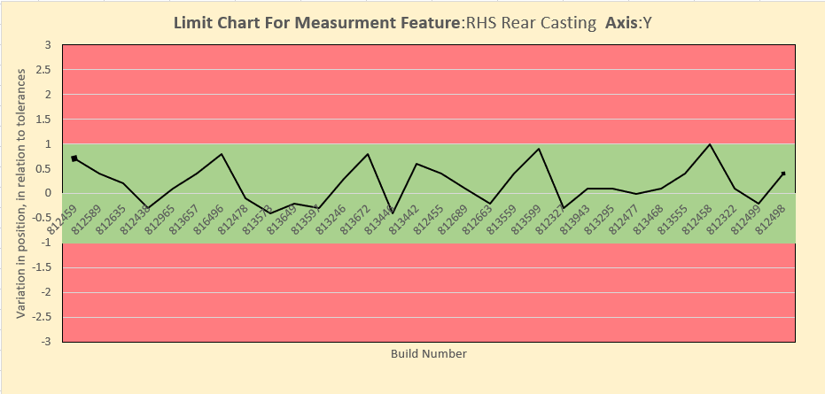
Fig10. Image of LHS and

Position 4 of Fig5. Known as the Rear Left Casting. This part of the vehicle joins the lower part of the bumper to the body, using a bracket attached to the casting and tailpipe finisher. The position of this bracket in “Y” could affect the gap between rear bumper and tailgate. However, due to where the bracket is fixed to the bumper it has little or no effect on the gapping between tailgate and rear bumper. Also, designer incorporated oversize holes to allow positional adjustment during fitment.

7.0. Problem Solutions

After conducting the problem-solving activities, analyzing data and fully understanding the manufacturing capabilities of the facility. It was apparent the only way to eliminate any issues causes by unstable component from the body manufacturing process was to change the design of how the rear bumper interfaced with the body.

The new design must incorporate a method in which the gap between tailgate and bumper can be manipulated easily within the 27 minute takt time. The data analysis pointed to the interface which had the most effect on the gap condition between tailgate and bumper, in this case it was the TLS Bracket and how it interfaced with the rear bumper.

After investigating current adjustment methods within Aston Martin. Flexitol fixings were the best option to allow for easy adjustment. However, the current rear bumper design did not allow flexitols to replace the current fixings on the TLS bracket. Therefore, a redesign of the bracket was required. The current torque applied to the TLS bracket is 5Nm with a M6 Pan head fixing. The M6 Panhead has a 27mm diameter head which allows for maximum surface coverage when secured. When choosing the new fixing strategy surface coverage was priority

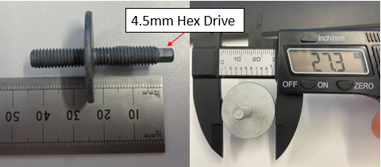

Fig.11, Image of Selected M6 to M6 Flexitol Fixing

The bumper did not have enough allowable flex to lift the outer skin of the bumper over the 22mm section of the flexitol. Therefore, another method had to be designed to allow the flexitol to be fitted without impacting the quality or potentially damaging the bumper.

The only way in which this could work is if a slot was cut into the TLS bracket allowing the pre-fitted flexitol to slot into the TLS bracket. However, this could jeopardize the strength and rigidity of the TLS bracket. To ensure the slot would not reduce these characteristics of the TLS bracket tests had to be carried out.

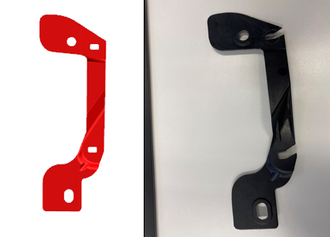

Fig.12, Current TLS bracket(Red) Design change proposal (Black).

I contacted the design engineering team to explain what I would like to do in terms of redesigns. As I did not own the parts from a design perspective, I had to consult them before any actions were carried out. The engineer which owned the TLS bracket was on board with the design as long as I tested the integrity of the part once the slot was cut. The engineer wanted me to ensure the new fixings had maximum surface coverage for best clamp load and re-introduce and rigidity which may have been lost through the removal of material. The Engineer also advised to apply more than 2.5 x the current torque to ensure the bracket was fully capable of taking 5Nm with the slot in the bracket.

However, although the flexitol was chosen as the fixing which was going to allow adjustment in the bumper. Additional Fixings still had to be selected to secure the bumper in place. Bearing in mind what the engineer said regarding the integrity of the TLS bracket. I looked at Fixings with a large surface area to compensate for the material which had been removed.

To identify suitable fixings, I used the catalogue which Aston Martins fixing supplier uses. Therefore, I knew the fixing available would be of high quality. An M6 nut was selected and a large washer suited to an M6 bolt. The washer and the nut were both coated to increase corrosion resistance, preventing the fixing from corroding and causing a failure in the future. The M6 nut was galvanized zinc plated and the washer was phosphate coated. The washer had a diameter of 30mm to ensure maximum clamp could be achieved while spreading the force. The 30mm diameter made up for most of the material removed from the bracket reintroducing the rigidity to the part.

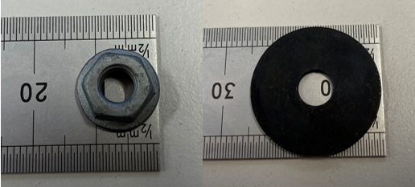

Fig.13, M6 Zinc Galvanized Nut and M6 Phosphate Coated Washer.

When suitable fixings were selected the integrity testing could be carried out to ensure the slotted TLS bracket would withstand at least 2.5 x the current torque applications. Therefore, 5Nm x 2.5 = 12.5Nm. Although, 12.5Nm was the suggested toque to apply. I took the clamp to 15Nm with no damage or cracking caused to the bracket. The fixing set up is shown below to show how the system would work once fitted to the TLS.

To allow the flexitols to adjust the Gap, the large fixed washer must rest against the outter edge of the TLS bracket. The large washer would then sit between washer and J clip which is fitted to the rear bumper. In theory, when the flexitol is turned anti-clockwise the J-nut would be pushed outboard opening the gap and when turned clockwise the J-nut would be drawn inboard closing the gap. The 4.5mm Hex drive allows for easy adjustment with ratchet or driver.

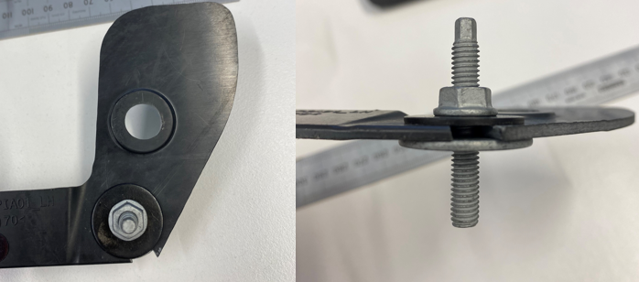

Fig.14, Fixing strategy used one the TLS bracket, including Flexitol, M6 Nut and M6 Washer.

After the strength/Intergrity test was complete. The bracket was visually inspected for any cracking or deformation. To ensure there were no micro fractures or deformation was caused during the torque application a microscope was used to inspect the bracket in higher detail.

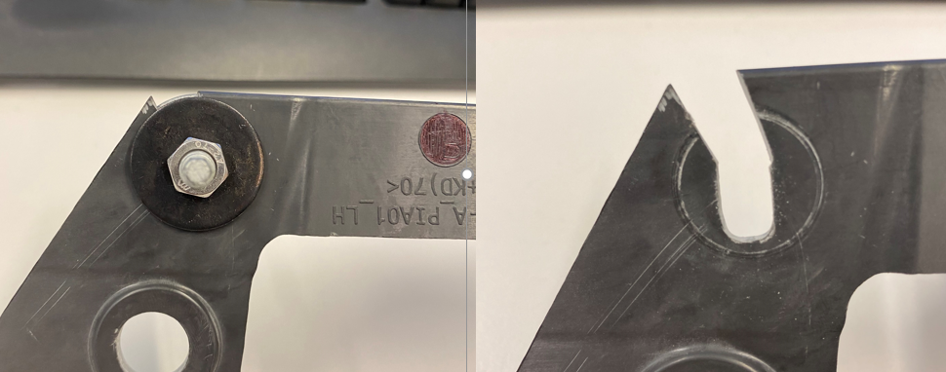

Fig.15, Image of TLS bracket under clamp load and after fixings are removed.

To ensure time was not wasted in pursuing the new design, the integrity of the part had to be tested from a process perspective. As the results from the test came back positive the next steps could be carried out on an actual body. Aston Martin quality department own a damaged body of a DBX with in which new designs can be proven on. Using the body allowed me to sure up the new design and prove out the theory.

A small portion of the bumper was obtained from production to test the theory before a complete bumper assembly was used. The part of the bumper which was used was fitted directly to the TLS bracket.
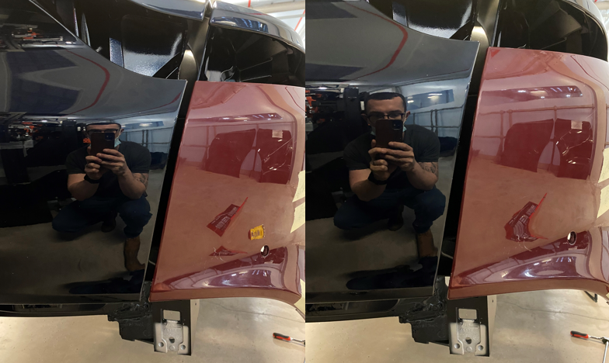

Fig.16, Gap manipulation using flexitols strategy.

The slots in the TLS bracket on the body were created by using a Dremel. Once the slots where cut, the bumper section was set up with the new fixing strategy and fitted to the body. The images above show the manipulation which is can be achieve without removing the bumper. You can compensate for any tapering, oversize or undersized gap.

A scrap bumper which only had aesthetic damage (Deep scratches) was obtain from the production team. A bumper with only aesthetic damage was used to ensure the dimensional accuracy was as close to current design phase as possible. However, the body which was used had an issue with the tailgate. The tailgate bracket was damaged during transfer and twisted the tailgate toward the left. Resulting in the large gaps on the right-hand side between bumper and tailgate, which can be seen in Fig.16.

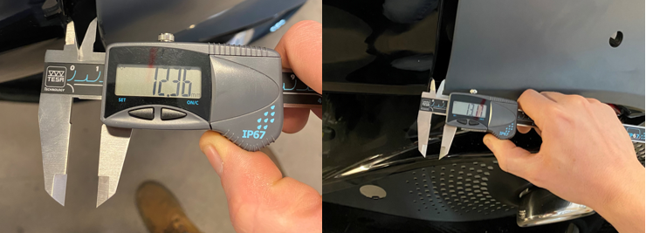

Fig.17, Image of maximum gap capability of flexitols.

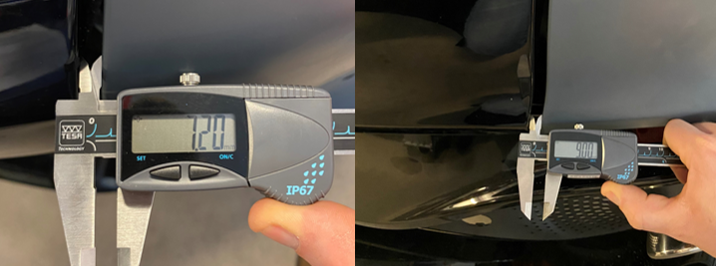

Fig.18, Image of Minimum gap capability of flexitols

Due to the tailgate being twisted toward the left side of the vehicle the gap sizes do not represent the current gaps on production bodies. However, this exercise was conducted to prove out the method and design. Before, trying the new design on a fully functioning vehicle.

Referring to Fig.17 and 18, the left hand images show the upper section of the gap and the right hand images show the lower section of the gap.

Upper Gap Max – 12.36mm
Lower Gap Max – 13.17mm

Upper Gap Min – 7.20mm
Lower Gap Min- 9.00mm

The upper section of the gap had a gap had an adjustment range of 5.16mm and the lower section of the gap had an adjustment capability of 4.17mm. Therefore, the average adjustment capability of the gap was 4.7mm.

8.0 Conclusion

The purpose of this report was the highlight how issues are identified and resolved within Aston Martin. Going into detail, describing how the manufacturing systems are used within Aston Martin to highlight a problem. Also, using proven problem-solving methods to identify the root cause. Followed by the steps taken to create a new design and implement it into manufacturing.

The task was set to improve quality and overall efficiency. Using Aston Martins manufacturing systems, I had the ability to quickly identify an issue with a current manufacturing process. Lots of data is captured daily on the FLAG system. However, using filters and current data I could pinpoint an area that I am responsible for and see the issues occurring there.

Once identified the first response was to go and look at the problem in the field. The problem was identified in a section of the production line where the rear bumper is fitted to the vehicle. Closely inspecting the fit process allowed me to see any obvious reason why the problem was occurring. Speaking to the technicians who fit the bumper gave a more in-depth understanding of the process and what they believe is causing the problem.

The technicians explained it was taking them too long to fit the rear bumper, resulting in them going over the productions lines current Takt. Therefore, to ensure they could hit takt the technicians would not adjust the bumper using the current adjustment method. Removing the bumper, to add or remove washers was too time consuming. Leaving it to the rework team to adjust the bumpers when the car is taken off the production line. When the rework was captured in FLAGS it started to show the severity of the issue.

When the issue was fully understood the root cause analysis could take place. Using proven methods such as 5 WHY’s and Ishakawa (Fishbone Diagram) to break down the issue. To help understand why it’s happening and the factors which may affect it. Breaking it down to manufacturing process and the design of parts. Using the metrology lab to help identify any other problem with incoming parts or even assemblies manufactured within Aston Martin. The Rear Bumper was a bought finished part and received by Aston Martin fully assembled. A batch was measured for dimensional accuracy using coordinate measurement machinery within the metrology lab. The measurement data confirmed the Bumper was within spec. therefore, illuminating the geometry of the bumper as the issue.

However, after analysis of process and design the TLS bracket plays a major factor in gap condition. The results from CMM shown that although the TLS bracket was bonded within tolerance it was still very stable within that tolerance. Showing lots of variation from build to build. Therefor, different amount of washers were required to achieve the correct gap from vehicle to vehicle.

Discussions were had with the body manufacturing team about including the set of the TLS bracket with the full body side. This was a suggestion due to the stable condition of the body side. However, the response from the body team was. Any modifications made to the current setting fixture would cost a lot of money and potentially interfere with the current stability of the body side. Therefore, a different avenue had to be explored due to the high risk of modifying the body setting fixture.

Inspecting the current design lead to the decision that increasing the adjustability of the bumper would be the greatest chance of bringing the gap condition into spec. Although, Aston Martins goal is to get parts to fit straight onto the vehicle without having to adjust them. In this case it was not possible this time.

Since investigating the problem, the TLS bracket was highlighted to have the largest effects on gap condition. Leading to the decision to change how the bumper interfaces with the TLS bracket. When the decision was made to modify the bracket, certain actions had to take place to ensure feasibility and potential affects to the product. As a manufacturing engineer I had to contact the design team to ensure the correct steps were taken before testing and implementing the new design. Good communication was made with the design team to ensure the correct steps were followed and everybody understood what we was trying to be achieved. They advised to conduct testing on the TLS bracket to ensure the integrity of the part when material was removed.

Although tests on the bracket were successful and it was capable of withstanding over 2.5 x the specified torque. The testing could have been improved by recreating this set up on multiple brackets to ensure there were no failures across a larger sample. Later, the test was recreated on an actual body with a fully assembled bumper. Again, this could have been improved by conducting multiple test sample when under load from the bumper. However, this was not possible due to lack of access to multiple cars.

The brackets which were on the test vehicle were also taken to over 2.5 x the specified torque. This was to ensure no cracking or damaged was caused then the bracket was under load from a fully assembled bumper. When the bumper was placed onto the body the theory was proven that the flexitol fixing gave the ability to compensate for more than 4mm of variation in TLS positioning in Y.

Once the theory was proven on the test body, It had to be proven on a working vehicle. Aston Martin own a pool of engineering vehicles which can be modified to test new designs, Providing the correct steps are taken before conducting the tests.

The implementation of the modifications to the TLS bracket are still in test phases. An engineering vehicle is currently being used to travel 6,000 miles with the new bumper design in place. This is to ensure the integrity of the part has not been compromised by removing material when stresses and strains are during the time the vehicle is being operated. The engineering vehicle is roughly half was through this the first test phase. The bumper and bracket was inspected at 2,000 miles and no damage or cracking was observed.

The suppliers of the bracket have been contacted by the design engineers which own the part. This was to ensure the feasibility of modifying the bracket. The supplier confirmed, the square hole in the TLS bracket can be changed to a slot with no additional cost. This can be achieved by slightly modifying the code in the current CNC machine which manufactures the bracket.

Overall, to get to this phase the project has taken almost 4 months. When referring to the Gantt chart it shows the amount of time which could be dedicated to drive this project. Mainly Fridays due to amount of current work load. I believe this project could currently be further into the test phase and closer to implementation if more time was dedicated to the project. Progress was slow due to limited time available to commit to gathering and analyzing data. Also, having to obtain and modify parts was very time consuming. More time would have also allowed for more detailed and strategic planning. Leading to potentially conducting more test before implementing the design. More access to parts would have also allowed for more testing to be conducted.

- References

American Society for Quality, 2021.
Available At: https://asq.org/quality-resources/six-sigma
[Accessed 14/04/2021]

Adam Henshall, 2018.
Available at: https://www.process.st/six-sigma-principles/
[Accessed 14/04/2021]

J, M Juran 1999.
Available at: Juran's Quality Handbook (5th Edition). Page, 2.
[Accessed 16/04/2021]

G, Watson, 2004.
Available At: The Legacy Of Ishikawa. Pages, 47-54.
[Accessed 16/04/2021]

Oliviera Serrat, 2014.
Available at: https://www.researchgate.net/publication/318013490_The_Five_Whys_Technique#pf2 [Accessed 27/04/2021]

Graham, T Smith ,2016.
Available at: Machine Tool Metrology: An industrial Handbook. Page, 443.
[Accessed 27/04/2021]

Benjamin Reese, 2017.
Available at: https://blog.3dcs.com/what-is-a-tolerance-stack-up
[Accessed 27/04/2021]

Gantt Chart



