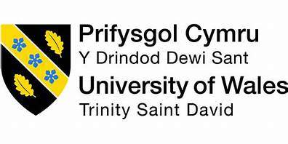

REPORT EFFECTIVE TEAM WORKING FOR TEAM SUCCESS
-Component 1-

Programme: Certificate for Higher Education Skills for the Workplace

Name: Claudia Madalina Mitu
Student ID: 2110988

Lecturer: Munodzinesa Zuqirai

Abstract
Effective teamwork has an efficient problem-solving skill that helps in taking necessary decisions for identifying skills of employees and based on it tasks can be assigned based on the abilities. Teamwork within the business helps in expanding new skillsets along with creating enthusiasm for enhancing learning approaches. It has been discussed about the barriers to effective teamworking identified in the scenario. Also, the team-effectiveness model has been discussed within the study. Different theories are discussed based on the issue that is there and the benefit of the integration of the theory in overcoming the situation.

Table of Contents
Introduction 3
Analyse how Abdul can develop an effective team by the use of a model 4
Discussion to the types of roles that are needed for creating an effective team 7
Analyse the impact that can be effective in teamworking for achieving success of the team 9
Barriers to effective teamworking identified in the scenario 13
Conclusion 14
Reference list 15

Introduction
In any project, integration between team members is needed for understanding the roles and responsibilities along with monitoring the progress of the project along measuring the achieved areas. In the current scenario, the Vodafone UK project was assigned to Abdul, who was the task manager and was assigned to handle 18 employees for delivering community events with commercial businesses, local stakeholders, and voluntary organisations. However, the Covid restrictions were there that made the working process slower and thus Abdul contacted each of the members for discussing the roles and responsibilities. Abdul found that team members failed to complete the project tasks because they seemed unconcerned about others of the team and there is no support provided to each of them as a team. Also, the staff from the sales team was found to fail to attend an important meeting. Thus, this study is going to be discussing what Abdul needs to do for holding the members of the organisation.

Analyse how Abdul can develop an effective team by the use of a model
Team building is not an easy exercise as it requires taking necessary actions that can bring a group together to work collaboratively. Abdul needs to motivate its group members so that they can give their best in understanding their roles and responsibilities to complete the project effectively on time. Abdul found that there is no integration within the team members, which is affecting project tasks. Thus, Abdul discussed few steps that Abdul can take to develop an effective team;
Goal setting: It is one of the important steps in building an effective team as it will help the individuals of the group to understand what is required for them to do, when to do and how much it requires their effort. Goals are also seen to provide clarity to teams on how to achieve them. Abdul can use the 'SMART' acronym for effective team building (Sivathanu and Pillai, 2018). It stands for specific, measurable, attainable, relevant, and time-bounded. Employees after knowing how to set goals and understanding the process will work toward the same objective.
Problem-solving: As the project will progress there will be chances for every member to encounter problems. Therefore, it is important for Abdul to provide its team members with a training program on problem-solving because this will help in developing critical thinking and useful strategies. Once the employees will know to tackle problems, they will work collaboratively and the productivity of the team will be high.
Project management: The success of any project depends upon the effectiveness of the teams working on the project. This is why it is important for every employee to have project management skills as it will help them in understanding the process (Meredith et al. 2017). Employees also need to have effective communication skills that will help them work well in a team.
Collaboration: Abdul will have to communicate the importance of collaboration to each member involved in the project. Strong collaboration skills are seen to be beneficial in raising the productivity of the team and opening channels for innovations in the process.
In this scenario, the T7 model of team effectiveness can be used. It was developed by Michael Lombardo and Robert Eichner in 1995. According to them, there are five internal factors and two external factors that can affect the effectiveness of a team. The internal factors are;
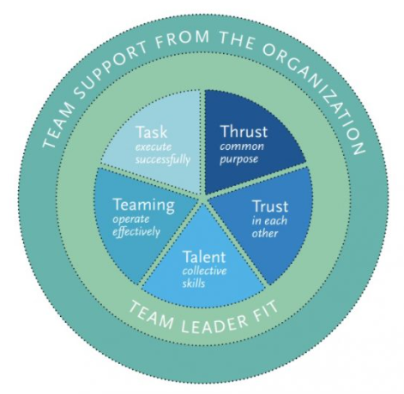
Figure 1: T7 Model of team effectiveness
(Source: Kobushko et al. 2020)
Thrust: It is the common goal or objective of the team that is need to be achieved in due time. It helps employees in understanding their roles and responsibilities.
Trust: It represents the knowledge of the team members that is important for the project (Kobushko et al. 2020). Having a knowledgeable person in the team is seen to benefit as they will help the team in a situation that requires their efforts.
Talent: It is the skill set that is required for the project. Having the right set of skilful people in the team is beneficial for the effectiveness of the team. Skilful people will do their part of the job with perfection in the team.
Teaming skills: It is also known as collaboration skills. Each member of the team needs to have this skill as the success of any project depends upon the effectiveness of the teams. An effective team can be made only when each member is comfortable enough to work with each other.
Task skills: The team members need to have the task skills as having knowledge and skill is not enough. The team members need to have the ability to execute tasks.
The External factors are;
Team leader fit: The effectiveness and efficiency of a team depending upon the role of the team leader (Kobushko et al. 2020). It is important to know the kind of team leader required for a specific project.
Team support from the organisation: The effectiveness of the team also depends upon the support of the organisation as it encourages and motivates the employees in working to achieve the objective.

Discussion to the types of roles that are needed for creating an effective team
The building of an effective team requires the contribution of the different people involved in the team. No team can thrive without the team members having roles and responsibilities that better suit them. Abdul is found that community group has objected about the poor level of communication. Thus, Abdul focused on discussing the five roles that are important for an effective team;
Leader: The role of a leader in a team is crucial as it is the leader who is responsible for providing direction, vision, and motivation to the team (Mintzberg, 2019). Leaders decide the mode of communication that is being followed and how things will be reported. They made the ground rules for others in the team on how the proceedings will take place.
Creative director: Creativity is seen to be an important element of an effective team. People working in a team need someone who can think out of the box and introduce new concepts. It helps in preventing the downfall of the performance of the team and constantly enhancing the working of the team. It is the duty of the creative director in the team to keep the morale of the team high.
Facilitator: The role of the facilitator in the team is to help the team in making decisions. They actively participate in the brainstorming process, discuss the plan, and ideas, and log every activity (Martin et al. 2019). It is also the role of the facilitator to help the team in understanding the objectives and helping in achieving goals. They also motivate, communicate and manage discipline activity in the team.
Coach: The role of a coach in the team is to help the team members in getting training. They also solve the problems of the team. In some cases, team leaders can play the role of the coach because of the expertise they carry with themselves. It is the role and responsibility of the coach to bring skilled professionals into the team.
Member: The last important role of an effective team is its team members. It is the duty of team members to participate in a team meeting and complete the tasks assigned to them. Members can also provide valuable input in team meetings, generate ideas, and support the team (Breevaart and Bakker, 2018). They also need to communicate with their team leaders regularly and understand what leaders want from them. They also need to communicate with other team members and support them too as it will increase the collective productivity of the team.

Analyse the impact that can be effective in teamworking for achieving success of the team
In the current scenario, the employees are found to be lacking integration, which has led them towards leaving the job. Also, issues were there which Abdul found were related to lack of management and integration between them lead to delay the timeline to get not met. Also. There was no coordination between the members. Abdul was found to have a need of enhancing Collaborative problem solving technique, which is necessary for supporting members of the team along with increasing job satisfaction to reduce stress (Rajamohan et al. 2019). Teamwork also generates a bigger pool of ideas for working together, which helps in creating an enthusiasm for generating ideas that people cannot experience alone. The impacts that effective team working have on enhancing the success of the team are;
Improving productivity for bringing better business results- Teamwork helps in inspiring people for working harder along with motivating people to be more productive. It is considered as a useful roadmap that helps in understanding members of the team for analysing the strengths and weaknesses.
Working in teams to boost employee motivation and morale- Teamwork helps in boosting overall satisfaction at work for working in a better way. Sharing success is also a part of the teamwork that motivates people within the business along with enhancing a greater feeling of ownership (De Vito et al. 2018). Working within a team helps in enhancing a feeling of belonging along with staying connected to the company to fulfill their work.
Teamwork relieves stress- Teamwork helps in reducing levels of stress as workload gets shared among people. Any employee tackling the workload by himself can become a workload instead of people helping each other through it. Besides working long hours, it can affect physiological factors, which also can be handled by the members. It is the support the team members can provide to each other.
Teamwork is found to be useful in improving service along with enhancing service quality. For enhancing collaboration, online collaboration tools can be used. From the research, it was found that online collaboration tool is found to scale up productivity by 30%. Also, effective communication helps in generating 4.5 higher talent retention. Also, the studies have shown that 99.1% of people want to be a part of an organisation that helps in nourishing communication.
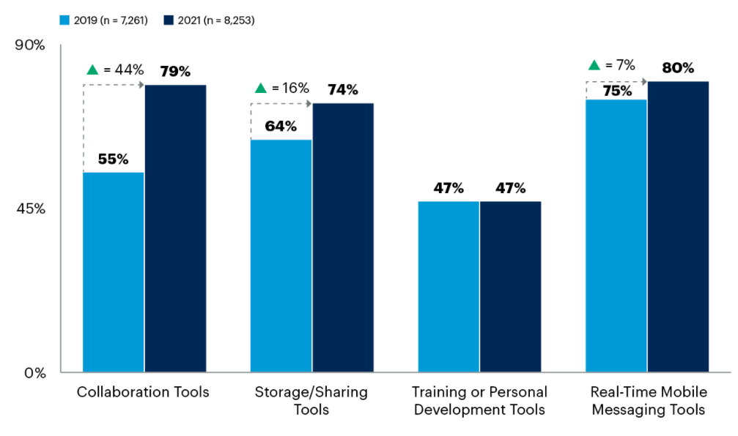
Figure 2: Changes in Digital workplace Technology
(Source: Conn, 2021)
In 2021, 80% of the workers are found to use collaboration tools in work. By 2024, the survey shows that the online collaboration industry needs to hit $48.1 billion. The adoption rate can increase the usage of mobile devices for enhancing collaboration.
In the chosen scenario, Katzenbach and Smith’s theory can be useful as it looks after achieving goal along with conducting personal growth and integration; which is lacking in Abdul’s case. Team basics of the team development theory are;
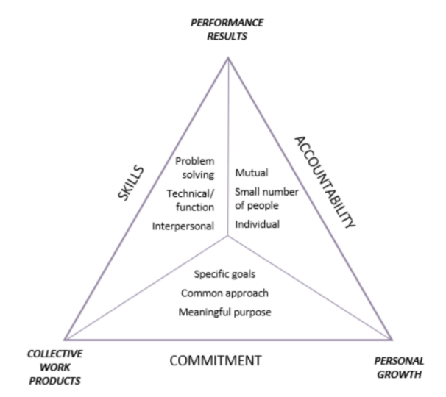
Figure 3: Katzenbach and Smith’s theory
(Source: Potter, 2021)
Accountability- It is mutual team basis for each individual for staying accountable within members of team.
Commitment- It is driven by meaningful and agreed purpose for the team that looks after meeting specific goal (Potter, 2021).
Skills- It is necessary for the team to cover technical and functional skills for developing problem-solving abilities.
This theory can be useful in managing members to work towards a common goal along with understanding the areas that needs improvement.

Barriers to effective teamworking identified in the scenario
Considering the current scenario, successful collaboration helps in producing innovative solutions for handling complex problems and working efficiently towards meeting shared goals. Understanding the roles of team members are needed for providing value along with establishing open and interpersonal communication that can lead to other functions. It is needed to establish open and interpersonal communication that can lead to other functions. Developing respectful and trusting relationships helps in developing common understanding (Ghazinejad et al. 2018). Barriers to teamwork are found to create an obstacle that makes it challenging for the group to work collaboratively along with achieving shared objectives. Considering the current scenario, the barriers within the workplace are;
- Goal confusion- Successful collaboration helps in establishing shared goals of the team members, which is lacking in the current scenario. Overcoming the goal confusion is needed for establishing a standard protocol for setting goals by analysing those along with outlining workflow to achieve those efficiently.
- Communication gaps- As there is no bond between members, it has developed a communication gap. Communication gaps can result in lacking clarity, which slows down the process. Teams need to work collaboratively for mitigating gaps and providing necessary support to each other.
- Unsatisfied employees- Lack of collaboration can lead to disrespectful relations getting developed, which has been experienced in the case where one member from the sales team was found to fail to attend along with not providing an apology to it.

Conclusion
From the study, it came to know about the issues that Abdul realised within the workplace and the ways that Abdul can integrate for developing an effective team. T7 Model has also been discussed for developing an effective teamwork process. Teamwork helps in benefiting the business along with boosting the morale along increasing job satisfaction for handling the abilities to raise the profit margin. It also helps in enhancing creative ideas along with an increasing sense of belonging. Different types of roles are been discussed for creating an effective team.

Reference list
Breevaart, K. and Bakker, A.B., (2018). Daily job demands and employee work engagement: The role of daily transformational leadership behavior. Journal of occupational health psychology, 23(3), p.338.
Conn, S., (2021). Gartner Survey Reveals a 44% Rise in Workers’ Use of Collaboration Tools Since 2019. https://www.gartner.com/en/newsroom/press-releases/2021-08-23-gartner-survey-reveals-44-percent-rise-in-workers-use-of-collaboration-tools-since-2019#:~:text=Nearly%2080%25%20of%20workers%20are,44%25%20since%20the%20pandemic%20began.
De Vito, L., Brown, A., Bannister, B., Cianci, M. and Mujtaba, B.G., (2018). Employee motivation based on the hierarchy of needs, expectancy and the two-factor theories applied with higher education employees. IJAMEE.
Ghazinejad, M., Hussein, B.A. and Zidane, Y.J.T., (2018). Impact of trust, commitment, and openness on research project performance: Case study in a research institute. Social Sciences, 7(2), p.22.
Kobushko, Y.V., Kobushko, I.M., Starynskyi, M.V. and Zavalna, Z., (2020). Managing team effectiveness based on key performance indicators of its members.
Martin, F., Budhrani, K., Kumar, S. and Ritzhaupt, A., (2019). Award-winning faculty online teaching practices: Roles and competencies. Online Learning, 23(1), pp.184-205.
Meredith, J.R., Shafer, S.M. and Mantel Jr, S.J., (2017). Project management: a strategic managerial approach. John Wiley & Sons.
Mintzberg, H., (2019). Managerial work: Analysis from observation. In Managerial Work (pp. 99-112). Routledge.
Potter, A., (2021). Putting theory into practice: Katzenbach & Smith's teams. https://www.wbs.ac.uk/news/putting-theory-into-practice-katzenbach-smiths-teams/
Rajamohan, S., Porock, D. and Chang, Y.P., (2019). Understanding the relationship between staff and job satisfaction, stress, turnover, and staff outcomes in the person‐centered care nursing home arena. Journal of Nursing Scholarship, 51(5), pp.560-568.
Sivathanu, B. and Pillai, R., (2018). Smart HR 4.0–how industry 4.0 is disrupting HR. Human Resource Management International Digest.

