EJAZ MALIK

ACADEMIC & EMPLOYABILITY SKILLS
BMSW4001
2028686

As our main module is an Academic and Employability skill so would like to begin my assignment with what these skills are and how they put impact in our practical life.

Academic and Employability Skills
Academic skills can be define as the basic skills which students learn in their schools, colleges and universities like written skills, how to do presentation, references etc. Once you have your academic skills next step comes up as employability skills. Employability Skills can be demonstrated as those skills which an individual can adopt to make them Employable. Alongside an individual must have technical understanding latest technology awareness and also particular subject knowledge which employers often ask from their worker.
In order to support my assignment have chosen four topics on which I will talk about and will try to elaborate each of them by best of my knowledge and with references.
The topics are

- Time management / Organising study
- CV writing
- Public Speaking And Giving Presentation
- Online Learning Experience

Time Management / Organising Study
Basically Time management can be defined as to organise your activities in a way that you can save your time or to complete your task in a specific time frame, if you are able to manage your time then you could be a smart worker who are loved by their employers. In difficult or high pressure times when work load is always stay above your head if you know how to manage your activities you can done more tasks in less time. According to Charles Richards ‘’ Don't be fooled by the calendar. There are only as many days in the year as you make use of. One man gets only a week's value out of a year while another man gets a full year's value out of a week.’’
There is also another very famous saying ‘’Time is not only the main thing, It is the only thing’’ by Miles Davis

I would like to explain this topic with one diagram
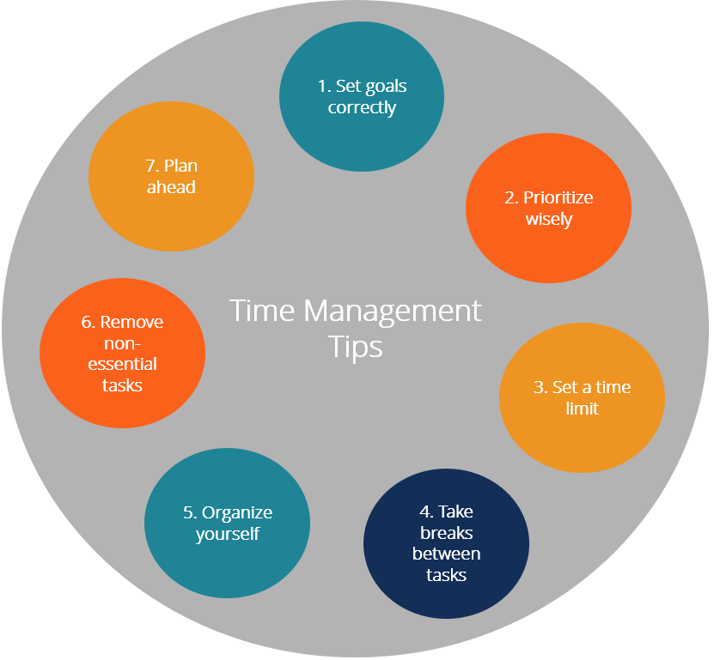
To be a smart worker or to have an expertise in time management one should follow and remember few things always set your goals and you have to be very clear in your mind that what you really want to achieve and accomplish with in your time frame. Second step is classifying your tasks in a way where you should understand what needs to be done first and what you can do afterwards. Then comes up the time frame the most import tool in managing your tasks. Take regular intervals while doing your tasks in order to keep your mind fresh and keep working on what you are doing. Organise yourself in a way where you could clearly see your goals. Another important tool while managing your task is to neglect the non-essential things, things which are not important means do not confuse yourself by thinking too much or add ideas. Once you done with these above steps plan for your final destination and just focus on your goals.

CV Writing
Another interesting and most important skill is to make your CV (Curriculum Vitae) correct, when writing you CV always remember to research the company and the job where you applying for, select a CV style which suits you in that situation or an employer in that particular type of job prefer. Always write the correct information in your CV which you can justify with the employer once you get the opportunity to get an interview. Your CV is like you are presentation yourself in a formal way to an employer where your presence physically is not there but imaginary he can assume your personality and cam make his mind that this person could fit in this job role.
There are few patterns and styles in CV like for beginners, students and for internship every field required different style in order to get attracted. As in profession no matter what profession you chose it has to be perfect and should be designed in such a way where an employer could make his mind straight away.
Basic components of CV
Letterhead (name, address, phone, email etc)
Objective
Skills
Work Experience
Education
Awards & Recognition
Hobbies & Interest
References
When you make CV always mention your full credentials like your full name which is mention on your Passport or Id your address and most importantly your contact details either your phone number or e-mail which an employer can use to contact you. Your main objective, your desire why you want to join that specific firm? what benefits can this employer can get from you? Why this employer should offer you this job? What difference you can make?
Do not forget to mention your specialities what you can offer to the employer. Any work experience related to the field or any experience you have in your practical life which can help your CV to look more professional. Your education plays an important role in your CV as that reflects the standard of growth, your personality and your interest. While writing down CV mentions your achievements and recognition that has been awarded to you by recognising your skills and worth. Your hobbies and interest indicates your personality that leaves an impact on an employer that what kind of mentality this candidate have and will these hobbies or his individual interest can help him to progress in their team or company.

Reference is something that gives an employer an extra satisfaction about the reliability of the candidate and you should mention specifically that an employer is more than welcome to inquire with this reference if it’s required.

Public Speaking & Giving Presentation
While working in any field no matter what job you are in or what role you are playing in your company it is very important that your speaking and communication skills must be very good and spot on so people can listen to you, your ideas your views. It’s not necessary that every time you will be right and every time your ideas will be appreciated but still you should have that courage to present yourself professionally. You should understand the environment in which you are working so it will help you put your point in front of them. A leader is someone who people look onto and a leader is someone when he speaks others listens.
“A wise man speaks because he has something to say, a fool speaks because he has to say something.” By Plato
According to Benjamin Franklin
“Remember not only to say the right thing in the right place, but far more difficult still, to leave unsaid the wrong thing at the tempting moment.”
On other occasion it’s been said that
“If you have an important point to make, don’t try to be subtle or clever. Use a pile driver. Hit the point once. Then come back and hit it again. Then hit it a third time – a tremendous whack.”
-Winston Churchill
Considering these above references it can be assumed that it’s not just speaking it’s about what you speaking and how it’s effecting to the audiences. You have to be prepared while you delivering your speech that anyone can question your opinion, you must not panic, your body language must be professional in order to convince your audience. You must not lose your rhythm when you are connected with the audience otherwise they will not listen to you or even they will not bother to even understand your point of view.

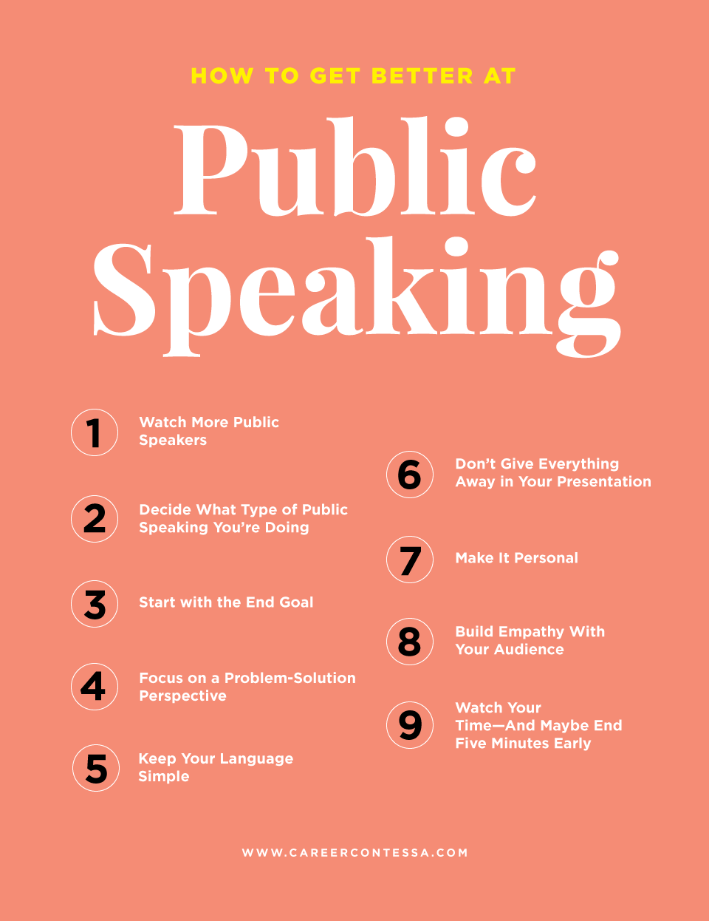
Few points can improve your speaking skills like to become a good speaker you should listen to other speakers and you should be able to differentiate what qualities can be adopted or what skills can make you better / different from other speakers. Before speaking in public you should research what audience you are speaking and get prepare your speech. While presenting yourself you should start your speech with your end goal so the audience know what your point is what is the main agenda of your speech / or conversation that will create an easy environment between speaker and the audiences. Do not just raise the point always try to come up with the solutions rather than just to pin point the negatives that will just leave negative impact to the audience. Stay focus, stay positive stick to your point and try to convince the audience with your ideas, solutions. When you are speaking in public always remember that there will be every type, every race and every community will be there so always use the simple language which can be understood by everyone.
Do not just throw away everything towards the audience just share your ideas with them but not the plans that how things will be done but how things can be done. Treat your audience like you are part of them, make them understand as if you were in there place. Always try to build up a relation with your audience that u understand their feelings. You should not just carry on with your speech or your conversation, if you are in public then try to finish your point after conveying your message. It has to be a professional meet and greet you should not be making any jokes or making fun of any one as that will not give your audience a positive impact.

Online Learning Experience
Online learning experience is always an excited experience as you learn things in a different way which you normally do not experience in your private life. This is a new experience for almost every one as we normally do not bother to learn in this way. Also you will have to learn that how to use technology as well, like if a person has to take online class from his school/college or university he will have to learn how to do it as we have a very clear example of Covid-19 situation. In this pandemic most of the students took their classes online and even for the office workers they had to use technology in order to continue their jobs. Different technologies have been used like Zoom classes for students and even zoom meetings with in the workers. Skype classes.
For some people online learning experience was not as excited as for others because few people do not have that much resources or maybe they had no one else to teach them how to use these technologies. Few people did not like it as some parents were not comfortable for their kids to take online classes.
Where there are few advantages of online learning there few disadvantages well like
Half of the tasks can be done independently
More tasks in less time
Chance of learning about new technologies
Time savings
Friendlier environment
Disadvantages like
For old / aged people technology is like headache as to go at work and do their work physically is easier than to sit at home and to use devices like computers or laptop which they normally not use to off. Not every parent has the excess for tablets/laptops from schools/colleges.

Over all if I had to comment on this I thoroughly enjoyed online learning as it was no hassles to wake up early get ready and stuff like that specially when you have kids to look after them it gives you such an ease, your classes are just a click away you click it and you are in your class room / work place or straight into a meeting.

Conclusion
It is proved from every angle and aspect that the importance of Academic and employability skills is infinite. You cannot progress in your life if you do not have these skills, as these skills make the difference. As food is important for living similarly these skills are very important for living healthy life, a secure life for you and for your family. If I had to say that a life without skills is useful I will not hesitate to say that. In your professional life only thing what matters is how skilful you are.

