Amina Meah 2237650
University of Wales Trinity Saint David [Company address]
Design and Implementation of a Centralized Relational Database System for MelodyHwb

Table of Contents
Database Performance Tuning 2
Slow Query Performance/Inefficient Indexing 2
Data Redundancy and Inconsistency 2
Insufficient Hardware Resources 3
Data Security and Access Control - Data Security Plan for MelodyHwb Database 4
Identify Potential Security Risks and Vulnerabilities 4
Unauthorized Access 4
Data Breach 4
Insider Threats 4
Measures to Protect Sensitive Customer Information and Ensure Data Integrity 4
Encryption 4
Regular Security Audits 4
Data Backup and Recovery 5
Access Control Policies and Authentication Mechanisms 5
Role-Based Access Control 5
Multi-Factor Authentication 5
Audit Trails 5
Regular Password Policies 5
Employee Training 5
Conclusion 5
MelodyHwb Music Store Application Documentation 6
Introduction: 6
Architecture 7
Presentation Tier 7
Application Tier 7
Data Tier 7
Functionality 7
Product Management 7
Order Management 7
Repair and Maintenance Services 7
Reporting and Analytics 7
Integration with E-commerce Platform 7
Deployment Instructions 8
Database Setup 8
Backend Server 8
Frontend (MelodyHwb Website) 8
Ensure Security Measures 8
Detailed Descriptions of Each Table in MelodyHwb Database 8
Entity-relationship diagram 12
Conclusion 12
Bibliography 13

Database Performance Tuning
Performance issues in a database can impact the efficiency and responsiveness of the MelodyHwb music store's operations. Database performance tuning is a set of activities carried out by Database Administrators to optimise and ensure the smooth operation of databases. It involves a comprehensive re-optimisation of the database system, from the software to the hardware, to enhance its overall performance [1]. Key tuning strategies include speeding up query responses, enhancing indexing, implementing clusters, and adjusting operating systems based on their optimal usage for supporting system functionality and user experience. This process aims to provide a seamless and efficient database system [1]. Here are some potential performance issues and corresponding solutions to optimise the database performance.

Slow Query Performance/Inefficient Indexing
Performance issues can arise when executing queries that retrieve or manipulate large volumes of data, leading to a decrease in system responsiveness. This is particularly prevalent in scenarios where indexes are poorly designed or absent, resulting in slower query performance [2]. To mitigate these issues, several strategies can be employed. The implementation of appropriate indexing on columns that are frequently queried can expedite data retrieval. Regular analysis and optimization of queries, facilitated by tools such as SQL Server Profiler and Database Engine Tuning Advisor, can enhance performance. Furthermore, the creation of indexes on columns used in WHERE clauses, JOIN conditions, and ORDER BY clauses can significantly improve query performance. It is also crucial to regularly review and update index statistics to ensure their effectiveness [2].

Data Redundancy and Inconsistency
redundant or inconsistent data can lead to increased storage requirements and negatively impact query performance [3]. To address these issues, several strategies can be employed.
Firstly, normalizing the database schema can help eliminate redundancy. Normalization is a systematic approach to decompose a larger table into smaller tables, which helps to get rid of data redundancy and other insert/update anomalies [4]. It involves applying rules to a set of data, transforming the data to a certain structure, called a normal form. There are several normal forms, but the first three (1NF, 2NF, 3NF) are the most common [4].
Secondly, enforcing data integrity constraints, such as foreign keys, can maintain consistency. Constraints are rules that the SQL Server Database Engine enforces for you [5]. For example, you can use UNIQUE constraints to make sure that no duplicate values are entered in specific columns that do not participate in a primary key [5].
In conclusion, the careful application of these strategies can significantly enhance the performance of Microsoft SQL Server, ensuring efficient data retrieval and manipulation.

Insufficient Hardware Resources
Insufficient hardware resources allocated to the database may lead to performance problems, causing slow operations and intermittent crashes due to resource shortages [6]. Load testing is essential to ensure optimal performance under anticipated loads. Solutions include increasing RAM, CPU, or disk space based on load testing results to address resource deficiencies and enhance the database's overall performance [6].
By addressing these performance issues, MelodyHwb can enhance the overall efficiency and responsiveness of its music store operations, ensuring a seamless experience for both customers and staff. Regular monitoring and proactive optimization efforts are crucial for maintaining optimal database performance over time.

Data Security and Access Control - Data Security Plan for MelodyHwb Database

Identify Potential Security Risks and Vulnerabilities

Unauthorized Access
Risk: Unauthorized individuals gaining access to sensitive customer information [9].
Vulnerabilities: Weak passwords, unsecured network connections, and inadequate access controls [9].
Mitigation: Implement strong password policies, encrypt network communications, and employ robust access control mechanisms [9].

Data Breach
Risk: Unauthorised disclosure of customer data can be caused by SQL injection [8].
Vulnerabilities: Weak encryption, insecure data storage, and inadequate intrusion detection [8].
Mitigation: Utilize encryption for data at rest and in transit, regularly update intrusion detection systems, and implement secure storage practices [8].

Insider Threats
Risk: Malicious or unintentional actions by employees [7].
Vulnerabilities: Insufficient user privileges, lack of monitoring, and inadequate training [7].
Mitigation: Implement the principle of least privilege, conduct regular employee training on security protocols, and monitor user activities [7].

Measures to Protect Sensitive Customer Information and Ensure Data Integrity

Encryption
Implementation: Employ end-to-end encryption for data in transit and encryption at rest for stored data [12].
Purpose: Protect sensitive customer information from unauthorized access during transmission and storage [12].

Regular Security Audits
Implementation: Conduct regular security audits and vulnerability assessments [8].
Purpose: Identify and rectify potential security weaknesses, ensuring continuous improvement and resilience against evolving threats [8].

Data Backup and Recovery
Implementation: Regularly back up customer data and establish a robust recovery plan [11].
Purpose: Ensure data integrity by having reliable backup mechanisms in place to recover from data loss incidents [11].

Access Control Policies and Authentication Mechanisms

Role-Based Access Control
Implementation: Adopt RBAC to assign specific roles and permissions to users [7].
Purpose: Restrict access based on job responsibilities, minimizing the risk of unauthorized data access [7].

Multi-Factor Authentication
Implementation: Enforce MFA for user authentication [8].
Purpose: Enhance authentication security by requiring multiple forms of verification [8].

Audit Trails
Implementation: Implement audit trails to track user activities [9].
Purpose: Monitor and review user actions for suspicious activities, aiding in the detection of potential security breaches [9].

Regular Password Policies
Implementation: Enforce strong password policies, including regular password updates [10].
Purpose: Mitigate the risk of unauthorized access through compromised passwords [10].

Employee Training
Implementation: Conduct regular security awareness training [7].
Purpose: Educate employees about security best practices, reducing the likelihood of inadvertent security breaches [7].

Conclusion
This comprehensive data security plan for the MelodyHwb database aims to address potential risks and vulnerabilities, safeguard sensitive customer information, ensure data integrity, and restrict unauthorized access through robust access control policies and authentication mechanisms. Regular evaluations and updates to the security plan will be crucial to adapt to emerging threats and maintain a secure database environment.

MelodyHwb Music Store Application Documentation

Introduction:
The MelodyHwb Music Store Application aims to streamline operations, enhance customer satisfaction, and establish MelodyHwb as a leading music store. This documentation outlines the application's architecture, functionality, and deployment instructions. The system utilizes a centralized relational database and associated IT systems to manage products, customers, orders, repairs, and more.

Architecture
The application follows a three-tier architecture:

Presentation Tier
Frontend: User interfaces, including the MelodyHwb website and any other customer-facing platforms.
User interactions are processed and relayed to the application layer.

Application Tier
Backend Server: Hosts the business logic, connecting the presentation tier to the data tier.
Application Server: Manages the interaction between the frontend and the database.

Data Tier
SQL Database: Stores data related to products, customers, orders, repairs, and payments.

Functionality

Product Management
Products are stored in the product_table, containing information such as name, description, price, and quantity in stock.
Customer Relationship Management (CRM)
customer_table: Customer details, including contact information, preferences, address information and marketing preferences.
service_table: Stores appointment information for services.
enquiry_table: Tracks customer inquiries.
returns_table and exchanges_table: Manage returns and exchanges.

Order Management
order_table: Tracks customer orders, including order details, quantities, and payment information.
order_payment_table: Records order payments.

Repair and Maintenance Services
repair_table: Stores repair requests, service notes, and statuses.
repair_payment_table: Records repair payments.

Reporting and Analytics
Reports on sales performance, popular products, customer demographics, and service efficiency are generated based on the application's data.

Integration with E-commerce Platform
The application integrates seamlessly with the MelodyHwb website's e-commerce platform, ensuring real-time updates on inventory, orders, and customer data.

Deployment Instructions

Database Setup
Create the database and then execute the SQL script provided to create the necessary tables (product_table, customer_table, etc.) in the SQL database. Then execute the SQL script provided to insert the data into the tables.

Backend Server
Deploy the backend server that hosts the business logic. Ensure it is configured to communicate with the SQL database.

Frontend (MelodyHwb Website)
Integrate the frontend with the backend server using appropriate APIs. Implement secure communication protocols to interact with the backend.

Ensure Security Measures
Implement encryption for data in transit and at rest.
Configure access controls, including role-based access and strong password policies.
Regularly update and patch software components.

Detailed Descriptions of Each Table in MelodyHwb Database
- Product Table:
  - product_id (INT, Primary Key): Unique identifier for products.
  - product_name (VARCHAR(50)): Name of the product.
  - description (VARCHAR(255)): Description of the product.
  - price (DECIMAL(12,2)): Price of the product.
  - quantity_in_stock (INT): Non-negative stock quantity (Check Constraint).
- Customer Table:
  - customer_id (INT, Primary Key): Unique identifier for customers.
  - first_name (VARCHAR(50)): First name of the customer.
  - last_name (VARCHAR(50)): Last name of the customer.
  - email (VARCHAR(50), UNIQUE): Unique email constraint for uniqueness.
  - mobile_number (VARCHAR(50), UNIQUE): Unique mobile number constraint for uniqueness.
  - street, city, postcode, country (VARCHAR(50)): Address details.
  - date_of_birth (DATE): Date of birth of the customer.
  - gender (VARCHAR(10), CHECK): Gender constraint ('Male', 'Female', 'Other').
  - preferred_contact_method (VARCHAR(20), CHECK): Contact method constraint ('email', 'sms', 'push notification').
  - marketing_opt_in (BIT, DEFAULT 0): Marketing opt-in defaulting to 0 (false).
- Repair Table:
  - repair_id (INT, Primary Key): Unique identifier for repairs.
  - product_id, customer_id (INT, Foreign Keys): References to product_table and customer_table.
  - notes (VARCHAR(255)): Additional notes for the repair.
  - request_date (DATE): Date when the repair was requested.
  - repair_status (VARCHAR(11), CHECK): Repair status constraint ('in progress', 'completed', 'pending', 'cancelled').
- Order Table:
  - order_id (INT, Primary Key): Unique identifier for orders.
  - customer_id, product_id (INT, Foreign Keys): References to customer_table and product_table.
  - order_date (DATE): Date when the order was placed.
  - quantity (INT): Quantity of products in the order.
  - total_amount (DECIMAL(12,2)): Total amount of the order.
  - status (VARCHAR(20), CHECK): Order status constraint ('confirmed', 'dispatched', 'delivered', 'cancelled').
  - shipping_address, billing_address (VARCHAR(255)): Shipping and billing addresses.
  - payment_method, shipping_method (VARCHAR(20)): Payment and shipping methods.
  - tracking_number (VARCHAR(50)): Tracking number for shipment.
- Repair Payment Table:
  - repair_payment_id (INT, Primary Key): Unique identifier for repair payments.
  - repair_id (INT, Foreign Key): Reference to repair_table.
  - payment_date (DATE): Date when the payment was made.
  - amount (DECIMAL(4,2), CHECK): Non-negative payment amount constraint.
  - payment_method (VARCHAR(12), CHECK): Payment method constraint ('Credit Card', 'Debit Card', 'Cash', 'Paypal').
- Order Payment Table:
  - order_payment_id (INT, Primary Key): Unique identifier for order payments.
  - order_id (INT, Foreign Key): Reference to order_table.
  - payment_date (DATE): Date when the payment was made.
  - amount (DECIMAL(7,2), CHECK): Non-negative payment amount constraint.
  - payment_method (VARCHAR(12), CHECK): Payment method constraint ('Credit Card', 'Debit Card', 'Cash', 'Paypal').
- Returns Table:
  - return_id (INT, Primary Key): Unique identifier for returns.
  - order_id, product_id, customer_id (INT, Foreign Keys): References to order_table, product_table, and customer_table.
  - return_date (DATE): Date when the return was requested.
  - reason (VARCHAR(255)): Reason for return.
  - status (VARCHAR(50), CHECK): Return status constraint ('requested', 'processing', 'completed', 'denied').
- Exchanges Table:
  - exchange_id (INT, Primary Key): Unique identifier for exchanges.
  - order_id, product_id, customer_id, exchanged_product_id (INT, Foreign Keys): References to order_table, product_table, customer_table, and exchanged product in product_table.
  - request_date (DATE): Date when the exchange was requested.
  - status (VARCHAR(50), CHECK): Exchange status constraint ('requested', 'processing', 'completed', 'denied').
- Enquiry Table:
  - enquiry_id (INT, Primary Key): Unique identifier for enquiries.
  - customer_id (INT, Foreign Key): Reference to customer_table.
  - enquiry_date (DATE): Date when the enquiry was submitted.
  - subject (VARCHAR(255)): Subject of the enquiry.
  - message (TEXT): Detailed message of the enquiry.
  - status (VARCHAR(20), CHECK): Enquiry status constraint ('open', 'closed', 'pending', 'resolved').
- Service Table:
  - appointment_id (INT, Primary Key): Unique identifier for service appointments.
  - customer_id (INT, Foreign Key): Reference to customer_table.
  - appointment_date (DATE): Date of the service appointment.
  - appointment_time (TIME): Time of the service appointment.
  - service_type (VARCHAR(50)): Type of service requested.
  - notes (TEXT): Additional notes for the service appointment.
  - appointment_status (VARCHAR(20), CHECK): Appointment status constraint ('scheduled', 'completed', 'cancelled').
  - next_service_date (DATE): Date for the next service appointment.

Entity-relationship diagram
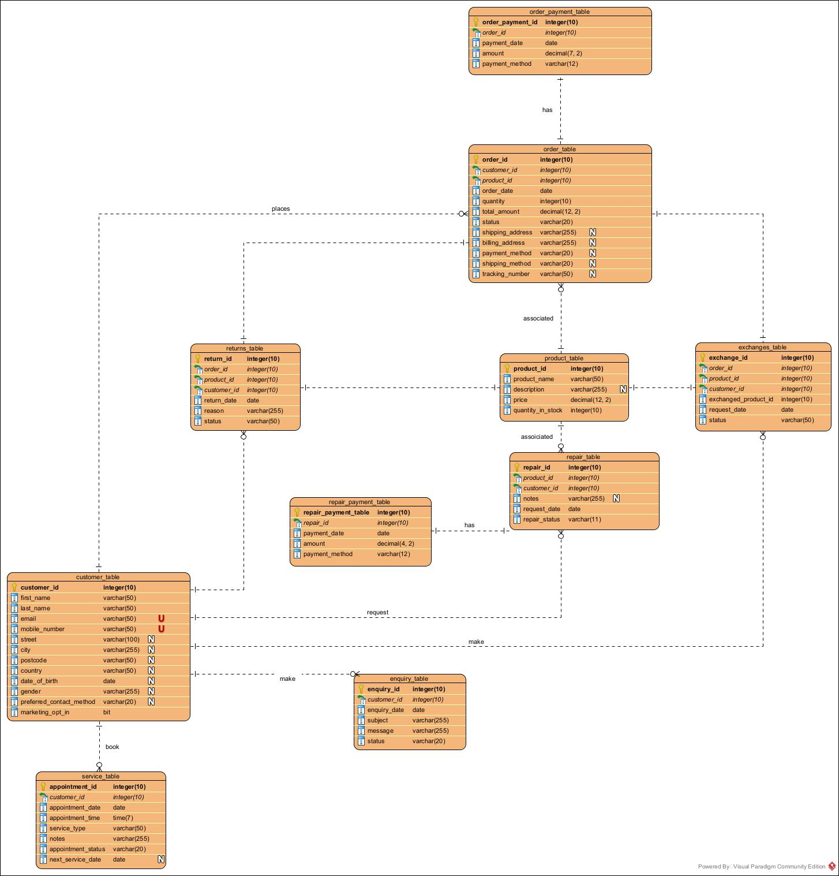

Conclusion
The MelodyHwb Music Store Application provides a solution for managing music store operations and customer interactions. Further enhancements could include implementing a distributed database to enhance scalability and fault tolerance and to consider data partitioning strategies for optimized performance. The MelodyHwb Music Store database can evolve by adopting advanced technologies and architectures, enhancing the user experience, and ensuring the scalability and availability of the system.

Bibliography
[1] “What is database performance tuning? - it glossary,” SolarWinds, https://www.solarwinds.com/resources/it-glossary/database-performance-tuning (accessed Jan. 1, 2024).
[2] dbForge Team, “SQL query optimization: 12 useful performance tuning tips and Techniques,” Devart Blog, https://blog.devart.com/how-to-optimize-sql-query.html (accessed Jan. 1, 2024).
[3] “Difference between data redundancy and data inconsistency,” GeeksforGeeks, https://www.geeksforgeeks.org/difference-between-data-redundancy-and-data-inconsistency/ (accessed Jan. 3, 2024).
[4] T. J. Teorey, “chapter 6,” in Database Modeling and Design Logical Design, Amsterdam: Morgan Kaufmann Publishers, 2011, pp. 109–112
[5] N. Parashar, “What is data consistency in RDBMS?,” Medium, https://medium.com/@niitwork0921/what-is-data-consistency-in-rdbms-e28559cc7da1 (accessed Jan. 1, 2024).
[6] J. Oksnevad, “How to uncover database performance issues with load testing,” LoadView, https://www.loadview-testing.com/blog/how-to-uncover-database-performance-issues-with-load-testing/#:~:text=Insufficient%20Hardware%20Resources,to%20a%20lack%20of%20resources. (accessed Jan. 1, 2024).
[7] A. Mousa, M. Karabatak, and T. Mustafa, "Database security threats and challenges," in 2020 8th International Symposium on Digital Forensics and Security (ISDFS), June 2020, pp. 1-5
[8] Teimoor, R.A., 2021. A review of database security concepts, risks, and problems. UHD Journal of Science and Technology, 5(2), pp.38-46.
[9] Murray, M.C., 2010. Database security: What students need to know. Journal of information technology education: Innovations in practice, 9, pp.IIP-61
[10] Shay, R., Komanduri, S., Durity, A.L., Huh, P., Mazurek, M.L., Segreti, S.M., Ur, B., Bauer, L., Christin, N. and Cranor, L.F., 2016. Designing password policies for strength and usability. ACM Transactions on Information and System Security (TISSEC), 18(4), pp.1-34.
[11] Gotseva, D., Gancheva, V. and Georgiev, I., 2011. Database backup strategies and recovery models. Challenges in higher education & research, pp.147-150.
[12] Mattsson, U.T., 2005. Database encryption-how to balance security with performance. (accessed jan.1,2024)

