School of Sport, Health & Outdoor Education

Assessment Feedback Sheet

Student No./Name: Joshua Charles
Module: Landscape and sustainable recreation
Module Code: SHSS6082

Personal Evaluation – to support your academic progress please complete the section below BEFORE submitting your work.
What do you consider to be the best aspects of this work? |  |  | Detailed reflection with links to relevant literature
Which aspects do you consider could have been improved in this piece of work? |  |  | Enhanced my appendices with sketches and further material to support my reflection
What have you found most satisfying whilst undertaking this submission? |  |  | Being able to visit interesting landscapes and furthering my knowledge and appreciation of these
ASSESSMENT CRITERIA | Learning  Outcomes |  | GRADE
ASSESSMENT CRITERIA |  |  | Poor  < 20% | Weak  20-29% | Unsatisfactory  30-39% |  | Satisfactory  40 – 49% | Good  50 – 59% | Very Good  60 – 69% | Excellent  70 – 84% |  | Exceptional  85– 100% | %
Your discussion of the nature of landscape within the context of the fieldwork locations | 1 |  |  |  |  |  |  |  |  |  |  |  | 20%
Your critical evaluation of external and internal influences that affect the perception, interpretation and use of landscape at the fieldwork sites. | 2 |  |  |  |  |  |  |  |  |  |  |  | 20%
Your critical discussion of the relationship between landscape and recreation and your suggestion of sustainable approaches to the interpretation and use of landscape for recreation. | 3 |  |  |  |  |  |  |  |  |  |  |  | 40%
Your identification and use of relevant academic and other material to help inform and develop your argument | 1,2,3 |  |  |  |  |  |  |  |  |  |  |  | 20%
It is expected that students will present work that is proof read, correctly referenced and adheres to the Assessment Checklist. Therefore a range of 0 – 10 marks will be deducted for non-completion of any of the points on the checklist below.
TUTOR COMMENTS:

Submission date:  via Turnitin |  | Return date:  (at least within 4 weeks) |  |  |  | Tutor: |  |  |  |  | Mark:

Assignment Checklist

- Please complete the Personal Evaluation section of the Assessment Feedback sheet, add your name and details, and paste the whole of this assignment document into the front of your assignment

- Submission is a single word file, clearly labelled with your name and module code
- Font style - Times New Roman, size -12 for text and 14 for headings
- Ink colour – black only
- Line spacing – 1.5 line spacing and 2cm- 2.5cm page margins
- Quotations more than three lines to be indented 1 line spacing
- One line space between paragraphs, paragraphs must be left aligned
- Pagination (your assignment should have page numbers)
- All tables and figures are internally referenced and have a title
- Word count checked and written at end of text (before references and any appendix)
- Assignment is within 10% of the word limit (excluding references and any appendices)
- All references in the text are included in the reference list
- Correct referencing following the Harvard style, as described in the Palgrave study skills book ‘Cite them Right’.
- Correct spelling using UK English
- Correct use of punctuation
- Grammar and syntax correct- double check anything that has a green line under it
- I have read my assignment out loud to myself and it makes sense and is easy to read
- Somebody else has read my work and it makes sense to him or her!
- I have checked and I have not plagiarised

SHSS6082: Landscape and Sustainable Recreation
Assignment 2
Reflective field work journal
In this essay I will critically reflect upon visits to three different sites throughout the module, with prime focus on 2 of these sites; Dinefwr park and Flat Holm. Reflections of each site will relate to issues surrounding the site including landscape character, landscape design, designations within the site, site usage, access and future potential of the site, to support this relevant literature will be referenced throughout with suggestions towards sustainable development of each site proposed. Internal and external influences of landscape perception, interpretation and the use of landscape will be evaluated within, with links being made to the relationship between landscape and recreation.

Flat Holm
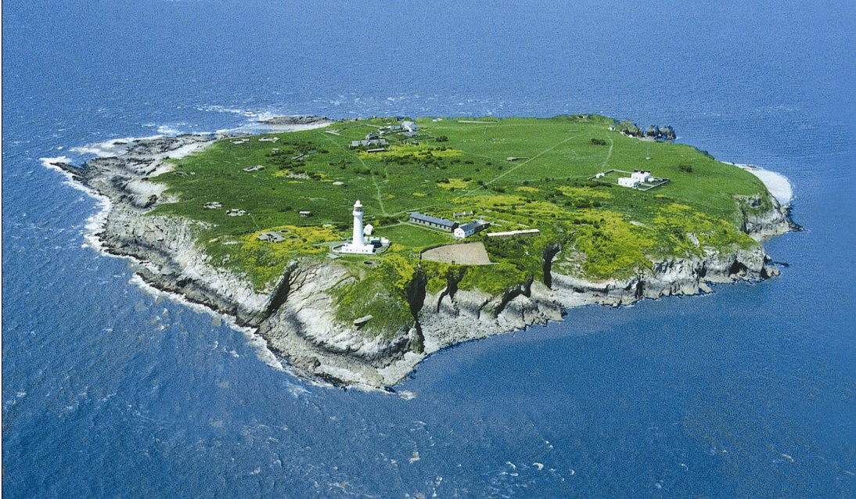
Situated in the middle of the Bristol channel 6km from the mainland, Flat Holm, an island with rich history and a name originating from Old Norse meaning ‘Island in an estuary’ (Ellis, 2018). Due to Flat Holm being an island the only method of access is via boat, I therefore kayaked across, minimising my impact upon the environment and coinciding with what The International Ecotourism Society (TIES) define the term Ecotourism as;
‘responsible travel to natural areas that conserves the environment, sustains the well-being of the local people, and involves interpretation and education’ (TIES, 2015). I believe that the experience of crossing to Flat Holm via kayak significantly contributed to the experience and had I chosen to cross on the ferry service that is provided the experience as a whole would have differed drastically; this very notion is influenced via my passion for kayaking, in this context an intrinsic influence on the experience and a contributor to why I chose Flat Holm, linking with Atkins et al (2014) and the notion of landscape as object that can be engaged with physically and how my interest has dictated my perception of this landscape (Lewis, 2010).
Furthering on from this I was lucky to have had a very favourable weather window for the crossing to Flat Holm, had the conditions differed to what was presented on the day the overall experience may have been affected by this factor. Not only would it have made the crossing over a greater risk but due to the isolated nature of the island the conditions there would be worse and more dangerous than on the mainland, with the sun out and wind low the panoramic views of the south wales and north Devonshire coastlines were in full view; this can be seen in the picture below. The 360 views available on the island coincide with one of Atkins et al (2014) concepts of landscape, as landscape as scenery.
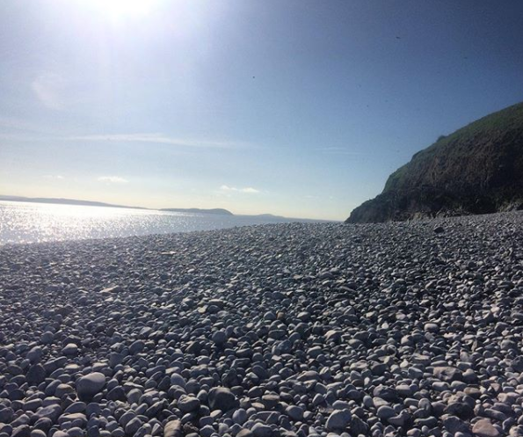

The site of Flat Holm is a Local Nature Reserve (LNR), Site of Special Scientific Interest (SSSI) and a Special Protection Area due to rare plants, breeding colony of Gulls and rare slowworms that reside on the island; it is therefore imperative that this delicate environment is preserved, and the species of flora and fauna protected. During the visit the warden explained the constant effort towards preservation, conservation and protection of the island’s unique natural and cultural features that the Flat Holm Project are responsible for the longevity of the site. In order for the Flat Holm Project to continue their vital work the warden enforces a landing fee, this contributes towards the funds provided by Cardiff Council towards the effort by the project and allows for developments such as the mini-grid installed in the previous decade that provide power to the buildings on the island, emphasising how the island is a showcase of sustainable technology in the modern day.
At several sites around the island there are interpretation boards with relevant information regarding different buildings, specific views and historical events that occurred on the island. These interpretation boards provided historical insights and enhanced my pre-existing knowledge. Overall this has influenced my perception of Flat Holm from being a site that I associate with personal recreation to one that I now can associate with more historical and culturally significant events; this has influenced wider aspects of my interest in sea kayaking towards taking greater interest in the marine history of different areas of coastline that I visit. The experience I therefore deem to have influenced my sense of place and furthering my understanding of the notion of nature as friend, connecting me with the landscape through my newly developed knowledge, understanding and appreciation of the landscape (Nettleton, 1993) Another factor that may have influenced my perception and the experience is that I was not part of a guided tour, only speaking to the warden about certain topics but mainly focussing on the future development of the site and the Flat Holm Project. It may be argued that being part of a guided tour would have broadened the experience and the knowledge gained may have been greater, however, being part of a guided tour would have likely prevented the one-to-one time and the quality of the knowledge that the warden was able to elaborate on, as well as this the guided tour is time restricted and only available on specific days.
With regards to future sustainable development of Flat Holm I truly believe that to maintain the unique beauty of this isolated landscape and allow for the Flat Holm project to continue their work that publicity surrounding the number of visitors are put in place to protect the assets of island. The Cardiff County Council’s report have highlighted that there is currently a delicate balance of protecting the island whilst generating tourist related income during restrictions to funding, it is estimated that around 2000 visitors visit the island on guided tours, ferried over on a boat specifically designed for the crossing. However, the toll of the journey has led to the boat requiring ‘significant maintenance’ (Cardiff County Council, 2012). Increasing the popularity and public interest would subsequently lead to an increase in the tourist related income, some of the methods for increasing popularity of the island put forward within the report was to provide overnight stays in pre-existing buildings modified into basic accommodation. Increased income would allow for essential maintenance work to be carried out on the boat, increasing the efficiency and overall experience of Flat Holm that visitors experience. This suggestion for development does however raise a separate issue, increased erosion from visitors having to use an alternative landing and access path to the designated landing. The new pathway has the potential to cause long-term damage and leave a permanent ‘scar in the landscape’, this permanent alteration may then prove to be a significant hinderance to a visitor’s perception of the largely unspoiled landscape. Currently the maritime grassland is kept by a small flock of sheep, a significant attribute in supporting why Flat Holm is a showcase for sustainable technology, the new access path is likely to herd the flock away from specific areas of the island, encouraging overgrowth of maritime grass and similar flora. This may then lead to overgrazing on the confined area of turf, leading to drastic land management being required in the interest of the longevity of the island.
Linking further with the sustainable future deployment on Flatholm, a key step in furthering the awareness of the issues surrounding this is to incorporate education. Within the report from Cardiff County council proposals from the public for a centre of alternative technology or recognised field study centre for young learners to visit and further their understanding of sustainability and environmental awareness. Incorporating this within what is already offered on the island would coincide with the curriculum from early years education through to GCSE’s and A levels. Therefore, fulfilling an essential area of learning that will provide lifelong benefit to each student and increasing the likelihood of learners re-visiting the island at a later date, thus linking back to the increase in tourist related income (Cardiff County Council, 2012; Cardiff Harbour Authority, 2018).

Dinefwr park
Situated in Llandeilo is the National Nature reserve of Dinefwr park, a National Trust estate spanning 800 acres surrounding a country estate. Contained within the site lay an enclosed deer park, ancient woodland home to trees over three centuries old and the ruins of Dinefwr castle (National Trust, 2018). The visit comprised meeting with head ranger Sarah, who would show us around some of the 800-acre site highlighting key design features of the landscape that she along with her team have applied, key issues that they face with the landscape and future development and management of the site. Dinefwr park is a SSSI due to the numbers of deer and expansive species of flora present. My perception of the landscape coincided with the landscape as being a physical object, a habitat for the wildlife within the park and an artefact due to the expansive history of the site and numerous historically significant buildings and areas that make Dinefwr what it is. Linking in with my own definition of the term landscape, as I deem a landscape to be subjective to the history and geography and flora and fauna of the land, thus linking with what Mitchell (1994) describes as a metaphorical communication between man and land due to your understanding and interest within its content. It is apparent that Dinefwr is a popular favourite for dog walkers and attracts high levels from the surrounding areas of Llandeilo and Carmarthen (National Trust, 2018), the link between landscape and recreation in this site is therefore tailored more towards dog walkers and those interested in the history and wildlife engagement, the underpinning reasoning behind this is more likely linked to the place dependence as this provides satisfactions of the persons needs and desired activity; thus a major intrinsic factors contributing to the decision on visiting. The landscape contained within this country estate has historic values that shaped the surrounding landscape as opposed to a site such as three cliffs bay where the design of the landscape dictates the versatility of recreational activities that take place there.
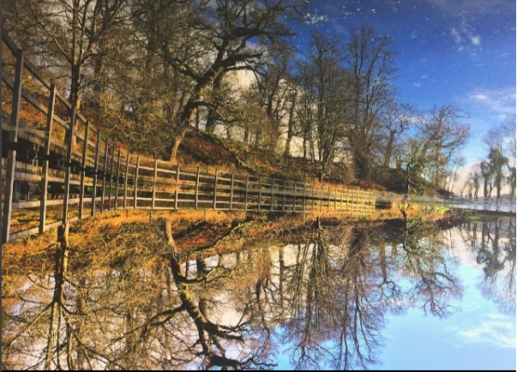
During the course of the visit the weather was largely dry with sunny spells (as can be seen in the picture below), making for a pleasant experience when walking in an exposed environment. The warden was keen to allow for engagement as much as possible with the surroundings and provided opportunity to explore the inside of a 900 year old hollow oak tree, providing a rich experience and incorporating the notion of embodiment as I was able to directly interact with the landscape I was immersed in, thus on reflection the knowledge from the day has remained with me longer than that of other visits to similar sites due to the quality of the experience, enhancing my sense of place and perception of the landscape within Dinefwr (Kudryavstev et al., 2010; Nast and Pile, 1998). The quality of the guidance we were given by the head warden was a key contributor and influence on my perception of the landscape, had the visit been more of a free-roam with no in-depth insight into the different issues and historical significance of the site I believe the experience would have been less fulfilling and consequently my perception and interpretation of this landscape would have been hindered significantly. Furthermore, I believe that the impact of the low volume of visitors to the park on this day was another significant influence upon my perception of the landscape; thus, the memories and sense of place associated with Dinefwr is one of peace and tranquillity. This very notion I put forward of it being a peaceful and tranquil landscape is further supported by the photo above, coinciding with landscape as scenery as put for forward by Atkins et al. (2014), the photo that connotes the character of the landscape and for me personally implies the metaphoric connection between humans and landscape, summarised adequately by Goldsworthy (1956) who suggests that we forget that we are not a sperate entity from nature, yet as a society we have lost our connection with nature, a metaphorical demise of friendship that reflects the loss of connection to ourselves.
From the outset we were informed about the events that the estate hosts throughout the year and how during the festive period the strain of hosting a widely renowned Christmas stall event has taken on the landscape surrounding the estate, one key issue raised was the facilitation of parking during such events. Due to the drastic surge in visitor numbers during the two day event the current designated parking area nearer to the estate were limited to disabled badge holders and coach pickup area for the shuttle organised for the day, the issue that was clear to see on our visit was the impact that the frequent coach shuttle had on the drive towards surrounding the disabled parking area, increased erosion on the perimeter of the tarmac had caused substantial build-up of water and cracking of the existing tarmac and drainage system. Because of this, a new drainage system for the lower end of the existing carpark would need to be installed to accommodate the liability of flooding due to it being situated on a flood plain. As a consequence of the main carpark being used for coach shuttling a field was used to accommodate the near 3000 visitors over the weekend, the substantial long-term damage that this caused was evident with the field suffering from excessive saturation. To counter this straw was used to act add traction, however this raises concerns regarding introducing foreign floral species; a long term and more sustainable land management solution as suggested by the National Trust (2016) is to now target the damaged field and install a honeycomb and gravel membrane under the existing turf in order to prevent future irreparable damage, according to the warden this would be a more appropriate solution and withstand the strain of such events. However, it is important to note that this may be a area of conflict between the multi-agencies who manage the landscape (Natural Resource Wales, Countryside Council for Wales, National Trust, etc.) as each agency has differing views upon the best method of sustainable development for sites such as Dinefwr, this links into what Butler (1999) believes the term ecotourism has been adopted for 3 main reasons, these being economics, public relations and marketing, understandably this is a concept that can be disputed but the overall aim of the ecotourism and the importance in this specific situation at Dinefwr is to reconcile the different values of each agencies perception of the environmental crisis surroundings the solution to provide a sustainable development action plan that fulfils the needs and values of all involved. Butler (1999) further argues that the concept of ecotourism ‘does not necessarily translate into acceptance of costs sacrifices that actual application may entail’, thus the work that is required within the damaged area will depend highly on the volunteers and limited National Trust members working within the area, thus the need to collaborate with partner organisations and agencies is ever more imperative (National Trust, 2016). As a whole the plans for future sustainable development to the landscape within Dinefwr park coincides with the current mission statement put forward by the National Trust regarding conservation ‘to nurse the natural environment back to health and reverse the alarming decline in wildlife’ the developments highlighted above, with innovative notions for managing tourist numbers and intermittent surges in visitor numbers during key events, these developments will be beneficial to the immediate landscape in the site, local economy due to the increase of public appeal and the benefit of those who manage the land in the surroundings areas.

WORD COUNT- 2590

Reference list
Butler, R.W., 1999. Sustainable tourism: A state‐of‐the‐art review. Tourism geographies, 1(1), pp.7-25.
Cardiff County Council (2012). Cardiff.gov.uk. Available at: https://www.cardiff.gov.uk/ENG/Your-Council/Councillors-and-meetings/Scrutiny/Scrutiny-reports/Documents/EC-%20Flat%20Holm%20operations.pdf [Accessed 23 Jan. 2018].
Cardiff Harbour Authority (2018). Flat Holm - Cardiff Harbour Authority. [online] Cardiff Harbour Authority. Available at: https://cardiffharbour.com/flatholm/#1488978342717-6b6c84df-5158 [Accessed 23 Jan. 2018].
Ellis, S. (2018). Flat Holm Island - Visit Cardiff. [online] Visitcardiff.com. Available at: http://www.visitcardiff.com/seedo/flat-holm-island/ [Accessed 23 Jan. 2018].
Goldsworthy, A., 1990. Andy Goldsworthy: A collaboration with nature. Harry N. Abrams.
Kudryavtsev, A., Krasny, M. and Stedman, R., 2010. The impact of urban environmental education on sense of place in youth. In North American Association for Environmental Education Research Symposium, Buffalo, New York, USA.
Lewis, J.L., 2010. Interethnic Preferences for Landscape Change A Comparison of First Nations and Euro-Canadian Residents. Landscape Journal, 29(2), pp.215-231.
Mitchell, W.J.T., 1994. Imperial landscape. Landscape and power, 5.
Nast, H. and Pile, S. (1998). Places through the body. London: Routledge.
National Trust (2016). Our plan to nurse environment back to health. [online] National Trust. Available at: https://www.nationaltrust.org.uk/news/our-plan-to-nurse-environment-back-to-health [Accessed 27 Jan. 2018].
National Trust (2018). Dinefwr. [online] National Trust. Available at: https://www.nationaltrust.org.uk/dinefwr [Accessed 26 Jan. 2018].
Nettleton, B. 1993. ‘A perspective of outdoor education: Nature as a friend’. The Outdoor Educator September: 17–21.
Roberts, B., Atkins, P. and Simmons, I., 2014. People, land and time: an historical introduction to the relations between landscape, culture and environment. Routledge.
TIES (2015). What is Ecotourism? | The International Ecotourism Society. [online] Ecotourism.org. Available at: http://www.ecotourism.org/what-is-ecotourism [Accessed 23 Jan. 2018].
Wind and Sun.org (2018). Flatholm PV & Wind system. [online] Web.archive.org. Available at: https://web.archive.org/web/20080401003354/http://www.windandsun.co.uk/projects_flatholm.htm [Accessed 23 Jan. 2018].

Appendices

Appendix 1- notes from Three cliffs bay visit
Overview-
Three cliffs bay; Gower heritage site with Dryad Bush Craft. Throughout the morning we walked to three cliffs bay and discussed the historical and cultural significance of the site, the edible plants that are present within the area with regular tasting sessions along the way. The notion of the folk tales surrounding the Faery folk was discussed, adding to the experience and influencing my sense of place and perception of the historic landscape. Along the route an egret was seen to be flying overhead.

The plants tasted included;
- Sea pursing
- Seabolt
- Gorse bush flowers
- Teasels
- Chanel bark
- Hairy bittercress
- Ale hoof
- Ground ivy

The castle ruins contain yellow willow grass that grows all over the stone, this is significant as it’s the only place in Gower where its found.

Historically North Gower is Welsh, compared to South Gower which was for the upper-class English as the south contained the better land- this is why many place names in the south of Gower are English.

The main rock at the site is carnivorous limestone and red sandstone which is estimated to be around 480 million years old.

Uses for the area include;
- Walking
- Historical talks
- Bush craft
- Foraging
- Climbing
- Golf

There is a mixture of access to the landscape as it is owned and managed by a number of agents, these being national trust, Gower heritage and the golf course.

