

Student Name: Md Ismail Hossan

Student ID: 2521543

Module Name: Marketing Management

Module Code: LCMB7024

Topic: “Marketing Environmental Analysis for Pioneers of company Amazon and Follower Company Alibaba”

Lecturer’s Name: Dr Muhammed Tariq

Work Count: 2698

Term 1

Table of Contents
1. Introduction 3
2. Task 1: Critical Analysis of the Macro Marketing Environment 4
2.1 Macro Marketing Environment 4
2.2 Analysis of Macro Factor 1 (Technological) 5
2.2.1 Impact on Amazon (Pioneer Organisation) 5
2.2.2 Impact on Alibaba (Follower Organisation) 5
2.3 Analysis of Macro Factor 2 (Legal) 6
2.3.1 Impact on Amazon (Pioneer Organisation) 6
2.3.2 Impact on Alibaba (Follower Organisation) 6
3. Task 2: Strategic Responses of Pioneering and Follower Organisations 7
3.1 Amazon’s (Pioneering Organisation) Strategic Responses 7
3.2 Alibaba’s (Follower Organisation) Strategic Responses 10
4. Conclusion 13
5. References 14

1. Introduction
Marketing management can be defined as the process of analysing, planning, implementing and controlling operations aimed to make value, meet customer needs and meet organisational goals in the competitive markets (Kotler et al., 2021). Marketing management is critical in balancing the face of business strategies with the transforming consumer behaviour, technological shift and competition dynamics in the fast-growing e commerce sector.
The rapid expansion of the digital technology world has redefined global retail with e commerce becoming a major player in the contemporary trade. Online retail is a large and rapidly expanding portion of all sales in the United Kingdom but stays driven by the rise in digital activities and consumer expectations. In this kind of environment, companies must dynamically remodel their marketing strategies to counter the forces of the macro environment which introduce opportunities as well as a source of competition (Whittington et al., 2023).
The two key competitors in the UK e commerce market that this report addresses are Amazon as the pioneer establishment and Alibaba Group, through AliExpress, as the follower. The opposition of their scales and positioning give them a good foundation to analyse. Learning and implementing the concepts of marketing management, as well as macro environmental analysis is important to the two firms so that they can remain competitive, adapt to the external environment, and continue to grow over time.
The objective of the present report is to critically examine the macro marketing environment and to review the strategic responses of Amazon and Alibaba using Ansoff matrix in the UK e commerce sector.

2. Task 1: Critical Analysis of the Macro Marketing Environment

2.1 Macro Marketing Environment
The macro environment is the wider external related forces that shape organisational performance and strategic decision making (Hooley et al., 2020). These forces need to be analysed in the marketing strategy and competitive positioning.
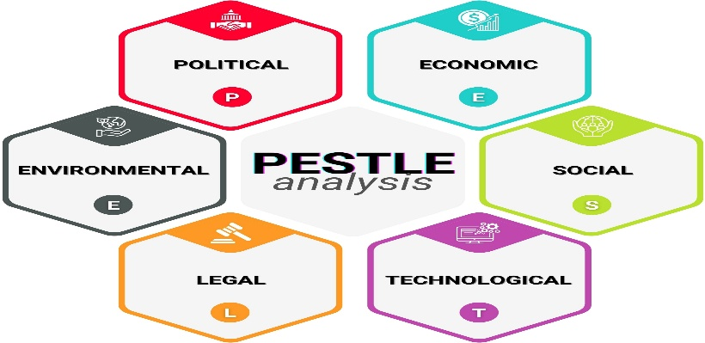
Figure 1: PESTLE analysis framework (CIPD, 2023)
The PESTLE analysis is a popular tool to evaluate the macro environmental factors such as political, economic, social, technological, legal, and environmental environments. This tool is used in the UK e commerce market to analyse the main external forces influencing both Amazon in the lead and Alibaba as the follower.
In this report, special attention will be paid to technological and legal aspects since they have the most important influence on innovation, competition, and regulatory adherence in this sector (US Department of Commerce, 2025).

2.2 Analysis of Macro Factor 1 (Technological)

2.2.1 Impact on Amazon (Pioneer Organisation)
Amazon's long-term dominance in the UK e Commerce space is firmly grounded in their early and ongoing investment in advanced technologies. Its deployment of AI driven recommendation systems, predictive logistics and cloud infrastructure through AWS has helped provide a highly integrated and efficient ecosystem to strengthen customer loyalty and operational efficiency (Market Research Future, 2025). The extent of adoption of Amazon Prime in the UK is indicative of the transformation of technological capability into a better customer experience and market dominance (Frisbi, 2024). Moreover, rapid growth of AI adoption provides great opportunities for Amazon to advance personalisation, optimise pricing strategies and automate fulfilment processes, furthering the differentiation advantage (US Department of Commerce, 2025).
However, this technological supremacy is not without problems. The rising accessibility/democratisation of AI tools lowers the barriers to entry as competitors can imitate some of Amazon's capabilities, which could erode its first mover advantage over time. Additionally, ongoing investment in state-of-the-art technologies, like its 2024 AI logistics purchase, entails great financial commitment and introduces the company to risks of implementation (Market Data Forecast, 2025). While technological advancement can lead to cost reduction and service enhancement, it simultaneously increases the pressure of competition and expectations within the UK e commerce industry (Carreño, 2024).

2.2.2 Impact on Alibaba (Follower Organisation)
Alibaba's AliExpress is a follower in the UK market, based more on winning by cost and in making incremental improvements in logistics than relying on advanced technological integration. Initiatives like the Global 5 Day Delivery programme have led to an improvement in fulfilment performance, bridging a key shortcoming of Amazon's quick delivery, while adding appeal to customers (BCP Publication, 2022). Furthermore, the usage of AI driven marketing by the platform during big events like the Double 11 Shopping Festival demonstrates its ability to use technology as a tool for acquiring and engaging customers (Sensor Tower, 2024).
Nevertheless, AliExpress is constrained in the technological advancement into sustained competitive advantage due to its structure. Its ecosystem is less developed and integrated than Amazon's infrastructure with limitations on consistent service quality at scale. While Alibaba's strategic shift towards AI driven innovation is a recognition of this gap's existence, its implementation within the UK context is complicated by individual consumer expectations, regulatory pressures and trust concerns (TechNode, 2024). Consequently, while technological advancement creates opportunities for efficiency gain, it also leaves AliExpress vulnerable to growing capability gaps and competitive ambiguity.

2.3 Analysis of Macro Factor 2 (Legal)

2.3.1 Impact on Amazon (Pioneer Organisation)
The regulatory landscape of the UK has expanded significantly to become more complex to digital market players (Kotler et al., 2020). Digital Markets, Competition and Consumers Act (2024) coined the term Strategic Market Status (SMS), which allows the Competition and Markets Authority (CMA) to utilise increased attention to companies with high impact in the digital economy a classification where Amazon is a candidate (US Department of Commerce, 2025). Also, a UK Digital Services Tax (DST) at a rate of 2 percent levied on qualifying revenues in April 2020, on the amount of revenues earned in the country, added about 860 million in 2024, and Amazon is among the biggest contributors (US Department of Commerce, 2025).
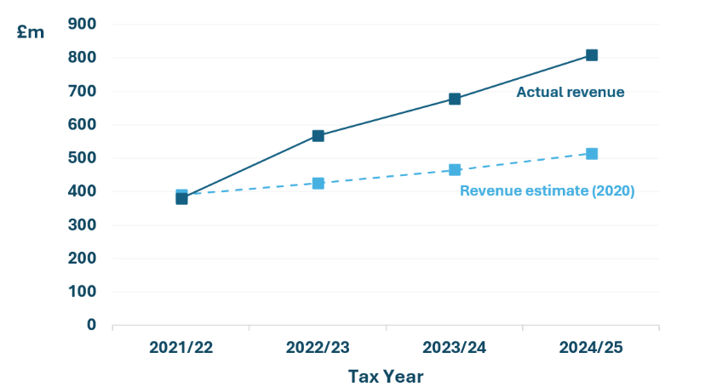
Figure 2: Tax Revenue Collection of UK Government; (Source (HM Revenue & Customs, 2020)
In the case of Amazon, regulatory complexity poses a threat because it raises compliance costs, constrained some competitive behaviours and exposes the company to the risk of litigation (Carreño, 2024). On the other hand, the legal and compliance infrastructure of Amazon that had been built throughout decades of operating in the UK market poses a competitive disadvantage. Its implemented compliance-related frameworks, GDPR-compliant data management, and compliance with the Consumer Rights Act is expensive to copy and is an unspoken benefit compared to more recent market participants (Market Research Future, 2025).

2.3.2 Impact on Alibaba (Follower Organisation)
As a follower organisation, Alibaba is particularly vulnerable to the disproportionately large threat of regulatory change. Being a cross-border platform, whose base is in a non-EU/UK, Alibaba is subjected to increased scrutiny by a set of online safety regulation (UK Online Safety Act) and data protection laws, which are like those in the GDPR, and consumer rights laws. Such non-compliance fines provided by the European Data Protection Board are up to 4% of annual global turnover which can be a substantial liability to a platform as massive as Alibaba (Market Data Forecast, 2025).
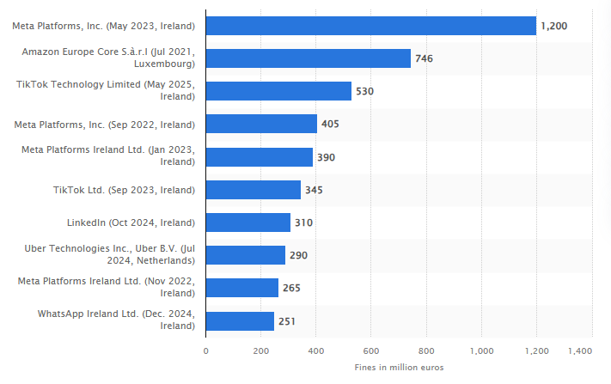
Figure 3: (GDPR) fines violations as of November 2025; Source (Petrosyan, 2025)
Moreover, the regulatory setting is growing sensitive to Chinese cross-border e-commerce platforms and their practises, especially their regard to product quality (eMarketer, 2024). Whereas Amazon has been able to spend decades incorporating compliance infrastructure in its UK business operations, AliExpress will need to invest massively to satisfy the demands of UK regulators and consumers, as well as compete on a price level (BCP Publication, 2022). Regulatory change therefore is a more immediate and structurally suppressive issue to Alibaba than Amazon. The combination of low institutional trust, high compliance investment requirements, and high sensitivity to geopolitically influenced regulatory tightening is its comparative weakness.

3. Task 2: Strategic Responses of Pioneering and Follower Organisations

3.1 Amazon’s (Pioneering Organisation) Strategic Responses
Response to External Challenges and Opportunities
Amazon is a technology and diversified e commerce company, which provides services such as Amazon Prime, online retail, Amazon AI, and logistics and AI. This diversified portfolio can help it to react strategically to external opportunities and threats.
Amazon's revenue has reflected continuous and strong growth, reaching to $691.33 billion by early 2025. The company embraces progressive attitude of technological change. Its 15 million Prime subscribers (around 39 per cent of buyers in the UK) testify to the retention and efficiency benefits of AI driven personalisation and logistics (Frisbi, 2024).
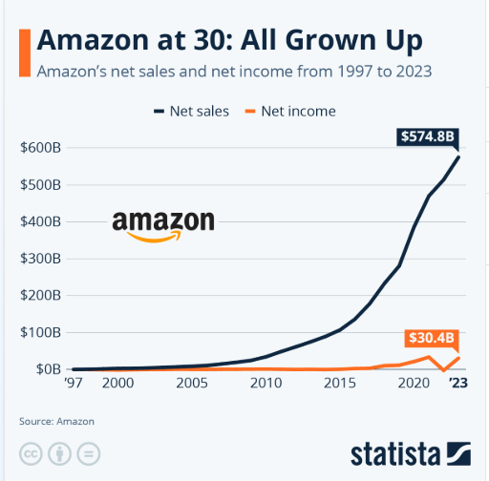
Figure 4: Amazon revenue data (Richter, 2024)
In 2024, Amazon gained revenue of 638 billion, and AWS generated more than 107 billion, which solidifies its financial foundation and technological dominance across the world (Market Research Future, 2025). These potentials provide great growth potentials in terms of innovation, automation, and streamlining of recurring revenues.
However, threats remain. The increase in the use of AI paves the way to competition, and regulation increases the costs associated with compliance. Amazon needs to keep investing in artificial intelligence and sophisticated technologies, improving its supply chain, and making the customer experience with the help of ecosystem to retain its market positions (Hassel and Sieker, 2022). Moreover, high-quality compliance systems and capitalising on entrepreneurial sources of its revenues enable Amazon to absorb environmental forces (Carreño, 2024). Most importantly, its capability to keep on innovating and maintain customer loyalty is at the core of standing long-term dominance at the market.
Application of Ansoff Matrix
The strategic growth of Amazon is pertinent to the Matrix of Ansoff, which is penetration, development, expansion, and diversification to maintain the competitive advantage in the UK and international markets (Ansoff, 1957).
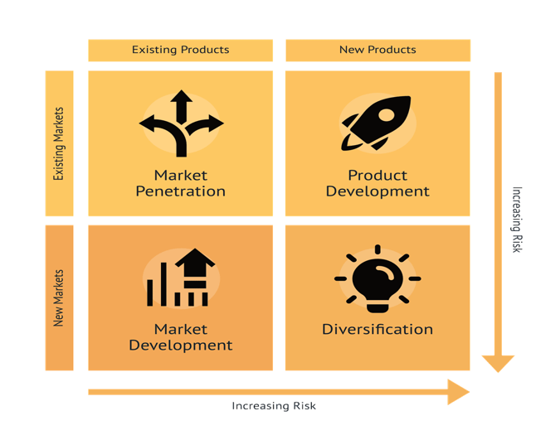
Figure 5: Ansoff Matrix (Ansoff, 1957)
Market Penetration: The market penetration of Amazon in the UK is also manifested in its 15 million Prime subscribers showing the UK online buyer count at about 39 percent of Amazon purchasers, thus, enhancing retention and loyalty to make a purchase (Frisbi, 2024). This scale enhances high switching costs but simplifies regulatory pressure of market power.
Product Development: The growing use of AWS and AI powered logistics systems, including the latest use of AI in fulfilment optimisation, points to a consistently developing product outside of the retail sector (Market Research Future, 2025). This enhances differentiation, but one must capitalize heavily.
Market Development: Amazon spreads its logistics and fulfilment networks worldwide, which allows the company to deliver with accelerated standards. Nonetheless, this growth introduces the company to various regulations and operational risks (Carreño, 2024).
Diversification: The expansion of Amazon into AWS, Prime Video, and smart products creates major nonretail sources of revenue, and dependence on e commerce becomes less essential (Hassel and Sieker, 2022). More importantly, this wide coverage adds complexity and regulation strain to an organisation.
Industry Examples Supporting Strategic Response
The strategy of Amazon can be demonstrated by tangible results in the industry. In the UK, 15 million users of Prime underline successful penetration on the market by growing loyalty, frequency of purchase, and switching costs (Frisbi, 2024). This model of subscription introduces customers into Amazon system, making it more stable in long run revenue.

Figure 6: Amazon service overview (Carreño, 2024)
The example of product development and diversification is quite clear with AWS that brings a great portion of the Amazon operating profit and makes the company a global technology powerhouse (Charles and Uford, 2023). This minimises the use of retail and fosters innovation throughout the business.
Furthermore, Amazon combines millions of third-party sellers, fulfilment and data system, and this offers effective network effects, hardly replicable (Ritala et al, 2014). Nonetheless, this leadership has enhanced the questioning of the labour conditions and market power within the UK. The examples show that strategy and operations are closely connected.

3.2 Alibaba’s (Follower Organisation) Strategic Responses
Adapted Strategy to Sustain Competitiveness
Relying on AliExpress, Alibaba takes an adaptive approach to be competitive in the UK, and it is mostly influenced by the follower position and lack of resources. Competition is based on cost efficiency, cross border scalability, and promotional intensity instead of technological leadership. The Global 5 Day Delivery option is a direct reaction to the fulfilment expectations that minimises one of the main drawbacks against faster delivery competitors (Yallabena, 2025).
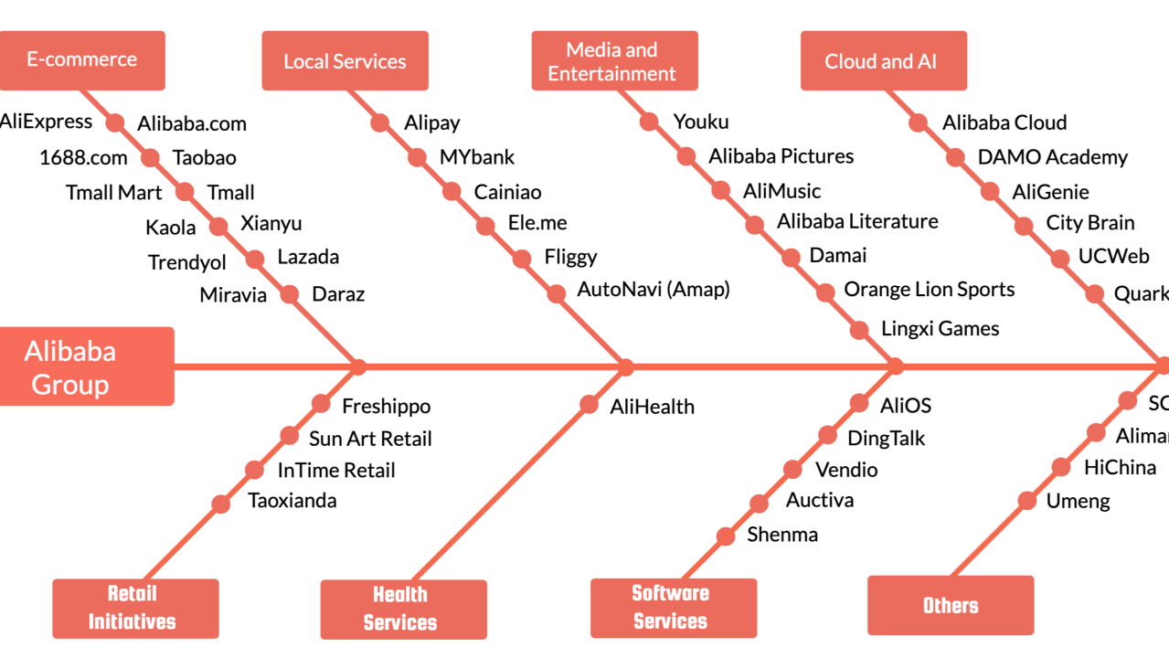
Figure 7: Analysis of Alibaba's Business Ecosystem (TechNode, 2024)
Nonetheless, such adaptation is mostly reactive. Despite AliExpress leveraging AI powered marketing, during the Double 11 campaign, the company struggled to attain high app ranking in the UK, but its technological ecosystem is less integrated to facilitate uniform service provision and differentiation (Sensor Tower, 2024). The action of Alibaba to reorganise into AI driven and user focused operation is indicative of strategic intent, though implementation remains problematic (TechNode, 2024).
More importantly, depending on the price sensitive consumer puts strain on the margin and poor loyalty. Although this is advantageous in the short term in terms of growth, it can provide little sustainable benefit, limiting its competitiveness with other market leaders (Rahman, 2024).
Application of Ansoff Matrix
Ansoff Matrix can explain the strategic growth of Alibaba by looking into penetration, development, expansion and diversification to maintain competitiveness in the international markets such as the UK (Ansoff, 1957).
Market Penetration: AliExpress enhances penetration in the UK market by using aggressive pricing and promotional activities like the Double 11, which has increased the download of apps and activity on the app to a very high level (Sensor Tower, 2024). It is an effective strategy in increasing short term purchase but restricting long term devotion (Kotler et al., 2021).
Product Development: Alibaba incorporates the use of AI driven recommendation systems and seller tools to enhance the functionality of the platform. Nevertheless, these advances are in the form of incremental development and inferior to the competitors (Rahman, 2024).
Market Development: AliExpress actively expands in Europe with the enhancements of cross border logistics including accelerated delivery programmes, which makes the company stronger within the UK market (Market Data Forecast, 2025).
Diversification: Alibaba uses wider ecosystem, such as logistics and digital service, assisted by organisational restructuring, to support global scalability (TechNode, 2024). Nonetheless, its influence of diversification in the UK is rather short.
Industry Examples Supporting Strategic Response
The competitive strategy of Alibaba in the UK is observed in the market behaviours and performance measures. Its differentiation with other fast rising models like Temu and Shein is how cross border low price retail models are redefining consumer segments especially to the buyers who are cost conscious (Yallabena, 2025). This suggests that AliExpress can scale its demand despite structural disadvantages.
One such example is its performance at the Double 11 Shopping Festival where the high download rankings in the UK serve to illustrate the effectiveness of targeted and data driven campaigns in generating high traffic and short-term engagement (Agus Putra et al., 2024). This strengthens its dependency on the intensity of the promotions as opposed to the enduring differentiation.
Also, the shift to a decentralised organisational structure of Alibaba reflects an endeavour to enhance responsiveness and innovation within global markets (TechNode, 2024). Nevertheless, functional results are still disproportionate especially the aspect of reliability of logistics and building of trust in the UK environment.
All these illustrate the idea that amidst scale and visibility, Alibaba shows limited competitive impact due to execution gaps.

4. Conclusion
This report has critically evaluated the macro marketing environment of UK e commerce industry with respect to the technological and legal aspects and assessed the strategic responses of Amazon and Alibaba. The results reveal that the technological development is one of the driving forces of competitive difference with technology, and the operational limits are formed by regulatory evolution of the frames where the firms can compete. As the first mover, Amazon makes use of superior technology capacities and already developed compliance frameworks to transform the external forces to strategic benefits. Alibaba, in its turn, is a follower and hence operates with a more reactive strategy, using cost efficiency and incremental gains, which restricts its capacity to succeed to differentiation over time. The strategic orientation being different is further noted with the application of the Growth Matrix of Ansoff. Amazon has a multidimensional growth strategy where it involves penetration, development, and diversification compared to Alibaba that has a more oriented approach of penetrating and expanding the market. All in all, the discussion reveals that macro environmental scanning is a key factor in the maintenance of competitiveness in the dynamic markets. Companies that seek to anticipate and address pressure posed by external factors is at a better position to continue benefiting, but those that use the response strategy have structural limits. Marketing responses that are adaptive therefore cannot be optional but are a necessity towards long term strategic success in a changing e commerce world.

5. References
Agus Putra, A., et al. (2024) 'Analyzing Alibaba: Unveiling the strategies, business ethics, and global market expansion', International Journal of Research and Review, 11(1), pp. 575–587. Available at: https://www.ijrrjournal.com/IJRR_Vol.11_Issue.1_Jan2024/IJRR64.pdf (Accessed: 22 March 2026).
Ansoff, H.I. (1957) 'Strategies for Diversification', Harvard Business Review, 35(5), pp. 113–124.
BCP Publication (2022) 'Competitive strategy analysis of cross-border e-commerce: AliExpress in the UK market', BM Journal. Available at: https://bcpublication.org/index.php/BM/article/download/3100/3053/3025 (Accessed: 23 March 2026).
Carreño, A.M. (2024) 'Analysis of Amazon's evolution from an online bookstore to a global tech giant', Institute for Change Leadership and Business Transformation. Available at: https://adolfocarreno.com/2024/12/02/analyzing-amazons-evolution-from-an-online-bookstore-to-a-global-tech-giant / (Accessed: 23 March 2026).
Charles, I.I. and Uford, I.C., 2023. Comparative analysis and evaluation of business and financial performance of Amazon. Com: A three-year period critical review of exceptional success. European Journal of Business, Economics and Accountancy, 11(2), pp.69-92.
CIPD (2023) PESTLE analysis. Available at: https://www.cipd.org/en/knowledge/factsheets/pestle-analysis-factsheet / (Accessed: 22 March 2026).
eMarketer (2024) AliExpress: Reports, statistics and marketing trends. Available at: https://www.emarketer.com/topics/category/aliexpress (Accessed: 23 March 2026).
Frisbi (2024) Comprehensive guide to Amazon UK in 2024. Available at: https://www.frisbi.com/blog/comprehensive-guide-to-amazon-uk-in-2024 (Accessed: 22 March 2026).
Hassel, A. and Sieker, F., (2022). The platform effect: How Amazon changed work in logistics in Germany, the United States and the United Kingdom. European Journal of Industrial Relations, 28(3), pp.363-382.
HM Revenue & Customs. (2020, March 11). Digital Services Tax. GOV.UK. https://www.gov.uk/government/publications/introduction-of-the-digital-services-tax/digital-services-tax
Hooley, G. J., Nicoulaud, B., Rudd, J. M., & Lee, N. (2020) Marketing strategy and competitive positioning. Seventh edition. Harlow, England ; Pearson.
Kotler, P., Armstrong, G., Harris, L. and Piercy, N. (2020) Principles of marketing. 8th European edn. Harlow: Pearson.
Kotler, P., Keller, K. and Chernev, A. (2021) Marketing management. 16th ed.
Market Data Forecast (2025) Europe e-commerce market size, share, 2033. Available at: https://www.marketdataforecast.com/market-reports/europe-e-commerce-market (Accessed: 23 March 2026).
Market Research Future (2025) UK e-commerce market industry impact insights 2035. Available at: https://www.marketresearchfuture.com/reports/uk-e-commerce-market-46301 (Accessed: 23 March 2026).
Petrosyan, A. (2025, February 17). Largest fines issued for violations of GDPR 2025. Statista. Retrieved March 27, 2026, from https://www.statista.com/statistics/1133337/largest-fines-issued-gdpr/
Priporas, C.V., Kamenidou, I., Nguyen, N. and Shams, R., 2020. The impact of the macro-environment on consumer scepticism towards cause-related marketing: Insights from an economic crisis setting. International Marketing Review, 37(5), pp.841-861.
Rahman, M.S. (2024) E-commerce evolution: a strategic analysis of Alibaba's business ecosystem, SSRN. Available at: https://ssrn.com/abstract=5109165 (Accessed: 22 March 2026).
Richter, F. (2024, July 4). Amazon at 30: All grown up [Infographic]. Statista. https://www.statista.com/chart/4298/amazons-long-term-growth/
Ritala, P., Golnam, A. and Wegmann, A. (2014) 'Coopetition-based business models: the case of Amazon.com', Industrial Marketing Management, 43(2), pp. 236–249.
Sensor Tower (2024) AliExpress case study: driving organic growth and store ratings improvement. Available at: https://sensortower.com/blog/aliexpress-case-study (Accessed: 23 March 2026).
TechNode (2024) Alibaba group restructures e-commerce operations, 22 November. Available at: https://technode.com/2024/11/22/alibaba-group-restructures-e-commerce-operations-to-boost-global-expansion/ (Accessed: 23 March 2026).
US Department of Commerce (2025) United Kingdom: Digital economy. Available at: https://www.trade.gov/country-commercial-guides/united-kingdom-digital-economy (Accessed: 22 March 2026).
Whittington, R., Regnér, P., Angwin, D., Johnson, G., & Scholes, K. (2023) Exploring strategy : text and cases. Thirteenth edition. Harlow, England: Pearson.
Yallabena (2025) AliExpress leads UK eCommerce market with Temu, Shein, and TikTok Shop, 13 January. Available at: https://yallabena.com/aliexpress-leads-uk-ecommerce-dominating-cross-border-retail-with-temu-shein-tiktok-shop/ (Accessed: 22 March 2026).

