Natalie Emma Male
1702161

DIgITAL Learning and collaboration
BMSP403 Alex Bell

Since the dawn of time man has participated in the pursuit of learning and the development of new technologies. From the invention of the alphabet to the first personal computer, we now have a voice that can be heard across many platforms. Progression from web 1.0 to web 2.0 means that we can evolve and collaborate in our learning journey. Digital literacy has become as important as the ability to express ourselves with pen to paper. Access to information is becoming portable and instantly available and for most individuals. As new technologies emerge, we may have an opportunity to enhance our learning both individually and collaboratively. This personal experience will vary and is dependant on many factors including opportunity, capability and access to technology.

I have grown up witnessing many changes with rapid advancements in technology. Our first personal computer was an Acorn Electron, I remember being in awe at what we would consider very basic games now. I now have a smart television with instant access to Netflix, YouTube and many other digital apps. This is an example of how web 1.0 and web 2.0 have been introduced into my home. I cannot help but feel I have had a privileged insight into the development of technology, perhaps I appreciate it more having witnesses its revolution.
It is possible that younger generations were born into the digital age. (Male A. , 2019) argues that “If you don't have the internet, I, and others I know feel extremely disconnected from society as all of our lives are online. Because of this, our main way of communication would be Snapchat and Instagram which requires the web, teens nowadays don't really use texts as these apps have made it easier to connect with people all over the world”. This declaration from my fourteen-year-old daughter is only representative of her own opinion. Although she can speculate from her own experiences and that of her peer group. In contrast this statement is not representative of all young people. This could be due to geographical location, digital poverty or lack of access to current technology. Not everyone is able to have a digital identity.
Our digital Identity has developed since web 1.0 when we were only able to have little participation. There was only a limited interaction between sites and users. The development of web 2.0 has facilitated interaction between the users of its sites. Individuals are creating blogs, vlogs and to some extent we are the web. Leading us to opportunities for expression and collaboration, it can link users across space and time. As part of the course my own digital identity has increased. I had never used a blog and now have a twitter account.
My personal learning environment is somewhat of a collaboration of services. I use the library at university frequently. On one visit I was looking for literature on digital learning and web 2.0. Suddenly the penny dropped now isn't that a contradiction, looking for digital literature in the library, I should be searching online. I did to my astonishment find a book on digital Identities. Then I started to think will there become a point where we will no longer require a physical library and we will depend on a digital one. I hope that day will not come, there is something tangible about a book. It does not require batteries, will not turn off and requires no connectivity. A single book could be considered as portable and instantly accessible.

A varied PLE could be an important commodity in your learning journey. (Gallego & Gamiz, 2014) attempted to understand the relevance of using tools and services in University students PLE’S. Of all the tools available 33% did not use any in there PLE while others had at least one. When comparing the grades, the results returned were very similar, except in the higher grades. Several students who had included institutional tools had obtained the highest grade. Image 1 below displays the results.

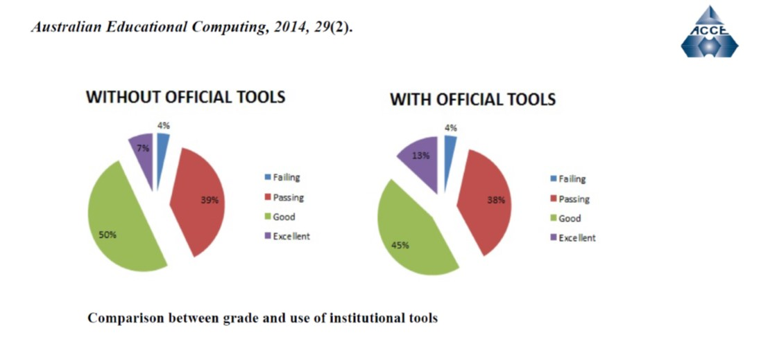

Image 1 (Gallego & Gamiz, 2014)
It is interesting that the results are similar in both failing and passing. There is a small difference in the good and excellent marks. It may go someway to explain how many students are able to pass without the need for an extensive PLE. I personally feel that any new technology that can help in my learning journey should be explored further. This evidence shows that a PLE could help me to achieve higher grades. Image 2 below is a diagram of my own PLE.

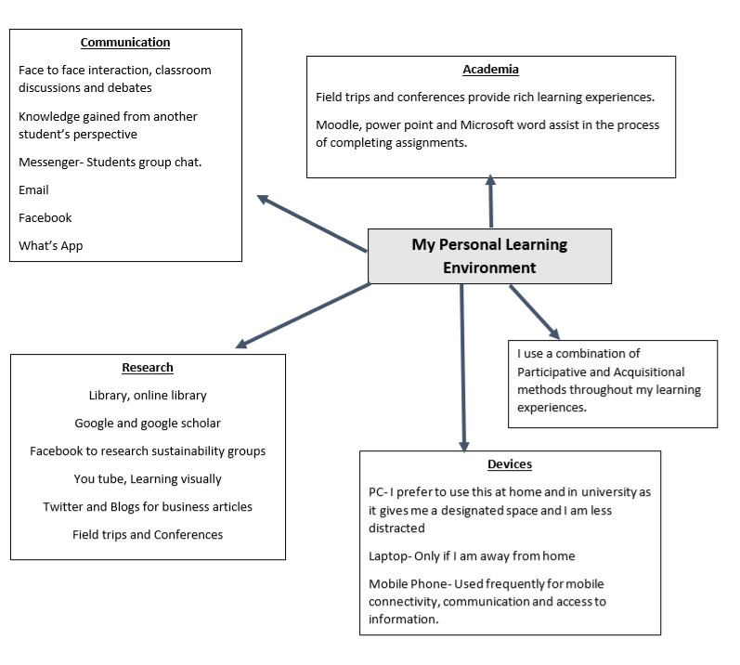
Image 2

There are many tools available to enrich our learning. As University students some we must use, such as Moodle. Yet for the moment we do have a certain control over the tools we use to access the information we require. At some point I feel the choice may be taken away for example as libraries catalogues get smaller and lead to their closure. To critically review, I propose my PLE is like that of my peers, when comparing examples on the forum. There were some notable differences however this tended to be tools used in employment. An example from a fellow student over twenty years younger can be seen in Image 3
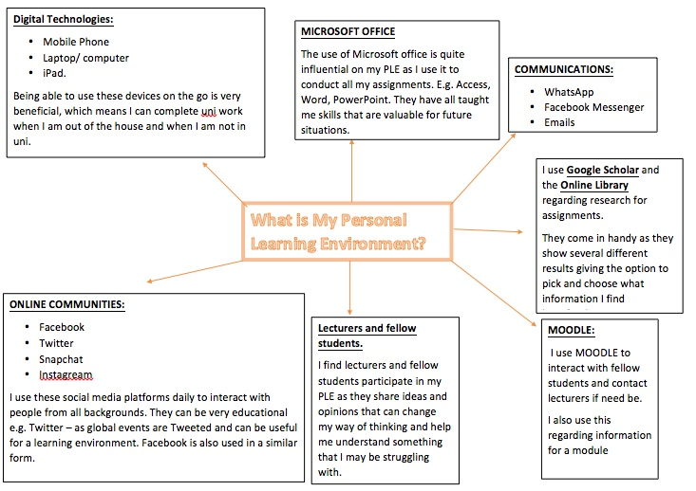
(Thomas , 2019) Image 3
The notable differences are social media, this student has more accounts. This goes some way to support the theory proposed earlier by A. Male, the desire for connectivity. I particularly like the way this student has included Lecturers and students as part of her PLE. Although my PLE is not comprehensive it is assisting me to obtain good grades. It is likely that by the end of year 3 my PLE will have vastly changed.

Collaborative learning can be a useful tool in obtaining different viewpoints. This assists in my learning and in turn sharing my ideas for interpretation. The forum was an excellent example of collaborative learning, although it is highly dependent on others input. I found that some did not participate or engage in questions asked by others. Perhaps this is due to confidence. People can be protective of their knowledge and do not wish to share, they may feel it will give others an advantage. I felt that the forum exposed my insecurities at first, but I tried to embrace the process.
There was a different feeling to answering a question in the lecture to answering it through the forum. It felt that my answers were almost concrete, what if I had interpreted it wrong and others had followed. I can only be guided by my own viewpoint and experiences. It gave an interesting insight to how we were connected not physically but digitally. I highly value knowledge and experience as an important resource for my own learning. (Confucius, 2019) stated that "When I walk along with two others, from at least one I will be able to learn." The Philosopher born in 551BC appeared to recognise the importance of collaborative learning. Knowledge could be considered as a precious commodity for personal and collaborative advancement.
I feel we are rarely learning individually. Although we bring our personal experiences they have usually be shaped by others. We have gained ideas from our tutors and fellow students, during our assignments we access and include the works of others. This could be considered a collaboration. Perhaps the development of new technologies, access to online learning and courses would make individual learning possible. This in turn may help to bridge the divide in the opportunities of education.
At some point in the future this could surpass our need to have tutors or teachers in the traditional classroom environment. (Male N. E., 2018) argues that “The impact of this weakening link would certainly be different for each student. I personally value the learning environment we are in. I think it would be a sad day when technology surpasses our need for classroom base learning”. (Sclater, 2008) proposes the importance of the learning environment. He argues that although independent learning is commendable. To leave students in charge of their own learning without management, will likely result in students dropping out.

Individual learning can become difficult for some without the support of both tutors and students. I consider the classroom to be an intrinsic and rich resource for my personal learning. I find that the structure is encouraging and informative. Fellow student (Price, 2019) argues that “Personally, I don’t think it’s helping me at all. I’m finding it stressful and I’m actually struggling with it. Because I’m trying to fit this in around everything else, I’m finding I’m not having the time. I much prefer classroom learning as it is more structured”

Literacy is often defined through the medium of writing. Digital Literacy could be defined as an individual’s ability to utilise digital technology. (Fraser, 2012) suggests that “The definition I most frequently use is this one: digital literacy = digital tool knowledge + critical thinking + social engagement”. It is difficult to assess one’s level of digital literacy although research conducted by the BBC found that in 2014 twenty one percent of the British population lacked even a basic ability. In 2014 the government developed the digital inclusion policy, Image 4.
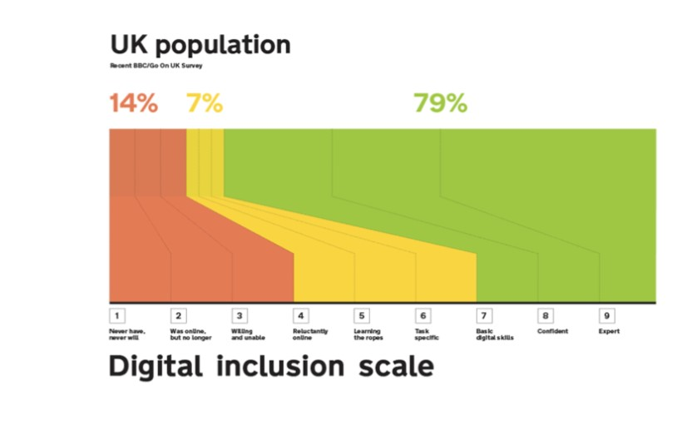

Image 4 (Government Digital Inclusion Strategy, 2014)
In comparison with this chart I would put myself in the range of confident. However, it would be interesting to see this information reflecting current trends. Whilst there is room for improvement, I can navigate my way confidently and follow instructions. My digital literacy has certainly improved throughout this semester. I have acquired additional skills such as the use of an aggregator to condense my news feeds in one place. I believe digital scholarship is a valuable tool, for the future challenges of the workplace.

My advice to other students in the 21st century would be to embrace digital learning as an important tool for your personal advancement. Most of the course requires a degree of digital literacy, although it is good to have a combination of all learning technologies never rely on just one. There is still much to be gained from all types of learning, an open mind will gain far more insight. (Prensky, 2012) purports that “The human brain, and the mind it produces, is seen by many people -probably most people- as nature’s greatest achievement. It certainly is the most complex thing on earth”. Be comfortable and confident in your learning journey and explore all resources to the best of your ability. Having access to education is a privilege not afforded to all, take full advantage of this opportunity, both individually and collaboratively. The skills you gain will be advantageous when you seek employment after graduating.

As I reflect on my learning journey thus far, I realise that my stance on digital technology has changed. I started the course will the preconceived idea that our learning would be more book related with referencing from books. I can only attribute this to my learning environment as a child. This would undoubtedly give me a limited pool of resources. Though I do still regard the library as an additional resource, I am becoming more confident in my search for credible information. Each learning journey is unique as we are shaped by our own experiences. Digital technologies are constantly changing and to keep adrift my literacy is also evolving. In conclusion, the one element that remains constant is my desire to be educated. Although the methods I use to reach this goal may have changed, essentially the destination remains the same.
References
Confucius. (2019, March 1). 12 famous Confucius quotes on education and learning . Retrieved from The open University: https://www.open.edu/openlearn/education/12-famous-confucius-quotes-on-education-and-learning#
Fraser, J. (2012, May 15th). 20 ways of thinking about digital literacy in higher education . Retrieved from The Guardian: https://www.theguardian.com/higher-education-network/blog/2012/may/15/digital-literacy-in-universities
Gallego, M. J., & Gamiz, V. M. (2014). Personal Learning Environments (PLE) in the Academic Achievement of University Students . Australian Educational Computing, 5.
Government Digital Inclusion Strategy. (2014, December 4th). Retrieved from GOV.UK: https://www.gov.uk/government/publications/government-digital-inclusion-strategy/government-digital-inclusion-strategy
Male, A. (2019, February 21). Generations of information seekers. Retrieved from moodle uwtsd: https://moodle.uwtsd.ac.uk/mod/forum/discuss.php?d=10576
Male, N. E. (2018, March 3rd). Are there any implications for learners arising from this weakening of the link between a learner and their teachers and institutional base? Retrieved from Moodle: https://moodle.uwtsd.ac.uk/mod/forum/discuss.php?d=10824
Prensky, M. (2012). Brain Gain: Technology and the Quest for Digital Wisdom. New york: Palgrave Macmillian.
Price, L. (2019, March 3rd). How does Web 2.0 transfer to Learning 2.0? Retrieved from Moodle: https://moodle.uwtsd.ac.uk/mod/forum/discuss.php?d=10821
Sclater, N. (2008). Web 2.0, Personal Learning Environments, and the Future of Learning Management systems. Educause Center for Applied Reasearch, 6.
Thomas , H. (2019, March 7th). Your own PLE as a diagram. Retrieved from Moodle: https://moodle.uwtsd.ac.uk/mod/forum/discuss.php?d=11027

