
Master of Business Administration

Marketing Management (LCMB7024)
Assessment Component 1: Marketing Environment Analysis

Title: Marketing Environment Analysis and Strategic Growth: BHP Group’s Transition Towards a Lower-Carbon Business Model

Lecturer Name: Taonga Kaonga Sobere-Snithers
Student Name: Mankeerat Singh
Student ID: 2615721

Words: 2,516
Submission Date: October 22nd, 2026

Contents List
1 Introduction 3
2 Task 1: Marketing Environment Analysis 3
2.1 External actor 1: Natural environment 3
2.2 External actor 2: Social Infleuence 5
2.3 External actor 3: Political and Legal 6
2.4 Critical synthesis and implications 6
3 Task 2: Strategic Growth and Competitive Positioning 7
3.1 Introduction to the Ansoff Matrix 7
3.2 Evaluation of growth options 7
3.3 Recommended strategy: Product development supported by market penetration 8
3.4 Competitive advantage and implementation 9
3.5 Risks and strategic controls 9
4 Task 3: Managerial and Professional Reflection 9
4.1 Rationale for selecting BHP 10
4.2 Reflection on environmental actor selection 10
4.3 Reflection on strategic growth recommendations 10
4.4 Limitations and further information required 10
Reference list 12

Introduction


BHP Group is a large transnational resources firm that produces essential commodities to the industrial markets all over the world such as iron ore and copper to be used in making steel, manufacturing and building of infrastructure (BHP, 2024). On the other hand, there is a growing demand on issues to mitigate on greenhouse gas emission, save natural resources and adopt lower-carbon economy in metals and mining industry (Enemuo and Ogunmodimu, 2025). The idea of environmental sustainability has also been turned into a strategic priority. BHP acknowledges the climate-related risks and opportunities of emerging technologies, policies and the market conditions (BHP, 2026a).
This report critically analyzes three external marketing environment actors affecting the transition of BHP and what they imply about the sustainable growth and competitive positioning.

Task 1: Marketing Environment Analysis
Analysis of the marketing environment assists organisations to determine the external opportunities and threats that affect customer value and strategizing (Kotler et al., 1996). In the case of BHP, the aspect of natural environment and the industrial customers (and government regulatory bodies) are quite important since they affect the levels of sustainability, the cost of their operations and their future prospects in the market.

External actor 1: Natural environment
The biggest external player that can affect the change of BHP to a lower-carbon business model is the natural environment. The mining activities use a significant amount of energy and water resources and disturbs the land and produces emissions by using fuel, electricity, and the process of the industry (Igogo et al., 2021). Moreover, the transformation of iron ore into steel also produces significant emissions. The global mining and metals sector is responsible for 11% of the global greenhouse gas (GHG) emissions, according to a report from the International Council on Mining and Metals (ICMM) (Mares, 2026).
However, there are also growth opportunities due to environmental pressures. As an outcome of electrification and energy-system transformation, the IEA (2025) enumerates rising demand of the critical minerals, such as copper. BHP has an opportunity to provide materials that are needed in electricity networks and in infrastructure of renewable energy. None the less, increased demand of minerals does not necessarily make mining sustainable. Further extraction may lead to even greater land disturbance, generation of wastes, and water pressures, necessitating effective environmental protection.

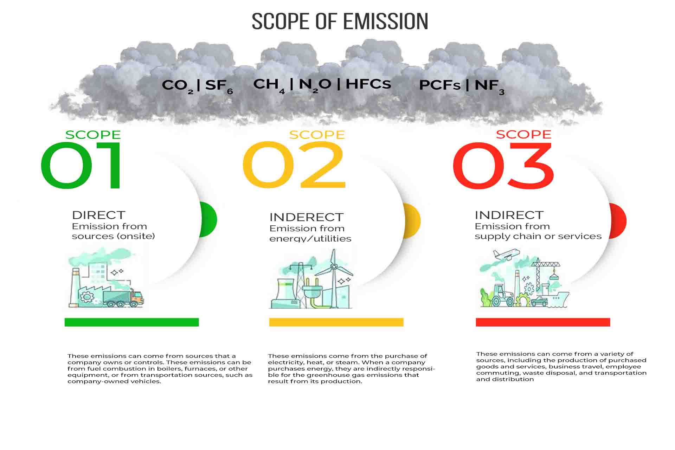
Image 1: Scopes of Emission (Rai, 2024)
The critical appraisal should be able to differentiate Scope 1, Scope 2 and Scope 3 emissions. Scope 1 deals with direct emissions, Scope 2 deals with the purchased energy, and Scope 3 deals with the emissions of the broader value chain, such as how customers process and use their products. Minimal operational emissions can be achieved through renewable electricity, energy efficiency, and proper electrification of equipment. However, the applicability of the scope 3 cuts depends enormously on whether or not the customers can afford to move to cleaner steelmaking processes and invest in decarbonising the industry. Despite the latest Climate Transition Action Plan (CTAP) by BHP (BHP, 2026), its assessment should be contrasted with quantifiable changes, technological ways and investments. Also, BHP should show concern on environmental change instead of giving promotional remarks that may jeopardize the trust of the stakeholders.

External actor 2: Social Infleuence
Industrial customers, such as steelmakers and manufacturers shape the product needs of BHP, their buying decisions and sustainability communications. Such customers need dependable access to material supplies at affordable prices, yet the increasing interest in supply chain emissions can also motivate them to promote the environmental performance when choosing a supplier.
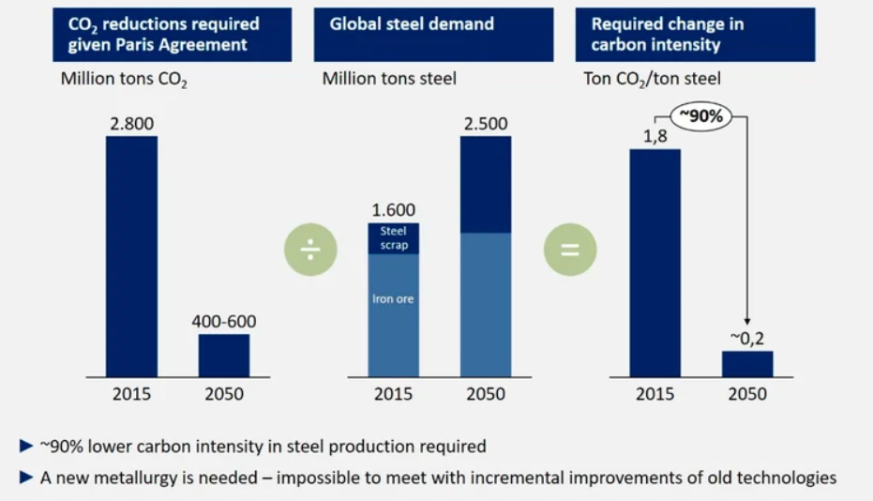
Image 2: Global steel demand and CO2 emissions (Researchgate, 2020)
Image 2 depicts the demand format of near-zero-emissions steel which is a significant device of facilitating the production of cleaner industries. BHP can counter this by working on building customer relationships, supplying believable environmental data, and assisting in joint action to minimize emissions throughout the steelmaking value chain. These operations may enhance its relationships and increase its image among the environmentally aware customers. However, sustainability assertions should be clear, quantifiable and backed up by veracious data.
Competitive advantage cannot be achieved through environmental differentiation, itself. Price, reliability of quality and supply must be considered by customers as well (Basile, 2025). Unless the lower-carbon products are affordable or larger amounts are available, consumers might gravitate towards traditional products. To BHP, this means that environmental performance should be combined with commercially competitive products that sustainability will always serve as an addition, and never a substitute to the fundamentals of customer value.

External actor 3: Political and Legal
Environmental laws and emissions regulations, reporting and project approvals all set by government and regulatory bodies affect BHP. This is due to the different regulatory frameworks that make BHP a company that has some complexities in planning and making required compliance investments as an international company. The Safeguard Mechanism provides the Australian industry with the basis of emissions of industrial institutions and as a rule, decreases them over several years, making it possible to motivate businesses to control emissions (DCCEEW, 2025). In case of BHP, this makes the operational efficiency and benefits of prudent decarbonisation investment much more significant.
Additionally, on the international level, the Carbon Border Adjustment Mechanism of the European Union took a concrete regime in January 2026, which is introducing the associated obligations concerning the embedded emissions of qualifying imported goods (European Commission, 2025). Its BHP implications would be on applicable products and trade flows, but this illustrates how climate policies can affect the supply chains and competitiveness.
Regulation gives companies an opportunity since it will encourage the adoption of clean technologies, transparency, and increase the power of demand to less-polluting materials (Qamruzzaman, 2026). International demands, however, may act as a bane to the business due to inconsistent international requirements, uncertainty of the policy, and costs involved in compliance. Regulatory developments should be thus factored into investment planning and appropriate environmental disclosures should be made by BHP.

Critical synthesis and implications
BHP is affected by the natural environment, social influence in combination towards its sustainability strategy. Environmental pressures also provide the requirement to reduce the emissions, business price of less-carbon (as established by the customers) and the regulatory authorities establish the standards that affect the cost and interface in the markets. The global size and industrial relations form the strengths of BHP. However, this is not so with emissions-intensive value chains to create a challenge in particular where the customer has to make an investment to boost developments.
Conversely, chances are on the growing need of critical miners and cleaner technologies, risks: climate disruption, regulatory risk, prices high decarbonisation. This implies that BHP should consider incorporating operational carbon management with integrated sustainability reporting and customer engagement. These priorities provide some bit of rationale on choice of growth strategy, capable of accommodating the environmental growth and the business competitiveness.

Task 2: Strategic Growth and Competitive Positioning

Introduction to the Ansoff Matrix
The Ansoff Matrix is a framework of strategic planning which defines four alternative growth strategies depending on existing markets or new ones based on existing or new products (Ansoff, 1957). For BHP Group, the framework assists in assessing the possibilities concerning the evolution of its role in the metals and mining sector and moving towards a lower-carbon business model. The use of proper strategy depends on environmental goals, customer values and the possibilities of the technology and business profits.
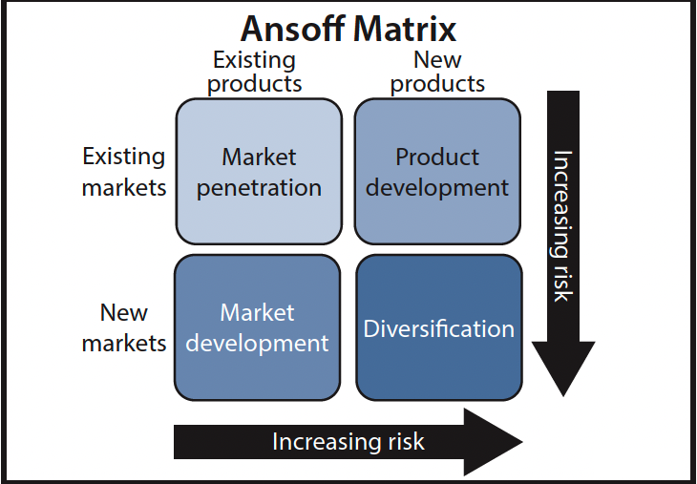
Image 3: Ansoff Matrix (Ganguli, 2024)

Evaluation of growth options
Market penetration | Market penetration is the growth in sales of the existing products to current customers by enhancing customer relationship, efficacy and dependability in operations (Abdul-Gafar et al., 2023). In the case of BHP, such is a relatively lower-risk opportunity to cement existing industrial alliances.
Market development | Market development is the part in which the existing sales of the commodity are extended to new geographical markets or customer segments especially where electrification and infrastructure development enhance mineral demand (Jones, Nguyen‐Tien and Elliott, 2022). Yet, the growth of the market is contingent on the local regulations and logistics and competitive conditions.
Product development | The product development presents possibilities of upgrading the current products by enhancing their environmental performance, product traceability and information in certified sustainability (Jan et al., 2023). This strategy would assist BHP in addressing the needs of customers interested in reducing emissions of their supply chains.
Diversification | Diversification entails extended product/market entry whereby the chosen technologies or service offerings could facilitate industrial decarbonisation (Patra, Bharatiya and Bhavan, 2020). But in most cases, it brings increased both financial and operational uncertainty.
Table 1: Ansoff Strategic Analysis
The BHP corporate strategy recognises copper and other commodities which are related to electrification and decarbonisation as the potential areas of growth (Argus and Samson, 2021). However, increased importation of these commodities does not necessarily translate to profitability and sustainable environment. Before investment, BHP will have to evaluate the demand in the market, cost and impact of the project on the environment. In general, product development and market penetration seem to be quite appropriate since these components expand on already existing capabilities of BHP and customer relations of the company, as well as contribute to a slow yet gradual environmental change.

Recommended strategy: Product development supported by market penetration
BHP should focus on product development as its main growth strategy enhanced by penetrating the market. This integration would enable the company to enhance environmental performance and transparency of the current offerings as well as enriching its relationship with old industrial clientele (Adams et al., 2016). It is more in sync with the current capabilities of BHP than engaging in massive diversification in areas they are not well acquainted with.

BHP may invest in purposeful mining machines, renewable energy, and lower emission sources of electricity (Pouresmaieli et al., 2023). It might also elaborate further product-level environmental information, backed by open-minded emission techniques and external audit. This would assist customers to assess the environmental properties of the materials provided and enhance their reporting on the supply chain. Cooperation with steelmakers would also help to implement technologies that will decrease the amount of emissions during the processing of iron ore and the production of steel.
This strategy might provide differentiation where customers appreciate believable environmental performance and price, quality and reliability of supply. Its success though relies on these improvements being identified and rewarded by customers. BHP must then investigate projects that can be shown to have both quantifiable environmental deliverables as well as be commercially viable.

Competitive advantage and implementation
Environmental differentiation, operational efficiency and customer collaboration are some of the factors that enable BHP to create competitive advantage (Mwaniki, He and Chege, 2025). Certified environmental performance may also become differentiating its products with industrial customers focusing on the supply chain emissions. In the meantime, operation costs might be decreased by energy efficiency and better use of resources, which might enhance resilience. Loyal customer relationships could also help to accomplish joint innovation, and open reporting could help to increase the level of trust between the stakeholders (Peláez et al., 2023). These advantages however are tied on measurable outcomes in contrast to the claims of sustainability itself
Furthermore, operational emissions intensity, energy use, customer retention, investment returns and progress toward pertinent climate targets should be among the performance indicators. BHP should also observe how customers embrace the information regarding sustainability of products. Frequent performance evaluation would help the management to make amends in investments when technologies, regulations and market conditions are modified. This incremental strategy would prevent unwarranted spending and tie sustainability progress with the long-term competitiveness (BHP, 2025).

Risks and strategic controls
The suggested plan contains hazards such as substantial capital outlays, lack of certainty of technology effectiveness, erratic commodities demand and lack of willingness to pay by the customers towards environmental enhancements. False sustainability assertions may also tarnish the reputation of BHP (Dempere, Alamash and Mattos, 2024). These risks must be addressed in phases (investment), by evaluating the feasibility, environmental information must be properly confirmed by independent verification and frequent reviews of the market. Management needs to scale initiatives when there is a credible evidence of beneficial effects on the environment and returns that are commercially viable.

Task 3: Managerial and Professional Reflection

Rationale for selecting BHP
I chose the BHP Group as it works in an industry that is experiencing serious threats to the environment and provides commodities necessary to develop industry and the energy transition. Its business in iron ore and copper gives an appropriate context of analysing how sustainability, customer expectations and competitive growth ties. The presence of both corporate report and industry research also facilitated an evidence-based analysis. BHP presents, as a managerial aspect, how difficult it is to balance commercial activity and environmental obligations. Nonetheless, its global size implies that the results might not be identical in the context of small mining enterprises.

Reflection on environmental actor selection
I valued the natural environment since the following factors were foundation on climate change, reduction of resources and emissions directly influence the mining activities and long-term resilience. Nevertheless, environmental pressures cannot be regarded outside of other external players. The industrial users determine the effect of lower-carbon materials in creating market value and governments develop regulations which impact investment and costs of operation. The analysis enabled me to understand that sustainability is an environmental and a marketing challenge.

Reflection on strategic growth recommendations
The strategies I proposed as being backed by product development envisages development in line with market penetration since these strategies are reinforced on the existing BHP products, capabilities and customer relationships. This method seems more feasible as compared to direct diversification, which might need to be giving new unknown skills and large sums of money. An enhancement of environmental performance, reinforcement of customer cooperation and provision of independently proved sustainability information may facilitate differentiation and trust amongst stakeholders. Nonetheless, customers could still focus on price and the ability to supply, and cleaner technologies do not necessarily achieve direct profit. I would thus suggest pilot projects with environmental indicators that are measurable.

Limitations and further information required
The major shortcoming of my study is that it used secondary sources such as disclosure of companies and magazines in the industry. Though these sources could offer valuable evidence, company reports can focus on strategic gains and not show their far-reaching performance by themselves. Besides, the report does not include primary customer research and in-depth competitor comparisons and project-level financial modelling, which restricts the level of confidence of the recommendations.
Part of my advice as a consultant would be to find independently confirmed emissions data, interview with customers and to pay research to find out the market potential of cheaper carbon materials. I would also research of competitors environmental performance, technology cost, regulatory progress and anticipated rate of returns on investments. Lastly, I would consider other commodity-price and market-demand situations to see whether the proposed strategy is viable in terms of commercial viability in the face of varying economic conditions. This would add extra weight to the analysis and help the top management to make more informed decisions regarding sustainable growth.

Reference list
Abdul-Gafar, A., Arowogbadamu, Oziri, S., Bibire, O. and Lande, S. (2023). Retail rollout optimization models for maximizing customer reach and driving sustainable market penetration. International Scientific Refereed Research Journal © 2023 GISRRJ |, [online] 6, pp.2582–0095. Available at: https://gisrrj.com/paper/GISRRJ236822.pdf [Accessed 20 Oct. 2026].
Adams, R., Jeanrenaud, S., Bessant, J., Denyer, D. and Overy, P. (2016). Sustainability-oriented innovation: A systematic review. International Journal of Management Reviews, 18(2), pp.180–205. doi:10.1111/ijmr.12068.
Ansoff, H. (1957). Strategies for diversification. [online] Available at: https://www.researchgate.net/profile/Faris-Alshubiri/post/is_there_any_research_article_suggesting_further_study_on_market_penetration_and_market_development/attachment/59d6202279197b807797e9c0/AS:288872320782343@1445883937051/download/2.pdf [Accessed 20 Oct. 2026].
Argus, D. and Samson, D. (2021). BHP (c): Minerals. Strategic Leadership for Business Value Creation, pp.291–323. doi:10.1007/978-981-15-9430-4_11.
Basile, V. (2025). Strategy and competitive advantages. Future of Business and Finance, pp.5–81. doi:10.1007/978-3-032-02766-5_2.
BHP (2024). BHP | A leading global resources company. [online] BHP. Available at: https://www.bhp.com/ [Accessed 20 Oct. 2026].
BHP (2026). Climate transition action plan | BHP. [online] Bhp.com. Available at: https://www.bhp.com/sustainability/climate-change/climate-transition-action-plan [Accessed 20 Oct. 2026].
DCCEEW (2025). Safeguard mechanism. [online] Dcceew.gov.au. Available at: https://www.dcceew.gov.au/climate-change/emissions-reporting/national-greenhouse-energy-reporting-scheme/safeguard-mechanism [Accessed 20 Oct. 2026].
Dempere, J., Alamash, E. and Mattos, P. (2024). Unveiling the truth: Greenwashing in sustainable finance. Frontiers in sustainability, [online] 5. doi:10.3389/frsus.2024.1362051.
Enemuo, M. and Ogunmodimu, O. (2025). Transitioning the mining sector: A review of renewable energy integration and carbon footprint reduction strategies. Applied Energy, [online] 384, p.125484. doi:10.1016/j.apenergy.2025.125484.
European Commission (2025). Carbon border adjustment mechanism. [online] European Commission. Available at: https://taxation-customs.ec.europa.eu/carbon-border-adjustment-mechanism_en [Accessed 20 Oct. 2026].
Ganguli, M. (2024). Ansoff matrix 101: The 4 strategies for growth and expansion. [online] Medium. Available at: https://meghaganguli23.medium.com/ansoff-matrix-101-the-4-strategies-for-growth-and-expansion-2149da4b5a76 [Accessed 20 Oct. 2026].
IEA (2025). Global critical minerals outlook 2025 – analysis - IEA. [online] IEA. Available at: https://www.iea.org/reports/global-critical-minerals-outlook-2025 [Accessed 20 Oct. 2026].
Igogo, T., Awuah-Offei, K., Newman, A., Lowder, T. and Engel-Cox, J. (2021). Integrating renewable energy into mining operations: Opportunities, challenges, and enabling approaches. Applied Energy, [online] 300. doi:10.1016/j.apenergy.2021.117375.
Jan, A., Salameh, A.A., Haseeb Ur Rahman and Alasiri, M.M. (2023). Can blockchain technologies enhance environmental sustainable development goals performance in manufacturing firms? Potential mediation of green supply chain management practices. Business Strategy and the Environment, 33(3), pp.2004–2019. doi:10.1002/bse.3579.
Jones, B., Nguyen‐Tien, V. and Elliott, R.J.R. (2022). The electric vehicle revolution: Critical material supply chains, trade and development. The World Economy, 46(1). doi:10.1111/twec.13345.
Kotler, P., Armstrong, G. and Balasubramanian, S. (1996). Principles of Marketing Principles of Marketing, 19e. [online] Available at: https://middleeast.pearson.com/content/dam/region-core/middle-east/pearson-middle-east/catalog-files-2025/discipline-based/MARKETING2025.pdf [Accessed 20 Oct. 2026].
Mares, F. (2026). Mining accounts for 11% of global GHG emissions. [online] Mexico Business. Available at: https://mexicobusiness.news/mining/news/mining-accounts-11-global-ghg-emissions [Accessed 20 Oct. 2026].
Mwaniki, A.W., He, F. and Chege, S.M. (2025). Impact of differentiation strategy on organizational performance in developing countries. Human Systems Management, 45(2), pp.276–303. doi:10.1177/01672533251372826.
Patra, R., Bharatiya, V. and Bhavan (2020). BIMS Journal of Management. [online] Available at: https://bimskol.org/pdf/E-copy-BIMS-Journal-Management-Kolkata-Vol5-Issue-1-July-2020.pdf#page=26 [Accessed 20 Oct. 2026].
Peláez, R.M., Brust, A.O., Rivera, S., Félix, V.G., Ostos, R., Brito, H., Félix, R.A. and Mena, L.J. (2023). Role of digital transformation for achieving sustainability: Mediated role of stakeholders, key capabilities, and technology. Sustainability, 15(14), p.11221.
Pouresmaieli, M., Ataei, M., Nouri Qarahasanlou, A. and Barabadi, A. (2023). Integration of renewable energy and sustainable development with strategic planning in the mining industry. Results in Engineering, [online] 20(1), p.101412. doi:10.1016/j.rineng.2023.101412.
Qamruzzaman, Md. (2026). Asymmetric effects of environmental tax, energy uncertainty, and trade freedom on green technological innovation in OECD countries. Quality & Quantity, 60(2), pp.7239–7274. doi:10.1007/s11135-025-02567-z.
Rai, M. (2024). Scope 1, 2, and 3 carbon emissions explained. [online] Carbon Trail. Available at: https://carbontrail.net/blog/what-are-scopes-1-2-and-3-of-carbon-emissions/ [Accessed 20 Oct. 2026].
Researchgate (2020). Global steel demand and required decrease of CO2 emissions in 2050. [online] Available at: https://www.researchgate.net/figure/Global-steel-demand-and-required-decrease-of-CO2-emissions-in-2050-data-from-1_fig1_343071585.

