Name: Marcin Zuchlinski
Student number: 2613725
Assessment 1 – Reading Task Template
PART 1: Upload your photo of your A3 in-class notes here:
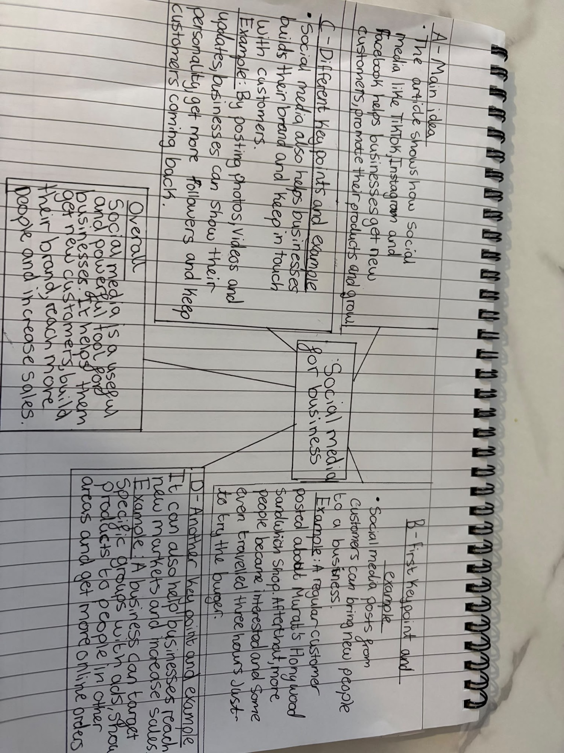
PART 2:
1. What is the main idea of the whole text?
The article shows how social media like TikTok, Instagram and Facebook helps businesses promote their products, get new customers and grow.
2. What is one key point that supports the main idea, and which specific example from the text shows this?
Social media posts from customers can bring new people to a business. A regular customer posted about Murat’s Honywood Sandwich Shop and after that some people travelled three hours just to try the chicken burger.
3. What is a different key point that supports the main idea, and which specific example from the text shows this?
Social media can help a business grow and change the way it works. Linda Hunter started posting videos in the pandemic, moved her clothing business online and now has 320,000 followers on Facebook and Instagram.
4. Which part of the text do you think is most important, and why?
The sandwich shop part is the most important. People travelling three hours just for a chicken burger shows how powerful social media can be and how it can make a small local shop famous quickly.
Reflection:
5. What did you find difficult in this task (including in-class components), and why was it difficult?
I found it hard to pick out the main points from the long article. There was a lot of information, and I was not sure which examples were the most important.
6. What helped you with this difficulty, and how did it help you?
Breaking the article into smaller sections and making a simple mind map helped me. It made it easier to see the main idea and the key examples clearly.

