Mark Wilmore – Student Number – 2319745 – Assignment 1
Essay one – Maintaining Professional Standards
Professional standards within policing are critical to maintain public trust, ensuring positive results and promoting an ethical behaviour. The effectiveness of policing hinges on its ability to balance authority with accountability while safeguarding the rights of individuals. To achieve this Police forces, rely on a number of frameworks, such as the Police and Criminal Evidence Act 1984 (PACE), the Code of Ethics, the National Decision Model (NDM) and the use of Body-Worn Video (BWV). Each of these tools is designed to assist in upholding professional standards, however they are not without their limitations. This essay will explore how these mechanisms are used to enhance professionalism and public confidence, while addressing some weaknesses.
PACE is a cornerstone of policing in the UK, establishing a statutory framework which establishes the powers of the police to combat crimes while protecting the rights of the public. (Home Office, 2013). Its provisions govern key police activities such as stop and search, arrest, questioning and the collection of evidence. By providing clear rules, PACE aims to prevent abuses of power, promote fairness and ensure the admissibility of evidence in court.
One of the most significant contributions of PACE is the emphasis on procedural safeguards. For example, the requirement to inform individuals of their rights under the “caution” upon their arrest ensures transparency and accountability. Additionally, PACE mandates that suspects held in custody are afforded basic rights, such as access to legal representation and regular reviews of their detention. This assists in mitigating the risk of wrongful convictions and misconduct.
However, PACE is not without criticism. For instance, Section 1 of PACE which provides the police with a power to stop and search a person or vehicle where they have reasonable grounds to suspect that they will find prohibited items. (Home Office, 2018) Stop and Search powers have been controversial and remain under the spotlight for the media and general public. Critics argue that this undermines public confidence and reinforces perceptions of institutional bias within policing. This lack of trust stems from an incident in Brixton in August of 1981 that caused national concern. The unrest in Brixton predominately involved young black Britons clashing with the police. The Government commissioned Lord Scarman to undertake an inquiry into the disturbances. The Scarman Report concluded that the disturbances were an outburst of anger and resentment felt by black youths about how they were treated by police. The Scarman Report recommended replacing the SUS laws with new stop and search legislation. (Nickolls and Allen, 2022).
The Code of Ethics established by the College of Policing in 2014, serves as a moral compass for officers, outlining principals such as honesty and integrity, fairness and respect. It provides a framework for ethical decision making and reinforces the public service ethos central to policing. By embedding ethical standards in daily practice, the Code seeks to prevent misconduct and promote accountability. (College of Policing, 2024)
One of the strengths of the Code of Practice is its emphasis on professional responsibility. Officers are required to challenge unethical behaviour and report breaches of professional standards, thereby creating a culture of self-regulation. Furthermore, the Code encourages reflective practice, enabling officers to learn from their experiences and improve their decision making. The decision to issue reflective practice sits with an independent Appropriate Authority (AA) to ensure consistency and fairness in decision-making, with line managers taking a lead on the process. RPRP encourages officers to discuss what has taken place with their line managers whilst exploring opportunities for learning, development and improvement. (Metropolitan Police , 2023)
Despite its aspirational goals, the Code of Ethics faces challenges in implementation. Cultural resistance within some forces can hinder its effectiveness, particularly when informal norms conflict with formal ethical principles. Additionally, the lack of robust enforcement mechanism means that adherence to the Code often relies on individual commitment rather than systemic accountability. This has led to question about whether the Code is truly transformative or merely symbolic.
The National Decision Model is a structured approach to decision making used by police officers. It consists of six key elements: Code of Ethics, information and intelligence, assessment of risk and threat, powers and policy, options and contingencies, action and review. By providing a constant framework the NDM helps officers make informed, transparent and defensible decisions.
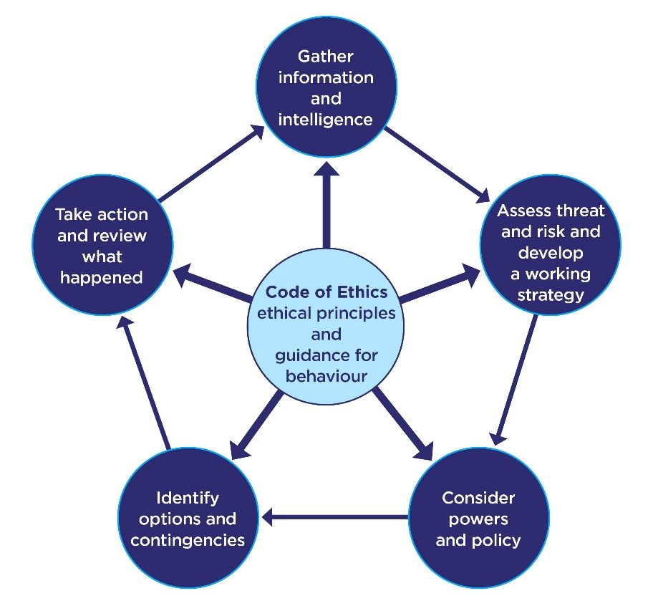 (College Of Policing, 2013)
One of the key strengths of the NDM is its emphasis on proportionality and necessity. For example, when using force, officers must evaluate whether their actions are reasonable and justified in the circumstances. Studies suggest that this structured approach improves accountability and public trust. (Macvean and Neyroud, 2012)
However, the NDM is not infallible. Critics argue that it can be overly reliant on subjective judgment, particularly in high pressure situations. While the model encourages reflection, the quality of decisions often depend on the availability of accurate information and the officer’s training. In cases where intelligence is incomplete or ambiguous, the NDM may lead to inconsistent outcomes.
While PACE, the Code of Ethics and the NDM each contribute to maintaining professional standards, their effectiveness depends on how they are implemented and perceived. Together, these tools provide a robust framework for accountability and ethical practice, but they also highlight the complexities of modern policing.
One of the overarching challenges is the tension between procedural compliance and public perception. Even when officers adhere to established standards, public trust can be eroded by broader concerns about institutional bias, excessive force, or lack of transparency. This underscores the importance of ongoing training, community engagement and independent oversight.
Professional standards in policing are maintained through a combination of legal, ethical and operational frameworks. PACE provides procedural safeguards to ensure fairness and accountability, while the Code of Ethics promotes a culture of integrity and respect. The NDM offers a structured approach to decision making. Together, these tools help build public confidence and uphold the legitimacy in policing.
However, these mechanisms are not without limitations. Issues such as bias, cultural resistance, and resource constraints can undermine their effectiveness, highlighting the need for continuous improvement and adaption. To truly maintain professional standards, policing must be responsive to social expectations, proactive in addressing systemic issues and committed to fostering trust through transparency and accountability. Only by embracing these principles can police ensure that they remain a force for good in a complex and evolving world.

Word Count - 1054

Essay two – Public Protection
Exploitation by criminal gangs is a pervasive issue affecting individuals across various demographics. Understanding the characteristics that render individuals vulnerable to such exploitation is crucial for developing effective prevention and intervention strategies. This essay examines the personal, familial, educational, peer-related and community factors that contribute to an individual’s susceptibility to gang exploitation.
Certain personal characteristics have been identified as increasing a person’s risk of exploitation. Personal characteristics are the qualities or features that belong to a person and make them recognisable (Colins Dictionary). Aggressiveness and early indication of violent behaviour are significant risk factors. Individuals exhibiting these behaviours may be more prone to engaging in delinquent activities, making them attractive targets for gang recruitment (Youth.Gov, 2019). Additionally, experiences of child maltreatment, including abuse and neglect, can lead to psychological trauma and low self-esteem, further increasing vulnerability. Individuals who have experienced this may be enticed by the sense of belonging or want by other members of a gang.
Family dynamics play a pivotal role in an individual’s risk of gang exploitation. Parental criminality or low levels of parental involvement are significant contributors. This ties into the individual chasing that sense of belonging, but also stems from adverse childhood experiences (ACES). Adverse childhood experiences (ACEs) are highly stressful and potentially traumatic events or situations that occur during childhood and/or adolescence (Young Minds, 2018).

(National Lary of Medicine, 2013)
The table demonstrates the correlation between the number of ACES an individual experiences as a child and the criminal offences committed by the individual later in life. This suggest that the more ACES experienced then the greater involvement an individual will have in criminality.
Studies conducted by the BBC have highlighted that “if a child is brought up in a family where there is 'poor parenting' – children unsupervised, parents not spending time with children – or where the parents have problems in their own lives – alcohol dependency or family break-up/divorce – then that child is far more likely to be involved in crime as they become older” (BBC, n.d.).
Academic failure and low educational aspirations are critical factors for gang involvement. Students who struggle academically or feel disconnected from the educational system may experience frustration and diminished self-worth, making gang involvement appear as an alternative path to success.
Research shows that 59% of children that had been permanently excluded from school were cautioned or sentenced for an offence. Of these, 22% were also cautioned or sentenced for a serious violence offence, and 21% were cautioned or sentenced for a prolific number of offences (Education, Children’s Social Care and Offending, 2022). This demonstrates the correlation between the lack of education and a person’s involvement in criminal activities.
Association with delinquent peers is a well-documented risk factor for gang exploitation. Individuals surrounded by peers who engage in criminal activities are more likely to adopt similar behaviours due to peer pressure and the desire for social acceptance. “Peer pressure is the influence that peers have on an individual's behaviour, attitudes, and beliefs. It can be positive or negative, but when it comes to criminal behaviour, it is often negative. Young people are particularly susceptible to peer pressure, as they seek acceptance and approval from their peers. If their peers are engaging in criminal behaviour, they may feel pressure to do the same to fit in” (Tutor Chase, 2023).
The presence of delinquent siblings also increases this risk, as familial bonds can reinforce the normalisation of criminal behaviour. In interviews carried out in 2016 at Polmont Young Offenders Institute, some young offenders described the powerful effect of peers, especially the influence of older young people, while they were excluded (from school) and the sometimes rapid, escalation of substance abuse, violence and offending at that time (BBC, 2024).
Community disorganisation, characterised by poverty, high crime rates and lack of social cohesion, significantly contributes to gang exploitation. Individuals residing in such environments may perceive gang involvement as a means of protection or economic opportunity. In areas such as this the availability of drugs further facilitates engagement in criminal activities.
Another aspect of exploitation is the exploitation of children and young people by criminal gangs referred to as County lines. This is particularly associated to the storage and distribution of drugs, but also relates to money, (in relation to the sale of drugs).
The NSPCC says “County lines is a form of criminal exploitation where urban gangs persuade, coerce or force children and young people to store drugs and money and/or transport them to suburban areas, market towns and coastal towns (Home Office, 2018). It can happen in any part of the UK and is against the law and a form of child abuse.” (NSPCC, 2023)
These gangs use the threat of harm, or harm to loved ones, intimidation, and also threat to vulnerable individuals, often those with mental health issues, or addiction problems, to coerce young people into criminal activity, usually within a specific location, or where the gangs have established their criminal activity.
Often coercing the young people to take the most “at risk” roles, usually transporting/ conveying of drugs or the proceeds of crime. Putting these young people directly at risk of detection as well as distancing the criminal gangs from the forefront of criminal activity and police detection.
A comprehensive understanding of multifaceted characteristics that make individuals vulnerable to exploitation by criminal gangs is essential for developing targeted prevention and intervention strategies. Addressing personal, familial, educational, peer-related, and community factors can mitigate these risks and reduce the prevalence of gang exploitation. Future research should continue to explore these dynamics to inform policy and practice effectively.

Word Count - 925

Essay three – Vulnerability & Risk
Youth offending remains a significant concern for communities in the UK. Through the exploration of various strategies UK forces seek to mitigate the issue. Among these strategies, early intervention has gained considerable attention. This essay will look into the effectiveness of early intervention in preventing youth offending and examine factors that either increase or diminish its effectiveness.
Early intervention encompasses proactive measures aimed at identifying and addressing risk factors that may lead to delinquent behaviour among young individuals. Research indicates that such interventions can be vital in preventing the onset of criminal activities. “Early intervention prevents the onset of delinquent behaviour and supports the development of a youth’s assets and resilience. It also decreases rates of recidivism by a significant 16% when youths go on to engage with the justice system. While many past approaches focus on remediating visible and/or longstanding disruptive behaviour, research has shown that prevention and early intervention are more effective”. (Youth.Gov, 2022).
Furthermore, a review by the UK government highlights that early intervention in youth justice is typically divided into prevention and diversion activities. “Prevention helps stop children becoming involved in crime by helping to address their unmet needs and vulnerabilities and promote positive outcomes – such as supporting them to stay in school or making sure they have a safe home environment” (Hancock, 2023).
Several factors contribute to the success of early intervention programmes. One of these being family engagement. Engaging families in the intervention process ensures that the support system extends beyond the individual, fostering a nurturing environment that discourages delinquent behaviour. “Good parenting is vital to a child’s well-being and is a powerful agent for change in a range of social problems including anti-social behaviour and criminal exploitation. It can increase the child’s confidence and resilience and empower parents and carers in addressing complex issues. Parents are important in fostering and promoting a child’s pro-social identity. Parenting support can reassure parents and carers and help them to understand what ‘good enough’ parenting looks like” (Gov.UK, 2022).
Another factor is community-based approaches. Tailoring interventions to address specific community needs enhances their relevance and effectiveness. Early intervention not only helps the child or young person but the community as a whole. “Successful interventions in the community setting are mostly ones that aim to help child development by tackling risk factors or reinforcing protective factors. Others aim to shape the situations that young people encounter so as to divert them from criminal opportunities.” (Department for Education, n.d.)
Early identification and support is vital as identifying youths at risk at the earliest opportunity allows for timely intervention. “There is compelling evidence that shows us that if we intervene earlier with vulnerable children, then their likelihood of committing an offence is much lower. And in turn this means fewer victims and safer communities for us all” (Hancock, 2023).
There are also a number of factors that can undermine the success of early intervention. One may be the lack of access to services. Families who are faced with poverty often miss out of opportunities and face barriers to early childhood support. “Young children and babies living in low-income households are often the most likely to miss out on early childhood support despite being among those most in need of help” (Lepper, 2024). This could result in young people missing out on opportunities and falling into criminal activity as they grow up.
Another factor is that by identifying a young person as “at risk” and at need of early intervention may push them further into engaging with criminal activities. “A report based on the Edinburgh Study of Youth Transitions and Crime that tracks 4,300 youngsters who started secondary school in 1998, finds “a sharp distinction between those who were identified at an early age as being `at risk’ and those who later became offenders”. One statistic in particular showed how difficult it is to identify future offenders, even by their mid-teens: 76 per cent of violent offenders at 17 had not been referred to either social work or the children’s hearing system by the age of 15.” (Hepburn, 2012)
Another factor is insufficient funding and resources into early intervention services. Limited funding can result in the reduction or disconnection of effective programmes. “With organised crime is a big threat to the UK, it is important to intervene before it’s too late. Research by Action for Children and partners has found that funding for early intervention decreased by 46% between 2010 and 2022, while later intervention spending, including for children in care, increased by 47%. One teenager who had committed almost 600 offences before being referred to the services has not reoffended since being supported by scheme.” (Action for Children, 2019).
Another factor that may undermine intervention is delayed or late intervention. This has a negative effect as young offenders will need further support and guidance compared to youths who had been identified as at risk earlier. Delayed intervention also has an effect on the cost. “Nearly £17 billion per year is spent in England and Wales by the state on short-run Late Intervention, with the largest single items being the costs of children who are taken into care (Looked After Children), the consequences of domestic violence, and welfare benefits for 18–24-year-olds who are not in education, employment or training (NEET). Late Intervention services in the area of child protection and safeguarding account for over a third of the total, followed closely by spending in response to crime and anti-social behaviour”. (Chowdry and Oppenheim, n.d.)
Early intervention emerges as an important strategy in preventing youth offending, with its effectiveness contingent upon various factors. Programmes that engage families, are community based, identify at-risk youths early and are implemented with high quality tend to be more successful. Conversely, challenges such as limited access to services, insufficient funding and delayed intervention can detract from the efficacy of these programmes. Addressing these challenges through comprehensive, well-resourced and timely interventions can significantly contribute to reducing youth offending and promoting positive developmental outcomes.

Word Count - 996
Essay four – Valuing Difference & Inclusion
Within the UK, police forces operate within richly diverse communities, encompassing a multitude of cultures, religions and social backgrounds. When looking at diversity, it is important to recognise this does not just relate to someone’s ethnicity, but also encompasses age, gender, (both gender identity and gender expression), sexual orientation, disability and religious beliefs. Effectively policing such a multifaced populace necessitates not only internal diversification within the police force but also the development of strategies that allow trust and co-operation with various communities. This essay looks at the extent to which UK policing has adapted to accommodate diversity, focusing on both engagement practices and composition of the police workforce.
Efforts to diversify the police workforce have been a focal point in UK policing strategies. The National Police Chiefs’ Council (NPCC) has emphasised the importance of creating inclusive organisations, recognising that a diverse workforce can enhance operational effectiveness and public trust. The NPCC’s diversity, equality and inclusion stratagem (2018-2025) highlights objectives to improve, recruitment, retention, and progression of underrepresented groups within the police force. The NPCC strategy states, “as Chief Constables both individually and as a collective, we recognise the significant work that has been undertaken to embed diversity, equality and inclusion into our workforce and into the services we provide to our communities. However, we recognise there is still significantly more to be done, and we do not underestimate the effort needed to truly embed it within all that we do” (NPCC, 2018). This shows that despite best efforts, they understand that further support and commitment to this strategy is required to achieve their goal.
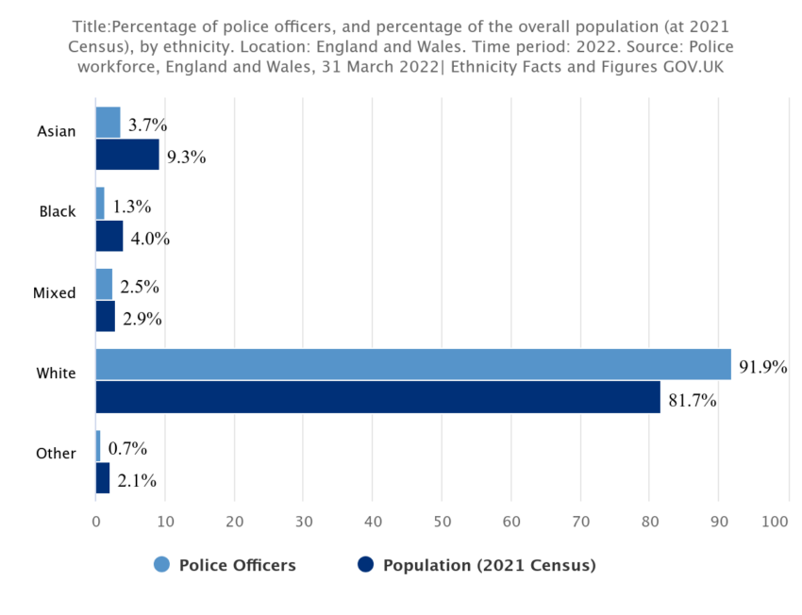
(Government Events, 2024)
The findings above are from Government Events who have identified that the percentage of police officers who are from different ethnic minority groups is significantly lower than the percentage of our population that are made of people from different minority groups. Government Events have developed 5 different strategies that can be used to ensure equality, diversity, and inclusion within UK police forces. These strategies include Recruitment and Retention, Training and Education, Leadership and Accountability, Community Engagement, and Policy and Procedural Reforms. They state that, “by implementing these strategies, the UK police force can make significant progress in advancing equity, diversity, and inclusion. By fostering a more diverse and inclusive workforce, the police force can better serve the needs of all communities, enhance public trust, and contribute to a safer and more equitable society” (Government Events, 2024).
Building trust and effective communication with diverse communities are crucial components of modern policing. The college of policing have developed a number of resources and strategies that police officers can utilise to ensure they are continuing to build trust with our communities and increase public confidence.
Police forces throughout the UK have developed strategies that can be applied in their communities to enable public engagement and develop trust. Strategies have been made with the aim to provide a range of activities, and events that encourage confidence, self-belief and aspiration with a focus on promoting wellbeing and equality for people from diverse communities.
One police force in the UK developed the Peel Street Project. “This aims to promote and celebrate meaningful inclusion of people from black and minority ethnic communities within Hull, and to have a positive impact on the lives of people living within the most deprived and diverse areas of the city. The project was designed to build community cohesion across various diverse communities that resided in the surrounding areas and provide activities for local young people. This initiative improves cohesion within communities – helping neighbours connect through police interventions – and between communities and the police, ensuring they are aware of how the police are there to support them” (College of Policing , 2024).
Another key adaption has been the introduction of equality and diversity training programmes for police officers and police staff. These programmes assist in improving cultural competence, helping officers understand the needs and experiences of diverse communities. Several police forces in the UK have adopted No Boundaries Training, “No Boundaries is a specialist training & management consultancy that specialises in diversity and inclusion awareness and education. Our aim is to help make education and workplaces fairer for everyone by eradicating prejudice and unfairness wherever it exists.” (No Boundaries, 2020).
With the presence of equality and diversity training within police forces, it allows both officers and staff to develop an understanding of the cultural differences within our community. As well as a better understanding of correct terminology and language, to ensure no-one is offended or ostracised. In turn, this allows both officers and staff to engage with our communities and continue to build and develop trust with members of the public.
While UK policing has made strides in adapting to accommodate diversity through various initiatives aimed at diversifying the workforce and improving community engagement, significant challenges remain. The focus on recruitment has not been matched with efforts in retention and progression, resulting in limited diversity at senior levels. Progression has been seen in some UK forces, such as Merseyside Police who implemented policies to support the advancement of underrepresented groups into leadership roles. This has led to an increase in minority ethnic and female officers in leadership positions providing role models and champions for EDI initiatives. However, this is not matched by many UK forces.
Cultural and structural barriers continue to impede the effectiveness of diversity initiatives, and issues such as systemic misconduct and ineffective policing strategies exacerbate mistrust among diverse communities. To achieve meaningful progress, a comprehensive approach that addresses these multifaceted challenges is essential.
Word Count – 921

Reference List
Action for Children (2019). Young People and Serious Organised Crime - How Early Intervention Can Help. [online] Action for Children. Available at: https://www.actionforchildren.org.uk/blog/young-people-and-serious-organised-crime-how-early-intervention-can-help/.
BBC (n.d.). Peer Pressure - Causes and Theories of Crime - Higher Modern Studies Revision. [online] BBC Bitesize. Available at: https://www.bbc.co.uk/bitesize/guides/zdwwt39/revision/5.
BBC (2024). Violent Media - Causes and Theories of Crime - Higher Modern Studies Revision. [online] BBC Bitesize. Available at: https://www.bbc.co.uk/bitesize/guides/zdwwt39/revision/6.
Breslin, G., Mckeown, C. and Groves, R. (2012). Collins Dictionary. Glasgow: Harpercollins.
Chowdry, H. and Oppenheim, C. (n.d.). Spending on Late Intervention. [online] Available at: file:///C:/Users/409304/Downloads/spending-on-late-intervention-how-we-can-do-better-for-less.pdf.
College Of Policing (2013). National Decision Model. [online] College of Policing . Available at: https://www.college.police.uk/app/national-decision-model/national-decision-model.
College of Policing (2024). Ethical Policing Principles. [online] www.college.police.uk. Available at: https://www.college.police.uk/ethics/code-of-ethics/principles.
College of Policing (2024). Peel Street Project – Supporting Diverse Communities through Community Engagement | College of Policing. [online] College of Policing. Available at: https://www.college.police.uk/support-forces/practices/peel-street-project-supporting-diverse-communities-through-community-engagement.
Department for Education (n.d.). Revention and Reduction: a Review of Strategies for Intervening Early to Prevent or Reduce Youth Crime and anti-social Behaviour . [online] Available at: https://assets.publishing.service.gov.uk/media/5a7a36f2e5274a34770e5114/DFE-RR111.pdf.
Education, Children’s Social Care and Offending. (2022). [online] Department of Education. Available at: https://assets.publishing.service.gov.uk/media/6227a9b58fa8f526dcf89e17/Education_children_s_social_care_and_offending_descriptive_stats_FINAL.pdf.
Gov.UK (2022). Case Management Guidance - How to Support Parents and Carers of Children in the Youth Justice System - Guidance - GOV.UK. [online] www.gov.uk. Available at: https://www.gov.uk/guidance/case-management-guidance/how-to-support-parents-and-carers-of-children-in-the-youth-justice-system.
Government Events (2024). 6 Key Strategies: Progressing EDI in the UK Police Force. [online] Government Events. Available at: https://www.governmentevents.co.uk/ge-insights/6-key-strategies-progressing-edi-in-the-uk-police-force/.
Hancock, S. (2023). Early Intervention for Lifelong Benefits. [online] GOV.UK. Available at: https://www.gov.uk/government/news/early-intervention-for-lifelong-benefits.
Hepburn, H. (2012). Early Intervention on Crime May Do Youngsters Harm | Tes Magazine. [online] www.tes.com. Available at: https://www.tes.com/magazine/archive/early-intervention-crime-may-do-youngsters-harm.
Home Office (2013). Police and Criminal Evidence Act 1984 (PACE) Codes of Practice. [online] GOV.UK. Available at: https://www.gov.uk/guidance/police-and-criminal-evidence-act-1984-pace-codes-of-practice.
Home Office (2018). Police ‘stop and search’ powers. [online] GOV.UK. Available at: https://www.gov.uk/government/consultations/police-stop-and-search-powers.
Lepper, J. (2024). Families in Poverty Face Barriers to Early Childhood Support ‘at Every level’, Charities Warn - CYP Now. [online] CYP Now. Available at: https://www.cypnow.co.uk/content/news/families-in-poverty-face-barriers-to-early-childhood-support-at-every-level-charities-warn/.
Macvean, A. and Neyroud, P. (2012). Police Ethics and Values. Los Angeles: Sage.
Metropolitan Police . (2023). Officers with Reflective Practice. [online] Available at: https://www.met.police.uk/foi-ai/metropolitan-police/disclosure-2023/july-2023/officers-reflective-practice-april2021-april2023/.
Nickolls, L. and Allen, G. (2022). Police Powers: Stop and Search. [online] UK Parliament. Available at: https://researchbriefings.files.parliament.uk/documents/SN03878/SN03878.pdf.
No Boundaries (2020). No Boundaries Training & Consultancy. [online] Noboundaries.org.uk. Available at: https://www.noboundaries.org.uk/.
NPCC (2018). NPCC Diversity, Equality and Inclusion Strategy. [online] NPCC, pp.1–16. Available at: https://www.npcc.police.uk/SysSiteAssets/media/downloads/publications/publications-log/2018/npcc-diversity-equality--inclusion-strategy-2018-2025.pdf.
NSPCC (2023). Protecting Children from County Lines | NSPCC Learning. [online] NSPCC Learning. Available at: https://learning.nspcc.org.uk/child-abuse-and-neglect/county-lines?_gl=1 [Accessed 27 Jan. 2025].
Reavis, J., Looman, J., Franco, K.A. and Rojas, B. (2013). Adverse Childhood Experiences and Adult Criminality: How Long Must We Live before We Possess Our Own Lives? The Permanente Journal, [online] 17(2), pp.44–48. doi:https://doi.org/10.7812/tpp/12-072.
Tutorchase.com. (2023). Influence of Peer Pressure on Criminal Behaviour . [online] Available at: https://www.tutorchase.com/answers/a-level/psychology/discuss-the-influence-of-peer-pressure-on-criminal-behavior.
Young Minds (2018). Understanding Trauma and Adversity. [online] YoungMinds. Available at: https://www.youngminds.org.uk/professional/resources/understanding-trauma-and-adversity/.
Youth.Gov (2019). Risk & Protective Factors | Youth.gov. [online] Youth.gov. Available at: https://youth.gov/youth-topics/preventing-gang-involvement/risk-and-protective-factors.
Youth.Gov (2022). Prevention and Early Intervention | Youth.gov. [online] Youth.gov. Available at: https://youth.gov/youth-topics/juvenile-justice/prevention-and-early-intervention?.

