Assignment 1 Management Economics
Coursework: Essay

Lecturer: Taye Osadiya
Module Code: LCBB5008
Student ID:2024471
Student Name: Tsvetelin Brankov

Contents
Introduction 3
Identifying Demand and Market Equilibrium 3
Summary of Demand and Market Equilibrium 5
Intels statistics and graphs 5
Gross Margin 6
Price Elasticity of Demand 7
Summary of Price Elasticity of Demand 8
Recommendations for Intels Pricing Policy 8
Conclusion 8
References 9

Introduction

The Intel Corporation is a powerful titan in the field of technology with a spectacular history that has influenced the modern digital world. Robert Noyce and Gordon Moore founded Intel in 1968, and since then, the company has consistently remained at the forefront of semiconductor research, creating a wide range of devices that have been essential to the development of computers. This coursework attempts to explore Intel Corporation's diverse history while concentrating on its flagship product, microprocessors, and why this decision is crucial to comprehending the company's influence on the technological landscape. With more than $21 billion in annual revenue, the Santa Clara, California-based Intel Corporation is the market leader in producing computer processors for personal computers. When Robert Noyce and Gordon Moore chose to quit the transistor business they had helped build, Fairchild Semiconductor, they created Intel in 1968. Although he didn't make the first investment in Intel, his colleague Andy Grove is regarded as one of the founders. Intel started to make memory chips exclusively for computers rather than compete with the previous firm in the transistor market. They were selling chips successfully by 1971. A microprocessor, which differed from the fixed circuits on a chip in that it could be reprogrammed to do computations, was created by Intel scientists in the same year. The microprocessor, the essential electrical component that powers a computer, has evolved into the "brain" inside of a computer. Over the past three decades, Intel's microprocessors have become smaller, faster, and more affordable, and they are currently dominating the global market (Intel, 2023).

Identifying Demand and Market Equilibrium

Price of Alternatives: Advanced Micro Devices (AMD) is a prominent alternative to Intel's microprocessors. AMD, a significant rival of Intel in the semiconductor market, creates microprocessors with features that are comparable to those of Intel's offerings. Consumers could be more likely to pick AMD goods over Intel's if AMD's microprocessor prices drop, which might result in a drop in demand for Intel's CPUs. In contrast, if AMD's CPU costs rise, customers may switch to Intel's options, which might enhance demand for Intel's goods (PINES, 2023). Microprocessors are enduring, therefore demand is driven by replacement: the market for personal computers in 2004 replacements were made. Increased innovation over the short term widens the quality gap between existing items and new ones, increasing demand and driving up pricing and sales. Prices and sales decline following the upgrade boom as replacement demand declines. Because microprocessors do not physically deteriorate, businesses must continue to innovate to increase replacement demand (Goettler, 2011).
Price of Complements: Building working computers and gadgets using Intel microprocessors need complementary products like motherboards, RAM, and graphics cards, among others. The entire cost of making computers increases if the price of these related commodities rises. Due to the increased overall cost, this might reduce customer desire for computers, which would then have an impact on the market for Intel's microprocessors. To indicate that it won't participate in any ex-post "squeezing" of new entries, Intel seems to rely on three main approaches. First, it signals that it expects Intel and its competitors to both make money in complementary markets and that it will not "suck all the air" out of them by using an internal organizational structure (separate divisions with their own profit & loss operations) and a widely publicized rhetorical device. Second, it makes an effort to minimize entry costs for all possible competitors, mostly but not only through the creation and extensive use of intellectual property. This is done rather than directly subsidizing entrance into complementary industries. Third, by establishing a separate organizational unit (the Intel Architecture Lab or IAL) that is explicitly structured as a cost center and rewarded for its success in "promoting the health of the ecosystem" as a whole or for boosting demand for microprocessors, it attempts to commit to the stability and security of these subsidies as well as, given its frequent entry into markets for interface technologies, to the promise not to change "the rules of the game" in these markets (Annabelle Gawer, 2007).
Consumer Income and Choice: The level of consumer income has a big influence on how popular Intel's microprocessors are. More people have the means to purchase laptops, PCs, and other digital equipment if consumer income is rising. This increase in disposable income may increase demand for technology that uses Intel microprocessors. On the other hand, if consumer spending is declining, the affordability of such gadgets may likewise do so, which might result in an overall decrease in the demand for goods including Intel's microprocessors. Demand for Intel's microprocessors is greatly influenced by consumer tastes and preferences. Consumer tastes are evolving toward products that offer better performance, greater energy economy, and cutting-edge features as technology develops quickly. The rising demand for gaming laptops and high-performance PCs, for instance, shows customers' preference for engaging computer environments. Demand may be greatly impacted by Intel's capacity to match its product offerings with these changing tastes. If Intel is successful in developing microprocessors that satisfy these shifting tastes, it may anticipate a rise in demand as customers turn to its goods (CORPORATION, 2022).
Expectations of Price and Demographics: Current demand for Intel's microprocessors may be influenced by consumer expectations for future price adjustments. Customers may put off purchases if they believe Intel's microprocessor pricing will drop in the future, allowing them to take advantage of reduced costs later. This can cause the existing demand to decline. On the other hand, if customers anticipate future price increases, they can rush to acquire Intel's microprocessors now, increasing the present demand. Based on how customers anticipate future price changes, these expectations may cause changes in demand patterns. The quantity of potential clients and the demographic makeup of the market are important demand drivers. The increased use of technology in daily life and the expanding worldwide population both point to a potential growth in the market for devices utilizing Intel microprocessors. The demand for gadgets like laptops, PCs, and other equipment is projected to rise as more people of all ages and demographics join the digital environment. The demand for Intel's microprocessors may increase as a result of growing consumer spending power (CORPORATION, 2022).

Summary of Demand and Market Equilibrium

There are several variables that affect how much people want Intel's microprocessors. Rising consumer income, complying with consumer preferences, and the expansion of the consumer base can all have positive effects on demand, even though the price of substitutes like AMD's microprocessors, the cost of complementary goods, and consumer expectations of price changes may cause fluctuations in demand. According to the analysis as a whole, depending on how these variables interact and the company's strategic choices, the demand for Intel's microprocessors may be impacted by both rising and falling trends. Consumer tastes and preferences have a big effect on Intel's CPU demand. Intel may increase demand by harmonizing product offers with changing consumer tastes. Furthermore, the interaction of consumer price change expectations and demographic trends might result in dynamic alterations in demand patterns. Intel will need to monitor and change strategy based on these criteria in order to successfully respond to changing market dynamics and maintain a competitive edge. The cost of complements and customer income are important factors in determining demand for Intel's microprocessors. An increase in the price of complements may lower demand for Intel's goods indirectly by increasing the entire cost of acquiring devices. Increased consumer wealth, on the other hand, can boost demand by allowing more people to acquire technological products powered by Intel's microprocessors. A fall in consumer income, on the other hand, might lead to decreased affordability and dampened demand. Intel must actively watch these changes in order to adjust its plans and negotiate future disruptions in demand patterns.

Intels statistics and graphs

The graphics and tables below are presented for the following years 2022 vs. 2021. Revenue in 2022 was $63.1 billion, a $16.0 billion, or 20%, decrease from 2021. CCG revenue was down 23% from 2021 owing to lower consumer and education market notebook and desktop volume, as well as lower revenue from the continuing ramp down from the departure from the 5G smartphone modem business and weaker demand for wireless and connection solutions. Notebook volume fell due to decreasing demand in the consumer and education markets, but ASPs rose as a result of the ensuing product mix. Desktop volume fell owing to decreasing demand in the consumer and education markets, but ASPs rose due to a greater mix of business goods. DCAI sales fell 15% from 2021 to 2022 owing to weaker business server demand and clients moderating orders to minimize current inventories in a weakening data center market. Higher revenue from our FPGA division mitigated some of the decline. Server ASPs fell as a result of customer and product mix. NEX revenue climbed 11% year on year from 2021, led by better Ethernet ASPs and greater demand for 5G products, offset in part by decreased demand for Network Xeon. Mobileye revenue climbed 35% from 2021 to 2022, owing mostly to increasing demand for EyeQ products and Mobileye Supervision systems. The "all other" revenue decreased as a result of $4.3 billion in revenue recognized in 2021 from the divested NAND memory business, for which historical results are reported in "all other," and $584 million in revenue recognized in 2021 from a prepaid customer supply arrangement (CORPORATION, 2022).

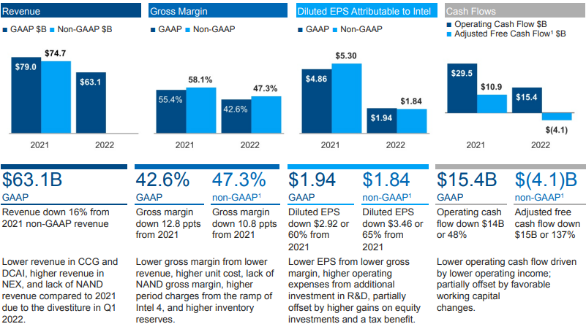
Table 1, Source: (CORPORATION, 2022)

Gross Margin

The sale of items in the CCG and DCAI operating divisions accounted for the majority of Intels overall gross margin in 2022. The company’s entire gross margin dollars declined by $16.9 billion, or 39%, in 2022 compared to 2021, and climbed by $203 million, or almost flat, in 2021 compared to 2020.
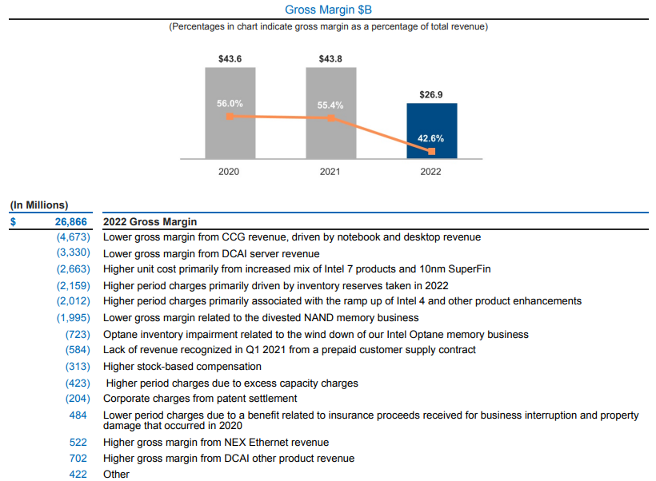
Table 2, Source: (CORPORATION, 2022)

Price Elasticity of Demand

Substitution Effect: Intel's microprocessors are gradually becoming a need rather than a luxury for consumers. As technology improves, the use of microprocessors into daily life becomes more prevalent, highlighting their critical role in employment, education, entertainment, and communication. In this setting, Intel's microprocessor demand is more inelastic. Consumers regard these items as essential and are less inclined to replace them with alternatives, even if the price increases. Intel's microprocessors' fundamental functionality and interoperability with a wide range of applications enhance their essential status, leading to their inelastic demand. Income Effect: The cost of buying of Intel microprocessors accounts for a modest portion of a consumer's entire revenue. While the actual price varies depending on features and model, the microprocessor is often a portion of the entire device cost. In a laptop or desktop computer, for example, the price of the CPU is dwarfed by the whole cost of the system. This property makes Intel's chip demand more elastic. Even slight pricing changes can have a huge influence on the consumer appeal of these items. Because the cost of a microprocessor is just a small fraction of a consumer's income, increases in its price might cause customers to consider alternatives or postpone purchases (Annabelle Gawer, 2007).

Summary of Price Elasticity of Demand

The delicate interaction between substitution effects and Intel's microprocessors' need leads to their inelastic demand. Consumers rely substantially on these microprocessors for vital tasks, making it less likely that they will move to alternatives despite price fluctuations. The income impact, on the other hand, leads to more elastic demand due to the microprocessor's modest fraction of a consumer's income. Consumers are sensitive to price fluctuations since they have a little influence on their entire budget. The price elasticity of demand for Intel's microprocessors is a complex mix of inelasticity caused by need and inelasticity caused by the income impact. Understanding these elements is critical for Intel's pricing strategy, which should take into account both the goods' indispensability and consumers' sensitivity to price adjustments depending on their financial considerations.

Recommendations for Intels Pricing Policy

Based on a thorough examination of the factors impacting demand and the price elasticity of Intel's microprocessors, the company should implement a tiered pricing plan. This technique entails providing several product versions at various price points in order to appeal to both inelastic demand driven by necessity and elastic demand influenced by income concerns. Intel can attract diverse market segments by offering a variety of solutions while maintaining its premium position. This strategy caters to a wide range of consumer tastes and economic levels, maximizing revenue while retaining market share. The tiered pricing model capitalizes on Intel's microprocessors' inelastic demand due to their need, as well as the elastic demand caused by income effects. Intel maximizes its consumer base by offering higher-priced versions for consumers who seek top-tier performance and features, as well as lower-priced choices for budget-conscious purchasers. This method also recognizes that pricing changes affect various consumer groups differently owing to economic discrepancies. As a result, the plan assures that Intel's microprocessors are crucial while still tolerating price sensitivity.

Conclusion

Finally, the detailed examination of Intel's microprocessor demand, market equilibrium, and price elasticity highlights the delicate balance between necessity-driven inelasticity and income-based elasticity. A tiered pricing plan emerges as the best option, allowing Intel to meet a wide range of customer demands, capitalize on the indispensability of its goods, and accommodate consumers' price sensitivity. This strategy secures Intel's long-term revenue growth and market supremacy in the volatile semiconductor industry.

References
Annabelle Gawer, R. H., 2007. Platform Owner Entry and Innovation in Complementary Markets:Evidence from Intel. Journal of Economics and Management Strategy, 16(1), pp. 1-250.
CORPORATION, I., 2022. We are an industry leader, Santa Clara, California: UNITED STATES SECURITIES AND EXCHANGE COMMISSION.
Goettler, R. L., 2011. Does AMD Spur Intel to Innovate More?. Journal of Political Economy, 119(6), pp. 1141-1175.
Intel, 2023. Explore Intel’s history. [Online]
Available at: https://timeline.intel.com/
[Open on 30 08 2023].
PINES, L., 2023. Who Are Advanced Micro Devices' (AMD) Main Competitors?. [Online]
Available at: https://www.investopedia.com/articles/markets/041816/who-are-advanced-micro-devices-main-competitors-amd.asp
[Open on 31 08 2023].

