Holland coast (between Den Helder and Cadzand) (NL)
Problem setting
Coastal erosion is a common feature along the Dutch sandy shorelines. Since 1990 a policy has been adopted that aims at controlling structural erosion mainly through sand nourishments. Although this policy has proven to be successful to keep the coastline at its 1990 position, there is increased concern with regard to the fate of the strategic sediment reserves in deeper water, in view of sea level rise, new claims for sand mining and construction of new harbours (e.g. Maasvlakte 2).
Description of the coastline
The Dutch coastline along the southeast part of the North sea is about 350 km long. The coast can be divided into three regions, viz. the Delta coast in the south, the Holland coast in the centre and the Wadden coast in the north. The coast consists of straight sandy beaches and various large-scale tidal inlet coasts. Large stretches of the coast have dunes that prevent the low lying hinterland (which at many places is below sea level) from being regularly flooded. Where dunes are lacking, sea dikes have been constructed as a flood protection measure.
Application of the Frame of Reference approach
The Frame of reference approach provides a systematic framework for the development and implementation of a policy for coastal management. The application of the Frame of Reference to the Dutch coast is illustrated in the figure below and contains the following elements:
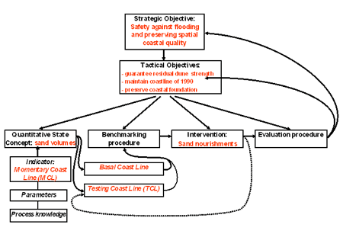
Strategic Objectives
In order to stop any further structural recession of the coastline, in 1990 the Dutch Government adopted the national policy of Dynamic Preservation. The strategic objective of this policy is: a sustainable safety level and sustainable preservation of values and functions in the dune area. This objective was translated into the tactical objective to maintain the coast line at its 1990 position. Considering that morphological developments at larger scales (e.g. sand losses at larger depths and long term developments like seal level rise) are neglected, in 1995 the Dutch Government decided on an extended large-scale approach: additional compensation of sand losses at deeper water. The recent National Spatial Strategy (2004) reconfirmed the strategic objective of the large-scale coastal policy in the Netherlands, rephrasing it as: to guarantee safety against flooding and to preserve spatial quality of the coastal zone. As an additional large-scale tactical objective, the Strategy defined the preservation and improvement of the Coastal Foundation: the area between dunes and the –20 m depth contour. The Coastal Foundation is a new large-scale indicator acknowledging sand as ‘the carrier of all functions’.
In fact the coastal policy of Dynamic Preservation aims to maintain morphological boundary conditions proportional to changing hydrodynamic boundary conditions; as such the objective has been described recently as “growing with sea level”. In this way, safety against flooding of the predominantly sandy coast - primary concern of coastal policy in the Netherlands -, can be guarenteed in a sustainable way.
Tactical Objectives
Strategic coastal policy objectives have been translated into tactical management objectives at three different scales (see Fig. 2).
- Guarantee residual dune strength
- Maintain coastline position of 1990 (basal coast line)
- Preserve and improve coastal foundation
The basic idea behind the distinction into different management scales is that the large scale provides boundary conditions for the smaller scales. The minimum requirement of the dune rest strength creates boundary conditions for safety against flooding at any place and any moment. The maintenance of the Basal Coast Line (BCL) creates boundary conditions for the assurance of the dune rest strength over a period of (10) years and alongshore distances of kilometers. And the preservation of the Coastal Foundation in turn creates boundary conditions for maintenance of the BCL over decades to centuries and over alongshore distances of 10’s to 100’s of kilometers.
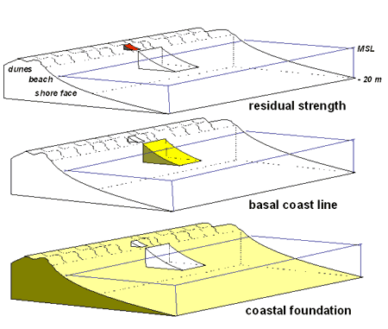
Fig. 2 Definition sketch of three different management objectives: dune residual strength (days – metres); Basal Coast Line (years – kilometers) and Coastal foundation (decades to centuries – 10’s to 100’s of kilometers)
Quantitative State Concept
The first element of the decision recipe for coastline management is an objective assessment of the state of the coastal system.
To guarantee safety against flooding, safety standards have been defined in the Flood Defence Act (1996) : dunes must be able to withstand a storm event with a probability of exceedance of 1 in 10,000 years in the provinces of North- and South Holland. For coastal provinces with less economic value the probabilities are 1 in 4,000, respectively 1 in 2,000 years. A test procedure using a dune erosion model during hydrodynamic design conditions, indicates the strength of the dunes as a flood defence. At the tactical level the objective of the safety policy is to preserve the residual strength of the dunes, defined as the minimal dune volume to withstand the design storm ( Fig. 3).
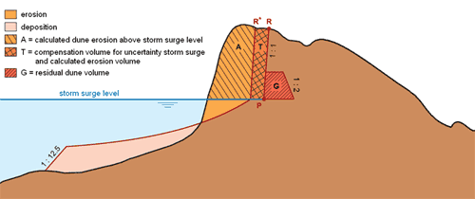
Figure 3 – Cross section of a coastal profile defining erosion and deposition during design conditions, the resulting position of the erosion line (R) and the position of the residual dune volume
To guarantee a sustainable preservation of safety, the concept of the Momentary Coastline (MCL) has been developed, defining the coastline position as a function of the volume of sand in the near shore zone ( see Fig. 4).
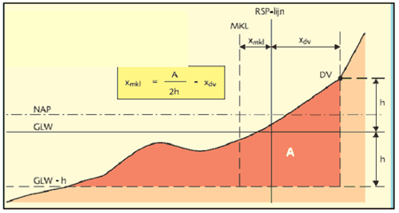
MKL = Momentary Coast Line  DV = dune foot  GLW = mean low water line | A = Momentary Coast Line zone (m²)  RSP = reference line  x = cross shore distance
h = height between dune foot and mean low water line
Fig. 4 Definition sketch of Momentary Coast Line ( TAW, 2002).
The calculation of the MCL is based on data from the Dutch annual coastal monitoring programme JARKUS, which has been operational since 1963. JARKUS measures coastal depth profiles from the first dunes up to 1 km in a seaward direction, at alongshore intervals of 250m (Fig. 5).
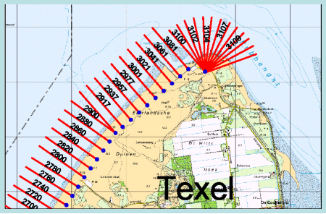
Fig. 5 Alongshore position of yearly coast line observations (250 m intervals)
Benchmarking procedures
A benchmarking procedure was developed, aimed at an objective assessment of erosion problems of a structural nature. For this purpose a predefined reference state needs to be compared with an observed (or predicted) system state.
For the decision of interventions the benchmarking procedure uses two criteria: 1) the position and trend in momentary coastline (MCL) and 2) the sand volume per coastal cell of the coastal foundation (i.e. Delta-, Holland- and Wadden-coast) (see figure 7).
With respect to the position and trend in momentary coast line the following procedure applies: As a standard of reference the Basal Coast Line (BCL), i.e. the position of the coast in 1990, has been defined for each coastal section of 250 m wide. The actual state of the coastline is based on the Testing Coast Line (TCL). The position of the TCL is determined, in a similar way as the BCL, by linear extrapolating the trend of coastline positions (MCL) of ten previous years (see figure 6). The state of the system is compared with the reference state, i.e. by comparing the TCL position with the BCL position. This comparison provides an indication for the need for intervention.
The advantage to use the TCL instead of the MCL is that the decision for intervention is based on a ten year trend instead of the actual position of the coastline in a single year.
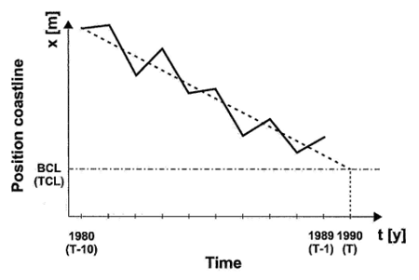
Fig. 6 Definition of BCL ( Basal Coast Line) and of TCL ( Testing Coast Line) by linear extrapolation of a 10 year trend.
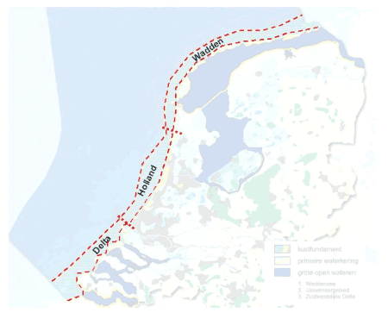
Fig. 7 Coastal cells of the Dutch coastal foundation
The procedure for preservation of the sand volume in the coastal foundation, is based on compensation of the yearly sand losses in the coastal foundation.
Geological information indicates that on a time scale of 50 – 200 years, the coastal foundation may be considered a closed system. Due to this fact, sea level rise has a major negative effect on the active sand volume of the coastal system. This sea level rise effect may be calculated as the product of the area of the active coastal system and the observed average sea level rise over the last century.
Other factors resulting in sand losses of the coastal foundation are sand mining, subsidence due to gas extraction and sediment redistribution towards the tidal basins as a result of major engineering works in the past ( e.g. closure of the Zuiderzee in 1932).
The sum of all losses makes up the total of the required compensation.
Intervention
As stipulated in the policy of Dynamic Preservation, the principal (most preferred) intervention procedure is sand nourishment.
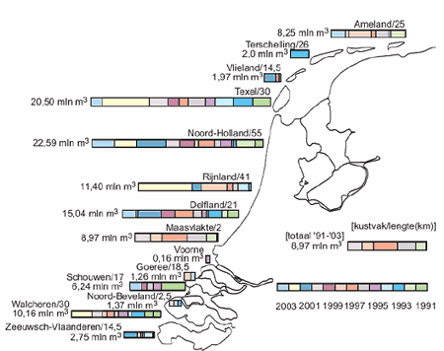
Fig. 8 Sand nourishments along the Dutch coast between 1990 and 2003 (RWS – RIKZ)

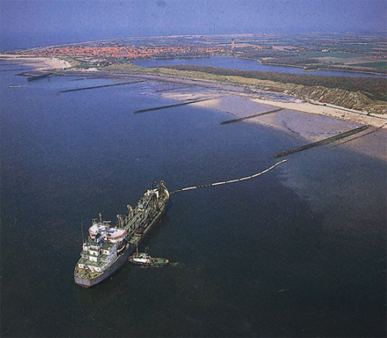
Fig. 9 Beach nourishment at Walcheren ( SW Netherlands).
Evaluation
The Dynamic Preservation policy since 1990, has been succesful in stopping structural erosion maintaining the position of the coast line. The number of locations where the BCL is exceeded has dropped to below 10% per year. The position of the dune foot along the Holland Coast on the average has shifted seaward at a rate of 1 m per year (Koster, 2007; Arens, 2009). The total yearly nourishment volume, 6 Mm3 between 1990 and 2000, was raised to 12 Mm³/year in 2001 in order to preserve the total volume of the Coastal Foundation.
Besides the success of maintaining the Basal Coast Line, the policy evaluation report (RWS, 2006) states some critical remarks: (-) considerations regarding nourishment of the coastal foundation need to be more transparant; and (-) nourishments aimed at functions other than safety against flooding ( e.g. recreation and ecological and natural values) need to get more attention.
Latest insight in the state of the coastal system (De Ronde, 2009) shows that at the present rate of sea level rise ( 2 mm/year), the total sediment loss from the coastal foundation amounts ca. 20 Mm³/year. Apparently, the present 12 Mm³/year is insufficient to compensate for all losses from the coastal foundation. The scale of nourishment will need upscaling in the near future.
In a study on options for climate adaptation of the Netherlands for the coming century, the Deltacommissie (2008; see www.deltacommissie.com) is promoting sand nourishment as the major method to guarantee a climate proof coastal zone, even suggesting a raise of the yearly nourishment volume up to 84 Mm³/year untill 2050, to anticipate a SLR of 13 mm per year. Such a proposal is feasible in light of the fact that no physical limitations exist in availability of sand resources on the North Sea. Spatial reservation for future sand mining of a zone between minus 20 m and the outer limit of 12 miles, must be able guarantee this availability.

