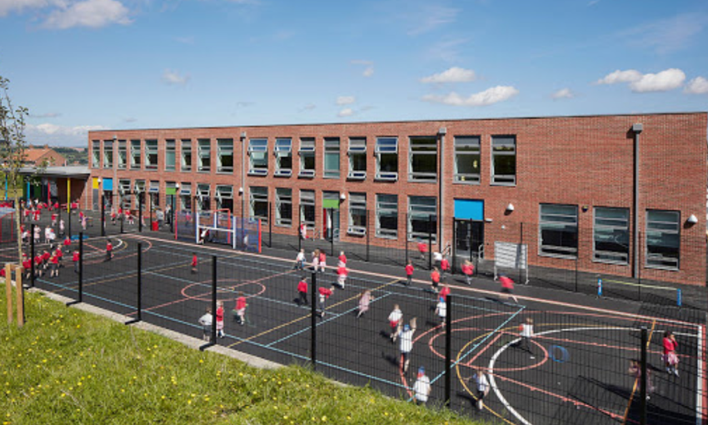

We thank you for taking time to read this information booklet that we made. As a school, we hope that it has given you information that you were not aware of before reading this. Thank you

Ysgol Bro Carfon

Croeso
Welcome

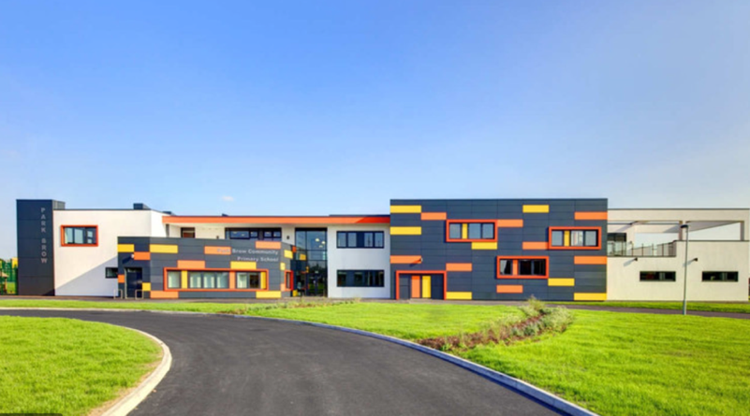

Parental
Responsibilities

It is the parent’s jobs to ensure that their child is supported financially. Because they not only have the right to, but also they have the responsibility to ensure that they are taking care of their child, whether they have parental responsibility or not, for example, guardian, every parent has the duty of care to:
- Provide a safe home for the child
- Protect and maintain the child
Parents/guardians also has the right to ensure they are:
- Disciplining the child in a correct manor
- Choosing and providing for the child’s education, taking the feelings of the child’s into account
- Agreeing to the child’s medical treatment
- Naming the child and agreeing to any change of name
- Looking after the child’s property (www.gov.uk).
Children’s rights. What are they?

- No to discriminate- this states that all children have the equal right to develop and achieve to their potential in all situations. For example, in the classroom. Every child should have equal access and beliefs to education, race, ethnicity, nationality, religion, disability, parentage, sexual orientation. Or anything else that they are entitled to.
Why do children need rights?
- If in a school environment and there are any conflicts, it is the teacher’s job to resolve the issue straight away. However, the best interest of the child needs to be taken into account, as it is. all about the child.
- Development and survival. These underscores the vital importance of ensuring the access to the basic services and to the equality of opportunity in order for children to achieve their full development and to reach their fullest potential. And reach as far as they can. For example, a child with a disability should have an effective access to education and health care. This is to ensure that they are safe and in good care if need.
- Views of the child- Voice of the child is vital as they are the ones that are learning the work that the teacher gives. If they do not enjoy the work, then this may have an impact on their learning as they are too bored to learn, or they lose interest very soon. Their voice must be heard and be respected at all times as it concerns their rights. For example, teachers should be asking the children what they would like to learn before making the decision that will affect them (Childrensrights.ie. (2015)).

- Children have their own set of rights. This is because they are separate and unique to adults. They need special protectors as they are young and may be venerable as they are still developing their maturity. Rights are there to as adults may not take children seriously because of their age, they can also be less articulate than adults (Crae.org.uk. (2017)).


https://acegif.com

Educational Rights

As states in two different articles, article 28 and 29 focuses on a child’s right to an education, the quality and the content of the education. It states in article 28 that the “state parties recognise the right of the children to education”. Article 29 focuses on the aims of education. Within the article, it states the:
- Development of the child’s personality, their talents, mental and physical abilities to their fullest potential.
- Developmental respect for human rights and fundamental freedoms. Also, the freedom and the principles related to the United Nations (www.unicef.org.uk).

The Children’s Rights

What are Children’s rights?...
Children rights are an asset of basic needs that all adults need to ensure they follow. If they do not follow these, then it signals that they are not meeting the child’s needs. These rights exist to ensure that all children are treated properly, but most importantly, treated fairly. And they are given the freedom to develop to their full potential and to reach as far as they want to go.
Children have special rights as they need extra protection that adults do not. This is where the UNCRC comes in. The UNCRC is an international document that sets out all of the rights that children have and are entitled to (lawstuff.org.uk).
The government must ensure that all of the child’s best interests are taken into account when decision making, as it affects the child more than the adult at times. All organisations that work alongside children, for example, teacher or speech therapist, they must all ensure that the work is made in the best way for the children as they can. Depending on the child’s age, the work has to be easy. If a child is four years of age, then the teacher cannot expect them to do year six work.
Another example of a right that children are entitled to is, the child is to be registered at birth. And that the child has a name and a nationality, also that they know who their parents are. Having their birth registered is important as it helps with other rights. For example, access to education and it will also allow the child to vote when it comes to their time (lawstuff.org.uk).

Article 2
- Article 2 is about respect and ensuring the rights are set forth in the present Convention to each child within accordance, irrespective of the child’s or his/her parent’s or legal guardian’s race, colour, sex, language, religion, political or other opinion, national, ethnic or social origin, property, disability, birth or other status. It does not matter what the situation is, they should always be respected and listened to at all times.
- It also states that all appropriate measures must be taken to ensure the child is protected from all forms of discrimination or punishment on the basis of the status, activities, expressed opinions, or beliefs of the child’s parents/legal guardians or other family members (unicef.org.uk).
Article 12
- They must ensure the child is capable of forming their own views on a situation as they have the right to express those views freely in all situations without the feeling of judgement.
- For example, the child is particular be provided the opportunity to be heard in any judicial and administrative proceedings that is affecting them. This can be done either directly or through a representative, in a manner that is consistent with the procedural rules of the national law (unicef.org.uk).
ARTICLE 29
When Education was made, it was made in order to help children develop their personality, their talents and also mental/physical abilities to the max. All of this is to develop the respect children have for their own rights and those of others, respect for their parents, their own culture and others. Also, for the natural environment (Savethechildren.org.uk).
Article 23
Within this article, it does state that every child with any kind of disability has the right to live a decent life to the max as they want to alongside the dignity. To. Go as far as they can, independence and to plan an active role with the community they are part of. The government must ensure that they are providing as much support that they can offer towards children with a disability, also their families, as it affects the family too (www.savethechildren.org.uk/).
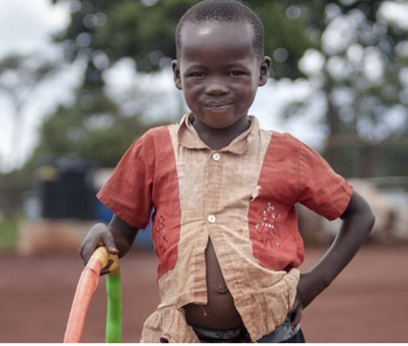
Article 2
Article 2 states that everyone must respect and to ensure that the rights that are set forth in the convention that is present to each child within their jurisdiction without and discrimination, judgement of the child’s nor the parents/legal guardian’s race, colour, gender, language, religion, political views or any other opinion, nationality, ethnic or social origin.

This article is very relatable to the Equality Act 2010. The Equality Act 2010 does provide the basic framework of protection that is against direct and indirect discrimination, harassment and victimisation.
It is also in protection of the services and public functions, premi, work, education, associations and transport (www.gov.uk).
According to Article 2 (www.unicef.org.uk) that is related to disability, each and every child needs to be protected against disability discrimination. There are so
many different types of disabilities in schools.
These can include, autism, wheelchair bound, hearing/speech impediment and so many more as not every disability is visible.
According to (www.bbc.co.uk 2014 assessed 09 July 20) ‘The study found 12% of seven-year-olds with special needs felt bullied all the time, compared with 6% of non-disabled peers’. These percentages are extraordinary as it shows double the children are being bullied as they have some kind of disability which is so wrong as they are not different to their peers.
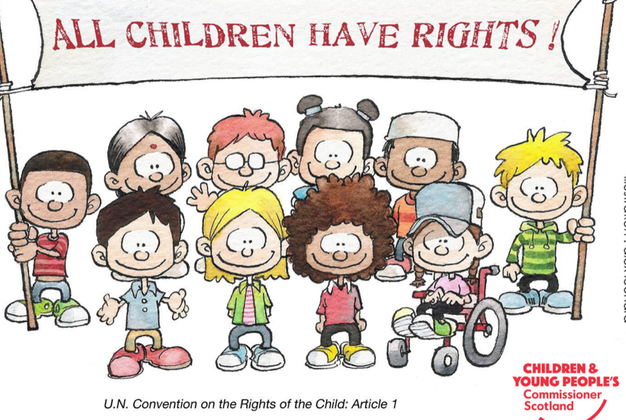

Article 12
Within this article it does state that the child wants to express their own opinions and views have the right to express those very freely without any kind of judgement. In relation to this article, particular, the child needs to be provided the opportunity to be heard and listened to in every situation that affects them. They can either talk about their views themselves, or if they feel like they have not got the confidence to, they can talk to an adult and get the adult to express their opinions on their behalf (unicef.org.uk).
Every opinion the child/young person has, it must be taken into account all the time, not only in schools. But this is also at home with their family members and everywhere else they go. This is vital at any part of their age. No matter how young nor how old, their opinion must be taken into account. On the other hand, the importance of their opinion changes in every situation that does rise. Also, by the time they get more mature, the importance again changes, in accordance to their age (www.cypcs.org.uk).
The UNCRC is an international human right that sets out every child’s entitlement. 31 years ago, the UNCRC was altered and since then it has been ratified by every country in the world, besides USA. In 1991, the United Kingdom ratified the UNCRC, however, it was yet to be incorporated into domestic laws. This states that many of the protections that is contained within it, are not yet accessible to the children/young people within the UK (www.cypcs.org.uk).
However, there is a wider group of rights/articles, that addresses the. Right of. Children to participate, also to influence their understanding of why to participate. This does include the child’s right to seek and receive information to express their own views/opinion and to associate themselves with others www.unicef.org.uk).
This article, article 12, applies to everyone. Care needs to be taken to ensure that it can be exercised by everyone on a day to day basis. For example, different materials need to be placed in measure for children and young people that have a disability to ensure that they can take part too. These are put in place to ensure that they are able to participate. Also, special consideration must be given to children and young people that are in care or if they are a refugee. But most importantly, the opinion of boys and girl must be equal, as there is no gender that are more important than the other.
The importance of this article is to ensure that children/young people are able to express and voice their opinions whenever they feel they want to. It does state that their feelings and opinions will not be dismissed or regarded as an individual because of their age (www.cypcs.org.uk).
The Children and Young People’s Commissioner in Scotland is Bruce Adamson. Adamson and his team, their work is to protect the rights of children. According to Adamson (www.cypcs.org.uk/) ‘the First Minister has committed to incorporation of the united Nations Convention on the Rights of the child into Scots law before the end of the current Parliamentary session in 2021’.
Article 23
Article 23 is the Universal Declaration of Human Rights, it is not only that Schools are supporting children and young people with a disability in the present, but also, they are helping to empower them and also their families for the future.
This Convention is for everyone under the age of eighteen, but of course human rights are for life. As every person have their rights until they die.
The article also underlines that everyone has the right to work, free choice of employment and also, favourable conditions of work and protections against unemployment. Also, everyone without discrimination, has the right to equal pay for equal work. Everyone also has the right to join trade unions for their own protection/interests (www.humanrights.com).

In case parents did not know, here is more information on education…

Article 26
In this article is states that everyone has the right to education.
- In the UK education is free no matter how far the child progresses. However, if the child decides to go to. University, they eventually have to pay back the loans they receive. Technical and professional education shall be made generally available and higher education shall be equally accessible.
- Education shall be directed to the full development of the human personality and to the strengthening of respect for human rights and fundamental freedoms. This is to ensure that it promotes the understanding, tolerance and most importantly, friendship amongst all nationalities, race or religion groups, and shall further the activities of the United Nations.
- However, parents do have the right to choose what kind of education is given to their child. For example, parents have the opportunity to home school their children, send them to private school, or send them to a public school. The decision is theirs. But the child has to receive a proper education as it is their future that is being affected (http://www.claiminghumanrights.org).

Ysgol Bro Caron are more than happy to spread this information with parents/guardians. As a worm, friendly welcoming school, each and every staff member work together to ensure each child has equal opportunities amongst others, but mostly importantly, to ensure that they are happy and excited to come to school.
As a school the staff here are more than pleased to be following these rights, not only as it is law, but on the hand that the school are delighted to and are happy to ensure every child are happy coming to school to learn, but importantly, have fun and build relationships with staff and making new friends.
As a school, Ysgol Bro Caron pride ourselves very highly on the fact that children have fun whilst being in school, as the school believes that every child learn more through play. By this, they are not realising that they are learning as they are having too much fun.

If you have any questions, please do not hesitate to come in and speak to Mrs Catchofield, (Headmistress).
Thank you

References
2020. [online] Available at: <http://www.claiminghumanrights.org/udhr_article_26.html#at28> [Accessed 10 July 2020].
BBC News. (2014). Young disabled 'are bullying victims'. [online] Available at: https://www.bbc.co.uk/news/education-27902500 [Accessed 2020].
Childrensrights.ie. (2015). What are Children's Rights? | Children's Rights Alliance. [online] Available at: https://childrensrights.ie/childrens-rights-ireland/childrens-rights-ireland [Accessed 2020].
Crae.org.uk. (2017). [online] Available at: http://www.crae.org.uk/media/123572/Barriers-and-solutions-to-using-childrens-rights-in-policy-E.pdf [Accessed 2020].
Downloads.unicef.org.uk. (2020). [online] Available at: https://downloads.unicef.org.uk/wp-content/uploads/2010/05/UNCRC_united_nations_convention_on_the_rights_of_the_child.pdf?_ga=2.82177430.1204514837.1582630402-130268758.1581957942 [Accessed 2020].
GOV.UK. (2015).
Policy Hub Scotland. (2020). Children's Rights - Policy Hub Scotland. [online] Available at: https://policyhubscotland.co.uk/in-house/childrens-rights/ [Accessed 2020].
Rights Respecting Schools Award. 2020. The Right To Education - Unicef UK. [online] Available at: <https://www.unicef.org.uk/rights-respecting-schools/the-right-to-education/> [Accessed 2020]. Humanrights.com. 2020. Article 23 Of The Universal Declaration Of Human Rights. [online] Available at: <https://www.humanrights.com/course/lesson/articles-19-25/read-article-23.html> [Accessed 10 July 2020].
Rights Respecting Schools Award. 2020. The Right To Participation For Rights Respecting Schools - Unicef UK. [online] Available at: <https://www.unicef.org.uk/rights-respecting-schools/the-right-to-participation/> [Accessed 2020].
Savethechildren.org.uk. (2020). [online] Available at: https://www.savethechildren.org.uk/content/dam/gb/reports/humanitarian/uncrc19-summary2.pdf [Accessed 2020].
Scotland, C. (2020). Your rights in pictures. [online] CYPCS. Available at: https://www.cypcs.org.uk/rights/picture/children [Accessed 26 Feb. 2020].
Scotland, C., 2020. Article 12. [online] CYPCS. Available at: <https://www.cypcs.org.uk/rights/uncrcarticles/article-12> [Accessed 2020].
Scotland, C., 2020. Incorporation Of The UNCRC. [online] CYPCS. Available at: https://www.cypcs.org.uk/policy/incorporation-of-the-un-convention-on-the-rights-of-the-child-
[Accessed 2020].
Equality Act 2010: guidance. [online] Available at: https://www.gov.uk/guidance/equality-act-2010-guidance#equality-act-provisions-commencement-dates [Accessed 27 Feb. 2020].
GOV.UK. 2020. Parental Rights And Responsibilities. [online] Available at: <https://www.gov.uk/parental-rights-responsibilities> [Accessed 2020].
Lawstuff.org.uk. 2020. What Are Children’S Rights? – Lawstuff.Org.Uk. [online] Available at: <https://lawstuff.org.uk/my-rights/what-are-childrens-rights/> [Accessed 12 July 2020].

