Entrepreneurs and Entrepreneurship World

By Ionela Madalina Saiz

Module: Entrepreneurship (LCMB7004)
Student Number: 1605699
Lecturer: Prof. Dr. Nandish Patel

May 2021

Table of Contents

Entrepreneurs and Entrepreneurship World 0
Introduction 2
Difference between Enterprise and Entrepreneur 2
Most Considerable Models related to Entrepreneurship 2
Theory of Innovation 3
Critical Evaluation 3
Need for Achievement Theory 3
Critical Evaluation 4
Theory of Leadership 4
Lessons learned from Great Entrepreneurs; 6
- Elon Musk 6
- Amazon 6
If I start my Venture as a CEO of a Micro level firm; what I have learned from theories and exemplary experience 7
Contribution of Entrepreneurs in the Execution of Government Policies 7
Government policies effects on Entrepreneurship 7
Entrepreneurship role in an Organization 7
Benefits of intrapreneurship in an organization 8
Empirical Research related to UK Government Regulation; entrepreneurs and Intrapreneurs 8
Discussion and Impact of Regulation 9
Non-profit and profit-Making Organization 10
Contextual Examples 10
Conclusion 11
References 12

Introduction
Entrepreneurship refers to business setups and innovation. It is all about taking steps to create setups to earn a profit under the legal framework of the country. The purpose of this report is to express a clear understanding regarding entrepreneur’s and entrepreneurship. Their importance for the economy as well as for any sector of the country as it has never-ending benefits for the community. The objective of this paper is to critically analyse the theory model, what drawbacks they serve and where they need to combine and work on. The main purpose is to establish finding and understanding considering theories related to entrepreneurship and their relation to organizational success and governmental policies (Audretsch, 2020).

Difference between Enterprise and Entrepreneur
There is a clear and profound difference between these two terms;
- An enterprise is an occupational venture whereas an entrepreneur is a person who starts an enterprise (Shane, 2019). The process of doing the business, planning, innovation, usage of skills, and learning is known as entrepreneurship.
- Entrepreneurs support financial growth by giving creative innovations, items, and organizations (Kwabena, 2019). Extended rivalry from business people moves existing firms to turn out to be more serious. Business people give new positions open doors in the short and extensive pull (Lumpkin, 2015).

Most Considerable Models related to Entrepreneurship
Several different schools of thought have evolved regarding the understanding of entrepreneurship so many different theories emerge. Some of the salient entrepreneurship theories are as following (Emden, 2019):
• Innovation Theory
• Theory of Need of Achievement
• Theory of Leadership
• Physiological Theory
• Economic Theory

Theory of Innovation
The theory of innovation is given by J.A Schumpeter. In this, it is said that an entrepreneur is an innovator that introduces a new idea (Mishra, 2015). This theory covers some important aspects of the business that is new for the consumer; he is not familiar with. The methods manufacture that hasn’t been introduced for long or maybe never are also covered in this theory (Strauss, 2016).
For example, when automobiles were becoming a big part of economy Ford Motor company just focus on providing cheap cars in the market but Alfred Sloan was more focused on retaining customer's relationship and looked for innovation in its product, resulting his company to outgrowing the cheap products of provided by Ford Motors.

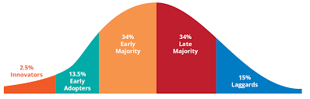
Figure 1 - Theory of Innovation
Source: (Langroodi, 2017).

Critical Evaluation
In the Schumpeterian hypothesis, the principal topic is development. He makes a qualification between a trailblazer and an innovator. As per him, a designer finds new techniques and new materials. Subsequently, pioneering improvement brings the monetary turn of events (Langroodi, 2017). Entrepreneurship adds not only self-governing manufacturers but also managers and subordinates, who are up in advanced function (Reynolds, 2020).

Need for Achievement Theory
This is represented by David. C. McClelland and is related to economic growth and the factors that affect human values, motives that can lead to exploit opportunities (McClelland, 2018).
This theory refers to do well in business but not at a level to make yourself recognize. The people are not much interested much for social recognition. He further says high motivation comes from high standards (McClelland, 2018).
For example, a person who is eager to bring change, and introduce something new into market must have achieved all type achievement in order to be at it full at dull potential, only than this individual can take risk that bring in potential outputs.

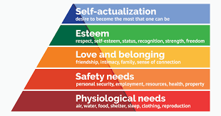
Figure 2 - Need to Achieve
Source: (McClelland, 2018).

Critical Evaluation
The experiential apparatuses of idea used by him are founded to be highly suspected. Moreover, in practice in present days. One thing required to keep under consideration, it is difficult to measure as it works under reinforcing circumstances (McClelland, 2018).

Theory of Leadership
This theory is presented by Hoselitz, and according to him, entrepreneurship is a purpose of executive services and management after considering finance (Timmons, 2015). It elaborates that a person who wants to be manufacturing entrepreneur has more purpose than the drive to make profits like the ability to manage and lead. It further explains three types of leadership (Emden, 2019).
According to theory leadership can be learned but not thought. The closer you get to learning the more you will let open your teammates to this. Learning can make a person leader. Human learn from the experience they get, the hardships they face and the way they get out of them. The more a person experience the more he learns to clear the prospective and vision to him and even others.
For example, Tesla is one of the most prestigious firms in the world recognizes the importance of leadership and how it brings amazing entrepreneurial skill to table hire managers who have leadership skills or give proper training to them to develop leadership skills.


Figure 3 - Theory of Leadership
Source: (Chell, 2020).

Critical Evaluation
Indeed, peripheral men or groups appreciating an abstruse culture and social position having no captivity from ritual express more entrepreneurship expansion. Moreover, it is absurd to say that entrepreneurship is gender-oriented as women are as much capable of bringing in change and bearing risks as men (Evans, 2019).

Importance of Theory of Entrepreneurship with respect to Entrepreneurs

Entrepreneurship theories put light on the behaviour exhibited by the different entrepreneurs. It also provides pathway for understanding the needs of entrepreneurship as well as expresses through evaluation that some people are more entrepreneurial than others. It also gives the concept of developing and managing a business venture in order to gain profit by taking several risks in the corporate world (Evans, 2019).
Entrepreneurial activities assistance makes innovative bounty (Langroodi, 2017). Further the models help us in every regard a lay man person can take guidance from it and make himself better in many ways and also work over their weaknesses (Emden, 2019). This is also to be considered these theories are the foundation that can help us. The entrepreneurial ideas serve the basis to it (Kwabena, 2019). The key abilities that should be available in a business person are motivation, imagination, vision to accomplish objectives, ought to be prepared to face determined challenges, should realize which steps to be taken at the ideal time and where to make changes in procedures (Reissman, 2018). When out of luck, advancement is supposed to be the need expertise for them to have. These skills make a business go for long as it's obvious, ideas without skills are nothing, and skills without ideas. All these elements are important for one another (Timmons, 2015).
Above define theories give us a model that helps to make business successful by using assumptions focused in the theories. Business venture hypotheses bring more prominent comprehension of business conduct displayed by various business visionaries. They empower one to comprehend the requirement for business venture and why a few groups are more pioneering than others.

Lessons learned from Great Entrepreneurs:

Elon Musk
Elon is not only focused on launching profitable businesses; he also has the bigger picture in mind for his enterprises than just making money. In the case of Space X, he wants to pave the way for humanity (not just astronauts!) to explore space. With Tesla, he is hell-bent on inventing completely new and environmentally friendly modes of transportation. To summarise, if you want to improve your thinking, leave aside traditional wisdom and try to see the world through new eyes, using objective evidence and clear-headed observation (Maamoun, 2021).

Amazon
Amazon is an excellent example of a company that has mastered the art of business management. No doubt, Amazon CEO Jeff Bezos always speaks up that in order to become successful entrepreneur, one should always do experiments and become an inventor. He always keeps needs of its customer on the top priority and develop processes. According to Jeff Bezos don’t think about failure is the key to successful entrepreneurship. Its development into what it is today, since its inception in 1994, is remarkable and serves as a valuable management education. It would have been a challenging bet to invest in Amazon based solely on its financial statements, but that isn't very meaningful when evaluating all other criteria that show constant growth (Grimmer, 2021).

If I start my Venture as a CEO of a Micro level firm; what I have learned from theories and exemplary experience
I consider Adaptability, persistence and hard work are the key to success, while starting any business. No doubt, person should be sound enough regarding start-up cost, financial plan, competition, market supply and demand, location and skill staff needs. I have learned to manage my expenses, consider opportunities, be active, show leadership and generate resources. In short, I also evaluate the things that can create hurdle for my business; if I use my mind wisely, taking the things being mentioned in theories and the exemplary people utilizes, I can overcome the limitations on the way. Further, the taxes make me learn that it is better to go for financing by starting a venture as a business partner, when it comes to funding. In this way, I can invest a limited amount of capital and will be able to start a business. If not this, I will borrow money from the close ones rather than going to the bank and taking loans at a high-interest rate. I put great efforts on providing best services to the customers by knowing customers’ needs and experiences for long term success.

Contribution of Entrepreneurs in the Execution of Government Policies
Government plans and programs are made in order to overcome its people problems, who are the real asset of the society. The successful entrepreneurship programs support government in many ways as follows (Lakhan, 2021):
- Executing and creating new job opportunities.
- Eliminating poverty to large extend.
- Promoting self-employment.
- Concentration of economic power.
- Most importantly this step will raise the standard of living.

Government policies effects on Entrepreneurship
The government polices of any country can highly impact on the entrepreneurship activities by fluctuation of the interest rates. If the interest rates rise, the cost of burrowing goes up and causes difficulties for the new business starters. No doubt, higher interest rates also decrease the consumers spending. On the other hand, the lower the interest rates lead the entrepreneurs to invest more, enhance production increases and generate revenue (Bradley, 2021).

Entrepreneurship role in an Organization
It plays important role in the development of any organization by (Zhao, 2021):
- Encouraging investments;
- Stimulate and encourage sense of competition with the competitors;
- Brings change and innovation;
- Create jobs;
- Enhance quality of life;
- Better distribution of income;
- Supports and create path for organizational goals.

Benefits of intrapreneurship in an organization
Organizations that embraced intrapreneurship have achieved higher financial returns, increased productivity, more innovation and higher levels of employee engagement. Intrapreneurs are responsible to perform as a leader and generate new ideas, inspire creativity and motivate other around them to add value to the business. They are responsible for taking proactive steps for improving business operations and ensure business meet targets to produce positive results important for further business promotion (Chouchane, 2021).

Empirical Research related to UK Government Regulation; Entrepreneurs and Intrapreneurs
The UK's competition regime is overseen by the Competition and Markets Authority (CMA). In the United Kingdom, there are approximately 90 regulatory agencies. In a business-driven culture, the UK government has enacted numerous business regulations to protect employees' rights, protect the environment, and hold firms accountable for the amount of power they yield.
Governments impose limitations on various topics, including environmental standards, employment policies, and advertising policies, among others. Promoting local business than international business, they do it by charging (Hart, 2020).
- Giving training to manage the business.
- Giving allowance on an advertisement
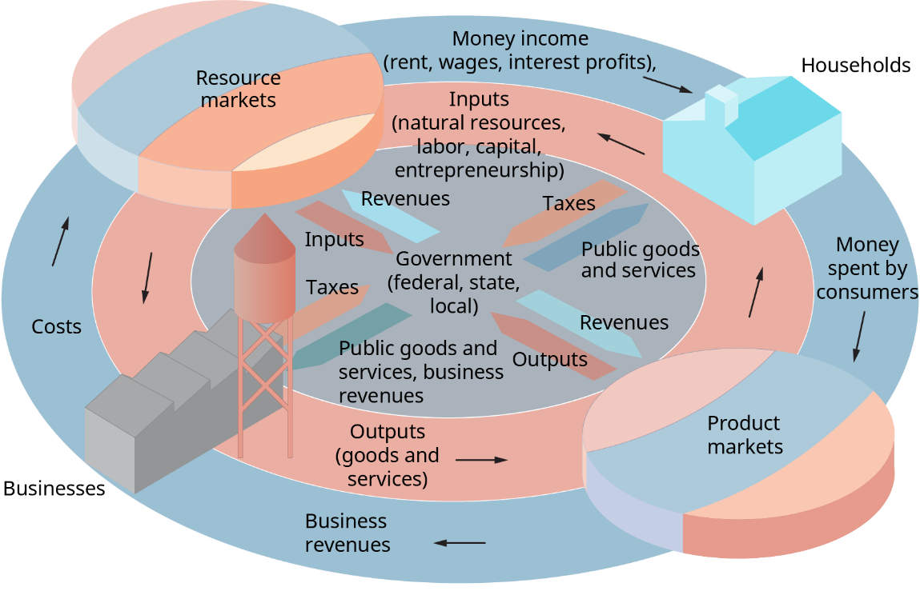
Figure 4:Regulation Chart
Source: (Bhidé, 2018).

Discussion and Impact of Regulation
The experiences of the UK's smallest firms in dealing with the total regulatory burden and summarises, what they said by interacting get to know 500 small firms and discovered that many are struggling to comply with existing regulations. Each new law or modification exacerbates their challenges. Businesses in the United Kingdom have the significant economic force with the capacity to grow even more, yet they face unique regulatory problems. Government of UK presents the following in the report where they give the impact on entrepreneurs, Intrapreneurs and their Ventures (Belitski, 2021).
- According to microbusiness owners, regulations not only stifles their growth but also limits their capacity to pay themselves a fair wage.
- Regulation, according to businesses, is an expensive distraction, with some business owners stating that it has caused them to be unable to pay themselves a minimum wage and to work long hours for little money.
- Furthermore, some compliance expenditures appear to be superfluous and/or redundant.
- Owners and managers are diverted from more economically profitable pursuits.
- Some of them were happy with the regulation, because they could afford the regulation expenses others were not.
- Government strategy can impact loan fees; an ascent wherein builds the expense of acquiring in the business local area. Higher rates likewise lead to diminished purchaser spending. Lower loan fees draw in venture as organizations increment creation. Organizations don't flourish when there is an undeniable degree of swelling.

Non-profit and profit-Making Organization
Those organizations that works for the wellbeing of society by funds collection is known as Non-Profit Organizations e.g.; NGO’s working in UK, whereas the organization that contribute in the economy by making money is known as Profit Making Organizations, such as Amazon, Tesla, different cafes.

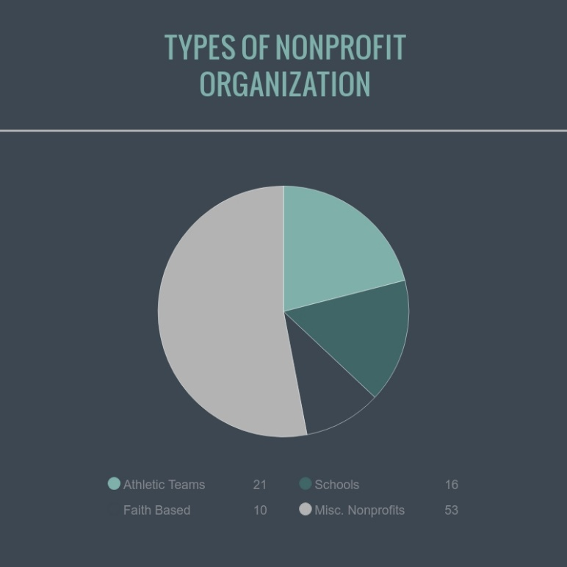
Figure 6- Non-Profit Organizations
Source: (Tariq Mehmood, 2019).
We can take help by these two organizations, we start a business that helps in wellbeing for people, like introducing products and services that helps them. Thus, well-being and profit both runs side by side. Secondly a business I will start with CSR that helps the satisfaction of consumers that what they buy, a part of it will contribute to the well-being by donations.

Contextual Examples
Firms those serve themselves for humanity without any interest of returns are known as non-profit making firms as their core motive is to provide shelter, humans right, water to the underprivileged people and to do good for the society (Bhidé, 2018).
A company like Tesla, Amazon, etc., provides good services to the customers and are good examples of profit-making organizations as their core motive is to generate more sale and earn profits.

Conclusion
No doubt, entrepreneur psychology makes more difference as it describes the approach and vision of the complete business towards progress. It may contribute to immense failure or success at the same time. Every theory has its importance, powers that make it different from others. And obviously, they have limitations that are different from others.
We should learn from great business Man like Elon Musk on what things we should work on. The best thing an entrepreneur can consider is to make all the theories a throughout and consider work on it as a combination to minimize the possibility of the lacks. Further, Profit and non-profit organizations have different worth according to every entrepreneur out there. The most important thing is that we must learn to consider the different views and further work on the limitations. The impact of regulation makes us work on what to invest or not.

References

- Audretsch, D. a. M. P., 2020. Democracy and entrepreneurship. Entrepreneurship Theory and Practice, p.1042258720943307.
- Belitski, M., 2021. Frank Knight, uncertainty and knowledge spillover entrepreneurship.. Journal of Institutional Economics..
- Bhidé, A., 2018. The Origin and Evolution of New Businesses., New york: Oxford University.
- Bradley, S. K. P. K. P. M. J. a. W. K., 2021. Policy for innovative entrepreneurship: Institutions, interventions, and societal challenges. Strategic Entrepreneurship Journal, 15(2), pp.167-184.
- Chell, E., 2020. Entrepreneurship: Globalisation, London: Innovation and Development.
- Chouchane, R. F. C. A. S. a. Z. S., 2021. Organizational support and intrapreneurial behavior: on the role of employees' intrapreneurial intention and self-efficacy, pp.1-17.. Journal of Management & Organization.
- Emden, C., 2019. Conducting a Narrative Analysis. Collegian, 5(3), pp. 34-39.
- Evans, J., 2019. Enterprise and small business; principles, practice and policy. third ed. England: Pearson.
- Grimmer, L. M. G. a. G. M., 2021. What’s next for Amazon after Jeff Bezos? No dramatic changes, just more growth and optimisation. The Conversation..
- Hart, M. B. K. P. N. R. A. L. J. a. M. S., 2020. Global Entrepreneurship Monitor: United Kingdom 2019 Monitoring Report.
- Kwabena, N., 2019. Entrepreneurship theories and Empirical research. Entrepreneurship, 6(1), pp. 90-100.
- Lakhan, G. S. B. a. C. A., 2021. Problems and restrictions perceived by the potential entrepreneurs in a developing context. Psychology and Education Journal, 58(5), pp.3102-3110.
- Langroodi, F. E., 2017. SCHUMPETER'S THEORY OF ECONOMIC DEVELOPMENT: A STUDY OF THE CREATIVE DESTRUCTION AND ENTREPRENEURSHIP EFFECTS ON THE ECONOMIC GROWTH. Historical and Normative Foundations of Economics, 2(1), p. 70 89.
- Lucy, T., 2017. Entrepreneur ; how to start small business. 1 ed. England: Capstone Publishing Ltd.
- Lumpkin, G. a. G. G. D., 2015. Clarifying the Entrepreneurial Orientation Construct and linking it to performance. Academy of Management Review, 21(1), pp. 135-172.
- Maamoun, A., 2021. Elon Musk and Tesla: An Electrifying Love Affair. SAGE Publications: SAGE Business Cases Originals.
- Manalel, J., 2015. Evolution of Entrepreneurship theories through different schools of thought. Ahmedabad, Joseph Cherukara.
- McClelland, D., 2018. The Achieving Society., Van Nostrand: Princeton.
- McClelland, D. a. D. C. W., 2018. Motivating Economic Achievement, Newyork: Free Press.
- Miller, D. a. P. H. F., 2019. Archetypes of Strategy Formulation. Management Science, 24(9), pp. 921-933.
- Mishra, R. K. Z. a. C., 2015. The Theory of Entrepreneurship. Entrepreneurship Research Journal, 5(1), pp. 4-9.
- Reissman, C. (., 2018. Narrative Analysis. London, Sage Publications.
- Reynolds, P. D. S. M. C. .. D. B. E. A. a. M. H., 2020. Global Entrepreneural Monitor, kansas: Kauffman Centre for Entrepreneural Leadership.
- Shane, S. E. L. a. C. J. C., 2019. Entrepreneurial Motivation. Human Resource managment Review, 5(2), pp. 240- 271.
- Strauss, A., 2016. Qualitative Analysis.. Newyork, Cambridge University Press.
- Tagiuri, R. a. J. D., 2016. ” Family. On the Goals of Successful Family Companies, 5(1), pp. 43-65.
- Tariq Mehmood, D. M. T. A. a. H. M. A., 2019. SCHUMPETERIAN ENTREPRENEURSHIP THEORY: EVOLUTION AND RELEVANCE. Academy of Entrepreneurship Journal , 4(1), pp. 1-10.
- Timmons, J. A., 2015. A Guide to Entrepreneurship. 4th ed. Homewood: Irwin.: New Venture Creation.
- Zhao, D. T. F. S. X. a. Z. D., 2021. The Effects of Entrepreneurship on the Enterprises’ Sustainable Innovation Capability in the Digital Era: The Role of Organizational Commitment, Person–Organization Value Fit, and Perceived Organizational Support. Sustainability, 13(11), p.6156.

