Managing Projects in the Organisation

Introduction

The COVID-19 pandemic has been the source of much change in all aspects of the populations personal and working life since last year.
With the measures taken by the government, such as temporary closures of schools, shops and offices, in order to stop the spread of the virus, people had to adapt their behaviours to the coronavirus’ restrictions, having less contact between friends and colleagues.
Consequently, the work environment has moved into the home and has therefore changed the normal organisational routine, in terms of private life and teamwork communication.
In regard to the interaction within companies in this pandemic period, communication technology platforms such as Microsoft Teams and Zoom have been developed and popularised to facilitate this process remotely from home out of the necessity for businesses to continue to run.
In the described picture, the companies have also had to adapt to this new change of system, pledging to keep their employees involved and motivated in their job and goals.
Therefore, it is a challenge for the project manager to preserve high quality communication amongst the team and deliver the task with them, in order to complete it and obtain productive results for the success of the company itself.
This report analysed the organisation Zalando, an online fashion platform which is based in Berlin. Zalando launched a new project in 2019 called do.More, it is divided in three main goals: reduce carbon emissions, recycle packaging and recycle fashion clothes. Their objective is to become the biggest sustainable fashion e-commerce company in 2023.
The report analysed the recycle fashion clothes cycle and in light of this, the aim of the paper is to show how a project manager has to plan and organised the work through the use of techniques like the Work Breakdown Structure, Gantt chart and Network diagram. Consequently, they can identify the critical path in order to be able to calculate the durations of the project and in the end, it explained how these tools helped the project manager to keep track and monitoring the progress of the tasks and how these are helpful in the COVID-19 scenario.

W.B.S.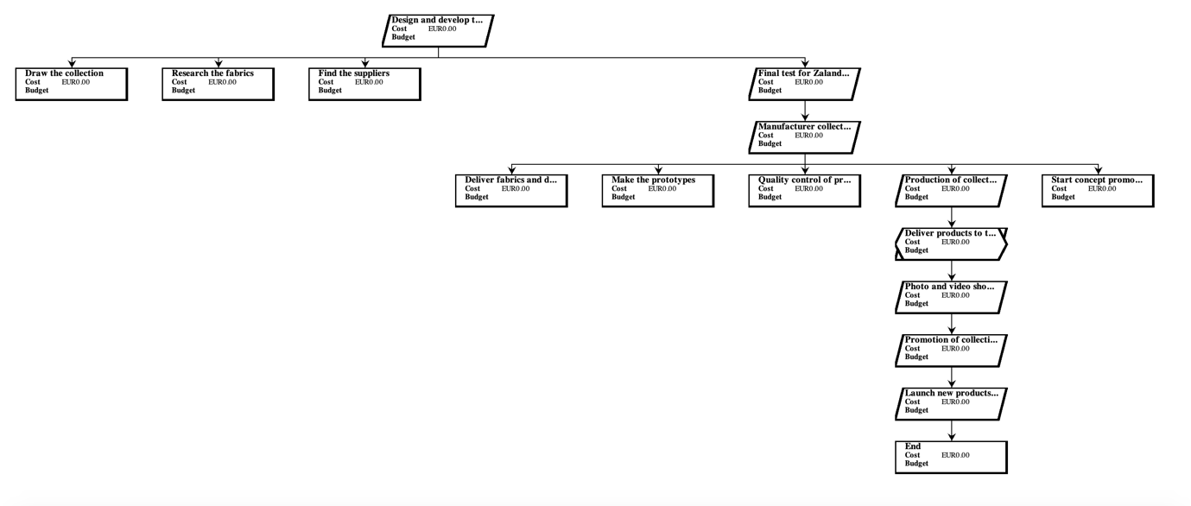

Task  Identifier | Task Description | Predecessor  Tasks | Time (days)
1 | Zalando Sustainable Clothing Collection |  | days
2 | Design and develop the collection | 1 | 67 days
3 | Draw the collection | 1 | 60 days
4 | Research the fabrics | 1 | 30 days
5 | Find the suppliers | 1 | 20 days
6 | Final test for Zalando  Sustainable standards | 3,4,5 | 7 days
7 | Manufacturer collection | 2,6 | 48 days
8 | Deliver fabrics and designs to factory | 6 | 1 day
9 | Make prototypes | 8 | 10 days
10 | Quality control of prototypes | 9 | 7 days
11 | Production of collection | 10 | 30 days
12 | Start concept promotion | 10 | 20 days
13 | Delivery products to the Zalando storage and distribution warehouse | 7,11,12 | 1 day
14 | Photo and video shoots of collection to create contents | 13 | 7 days
15 | Promotion of collection | 14 | 20 days
16 | Launch new products in Zalando e-commerce | 15 | 1 day

Gantt Chart

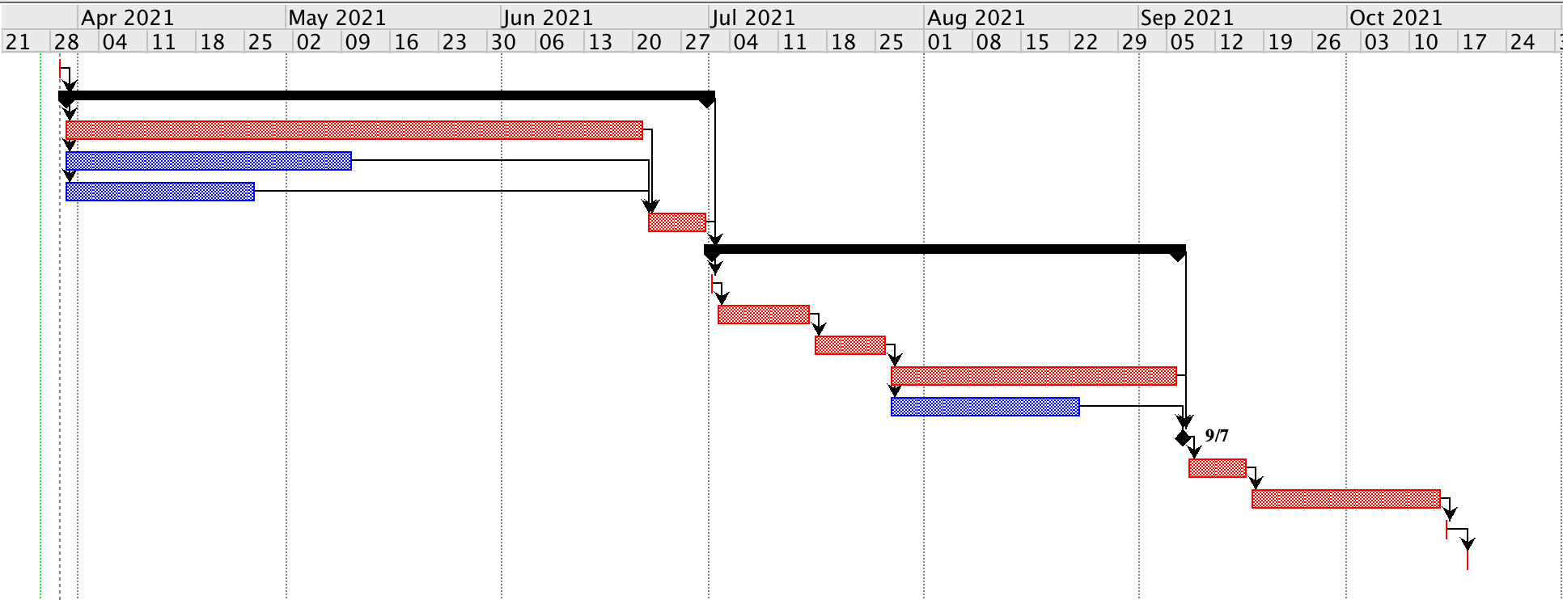

Network Diagram



