Marketing Channels

Student Name : Maria Manita
Student ID: 2227591
Teacher Name: Gayathri Mudiyanselage
Module: Marketing Essentials BMIH4005

Table of Contents
Component 2 3
Introduction 3
Situational analysis 3
SMART objectives 5
Strategy 5
Tactics 6
Gantt chart 7
Control 7
Conclusion 7
References 8
Appendices 9
i. SWOT 9
ii. PESTEL 9
iii. Perceptual positioning map 10
iv. Bowman clock’s strategy 10
Component 1 11

Component 2

Introduction
The main objective of this marketing plan is to explore a new marketing way for gathering more customers for the Premier Inn hotel. This essay will discuss the way of using social media platforms for letting guests book hotels in advance. That is why divergent key frameworks will be used including SOSTAC, marketing mix, Bowmans, and so on.

Situational analysis
The overall situation of Premier Inn hotel consists of 5 C’s. Such as:
Company
A micro-analysis is an internal analysis that can be conducted via SWOT analysis because this SWOT can help explore strengths, weaknesses, opportunities, and threats.
-Company: SWOT analysis
Strengths: It requires an ideal geographical location and represents a great first impression inside. Besides, its brand value can support reflecting the parent company’s portfolio with effective value. It has a great presence that insists on conducting customer-focused advertisements.
Weaknesses: It has an image of being low because of the absence of proper initiative and consideration of peak times as well as leisure travelers (Dutton, 2014). It does not require any up-to-date exterior.
Opportunities: It indulges in offering lots of facilities and price matches can be a good way to get more customers. That is why it is looking for the time of extending services (Premier Inn Hotel, 2023). Non-business loyalty programmers and efficient advertisements for bars or restaurants can support exploring market opportunities for this business.
Threats: Due to the economic recession, this hotel may get affected significantly. It requires some bad image or reputation due to some particular customers. The competition has increased the quality and service’s effectiveness. Besides, threats of potential new entrants are high.
-Customers: Customers’ profile’s similar web:
The global rank of this business is now 774,500 and, in the UK, 36,811 where the category ranks 183. Total visits 591,000. The bounce rate is 38.71% and it is experiencing 2.64 pages per visit (Premier Inn Hotel, 2023).
-Competitors:
Perceptual positioning map
From the map (attached in appendix), the close competitors of Premier Inn are ibis hotel and easyHotel. These competitors provide similar services at cheaper costs (Makhlouf, 2022). But Holiday Inn provides high-quality services but they are quite expensive.
Bowman’s strategy clock
From the graph (attached in the appendix), it is observed that Premier Inn follows a particular model that is called the integrated model consisting of the ownership of property, hotel operations, brand, and efficient inventory (Bhasin, 2019).
-Collaborations
In collaboration with Novus and other suppliers, Premier Inn focuses on supporting young adults with learning difficulties (Phillips, 2023). It has many sub-brands including Beefeater, Brewers Fayre, and Bar + Block.
-PESTEL
Political: Brexit restricts importing materials from EU member countries; Government incentives support overcoming critical situations, but the War affects the global operations of Premier Inn.
Economic: Increasing inflation rate affects the current demand and supply; the decline in currency value may support hiring employees at low cost; the increasing unemployment rate can be resolved but this hotel can terminate many employees; price level will go up that may affect purchasing power.
Social: Changes in taste patterns, demographic issues, social needs, and status need to be considered (Jobber & Ellis-Chadwick, 2020).
Technological: Digital marketing, Wi-Fi, internet, modern equipment and facilities, and so on are in high demand in the hotel.
Environmental: CSR activities, environmental campaigns, and emission of CFC from AC, refrigerators, etc. can increase the brand image of Premier Inn.
Legal: The Employment Act, environmental regulation, national minimum wage act, etc. are major legislative issues.
-Marketing mix
Product/Services: Hotel room services are the value proposition that is available here and there in the UK.
Price: value-based pricing for which guests will pay for the services.
Place: In the UK, it has 800 branches.
Promotion: social media, email marketing, blog marketing, video ads, digital boards, sponsorship, partnerships, etc. are major promotional issues of this business.

SMART objectives
This marketing project for Premier Inn Hotel aims at increasing social media followers and for this, it will focus on increasing followers by 4,500 which requires uploading different content, and video ads on different social media platforms, especially on Facebook, Instagram, TikTok, LinkedIn, and YouTube. Last time, website views have been increased by 5,000 that have supported raising sales turnover. This entire objective will be obtained by the end of September 2023.

Strategy
Value proposition
This business’s new value proposition can be the social media platforms because these platforms require a large audience that can support reaching many targeted customers (Jobber & Ellis-Chadwick, 2020). Besides, social media booking rooms can be a unique way of having guests in hotels.
Ansoff Marketing Mix
Considering the overall conditions and situations of the hotel, this business cannot develop the market or enter the same market with the same products or services (Kotler & Armstrong, 2020). Besides, a diversification strategy can be a risky project for this business. That is why a product development strategy can bring fruitful results for this business. In this case, it can utilize social media platforms for increasing followers and the option for booking rooms via social media.
For overcoming the bad reputation of some customers who provided poor ratings, social media learning, and services will be grabbed. This can help the hotel to ensure frequent and continuous interaction with the customers.
In the case of the distribution channel, there will be no change in the old channels; rather, a new channel will be added for increasing more guests for the hotel.

Tactics
RACE communication mix
Reach: It is required to build awareness on other sites and in offline media and drive to web presence. Social media awareness will be easier of getting more customers.
Act: It is required to engage the audience with the brand on the hotel’s website. But in this case, social media platforms will also be considered (Clow & Baack, 2022).
Convert: It is required to acquire conversion to marketing objectives, like fans, leads, or sales on the web presence and social media activity.
Engage: In this case, relationships between the customer and the hotel will be built up via time to acquire retention objectives.
Implementation of strategies
Among four marketing mixes, a promotional mix will be developed. In this case, social media marketing will be sharpened. Besides, a new distribution channel will be developed on this platform (Czinkota et al., 2022). This will be done by investing in the social media market that will insist on creating more digital content, videos, and posts.

Gantt chart
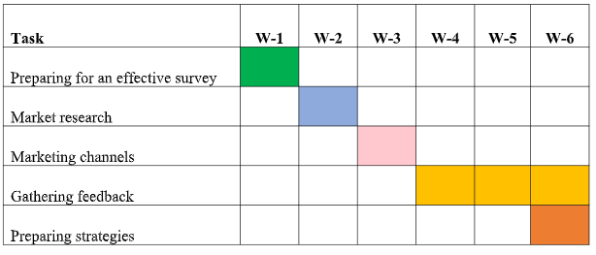
Justification: Within six weeks, the entire marketing issues will be considered that will be started from preparing a survey to the preparation of the ultimate strategies, like social media marketing strategies.

Control
USP: This number of viewers, subscribers, followers, and emotion providers and their activities will determine the success rate for this business. The more viewers intend to book rooms via social media, the higher will be the sales turnover for this hotel (Czinkota et al., 2022). In this case, the unique selling point will be the facility of booking rooms via social media and the original website of the hotel. The most interesting thing is that there will be distinct regional pages for this hotel that can control and track the overall operations and functions.

Conclusion
Marketing essentials are quite mandatory for any new or established business because their effective usage can bring the ultimate objective of the business. That is why this essay has discussed the overall concept of Premier Inn and its relative marketing strategies that will be obtained by the end of October 2023.

References
Bhasin, H. (2019) What is Bowman’s strategy clock? Marketing91. Available at: https://www.marketing91.com/what-is-bowmans-strategy-clock/ (Accessed: 19 May 2023).
Bowie, D. et al. (2017) Hospitality marketing. 3rd edn. London: Routledge.
Brotherton, B. (2013) ‘Hospitality and hospitality management’, Key Concepts in Hospitality Management, pp. 60–63. doi:10.4135/9781526435606.n14.
Chaffey, D. et al. (2019) Digital Marketing. 7th edn. Harlow: Pearson.
Clow, K.E. and Baack, D. (2022) Integrated Advertising, promotion, and Marketing Communications. 6th edn. Harlow, England: Pearson.
Czinkota, M.R., Ronkainen, I.A. and Cui, P. (2022) International Marketing. Boston: Cengage Learning.
Dutton, M. (2014) Premier Inn Newcastle SWOT analysis, prezi.com. Available at: https://prezi.com/tnqj7y7wekro/premier-inn-newcastle-swot-analysis/ (Accessed: 19 May 2023).
Jobber, D. and Ellis-Chadwick, F. (2020) Principles and practice of Marketing / David Jobber and Fiona Ellis-Chadwick. 9th edn. Maidenhead: McGraw-Hill Higher Education.
Kotler, P. and Armstrong, G. (2020) Principles of Marketing. 8th edn. London: Pearson.
Kotler, P., Kartajaya, H. and Setiawan, I. (2017) Marketing 4.0 moving from traditional to digital. Hoboken: John Wiley and Sons.
Makhlouf, A. (2022) ‘Impact of management information systems on hotel management’, Gostinichnoe delo (Hotel Business), (8), pp. 512–515. doi:10.33920/igt-2-2208-03.
Phillips, D. (2023) Collaboration with premier inn to provide ‘premier’ hotel rooms at Hereward College, BRCS. Available at: https://brcs.co.uk/collaboration-with-premier-inn-to-provide-premier-hotel-rooms-at-hereward-college/ (Accessed: 19 May 2023).
Premier Inn Hotel (2023a) Premier Inn Hotels: Book Direct, Premier Inn Hotels | Book Direct. Available at: https://www.premierinn.com/gb/en/home.html (Accessed: 19 May 2023).
Premier Inn Hotel (2023b) Website traffic - check and analyze any website | Similarweb, Similar Web. Available at: https://www.similarweb.com/ (Accessed: 19 May 2023).
Ryan, D. (2017) Understanding Digital Marketing: Marketing Strategies for engaging the digital generation. London, England: Kogan Page.

Appendices

i. SWOT
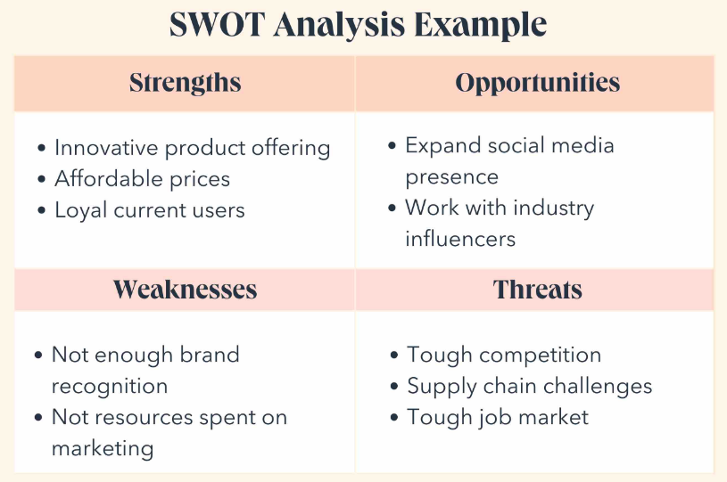

ii. PESTEL
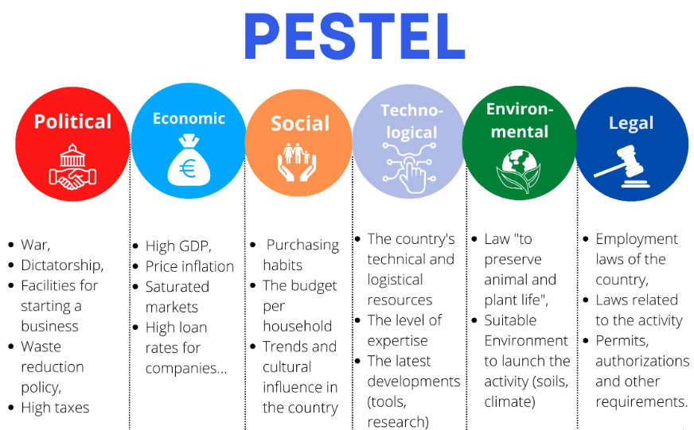

iii. Perceptual positioning map
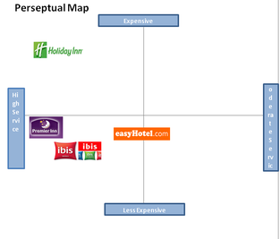

iv. Bowman clock’s strategy
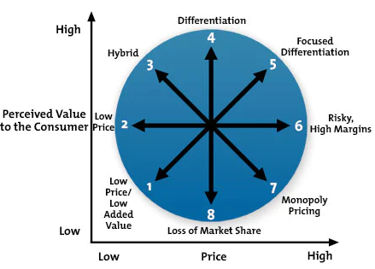

Component 1
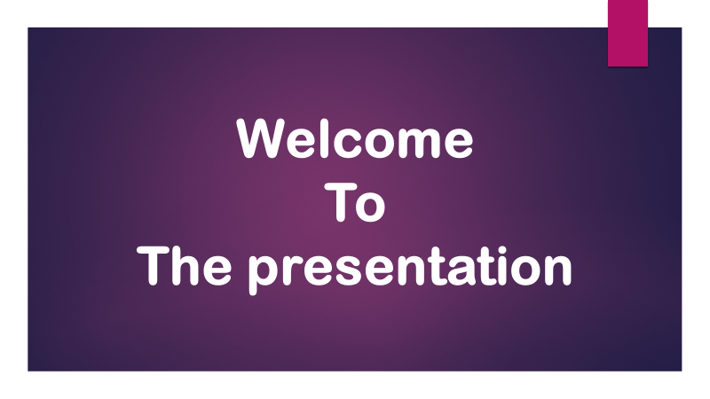
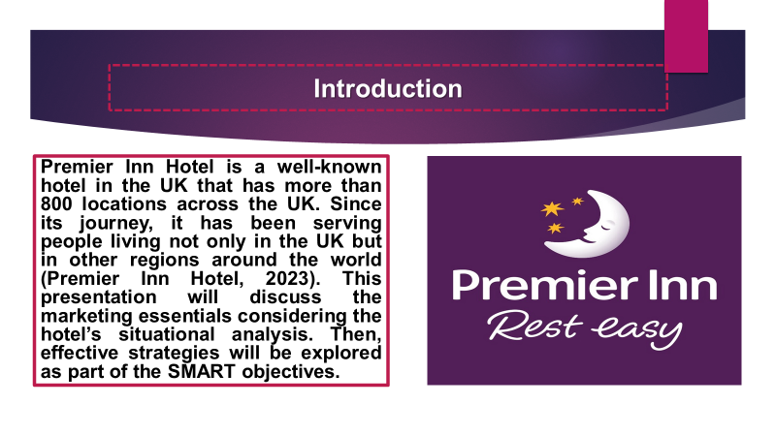
Note
Premier Inn Hotel is a well-known hotel in the UK that has more than 800 locations across the UK. Since its journey, it has been serving people living not only in the UK but in other regions around the world (Premier Inn Hotel, 2023). This presentation will discuss the marketing essentials considering the hotel’s situational analysis. Then, effective strategies will be explored as part of the SMART objectives.
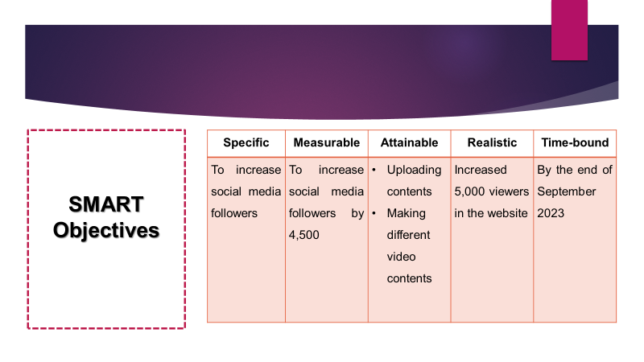
Note
The marketing essential of Premier Inn aims at maximizing the social media followers and implementing an approach for allowing customers to give social media bookings. That is why it has targeted to achieve 4,500 followers on its divergent social media pages. For implementing and acquiring this issue, different and relative contents will be uploaded. Besides, divergent video content will be created. In the past, it has gained 4,000 viewers by strengthening and developing the website of Premier Inn. Overall, the main purpose will be accomplished within September 2023.

Note
Situational analysis: SWOT
Strengths: Geographical locations, brand value, great presence, and customer-focused activities are the major strengths of this hotel (Dutton, 2014).
Weaknesses: There is an absence of proper initiative, peak time, leisure travelers, and so on (Premier Inn Hotel, 2023).
Opportunities: It can technologically advanced hotel and explore the target market significantly.
Threats: The increasing market competition and new entrants are the major threats to this hotel.
Customer profile
This customer profile represents the position of this hotel in the market. Total visits to the website have increased. But the bounce rate remains unchanged and the visit per page has decreased (Premier Inn Hotel, 2023).
Competitors
Ibis Hotel and Easy Hotel are the closest competitors in the UK. Besides, Holiday Inn also focuses on providing high-quality services at higher prices (Clow & Baack, 2022). Travelodge is one of the biggest competitors and it also experiences competition from Trivago, Laterooms, and Hotel UK.
Collaborations
It has a partnership with Novus for supporting young adults learning (Phillips, 2023). It collaborates with different corporate clients and makes sponsorship of any local sporting events.
PESTEL
Political: Brexit and the war between Russia and Ukraine. Pandemic situation.
Economics: Inflation rate, price level, currency value, purchasing power, etc.
Social: The changes in taste patterns, social demand, and need.
Technological: Digital marketing, social media marketing, website, internet facilities, and so on.
Environment: Emission of CFC gases and carbon-di-oxide.
Legal: International standards, employment acts, etc.
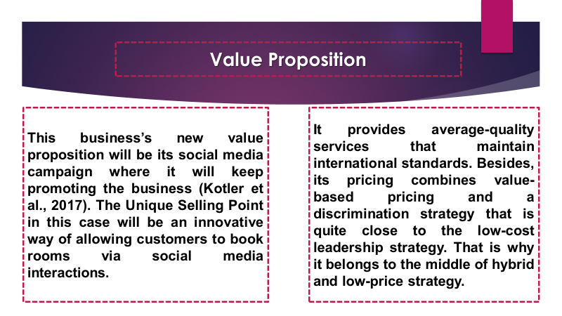
Note
This business’s new value proposition will be its social media campaign where it will keep promoting the business (Kotler et al., 2017). The Unique Selling Point in this case will be an innovative way of allowing customers to book rooms via social media interactions.
It provides average-quality services that maintain international standards. Besides, its pricing combines value-based pricing and a discrimination strategy that is quite close to the low-cost leadership strategy. That is why it belongs to the middle of hybrid and low-price strategy.
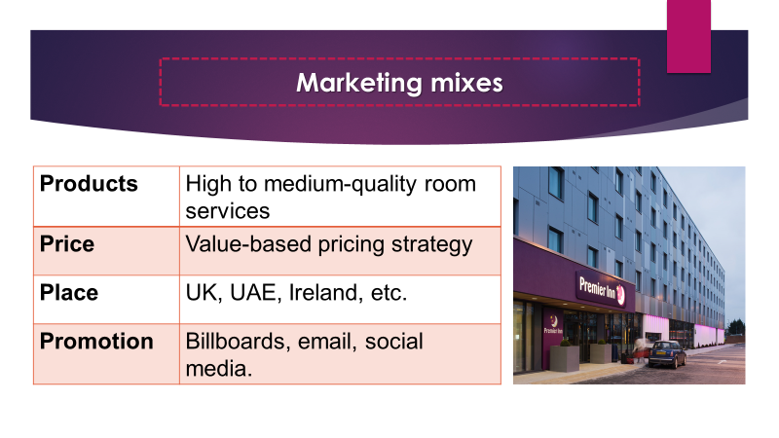
Note
Premier Inn Provides high to medium-quality room services to customers where it follows a value-based pricing strategy and in this case, the customers will pay for the value that they will get. It has different locations across and different branches on different continents (Dutton, 2014). It prioritized regional promotional approaches and for this, billboards are written in the English language. Besides, it prioritizes email and blog marketing. Social media marketing is also a prominent issue for this business.
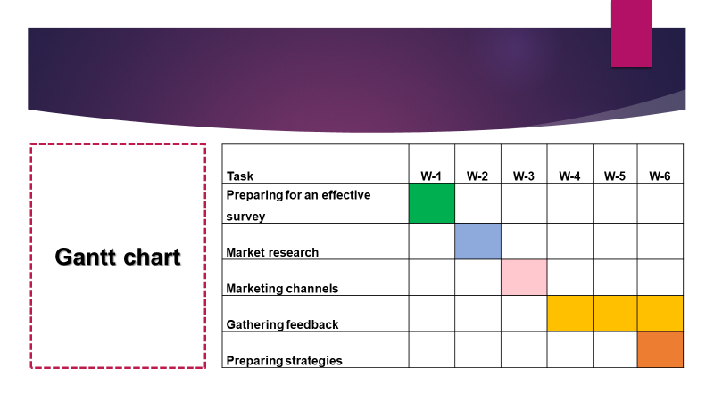
Note
Here is the Gantt chart that shows the path to accomplishing the project.
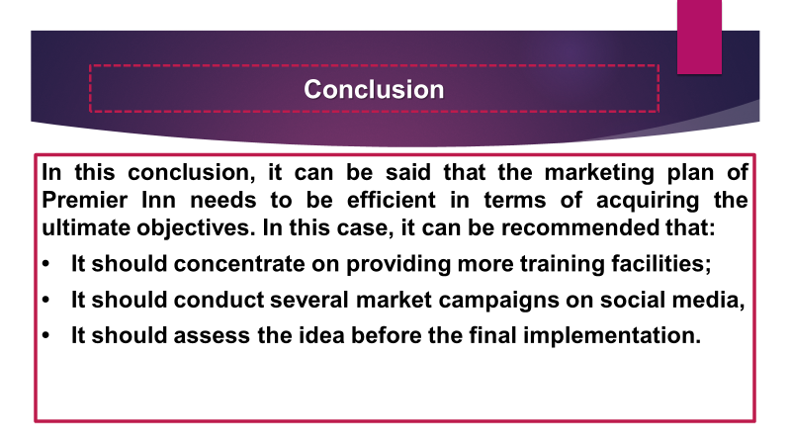
Note
Conclusion
In this conclusion, it can be said that the marketing plan of Premier Inn needs to be efficient in terms of acquiring the ultimate objectives. In this case, it can be recommended that:
- It should concentrate on providing more training facilities;
- It should conduct several market campaigns on social media,
- It should assess the idea before the final implementation.


