Manufacturing process and material selection

This assignment will look at the historic process of both human, and animal prosthetics, and how that process has developed and improved over the years to where it currently is now.

(GE Additive, 2020) Additive manufacturing, which can also be known as 3D printing is a transformative approach to producing lightweight, and more robust parts and systems. This process has the potential to revolutionise higher volume production of fully functioning components. There are many benefits to this process such as:
- Cost reduction
- Customer satisfaction
- Mass production and customisation
- Speed of manufacturing process

Task 1

This part of the assignment will look at the historic process of prosthetics, both human and animal. It will focus on why this product was first developed, how they were originally created and the chosen materials used to manufacture this product.

Bell, 2015 stated that “An effective prosthesis delivers renewed functionality and is cosmetically pleasing, but it also serves to complete the wearer’s sense of wholeness. A prosthesis then, is as much medical device as it is an emotional comfort, and so the history of prosthetics is not only a scientific history, but the story of human beings since the dawn of civilization who by birth, wound, or accident were left with something missing.”

(Bell, 2015) The earliest example of a prosthesis discovery is a toe – a big toe. It belonged to an Egyptian noblewoman and was dated to be between 950-710 BCE. In Egyptian culture, it is particularly important to wear the traditional Egyptian sandals. The discovery of the big toe is representative of historic prosthetics being as much about functionality as the importance of true identity. The construction of this early toe prosthesis helped complete the woman, which gave her the opportunity to truly follow the Egyptian culture, despite her missing limb.

(Vaughan, 2017) Dating back to the period of classical and other human civilizations before the middle ages, prosthetics were used to correct disabilities in humans. In Capua, Italy, in the year of 1858, an artificial limb dating back to approximately 300 BC was discovered. It was made of iron and bronze, with a wooden core, and the prosthesis found was determined to be a design for a below-the-knee amputation. It has also been documented that a Roman general in the Second Punic War, after losing his right arm, had an iron fist created for him to ensure he was still able to hold his shield and could return to battle.

(Vaughan, 2017) There are a variety of reasons why animals may require prosthetics, with one of the most common reasons being neonatal injuries, which in turn, eventually result in amputation. However, just because a prosthetic limb may be beneficial to an animal, doesn’t necessarily guarantee that they will receive one. A colossal amount of factors are to be considered when determining whether the animal is a good candidate or not. These include, but are not limited to:
- Age of the animal
- Size of the animal (Both very small, and very large animals pose more difficult challenges)
- The amount of residual limb
- Orthopaedic complications with the limb
- Gait concerns

(Bell, 2015) Ambroise Pare, a doctor in the early sixteenth century made striking advances in the development of prosthetic limbs as a result of amputation surgery. He was the first person to introduce advancements such as a leg with a locking knee joint and a hinged prosthetic hand. Between the 1500’s and 1800’s, although there was minimal progress in the prosthetic limbs themselves, incredible advancements were made during amputation surgery. There was greater focus on shaping the residual limb which enabled them to be more receptive in attaching a prosthesis. This resulted in the receivers feeling more comfort in their new way of life.

Bell, 2015 stated that “the carnage of the Civil War led to a dramatic increase in the number of amputees, and the field of prosthetics needed to rise to the demand.” (Hanger.com 2019) It was documented that the first amputee of the war was soldier, James Hanger, who invented the ‘Hanger limb’. Manufactured from barrel staves and metal, a prosthetic leg was created, including hinged joints at both the ankle and knee. Hanger later went on to secure two patents from the Confederate government, and eventually commissioned to create prosthetics for veteran soldiers. “Hanger, Inc. still honours and abides by the tenets articulated by its founder, James Edward Hanger.”

Despite the incredible loss of limb in the World Wars, innovation for prosthetics wasn’t reflective of this. (Thorndike, 1949) However, in 1946, researchers at UC, Berkley developed a suction sock for lower-limb amputees. The successfulness of this process is highlighted by the fact that similar attachment technology is still used today.

Task 2

This part of the assignment will look at the current process of animal prosthetics. It will focus on how this product has advanced in its manufacturing process and the benefits as a result. There will be focus on two very different, real life case studies - juvenile dogs with canine hip dysplasia and a tortoise with only 15% of her shell, to highlight the successful improvements that have been made.

(Vaughan, 2017) Greater comfort and functionality are components that need to be considered in great detail, which has encouraged the evolution of prosthetics, to ensure customer satisfaction.

(Hadhazy, 2010) Most animals are able to stay mobile with just using three out of four of their appendages. However, for over a century, the only resolution for vets with patients with severely injured limbs, was full limb amputation. Therefore, those patients that had suffered incredible trauma to multiple limbs were simply left with euthanasia as the only humane option. As a result of ever evolving technology, this is no longer the only option - With the development of both animal prosthetics, which replace a missing or non-working body part, and orthotics, which brace damaged limbs.

(Fitzpatrick, et al. 2011) Professor Noel Fitzpatrick, the managing director of Fitzpatrick Referrals, is a world class orthopedic-neuro veterinary surgeon. Many of his cases incorporate the use of additive manufacturing of prosthetics.

(Rodriguez, N.D) The BFX EBM titanium stem was first introduced to the universal hip system in 2010. It improved upon the existing implant technology used for biologic fixation. In order to achieve a stable press-fit with titanium, plasma spray and beaded coating technologies had previously been used. Electron Beam Melting (EBM), most commonly used for medical implants, is the additive manufacturing process by which metal powder is fused layer by layer in a high vacuum using the computer model of the implant. This process allows for a porous surface to be printed as an integral part of the stem, instead of making use of a spray or coating, which reduces the cost of materials used. The interconnected porous surface facilitates both a greater coefficient of friction and superior bone in-growth potential within the first six to eight weeks following a total hip replacement (THR) procedure. The BFX EBM stem is manufactured from a wrought titanium alloy for maximum biocompatibility and is designed with cranial and caudal flutes for easier stem insertion. As the standard stem for the universal hip system, it should be a surgeon’s first consideration during preoperative planning. The BFX EBM stem is designed to achieve press-fit stabilization within a prepared femoral canal. After broaching, the stem is inserted into the correct position within the femur. Optimal hip reduction is assessed using femoral heads, with the BFX EBM stem being implanted with either a BFX or CFX acetabular cup.

Case Study

(Fitzpatrick, et al. 2011) Cement-less total hip replacement in 20 juveniles using BFX arthroplasty

The objective of this study was to determine the successfulness and effectiveness of cement-less THR using biological fixation implants in skeletally immature dogs, between the ages of six to ten months old.

The cement-less total hip replacement using BFX implants process was carried out because of considerable weakness sourced from the hip and thigh area, as a result of canine hip dysplasia. Medical management was carried out beforehand, however the results were deemed unsatisfactory.

Medical records of each juvenile that received a cement-less THR were reviewed. Preoperative radiographs were analyzed and compared to the postoperative radiographs, to evaluate the effectiveness of this particular type of total hip replacement. Postoperative radiographs revealed satisfactory implant positioning and stability. The acetabular cup orientation remained unchanged throughout. There was one minor complications involving a superficial infection that was recorded and treated. Successfulness was also measured by the increased strength and mobility without pain. This was proven in that all dogs had greatly improved by 6 weeks postoperatively.

In conclusion, cement-less total hip replacement using BFX implants can be performed safely, effectively and successfully in skeletally immature dogs, providing desired results starting at just 6 weeks post operation.

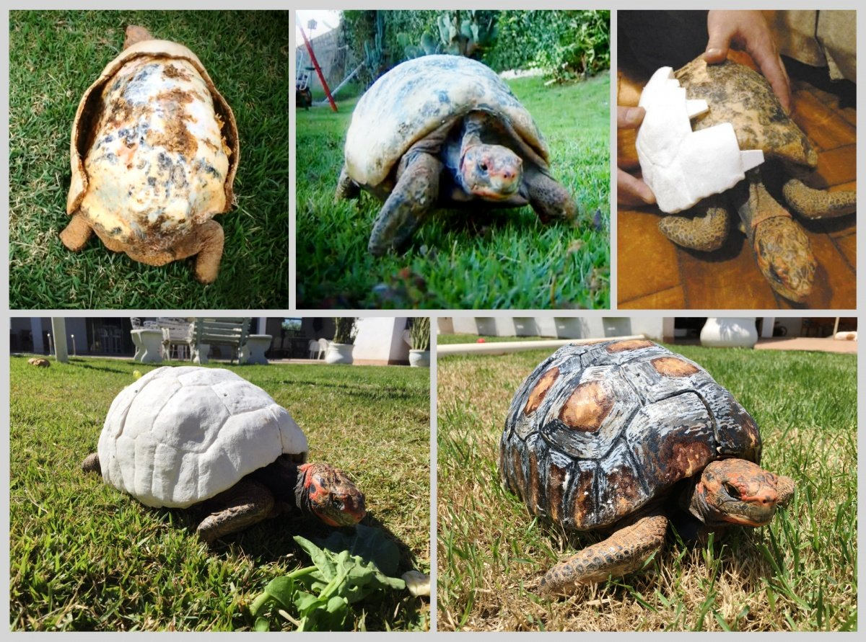
(MacDonald 2016) Another example of how additive manufacturing can be used in animal prosthetics is with 3D printing. A tortoise had a prosthetic shell 3D printed after it was burnt off in a forest fire in Brazil, where she got her name Fred, after Freddy Kruger. Fred had lost almost 85% of her original shell so the team were required to virtually reconstruct a shell, after looking at photos of healthy tortoise shells. The design process to approximately 40 photos, including reconstructing the animal in 3D and inputting it into the computer. The design was then printed out in what can be described as four individual jigsaw like pieces that fit entirely around Fred to full create that completed shell.

Costing only £136 per kilogram, the entire structure was made from a corn based plastic, but it is very time consuming – with each piece taking 50 hours to print. The final two steps were painting a unique design for Fred, and then fitting it.

Figure 1 – the 3D printing process for Fred’s new shell (MacDonald, 2016)

References
Bell, M. (2015). The History of Prosthetics. [online] Unyq.com. Available at: http://unyq.com/the-history-of-prosthetics/ [Accessed 3 Feb. 2020].
Fitzpatrick, N., Law, A., Bielecki, M. and Girling, S. (2013). Cementless Total Hip Replacement in 20 Juveniles Using BFX™ Arthroplasty. Veterinary Surgery, p.n/a-n/a. [Accessed 2 Feb. 2020].
GE Additive. (2020). What is Additive Manufacturing?. [online] Available at: https://www.ge.com/additive/additive-manufacturing [Accessed 4 Feb. 2020].
Hadhazy, A. (2010). Bionic Devices Let Injured Animals Roam Again. [online] livescience.com. Available at: https://www.livescience.com/10742-bionic-devices-injured-animals-roam.html [Accessed 7 Feb. 2020].
Hanger.com. (2019). The J.E. Hanger Story - Hanger, Inc.. [online] Available at: http://www.hanger.com/history/Pages/The-J.E.-Hanger-Story.aspx [Accessed 7 Feb. 2020].
MacDonald, F. (2016). Adorable Tortoise Receives a 3D-Printed Shell After Being Burnt in a Fire. [online] ScienceAlert. Available at: https://www.sciencealert.com/adorable-tortoise-receives-a-3d-printed-shell-after-being-burnt-in-a-fire [Accessed 7 Feb. 2020].
Rodriguez, M. (n.d.). BFX® EBM Titanium Stem - BioMedtrix. [online] BioMedtrix. Available at: https://biomedtrix.com/bfx-ebm-titanium-stem/ [Accessed 2 Feb. 2020].
Thorndike, A. (1949). Suction socket prosthesis for above-knee amputees. The American Journal of Surgery, 78(5), pp.603-613. [Accessed 3 Feb. 2020].
Vaughan, D. (2017). Pets and Prosthetics: Growing Interest, Advancing Technology. [online] American Veterinarian. Available at: https://www.americanveterinarian.com/journals/amvet/2017/june2017/pets-and-prosthetics-growing-interest-advancing-technology [Accessed 4 Feb. 2020].

