Project Report – Strategic Response to a Contemporary Issue



January 17th 2020

MODULE NAME: Contemporary issues in marketing management
Name: Samuel charles Dymock-Brown
Word count: 1955
Student Number: 1706575

Executive Summary

Within this report, the reader will be able to find out information surrounding Sinner Barbershop. This includes the background of the organisation along with the opportunities that Sinner Barbershop are missing out on which are covered in detail. Following these sections, the aims and objectives of the business are covered which shows what they plan to do and how they plan on executing it. The reader can then find a definition on content marketing, what it is and how it works. An example is then used to show the power of using content marketing with Rip Curl being the example. Following this, advantages and disadvantages are discussed for the reader to see it’s not all good or bad. The implementation plan can then be found and shows how Sinner Barbershop can use content marketing to their advantage with the conclusion and recommendations following.

Introduction
Over recent years blogs, YouTube videos and social media in general have become a major part of most businesses success. Creating online content for consumers to indulge is a great way to stimulate interest in its products or services. (Linn, 2017) With society going the way it has many brands use YouTube and various blog sites to provide content for their consumers, with this being done the businesses are creating a higher volume of brand awareness which is only a good thing for the businesses which are offering a service to its client base. By businesses creating higher brand awareness through free content it shows that the business cares about the customers and shows the vision of new loyal customers.

Background of Organisation
Sinner Barbershop is a barbershop based in the marina of Swansea, Wales. The organisation has been established since August, 2019 and has grown as a brand ever since with the local marketing strategies that are used with the short-term intention of becoming the biggest barbering brand in Swansea. The owner of Sinner Barbershop has been a qualified barber for over 6 years with the aim of creating a brand from the service that is being provided. The organisation has grown from inside to out with the owner being very fond of training young apprentice barbers to allow growth within the business. Trust is a major factor of succeeding within the barber industry and creating a strong bond between the business and its clients is critical. Trust can be formed in many ways with the most common being providing a good service that people will not want to miss out on but Sinner Barbershop are often creating value for their clients by offering the chance to have free haircuts sporadically through different times of the year. (Sinner, 2019)

Opportunities
Sinner Barbershop have many opportunities to grow and expand as haircuts are never going to stop so they have the ability to try anything they want within the field to help expand the business and create a brand from the services that are provided. Many marketing strategies from barbers are all exactly the same stemming from Instagram. This is due to the photo sharing aspect of the social media platform enabling barbers to create a portfolio-like profile in order to attract new clients. By using Instagram as their main marketing flow there is also an argument to be made that Sinner Barbershop are missing out on huge opportunities to improve the business and create a well established brand over more than just Instagram. Content is key to all businesses these days and for a business that offers a service, content for people to see and enjoy can be a massive boost in the barbering industry.

Aims and Objectives
Sinner Barbershop have many aims in which they one day want to reach but they all go along the lines of other barbershops within the industry. Their main current aim is to expand the business by opening up different shops around Swansea and eventually venture out into Cardiff. With these aims this just caters for the current followers of the business with the hope that the footfall to client ratio is at a high figure. By growing the barbershop with the aim of building a brand, content marketing is a crucial way in which a barbershop can do this.
Aims
- Advised - Create brand recognition online
- Current - Increase client figures in and around the Swansea area
- Current - Create a brand where the business ventures out into different markets
Objectives
- Advised - Create content online for aspiring barbers – Blogs and YouTube tutorials
- Advised - Provide training camps through online sources
- Current - Offer clients with a high social media following an affiliate marketing scheme
- Current - Use sponsorship with local sports teams to allow growth
- Current - Create clothing to off spring from the Sinner Barbershop Brand
- Current - Provide clients with a place to relax not just go for a haircut

Content Marketing
The definition of content marketing is as follows.
“Content marketing is a marketing technique of creating and distributing valuable, relevant and consistent content to attract and acquire a clearly defined audience – with the objective of driving profitable customer action.” (Steimle, 2014)

As we have passed through the last decade, digital marketers have preached the “content is king” phrase to great numbers of people. Whatever problems that have been occurring in digital marketing, content from businesses has been a solution to many things. (Olenski, 2017)
These Include:
- Quality content driving traffic to the site
- Using quality content to educate customers
- Higher number of conversions
- Reducing customer churn
From 2016, there has been a shift to where many businesses have turned away from content due to many content marketing campaigns actually ending in failure. (Grybniak, 2018) We currently are living in a state of content saturation, as of 2017, more and more companies were engaging in content marketing with 90 percent doing so. Many businesses these days do use content marketing due to figures that show 70 percent of customers prefer to learn about companies, products and services through the organisations own natural content, not paid ads or any other form of advertisement online. (Grybniak, 2018)

Content Marketing Example
With content marketing being all about using wide ranges of content to attract and preserve visitors which eventually turn into customers for the business, with most people who use it know that the method is effective.
When a business first considers using a content marketing strategy, blogging is usually the first thing that comes to mind. Blogging allows a business to get the attention of visitors with helpful information and provides content to fuel the growth of the social media channels.
Rip Curl have tipped themselves as the “ultimate surfing company”, have been showing that strong claim is through an online publication called, The Search. The search allows the visitors to search for anything surfing related, from the best waves to ultimate surfing lifestyle with photography and stories shared from surfers all over the world. By using YouTube Rip Curl have been able to amass more than 100,000 subscribers with their engaging content along with in excess of 2 million Facebook followers, this example is great as it shows that if a business matches their content to their target, growth is inevitable and profitability will soon follow. (Hurley, 2020)

Advantages and Disadvantages
There are a number of advantages and disadvantages to using content marketing when deploying a new strategy these include the following examples.
Firstly, increased search engine rankings for an organisation is one of their top priorities when attempting to grow. By a company publishing consistent blog posts and YouTube videos that are highly engaging and effective can help organisations, such as Sinner Barbershop more traffic to their site over time. According to HubSpot, the companies that posted more than 16 blog posts per month would get almost 3.5 times more traffic than the organisations that would only post 4 or less publications. This shows that businesses wanting to improve site traffic need to publish efficiently with quality content on a regular schedule. (HubSpot, 2019)
Arguably the ultimate benefit of using content marketing is that it helps a company drive more communications over time. Research has shown that the companies which create consistent marketing content for their customers experience conversion rates that are nearly 6 times higher than their competitors who don’t focus on their content marketing. By using this, it shows that tough content marketing often requires a significant investment of time, money and resources and this all eventually pays off due to the high increase in conversions. (Lyfe Marketing, 2018)
The first disadvantage is that content marketing is not a quick fix to solve issues. It is a strategy that takes time, this can take up to a year before seeing results of a steady stream of traffic to the site. Following that, creative ideas are hard to come by. If you are not creative or don’t have experience creating content, it can be very difficult to get started. (Hope, 2019)

Implementation
There are multiple ways in which Sinner Barbershop can approach a content marketing strategy in order to create brand awareness. One way the business can implement content marketing into their strategy is by following the content marketing sales funnel.
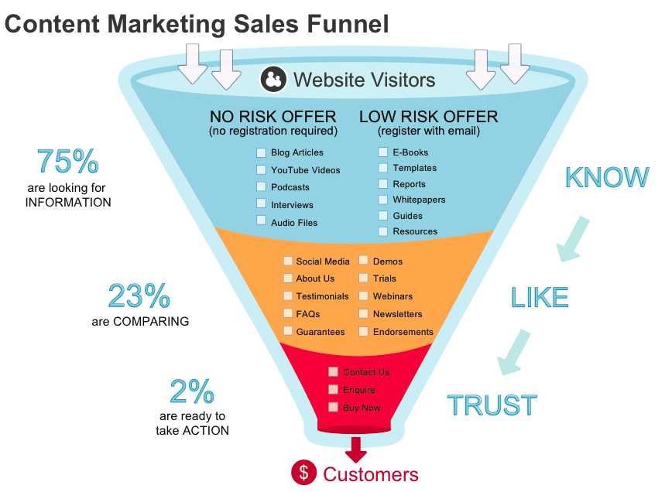
Figure 1: Content Marketing Sales Funnel (adastra, 2018)
The idea of the content marketing funnel is that the cluster of potential customers becomes smaller as the first transaction with the business becomes ever closer. At the top of the funnel lie many people who will become aware of the brand that is creating content. As the funnel gradually gets smaller, there are fewer people who will be willing to pay for the product or service that is being offered. As the bottom of the funnel is reached this will be the fewest number of people who have considered purchasing the product or service but ultimately failing conversion. As a marketer within a business, the aim is to make the funnel as solid as possible, guiding potential customers towards conversion. (Moz, 2017)
By Sinner Barbershop implementing a funnel into their marketing strategy they will have the ability to monitor what creates a successful conversion rate. By the business pushing out content through multiple channels this will create a widespread channel for them to offer their service which is ultimately what the goal would be. By a barbershop showing their skills through video and blog content it shows the skillset they have and potential customers are able to see this for themselves before committing to the service that is provided due to the trust needed within the barber. A great example of a barber using this to his advantage is, 360Jeezy a barber from California. Jeezy has amassed a massive 2.7 million subscribers on YouTube due to his tutorial videos going viral which have almost taken in 400 million views due to consistent uploads which are fun and engaging as well as educational. As well as 2.7 million subscribers on YouTube he also has a great following on Instagram with over 620,000 people following his account. (Socialblade, 2020)

Conclusion
To conclude, a content marketing strategy would be a brilliant place to start for Sinner Barbershop to complete their aims. By using a content marketing strategy they will grow not only with clients visiting the shop but their online presence will increase dramatically and many new business ventures can come from having a great brand reputation online. As well as gaining a presence online, they will develop a strong relationship with their clients and viewers creating a trustworthy brand with a high quality service and that is what is needed within the barbering industry.

Recommendations
The recommendations that Sinner Barbershop should follow in order to complete all of their aims would firstly be to incorporate the content marketing strategy as soon as possible. With YouTube being so popular with the current generation, many aspiring barbers will turn to YouTube in order to self-train. With Swansea being such a beautiful part of Wales, there is the opportunity to make amazing videos which would have the potential to go viral. For clients to have a look at what’s on offer at the barbershop videos of the process would be a perfect place to start. Another recommendation for Sinner Barbershop would be to create a daily blog with a forum for barbers to ask questions for tips within their own development as a barber. This would show that the brand is able to educate as well as provide a service and would create many relationships across the world.

Bibliography

adastra, 2018. adastra. [Online]
Available at: http://adastrauk.com/content-marketing-sales-funnel/
[Accessed 17 January 2020].
Grybniak, S., 2018. Clutch. [Online]
Available at: https://clutch.co/agencies/content-marketing/resources/why-content-marketing-doesnt-work-every-business
[Accessed 16 January 2020].
Hope, S., 2019. Handmade SEO. [Online]
Available at: http://handmade.marketing/2019/01/15/6-disadvantages-of-content-marketing/
[Accessed 17 January 2020].
HubSpot, 2019. HubSpot. [Online]
Available at: https://www.hubspot.com/
[Accessed 16 January 2020].
Hurley, S., 2020. Optinmonster. [Online]
Available at: https://optinmonster.com/content-marketing-examples/
[Accessed 17 January 2020].
Linn, M., 2017. Content Marketing Institute. [Online]
Available at: https://contentmarketinginstitute.com/2017/07/explain-content-marketing/
[Accessed 14 January 2020].
Lyfe Marketing, 2018. Lyfe. [Online]
Available at: https://www.lyfemarketing.com/blog/benefits-content-marketing/
[Accessed 16 January 2020].
Moz, 2017. Moz. [Online]
Available at: https://moz.com/beginners-guide-to-content-marketing/marketing-funnel
[Accessed 17 January 2020].
Olenski, S., 2017. Forbes. [Online]
Available at: https://www.forbes.com/sites/steveolenski/2017/06/21/why-content-will-always-always-king/#386159beeb37
[Accessed 17 January 2020].
Sinner, 2019. Facebook. [Online]
Available at: https://www.facebook.com/Sinner-Barbershop-111826130159983/
[Accessed 17 January 2020].
Socialblade, 2020. Socialblade. [Online]
Available at: https://socialblade.com/youtube/user/360jeezy
[Accessed 17 January 2020].
Steimle, J., 2014. Forbes. [Online]
Available at: https://www.forbes.com/sites/joshsteimle/2014/09/19/what-is-content-marketing/
[Accessed 16 January 2020].

