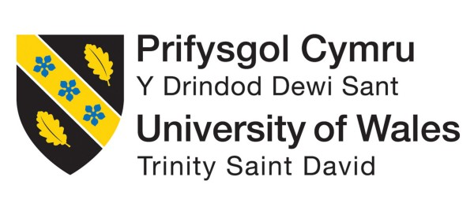

NAME: DIVYA HARISHKUMAR SOLANKI
STUDENT ID:2237588
PROGRAMME: MASTER OF BUSINESS ADMINISTRATION
MODULE: ENTREPRENEURSHIP
MODULE CODE: LCMB 7004

LECTURER: MASUD IBRAHIM

Table of Contents
Overview of proposed business idea 3
Market Gap and Addressing Strategies 3
Business Location and Legal Entity 6
SWOT Analysis 7
Target Market and Capture Strategies 8
Determining Financial Plan, Funding Requirements, and external sources of the business 10
References 14

Overview of proposed business idea
Greentech Innovations in the UK strives to use a “Waste-To-Energy (WTE) conversion” mechanism to transform the renewable energy sector. Simply utilizing the energy generated by waste that is organic resources, this cutting-edge technology reduces the negative environmental effects of disposing of waste by producing clean, sustainable electrical power. The cutting-edge waste treatment plant, complete with cutting-edge anaerobic digestion along with gasification technology, is the foundation of our business strategy (Foster et al., 2021). This procedure not only deals with the critical issue of waste management, but it also makes a major contribution to the fight against climate change by lowering greenhouse gas emissions.
These systems effectively release syngas along with biogas from the breakdown of organic waste, including food scraps, agricultural wastes, and other substances that break down. After being caught, these gases are used to produce heat and power. The system removes the requirement for disposal in landfills, which is an important contributor to greenhouse gas emissions, it provides a low environmental effect. In order to finish the sustainability circle, the resultant organic waste will also be utilized as premium compost or fertilizer. This creative solution not only solves the urgent problem of disposing of waste, but it also makes a major dent in the generation of greenhouse gases. Greentech Innovations remains at the forefront of sustainable energy, revolutionizing the disposal of garbage by turning organic materials into renewable warmth and electricity. Simply removing organic waste from burning and garbage dump companies, immediately reduces the amount of hazardous gases released into the atmosphere. Moreover, the heat and current produced will be utilized locally or linked to the current energy systems, enhancing energy safety and durability. Greentech Innovations hopes to pave the path for a more ecologically conscious and sustainable world by turning garbage into an asset with the operation of this venture.

Market Gap and Addressing Strategies
The growing worldwide environmental challenge brought on by the effects of climate change by utilizing “Waste-To-Energy Conversion” technological advances, "Greentech Innovations" offers a sustainable alternative. This creative endeavour aims to solve the pressing problem of waste management simultaneously capitalizing on the rising need for alternative energy sources.
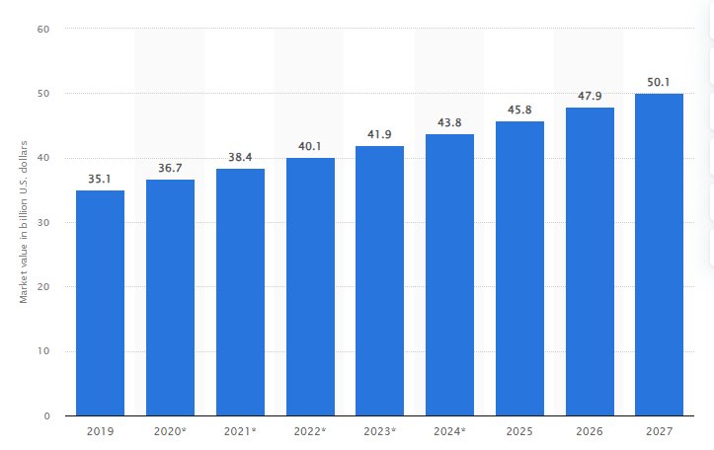
Figure 1: Waste-to-energy market value from 2019 to 2027
(Source: statista.com, 2023)
In 2019, the energy from waste marketplace had a valuation of 35.1 billion US dollars worldwide. The waste-to-energy market is projected to reach a valuation of 50.1 billion USD by 2027, with compound annual growth rate (CAGR) of 4.6% (statista.com, 2023). Global warming has become mostly to blame for the rising frequency of natural disasters, that has made the demand for sustainable energy sources critical. This urgent problem has brought attention to a huge market gap for sustainable and effective energy generation techniques. Technology that converts waste into energy offers a convincing answer to this conundrum.
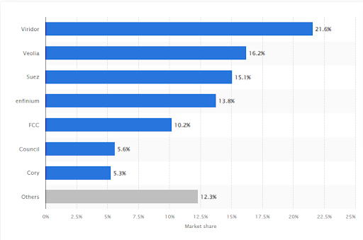
Figure 2: Market share of energy-from-waste incinerator operators in UK in 2021
(Source: statista.com, 2023)
Estimating input quantity, recycled materials, and garbage disposal companies had 21.6% of the waste-to-energy market in 2021. Veolia, a French waste-handling business, came next and in that particular year, the yearly capacity of UK EfW factories exceeded 17 million metric tonnes (statista.com, 2023). Staff will reduce the amount of waste going to landfills and produce renewable electricity that is clean by utilizing the potential energies that are present in different types of waste. This innovative approach merely addresses the pressing issue of garbage disposal, but it also significantly reduces greenhouse gas emissions. By converting natural substances into renewable power and warmth, Greentech Innovations continues to be at the cutting-edge of environmentally conscious energy, revolutionising the way waste is disposed. This strategy marks a significant advancement in the direction of a more environmentally friendly and sustainable future by directly addressing the twin issues of waste disposal and producing energy sustainably.
Addressing Strategies
Technology Advancement: Greentech Innovations is dedicated to ongoing investigation and creation of technologies for waste-to-energy transformation. Companies will seek partnerships with top research organizations and subject matter experts to make sure companies stay at the cutting edge of scientific advancement (Kalair et al., 2021).
Market Research and Localization: Determining those areas have high rates of waste creation and restricted access to dependable energy sources that are renewable, a thorough market research study will be carried out. thereby customizing our suggestions to these regions' unique demands and obstacles, one will hope to gain a competitive edge and promote local collaborations for sustainable development over time.
Regulatory Compliance and Environmental Impact: Greentech Innovations understands the importance it is to follow strict environmental laws. In order to ensure complete adherence to regional, governmental, and global standards, the community will collaborate closely with administrative organizations. In addition, a thorough evaluation of environmental impacts will be carried out to quantify and minimize any possible ecological footprint related to our activities.
Partnerships and Collaborations: Greentech Innovations intends to establish strategic alliances with renewable energy proponents, governmental bodies, and waste disposal organizations. These partnerships will additionally make it easier to obtain a consistent stream of waste products, but they will also allow us to make better use of the assets and structures that are already in place.

Business Location and Legal Entity
The business location will be chosen in East Sussex, United Kingdom.
Justification for location
The waste-to-energy conversion company of Greentech Innovations has found the perfect home in East Sussex, UK. The location is a great fit for this project because of its strategic benefits. First off, there is a lot of garbage produced in East Sussex due to the region's flourishing industrial economy and crowded population of cities. This guarantees a steady and dependable supply of feedstock for waste-to-energy converting processes, and that is essential to the long-term viability and financial success of the enterprise. Second, the effective transportation of waste materials is made possible by their close proximity to important urban centres involving Brighton and Hastings. This maximizes income potential for Greentech Innovations by lowering logistical expenses and positioning the company to serve a large number of customers for its energy solutions. The UK's favourable regulatory climate is in line with the company's goal, particularly in reference to measures promoting renewable energy (Hussain et al., 2020). Regarding companies using sustainable practices, the government provides a variety of loans, incentives, and assistance, adding another level of backing and security to Greentech Innovations' finances.
Legal Entity
Greentech Innovations will operate as a legal entity that is registered under the Companies Act 2006. Simply limiting their individual liability, the proprietor's and shareholders' personal possessions are shielded from any legal troubles and financial hardships. The company's financial security and expansion potential are guaranteed by the legal structure that has been selected, which permits a variety of capital-raising strategies, including the issuance of shares and the pursuit of venture capitalist funding. The selected legal entity clarifies its operational obligations and decision-making processes by outlining the regulatory structure and the respective positions and obligations of stakeholders.

SWOT Analysis
Strengths:  - Greentech Innovations has established itself as a leader in the field of renewable power by utilizing state-of-the-art waste-to-energy conversion systems.  - The company will use a variety of waste from factory byproducts, residue from agriculture, and solid waste from the community (Vrabie, 2021).  - Globally, governments are putting policies into place to support renewable energy sources.  - Considering a staff of specialists in waste-to-energy conversion technology, Greentech Innovations will guarantee dependable and effective operations. | Weaknesses:  - Waste-to-energy plant establishment necessitates a large upfront expense for equipment, technology, and operational setting.  - The market for renewable energy is getting more and more competitive (Tang et al., 2020). Greentech Innovations will have to demonstrate outstanding technology or efficient operation.  - It is possible for project execution to be delayed by the lengthy and complicated process of obtaining the required permissions.  - It will be difficult to secure a steady and dependable supply of waste feeding because it depends on things like waste management regulations.
Opportunities:  - There is scope for growth in the waste-to-energy sector globally, particularly in areas where trash generation is significant.  - Ensuring a consistent supply of waste material and obtaining support for the project, Greentech Innovations will investigate opportunities for partnership with waste management firms, municipality officials, and other stakeholders.  - Further investigation and advancement may yield advancements in the field of waste-to-energy technologies.  - Putting money into educational programs and public education efforts will assist in changing people's opinions of waste-to-energy conversion. | Threats:  - The company will become susceptible to changes in energy costs, which could have an impact on the affordability of waste-to-energy options.  - The company will be significantly impacted by changes to laws and rules pertaining to waste management.  - Conventional waste-to-energy solutions will find themselves outdated due to the rapid improvements in renewable energy sources.  - Environmental issues that will impact the operational viability of waste to electricity plants include natural disasters and disruptions in trash supply networks.
Developing a strong business strategy for Greentech Innovations' Waste-To-Energy Conversion project will need to consider these strengths, weaknesses, opportunities, and threats. A thorough market study, financial forecasts, plans for operations, and a thorough risk management strategy should all be part of this plan. Investors and other interested parties will also need to be convinced of the company's dedication to ecological and environmental responsibility.

Target Market and Capture Strategies
The “Waste-to-Energy Conversion” company of Greentech Innovations uses the “Segmentation, Targeting, and Positioning (STP)” approach to precisely define and seize its target market.
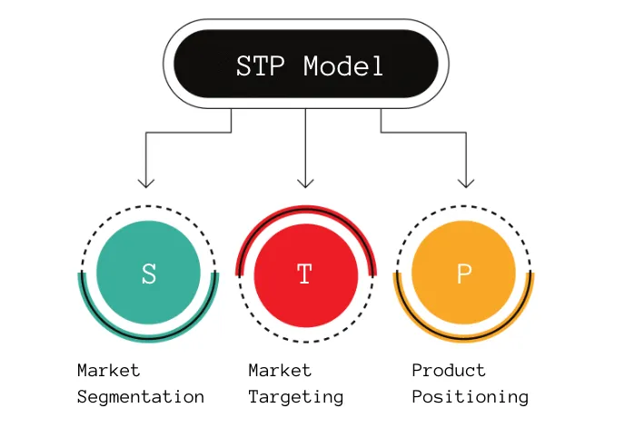
Figure 3: STP Model
(Source: productmindset.substack.com, 2023)
Segmentation: The market has to first be divided into discrete segments according to shared needs, behaviours, and features. The three main markets for Greentech Innovations are agriculture, businesses, and municipalities. There are distinct prospects for garbage collecting and energy generation in each section. Municipalities are a vital market for garbage collection services since they produce large amounts of solid waste from their communities. Industries generate specific waste streams that are able to be effectively transformed into energy, providing a possible channel for collaboration (Ram et al., 2021). Contrarily, agriculture provides a useful source of food waste that will be converted into renewable energy, therefore minimizing waste in agricultural sectors.
Targeting: Following market segmentation, Greentech Innovations determines which market sectors are most appealing in light of variables such as size, potential for growth, and alignment with the company's competencies. Here, the main emphasis is on the municipalities since they are a reliable and significant supply of waste. Greentech seeks to create effective waste disposal processes in collaboration with municipalities and authorities, guaranteeing a consistent supply of recyclable materials for energy production. Companies also have a lot of promise since they will handle their garbage and produce energy at the same time, which is a win-win situation (Dastjerdi et al., 2019). Utilizing agricultural wastes to generate renewable energy in line with ethical agricultural practices, agriculture offers another feasible goal.
Positioning: The process of positioning entails creating a unique brand and value proposal in the eyes of the intended market. Greentech Innovations presents itself as a cutting-edge, ecologically aware business committed to halting environmental deterioration and global warming. Greentech solves the problems of waste management and generation of electricity by turning trash into clean energy. The business places a strong emphasis on its dedication to lowering the release of greenhouse gases, resource conservation, and the advancement of sustainable practices (Hoang et al., 2022). Greentech facilitates comprehension and backing for the advantages of converting waste materials into energy by means of community involvement and instruction.
Capturing the target market successfully, Greentech Innovations uses a variety of tactics. The foundation is made up of local collaborations with municipalities, which guarantee a consistent flow of waste. Investing in state-of-the-art technologies to convert waste into energy increases energy output while lowering the ecological impact and strengthening the competitive position of the business. Efficiency increases are driven by a committed investigation and creation effort that continuously enhances waste conversion technologies. Initiatives for community involvement increase awareness and win support from the community, enhancing Greentech’s standing as a conscientious corporate citizen. Furthermore, the production and commercialization of “Renewable Energy Credits (RECs)” offer an extra revenue stream that reinforces the financial sustainability of the organization.

Determining Financial Plan, Funding Requirements, and external sources of the business
Financial Plan
Category | Description | Year 1 | Year 2 | Year 3 | Year 4 | Year 5
Initial Investment | Facility Construction and Equipment’s | £5,000,000
 | Research and Development | £500,000 | £300,000 | £200,000 | £150,000 | £100,000
Operating Costs | Waste Collection and Transportation | £200,000 | £250,000 | £300,000 | £350,000 | £400,000
 | Technology Maintenence and Upgrades | £150,000 | £175,000 | £200,000 | £225,000 | £250,000
 | Labor and Employee Salaries | £300,000 | £350,000 | £400,000 | £450,000 | £500,000
 | Regulatory Compliance and Permitting | £100,000 | £120,000 | £140,000 | £160,000 | £180,000
Revenue | Energy Sales |  | £500,000 | £1,000,000 | £1,500,000 | £2,000,000
 | Waste Collection Fees |  | £100,000 | £150,000 | £200,000 | £250,000
 | Sale of Renewable Energy Credits (RECs) |  | £50,000 | £100,000 | £150,000 | £200,000
Funding Requirements | Initial Investment | £5,000,000
 | Working Capital | £1,000,000 | £1,500,000 | £2,000,000 | £2,500,000 | £3,000,000
Table 1: Financial Plan and Funding Requirements
(Source: Self-created)
The financial plan of Greentech Innovations shows projected costs and income in GBP (£) during a five-year period. Initial investments, ongoing expenses, and expected income from energy trading and waste-related levies are all included. The strategy supports the business's waste-to-energy conversion initiative by outlining its finance requirements and projected financial growth.
External Sources
Government Subsidies: Initiatives pertaining to renewable energy are frequently supported by grants and subsidies from government bodies. Greentech will make use of these assets to encourage environmentally friendly company practices and reduce the cost of early investments. Securing government funding supports the government's renewable energy ambitions and line with larger policies relating to the environment, particularly in light of the growing worldwide push for a sustainable environment.
Venture Capital and Private Equity: The idea will receive a significant financial boost by looking for a combination of venture capital and investing in private equity. Venture investors also frequently contribute important contacts and industry knowledge, which raises the project's possibility of success (Mukherjee et al., 2020). Greentech’s Waste-to-Energy Conversion presents an intriguing prospect because these organizations are frequently drawn to cutting-edge and environmentally friendly solutions. .
Bank Loans and Commercial Financing: A dependable way to obtain funds is through standard financial institutions and business financing choices. Considering the prospect of profitability and social advantages of the waste-to-energy enterprise, several banks will be interested in offering competitively priced loans. This money will be used by Greentech for operational costs, equipment purchases, and building new facilities.
Corporate Partnerships and Strategic Alliances: Functioning together with well-known companies in the renewable energy space can provide financial support, industry knowledge, and possibly even access to current clientele. Creating strategic alliances can help projects move more quickly and give access to important networks and resources (Parashar et al., 2020). Additionally, these alliances may provide access to chances for collaboration or co-development.
Simply combining these avenues of funding, Greentech Innovations can obtain the funds required to launch and expand its waste-to-energy conversion company. In addition to reducing the dangers that come with depending too much on one source, diversifying funding sources can help guarantee the project's ongoing viability and effectiveness.

References
Dastjerdi, B., Strezov, V., Kumar, R. and Behnia, M., (2019). An evaluation of the potential of waste to energy technologies for residual solid waste in New South Wales, Australia. Renewable and Sustainable Energy Reviews, 115, p.109398.
Foster, W., Azimov, U., Gauthier-Maradei, P., Molano, L.C., Combrinck, M., Munoz, J., Esteves, J.J. and Patino, L., (2021). Waste-to-energy conversion technologies in the UK: Processes and barriers–A review. Renewable and Sustainable Energy Reviews, 135, p.110226.
Hoang, A.T., Varbanov, P.S., Nižetić, S., Sirohi, R., Pandey, A., Luque, R. and Ng, K.H., (2022). Perspective review on Municipal Solid Waste-to-energy route: Characteristics, management strategy, and role in circular economy. Journal of Cleaner Production, 359, p.131897.
Hussain, Z., Mishra, J. and Vanacore, E., (2020). Waste to energy and circular economy: the case of anaerobic digestion. Journal of Enterprise Information Management, 33(4), pp.817-838.
Kalair, A.R., Seyedmahmoudian, M., Stojcevski, A., Abas, N. and Khan, N., (2021). Waste to energy conversion for a sustainable future. Heliyon, 7(10).
Mukherjee, C., Denney, J., Mbonimpa, E.G., Slagley, J. and Bhowmik, R., (2020). A review on municipal solid waste-to-energy trends in the USA. Renewable and Sustainable Energy Reviews, 119, p.109512.
Parashar, C.K., Das, P., Samanta, S., Ganguly, A. and Chatterjee, P.K., (2020). Municipal solid wastes—a promising sustainable source of energy: a review on different waste-to-energy conversion technologies. Energy Recovery Processes from Wastes, pp.151-163.
productmindset.substack.com, 2023 STP Model: Segmentation, Targeting & Positioning [Online] Available at: https://productmindset.substack.com/p/stp-model-segmentation-targeting [Accessed: 27 October 2023]
Ram, C., Kumar, A. and Rani, P., (2021). Municipal solid waste management: a review of waste to energy (WtE) approaches. Bioresources, 16(2), p.4275.
statista.com, 2023 Forecast waste-to-energy market value worldwide from 2019 to 2027 [Online] Available at: https://www.statista.com/statistics/480452/market-value-of-waste-to-energy-globally-projection/ [Accessed: 27 October 2023]
statista.com, 2023 Market share of energy-from-waste (EfW) incinerator operators in the United Kingdom in 2021 [Online] Available at: https://www.statista.com/statistics/936137/waste-to-energy-operator-market-share-united-kingdom-uk/ [Accessed: 27 October 2023]
Tang, Y., Dong, J., Li, G., Zheng, Y., Chi, Y., Nzihou, A., Weiss-Hortala, E. and Ye, C., (2020). Environmental and exergetic life cycle assessment of incineration-and gasification-based waste to energy systems in China. Energy, 205, p.118002.
Vrabie, C., (2021). Converting municipal waste to energy through the biomass chain, a key technology for environmental issues in (Smart) cities. Sustainability, 13(9), p.4633.

