Sarah Ismail (2312694)

Campus club management system
Database and application development

Contents
Identification of Main Entities, Attributes and Relationships. 2
Database Normalisation (3NF) 4
Database Implementation 8
Stored Procedure and Transactional Processing 17
Performance Tuning Enhancement: Query Optimization 27
Conclusion and Reflection 29
References 30

Database Design

Identification of Main Entities, Attributes and Relationships.
The Campus Club Management System (CCMS) aims to provide essential features for the student’s union to efficiently run clubs, memberships, events, and communications. By analysing the scenarios presented, the system identifies various key entities that will stand for the real, world objects and activities involved in club management.
Students are represented as a key entity of the model, which comprises individual students registered at the university who may attend clubs and participate in events. The main characteristics of this entity comprising a unique student identifier, first name, last name, email address, course, and year of study. The student identifier is the primary key used to uniquely distinguish each student record.
Clubs are the entities representing the numerous clubs and societies supported by the student’s union. Some attributes related to this entity are the unique club identifier, club name, category, founding date, and a short description of the club. Each club can organise an event and publish announcements for its members.
The membership entity captures the relationship between students and clubs. The students can be members of more than one club, and each club can have many student members. Hence, this is a many, to, many relationships. To manage it correctly, a separate membership entity is introduced. It stores details specific to a student's involvement in a club, such as membership identifier, student identifier, club identifier, join date, and the student’s role. This method decreases the replication of data and separates membership information from students and clubs. The event entity is to represent the activities organised by clubs, such as meetings, workshops, or social events. Each event is linked to a single club, creating a one, to, many relationships between clubs and events. Attributes for this entity include event identifier, event name, event date, start time, venue, capacity, and a flag which will indicate whether the event is restricted to members only.
To keep track of students attending events, the eventParticipation entity will help us keep track. This entity addresses the many, to, many relationships between students and events, as a student may attend multiple events and each event may have multiple participants. It comprises attributes such as participation identifier, student identifier, event identifier, and participation status.
The announcement entity is designed to hold records of official communications sent by clubs. Each announcement is linked to one club, thus, there is a one, to, many relationships between clubs and announcements. Attributes comprise announcement identifier, title, message content, and the date when the announcement was sent. Finally, the announcemenRecipent entity records which student receive specific announcements. This represents a many-to-many relationship between announcements and students, as announcements can be sent to multiple students and students can receive multiple announcements.
Overall, the identified entities and relationships represent the system requirements and provide a solid basis for the database design.
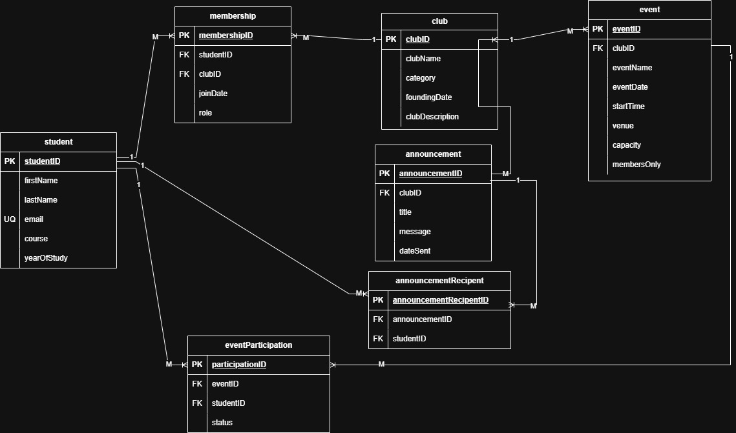

Database Normalisation (3NF)

The database was normalised to third normal form which is used to reduce data duplication which will maintain data integrity.
First Normal form (1NF) is met because each table stores information in a clear and structured way, with one value stored in each field. No table contains repeated groups of data, and every table will include a primary key to ensure that each record can uniquely identified.
Second Normal Form (2NF) will be achieved by ensuring that all non-key attributes depend on the full primary key. This is mainly shown using junction’s tables to manage many-to-many relationships. For example, the membership table links students and clubs, and attributes such as role and joinDate relate to specific student’s membership in a particular club. This will be the same as the eventParticipation table which will store details that relate to a student’s involvement in a specific way.[1]
Third Normal Form (3NF) is satisfied because they’ll be no indirect dependencies within the tables. All non-key attributes depend only on the primary key of their table. Club details are stored only in the club table and referenced by other tables such as event and announcement using foreign keys, which will be better than repeated. Student information is also stored only once in the student table and referenced where required.
Overall, the database designs follow Third Normal Form, helping to reduce redundancy while improving accuracy, maintainability, and reliability of the data.
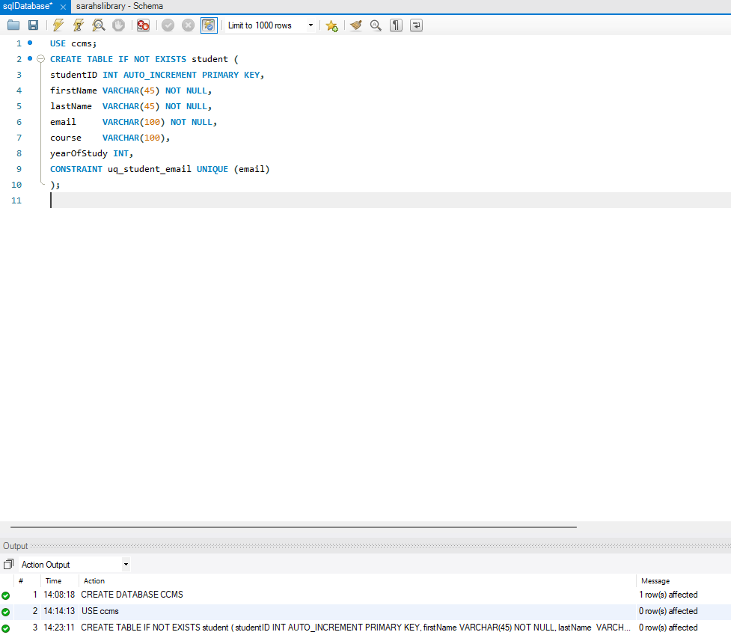
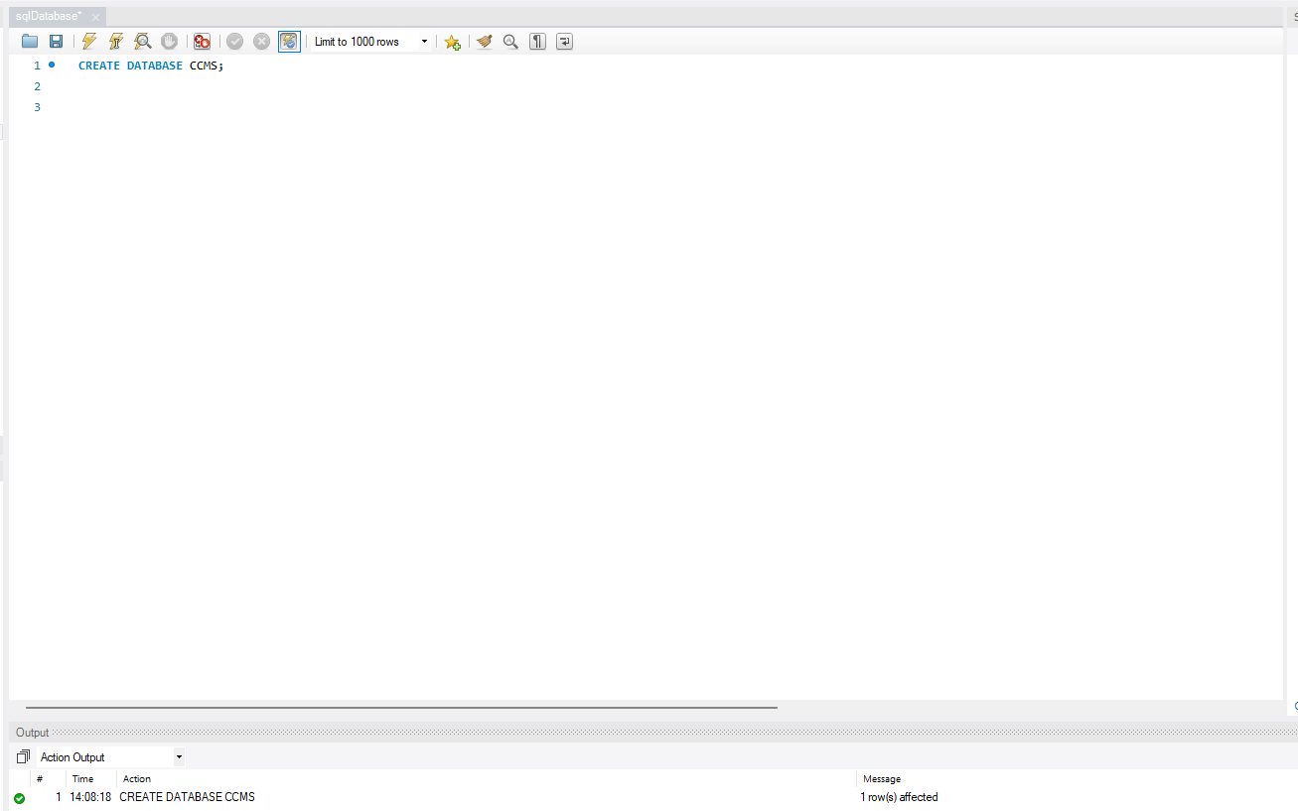

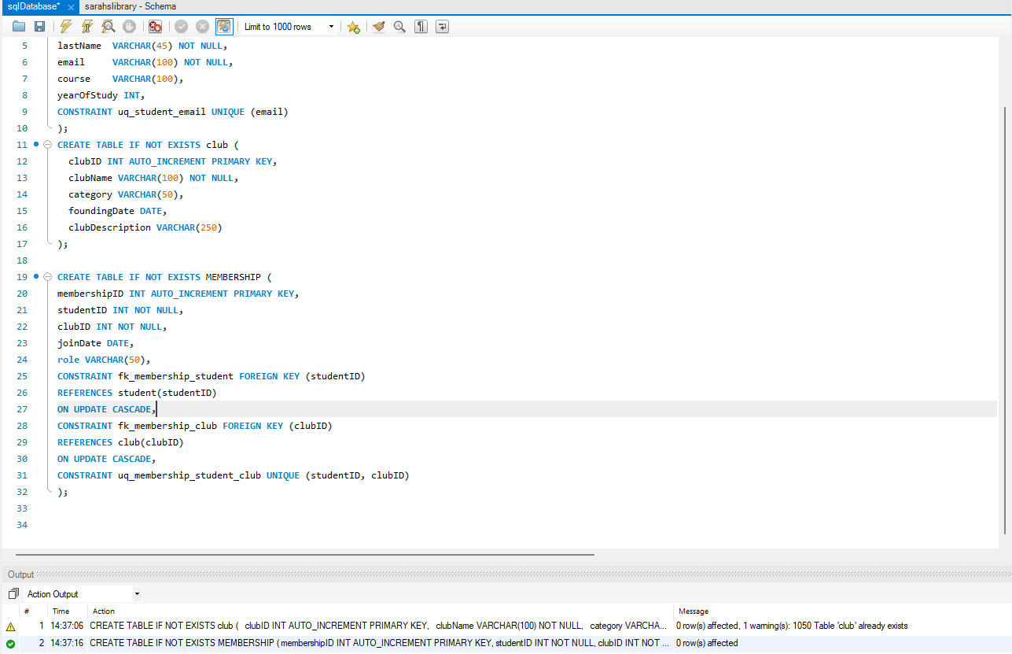
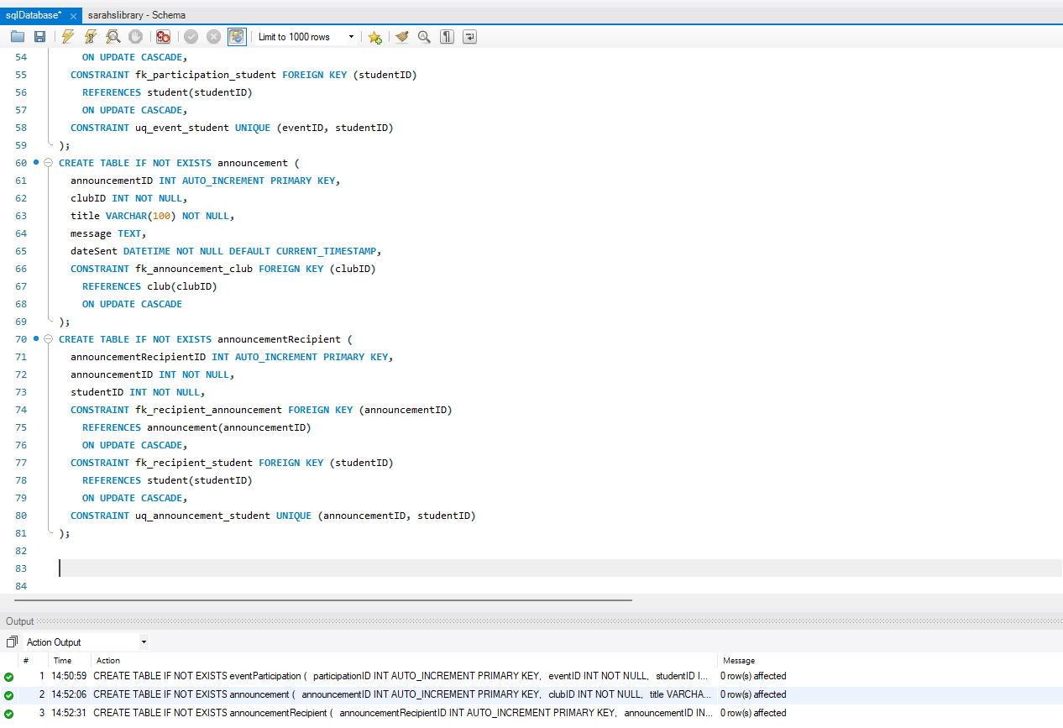

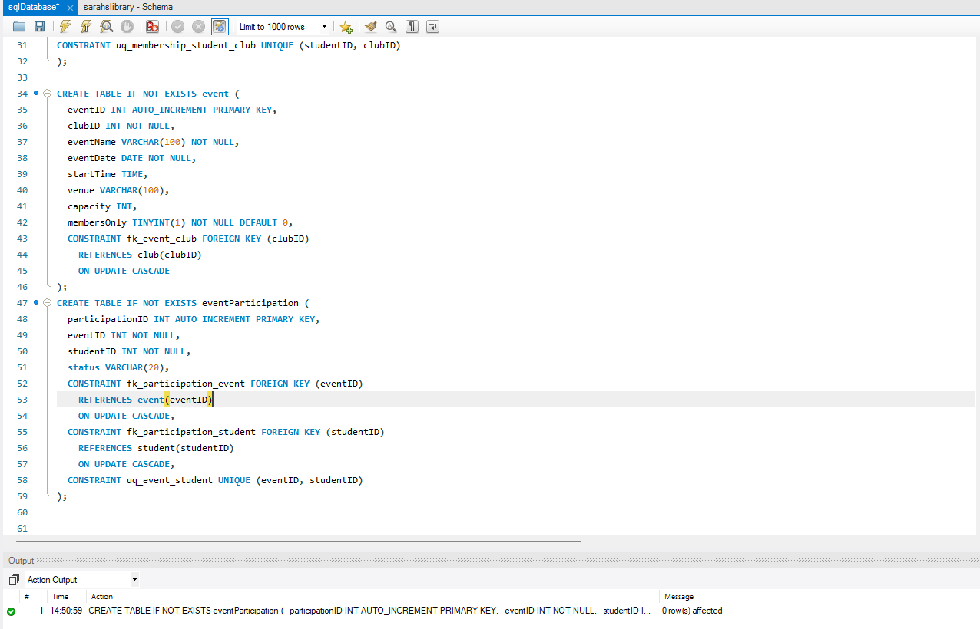

Database Implementation

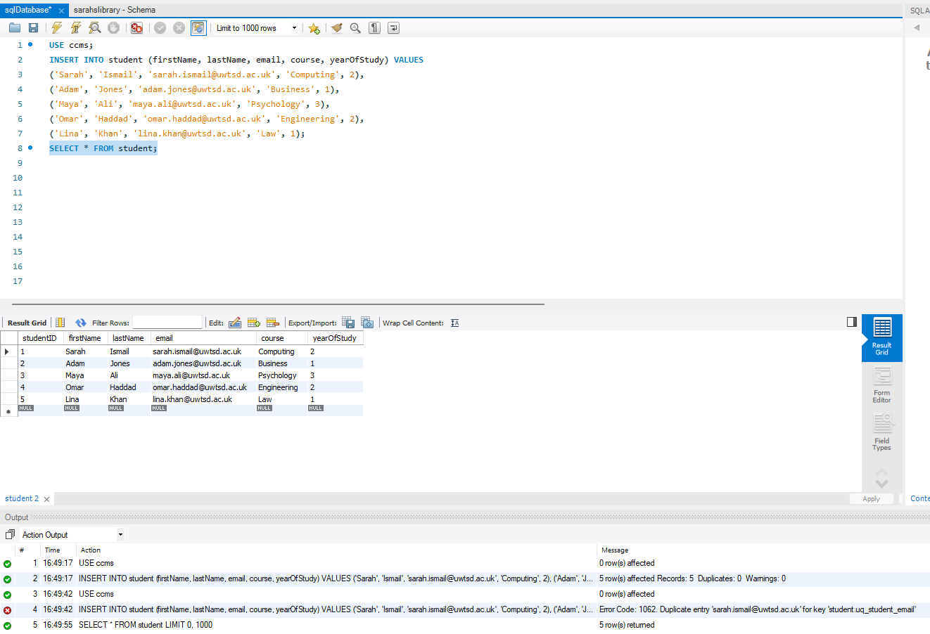

I have entered student records to represent typical users of the system. This data will be used to test memberships, event participation, and announcements recipients.

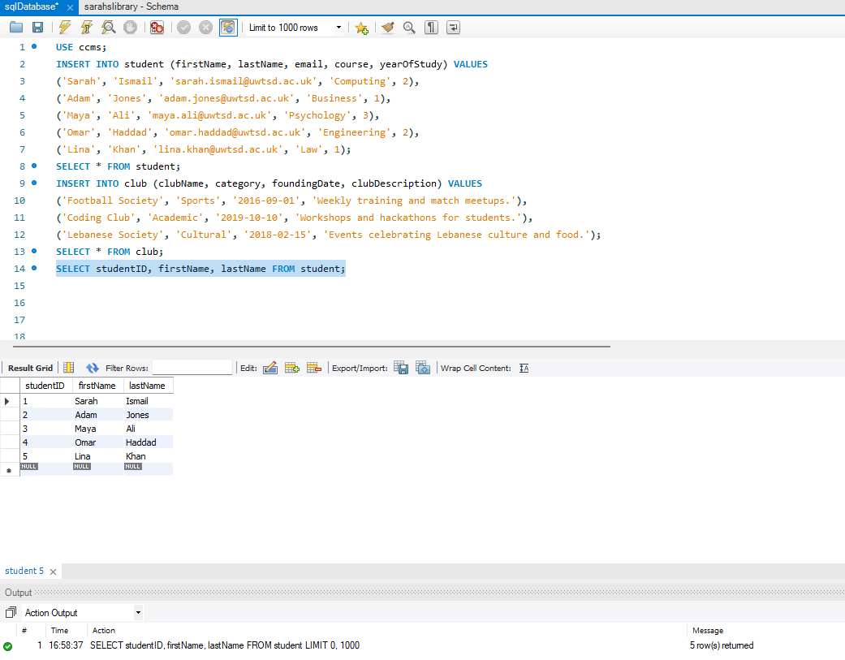
These are studentID records that are verified using the query above and will now be used in the membership table.

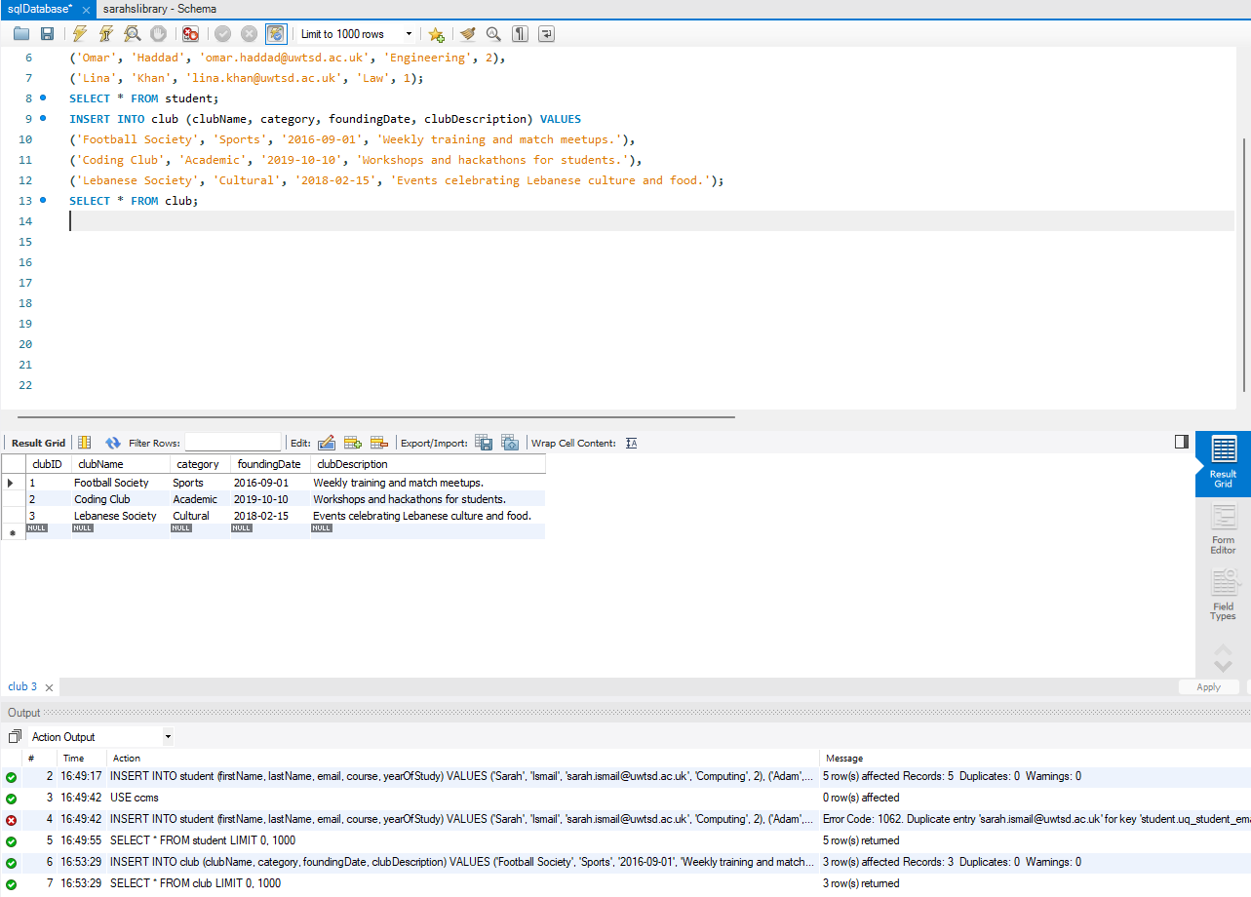
Clubs were added to represent different categories, which were described in the scenario.

These are studentID records that are verified using the query above and will now be used in the membership table.
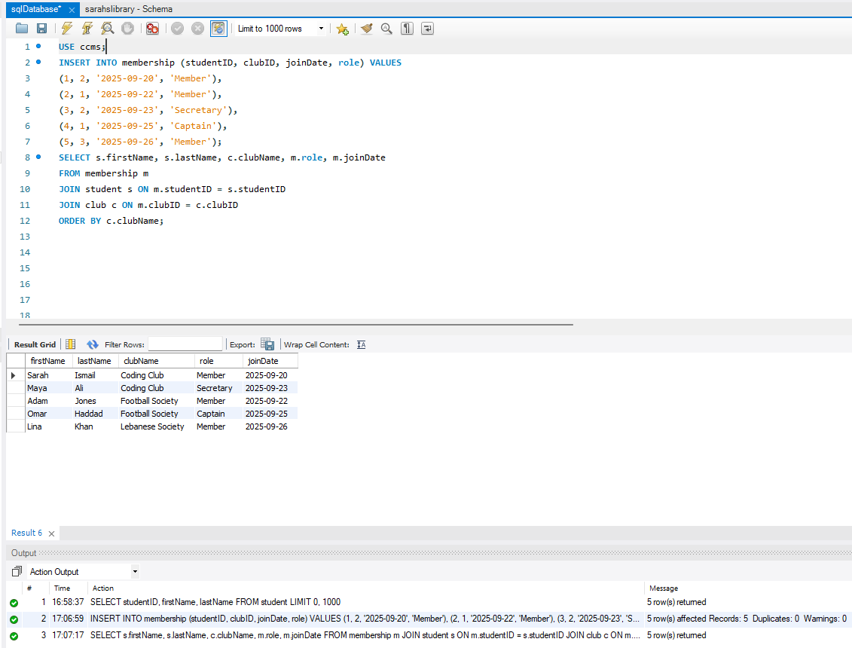
Inserted data for the membership table. This query will retrieve consolidated membership data by joining the membership table functions as a junction entity that resolves the many-to-many relationships between students and clubs while storing relationships-specific attributes such as role and join date. Inner joins ensure that only records with valid references across all related tables are returned, confirming correct enforcement or referential integrity. The results are ordered by club name to support common operational tasks such as viewing or managing club membership lists.

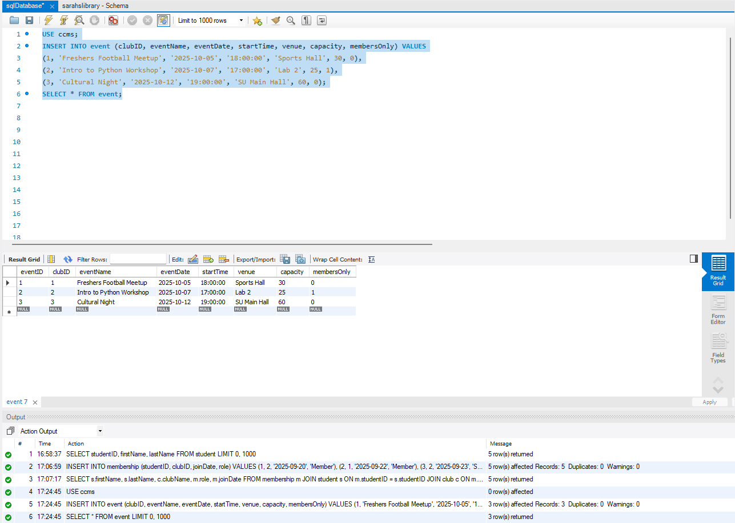
Event records were inserted to represent a list of activities which are organised by different clubs, including both open and members-only events. Each event will be linked to a single club through a foreign key, validating the one-to-many relationships between clubs and events. This data will later be used to test student participation.

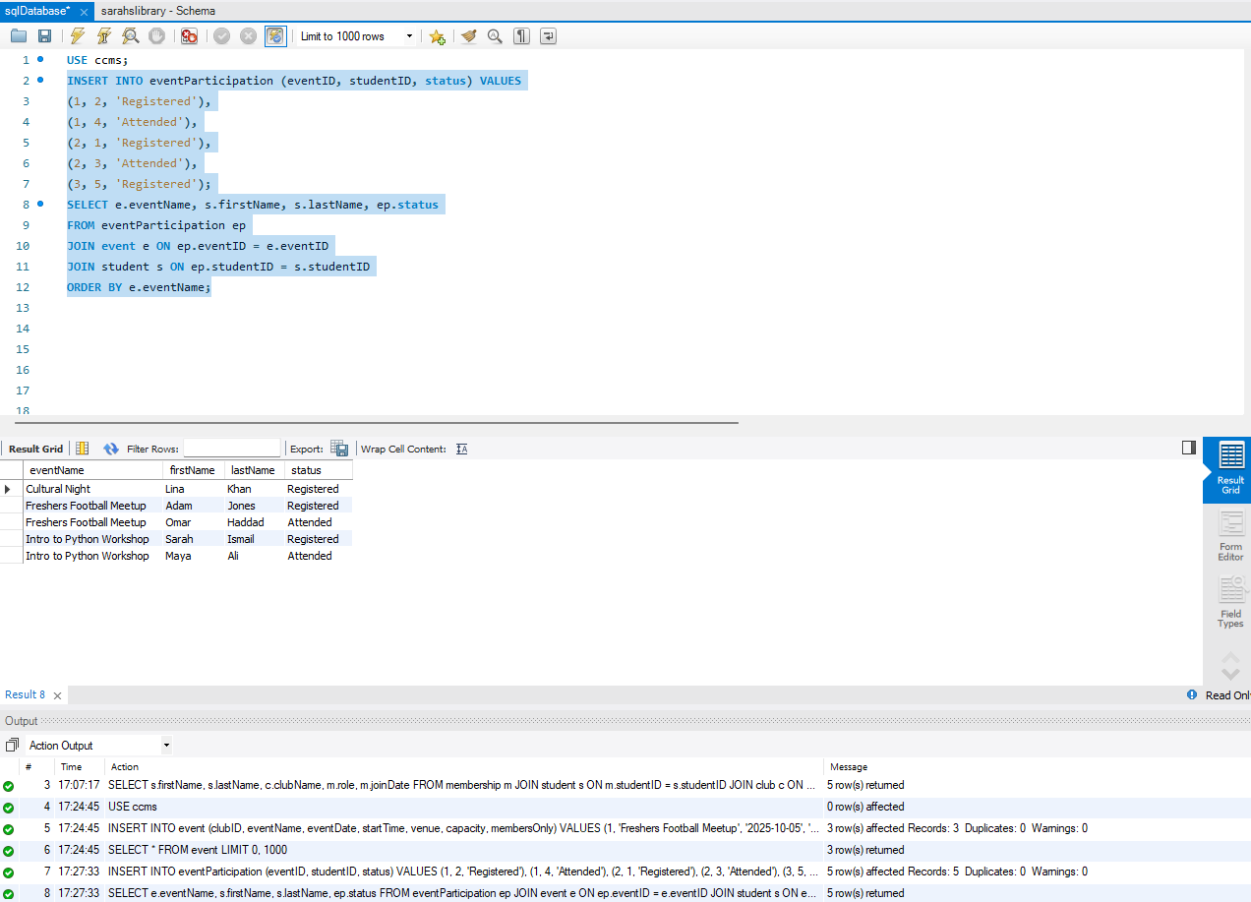

The eventParticipation table was populated to represent student involvement in club events. This table will resolve the many to many relationships between students and events while storing participation specific information such as attendance status. The join query validates the events and student records are correctly linked using foreign keys constraints. This supports accurate tracking of student engagement across multiple events.

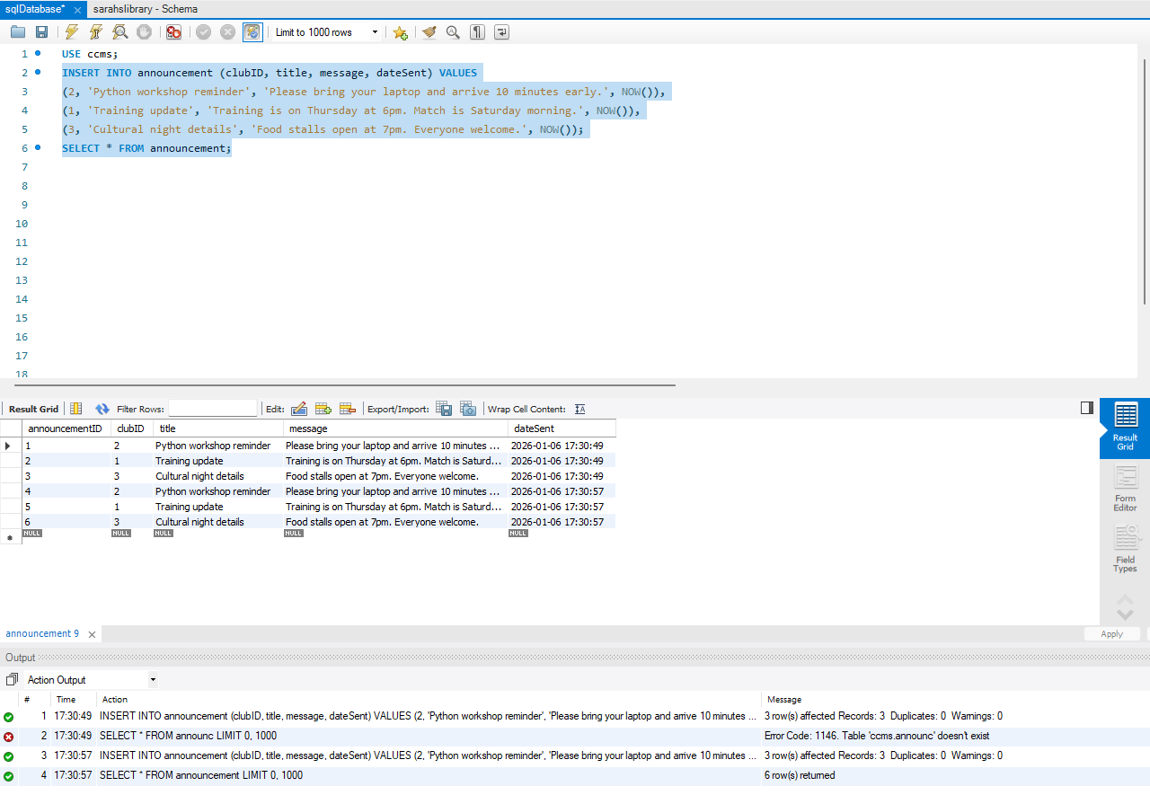

Announcements were inserted to simulate club communications stored for reference. Each announcement is linked to a specific club using the clubID foreign key, supporting the one-to-many relationship between club and announcement. This data is later used to test recipient tracking through the announcementRecipient table.

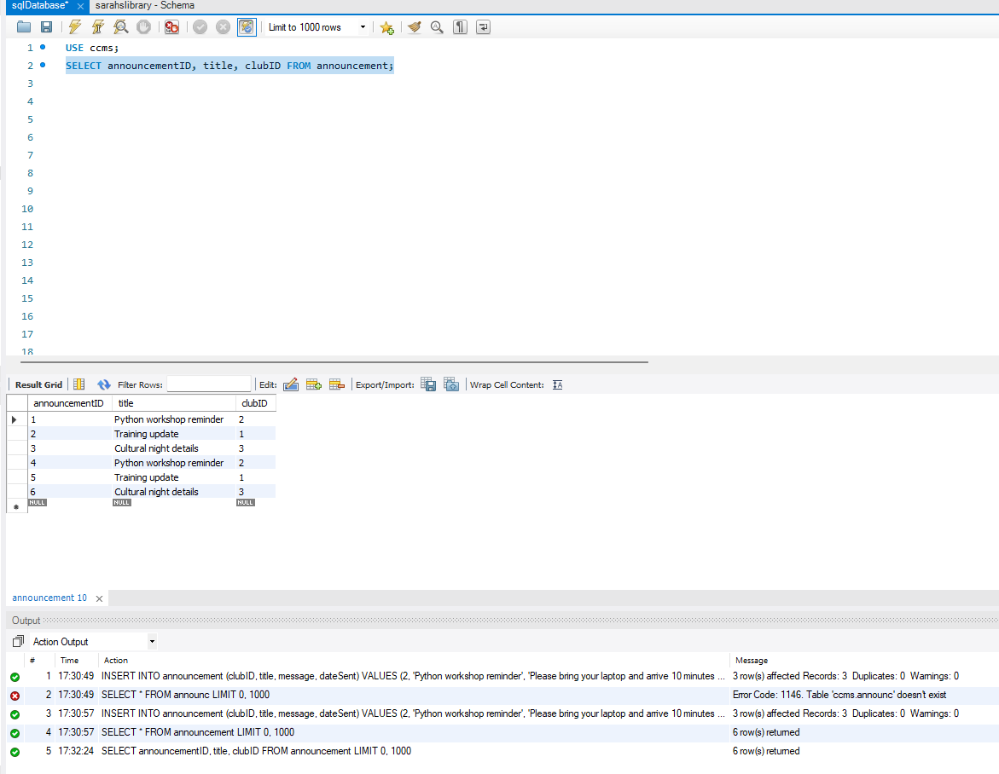
This result grid is showing that announcement exists and is showing the IDs which will be used.

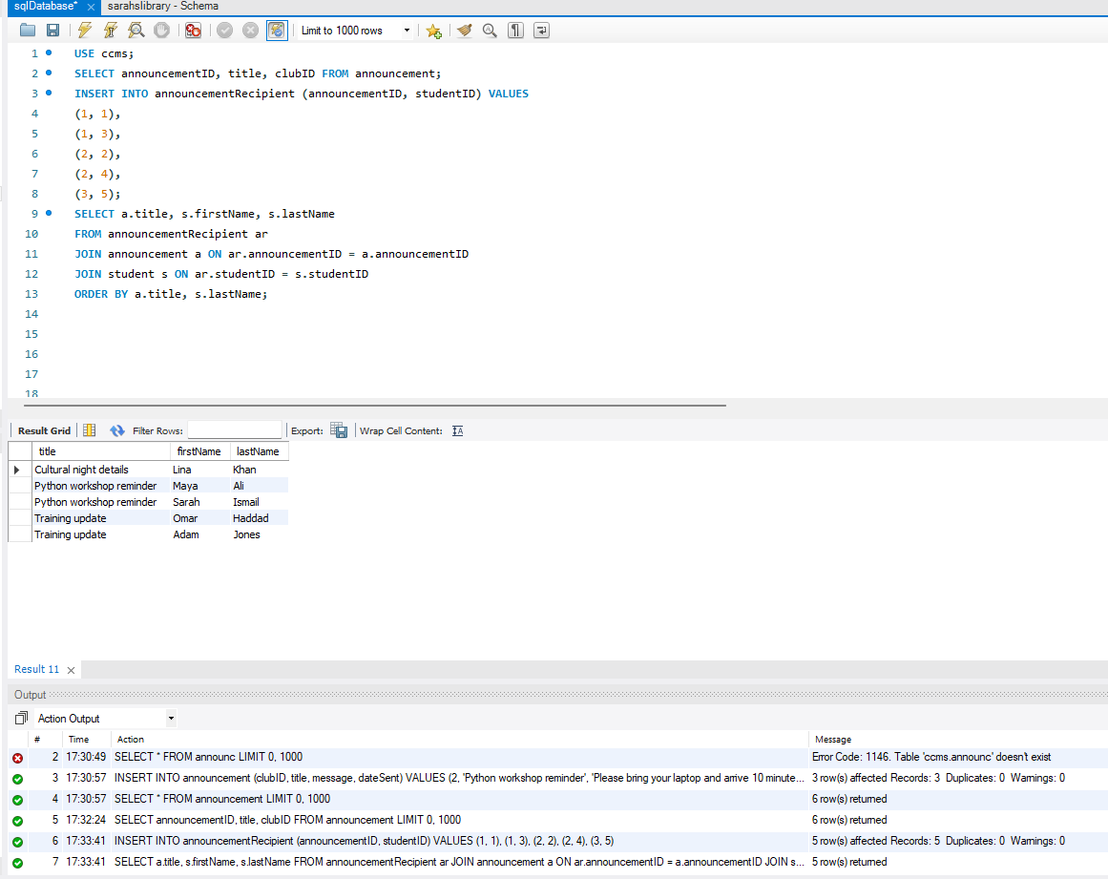
The announcementRecipient table was populated to record which students received each announcement. This junction table resolves the many-to-many relationship between students and announcements without duplicating student or announcement details. The join query confirms that announcement and student records are correctly linked through foreign keys, supporting auditing and traceability of communications. This demonstrates that the database can support real operational tasks such as viewing announcement distribution lists.

Stored Procedure and Transactional Processing
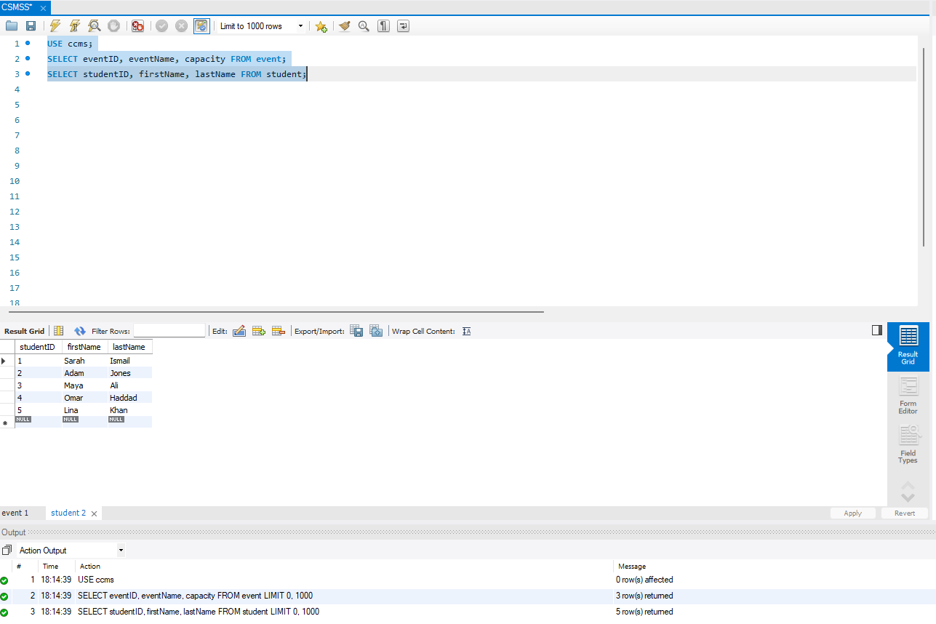

The use of ‘USE ccms’ is to ensure that the stored procedure is being tested and executed within the correct database schema which I’ve created.
Just below the query that was used to identify a valid student and event records which will be testing the stored procedure.
An event with available capacity was selected so this can demonstrate a successful transaction.

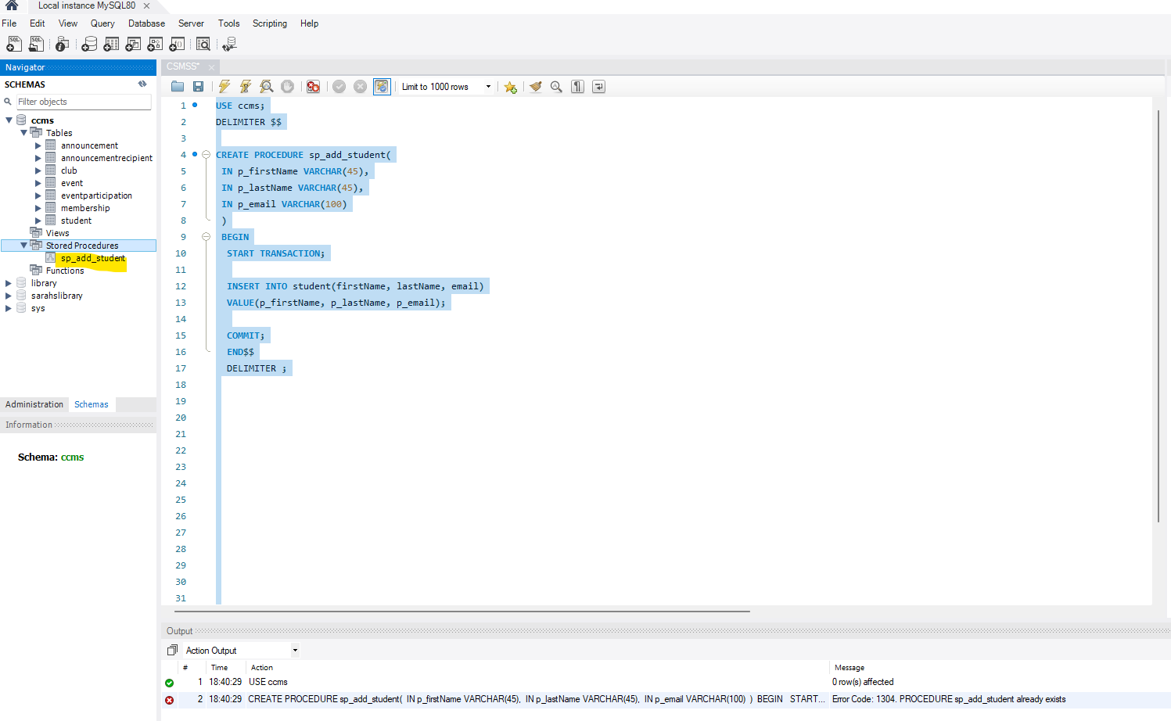
This stored procedure will perform a CREATE operation for the student table. This is showing that a transaction has started before the insert and committed after the insert completes successfully. When using a transaction, it will ensure that the student record will only be saved if the operation completes without errors.[2]

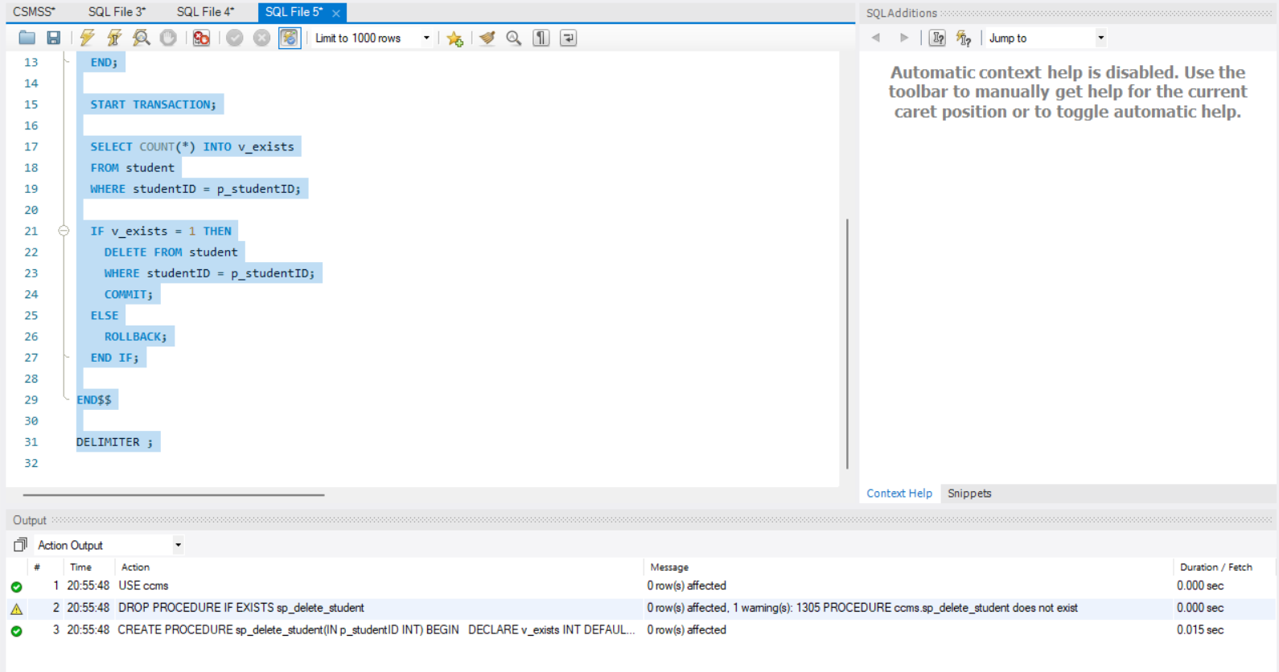
As shown above this stored procedure is used to delete a student record from the database with using a transactional control. A transaction will be starting before the delete operation will be performed. The procedure will first check whether the provided studentID exists in the student table. If the student exists, the record is deleted and the transaction is committed. If the student does not exist, the transaction will be rolled back to avoid unnecessary changes. This will help maintain data integrity and prevent partial or incorrect deletions.

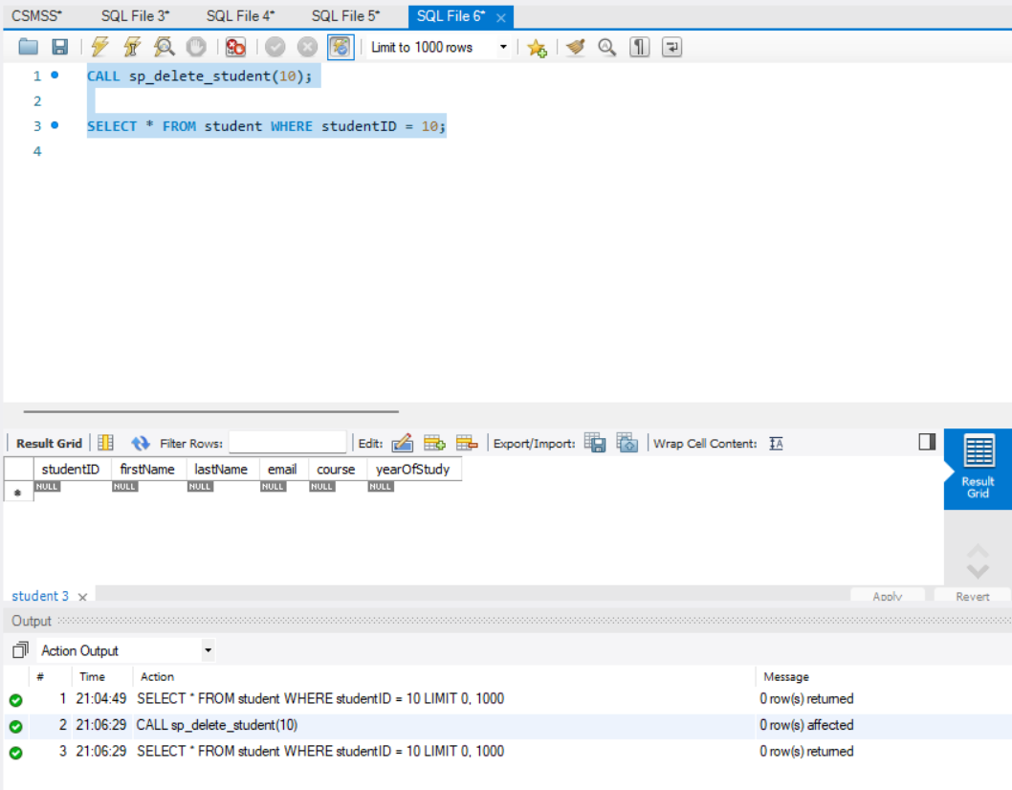
The screenshot below is showing the execution of the sp_delete_student stored procedure using an invalid studentID. Since the student does not exist, the delete operation is not performed and the transaction will be rolled back. This is showing no student record was removed.
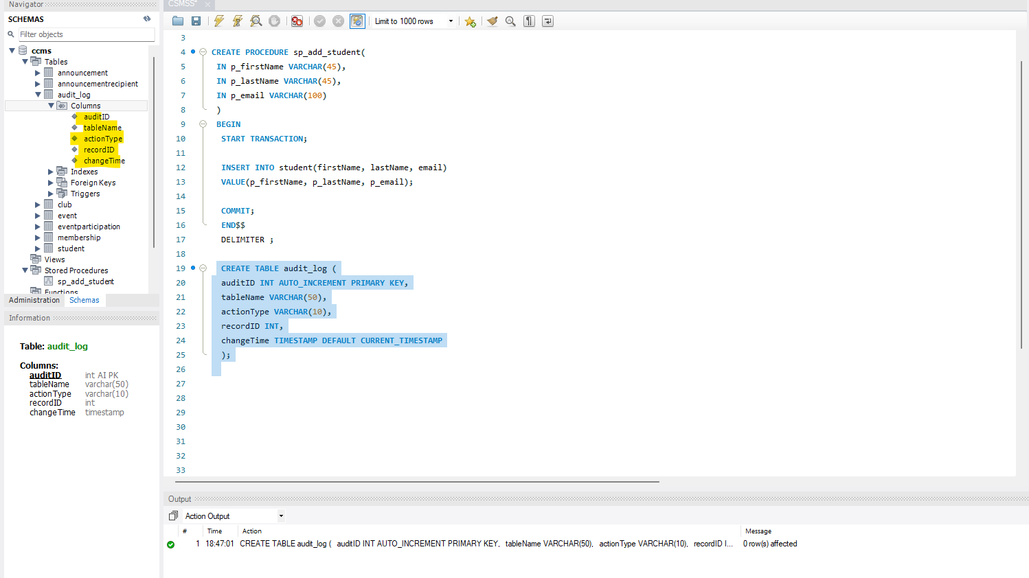

As you can see, I have created an audit_log which will store a history of changes made to the database tables. It records which table that is going to be affected, and it will show what type of operation was performed and the time of the change.

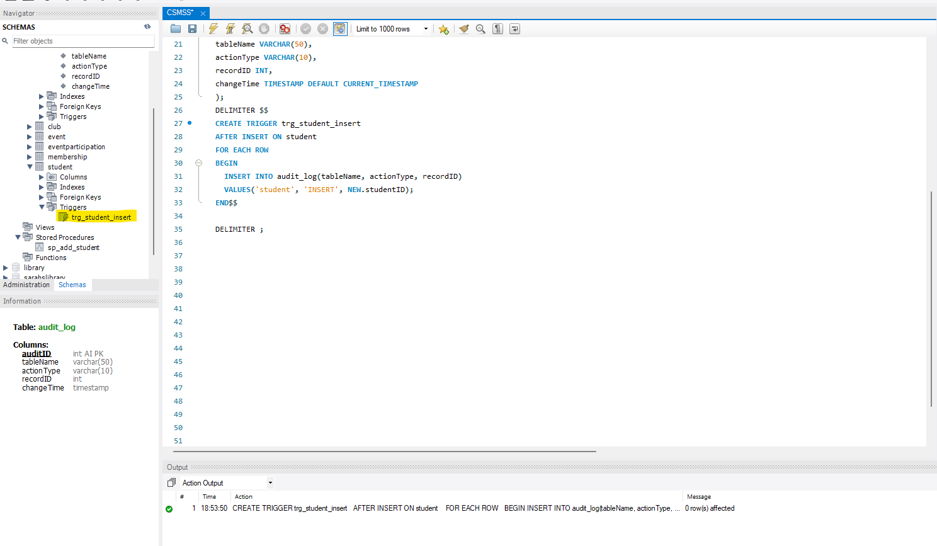
As you can see, I have created a trigger which will automatically run after a new student is inserted into the database. It will record the section in the audit_log without requiring manual input. This will ensure all insert are tracked which in the long term make sure they are consistent and reliable.
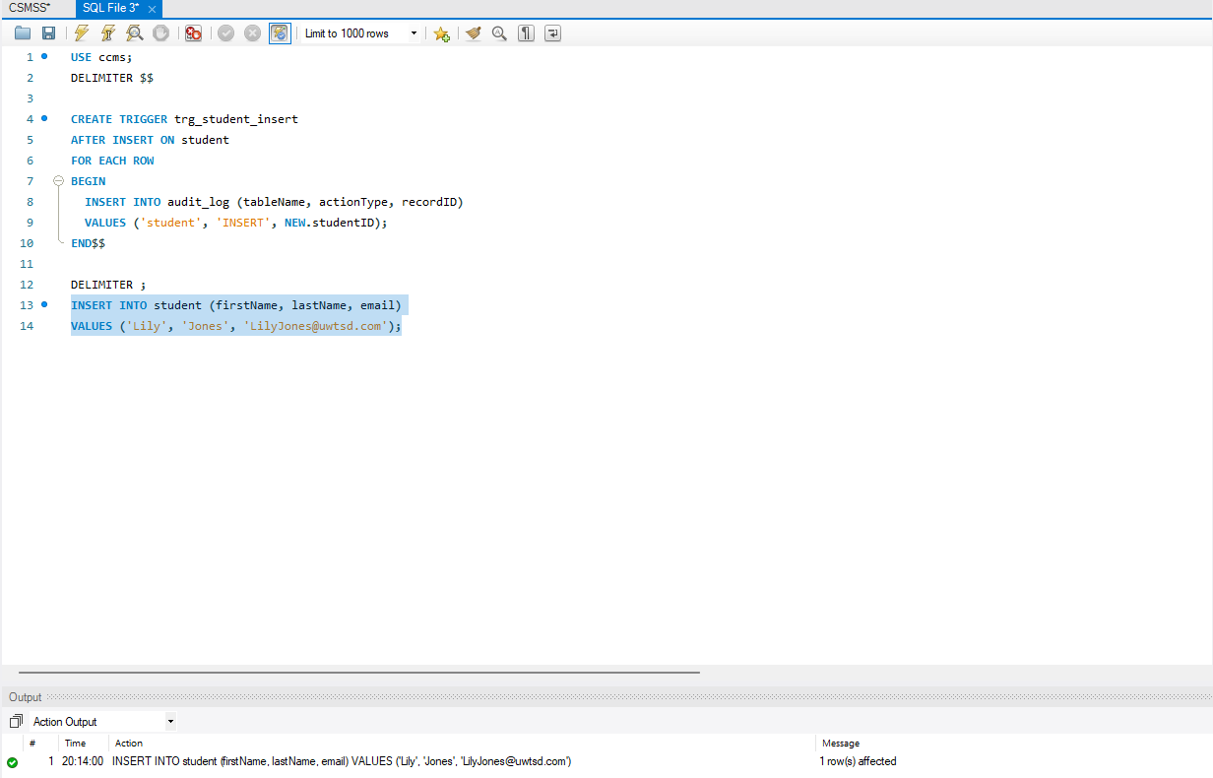

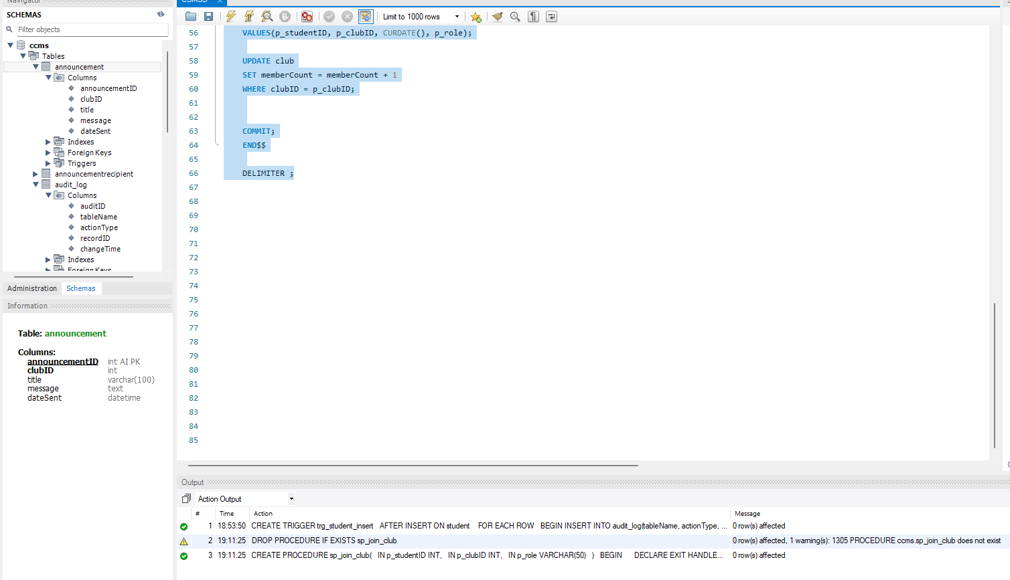
This screenshot shows the successful creation of a transactional stored procedure within CCMS database. This performs multiple related operational, including inserting a membership record and updating the club member count, which will be executed within a single transaction. The use of the COMMIT statement will ensure that all changes are permanently saved only when the entire transaction completes successfully. This action output confirms that the stored procedure was created without errors after safely removing any previous version.
On the screenshot you can see a warning message is shown when attempting to drop the procedure before creation, which is expected behaviour when the procedure was created without errors after safely removing any previous versions.

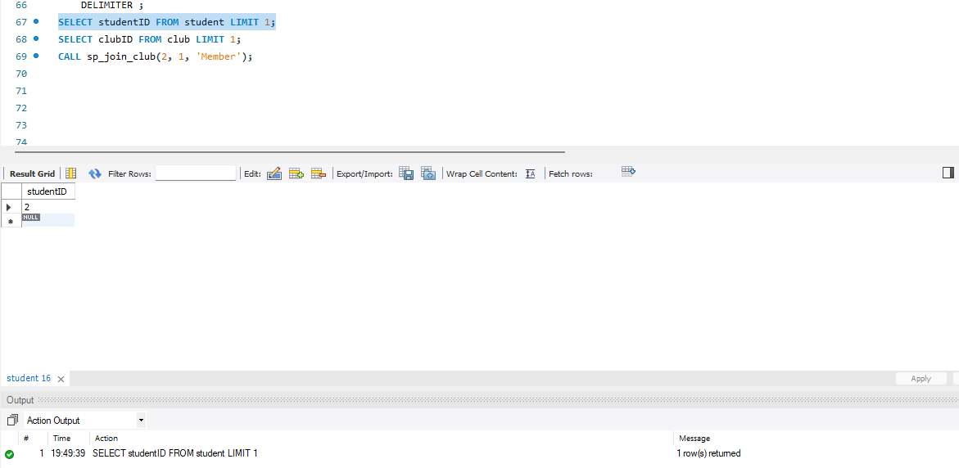
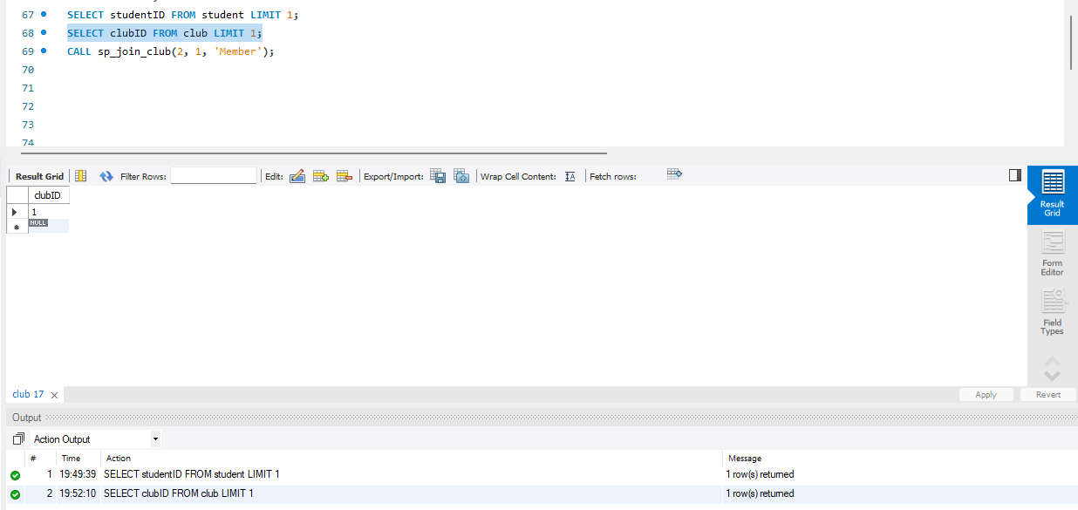
This screenshot shows the selection of valid studentID and clubID values from the database prior to executing the transactional stored procedure. These values will be used as input parameters to ensure the procedure is tested using existing records. The stored procedure is then executed while using the selected identifiers to performs the transaction in a controlled and valid manner.

This screenshot shows the retrieval of an existing clubID from the club using simple SELECT query.
The returned value confirms that a valid club record exists and can be safely used as an input parameter for the transactional stored procedure. This step will ensure that the transaction is executed using valid and existing data which will reduce the risk of runtime errors.

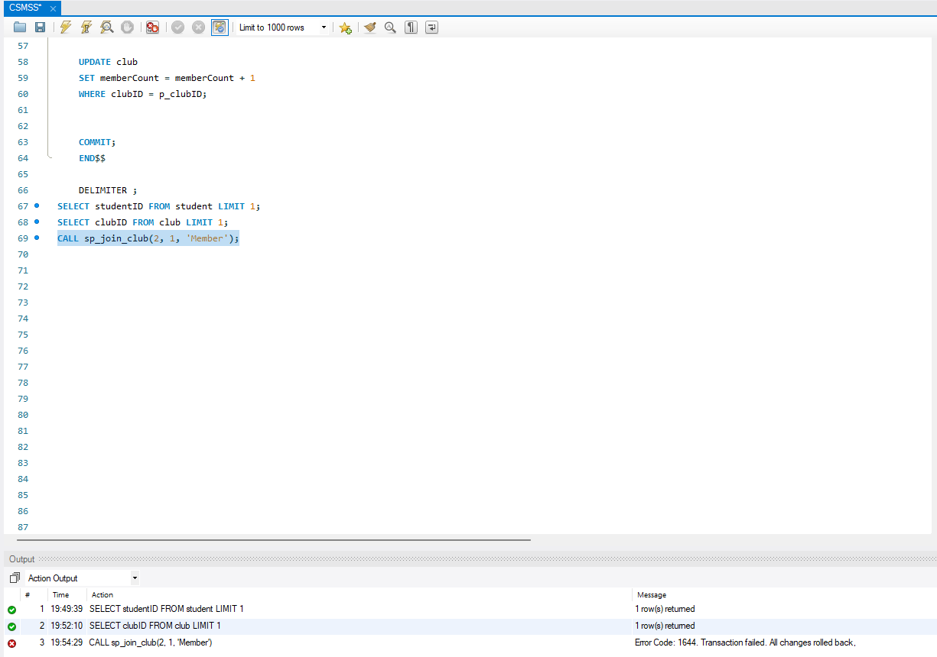
This screenshot shows the execution of the transactional stored procedure using valid student and club identifiers. When the procedure is being executed, an error will occur due to a constraint violation, such as attempting to add a duplicate membership.
As a result, the membership will fail and all changes will be rolled back automatically, as you can see on the error message that is indicating the changes were done.
This demonstrates the correct use of rollback logic to prevent partial updates and maintain integrity.

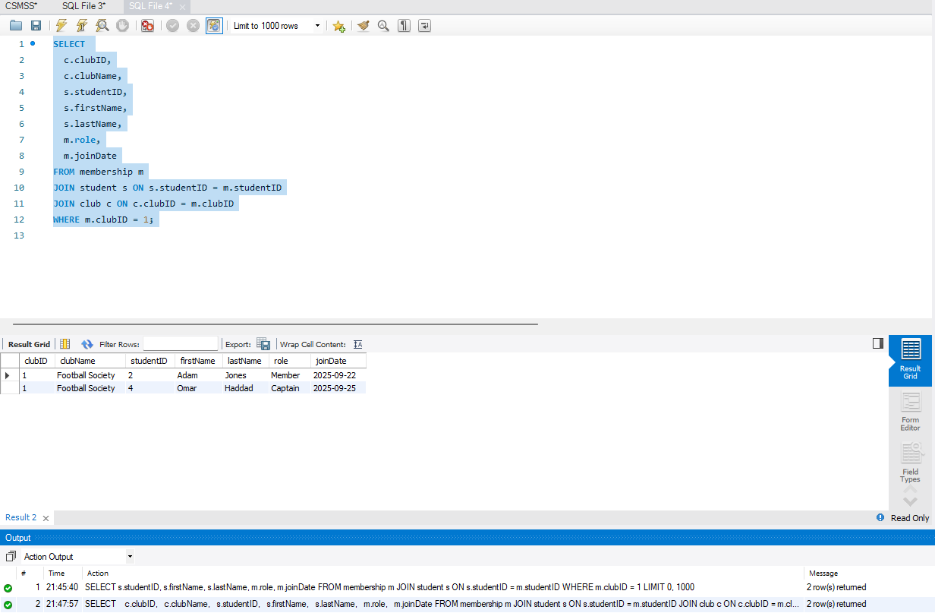
The query above will join the membership, student, and club tables to return the full membership lists for a selected club. Which in this case is clubID = 1.
This will show the club details (clubID, clubName) alongside each member’s details (name, role, join date), providing a clear view of who belongs to the club.
This is important feature of CCMS and will be frequently used to view a club profile and managing membership records.

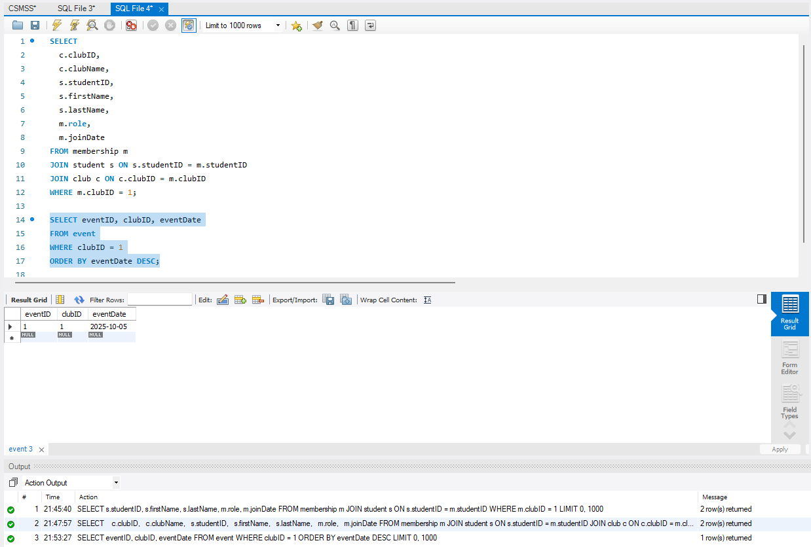
This query filters events by a particular club and sort them by date. This will show upcoming and past events for only selected club that is inputted in the query in order, supporting event browsing and planning. This is important as events are accessed regularly by members and organisers, so retrieving them quickly is important as dataset will grow.

Performance Tuning Enhancement: Query Optimization
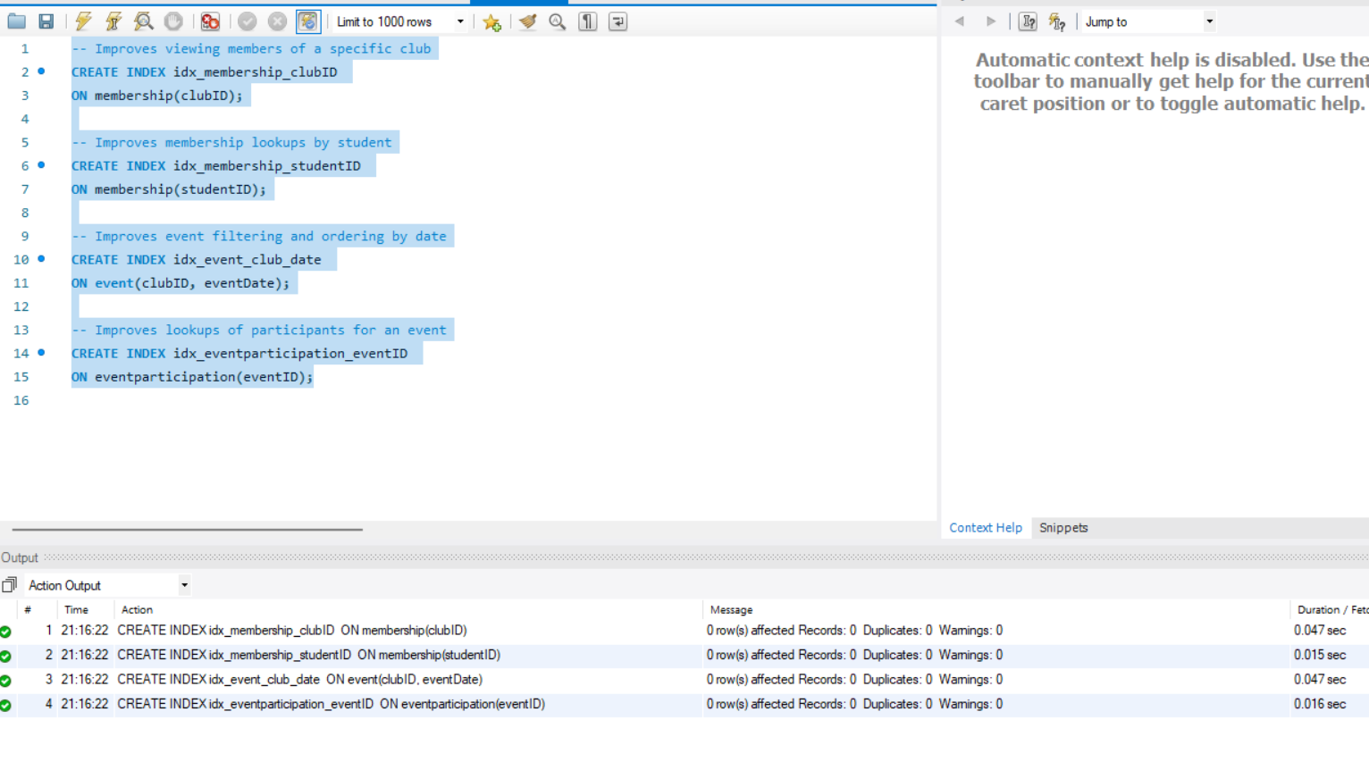

The screenshot above is showing a creation of a secondary index to optimise query performance.
These secondary indexes were created on columns that will be frequently used in the join condition and filtering operations. These indexes will improve the performance of queries that retrieve club members or are checking student memberships.[3]

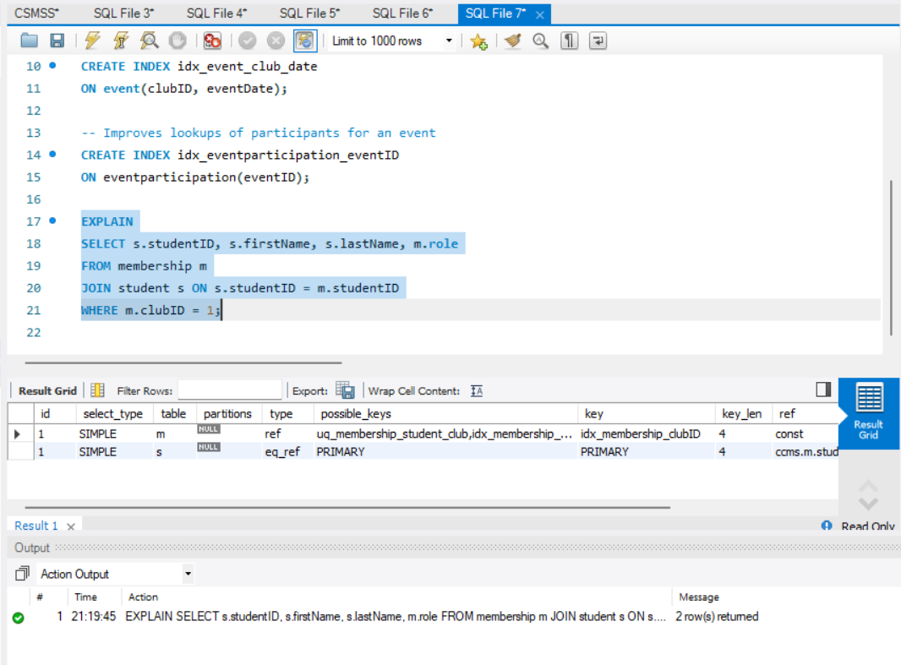
The explain output will show that the database engines are using idx_membership_clubID index when executing a query that are going to retrieve members of specific club. By using this index, the query avoids a full table scan and instead performs indexed lookups which improve efficiency. As shown above the index strategy successfully optimises performance queries and supports faster data retrieval.

Conclusion and Reflection

This assignment focused on the design and implementation of a relational database for the campus club management system, this is intended to support the effective management of student clubs, memberships and events. This database was designed using normalised relational structure with clearly defined entities, primary keys and foreign keys relationship which is used to ensure data consistency and integrity.
The implementation demonstrated the use of stored procedures which is used to support full CRUD functionality with the embedded transaction handling. Transactions were used to ensure rollback mechanism were preventing updates where errors and constraints occurred. A transactional scenario involving the club membership was implemented so I could demonstrate how multiple related operations can be executed safely within a single transaction. Triggers were used to support auditing which can automatically record changes to key tables.
Performance tuning was addressed through creating of secondary indexes on used queries columns. This was effective because one of the indexes was using EXPLAIN, which confirmed that performance critical queries utilised indexed lookups rather than full table scans. This optimisation will improve query efficiency and support the volume of data increases.
Overall, the final database solution meets the functional requirements of the CCMS and demonstrates the practical application of the database concepts. However, future concepts would be to enhance reporting features, more validation logic and a front end application to support real word use.

References

[1] T. Connolly and C. Begg, Database Systems: A Practical Approach to Design, Implementation and Management, 7th ed. Harlow, UK: Pearson, 2015.
[2] A. Silberschatz, H. F. Korth and S. Sudarshan, Database System Concepts, 7th ed. New York, NY, USA: McGraw-Hill, 2019.
[3] Oracle, “MySQL 8.0 Reference Manual – Optimization and Indexes,” Oracle Corporation, 2023. [Online]. Available: https://dev.mysql.com/doc/refman/8.0/en/optimization-indexes.html

