Programme: BA International Hotel Management
Module: Financial Management for the Hotel Industry
Module code: BMIH5007
Assignment Title: Business Report - Comparison of Two Hospitality Organizations
Lecturer: Tristan Hawkins, Jaliya de Silva
Word Count: 2000 words

Table of Contents
1 Introduction 3
2 Background of the Industry 3
3 Comparison between the Hotels 3
3.1 Total Revenue 4
3.2 Market Position 6
3.3 Growth Potential 8
3.4 Financial Commitment to CSR 9
4 Conclusion and Recommendation 9
5 References 11

Introduction
The report aims to evaluate the financial management of the two well-recognized hotels in regard to exploring the progressive approach towards financial performance and sustainability. Financial management is the key factor for the prosperity of the project or business, as delayed payment or inadequate financial balance can cause difficulty in the flow of work (Elghaish et al., 2022). Therefore, the present report will examine the fruitful strategies that could be implemented in the financial management of the two prominent hotels; Corinthia Hotels and Ibis Hotels. Through the means of revenue generated by the hotel, their market position, and the scope of their growth, the financial position of the hotels will highlight how successful the hotel's finance management is.

Background of the Industry
The hospitality industry is the umbrella term used for businesses that interact effectively with the consumer market in regard to delivering services and products. The study highlights that the hospitality industry suffered greatly due to the Covid-19 pandemic which caused heavy losses to the businesses within the industry (Breier et al., 2021). This indicates that the financial stability of the businesses within the industry was at stake and the business analyst was required to evolve the business strategies in regards to enhancing the business position. Moreover, effective financial management has to play a vital role in terms of managing a sufficient financial position. Along with other services hotels come under the hospitality industry which provides the customers with accommodation. Hotels are beneficial endeavors within the hospitality industry that provide various services to the customers and also contribute to the country's economy (Ampofo, 2020).

Comparison between the Hotels
The report is based on the financial management comparison between two prominent hotels which are Corinthia and Ibis. Corinthia Hotel is a well-recognized hotel in London, whereas Ibis Hotel is a French brand of budget hotel. The research signifies that the financial position of the higher-category hotels is more suitable than the lower-category hotels thus, the lower-category hotels must incorporate the activities that higher-category hotels are doing (Bacik et al., 2020). Therefore, the financial management and the strategies incorporated by the two mentioned hotels will be evaluated in terms of revenue both the hotels generate along with the market position they have and the growth potential of both hotels. Furthermore, the financial commitment of both hotels in terms of their CSR will also be signified to portray the social responsibility of both hotels.

Total Revenue
The hotel revenue management should innovatively develop the strategies that set the metrics for the pricing of the hotel. Furthermore the evaluation of price through the pricing history in regard to estimating the customer response can aid in achieving fruitful outcomes (Baker, et al., 2019). The total revenue generated by the hotels in the year 2022 has been compared in this report. Total revenue generated by Ibis Hotel Services was reported to be €1,052 million which marked a 93% increase in revenue that was produced in year 2021. However, the consolidated group revenue of Accor group was €4,224 million in the year 2021 (Cambon, 2023).
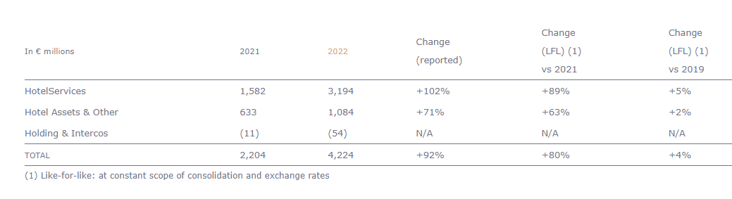
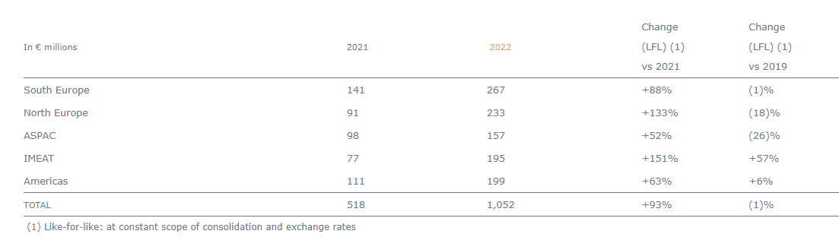
(Source: Cambon, 2023)
Whereas, the hotel service revenue for the Corinthia hotel was €201,894 in the year 2021 and the consolidated revenue produced by the group was €238,207,000 (Group, 2022).
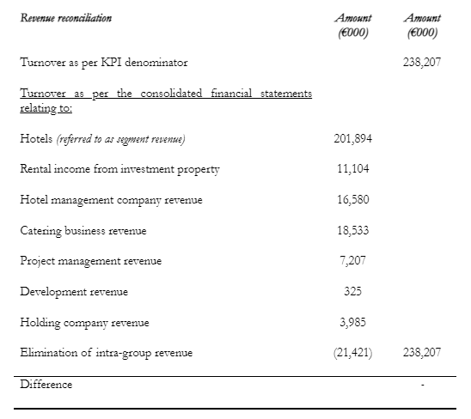
(Source: Corinthia Annual Report, 2022)
The sources through which the hotels generate revenue are mainly the accommodation and food services they provide. However, some other sources may include the events that the hotels organize or the meetings that are arranged by hotel management for the companies. Corinthia Hotel sources its revenue from the owned hotel revenue, rental income, catering income, and fee income from third parties. In comparison to this, the Ibis Hotel group sources revenue through the means of hotel services, hotel assets, and holding. The research highlights that renovation capital expenditure can have positive and negative impacts on the revenue of the hotel (Turner and Hesford, 2018). This indicates one of the factors which can aid in revenue growth or it can decline the revenue. The renovation factor enhances the hotel's image in the customer market but as it is a competitive industry thus, other hotels will swiftly take the ideas to implement which will result in slight tenure of the innovative renovation.

Market Position
The market position of the hotels are influential component in regard to deciding about the strategies and innovative technologies to be implemented to secure a place in a competitive market (Nam et al., 2020). The graphical representation of the most popular hotel brands is illustrated in the figure below. It highlights that Ibis Hotel is the 11th most popular hotel in the UK whereas, the graph does not include Corinthia Hotel within the figure.
Most popular hotel brands in the United Kingdom (UK) as of the third quarter of 2023
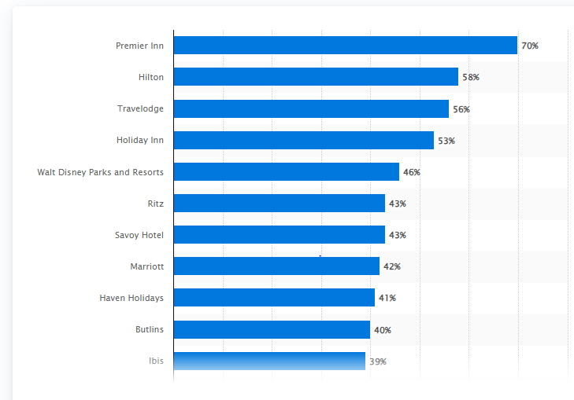
(Source: Statista, 2023)

Ibis Hotel implemented the marketing mix approach in regards to enhance its market position. The CEO of Ibis Hotel has excellence in the hospitality industry hence he has appointed efficient employees who deliver satisfactory services to the customers. Moreover, the pricing strategy of the hotel includes markdowns in the form of seasonal and festival discounts which influence the customers to approach the hotel for accommodation and services. In regards to promotional stance, the hotel has designed a strategy of providing discounts on online booking to the customers. The means of booking via online channels serve the objectives of approaching customers and generating revenues. Corinthia Hotel sustained its market position as one of the well-recognized hotels in the UK because of the view it has of the River Thames (Corinthia Group, 2024). Apart from the spectacular view from the hotel, the social media marketing of the hotel business analyst made it the most conspicuous hotel in the UK.
The above graph illustrates the brand position of Ibis Hotel in terms of customers' responses towards brand awareness, loyalty, and popularity. This indicates that Ibis Hotel shares a sufficient market position in the UK. Furthermore, the figure below demonstrates the market share of Corinthia Group in terms of its corporate bond market involvement. This highlights that with the passage of time, the market share of Corinthia within the bond market has decreased.
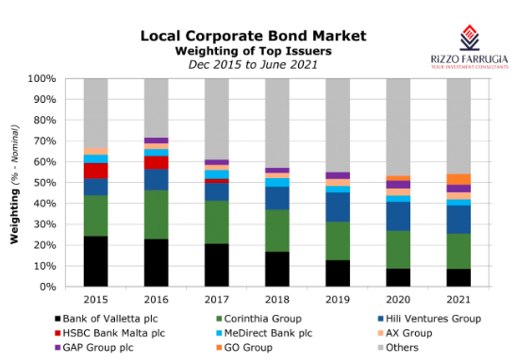
(Source: Rizzo, 2021)

Growth Potential
The disposable income of people is increasing due to the development in the global economy which is aiding the tourism industry to prosper. Therefore, budgeted hotels like Ibis have the opportunity to grab the marketplace and flourish by providing economically valuable hotels for tourists (Cheng, 2020). In addition to this, the net income growth of the Corinthia group represented through the figure below, indicates that the company has regained the growth income which was lost due to the Covid-19 pandemic.
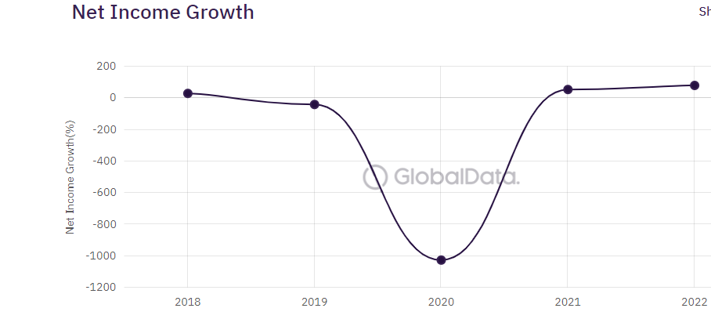
(Source: GlobalData Plc, 2023)
The hotel industry of the UK is required to enhance its efficiency at terms of local level whereas, in the context of the macroeconomic level the hotels must offer discounts (Tan and Despotis, 2021). This justifies that the growth of revenue along with the development of hotels in the UK could be achieved through these aspects. As the following bar chart illustrates the revenue generated by the hotels, it highlights that the growing scope of hotels is increasing eventually. Therefore, the Ibis Hotel and Corinthia Hotel should implement progressive strategies regarding flourishing in terms of financial and potential growth.
According to the research, the interconnection of the potential growth of the hotel could be achieved through the means of digital transformation as it will maintain the market share of the hotel through maximizing revenue (Alrawadieh, et al., 2020). However, the rapid advancement within the technologies creates difficulties for the hotel management to incorporate the latest technical shift. The transformation towards innovative technology requires training and often the employees resist shifting their traditional practices thus, it becomes challenging for the authorities to transform. Furthermore, the most debatable topic of the era is attaining sustainability. However, hotels are facing challenges in achieving sustainability because of the barriers in terms of financial challenges, lack of resources, and due to time-consuming processes (Khatter et al., 2021). These factors are influential for the potential growth of the hotels whereas, the implementation of these elements is challenging and often seems a barrier to the progressive development of the companies.

Financial Commitment to CSR
Corporate social responsibility plays a vital role in the firm's financial aspects therefore, the business intellectuals solely focus on CSR to achieve the desired objectives (Awaysheh et al., 2020). The core purpose of implementing the CSR model in regard to achieving financial benefits is because the consumer market is concerned about societal progress. The evolvement of the SDGs has influenced customer behavior in terms of shaping their notions to approach sustainable businesses. The figure below indicates that the consumer's attitude toward CSR highlights that the businesses are not fulfilling the sustainability objectives for a safe environment.
The CSR model enhances the financial performance of the organizations in several aspects as the green innovation within the firm enriches the financial position of the business (Ma et al., 2023). Sustainable development does not only achieve the environmental aims of achieving green practices rather it also influences the customer or consumer market. Furthermore, the mentioned hotels in the report can incorporate sustainable practices such as proper waste management, reduced water consumption, and safe energy resources. Other than this the hotel can create a green environment throughout the hotel boundaries in order to reduce the carbon footprints. Achieving the sustainability development goals will financially payback in the long-term and the hotels will generate sufficient revenue from the customers who support sustainability.

Conclusion and Recommendation
In a nutshell, the present report explores the financial management aspects of the prominent hotels, Corinthia and Ibis. The core objective of evaluating financial management is to investigate the financial performance of the hotels along with the sustainability perspectives it deliver. As the hotels belong to the large hospitality industry within the UK thus, fruitful financial management is the key requirement for the hotels to stay within the competitive market. The comparison of the hotels was considered in order to investigate how prolific financial management hotels can incorporate in regard to achieving business goals. The hotel comparison was performed through the means of evaluating their total revenue, the market position they have, the growth potential of the hotels within the competitive sector of hospitality, and their financial commitment with regard to the CSR policy. In addition to this, the findings and the in-depth insight into the hotel's financial management evaluate that the sustainability incorporation within the business strategies can prove to be beneficial for the hotels to progress. Thus, in regard to offering recommendations the Corinthia Hotel and Ibis Hotel must promote green practices through the hotel management and services. Along with this, the hotels can promote the sustainability development goals through the means of campaigns. These promotional tactics will enhance the brand image of the hotels which will influence the consumer market and along with this, the sustainability development goals will also be achieved by the hotels. Therefore, it emphasizes that the financial stance can be accomplished while implementing the green practices.

References
Alrawadieh, Z., Alrawadieh, Z. and Cetin, G. (2020). Digital transformation and revenue management: Evidence from the hotel industry. Tourism Economics, 27(2), p.135481662090192. doi:https://doi.org/10.1177/1354816620901928.
Ampofo, J.A. (2020). CONTRIBUTIONS OF THE HOSPITALITY INDUSTRY (HOTELS) IN THE DEVELOPMENT OF WA MUNICIPALITY IN GHANA. International Journal of Advanced Economics, 2(2), pp.21–38. doi:https://doi.org/10.51594/ijae.v2i2.155.
Awaysheh, A., Heron, R.A., Perry, T. and Wilson, J.I. (2020). On the relation between corporate social responsibility and financial performance. Strategic Management Journal, 41(6).
Bacik, R., Fedorko, R., Gavurova, B., Ivankova, V. and Rigelsky, M. (2020). DIFFERENCES IN FINANCIAL PERFORMANCE BETWEEN VARIOUS CATEGORIES OF HOTELS IN THE VISEGRAD GROUP COUNTRIES. Journal of International Studies, [online] 13(2), pp.279–290. Available at: https://www.ceeol.com/search/article-detail?id=980620.
Baker, T., Eziz, A. and Harrington, R.J. (2019). Hotel revenue management for the transient segment: taxonomy-based research. International Journal of Contemporary Hospitality Management, ahead-of-print(ahead-of-print). doi:https://doi.org/10.1108/ijchm-01-2019-0065.
Breier, M., Kallmuenzer, A., Clauss, T., Gast, J., Kraus, S. and Tiberius, V. (2021). The role of business model innovation in the hospitality industry during the COVID-19 crisis. International Journal of Hospitality Management, [online] 92(92), p.102723. doi:https://doi.org/10.1016/j.ijhm.2020.102723.
Cambon, A. (2023). Full-Year 2022 Results Solid and sustainable rebound in activity in 2022. [online] Accor – Newsroom. Available at: https://press.accor.com/full-year-2022-resultssolid-and-sustainable-reboundin-activity-in-2022sustainable-revpar-recovery-above-pre-pandemic-levelfy-2023-group-revpar-expected-up-between-5-and-9-lfl-yoy-return-of/?lang=e [Accessed 30 Jan. 2024].
Cheng, J. (2020). Research and Suggestions on Declining Market Shares of Ibis Budget Hotels. Open Journal of Social Sciences, [online] 08(1), p.253. doi:https://doi.org/10.4236/jss.2020.81018.
Cocks, P. (2021). Corinthia to target 4-star space under new brand to be launched by 2023. [online] BusinessToday.com.mt. Available at: https://www.businesstoday.com.mt/business/business/1849/corinthia_to_target_4star_space_under_new_brand_to_be_launched_by_2023.
Corinthia Group (2024). UPLIF TING LI V ES. [online] Available at: https://www.corinthia.com/globalassets/corinthia-global/documents/development/corinthia-development-presentation-may-2023-compressed.pdf.
Elghaish, F., Pour Rahimian, F., Hosseini, M.R., Edwards, D. and Shelbourn, M. (2022). Financial management of construction projects: Hyperledger fabric and chaincode solutions. Automation in Construction, [online] 137, p.104185. doi:https://doi.org/10.1016/j.autcon.2022.104185.
GlobalData Plc (2023). International Hotel Investments plc Company Profile - Overview. [online] Globaldata.com. Available at: https://www.globaldata.com/company-profile/international-hotel-investments-plc/ [Accessed 30 Jan. 2024].
Group, C. (2022). & Financial Statements. [online] Available at: https://www.corinthiagroup.com/wp-content/uploads/2023/06/37547-CORINTHIA-ANNUAL-REPORT-2022_WEB-min.pdf.
International Hotel Investments p.l.c. Annual Report & Financial Statements. (2022).
Khatter, A., White, L., Pyke, J. and McGrath, M. (2021). Barriers and drivers of environmental sustainability: Australian hotels. International Journal of Contemporary Hospitality Management, 33(5), pp.1830–1849. doi:https://doi.org/10.1108/ijchm-08-2020-0929.
Ma, C., Chishti, M.F., Durrani, M.K., Bashir, R., Safdar, S. and Hussain, R.T. (2023). The Corporate Social Responsibility and Its Impact on Financial Performance: A Case of Developing Countries. Sustainability, [online] 15(4), p.3724. doi:https://doi.org/10.3390/su15043724.
Nam, K., Dutt, C.S., Chathoth, P., Daghfous, A. and Khan, M.S. (2020). The adoption of artificial intelligence and robotics in the hotel industry: Prospects and challenges. Electronic Markets, 31(3).
Rizzo, E. (2021). Composition of bond market | Rizzo, Farrugia & Co. (Stockbrokers) Ltd. - Malta. [online] Rizzo Farrugia. Available at: https://rizzofarrugia.com/published-articles/weekly/composition-of-bond-market/ [Accessed 30 Jan. 2024].
Statista.com (2023). Most popular hotel brands in the UK 2019. [online] Statista. Available at: https://www.statista.com/statistics/951262/most-popular-hotel-brands-uk/.
Tan, Y. and Despotis, D. (2021). Investigation of efficiency in the UK hotel industry: a network data envelopment analysis approach. International Journal of Contemporary Hospitality Management, 33(3), pp.1080–1104. doi:https://doi.org/10.1108/ijchm-07-2020-0641.
Turner, M.J. and Hesford, J.W. (2018). The Impact of Renovation Capital Expenditure on Hotel Property Performance. Cornell Hospitality Quarterly, 60(1), pp.25–39. doi:https://doi.org/10.1177/1938965518779538.

