

IUPS5006: SOCIAL PSYCHOLOGY
ASSIGNMENT: RESEARCH REPORT
TOPIC: GENDER DIFFERENCES IN ATTITUDES TOWARDS FEMINISM

LECTURER: DR. JUDITH MARSHALL
STUDENT: REDACTED FOR ANONYMOUS MARKING

FOR THE OVERSEAS DUAL AWARD PROGRAMME

Student Feedback Form

This section details the extent to which the assessment criteria are demonstrated by you, which in turn determines your mark. The marks available for each category of skill are shown. Lecturers will use the space provided to comment on the achievement of the task(s), including those areas in which you have performed well and areas that would benefit from development/improvement.

Generic Assessment Criteria | Max  Marks | Marks Given
1. Engagement with Literature Skills
2. Knowledge and Understanding Skills
3. Cognitive and Intellectual Skills
4. Practical Application Skills
5. Transferable Skills for Life and Professional Practice

Assessment Mark (Assessment marks are subject to ramifications at the Exam Board. These comments and marks are to give feedback on module work and are for guidance only until they are confirmed.) | Late Submission Penalties |  | %
 | Up to 1 week late (40% max) |  | %
 | Over 1 week late (0%) |  | %

USE OF AI ACKNOWLEDGEMENT STATEMENT

I confirm that I have not used any AI tools in the research and creation of this assignment. I confirm that I have not presented any AI generated materials as my own work. I confirm I have copies of my drafts, notes, and other resources I used, which I may be asked to provide in evidence.

TABLE OF CONTENTS
STUDENT FEEDBACK FORM
USE OF AI ACKNOWLEDGEMENT STATEMENT
1.0 INTRODUCTION
2.0 METHODOLOGY
2.1 RESEARCH DESIGN
2.2 PARTICIPANTS
2.3 MATERIALS AND MEASURES
2.4 PROCEDURES
2.5 DATA PREPARATION
3.0 RESULTS
3.1 DESCRIPTIVE STATISTICS
3.2 ONE-WAY MANOVA AND FOLLOW-UP ANOVAS
4.0 DISCUSSION
4.1 OVERVIEW OF FINDINGS
4.2 IMPLICATIONS FOR FEMINIST ATTITUDES
4.3 RELATIONSHIP TO PREVIOUS RESEARCH
4.4 METHODOLOGICAL CONSIDERATIONS
5.0 CONCLUSION
REFERENCES
APPENDIX

INTRODUCTION

Feminism is broadly understood as a set of political, social, and intellectual movements concerned with challenging gender-based inequality and advancing equal rights, opportunities, and social status across genders. Although feminism encompasses diverse traditions and priorities, a central concern is the extent to which gender should determine individuals' access to education, employment, leadership, family roles, political participation, and personal autonomy. Attitudes toward feminism are therefore closely connected to beliefs about gender roles, in which people who endorse equal participation of women and men across domains are generally more likely to hold views consistent with feminist principles. Conversely, the belief that women and men should occupy distinct and fixed social positions may reinforce structural and interpersonal forms of gender inequality. (Henze et al., 2024)

Gender role attitudes refer to beliefs about the responsibilities, characteristics, and behaviours considered appropriate for women and men. Traditional gender role attitudes typically position men as primary economic providers, authority figures, and decision-makers. Women are positioned as caregivers responsible for domestic labour and childrearing. Egalitarian gender role attitudes reject this division as inherently necessary, and instead support the equitable sharing of responsibilities. These attitudes are consequential because they influence not only personal choices but also public responses to gender equality policies, workplace practices, parental leave arrangements, and women’s representation in positions of authority. For example, an employee who regards caregiving as principally a women’s responsibility may be less supportive of organisational policies that normalise equal parental leave. (Daw & Scharf, 2024)

Social role theory provides a useful framework for understanding why attitudes toward gender roles may differ between women and men. The theory proposes that observed gender differences partly emerge from the social roles historically assigned to each gender. Across many societies, women have been more strongly associated with unpaid domestic work and caregiving, while men have been more strongly associated with paid labour, physical protection, and public authority. These patterns can foster expectations that women should be communal, nurturing, and family-oriented, whereas men should be assertive, independent, and career-oriented. Although social and economic conditions have changed substantially, including increased female labour force participation and broader access to higher education, traditional expectations may continue to shape individual beliefs and institutional arrangements. Gender role attitudes may thus reflect both contemporary social realities and enduring cultural norms. (Reich-Stiebert et al., 2023)

Differences between men’s and women’s attitudes toward feminism may also be explained by their unequal exposure to the consequences of gender inequality. Women may be more likely to encounter barriers related to occupational advancement, unequal household labour, sexual harassment, discrimination, or expectations concerning appearance and caregiving. Such experiences may increase awareness of gendered disadvantage and strengthen support for egalitarian social arrangements. Men, in contrast, may experience fewer direct costs from conventional gender hierarchies, and may regard feminist change as a challenge to familiar identities, status relations, or family arrangements. However, these explanations should not be interpreted as suggesting that all women support feminism or that all men oppose it. Men may endorse feminist principles because of egalitarian values, personal relationships, or recognition of gender injustice. Women may endorse traditional roles due to religious beliefs, cultural norms, family socialisation, or individual preferences. (Sevincer et al., 2023)

Previous research has frequently found that women report more egalitarian gender role attitudes and more favourable views of feminism than men, on average. This pattern is consistent with scholarship on gender socialisation, sexism, and social dominance, which indicates that groups affected by unusual social arrangements may be more likely to question and resist them. Nevertheless, the size and direction of gender differences can vary across populations. Attitudes may be shaped by age, educational attainment, religiosity, political orientation, socioeconomic position, ethnicity, relationship and parenthood status, and national context. In multicultural societies such as Malaysia, for instance, attitudes toward women’s and men’s roles may also be influenced by the interaction of religious traditions, family values, economic opportunities, and rapid social change. It is therefore important to examine gender role attitudes within the specific characteristics of the study population. (Endut et al., 2020)

The present study investigates whether men and women differ in attitudes toward gender roles that are relevant to feminist principles. Attitudes were assessed using the Social Roles Questionnaire (SRQ), developed by Baber and Tucker, which measures beliefs about appropriate and desirable roles for women and men in different aspects of life.Accordingly, this study addresses the following research question: do men and women differ significantly in their attitudes toward gender roles? Based on previous research and social role theory, it is hypothesised that women will report more egalitarian and less traditional gender role attitudes than men. (Grigoropoulos, 2025)

METHODOLOGY

2.1 RESEARCH DESIGN
This study used a quantitative, cross-sectional, between-groups design to investigate whether men and women differ in attitudes toward feminism. For the purposes of this study, attitudes toward feminism were operationalised through attitudes toward gendered social roles. These included beliefs concerning men and women’s responsibilities in domestic, occupational, parenting, and wider social contexts. A between-groups design is appropriate because participants were allocated to naturally occurring gender groups, and each participant would complete the survey on one occasion only.

The independent variable was self-reported gender, comprising two comparison groups: men and women. The dependent variable was attitude toward gender roles, assessed using participants’ scores on the Social Roles Questionnaire. The design permitted statistical comparison of the average SRQ scores of men and women, while preserving the anonymous and one-off nature of participation. However, because gender is an existing participant characteristic rather than an experimentally manipulated variable, any group difference identified cannot demonstrate that gender causes particular attitudes. (Hess, 2023)

The research was conducted online through Qualtrics. This method is suitable because the study concerns potentially sensitive beliefs about gender, feminism, sexuality, and social expectations. Online participation may allow respondents to complete the questionnaire privately and reduce concerns about being personally judged by a researcher or other participants. Nevertheless, the lack of a researcher present during participation meant that respondents were not able to obtain immediate clarification of any questionnaire wording.

2.2 PARTICIPANTS
The sample consisted of 21 men and 17 women aged between 18 and 30 years. Participants self-selected by deciding whether to access and complete the online questionnaire, in which participation would be entirely voluntary and no individual would be coerced to take part. The study used convenience sampling, as participants were recruited through accessible personal, educational, and online networks. Although this approach is practical for a small scale research activity, it is non-probability based and therefore limits the extent to which the findings can be generalised to all men and women in the wider population. (Zrineh et al., 2026)

The selected age range is intended to reduce the potential influence of large age and generational differences in attitudes toward feminism and gender roles. Participants aged under 18 were excluded because they cannot provide adult consent within the study’s proposed ethical framework, while participants older than 30 were excluded to maintain a more age-homogenous sample.

Participants who did not provide consent were automatically screened out of the Qualtrics survey and would not be able to access the research questions. No payment, incentive, or direct benefit was offered in exchange for participation.

2.3 MATERIALS AND MEASURES
The principal research instrument was the 13-item Social Roles Questionnaire (SRQ), developed by Baber and Tucker (2006). The SRQ is an established questionnaire designed to assess attitudes toward the social roles of men and women in contemporary society. It examines whether individuals view social roles as gender-linked or gender-transcendent. The former views certain responsibilities or characteristics as more appropriate for one gender, while the latter views that roles should be determined by personal qualities, interests, and abilities. (Bolduc et al., 2025)

The SRQ provides an indirect but relevant measure of attitudes toward feminism. Feminism encompasses a broad range of concerns, including gender equality, discrimination, bodily autonomy, workplace opportunity, political representation, and resistance to gender-based violence. The SRQ does not measure all these dimensions directly, but rather, it measures beliefs about gendered expectations that may either support or challenge the social inequalities addressed by feminist thought. Consequently, results will be interpreted as evidence of differences in gender role attitudes to feminism, instead as definitive evidence of participants’ feminist identity or commitment to feminist movements. (Henze et al., 2024)

Participants responded to all 13 SRQ items using an 11-point Likert scale, with 0 representing “Strongly Disagree” and 10 representing “Strongly Agree”. The survey also collected limited demographic information, specifically participants’ age and gender. No direct identifying information was requested, and each response was instead stored with a unique code. It ensures that demographic and questionnaire data cannot be linked to an identifiable individual.

2.4 PROCEDURE
Data collection took place through an online Qualtrics survey, with data stored on its cloud platform. Potential participants were first presented with a participant information sheet on the opening page of the survey. This document explained the purpose of the research, the procedures involved, the voluntary nature of participation, the measures used to protect anonymity and confidentiality, as well as the participants’ right to withdraw without penalty before submitting their responses. Participants were informed in advance that the survey addresses attitudes concerning feminism, gender roles, sex-based stereotypes, parenting and household expectations, sexuality, gender identity, and experiences of gender inequality.

Following the information sheet, participants provided electronic informed consent through a compulsory tick-box agreement. This approach is appropriate for an internet-mediated study, in which physical written consent cannot be obtained. Participants who selected “Yes, I agree to take part” progressed to the survey, whereas those who selected “No” were automatically excluded from further participation. The consent procedure is consistent with the ethical approach described in the British Psychological Society guidance for internet-mediated research. (British Psychological Society, 2021)

Participants who provided consent completed the demographic questions before responding to the 13-item SRQ. They were able to withdraw at any time before submission and could choose not to proceed if they found the study topic uncomfortable or did not wish to disclose their views. The survey did not use deception, and participants were informed of the general purpose and nature of the study before responding. Participants were also given the option to omit questionnaire questions they did not wish to answer, where this was enabled in the survey design.

Upon completing and submitting the questionnaire, participants were directed to an online debrief page. The debrief provided a fuller explanation of the study’s purpose and aims, thanked participants for their contribution, as well as provided the contact details of the research team and the academic supervisor. Participants were able to contact the research team if they have questions or concerns after taking part. No individual feedback, personalised interpretation of scores, or summary of the final analysis was provided, which is appropriate given the low risk and anonymous nature of the survey.

2.5 DATA PREPARATION
Following anonymisation, the data was prepared for analysis by checking questionnaire completion, applying reverse scoring to gender-transcendent (GT) items, and calculating a total SRQ score for each participant. Total scores were generated by summing item responses across the questionnaire. Reverse scoring GT items allowed total scores to be interpreted consistently, following the approach described by Baber and Tucker. Higher values on both the GT and gender-linked (GL) subscales indicate more traditional gender role attitudes. (Bolduc et al., 2025)

RESULTS

3.1 DESCRIPTIVE STATISTICS

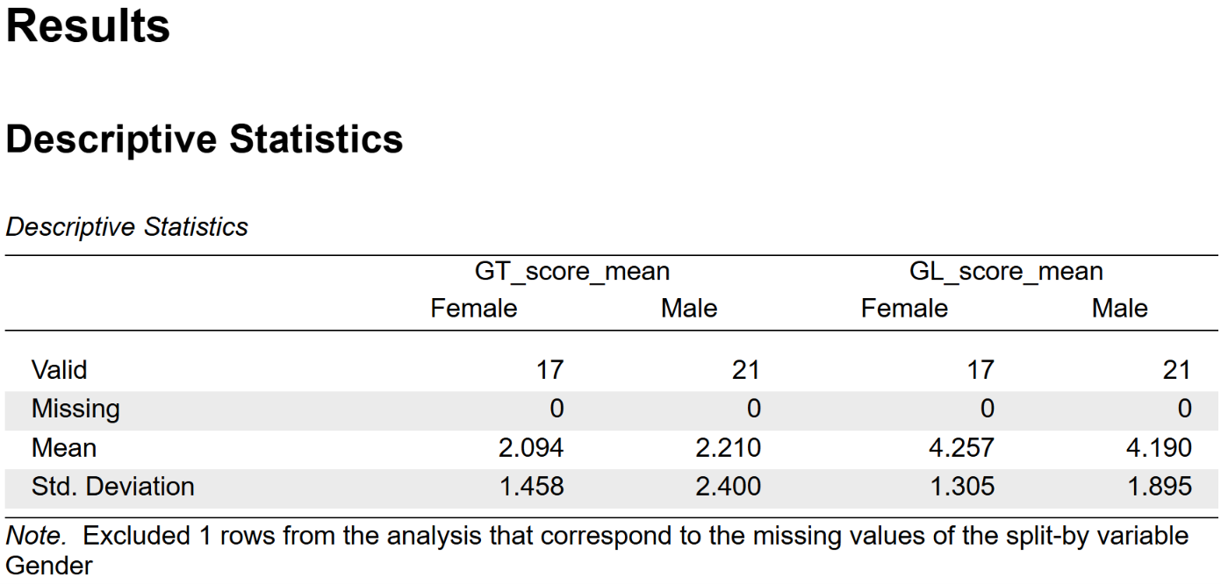

Data were analysed using JASP. One case with a nonbinary participant was excluded from analyses involving gender, leaving 38 valid cases of 21 men and 17 women. The analysis examined two dimensions of the Social Roles Questionnaire, being gender-transcendent role attitudes (GT) and gender-linked role attitudes (GL). Separate mean scores were calculated for each participant on both dimensions rather than using a single SRQ score.

Descriptive statistics were calculated for each gender group. Women had a mean GT score of 2.09 (SD = 1.46), compared with 2.21 (SD = 2.40) for men. For GL scores, women had a mean of (4.26 (SD = 1.31), whereas men had a mean of 4.19 (SD = 1.90). These descriptive results indicate only small mean differences between women and men on both SRQ dimensions.

3.2 ONE-WAY MANOVA AND FOLLOW-UP ANOVAS

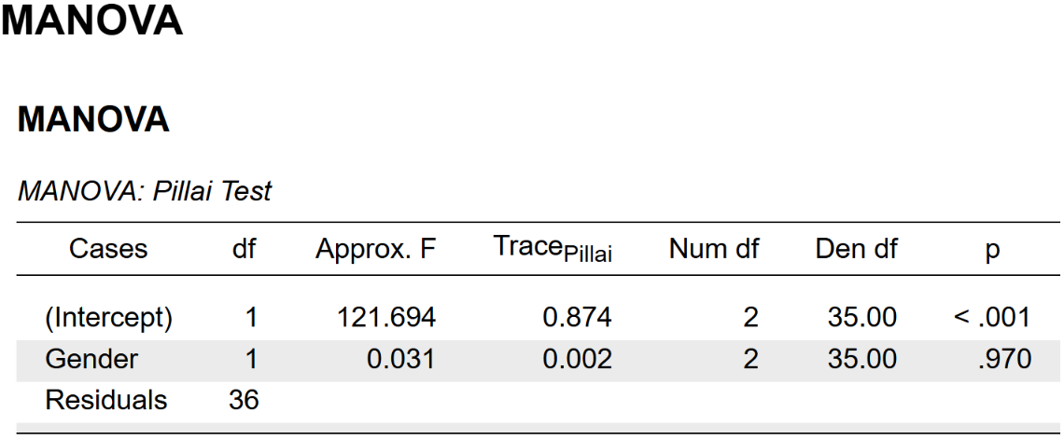

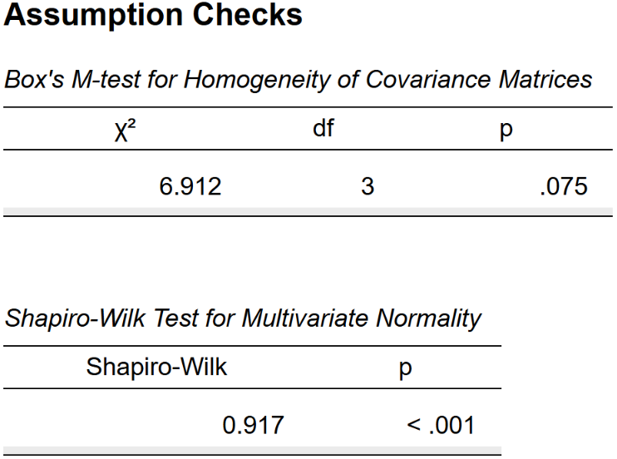

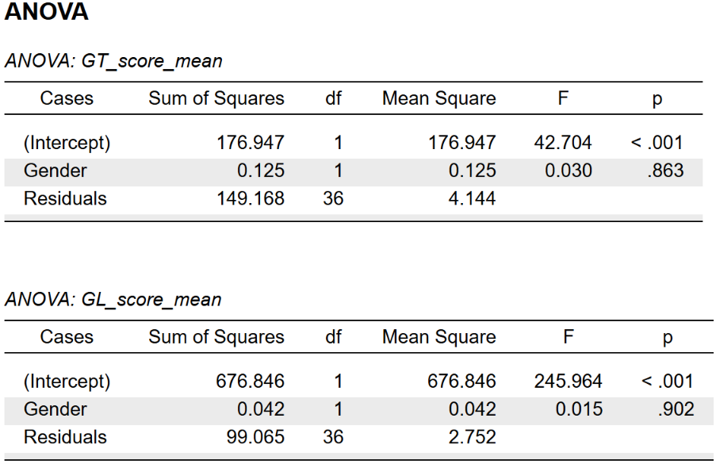

A one-way multivariate analysis of variance (MANOVA) was conducted with gender as the independent variable, as well as GT and GL mean scores as the dependent variables. MANOVA was selected because the study assessed gender differences across two conceptually related outcomes simultaneously. Pillai’s trace was used as the multivariate test statistic because it is relatively robust when assumptions are imperfect and group sizes are unequal. The multivariate effect of gender was not statistically significant, with Pillai’s trace = .002, approximate F(2, 35) = .031, and p = .970. Thus, when gender-transcendent and gender-linked attitudes were considered jointly, there was no evidence of a statistically significant difference between women and men in SRQ responses.

The assumptions of homogeneity of covariance matrices was assessed using Box’s M test and was not statistically significant, where M = 6.91 and p = .075. This result provided no statistically significant evidence that the covariance matrices differed between gender groups. However, the multivariate Shapiro-Wilk test was statistically significant, with W = .917 and p < .001, indicating a departure from multivariate normality. The MANOVA results should therefore be interpreted cautiously, particularly in view of the relatively small sample and unequal group sizes.

Follow-up univariate analyses of variance were conducted for each SRQ dimension. Gender was not significantly associated with GT scores, where F(1, 36) = .03 and p = .863. It was also not significantly associated with GL scores, where F(1, 36) = .02 and p = .902. Therefore, neither gender-transcendent nor gender-linked social role attitudes differed significantly between women and men in this sample.

DISCUSSION

4.1 OVERVIEW OF FINDINGS
This study investigated whether men and women differed in their attitudes toward feminism, operationalised through two dimensions of the Social Roles Questionnaire, being gender-transcendent (GT) and gender-linked (GL) role attitudes. The findings did not indicate statistically significant gender differences on either dimension. Women and men reported very similar average GT scores, and their GL scores were similarly close. The multivariate analysis also showed no significant overall effect of gender when both dimensions were considered together.

Accordingly, the results do not support the proposition that gender, by itself, meaningfully differentiated participants’ views about gendered social roles within this sample. Although women had a marginally lower GT mean and a marginally higher GL mean than men, these differences were extremely small and were not statistically reliable. The observed pattern should therefore not be interpreted as evidence that women were less supportive of gender quality or that men were more feminist. It suggests substantial similarity and considerable variation within each gender group. (Riesthuis, 2024)

4.2 IMPLICATIONS FOR FEMINIST ATTITUDES
The SRQ provides an indirect indicator of attitudes relevant to feminism because it assesses beliefs about whether social roles should be determined by gender. Gender-transcendent attitudes are broadly compatible with egalitarian feminist principles because they reject the assumption that occupational, family, and social roles should be allocated according to sex. Conversely, gender-linked attitudes may reflect greater acceptance of traditional gender role differentiation. Nevertheless, the SRQ does not measure feminism in its entirety, as it encompasses various concerns aforementioned. (Bolduc et al., 2025)

The present results therefore indicated that the female and male participants did not differ in their endorsement of the particular gender role attitudes represented by the SRQ. This distinction is important because individuals may support equality in social roles while declining to identify as feminist, or they may identify as feminist while differing in their views on particular role arrangements. The findings should consequently be framed as evidence concerning gender role attitudes associated with feminism. It should not be a definitive test of gender differences in feminism as an ideology. (Henze et al., 2024)

4.3 RELATIONSHIP TO PREVIOUS RESEARCH
Earlier research on feminist attitudes and gender role beliefs has often reported that women, on average, express more egalitarian views and greater support for feminism than men. This pattern is commonly explained by the differential social consequences of gender inequality. Women may be more likely to recognise and oppose systems that restrict educational, occupational, political, and domestic opportunities. Men may, on average, experience fewer direct costs from conventional gender arrangements and may therefore be less likely to endorse feminist identification or structural critiques of gender inequality. (Henze et al., 2024)

The absence of a significant gender difference in the present study does not necessarily contradict that broader literature. Group-level differences reported in larger studies may be modest, context-dependent, and influenced by cohort, education, political orientation, religious commitment, cultural norms, and personal experiences of discrimination. In a small sample, particularly one in which participants may share similar educational environments or social networks, these background characteristics can reduce observable gender differences. For example, university-based samples may contain both men and women who have been exposed to comparable discussions of equality, diversity, and gender norms. (Sevincer et al., 2023)

The present findings may also be consistent with research suggesting that attitudes toward gender equality are becoming less strongly determined by gender alone in some contemporary populations. Wider public discussion of workplace equality, gender-based violence, caregiving, and inclusive social policy may encourage egalitarian attitudes across gender groups. However, this interpretation requires caution. A non-significant result does not demonstrate that men and women hold identical attitudes, nor does it establish that gender is unimportant in the wider population. (Sevincer et al., 2023)

4.4 METHODOLOGICAL CONSIDERATIONS
Several methodological factors shape the interpretation of the results. First, the analytic sample was small, comprising 17 women and 21 men. Small samples have limited statistical power, meaning that genuine but subtle differences may not be detected as statistically significant. The sizable variability in scores within the gender groups further reduces the precision with which mean differences can be estimated. (Riesthuis, 2024)

Second, the assumption tests indicated a departure from multivariate normality. Although Pillai’s trace was used because it is relatively robust to assumption violations, the results should still be interpreted conservatively. The study also included only men and women in the gender comparison. It means the findings should not be generalised to people with non-binary, gender-diverse, missing, or undisclosed gender identities. (Sáiz-Manzanares et al., 2026)

Third, the cross-sectional, self-report design limits causal inference. The data cannot establish whether gender causes particular role attitudes, nor can it determine the processes through which these attitudes develop. Self-report responses may also be influenced by social desirability, especially because egalitarian attitudes are often socially valued. Participants may therefore report views that they regard as acceptable, even when those views are not fully reflected in their everyday decisions or behaviour. (Weijs, 2025)

CONCLUSION

The findings suggest that feminist-relevant gender role attitudes should not be understood solely through a binary gender lens. Gender remains theoretically relevant to experiences of inequality, but it may interact with other social and psychological factors that more directly shape attitudes. These include political ideology, religiosity, educational background, socioeconomic position, cultural context, exposure to feminist ideas, and personal experience with discrimination. These may help explain why individuals within the same gender category hold markedly different views. (Savas & Çakır, 2024)

Future research should recruit larger and more diverse samples to improve statistical power and external validity. It should also use measures that assess multiple dimensions of feminism directly, including feminist self-identification, support for gender-equality policies, perceptions of sexism, and beliefs about structural inequality. Combining the SRQ with these measures would distinguish support for non-traditional social roles from broader endorsement of feminist values. Such an approach would provide a more comprehensive account of how gender relates to feminism and of the contextual factors that may strengthen, weaken, or override gender differences. (Henze et al., 2024)

REFERENCES

Bolduc, R., Canivet, C., Hébert, M., & Godbout, N. (2025). That’s the Way ( I like It ): Latent Profiles of Sexual Power Dynamics and Gender Roles. Journal of Sex & Marital Therapy, 51(4), 426–443. https://doi.org/10.1080/0092623x.2025.2492859
British Psychological Society. (2021). Ethics guidelines for internet-mediated research. BPS. https://www.bps.org.uk/guideline/ethics-guidelines-internet-mediated-research
Daw, S., & Scharf, M. (2024). A small shift, a major leap: Changing gender‐role attitudes among adolescents across two ethnic groups. Journal of Adolescence, 96(8), 1942–1955. https://doi.org/10.1002/jad.12393
Endut, N., Bagheri, R., Azman, A., Hashim, I. H. M., Selamat, N. H., & Mohajer, L. (2020). The effect of gender role on attitudes towards inequitable gender norms among Malaysian men. Sexuality & Culture, 24(6), 2113–2136. https://doi.org/10.1007/s12119-020-09740-6
Grigoropoulos, I. (2025). Unveiling the social-psychological underpinnings of women’s self-silencing to sexist personal experiences. The role of ambivalent sexism and gender role-related attitudes. Polish Psychological Bulletin, 56–65. https://doi.org/10.24425/ppb.2025.153980
Henze, B., Buhl, S., Kolbe, E., & Asbrock, F. (2024). Should we all be feminists? Development of the Liberal Feminist Attitudes Scale. Frontiers in Social Psychology, 2. https://doi.org/10.3389/frsps.2024.1329067
Hess, D. R. (2023). Observational studies. Respiratory Care, 68(11), 1585–1597. https://doi.org/10.4187/respcare.11170
Reich-Stiebert, N., Froehlich, L., & Voltmer, J. (2023). Gendered Mental Labor: A systematic literature review on the cognitive dimension of unpaid work within the household and childcare. Sex Roles, 88(11–12), 475–494. https://doi.org/10.1007/s11199-023-01362-0
Riesthuis, P. (2024). Simulation-Based power Analyses for the smallest effect size of interest: A Confidence-Interval Approach for Minimum-Effect and Equivalence Testing. Advances in Methods and Practices in Psychological Science, 7(2). https://doi.org/10.1177/25152459241240722
Sáiz-Manzanares, M. C., Ortega-Renuncio, R., & Marticorena-Sánchez, R. (2026). Processing and analysis of portable EEG data for cognitive load assessment in neurotypical university students. Frontiers in Human Neuroscience, 20, 1737723. https://doi.org/10.3389/fnhum.2026.1737723
Savas, G., & Çakır, D. (2024). Breaking the chains: exploring gender inequality in Türkiye through the eyes of women NGO members. Frontiers in Sociology, 9, 1491058. https://doi.org/10.3389/fsoc.2024.1491058
Sevincer, A. T., Galinsky, C., Martensen, L., & Oettingen, G. (2023). Political ideology outdoes personal experience in predicting support for gender equality. Political Psychology, 44(4), 829–855. https://doi.org/10.1111/pops.12887
Weijs, J. (2025). Comfort in Conformity: To what extend does belief in social hierarchies lead young women to endorse benevolent sexism in contemporary America? [Master Thesis, Utrecht University]. https://studenttheses.uu.nl/handle/20.500.12932/49415
Zrineh, A., Al‐Usta, M., & Alwawi, A. (2026). Sampling Methods and sample size determination in Clinical Research: an educational review. Journal of General and Family Medicine, 27(1), e70096. https://doi.org/10.1002/jgf2.70096

APPENDIX

This page is intentionally left blank.

