

Assessment 2

Module: ACCA 5025 Cloud Computing Architecture
Deadline for submission: 03.05.2023

Lecture: Student: Ivan Nikolov
Koushik Modak 2125009 Cloud Computing
Content:
- Introduction
- Resources associated with VM
- Images in Azure
- Additional exercise
- Reference

- Introduction
Virtualization is the process of creating a software-based, or "virtual" version of a computer, with dedicated amounts of CPU, memory, and storage that are "borrowed" from a physical host computer—such as your personal computer— and/or a remote server—such as a server in a cloud provider's datacenter. A virtual machine is a computer file, typically called an image, that behaves like an actual computer. It can run in a window as a separate computing environment, often to run a different operating system—or even to function as the user's entire computer experience—as is common on many people's work computers. The virtual machine is partitioned from the rest of the system, meaning that the software inside a VM can't interfere with the host computer's primary operating system. (Microsoft, 2023)

- Resources associated with VM
Every virtual machine deployed in Azure automatically gets an operating system disk and a temporary (virtual hard) disk. As the temporary disk is labeled as the D:\ drive by default, it causes some confusion or problems when used for the wrong purpose. In Azure, every VM – regardless if Linux or Windows – gets a temporary disk assigned automatically. This temporary disk is located on the physical server (the hypervisor) where the Azure VM is hosted and is non-persistent. Disks used by the operating system or additionally added data disks are persistent disks and stored in Azure Storage. Azure VM’s can be moved from its current host to new host at any time due to maintenance, hardware failures or other reasons. In such an event, the data from the temporary storage will not preserve or moved to the new host. Apart from the hardware failures, there are many other reasons data from the temporary disk will be lost:
- Resizing of the VM
- Restarting of the VM
- Moving from one host to another
- Updating/upgrading of host (Luescher, 2020)
Creation VM using the Azure portal
Azure website is our login portal to the Azure platform, where we can create and manage our resources. To login in Azure platform we need open the URL https://portal.azure.com/ and then enter our credentials. Then next step is to create a Virtual machine. It needs to press the icon with monitor and inscription “Virtual machine”.
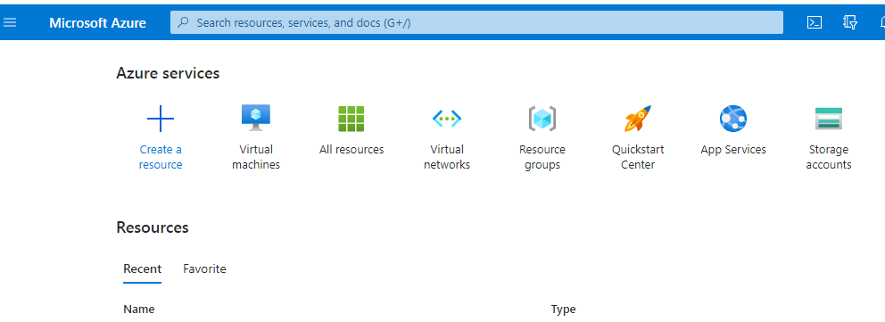
Then we can see the next opened site and the first icon looks like + (plus) and inscription “Create”.
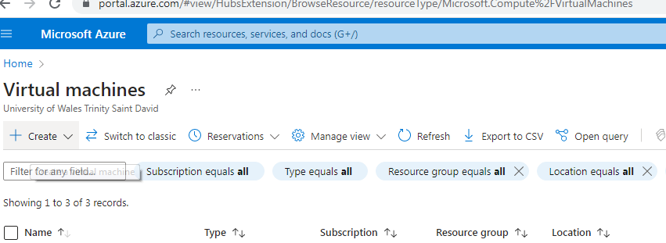
Pressing that button, then it will show drop down menu with the the following options:
- Azure Virtual machine
- Azure Virtual machine with preset configuration
- Azure Arc virtual machine
- Azure VMWare Solution virtual machine (Azure, 2023)

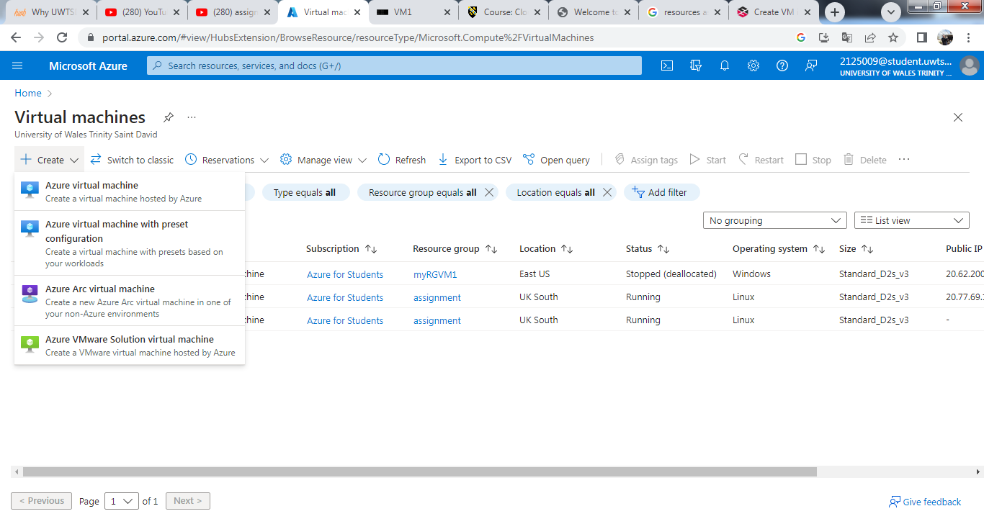
Let’s choose the first option – Azure Virtual machine. Then new opened window is directly on the basic settings of the virtual machine.
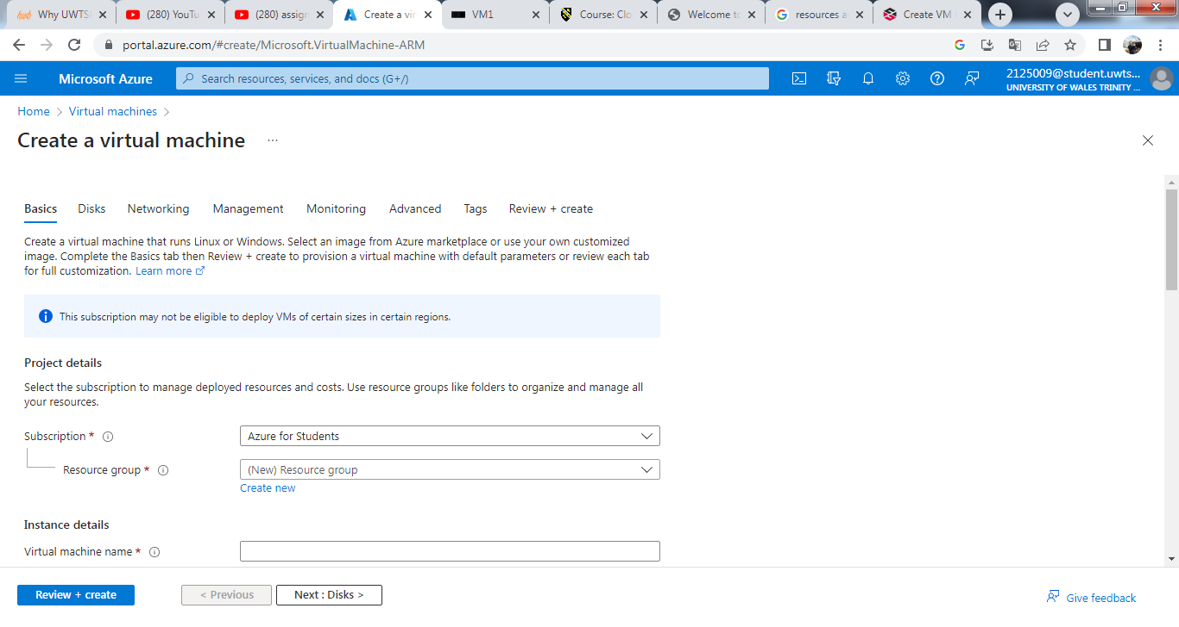
The first section is Project details. It includes subscription and resource group. All resources in an Azure subscription are billed together. A resource group is a collection of resources that share the same lifecycle, permissions and policies.
Next section is Instance details. Firstly, it needs to type the virtual machine name. Virtual machines in Azure have two distinct names: Virtual machine name used as the Azure resource identifier, and in guest host name. When it creates a VM in the portal, the same name is used for both the virtual machine name and the host name. The virtual machine name cannot be changed after the VM is created. It could change the host name when it logs into the virtual machine. (Azure, 2023)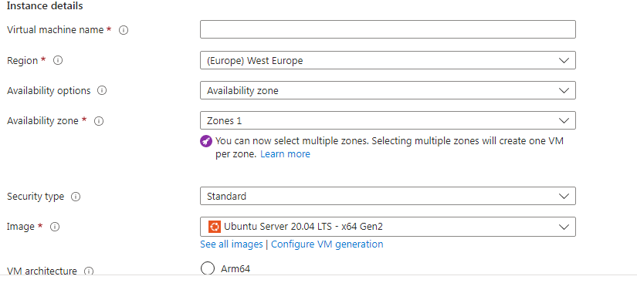
Next mandatory option it Region. It has to choose the Azure region which is suitable for the used computer. Not all VM sizes are available in all regions. Next one is not mandatory and it named Availability options. Azure offers a range of options for managing availability and resiliency for user’s applications. It could architect a solution to use replicated VMs in Availability Zones or Availability Sets to project the user apps and data from datacenter outages and maintenance events. Next option is availability zone. It could optionally specify an availability zone in which to deploy the user VM. If it chooses to do so it managed disk and public IP will be created in the same availability zone as user virtual machine. Next one is security type. Security type refers to the different security features available for a virtual machine. Security features like Trusted launch and Confidential machines help to improve the security of Azure generation 2 virtual machine. However, additional security features have some limitations, which include not supporting back up, managed disks and ephemeral OS disks. Next option is image. There it has to choose the base operating system or application for the VM. Next option is VM architecture. Azure provides a choice of x64 or Arm64-based virtual machines to run the applications. X64-based VMs provide the most software compatibility, while Arm64-based provide up to 50% better price performance than comparable x64 VMs. Arm64-based VMs also help developers build Arm-compatible software without cross-compilation. Next option to tick on or off it is Run with Azure Spot discount. Azure Spot offers unused Azure capacity at a discounted rate versus pay as you go prices. Workloads should be tolerant to infrastructure loss as Azure may recall capacity for pay as go workloads. Next option is mandatory and it called Size. It is for selection a VM size to support the workload that the user wants to run. The size that the user chooses then determines factors such as processing power, memory and storage capacity. Azure offers a wide variety of sizes to support many types of uses. Azure charges an hourly price based on VM’s size and operating system.
Next section is Administrator account. It cans choose between SSH keys for authentication or username/password. With SSH keys, Azure automatically generates an SSH key pair for the user and it allows him to store it for the future use. It is a fast, simple and secure way to connect to the user virtual machine. With the second option, the user has to create username and password, which have to meet certain criteria. (Azure, 2023)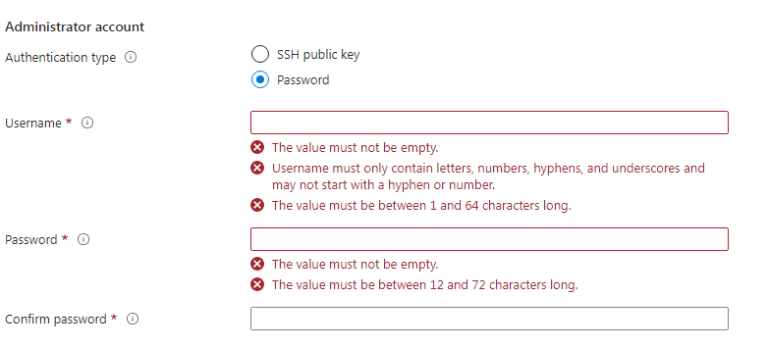
The last section is Inbound port rules. It can select which virtual machine network ports are accessible from the public internet. It can specify more limited or granular network access on the Networking lab. By default, access to the virtual machine is restricted to sources in the same virtual network and traffic from Azure load balancing solutions. It can select None to confirm or choose to allow traffic from the public internet to one of these common ports. (Azure, 2023)

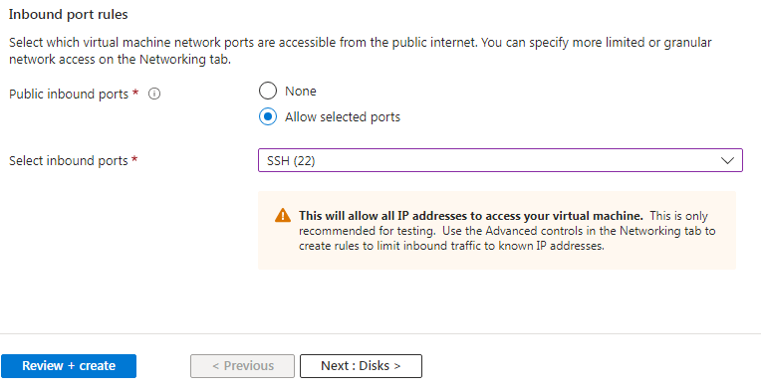
Except the basic settings, there are more like: Disks, Networking, Management, Monitoring, Advanced and Tags.
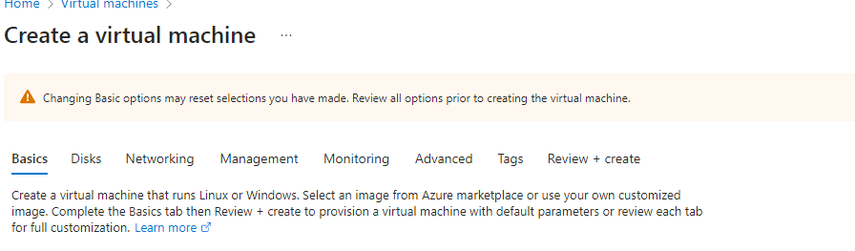
The page “Disks” includes 3 groups of settings – VM disk encryption, OS disk and Data disks. Azure VMs have one operating system disk and a temporary disk for short-term storage. You can attach additional data disks. The size of the VM determines the type of storage the user can use and the number of data disks allowed. Azure disk storage encryption automatically encrypts the user data stored on Azure managed disks at rest by default when persisting it to the cloud. (Azure, 2023)

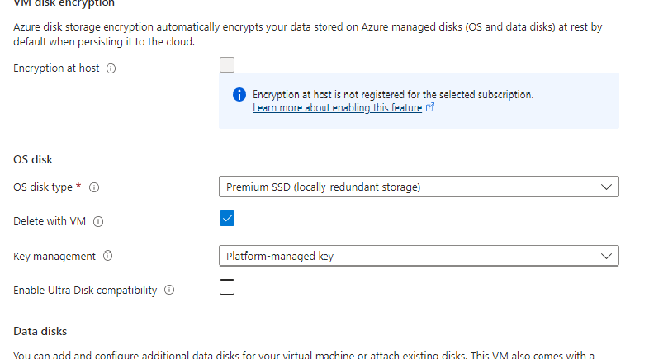

The page “Networking” includes Networking interface and Load balancing. Define network connectivity for your virtual machine by configuring network interface card settings. The user can control ports, inbound and outbound connectivity with security group rules, or place behind an existing load balancing solution. When creating a virtual machine, a network interface will be created by the user.
The page “Management” is for configuration of management option for user VM. Those options are system assigned managed identify, login with Azure AD, enable auto-shut down and backup, patch orchestration option.
The page “Monitoring” includes to configure monitoring option the VM like enabling recommended alert rules, boot diagnostics and to enable OS guest diagnostics.
The user can add additional configuration, agents, scripts or applications via virtual machine extensions or cloud-init on the page “Advanced”. Tags are name/value pairs that enable you to categorize resources and view consolidated billing by applying the same tag to multiple resources and resource groups. (Azure, 2023)
After all settings, the user needs to press Review + Create and it will create his virtual machine. Once created the VM, it could be managed by many options. 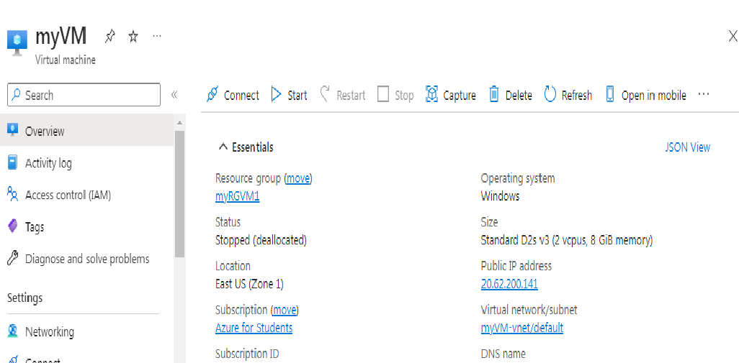
Then the user can connect, start, restart, stop, capture, delete, refresh or open in mobile his VM.
If we press connect, it will connect vie SSH by default. 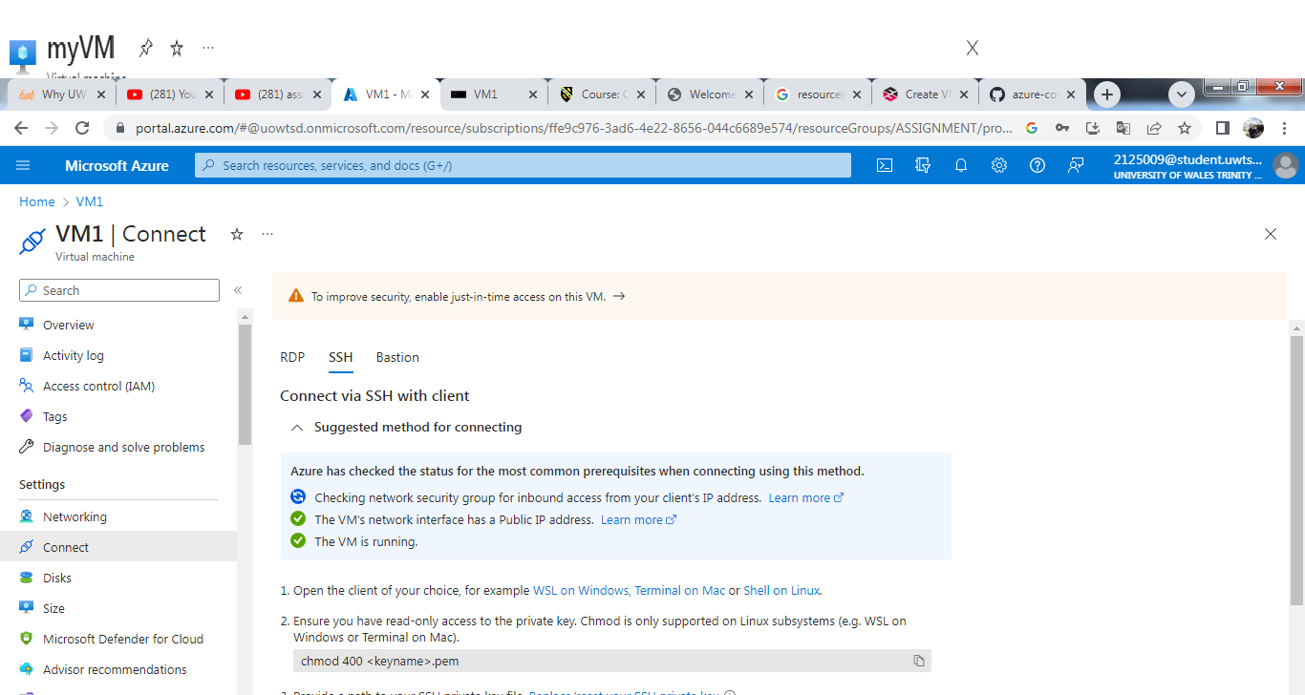
We can choose to connect vie Bastion, which we created earlier. Then we will see the page to enter user name and password. 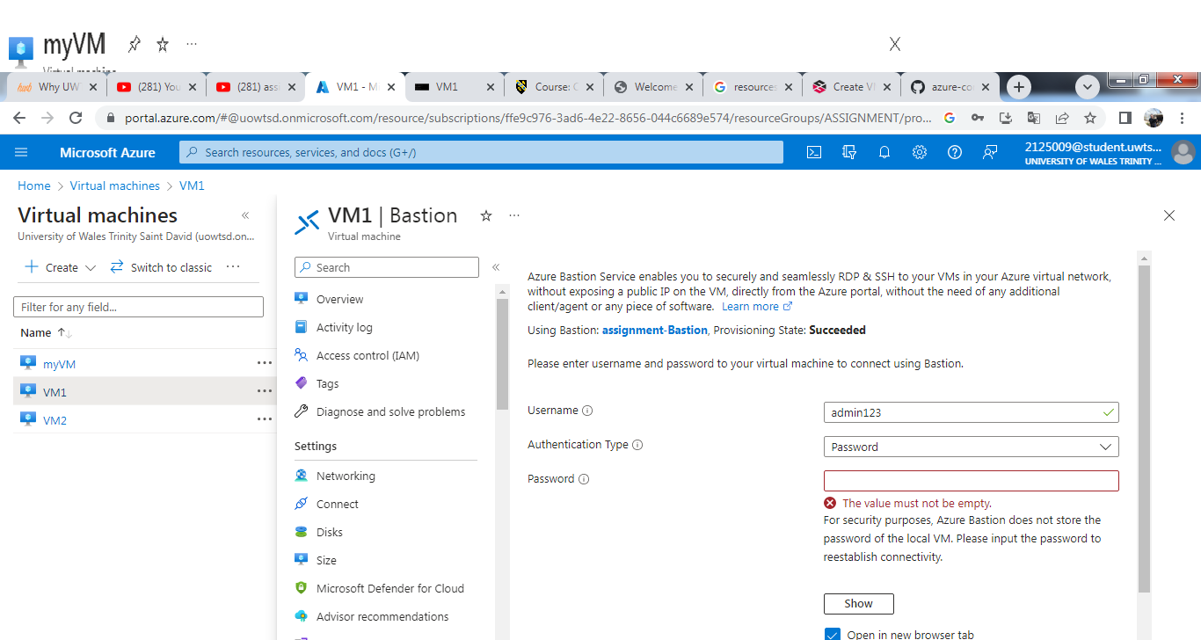
After correctly filled data, we can connect the VM and we will see the next CLI page.
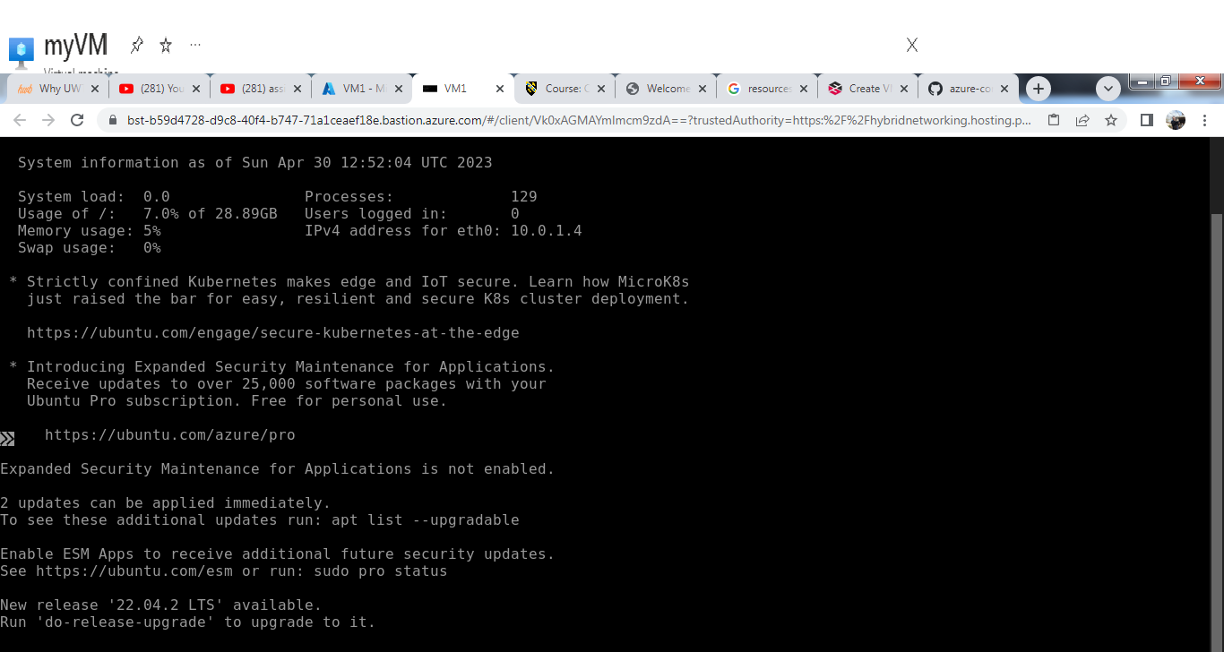
If in previous page on virtual machine with the option to manage, the buttons “Restart” and “Stop” were inactive, now they actives, while “Start” is inactive. Which mean that the VM is active.
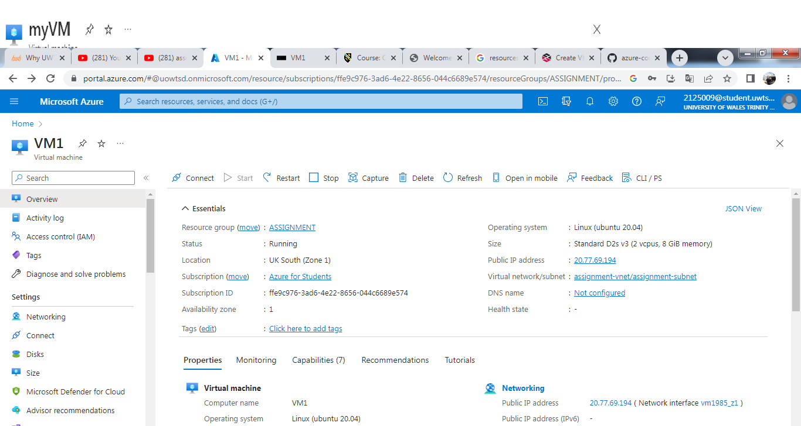
The status also shows that is running. We can copy the public IP address and open in a new page. Then we can check the running virtual machine. 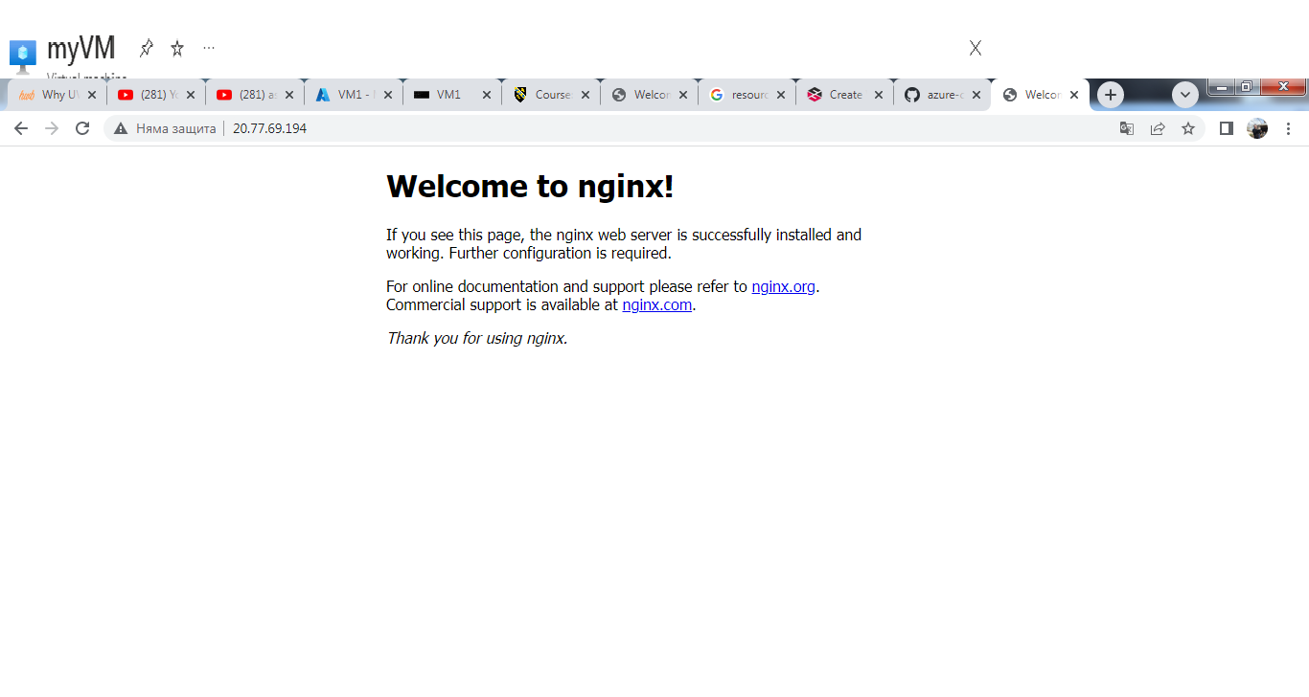
If we want to stop running the VM, we need to press Stop and just to confirm it. 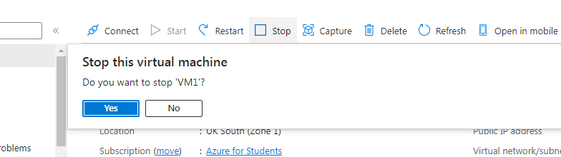
Then the VM is be stopped.

- Images in Azure
Images are used in Azure to provide a new virtual machine with an operating system. An image might also have one or more data disks. Images are available from several sources:
- Azure offers images in the Marketplace. It will find recent version of Windows Server and distributions of the Linux operating system. Some images also contain applications, such as SQL Server. MSDN Benefit and MSDN Pay-as-You-Go subscribers have access to additional images.
- The open source community offers images through VM Depot.
- The user can store and use his own images in Azure, by either capturing an existing Azure virtual machine for use as image or uploading an image.
Two types of images can be used in Azure: VM image and OS image. A VM image includes an operating system and all disks attached to a virtual machine when the image is created. This is the newer type of image. Before VM images were introduced, an image in Azure could have only a generalized operating system and no additional disks. A VM image that contains only a generalized operating system is basically the same as the original type of image, the OS image.
The user can create your own images, based on a virtual machine in Azure, or a virtual machine running elsewhere that you copy and upload. If the user wants to use an image to create more than one virtual machine, it will need to prepare it for use as an image by generalizing it. To create a Windows Server image, run the Sysprep command on the server to generalize it before you upload the .vhd file. To create a Linux image, depending on the software distribution, the user will need to run a set of commands that are specific to the distribution, as well as run the Azure Linux Agent.
The user can use the Azure Command-Line Interface (CLI) for Mac, Linux, and Windows or Azure PowerShell module to manage the images available to your Azure subscription. The user also can use the Azure classic portal for some image tasks, but the command line gives him more options.
- Get all images: Get-AzureVMImage returns a list of all the images available in your current subscription: your images as well as those provided by Azure or partners. This means you might get a large list. The next examples show how to get a shorter list.
- Get image families: Get-AzureVMImage | select ImageFamily gets a list of image families by showing strings ImageFamily property.
- Get all images in a specific family: Get-AzureVMImage | Where-Object {$_.ImageFamily -eq $family}
- Find VM Images: Get-AzureVMImage | where {(gm –InputObject $_ -Name DataDiskConfigurations) -ne $null} | Select -Property Label, ImageName this works by filtering the DataDiskConfiguration property, which only applies to VM Images. This example also filters the output to only the label and image name.
- Save a generalized image: Save-AzureVMImage –ServiceName "myServiceName" –Name "MyVMtoCapture" –OSState "Generalized" –ImageName "MyVmImage" –ImageLabel "This is my generalized image"
- Save a specialized image: Save-AzureVMImage –ServiceName "mySvc2" –Name "MyVMToCapture2" –ImageName "myFirstVMImageSP" –OSState "Specialized" -Verbose
The OSState parameter is required if the user wants to create a VM image, which includes data disks as well as the operating system disk. If the user doesn’t use the parameter, the cmdlet creates an OS image. The value of the parameter indicates whether the image is generalized or specialized, based on whether the operating system disk has been prepared for reuse.
- Delete an image: Remove-AzureVMImage –ImageName "MyOldVmImage" (Huachao, 2015)
- Additional exercise
Firstly we create Resource group call assignment. 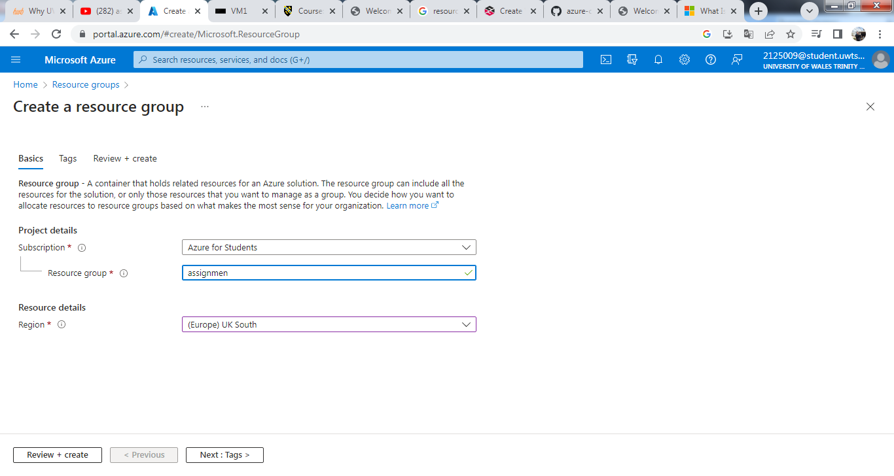
Then we choose the right region, which for our case is (Europe) UK South. Then we press Review + Create. Validation passed.
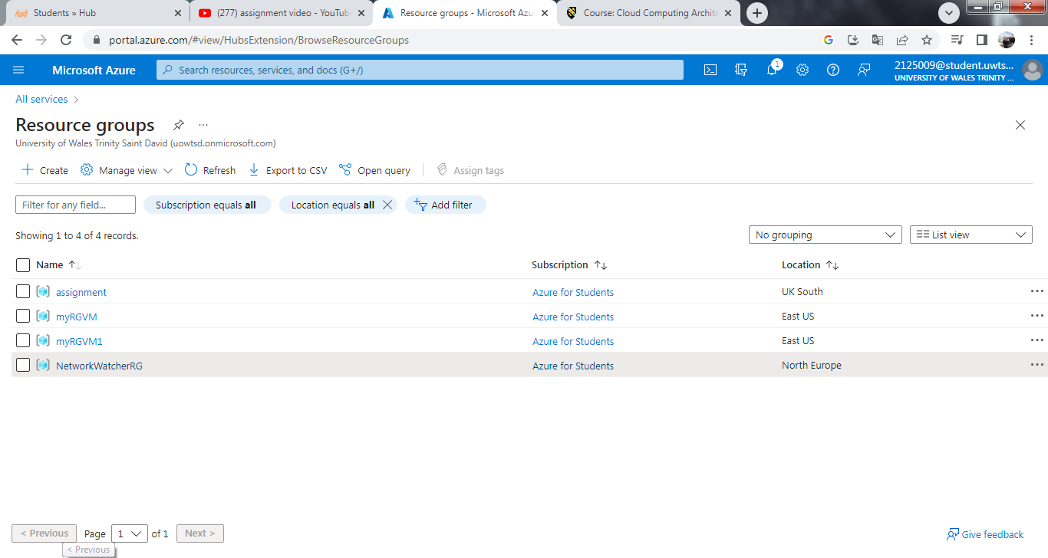

Then we have create virtual network. Then we press Home to go back and then we choose the Virtual Network. In the new page we choose the first option + Create. Firstly we fill up the basic settings like name, region and resource group. Then we go to IP address settings. 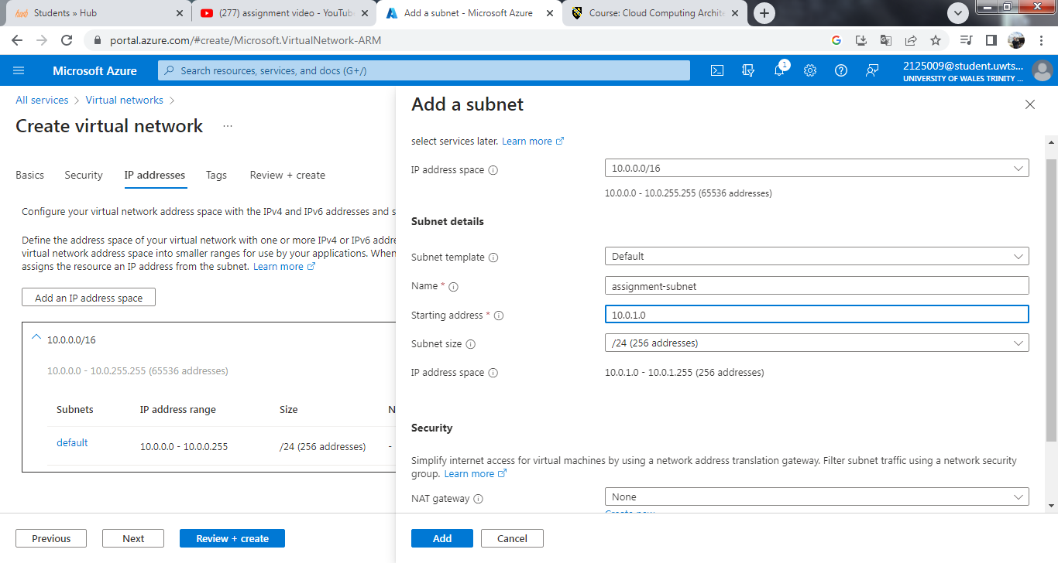
We fill up the needed settings and then we press the review + create. 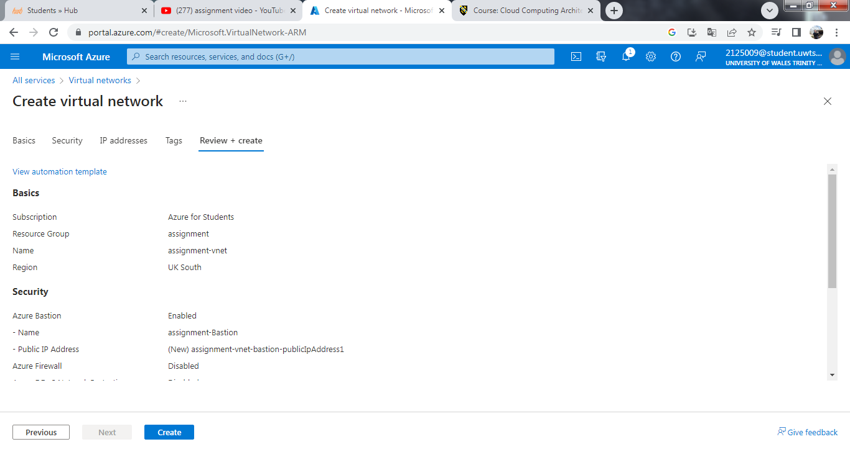
We can check one more time the details, if we want to change before finally to be create the virtual network. We wait few seconds until deployment is in progress. 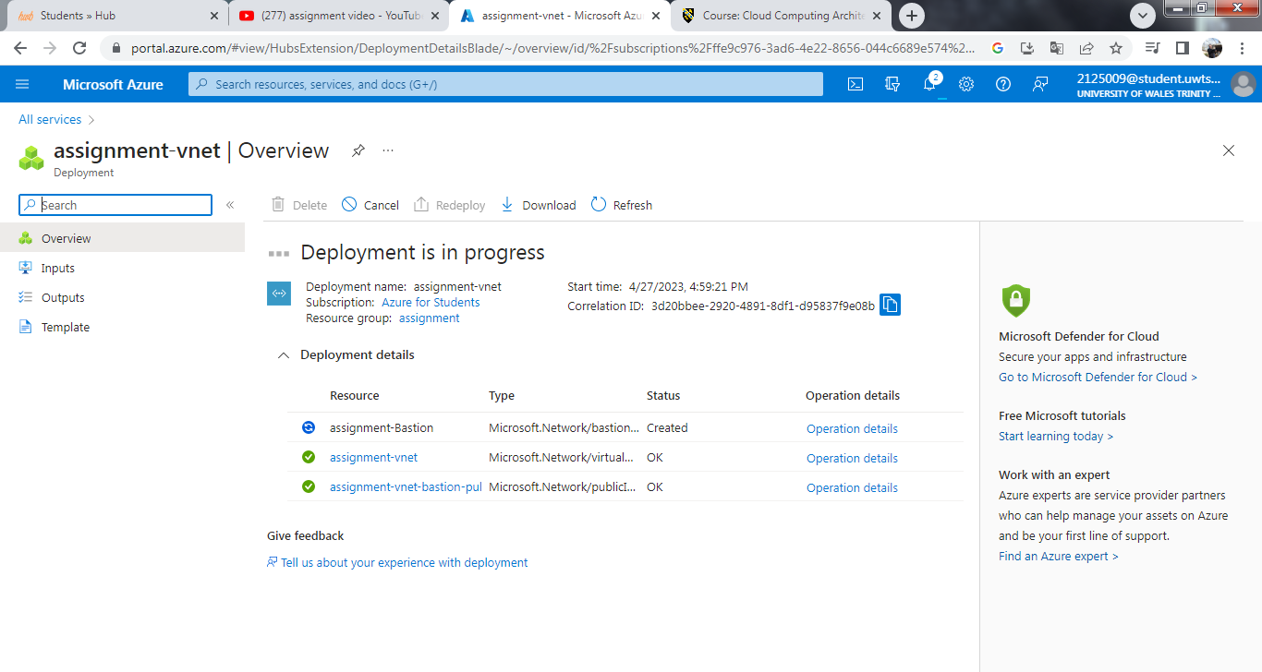
Then it is time to create the Virtual machine. From the main page, we press the icon for Virtual machine and then we press Create. We start with the basic settings. 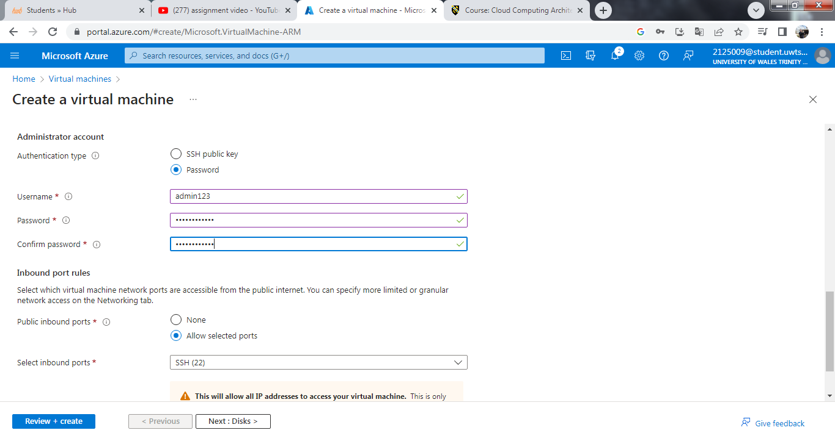
We fill up username, password and select inbound port. Then we check the Networking settings, where we connect our virtual machine with virtual network, which we created earlier. Then we press Review to check the filled information. 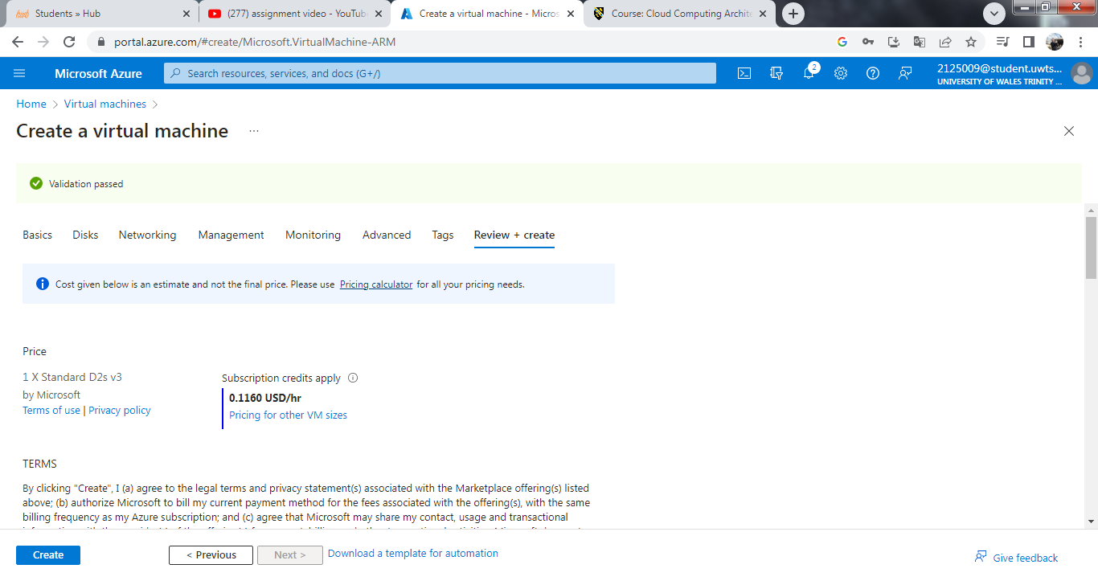
After validation passed, we can see the price and the terms. Then we press Create to finish the creation of the virtual machine. With the same way we will create the second virtual machine like we put different name and different admin name. The validation passed and we press Create to finalized the creation of the first virtual machine. Then we start the same process to create the virtual machine number 2.
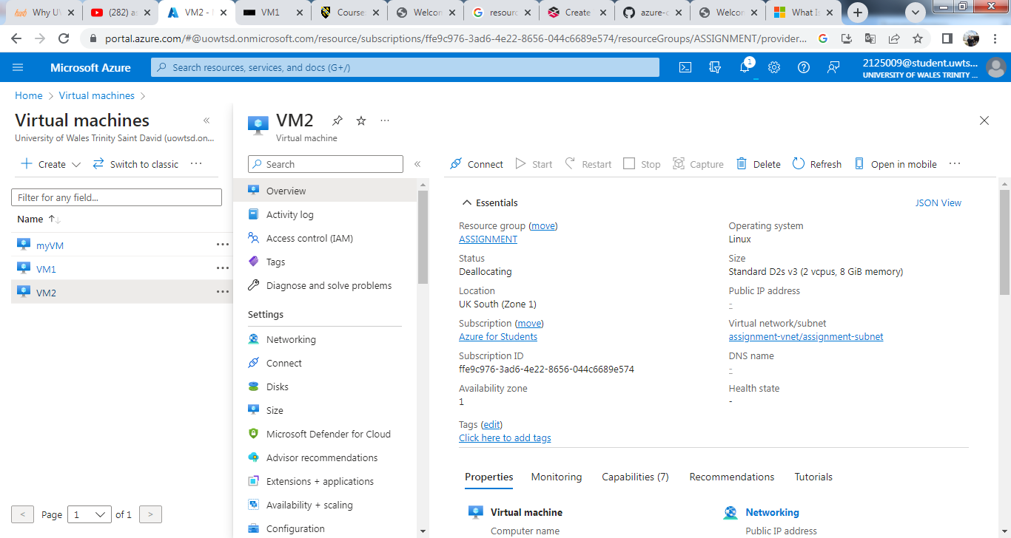
Then we go to VM1 and press to connect. We choose to connect via Bastion. 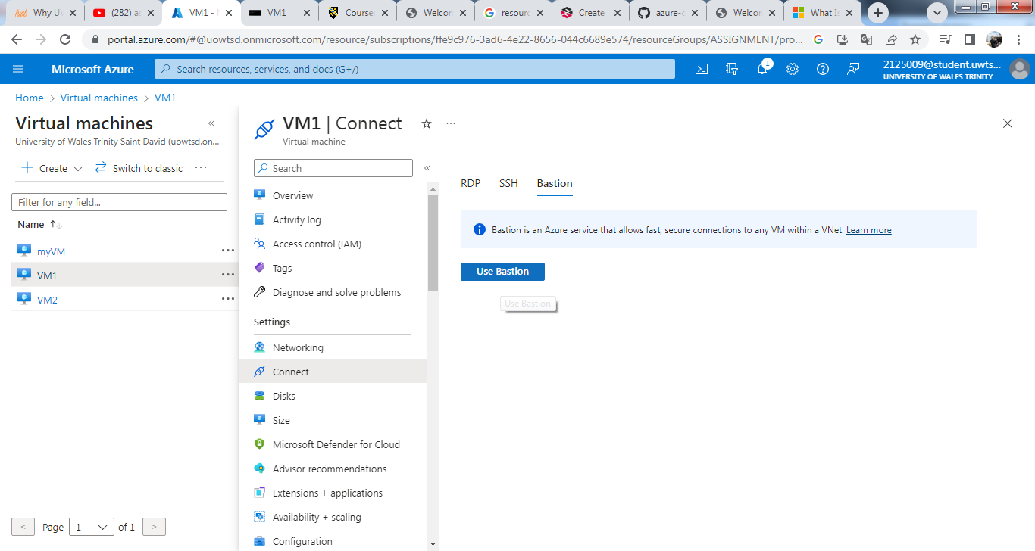
We put in the password for admin1 and then connect.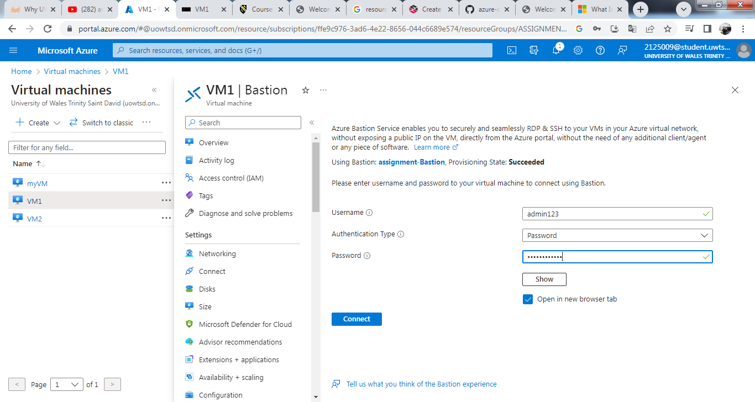Then VM1 is connected.
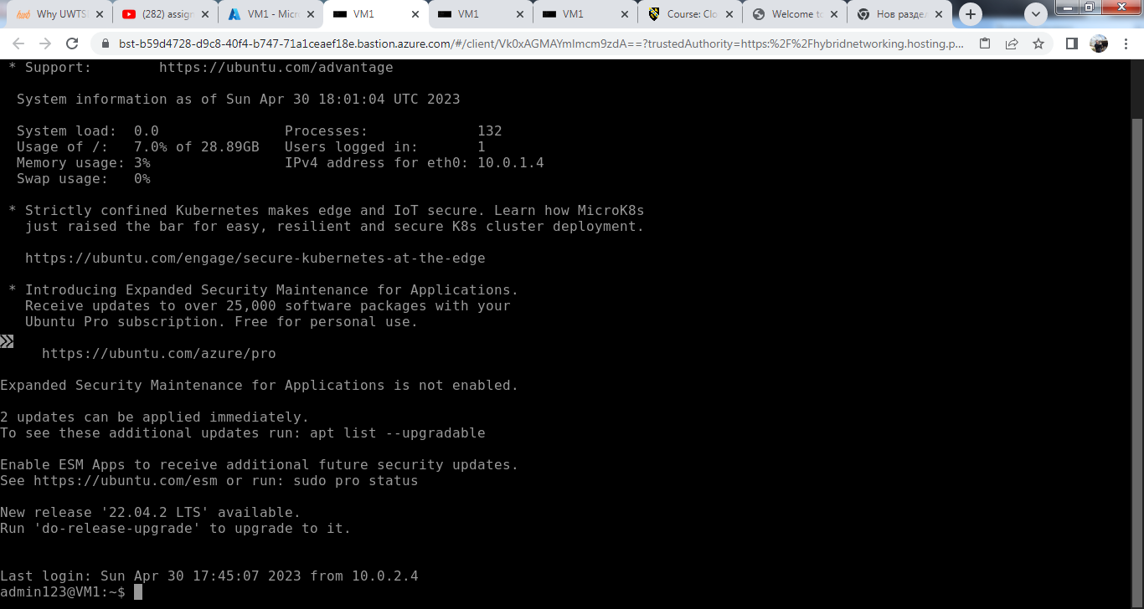
Then firstly we do update and then we install nginx. 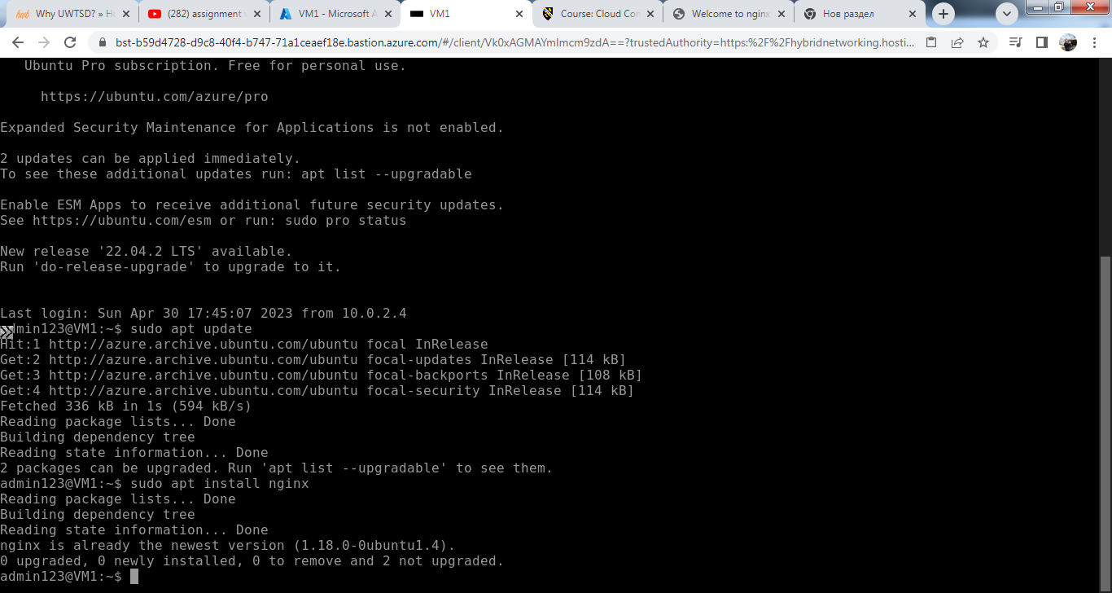
We enter the password and the authentication is complete. That means the nginx is running. 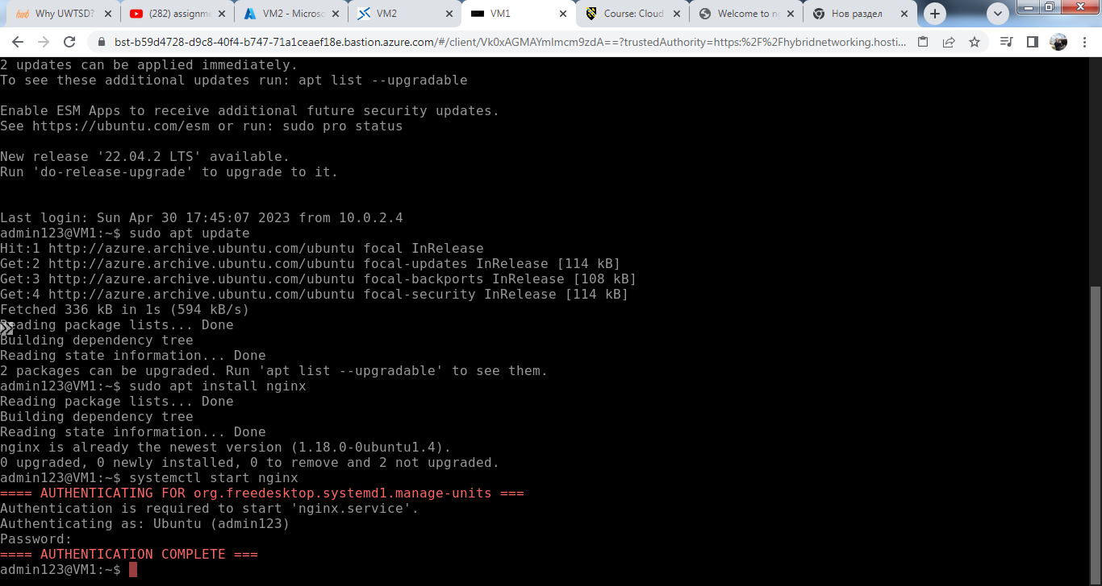
We can check when we go back to VM1 page and copy the IP address. 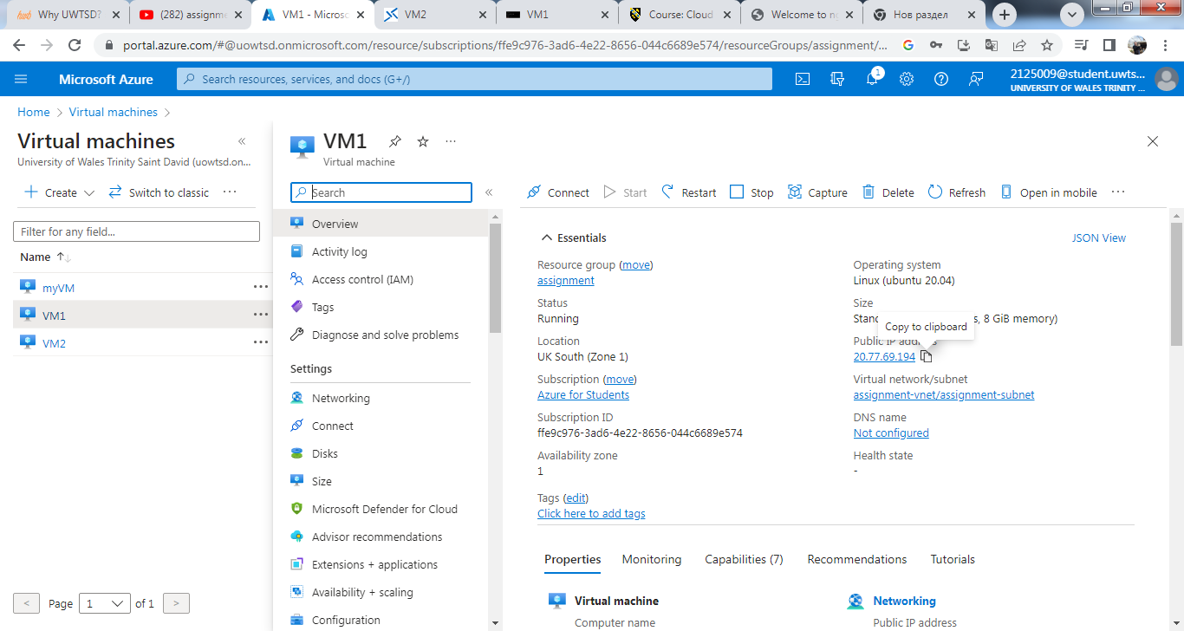
Then we open new page and have to paste the IP address there. Then we can see the nginx message. 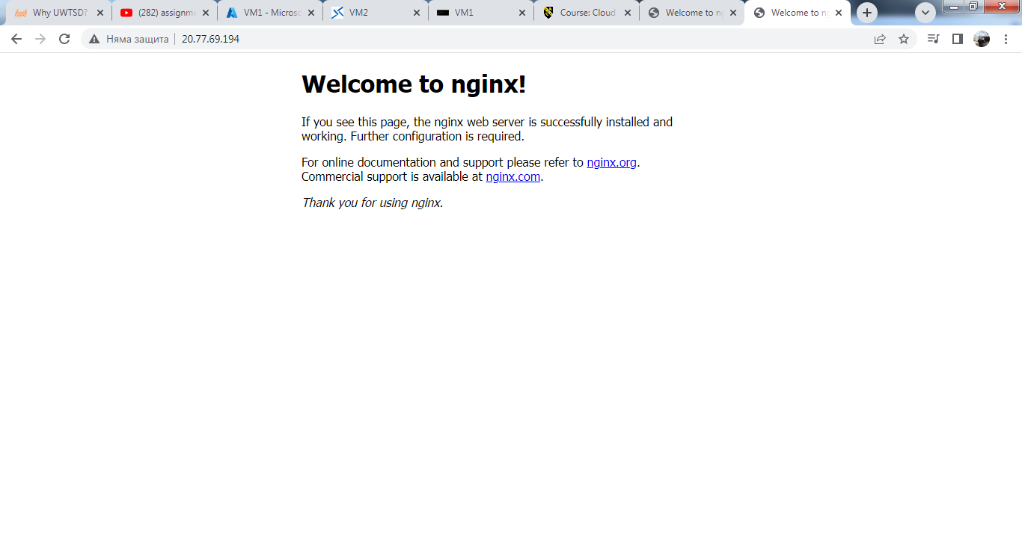
- Reference
Azure. (2023). Azure services. Retrieved from portal.azure.com: https://portal.azure.com/#home
Huachao. (2015, 12 02). About images for virtual machines. Retrieved from github.com: https://github.com/Huachao/azure-content/blob/master/articles/virtual-machines/virtual-machines-images.md
Luescher, M. (2020, 01 03). Azure VM’s and their Temporary Storage. Retrieved from /www.cloudelicious.net: https://www.cloudelicious.net/azure-vms-and-their-temporary-storage/
Microsoft. (2023). Virtual machines: virtual computers within computers. Retrieved from azure.microsoft.com: https://azure.microsoft.com/en-ca/resources/cloud-computing-dictionary/what-is-a-virtual-machine/

