University of Wales Trinity Saint David
BSc Cloud Computing

ACCB4002
Data Analysis and Visualisation

Assignment Title: t-Test
Student name: Moroi Victor (2021926)
Lecturer: Suneth Fernando

September 2021
Table of Contents
Introduction 3
Dataset 3
t-Test 3
Hypothesis 4
Types of errors 5
Test Tables of Hypothesis 5
Significance level 8
The outliers 9
Conclusion 10

List of Figures
Figure 1 - Visual Display of Hypothesis 4
Figure 2 - Type I and Type II Errors in Hypothesis Testing 5
Figure 3 - Scenario Dataset (with calculations) 5
Figure 4 - Critical Value of t-Test and Areas Formed By It 6
Figure 5 - t-Test Diagram p = 0.05 (based on scenario) 7
Figure 6 - table T (Critical Values of the T Distribution) 7
Figure 7 - Excel Function Example 8
Figure 8 - T-Test: Two-Samples (p = 0.05, p = 0.10, p = 0.01, p = 0.02) 9
Figure 9 - The Outliers Info 10

... we must not forget the only important -
the patient! He / she is living person, not just
α 0.05.

Dirk Maarten Barends

Introduction
Most often, psychological research reveals the identification of differences between two more groups of signs. The elucidation of such differences at the level of arithmetic means is considered in the procedure for analyzing primary statistics. However, the question arises as to how reliable these differences are and whether they can be extended to the entire population. For this solution of the problem, they most often use (under the condition of a normal or close to normal distribution) t - a criterion (t-Test), which is intended to be used, how significantly the indicators of one sample of subjects differ from another [1].

Dataset
Dataset is a collection of information ("observations") collected about a group of individuals or about specific variables that are of interest to the researcher. This can combine individual data elements into a single whole, with which various manipulations are performed during data processing. This data can be obtained from interviews, reviews, experiments, analysis, research methods etc [2].

t-Test
t-Test is one of the most developed and widely used statistical methods. It is a parametric test that shows how significant the differences are between groups. In other words, it lets you know if these differences (measured in means) could have happened by chance. t-Tests are so named because all test results are based on t-values. The t-Test examines the t-statistic, t-distribution values, and degrees of freedom to determine the likelihood of differences between the two datasets [3].
t-Test is used if is needed to compare only two groups of quantitative characteristics with a normal distribution (a special case of analysis of variance). This criterion cannot be used when comparing several groups in pairs, in this case it is necessary to use analysis of variance. Erroneous use of the t-Test increases the likelihood of "revealing" non-existent differences. For example, instead of judging several treatments to be equally effective (or ineffective), one of them is declared the best [4].
In the scenario was identify that the infection rate of covid-19 varied between white people and BAME patients. However, this is not the result of white people having any influence or pathogens compared to BAME - it is about the genetics of humans. Using the t-test, it is necessary to check whether there is a statistically significant difference between the mean values of infection rate and truthfulness of the findings in the groups of white people and BAME. The teaching materials assume that the infection rate data obeys the law of normal distribution and therefore the t-test is applied.

Hypothesis
A hypothesis is a scientific assumption whose true meaning is uncertain. Formulating a hypothesis, the researcher makes an assumption about how he intends to achieve the goal. In the process of research, the hypothesis is corrected, undergoes changes. Also, the hypothesis should naturally arise in the process of research, it may be an assumption that is only partially true. Acquaintance with dissertations shows that the hypothesis is based on exact knowledge of the final results and therefore loses its meaning [5].
When performing an experiment on the rate of Covid-19 infection, the experimenter must check certain points by statistical methods. If we study the infection rate of white people and the infection rate of BAME, we can make such a scientific assumption that the average coefficient of infection in white people differs from the average coefficient in BAME. This assumption is called a statistical hypothesis that can be confirmed or refuted [6].
Statistical hypothesis is a formal assumption that the similarity or difference in some parametric characteristics of the general population or sample populations is accidental or not accidental. Since statistics as a research method deals with data in which the patterns of interest to the researcher are distorted by various random factors, most statistical calculations are accompanied by testing some assumptions or hypotheses about the source of these data [7].
There are two concepts used when testing statistical hypotheses:
H₀ - null hypothesis – is a status quo statement that there is no difference or no effect on oneself. Also, is the main testable assumption, which is usually formulated as no difference, no factor influence, no effect, zero values of sample characteristics, etc. (Similarity hypothesis)
H₁ - alternative hypothesis – it states that there must be some difference (or effect), not always strictly opposite or opposite of the first. In other words, the underlying state will persist until there is evidence to the contrary. (Difference hypothesis) [8].
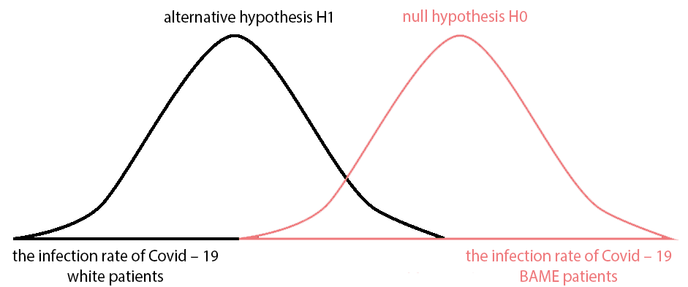
Figure 1 - Visual Display of Hypothesis

Types of errors
The discrepancy between the characteristics of the sample and the population from which the sample was made are generally estimated through errors. There are two types of errors: type I error and type II error arising from violation of the selection rules (or due to bias in selection).
In determining the type I error (false-positive), it is assumed that the data logging error (human error) is zero. When researchers cannot reject the null hypothesis, a type II error (false negative) occurs, and the null hypothesis is incorrect overall. Although, type I and type II errors cannot be completely avoided, researchers can reduce their probability by increasing the sample size (the larger the sample, the less likely there is a substantial difference from the general population) [9].
 |  | THE TRUTH
 |  | The null hypothesis  H₀ is true  (H₁ is false) | The null hypothesis  H₀ is not true  (H₁ is true)
THE DECISION THE ANALYST MAKES | Reject H₀  (Support H₁) | type I error  overreacting | Correct Decision
THE DECISION THE ANALYST MAKES | Fail to Reject H₀  (Do not support H₁) | Correct Decision | type II error  underreacting
Figure 2 - Type I and Type II Errors in Hypothesis Testing

Test Tables of Hypothesis
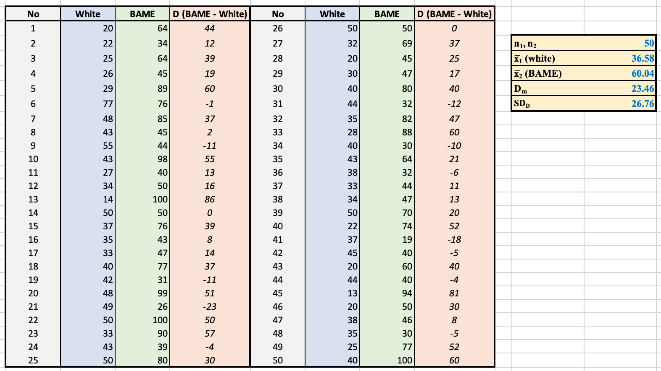
Figure 3 - Scenario Dataset (with calculations)

- It is necessary to choose the criteria - the criteria by which will give an answer. There is equal infection rate between white people with (x̅₁) and BAME (x̅₂). The researcher does not believe. So, the researcher’s hypothesis is that they are not equal (x̅₁ ≠ x̅₂). Consequently, an alternative hypothesis to my hypothesis, the null hypothesis (the opposite, often indicates the absence of statistically significant relationships / dependencies) will say that they are in fact equal to each other (x̅₁ = x̅₂), that all these discoveries are accidental, and in fact, I am wrong.
H₀: x̅₁ = x̅₂ and H₁: x̅₁ ≠ x̅₂
- The significance level is p = 0.05, since this is the maximum allowable for medical research is likely to mistakenly see non-existent differences.
- Calculating t_{obt} from empirical data using the formula:
$$t_{obt} = \frac{D_{m}}{\left(\frac{SD_{D}}{\sqrt{n}}\right)} = \frac{23.46}{\left(\frac{26.76}{\sqrt{50}}\right)} = \frac{23.46}{\left(\frac{26.76}{7.07}\right)} = \frac{23.46}{3.78} = 6.20$$
where:
x̅₁ – is mean of white people patients
x̅₂ – is mean of BAME patients
D_{m} – is the average (mean) of the differences between the two measurements
SD_{D} – is the standard deviation of the differences
- Determining t_{crit} the critical value of the t-Test. For this:
- determining the number of degrees of freedom (df). For independent samples, the number of degrees freedom is calculated as follows - the number of each of the compared groups decreases by one:
df = (n₁ - 1) + (n₂ - 1) = (50 - 1) + (50 - 1) = 98
- a Dependent Paired Samples t-Test (two-sided critical region) is chosen, since in advance, it is initially impossible to predict the direction of the difference (in which group of patients the average infection rate will be higher and in which it will be less).
- According to the table of critical values t-distribution (Fig. 5), we can find the critical point corresponding to the conditions of our study: t_{crit} = 1.98
- Comparing the value of the t Test, calculated from empirical data t_{obt} with its critical value t_{crit} (Fig. 4) [10].
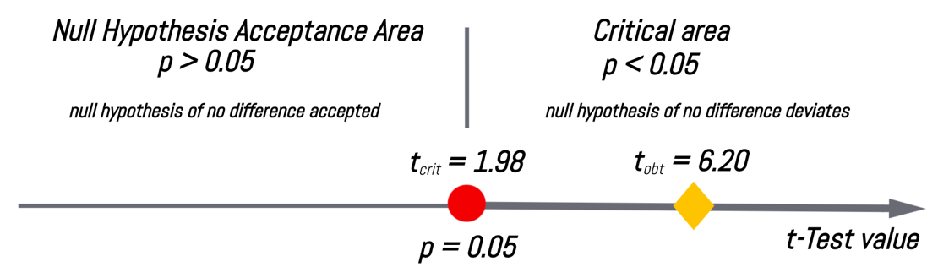
Figure 4 - Critical Value of t-Test and Areas Formed By It
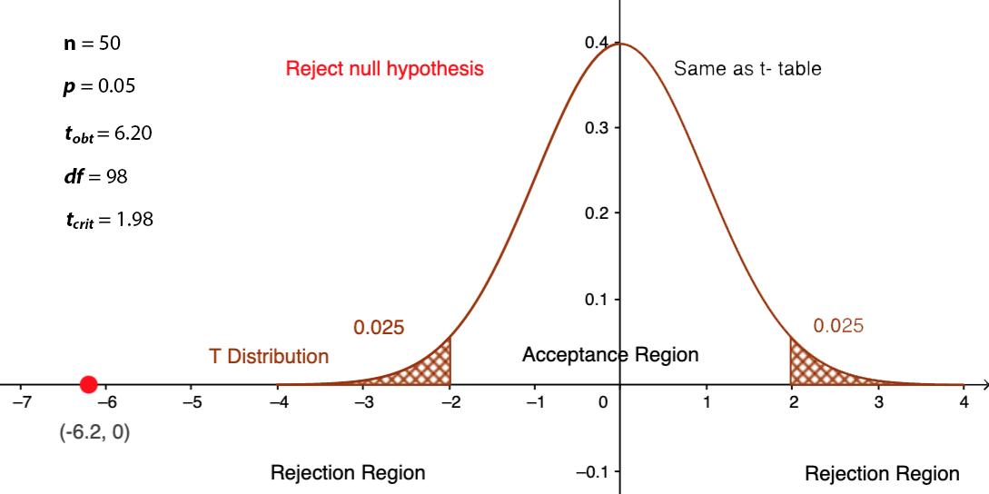
Figure 5 - t-Test Diagram p = 0.05 (based on scenario)

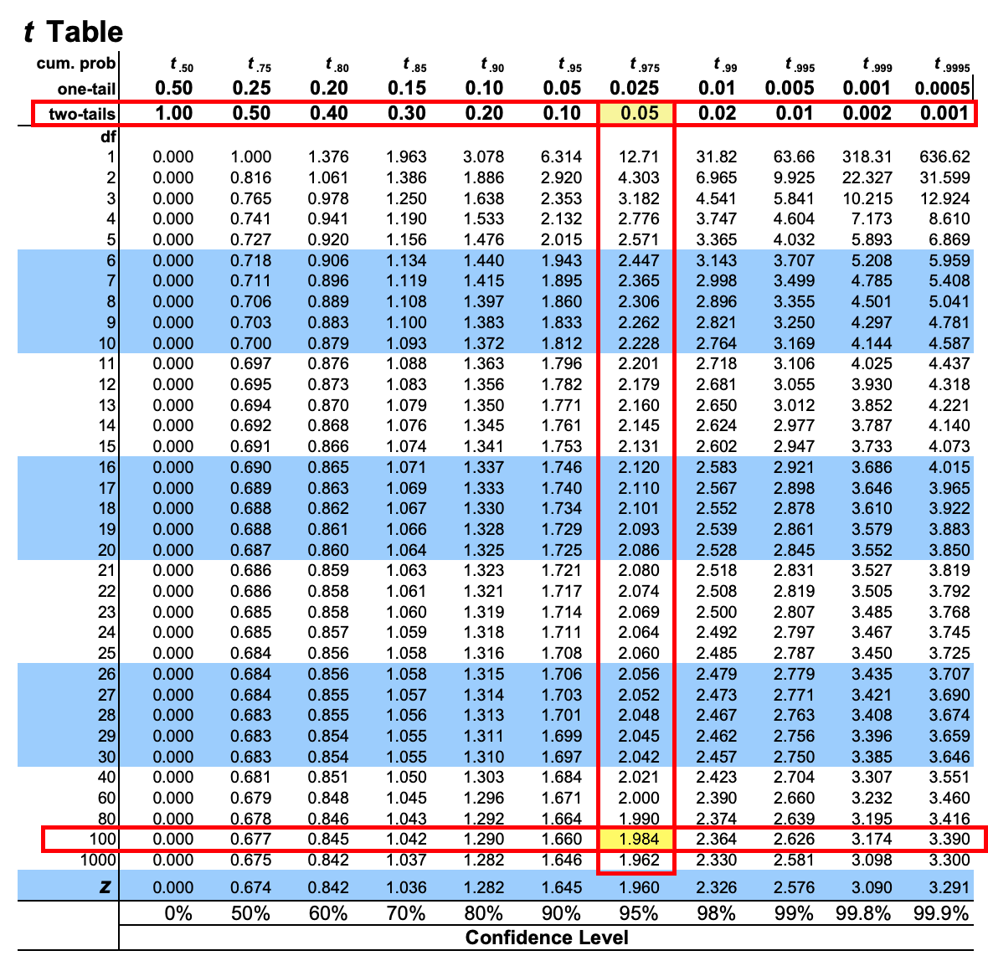
Figure 6 - table T (Critical Values of the T Distribution)
Conclusion: The null hypothesis of equality of infection with Covid-19 of the 2 groups of patients (white & BAME) is rejected, not sufficient arguments were received.

Significance level
Statistical hypothesis testing is based on comparing the calculated criterion value with the theoretical value selected with a given critical level of significance. The result of testing hypotheses and the conclusions made by the researcher depend on the chosen level of significance. Many textbooks and tutorials for using statistical packages provide a magic value of 0.05 to be chosen as the critical significance level [11].
When choosing a critical level of significance, it is necessary to pay attention to the sample size. The general idea is as follows. With a small sample size, it is more likely to get a random result, for example, to get the difference in two in the samples if they are homogeneous. Therefore, one can take a higher probability of a Type I error. With an increase in the sample size, random deviations compensate for each other, and it is less likely to obtain a significant difference in the samples if they are homogeneous. Therefore, one should take a lower level of significance. The standard significance levels are 0.1; 0.05; 0.01; 0.001. Therefore, one cannot always take a significance level of 0.05. It can adhere to the following conditional boundaries of the dependence of the sample size on the significance level. If the sample size is small, up to 100 units, then the null hypothesis can be completely rejected at a significance level of 0.05 or even 0.1. If the sample size is measured in hundreds - from 100 to 1000, the significance level should be lowered to at least 0.01. And with large samples, measured in thousands of observations, it is possible to confidently reject the null hypothesis only if the significance is less than 0.001 [12].
Also, when choosing a significance level, it is necessary to take into account the power of the criterion for an alternative hypothesis. Sometimes a large criterion power turns out to be more important than a small significance level, and its value is chosen relatively large, for example, 0.1 or even 0.2. Such a choice is justified if the consequences of Type II errors are more significant than the consequences of Type I errors [13].
Based on the scenario, the significance level p = 0.05, p = 0.10, p = 0.01 and p = 0.02 were given and calculated for each meaning separately. The exact value of the significance level can be easily obtained in a Microsoft Excel spreadsheet the t-Test: Two-Sample Assuming Equal Variances function (Fig. 7). The calculations were done in MS Excel and are presented below in figure 8.
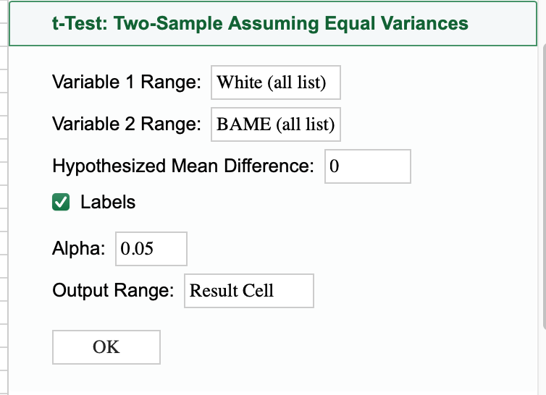
Figure 7 - Excel Function Example
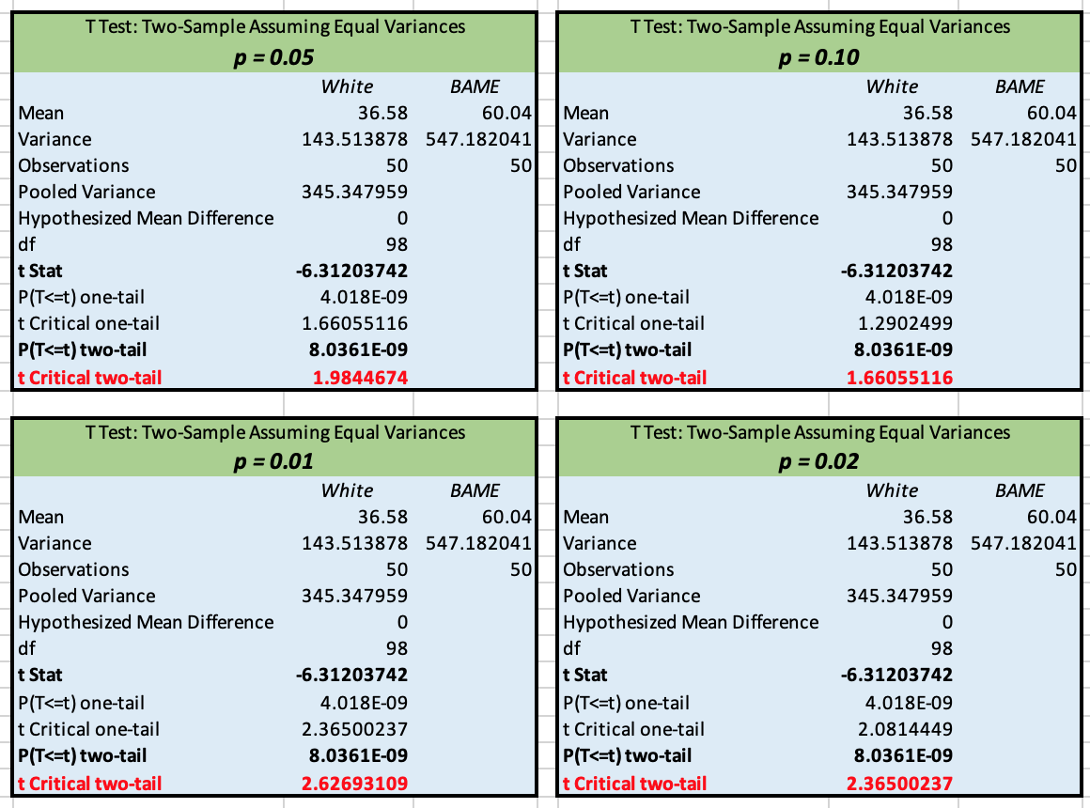
Figure 8 - T-Test: Two-Samples (p = 0.05, p = 0.10, p = 0.01, p = 0.02)
Conclusion: According to the data in the tables, the calculated value t Stat is equal to -6.31, which is greater (in absolute value) than its t_{crit} equal to 1.98. The probability of error is P ≈ 0.00078, which is less than all four specified significance levels (alpha) equal to p = 0.05, p = 0.10, p = 0.01, p = 0.02. Hence the null hypothesis is rejected. And the differences in the average values of the indicators are statistically significant: the correctness of the infection rate of Covid - 19 is varied between white people and BAME in the UK.

The outliers
It should be borne in mind that the presence of outliers in the sample can greatly increase or decrease the correlation coefficient. Outliers are easy to spot when visualizing data on a simple X-Y plot or a box-and-whisker-chart. They are points that protrude far in one or both coordinates from the main cluster, if any. Outliers should be treated with caution: they can both justifiably and unreasonably support or violate the general trend ("randomness is an unknown pattern"). In any case, it is recommended to check each outlier for the correctness of the initial data recording and to exclude the possibility of an accidental error [14].
TRUE indicates an outlier and as can be seen in the table (Fig. 7), there is only one outlier in the data in the scenario. A box-and-whisker chart shows the distribution of data by quartile, highlighting their outliers. In the figure below can be seen the only outlier outside the box.
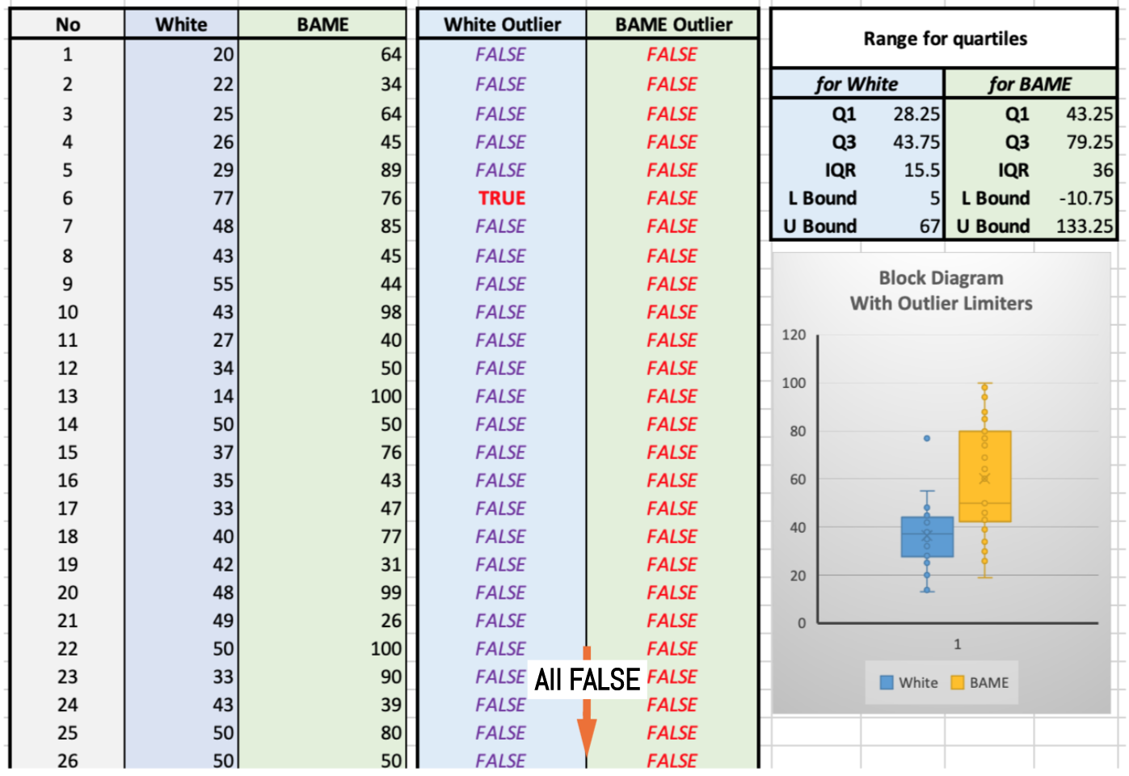
Figure 9 - The Outliers Info

Conclusion
All tests were defined by the following assertions: the specimens were comparable in every way but race, selecting was random, data sets were homogeneity of variance, and sampling distribution was equable.

Bibliography

[1] | S. R. Terrell, Statistics translated: A step-by-step guide to analyzing and interpreting data, Guilford Publications, 2021.
[2] | T. White, Hadoop: The definitive guide, O'Reilly Media, Inc., 2012.
[3] | T. K. Kim, “T test as a parametric statistic,” Korean journal of anesthesiology, vol. 68, no. 6, p. 540, 2015.
[4] | D. Semenick, “Tests and measurements: The T-test,” Strength & Conditioning Journal, vol. 12, no. 1, pp. 36-37, 1990.
[5] | R. B. Davis and K. J. Mukamal, “Hypothesis testing: means,” Circulation, vol. 114, no. 10, pp. 1078-1082, 2006.
[6] | J. Baskin, “An empirical investigation of the pecking order hypothesis,” Financial management, pp. 26-35, 1989.
[7] | D. Taeger and S. Kuhnt, Statistical hypothesis testing with SAS and R, John Wiley & Sons, 2014.
[8] | D. R. Anderson, K. P. Burnham and W. L. Thompson, “Null hypothesis testing: problems, prevalence, and an alternative,” The journal of wildlife management, pp. 912-923, 2000.
[9] | A. Banerjee, U. B. Chitnis, S. L. Jadhav, J. S. Bhawalkar and S. Chaudhury, “Hypothesis testing, type I and type II errors,” Industrial psychiatry journal, vol. 18, no. 2, p. 127, 2009.
[10] | E. Lann, Testing statistical hypotheses, New York: Wiley, 1959.
[11] | T. Dahiru, “P-value, a true test of statistical significance? A cautionary note,” Annals of Ibadan postgraduate medicine, vol. 6, no. 1, pp. 21-26, 2008.
[12] | K. C. Moisio, D. R. Sumner, S. Shott and D. E. Hurwitz, “Normalization of joint moments during gait: a comparison of two techniques,” Journal of biomechanics, vol. 36, no. 4, pp. 599-603, 2003.
[13] | S. Greenland , S. J. Senn , K. J. Rothman, J. B. Carlin , C. Poole, S. N. Goodman and D. G. Altman , “Statistical tests, P values, confidence intervals, and power: a guide to misinterpretations,” European journal of epidemiology, vol. 31, no. 4, pp. 337-350, 2016.
[14] | D. Ghosh and A. Vogt, “Outliers: An evaluation of methodologies,” Joint statistical meetings, vol. 2012, 2012.

