Programme: Master of Business Administration
Module: Human Capital Management
Module code: LCMB7023
Title: The influence of national and international labour markets on HRM and IHRM strategies
Word count:
Lecturer: Ejike Udeogu
Student Name: Nihar Rameshbhai Devani
Student ID: 2439635
Submission Date: 17th October 2025

Table Of Content

Introduction
Human Resource Management (HRM) as your organization's local team captain. It's all about managing employees right here in one country, where the company is based. Their main job is to handle all the typical staff stuff—like hiring people, training them, checking their performance, and sorting out any employee issues—all within the local rules and culture. You might see a little bit of movement if someone transfers within the country, and they mainly talk in the country's main language
International Human Resource Management (IHRM) is like managing a global sports team. It takes all those same HR tasks—hiring, training, benefits, and performance—and blows them up onto the world stage. It's about dealing with the tricky parts of having operations in lots of different countries. The big difference is that IHRM involves a ton of people moving around internationally (expats, global transfers), and the staff has to be great at communicating in multiple languages to deal with a truly diverse, worldwide workforce.
While they both care about the same core things—getting good people, training them up, and keeping them happy—HRM is focused on the local game, and IHRM is focused on the global game.

- How are technological advancements (e.g., AI, automation, digital platforms) reshaping labor markets, and what implications does this have for HRM and IHRM strategies?
1.1 How are technological advancements reshaping labor market.
The influence of technology on changing the job market dates back to the beginning of capitalism. However, the rise of new digital technologies, including AI and machine learning, has brought this topic to the forefront again. Automation and AI are creating new opportunities through the increased use of computers and robots, which directly affects the job market, as some people may lose their jobs due to automation and technological progress. For example, a warehouse previously employed two workers to lift all the heavy boxes.. The company bought a new robot to do the lifting. This robot only needs one person to run it, plus some programming. Because of this new machine, the company only needs one worker now, and the other person lost their job. So, it’s directly impact on an employer. Also, Due to Technology human are able to work easy and fast. (Self-Created) Let’s understand how many jobs are reshaping by technological advancement by this below chart.
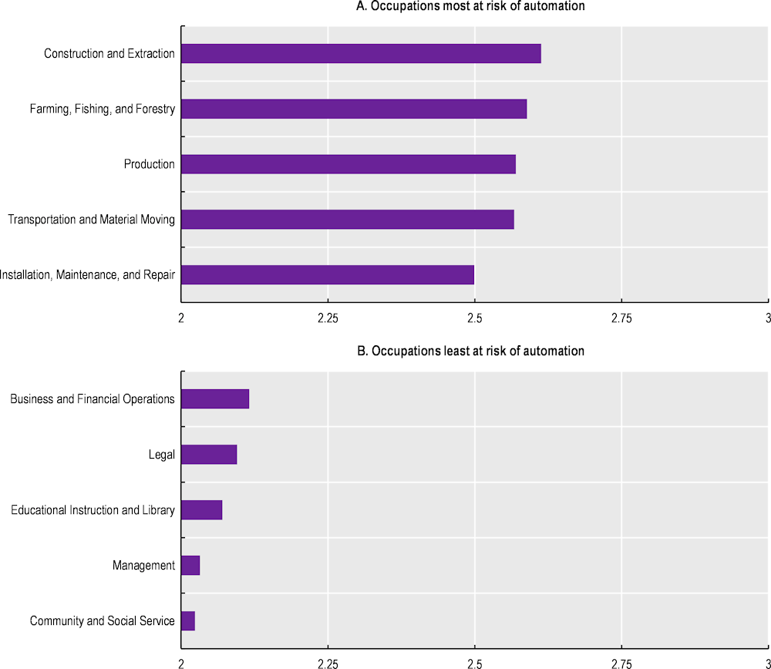
Figure 1.1.2 – (Occupation most at risk of automation) (2023). Artificial intelligence and jobs: No signs of slowing labour ... [online] www.google.com. Available at: https://share.google/images/ycbJwzCGMZLQD74nC)
1.2 what implications does this have for HRM and IHRM strategies?
The Books shows that AI enhances employee instruction and growth more efficiently.
Most important, these system can store Every worker's electronic resume providing a digital workforce inventory to the company. This helps in Recognizing skill gaps or creating appropriate training programs. It also aids organizations in finding suitable candidates internally.
Additionally, employees can utilize these systems to manage their career paths. If they have skill deficiencies, these AI systems assist in pinpointing their training requirements and completing necessary courses. Furthermore, online or virtual training offers several advantages for both the organization and its employees.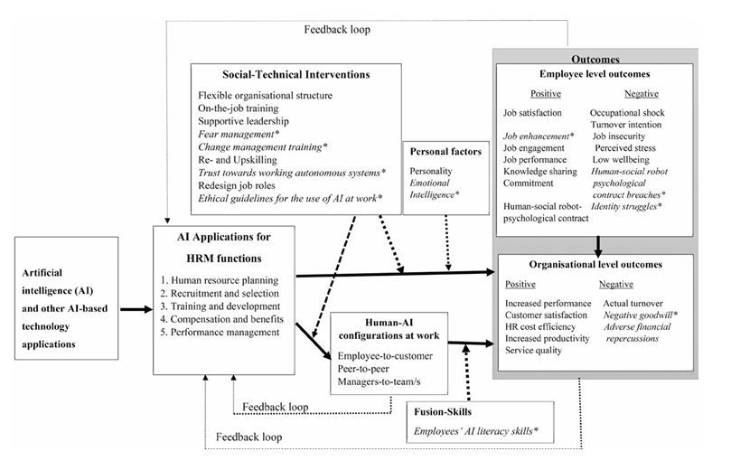
Figure 1.2.1An integrated conceptual framework of how AI-based application technologies affect outcomes at the organizational and employee levels. Note: Items indicated by asterisks and italics are those that require more testing.

- favorable results at the company level. HRM AI technologies affect business-level results in addition to employee-level results. According to the research on the implementation of AI-enabled HRM, it results in increased customer engagement and loyalty, cost savings, and operational efficiency (such as flexibility, scalability, safety, and dependability). By making the organization more cost-effective, AI can help increase returns on investment.
- Cost-effective service excellence (CESE), The other effect of AI technology on corporate productivity, describes companies that rank among the top performers in their competitive market in terms of both productivity and customer satisfaction. Singapore Airlines and Amazon, two of the biggest online retailers in the world, have both reached the CESE milestones. emerging technologies such biometrics, virtual reality, AI, big data, machine learning, mobile devices, the Internet of Things, geotagging, and speech recognition. offer a wealth of chances for comprehensive service innovations that could improve customer satisfaction, service quality, and productivity all at once.
- Negative results for each individual. Despite the literature's emphasis on the benefits of sophisticated technologies, a number of drawbacks have also been noted. For example, a high employee turnover rate may result from the inappropriate usage of such technology in HRM. Employees are seen as the most important resources in people-intensive services, despite the fact that service robots make a substantial contribution to the market. Furthermore, service robots are limited to cognitive and analytical jobs that don't require a lot of social or emotional intelligence.

- What are the key demographic and geopolitical factors influencing employment markets today, and how do they create challenges for HR professionals?
2.1 What are the key demographic and geopolitical factors influencing employment markets today?
The recent performance of the job market has been very strong. At a 30-year low, unemployment rates are much lower than most macroeconomists thought possible without causing major inflation increases. Job growth has been strong. To connect with many young people, low-skilled workers, single mothers, and other groups that are usually underrepresented in the workforce, employers have stepped up their hiring efforts. Even wages, which used to rise slowly, have begun to increase more quickly.
- Demographic Factors
- Age structure / population aging: -
A nation's economic growth is impacted by changes in the labor supply that occur when a population ages, birth rates fluctuate, or migration patterns shift. Changes in the population have a significant impact on how any country's labor force is shaped.(World bank blogs- article by Dorina Gergieva April 2024)
- Urban development: -
As more people live in cities than ever, urbanization is a major demographic change. This shift affects job trends, unusually the rise of industries and services in City areas compared to rural economies that depend on farming. Urbanization brings economic growth and new job opportunities, However, policies are also necessary to oversee the shift and guarantee fair and sustainable nonrural development.
- Cross-border movement: -
Global migration trends significantly influence population dynamics and labor markets worldwide. These trends are motivated by the present demographic
changes, Diverse economic prospects, environmental concerns, and humanitarian challenges. In 45 out of the 148 countries with available data, foreign-born individuals or foreign citizens constitute at least 10% of the labor force. The allure of better job opportunities, safety, and enhanced living conditions in their new countries often draws foreign migration.
- Family planning and gender equality: -
World Population Day's main themes include family planning and gender equality. Despite making up around half of the global population, women are less likely than males to be employed. When young children are present in the home, these gender disparities in participation become much more pronounced. According to research, women are disproportionately responsible for childcare because of gender norms. It should come as no surprise that moms of young children participate in the labor force at a considerably lower rate than women in families without young children. On the other hand, when males become fathers, their involvement rates vary considerably less. These discrepancies are a contributing factor to the startling gender differences in labor force participation, which for couples with young children reach 38 percentage points, while the gap for households without young children is only 23 points.

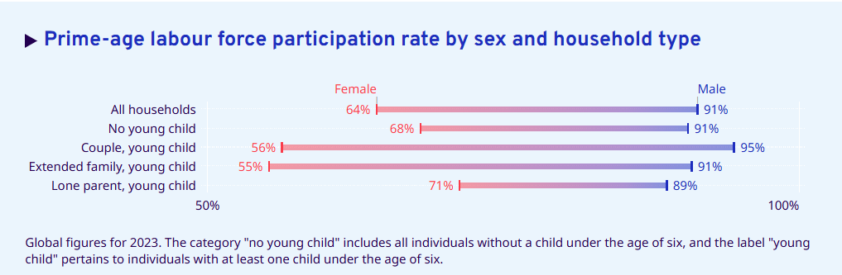
Figure 2.1.1 (Source ILO Modelled Estimates (ILOEST) database, May 2024 edition, ILOSTAT )

- Geopolitical Factors
- Political Stability: -
international politics and the economy could have a significant direct and indirect effect on the shipping industry. When a country enjoys political stability, investors feel more confident about putting money into its infrastructure, including ports and transportation networks. This leads to better-maintained and efficient shipping facilities, which can lower freight rates due to increased competition among shipping companies. Moreover, political stability often correlates with a consistent approach to trade policies and agreements.
- Trade Policies: -
Geopolitical relations between countries play a significant role in shaping trade dynamics, and they can indeed have a substantial impact on freight rates. In times of strained geopolitical relations, countries may impose trade barriers such as tariffs, quotas, or embargoes on each other's goods. These measures are often retaliatory in nature and aimed at protecting domestic industries or expressing displeasure over certain political actions.
- Environmental Regulations: -
Freight transportation is a cornerstone of global trade, facilitating the movement of goods across vast distances. However, this essential function comes with environmental costs, including carbon emissions, air and water pollution, and habitat destruction.

- How can organisations address persistent skills gaps and talent shortages in critical sectors (e.g., tech, hospitality, healthcare) through strategic HRM?
The current business environment is encountering a major issue: an increasing skills gap and a continuous shortage of talent in different sectors. Businesses are struggling to locate qualified individuals who possess the essential skills needed to occupy key positions as technology evolves rapidly and job demands shift.
Methods for Resolving the Talent Shortage and Skills Gap
- Training and developing current employees to improve or learn new skills:
One economical strategy to close the skills gap is to fund training and development initiatives for your present employees. You can adapt to your changing demands by leveraging employees' existing expertise and experience or retraining them for new responsibilities.
- Increasing Your Pool of Talent:
Look outside conventional avenues to expand your talent hunt. Think about utilizing underrepresented populations with exceptional unrealized potential, such as women, minorities, and those with impairments.
- Employer of Record (EOR) Services Utilization:
Work together with colleges, universities, and technical institutions to create specialized training programs that meet the demands of your sector. A pool of qualified graduates prepared to join the workforce may result from this.
- Developing Collaborations with Academic Establishments:
- Create specialized training programs in partnership with colleges, universities, and vocational institutions that meet the demands of your sector. As a result, there may be a pool of qualified graduates prepared to join the workforce.
Accepting Internships and Apprenticeships:
To give young talent practical experience and instruction, offer internships and apprenticeships. This enables you to evaluate possible candidates for future positions and can help develop a qualified team.

- Establishing a Culture of Education and Growth:
Encourage staff members to acquire new skills and knowledge by creating a workplace that values lifelong learning. Online courses, mentorship programs, and continual professional development opportunities can all help achieve this.
- Providing Competitive Benefits and Compensation:
Offer competitive pay, benefits, and incentives that meet industry norms and your target applicants' expectations in order to draw in and keep top personnel.
- Accepting Adaptability:
To attract a broader pool of applicants and meet a variety of needs, provide flexible work arrangements, such as remote work choices, flexible hours, or even hybrid employment.

