Enakshi Chowdhury (1713199)

UNDERSTANDING AND ENGAGING IN THE CUSTOMER EXPERIENCE

Contents
Executive summery 2
1.0 INTRODUCTION 2
2.0 FINDINGS 3
2.1. DEVELOPMENT OF TESCO 3
2.1.1 TESCO CRM 3
5
2.2 Ethical and Sustainability 6
2.3 Sustainability 8
2.4 QUALITY 11
3.0 CONCLUSION 12
3.1 SUMMATION OF THE REPORT 12
4.0 RECOMENDATION 13
4.1 REPORT BASED RECOMMENDATION 13
5.0 APPENDICES 14
14
15
15
6.0 ACKNOWLEDGEMENTS 15
7.0 REFERENCES LIST 16

Executive summery
This report is an overview of how organisation in this context “Tesco” understand and engage its customer relationship management and how it engages itself in the customer experience. While researching the report the author will try to critically identify and analyse all the management theories and model, which will help to determine how Tesco has its impact on customer satisfaction in terms of Ethics, Sustainability, and quality.
This research will also look at Tesco CRM system critically to find out how it will help Tesco to further develop so that it can make customers become an advocate of the organisation which in turn generates more profit.
The researcher will also offer few recommendations about the improvement which can be done in terms of Ethics, Sustainability, and quality and also how the CRM system can be made easy to make the customer experience nicer.

INTRODUCTION
The process of accumulating the report of understanding and engaging in the customer's experience will be complied by the researcher through all the facts and particular gather from Tesco. The data for compiling this report is gathered from books, newspaper articles, and mainly Tesco’s annual, strategic, financial report, used according to the requirement of explaining the Ethical, sustainability, and quality responsibility of the organisation.
Some particular findings will be researched on the CRM system of Tesco, to find out the improvement scope of the organisation towards customer satisfaction, going more revenue henceforth.
The research will also offer some recommendations after going through the research where Tesco has the scope of improvement to satisfy customers and make advocate for the organisation.
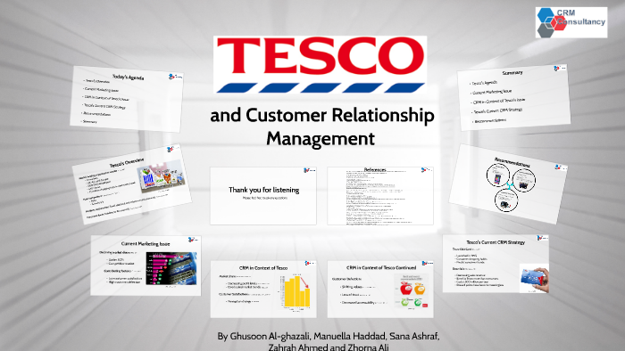

2.0 FINDINGS
2.1. DEVELOPMENT OF TESCO –
To judge the development of Tesco since it started, a clear timeline review can be presented to understand how it performed through its long more than 100 years of journey.
Jack Cohen began selling surplus groceries from a stall in the east end of London in 1919.
The first of these new stores opened in St Albans, Hertfordshire in 1948, and in 1958 the first supermarket opened in Maldon in Essex. Jack Cohen died on 24 March 1979, by 1982 checkout 82’ was launched by Sir Ian McLaurin, price cut was done between 3% and 26% on 1,500 food items. In 1992 school computers were launched, since 1992, the process has raised £185 million worth of equipment for schools in the uk, the same year “Tesco metro” brought value into the whole Tesco organisation. (Tesco defining moment ,2020) In 1995 the Tesco Clubcard was launched nearly five million customers was attracted in the first year, with its introduction, Tesco passed Sainsbury’s market share. in 2000 tesco.com was launched, the website has grown to serve over 20,000,000 customers browsed in each month, 2016 fresh food brands offer quality selling in the store. 2018 Tesco merged with Tesco, 2019 Tesco started cookery school and also celebrate its 100 years since its born. Entirely sourced from (Tesco our history,2020).

Find the key date and timeline diagram of Tesco in Appendices

2.1.1 TESCO CRM
Customer relationship management is a way through which the organization gets the path to build up a relationship between the organisation and customers, rendering good service so that the profit migraine of the organisation increase. (salesforce,2020)
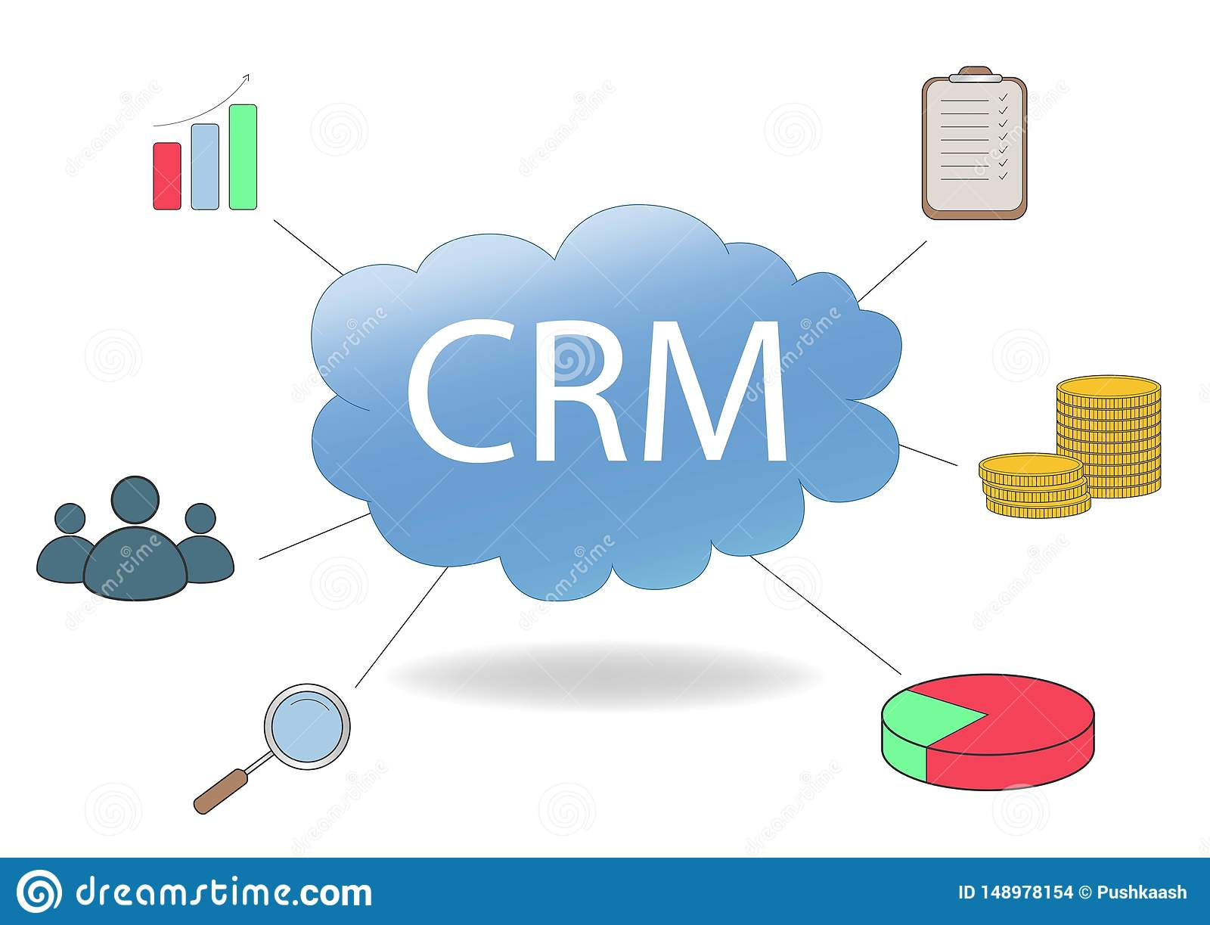
CRM or customer relationship management is the process or system through which the organisation tries to maximise its profit by giving more than the customers expected service. it is a process that organisation applies to keep the customer's retention high for further in the future. It is a system where the organisation tries to put its full effort to get better than its competitor through better service so that the customers will become loyal to the organisation. The CRM culture always reflects a leadership aspect, drawing of the formal system of the company and about the face hood and exposed stories that are beings in the organisation Culture within the organisation, the resources are assigned where the particular customer's values, reward, which advocate the employee's behaviour that in return improve the customer's holding and gratification, and as a result, the customer's information is stored, shared and can be applied in the business. CRM system is generally managed by a team concentrating on the job so that more useful time can be spent with a quality job but not finding unwanted material to make a relation with the guest stronger.
To critically discuss CRM, it can be seen as Customer relationship management refers to custom, exact source, and ways out that an organization religiously follow when rendering the service to the guest or the consumers. (Hargrave,2019)
To understand how Tesco used segmentation to build the relationship with the customers through the loyalty ladder, first loyalty ladder have to be understood, which is nothing but a tool where the customers are moved up by the ladder by providing outstanding service and by giving the customer a unique experience in marketing. The idea behind the ladder system is to make the customers loyal first to the organisation and then to make them advocate of the organisation so that promotion can be done automatically.

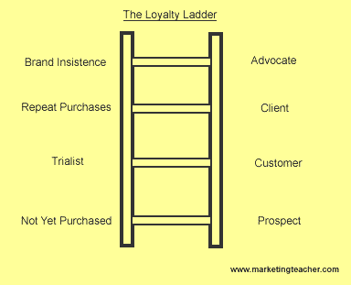
If the ladder can be explained
Prospect – when the customer is yet to buy the product but a probable customer.
Customers – the first experience to purchase somethings, when the customers get the first taste of the service, good or bad.
Client – At this point when the customers make a repeat purchase or use the service once more
Advocate – this is the most crucial step in the ladder system when the organisation tries to make the customer into an advocate, in this step the customer help the organisation to grow by promoting the organisation and help to grow the business, which is the success of the CRM system . (Leach.A,2020).

Customer satisfaction is the keyword behind customer loyalty, In terms of Tesco, it has been noticed that the satisfaction drives from Tesco's own brand product and its loyalty Clubcard. Another factor also drives the satisfaction label but during the recent pandemic, the online buying system and the delivery system have also jumped a massive 18% compared to the last months. According to the report in The Grocer by Ian Quinn, Tesco is planning to reach almost 900,000 slots in the next few weeks, an increase of almost 30% in just two weeks ) which definitely can be seen as a CRM strategy to make the customer's satisfaction level to the advocate mark. (Quinn,2020). So it can be summarised that Tesco is using the developing strategy of marketing, product and service to the keep its customers in the top advocate level in its loyalty ladder

Tesco perhaps being the largest supermarket in the UK have the largest loyal customer database. The loyalty card in the system is a unique success story of Tesco which helps in turn to created happy loyal customers. Tesco Group Chief Executive Dave Lewis commented in the Strategic report that – net promoter score have increased to 5 points as more customers are promoting Tesco as the place to shop and according to the report, 260,000 more customers are shopping in Tesco which proof that the loyalty or the advocate customers are growing. (Tescoplc.com. 2020.).

FIND THE TESCO PRICE MATCHING SCHEME WITH OTHER SUPERMARKET IN APPENDICES

Tesco have some unique strategy to be the champion in the CRM system, as it tries to make sure that all its customers receive the magazine which suits their lifestyle, it had also a strategy of advertising through promotional coupons in the 150,000 variants of Magazine, The loyalty card scheme is a great success to the CRM system, as the data acquired through this card is used to give personalised service keeping the cost in control, over 8 million customers data is linked to the customer's information system when they shop in the store and this data is then used to improve the CRM system. This type of CRM system helps Tesco to build a strong well-focused marketing strategy for the future progress of the organisation. (Tescoplc.com. 2020.). Tesco also uses McKinsey 7’s to strengthen and progress its relationship with the customers

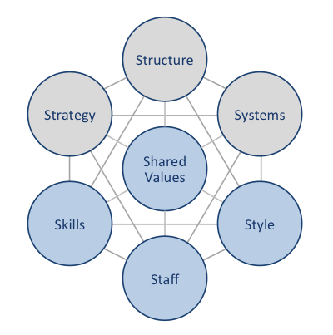
As McKinsey demonstrates that business has hard and soft elements, the values are shared as soft elements, which is the effect of interference with all the elements that have a direct effect on the behaviour and performance of an employee.

TESCO USE MC KINSEY 7s TO IMPROVE ITS CRM RELATIONSHIP, PLEASE SEE THE APPENDICS TO FIND MORE DETAILS

After discussing all the above Tesco policy, it could be critically assessed that if Tesco is achieving RAVE, which stands out to Respect, Appreciate, Value and Everyone. It is seen by research customers becomes happy when the service is quick, availability, warmly greeted by the staff, deliver as promised or promoted, need the issue addressed not only selling, have the training and skill to solve any problem, do not want to be neglected and a grand thank you. (Service H., 2020)

To meet the customer's RAVE satisfaction, Tesco is reaching PECA which stands out as Tesco is always paying attention that all the product price does stay low without losing the quality and make the customer satisfied, Tesco management always take the customers understanding with full empathy, while understanding the customer's problems or needs clarification about the issue should be the key so that the action can take place promptly, happy customers advocating about Tesco proves the points .

2.2 Ethical and Sustainability
Ethics is well explained by live example, that can be shown by the conversation as “That is the exact thing to do.” “he or she is the most balanced -minded, ethical human being I know.” “his /her behaviour so not so ethically!” etc. As a whole ethics stands to the nature of feelings and behaviour that empathetically take others ‘interest into account to achieve greater success. As a written explanation, of ethics can stands with various kinds of ideas, useful pragmatism, deontological, feature ethics, attention ethics, location ethics, and many more can offer the artwork for addressing the original issues

To understand the cross section of ethics and sustainability will totally depend on a large understanding of ethics, careful focus on and proper meaningful justification of what should be done to stay together with other people, ethics critically involved the quality of our interactions as well as our image on those behaviours and habit .(Becker,2013)

Ethics
. Sidgwick defines Ethics as ‘any sensible technique by which it is understood what personally human beings “must do “or “correct” for any individual —to do, or to seek to realize by voluntary action’. Further the explanation ‘individual’ purposely, to separate ethics from politics, is a worrying factor with the proper composition and public behaviour of the societies. The word ethics had a past history, but the word sustainability came out very recently.
FIND THE EXPLANATION WHY CUSTOMERS SHOPS IN TESCO MORE THAN ANY OTHER SUPERMARKET, ETHICALLY PROVED
TESCO
In the question of “is Tesco an ethical company”? it can be researched through different aspects like people, environment, political and Animal aspect of it. Research showed that Tesco become the most ethical supermarket in 2019 but around the same time a fact came out that one of its suppliers is using “slave labour” paying like 50 p a day, who are working in poultry firms, salvaging firm and poultry factory. So Tesco definitely has a part to play in that controversy, although it is denied. In regard to the use of the toxic chemical in the electronic product, it had a vow of zero discharge of hazardous chemical, but it does not include, electronics, leather, agricultural only, and textile. The use of Phthalates in many plastics as flame retardants and plasticizers have made Tesco looks really bad in terms of Ethical environment issue. In the contest of animals, ethics issue its retail factory framed meat and non-free-range eggs.

SAINSBURYS
This organisation outlines the employment practices and standards that is expected from suppliers, wherever it may be ,their policy is based on the Ethical Trading Initiative’s (ETI) Base Code, the International Labour Organisation (ILO) and the core conventions and the Universal Declaration of Human Rights .Aim of Sainsburys is to obtain the minimum standard so that it can monitor the suppliers performance constantly improve .Sainsburys is committed to the human rights ,also provide training ,sharing the knowledge and involving in collaborative organisation initiatives . (Ethical trading ,2020) .According to the supplier trading ethical report ,Sainsbury’s customers expect that the product they are buying from the supermarket are produce ethically ,maintaining the gov rules and regulation of the labour act , environmental policy ,keeping the social structure in tact . They are working with supplier ethical data exchange (Sedex)to maintain the supplier social and audit performances. Sainsbury also works closely with Association of professional social compliance Auditors to enhance or maintain the ethical stability in the organisation (Ethical trading ,2020)

ASDA
This organisation is the worst of the UK’s major retailer in its treatment of suppliers. Its position dropped below Morrisons, which came last in last year as ethics is concern .Number of issue is raised about Asda like wrong deduction from the invoice of the supplier without any kind of information ,henceforth making a huge profit margin from the supplier bills .Also making some kind of forensic audit of the supplies accounts
According to the reports around 63% suppliers have complained about violation of law against the supermarket. Incorrect deductions from invoices remain the top problem, affecting 32% of suppliers, followed by wrong data entry and the issue is not resolved quickly and unfair charges for packaging dispute. (The Guardian ,2017)
Ethics is to be separated from areas of sociology or psychology that practice morality as a social practice, or examine the psychological factors that will make the ethical judgments that is taken to the extent to which they influence the behaviour. This does not mean that there is no relation between ethics and the descriptive sciences. It is hard to decide what ought to be, or know how to bring it about, without knowledge of how things are. Moreover (p.15) Sidgwick is clear that pointing out what is essentially different from understanding what right and which judgments is about wrong and right are true. (Sustainability - What Is It? Definition, Principles and Examples, 2020)
Tesco is more ethical supermarket than others, graph shows why people do more shopping in Tesco
Find the graph in Appendices

2.3 Sustainability
Sustainable is an adjective for something that is bound to be sustained, which means it is “tolerable ” and “worth of being going on at a particular level”. In a summary it can be defined as something which can be expected to carry on for a certain level .for this reason nowadays, because of the natural and communal problems the society is facing it is used commonly used in a specific way. Therefore, sustainability can stand out as the course and movements through which humanity avoids the reduction of a natural reserve, to keep an environmental balance so that society’s balanced life does not decrease, and Tesco is not also out of the focus. (REFERENCE)

(An Update on Our Corporate Responsibility Commitments November 2016,2020)

According to their updated report of Social responsibility, it can be seen that is in evidence in their report as they are helping to the society to
Reducing the food waste – determine by coming years no food should be waste from uk stores, roll out food which is surplus to donation programme across the group

the measure is taken towards human rights and labour standard- social programme according to Tesco report helping nearly 45,000 from the local community.

making society healthier – cutting the sugar effect in all product by 5%, free fruits of all children actively takes part into helping to, raised over 13.7 million for the national charity along with diabetic uk and British heart foundation

Maintaining supplier’s relationship – Tesco said that the payment terms issue across the board has been solved, suppliers from other parts of the world also increase through the system.

Business ethics and anti-bribery. refresh code of business conduct is launched. the successful campaign of protector line whistleblowing hotline is done

” Tesco recommitment towards global compact – Tesco has not forgotten the responsibilities towards the future society, hence took the step forward to help things for the global future movement.
Helping to stop good food to go waste – according to the Tesco report it is constantly trying to stop good food to be wasted, Tesco is the first UK retailer to measure and publish assured food waste data for our UK operations
Develop the employees also – Tesco also stresses the fact that behind its success it’s the employee that is key to the success of the story. Tesco's motto is to reward the people who are behind the success of organisation. the main aim is to recruit, inspire, and develop the best people in the retail job. (An Update on Our Corporate Responsibility Commitments November 2016,2020)

Henceforth after discussing the social responsibility of Tesco let us find out how Tesco use the “three Bottom-line theory”

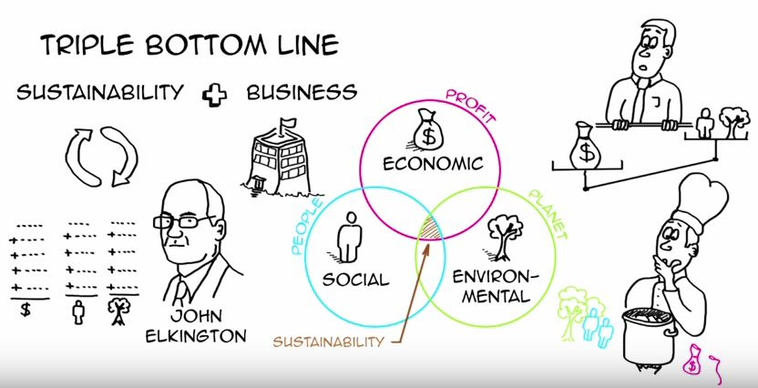

TESCO FOLLOW “THREE BOTTOM LINE” PLEASE CHECK THE APPENDICES FOR DETAILS EXPLANATION

2.4 QUALITY
“According to J.M. Juan, quality is appropriate for use, according to Philip Crosby quality is conformance to employment, according to Armand quality means the best of few customers situation, that is the use and the selling price of the material and according to Sam Walton quality is to provide the customer what they need “as cited by Joel E Ross. (Ross,1999)
Quality Management as a part of CRM
Financial goal: Economic, profitability, liquidity performance and annual increase,
Managerial task: Incorporate the task into the company and by process manage the owners' requirements.
Customers' view: Quality of service rendered, long commitment, relationship, etc.
Managerial task: To understand, manage the requirement of the customers. Create a competitive advantage in the internal environment
Internal goals: Productivity, rewards programs, responsibilities, staff protection etc.
Innovation and educational goals: Knowledge management, creating teams, a high degree of farsightedness of basic and long orders, and employee development, etc.
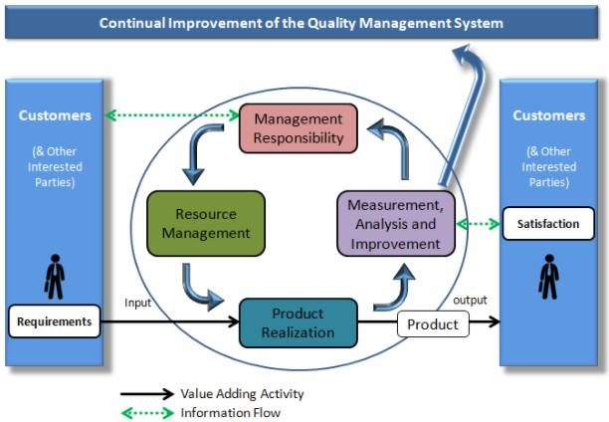

Customers nowadays are not biased by the promotion or somethings cheap and do not have the quality, rather they are more interested in the quality of the product. If different models have to be evaluated; it can be seen that Tesco put a fair understanding about the maintain of the quality
The quality management system (QMS) seems followed by Tesco -which can demonstrate what /how they do it -
Product development team – they have a special development team which keeps a good eye to produce the best quality of produce to the customers .The system works specially of supporting the Nutrition team which have the special job of ,engaging with the broader network of nutrition expert ,consumers forum ,supporting wider health activities ,helping to provide healthier product to the wide range of customers ,also helping to herness technology to develop healthy food product .

Labelling and Packaging – it is the necessary step for Tesco to communicate with the customers as through this, the essential and vital information is passed to the customer about the concerned product.
Supplier audit programme – Tesco not only produce their own band and do the audit on them but also, they have a strict audit programme to check the quality of product coming from the supplier. like for an example in 2019 Tesco have almost completed round about 2000 maintenance audit of the global supplier which is suppling to uk as well as to international store of Tesco achieving about 75% of the accuracy score
Food safety procedure – Tesco have a special cell of testing the produce so that the product can be tested in the lab and make sure that the product is safe to be sold ,as an example in 2019 ,5930 items have been tested microbiological way ,6664 sample have
Food safety in store – another special things in the QMS system is to look the product which is in the ware house should be in safe storage capacity ,staff are well trained to check all the product and maintain the safety still they leave the warehouse .
Withdrawal and recall – the last step the of the quality control system is the withdrawal or recall of product which is for sale in the store .Tesco work relentlessly with the supplier to take any action if some of the product have any issue it is recalled immediately .Safety of the customers come first
All sourced from (Product Safety & Quality, 2020).

3.0 CONCLUSION

3.1 SUMMATION OF THE REPORT - After discussing the whole matter, it can be well recognized that Tesco has established itself as a leading supermarket in UK by the process of understanding the quality system and control of the customers – improvement in the QUALITY. Different kind of module and theories which are critically assessed in the report also proves how Tesco uses its quality system in the workplace, what it is doing to make the customer experience better so that the customer become an advocate for the organisation .A detailed study has been done about the customer's relationship management and how Tesco is utilising it to make the guest happy to gain more profit. Improvement in ETHICS -It is also discussed how Tesco is trying to do things Ethically so that it creates more revenue for them, how Tesco is creating or maintaining its responsibilities towards society. It is also discussed how Tesco has done the improvement in SUSTAINABILITY -CSR worked so that the customer relationship improves to make customer loyalty towards the retailer. It is also discussed how Tesco have used the CRM system to get the most out of the it to get the desired result, so that it can improve the business in all aspect

4.0 RECOMENDATION
Some of the suitable recommendations which can have a good effect, that came out as a result of the entire research is
PROMOTING THE JACK which it had introduced recently, and figures show substantial growth, which in turn can compete with lower-cost competitors like Lidl and Aldi.

MAKING HANDSHAKE OR ALLIANCES STRATEGICALLY WITH OTHER COMPANY will give Tesco more opportunity to sell more product and make more profit.

JOINT COLLABORATION WITH LOCAL SMALL COMPANIES who have more sound knowledge of the local area can bring up the footfall of the customers more and can give the business more profitable.

ONLINE SHOPPING – During the recent pandemic, the online shopping has come up with a boom for all the supermarket and Tesco is not an exception, as discussed earlier it has substantial growth in the online shopping, hence it should concentrate in the online shopping and home delivery system more to gain more profit.

OPPORTUNITIES IN NEWMARKET OR IN NEW COUNTRIES which are emerging as a new custom field base country. This can be emerging countries like India, South Korea, Indonesia.

4.1 REPORT BASED RECOMMENDATION

ETHICS – It is seen that although Tesco is trying to be Ethical so that it can prove to its customers, about how it cares about its product and employee, still it need to improve a lot in its policies of dealing with the supplier, monitor their working system regularly so that it should not buy the product from an unethical supplier, it should also put forward a strict contract for the employee so that they feel that the company is looking after them ethically and in returns, they will help to grow the customer by rendering value service.

SUSTAINABILITY - The key objective is how to establish the mark way in the most recommended system as possible, know what to measure and how to make the system work and what are the needs of reporting them. The disturbing nature and wrong information from the public sources within the organisation make the process challenging. recommendation should have the most valuable and necessary information
for vital decisions to make, creating the areas to reach their goals (Griffin, 2010).

QUALITY In the matter of quality, it is noticed that Tesco is trying to put all efforts to make the quality a benchmark in the system to attract more customers. Research shows from the annual report that it should concentrate more on the process of creating a special team or research team to control the quality. The team should not only focus more into their own brand but more in the product supplied from an outside supplier which can easily have some glitch in the quality and not up to the required standard – source taken from the strategic report (Annual Report and Financial Statements 2020)

TESCO CRM –
Few recommendations of how the CRM system can be more improved as research in the above report
- Making the CRM software which is used in Tesco more easily accessible to everyone concern in the organisation, so that the effect will be immaculate
- Training is the key to this concern of CRM to the employee
- Keeping the data as a knowledge material so that it can be used further on for more improvement.
- Keeping the customer's activities through CRM so that it can help in the future.

5.0 APPENDICES

FIVE KEY DAYES IN TESCO HISTROY

1919: Tesco is born / 1929: First store / 1958: First supermarket / 1997: First Tesco Extra /2019: Tesco celebrates 100

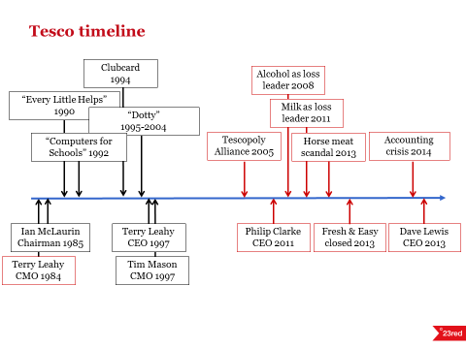

TESCO USE MC KINSEY 7s TO IMPROVE ITS CRM RELATIONSHIP,
In terms of STRATEGY, which is the hard effect, Tesco has been able to maintain the tag line of “every little help” through the strategy of bargaining with the supplier, which helps them to keep the purchasing costs low. Under the new management, it had taken some strict decision of reducing the capital expenditure, replacing the benefit pension scheme of the employee, and reviewing the property portfolio as a process of cost reduction. The priority of the new management seems to be the service, availability, and selectivity on product price so that customer relation remains the same in the crucial moments.
Tesco has applied a new appraisal SYSTEM where over 40 new reform systems can be seen to make the working system more smooth and easy under new management The new evaluation strategy has only six key performance measures which help the overall process more simplified. (Dudovskiy, 2020.)

In this context it can be noticed that Tesco also use their marketing mix strategy based on the cost leadership, Tesco marketing mix is related to their marketing message of “every little help”. In general marketing mix according to Edmund MacCarthy as cited by M Rahman consist of four key elements, product, price, place, and promotion. (Rahman, M. and David, J., 2020)

Tesco’s management STRUCTURE is hierarchical and structured with layers from the ground level salesperson to the CEO. In 2015 the new roles of deputy store managers came in as part of attempts to simplify the company’s structure. 10 members Board of Directors and the company’s Executive Committee have 11 members. This is how the structure of Tesco is formed.

TESCO PRICE MATCHING SCHEME WITH OTHER SUPERMARKET IN APPENDICES

Tesco uses all this element to make the customer relationship system stands out, especially the pricing strategy is based on the cost-effective strategy, where it is noticed that maintaining the product selling price as low as possible without any compromise in the quality, management of Tesco always ties to maintain a low cost in regards to the purchase from suppliers and also keep low the promotional cost and also huge competition from another supermarket giant like Aldi and Liddle always keep the pressure on Tesco to keep the price down and keep growing the Advocate customers. (Dudovskiy,2020) recently Tesco operates a Brand Match guarantee in-store and online, which ensures its price on branded products across 500 lines beats Asda, Morrisons and Sainsbury’s

ETHICAL EXPLANANTION OF TEXCO
Texco did the wrong things taking out the fixed end date on the animal
testing of the own-brand product. they also continue to sell products of other companies who did still test the animal. Politically also they have done things from time to time which is not ethical, like paying a huge sum of the money to their CEO, which according to the shareholder is not right, Tesco also used tax avoidance tactics with a number of its subsidies company in Hong Kong, Cyprus, jersey and in Guernsey. So, research shows that although Tesco tries to prove that they are the most ethically progressive supermarket in UK still the real fact is quite far from reality. (How ethical is Tesco plc? Ethical Consumer, 2020)

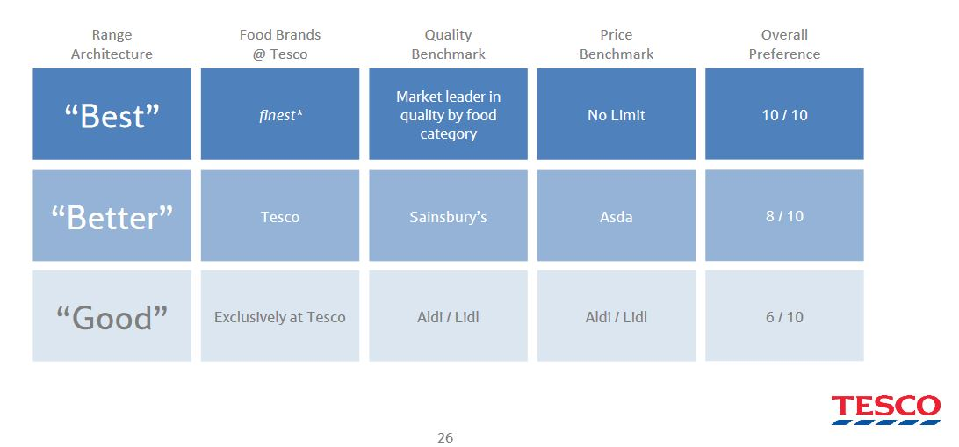

.

The word ethics, which has a big past history, but the word sustainability entered the public lexicon very recently. Early years days people use for the term were typically reserved for critically impose management prospective as an example to sustainable forestry and sustainable fisheries etc as part of a strong will to maintain a solid balance between natural resource availability and human or manmade harvest.

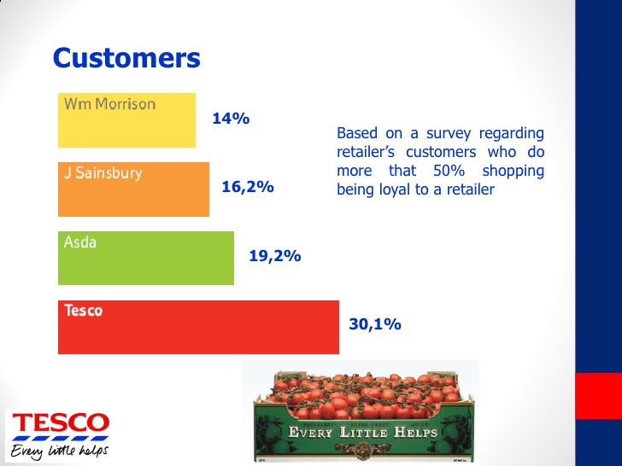

TESCO USE THREE BOTTOM LINE
In 1994 Jhon Elkington came out the word of three bottom lines .according to him first one is the measure of the corporate profit, the second one is the way the companies input in the social responsibilities and the third one is the responsibility towards the planet or environment (Triple bottom line,2009)

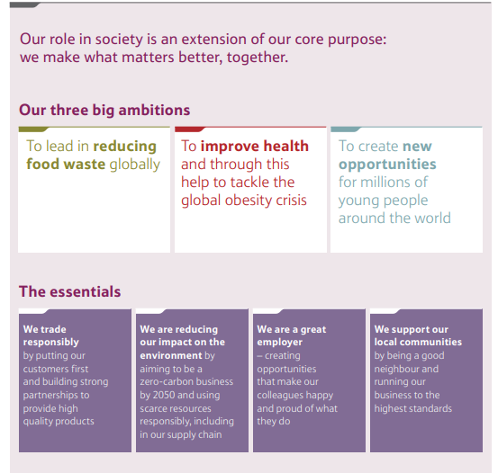

The above chart proves that Tesco does follow the “THREE BOTTOM LINE” THEORY to contribute the society, environment, and economic responsibility not only tries to generate profit only. Tesco is trying to lead in the campaign of reducing the food waste globally which shows the commitment in the environmental responsibility, Tesco also trying to tackle the global obesity crisis which proves the awareness as an organisation towards the society and the last is they are trying to create new opportunities for millions of young people around the world which shows Tesco’s consciousness towards the economic responsibilities of the organisation(Corporate Responsibility 2014/15 half-year update, 2020)

Research shows that Tesco completes all its economic responsibilities as per Carroll theory, fulfilling its legal responsibilities by following the rules and regulation, it keeps ethical by trying to live healthier and locally grown produce to the customers, thus keeping their responsibilities towards the environment also clean. It also has a major part to play by encouraging people and the employee to live a substantially healthier life (Tesco annual report 2019.2020)

6.0 ACKNOWLEDGEMENTS
A real thanks to Maria Hefferman for her relentless support through the tough time to complete this report. Also, appreciation goes to the way she guided us to compile the report by instructing how to get data from different material. Really thankful to her.

7.0 REFERENCES LIST
About.sainsburys.co.uk. 2020. Ethical Trading. (online) Available at: <https://www.about.sainsburys.co.uk/suppliers/ethical-trading> (Accessed 26 June 2020)
Dudovskiy, J., 2020. Tesco Mckinsey 7S Model - Research-Methodology. [online] Research-Methodology. Available at: <https://research-methodology.net/tesco-mckinsey-7s-model/> (Accessed 21 June 2020)
Dudovskiy, J., 2020. Tesco Marketing Mix - Research-Methodology. (online)Research-Methodology. Available at: <https://research-methodology.net/tesco-marketing-mix/#:~:text=Tesco%20pricing%20strategy%20can%20be%20described%20as%20cost%20leadership.&text=Tesco%20management%20aims%20to%> (Accessed 25 June 2020)
Ethical Consumer. 2020. How Ethical Is Tesco Plc? | Ethical Consumer. (online) Available at: <https://www.ethicalconsumer.org/company-profile/tesco-plc> (Accessed 27 June 2020).
Leach, A., 2020. The Basics of The Loyalty Ladder - Matrix. (online) Matrix. Available at: <https://www.matrix.co.uk/2018/02/basics-loyalty-ladder/> (Accessed 20 June 2020).
Lazari-Radek, K. and Singer, P., 2014. What Is Ethics? (online) Oxford Scholarship Online. Available at: <https://www.oxfordscholarship.com/view/10.1093/acprof:oso/9780199603695.001.0001/acprof-9780199603695-chapter-1> (Accessed 20 June 2020)
Quinn, I., 2020. Tesco announces massive increase to online delivery slots. The Grocer, (online) Available at: <https://www.thegrocer.co.uk/online/tesco-announces-massive-increase-to-online-delivery-slots/603523.article> (Accessed 20June 2020).
Ross, J., 1999. Total Quality Management. 3rd ed. London: St Lucie Press, p.107
Ricky W. Griffin, (2010), Management, Edition 10th, Published by Cengage Learning, 565-569
Rahman, M. and David, J., 2020. Marketing Mix of Tesco – Tesco Marketing Mix | How and what. (online) how and what. Available at: <https://www.howandwhat.net/marketing-mix-tesco-tesco-marketing-mix/> (Accessed 25 June 2020)
Service, H., 2020. How to Get Customers to Rave About You (And Your Service) - Awesome Support. (online) Awesome Support. Available at: <https://getawesomesupport.com/get-customers-rave-service/> (Accessed 26 June 2020).
Tescoplc.com. 2020. [online] Available at: <https://www.tescoplc.com/media/476557/tesco_2018_strategic_report.pdf> (Accessed 20 June 2020)
The guardian, 2017. Asda is named worst supermarket in treatment of supplier. (online) p.1. Available at: <https://www.theguardian.com/business/2017/jun/26/asda-supermarket-suppliers-walmart-morrisons> (Accessed 28 June 2020)
The Grocer. 2020. Tesco’s Defining Moments. (online) Available at: <https://www.thegrocer.co.uk/promotional-features/tescos-defining-moments/596508.article> (Accessed 20 June 2020).
The Economist. 2009. Triple Bottom Line. (online) Available at: <https://www.economist.com/news/2009/11/17/triple-bottom-line> (Accessed 30 June 2020).
Tescoplc.com. 2020. Corporate Responsibility 2014/15 Half-Year Update. (online) Available at: <https://www.tescoplc.com/media/476653/tesco_and_society_hy_update_2014_15-1.pdf> (Accessed 30 June 2020).
Tescoplc.com. 2020. An Update on Our Corporate Responsibility Commitments November 2016. (online) Available at: <https://www.tescoplc.com/media/475740/corporate-responsibility-update_nov-2016-final.pdf> (Accessed 30 June 2020).
Tescoplc.com. 2020. Tesco Annual Report 2019. (online) Available at: <https://www.tescoplc.com/media/476423/tesco_ar_2019.pdf> (Accessed 30 June 2020)
Tesco PLC. 2020. Product Safety & Quality. (online) Available at: <https://www.tescoplc.com/sustainability/publications/policies/downloads/product-safety-quality/> (Accessed 29 July 2020).
Tescoplc.com. 2020. Annual Report and Financial Statements 2020. (online) Available at: <https://www.tescoplc.com/media/755761/tes006_ar2020_web_updated_200505.pdf> (Accessed 30 June 2020).
Tesco PLC. 2020. Our History. (online) Available at: <https://www.tescoplc.com/about/our-history/> (Accessed 2 July 2020)
Youmatter. 2020. Sustainability - What Is It? Definition, Principles and Examples. (online) Available at: <https://youmatter.world/en/definition/definitions-sustainability-definition-examples-principles/> (Accessed 20 June 2020).

https://www.oxfordscholarship.com/view/10.1093/acprof:oso/9780199603695.001.0001/acprof-9780199603695-chapter-1

https://www.smartinsights.com/online-pr/reputation-management-online-pr/tesco-turned-marketing-strategy-around/

https://www.ethicalconsumer.org/company-profile/tesco-plc
https://www.birminghammail.co.uk/news/showbiz-tv/jason-manford-now-working-iceland-18429238
https://www.edie.net/news/5/Tesco-to-remove-one-billion-plastic-pieces-from-products-by-end-of-2020/
https://www.edie.net/news/5/Tesco-to-remove-one-billion-plastic-pieces-from-products-by-end-of-2020/

