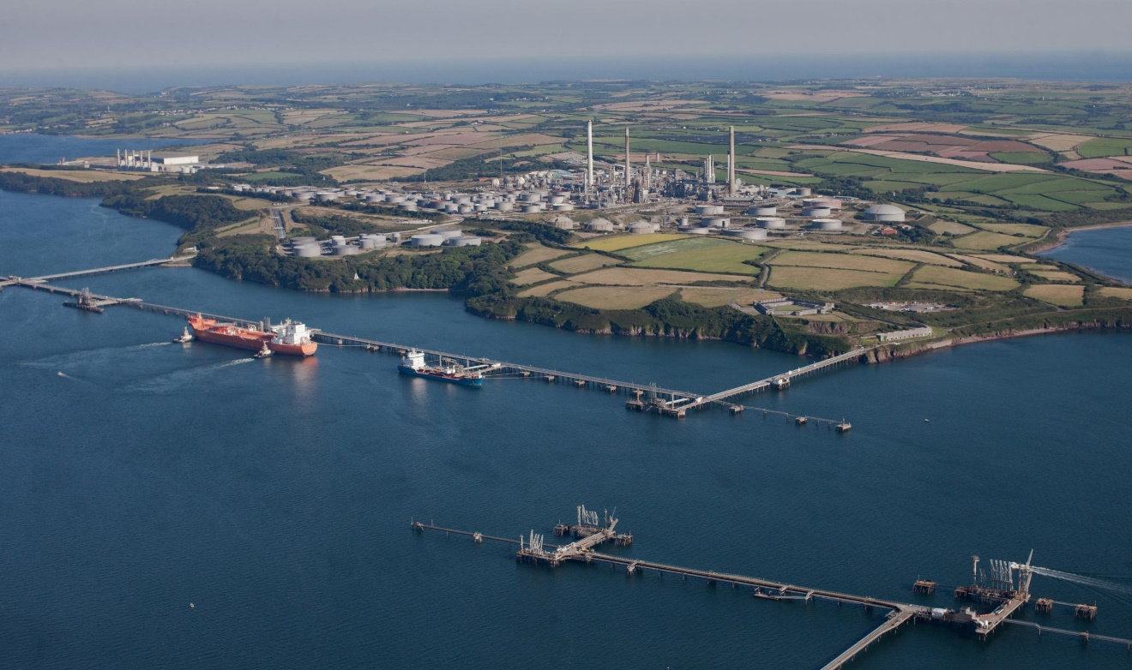

Effective Hydro testing methods during low temperatures using the minimum design metal temperature (MDMT).

George Wright | Research Proposals
1.0 Abstract
The aim of this proposal is to research an alternative hydro test method with heat exchangers during low temperatures, using the minimum design metal temperature (MDMT) to avoid the shell materials ductile to brittle transition (DBT). Using simulation models to analyze an effective hydro test method, this will then be implemented in the field to address the delays in hydro testing at Valero during shutdowns when temperatures are low. In addition, several alternative materials will be proposed for future use that have a lower MDMT than those in current standards hence avoiding the DBT.
2.0 Introduction
I work for Valero Energy in Pembroke who specialize in refining crude oil to make various products. Below is a simple diagram showing the refining process of crude oil:
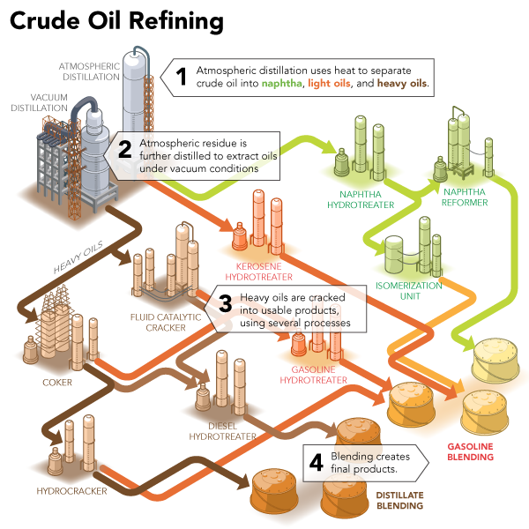
Figure 1: Products such as jet, diesel fuel, propane, fuel gas and petrol are all end products of refining crude oil (Stribling 2018).
As these units operate continuously, Valero needs to ensure each unit is operating at its full production capacity. To maintain this production, individual operating units in the refinery are shutdown during set periods to carry out statutory inspections and planned maintenance that cannot be done when the plant is operating (Bijvank 2004). These units are normally planned for shutdown during winter, where demand for Valero’s products are lower than in the summer. This is shown in figures 2 & 3 below:
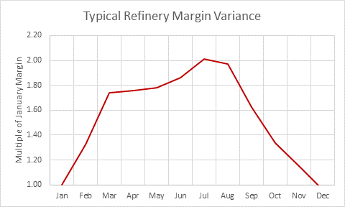
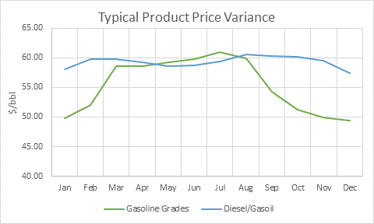
Figure(s) 2 & 3: Refinery margin variance against January and typical product price variance for Valero, Pembroke.
Some statutory inspections and repair packs, once completed, have a hydro test to comply with HSE and Valero inspection requirements (ASME B31.3 2016). The hydro testing can cause a problem to Valero if outside temperatures are low and, in this case, it is vital to consider the material’s MDMT (ASME B31.3 2016). Below this MDMT the material undergoes a DBT that can change the properties dramatically as seen in figure 4 below:

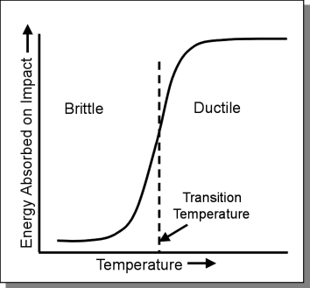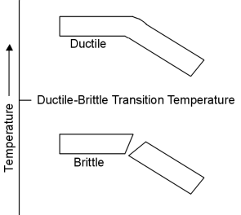
Figure 4: DBT for some metals. A metal can show ductility at high temperatures but be brittle at low (UNSW Sydney 2014).
The DBT is seen in body centered cubic structures, for example low carbon steel, but this tends to happen at low temperatures (Doitpoms.ac.uk 2018). At high temperatures some metals are ductile and can absorb more energy until they fracture. Metals at these temperatures tend to deform first and are resistant to fracture propagation which is known as toughness. At lower temperatures the metal is brittle and thus less energy is absorbed before a fracture can occur. At these temperatures the metal will tend to fracture instantly without deforming and so loses its toughness (Scheide 2018). It is this brittle nature of materials used in oil refineries that is the area of concern in this proposal. Between this high and low temperature, the metal goes from ductile to brittle and this is known as the DBT. DBT can occur over a range of temperatures or happen very suddenly depending on the mechanical properties of the material (Doitpoms.ac.uk 2018).
In Valero, if the equipment is under high stress, which happens during hydro testing, and it is under the MDMT, there is a possibility that the material could fracture if there are any micro defects as it less ductile. This could cause a catastrophic outcome to the plant and workers which could have an economic impact on the company. An example of this was in September 1998 at the Esso natural gas plant at Longford, Australia. An explosion took place as a heat exchanger became brittle after being exposed to considerable low temperatures after a plant failure. The equipment fractured after sudden re-introduction of high temperature service fluids, which resulted in a large amount of gas being released. This found a source of ignition causing an explosion resulting in two fatalities and eight injuries. Esso were prosecuted and heavily fined, and the result of the explosion left a two-week cut in gas supplies in the state (BBC News 2001).
To avoid such an outcome Valero would wait for outside temperatures that are higher than the MDMT and this waiting period can cause shutdowns to take longer than planned. During a shutdown Valero, or any other refinery, is not producing products at a maximum rate as it would normally with all units operating. Therefore, the longer the shutdown period, the more money is lost. For instance, a typical Hydro treater outage has a lost profit opportunity during winter months of $2-3 million.
3.0 Rationale/Relevance of the Project
In Valero there is no known procedure to carry out hydro testing of equipment when temperatures outside or that of the test medium are lower than the equipment’s MDMT. The purpose of this study is to find an effective method of hydro testing during low temperatures to prevent shutdown delays when taking into consideration the MDMT. In addition, alternative materials with a lower MDMT will be investigated as a possible future use instead.
Both investigations will aim to prevent the DBT and the outcome of this will allow Valero to successfully start the units up on time to allow their products to be refined at a maximum rate and meet customer demands.
4.0 Literature Review
The UK has several statutory laws that relate to the health and safety of personnel, to the environment, and plant and equipment during hydrotesting. The pressure systems safety regulations 2000 (PSSR) act looks at preventing serious injury resulting from a failure of a pressure system or one of its components (Hughes and Ferrett 2011). Additionally, there is the pipeline safety regulations 1996 act that states the designing of pipework, along with any modifications to it, should be made safe within its operating conditions as low as reasonably practicable (Legislation.gov.uk 2018). Both acts need to be taken into consideration when researching effective methods and exploring the use of other materials during hydrotesting in temperatures below the relevant MDMT.
To find and consider an effective hydro test method we need to understand what is currently being used in Valero. In addition, to explore the use of different materials we need to look what is currently being used and what past experiment techniques there are to analyze the MDMT and DBT.
4.1 Valero Mechanical Contractors
Currently Valero have Cape plc and Jenkins and Davies Engineering that are contracted to carry out equipment hydro testing after completion of a statutory inspection or repairs. Both companies have written method statements (MS’s) and risk assessments (RA’s) for hydrotesting equipment that have been approved by Valero health and safety officers and operations; these are referenced in the appendices A and B. However, both companies’ MS’s and RA’s fail to mention a procedure to follow if the MDMT of the material is breached. Normally when this happens the Valero coordinator, with the assistance of the inspection engineer, will put the job on hold until temperatures are above MDMT.
Recently an engineering work order had been raised in October 2018 to find the MDMT on several pieces of equipment that are planned for hydrotesting during Valero’s quarter 1 2019 outages. However, this does not address a method for hydrotesting in the event of low temperatures below the MDMT.
4.2 Current materials in Valero and ASME B31.3
When Valero undergoes planned maintenance set engineering standards must be followed when implementing the work scope required. Specifications have been directly generated and designed from referencing ASME B31.3, which is a code of requirements for various plants including the oil and gas industry. Careful referencing and use will allow companies to comply within their relevant jurisdiction (Asme.org 2018).
Referring to figure 5, the average low temperature at Valero Pembroke is about +2 ºC in February (normal shutdown period):
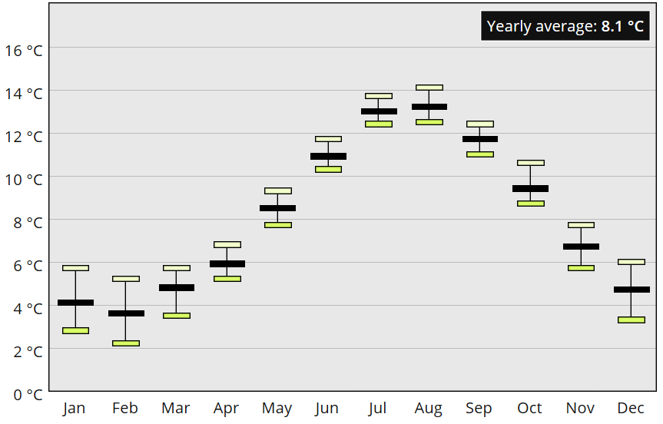
Figure 5: Pembroke’s yearly minimum temperature average from 1981 to 2010 (Metoffice.gov.uk 2018).
The hydro testing of heat exchangers causes Valero a problem around these temperatures of +2 ºC. Figures 6 and 7 show the components of a standard heat exchanger and a visual demonstration of heat exchanging between two products:

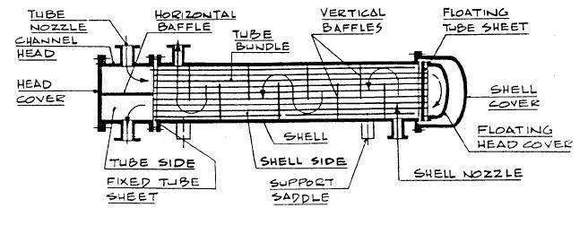
Figure 6: Heat Exchanger components (Piping Engineering 2018).
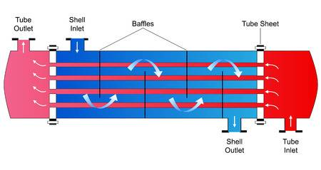
Figure 7: Hot product enters through the tube inlet exchanging heat with the shell product exiting through the tube outlet (123RF 2018).
Appendix C shows a Valero drawing of the 3-E-1’s oil feed effluent heat exchangers. In Valero, heat exchangers have statutory inspections carried out where the components, such as the channel head, are stripped and the tube bundle is pulled. Cleaning and inspection commence at this stage to all components, bundle and shell. If no repairs are required, the exchanger is put back together.
Both the tube and shell side are subjected to a hydrotest afterwards as required by ASME. Jenkin and Davies were at this stage with the 3-E-1’s in the early months of 2018, however they were stopped by Valero in proceeding with a hydrotest because outside temperatures were too low. This can be explained by referencing appendix C and summarizing a few facts in table 1 and figure 8 below:
Exchanger Component | Material | Thickness (inches)
Shell | CS ASTM A515 Grade 60 | 1 $\frac{6}{8}$’’
Table 1: 3-E-1 Shell properties.
Referencing ASME B31.3 the CS used for the shell is A515 grade 60 designed for pressure vessel plates that are in service intermediate or high temperature, with the 3-E-1 shell designed for high temperatures of 399 ℃. This material is suitable for the shell material in service as the 3-E-1’s has hydrocarbon liquid entering the shell inlet at approximately 100 ℃ and exiting the outlet around 315 ℃. However, this material is not suitable for low temperatures which can be explained using figure 8:

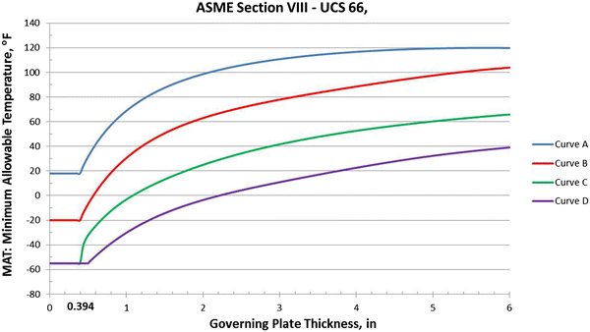
Figure 8: MAT against governing plate thickness without impact testing for various CSs (Benac et al 2018).
ASME B31.3 states that A515 grade 60 lies on curve B in figure 8 and using the thickness of the CS shell we find that 3-E-1 shell MAT (or MDMT) is 15℃ (60 °F). Below this figure the material must have an impact test to analyze the materials fracture characteristics (Banerjee et al 2015) as it now enters the DBT. However, the 3-E-1’s were constructed in the 1970’s and are unlikely to have their shell material changed without good reason due to the significant cost involved. Hence, this is the reason I am proposing a research to find an effective hydro test method. It is important to conclude from figure 8 that the thicker the CS material is the higher the MAT.
As stated previously, Pembroke can have average temperatures as low as +2 ℃ around February time which is -15℃ below the MAT of 3-E-1 shell material. At this temperature the material can be less ductile and less tough, and any small micro defects can result in a sudden fracture of the equipment under high stress. This is the reason behind Valero preventing J & D from carrying out the hydro test at these low temperatures and delaying the work until temperatures were higher than the MAT. These exchangers will be having maintenance again in next year’s HTU1 catalyst change out outage during January/February 2019 at a time when temperatures are low. This in turn could delay completion of the shutdown if temperatures continue to be low for the whole event unless an effective method of hydro testing can be researched that can aid this.
4.3 Ductile to Brittle Transition Experiments
4.3.1 Charpy Impact testing of Mild Steel (Sutar et al 2014)
The Charpy impact test is a well-known procedure to determine the DBT of a material and can be used as an experiment for investigating use of alternative materials. It was used by Sutar et al to look at the critical DBT of mild steel, where the material would lose all its ductility and becomes brittle. The steel (specimen) was prepped with a 2mm in depth notch with an angle of 45⸰ and set up in the Charpy impact test as show below:
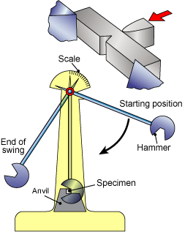
Figure 9: Charpy test layout with the notch in the specimen (TWI 2018).
In addition, the Charpy test used in this experiment had the specifications shown in table 2:

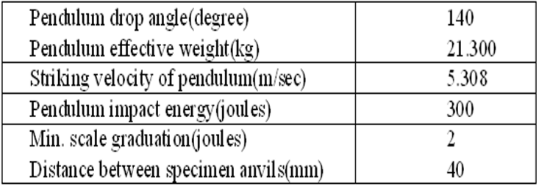
Table 2: Specifications of the Charpy test used by Sutar et al (2014).
The specimen was soaked in liquid nitrogen prior to testing for ten minutes to obtain a low temperature and positioned in the Charpy set-up with the notch facing away from the hammer. For several temperature readings the hammer would be released, impacting the specimen and fracturing it in the progress. From the gauge, the value of the impact energy absorbed that causes the fracture of the specimen was recorded. From this a graph of the specimen temperature against impact energy absorbed was generated and used to determine the DBT. The results of the experiment are shown in figure 10:
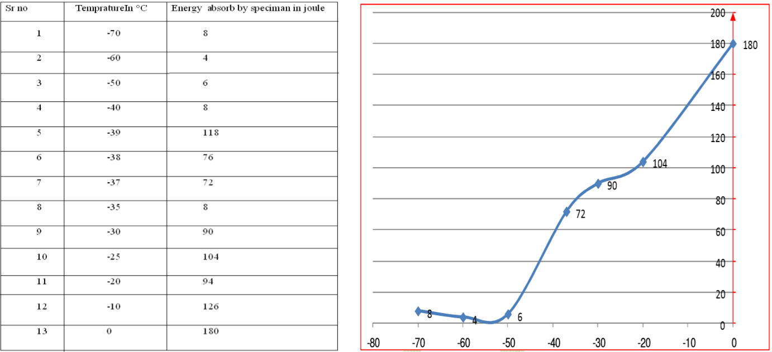
Figure 10: Results of temperature of the mild steel against the energy absorbed by Sutar et al (2014).
Sutar et al concluded from these results that the critical DTB temperature of mild steel was between -90℃ to -80℃.
The Charpy test has its advantages argued by Melo Moura et al. (2009) as it is fast to set-up and analyze the quality of the specimen. However, Melo Moura et al continues to state the disadvantages of the test as it does not take into consideration and calculation of the specimen being used in the relevant service. In addition, the Charpy test depends only on the specimen’s characteristics affecting the DBT but we know that this would be dependent on other parameters. Lastly, the notches and strain rates used in the Charpy test would usually not be seen in equipment used in service when they fail and fracture. Due to this, Melo Moura et al decided to look at alternative analyzation of the DBT using the traditional Charpy test.
The Charpy test would not benefit investigating an effective hydro test method as the equipment I’m looking into is already in service, but it can used for a quick evaluation when considering alternative materials.
4.3.2 Evaluating DBTT in Steel Low Carbon (Melo Moura et al 2009)
Melo Moura et al used five different methods to analyze and determine the DBT in steel low carbon ABNT 1016 using the Charpy test. These were lateral expansion, load diagram, shear fracture appearance, the average between lower and upper shelf, and master curve. The master curve uses Weibull probability statistics in determining of a material failing.
All five methods had difficulties in measuring the DBT as results were different to one another. In addition, Melo Moura et al concluded that the DBT differed depending on the direction of the impact that was either longitude or transverse direction. If I’m proposing an alternative material to Valero for future use in exchangers, I would need to know a precise answer of the DBT. Based on the different results I would use an alternative method in determining the DBT with the use of simulations.
4.3.3 Determining DBT using simulation models (Scheide 2018)
Scheide look at determining the DBT for artic applications using several simulation models to avoid the use of laboratory testing. Models included the Gurson RKR model used to identify cleavage fracture initiation and Weibull Beremin to analyze ductile damage and to calculate the probability of brittle failure through the DBT. Both models were then combined to generate a DBT simulation and were also used by Linse, Kuna and Viehrig (2014).
Scheide successfully used this simulation to show fracture geometrics and obtaining the fracture toughness through the DBT. However, Scheide recommended that this combined model does not agree with the weakest link principles in the Beremin model and thus does not completely alleviate any laboratory work being done. As both Scheide, Linse, Kuna and Viehrig used these models and were relevantly successful, I will use them with their recommendations and compare the data with my own simulation. I can then propose with confidence an alternative material to Valero to use instead of A515 grade 60 for 3-E-1’s.
5.0 Research Methods
My research is to produce a simulation of the 3-E-1’s during hydro testing using SolidWorks and analyzing quantitative data. The same 3-E-1’s design and materials will be implemented into this simulation and will be situated in low outside temperatures. I will be introducing the hydro test medium at the same temperature as the outside without applying pressure but instead circulating this medium through a hot water generator to produce a simulation like figure 11 below:
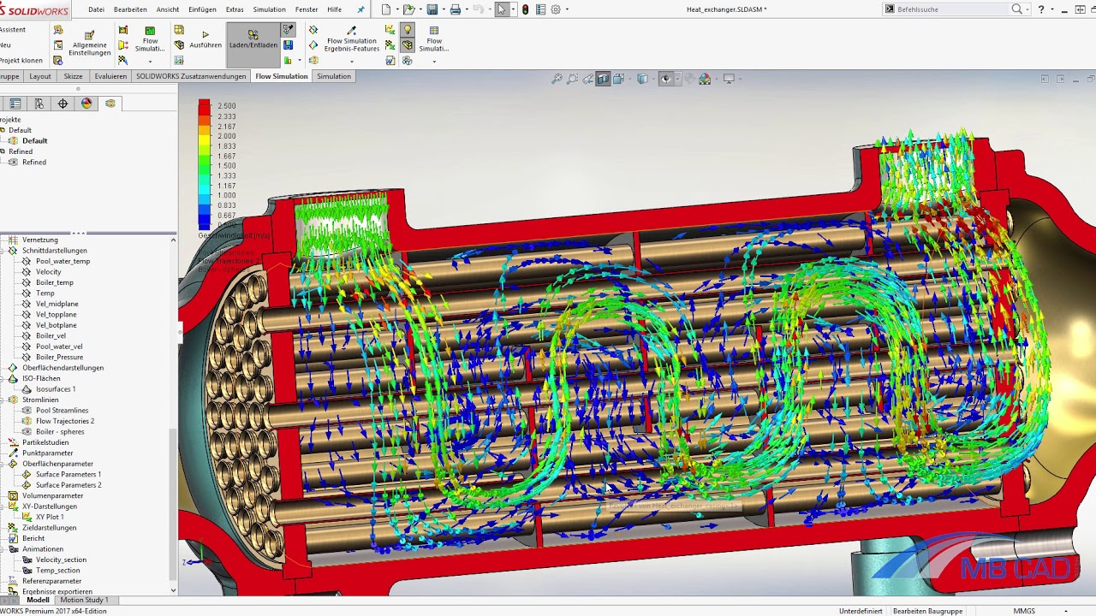
Figure 11: Flow simulation in SolidWorks (MA CAD GmbH 2018).
The medium will have the temperature increased in stages by +0.5 ℃ through the generator until the exchange shell and components are at that same temperature. At each +0.5 ℃ interval the stress analysis of the exchanger will be examined and recorded. The temperature of the water and components will be raised to a final temperature and then hydrostatic test applied for one hour. The temperature of the hydro test medium and components will be recorded in one-minute intervals to see if the MDMT is breached during hydro testing and the stress analysis recorded on the exchanger.
This procedure will be repeated at various final temperatures to determine the optimum temperature before proceeding with the hydro test. All data will be analyzed using graphs, and after completing the simulation this will be used in the field as a trail to evaluate its effectiveness. Temperature transmitters and pressure gauges installed on the equipment have regular calibration checks, therefore I will use these to record data in this research. If successful, this method can be implemented into the MA’s and RA’s used for hydro testing in Valero.
The same simulation can then be repeated to investigate the use of alternative materials analyzing stress and DBT of the material. I would investigate materials that lie on either curve C and D on figure 6 as these have lower MAT in general when compared to curve B, but would need to analyze if they can withstand the design temperature and pressure of the 3-E-1’s. In addition, I would also investigate use of a combination of materials using my simulation and compare it to the models of Sutar et al, Scheide, Linse, Kuna and Viehrig.
In all simulations I will incorporate micro defects and inhomogeneities as deformation of these causes’ fractures in the material (Linse, Kuna and Viehrig 2014). This would be the only way to see if a brittle fracture occurs in a simulation.
Ethical Considerations
It is important to keep all of Valero’s drawings and other data confidential. All research methods will abide to the health and safety laws mentioned previously in this proposal as well as abiding to the ASME code for pressure testing. All data will be repeated to avoid misrepresenting results and to be informed to the client. The research will be carried out such that it is not biased or deceives any personnel. The use of any materials will be referenced accordingly upon the research report.
Work Plan
A work plan and set milestones to ensure I am on schedule hitting key targets is shown below:
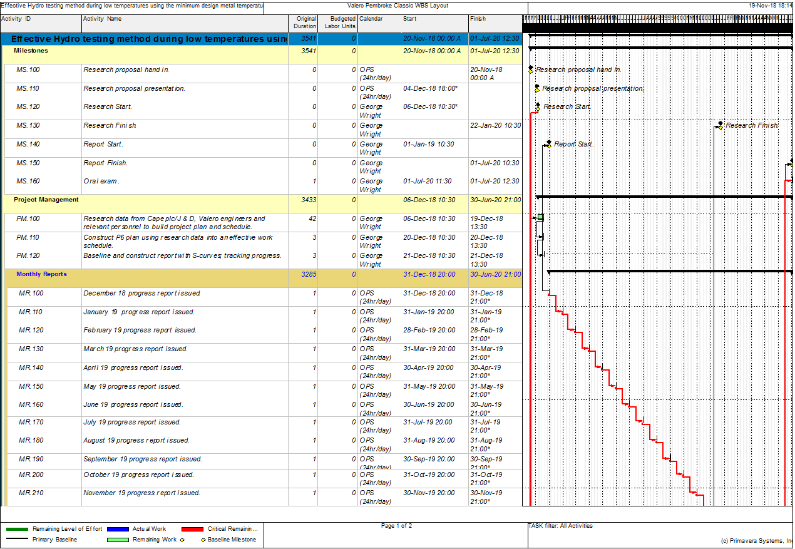
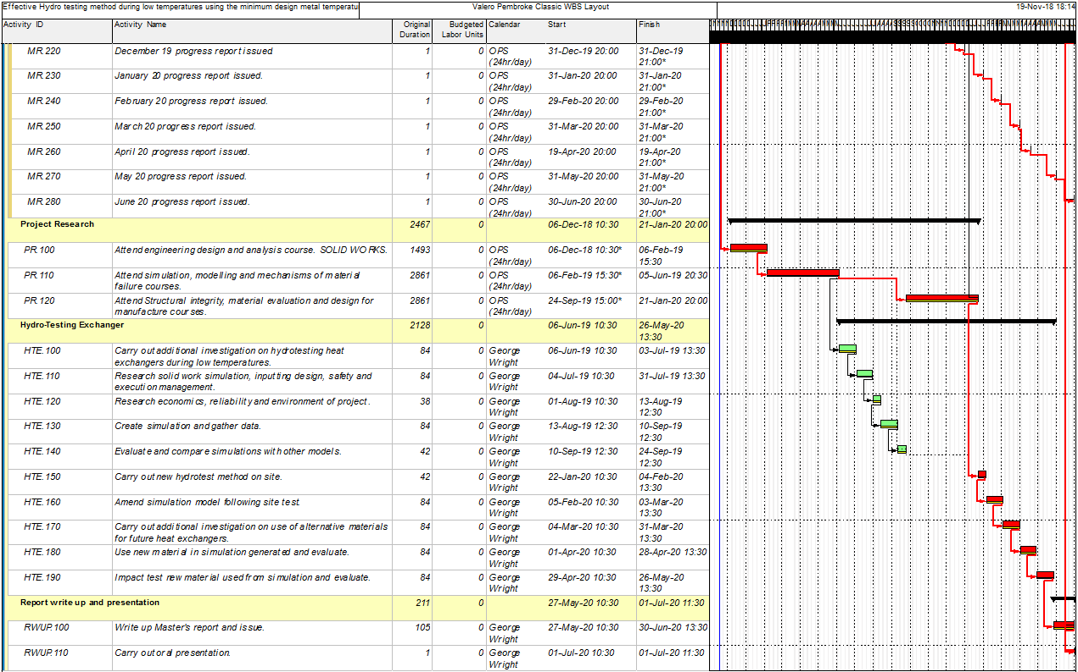
Figure 12: Project plan and schedule.
A constraint to the work plan will be enforcing the alternative method at Valero during an outage.
Budget
The only budget required for this proposal is when this alternative method is used at Valero when the unit will be offline, and several personnel need to carry out the hydro testing.
Conclusion
Carrying out this research will resolve delays in Valero outages from hydro testing that will result production commencing on time. Not only will this benefit Valero Pembroke but their other refineries and other companies with similar operational equipment. I have excellent problem-solving skills to carry out this investigation and I am confident that I will find a solution to both issues I have expressed in this proposal.

References
123RF (2018). Stock Photo - Shell and Tube Heat Exchanger. [image] Available at: https://www.123rf.com/photo_39572945_shell-and-tube-heat-exchanger.html [Accessed 10 Nov. 2018].
Asme.org. (2018). ASME - STANDARDS - Process Piping. [online] Available at: https://www.asme.org/products/codes-standards/b313-2016-process-piping [Accessed 2 Nov. 2018].
Banerjee A, Dhar S, Acharyya S, Datta D and Nayak N 2015. Determination of Johnson cook material and failure model constants and numerical modelling of Charpy impact list of armour steel. Materials Science & Engineering A, [online] 640, pp.200-209. Available at: https://ac-els-cdn-com.ezproxy.uwtsd.ac.uk/S0921509315300228/1-s2.0-S0921509315300228-main.pdf?_tid=79652092-7ee0-412b-889a-12099421e598&acdnat=1541932440_c9b45dc6a46a9bcbff59d19a456865d2 [Accessed 11 Nov. 2018].
BBC News 2001. Esso fined over fatal explosion. [online] p.1. Available at: http://news.bbc.co.uk/1/hi/world/asia-pacific/1464123.stm [Accessed 2 Nov. 2018].
Benac D, Cherolis N and Wood D 2018. Managing Cold Temperature and Brittle Fracture Hazards in Pressure Vessels. [image] Available at: https://link.springer.com/article/10.1007/s11668-015-0052-3 [Accessed 11 Nov. 2018].
Bijvank M 2004. A practical approach to handle shutdowns at refineries. Master thesis in Business Mathematics and Informatics. Vrije Universiteit Amsterdam.
Doitpoms.ac.uk 2018. DoITPoMS - TLP Library The Ductile-Brittle Transition - Ductile-to-brittle transition. [online] Available at: https://www.doitpoms.ac.uk/tlplib/BD6/ductile-to-brittle.php [Accessed 3 Nov. 2018].
Hughes P and Ferrett E 2011. Introduction to health and safety at work. 5th ed. Amsterdam: Butterworth-Heinemann/Elsevier, p.558.
Legislation.gov.uk 2018. The Pipelines Safety Regulations 1996. [online] Available at: http://www.legislation.gov.uk/uksi/1996/825/contents/made [Accessed 2 Nov. 2018].
Linse T, Kuna M and Viehrig H 2014. Materials Science & Engineering A. Quantiﬁcation of brittle-ductile failure behavior of ferritic reactor pressure vessel steels using the Small-Punch-Test and micromechanical damage models, [online] 614, pp.136-147. Available at: https://ac-els-cdn-com.ezproxy.uwtsd.ac.uk/S0921509314008946/1-s2.0-S0921509314008946-main.pdf?_tid=5aa29a9c-164c-4025-aef7-987a6340dc93&acdnat=1542378928_ed98f69c2c4010602ad68144a7e497ef [Accessed 16 Nov. 2018].
MA CAD GmbH 2018. SOLIDWORKS FLOW Simulation: Wärmetauscher. [image] Available at: https://www.youtube.com/watch?v=YV1rwRu8t4Yhttps://www.youtube.com/watch?v=YV1rwRu8t4Y [Accessed 13 Nov. 2018].
Melo Moura C, José Vilel J, Giovani Rabell E, Paula Martin G and Gonçalves Carneir J 2009. Evaluation of the ductile to brittle transition temperature in steel low carbon. [online] Rio de Janeiro: International Nuclear Atlantic Conference. Available at: https://inis.iaea.org/collection/NCLCollectionStore/_Public/40/106/40106396.pdf [Accessed 30 Oct. 2018].
Metoffice.gov.uk 2018. Pembroke climate information - Met Office. [online] Available at: https://www.metoffice.gov.uk/public/weather/climate/gchtbqcc9 [Accessed 2 Nov. 2018].
Piping Engineering 2018. Design Guide For Heat Exchanger Piping. [image] Available at: http://www.piping-engineering.com/heat-exchanger-piping-design-guide.html# [Accessed 10 Nov. 2018].
Process piping B31.3 2016. American Society of Mechanical Engineers, pp.47-50.
Scheide H 2018. Complete Simulation Models to Describe the Ductile-to-Brittle Transition of Steels for Arctic Applications. Master of Science in Mechanical Engineering. Norwegian University of Science and Technology.
Stribling R 2018. Chemistry 1010-013. [online] Richard Stribling's Eportfolio. Available at: https://richardstribling.weebly.com/chemistry-1010-013.html [Accessed 2 Nov. 2018].
Sutar S, Kale G and Merad S 2014. Analysis of Ductile-to-Brittle Transition Temperature of Mild Steel. Novatear Publications, [online] 1(1). Available at: http://oaji.net/articles/2014/1511-1419830589.pdf [Accessed 28 Oct. 2018].
TWI 2018. What is Charpy Testing. [image] Available at: https://www.twi-global.com/technical-knowledge/faqs/faq-what-is-charpy-testing/ [Accessed 2 Nov. 2018].
UNSW Sydney 2014. Ductile to Brittle Transition. [image] Available at: http://www.materials.unsw.edu.au/tutorials/online-tutorials/2ductile-brittle-transition [Accessed 2 Nov. 2018].

Appendix A
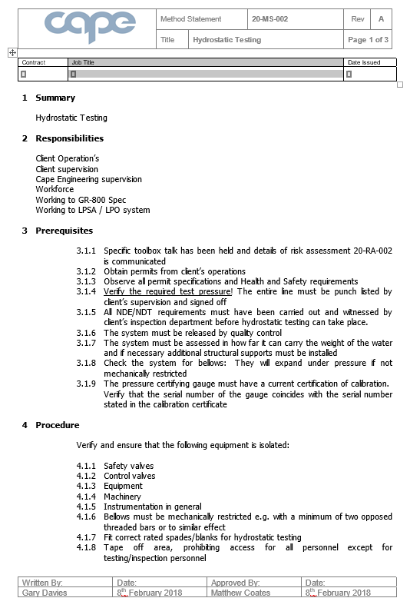
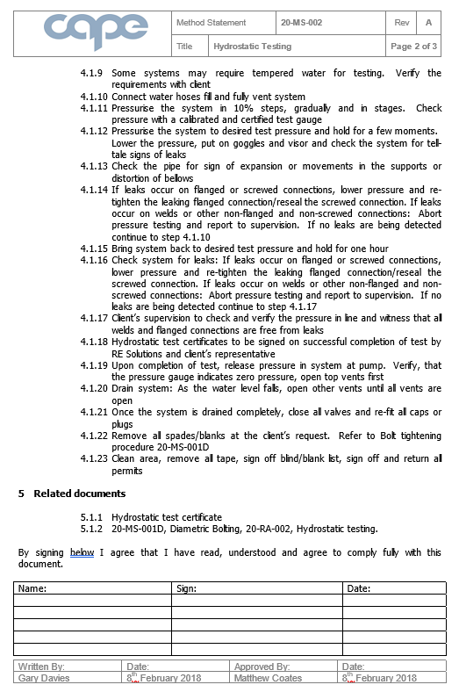
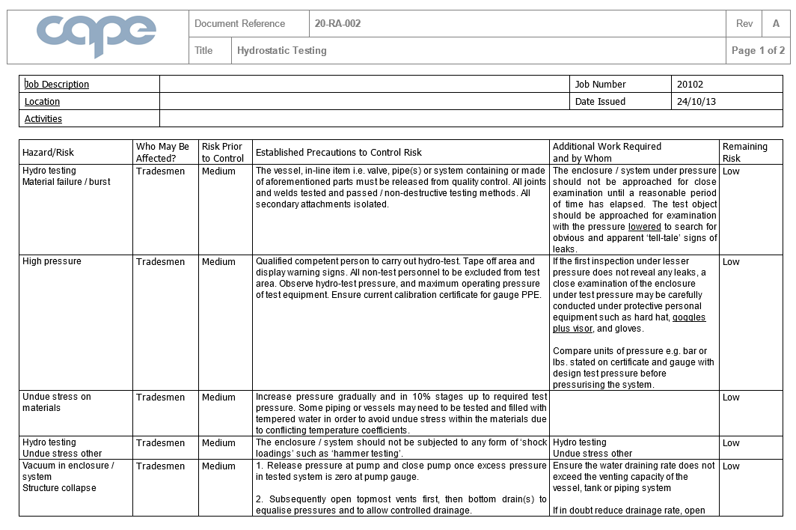
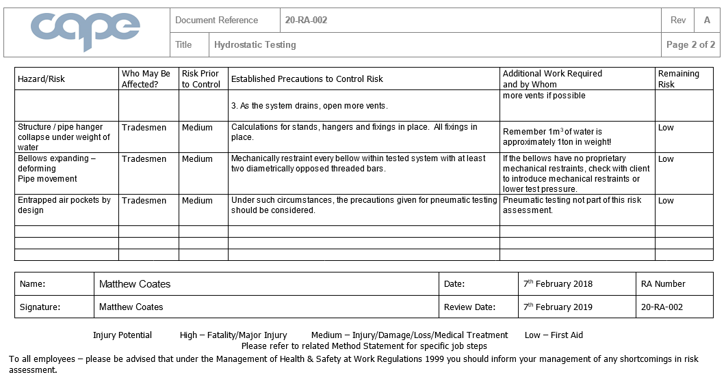

Appendix B
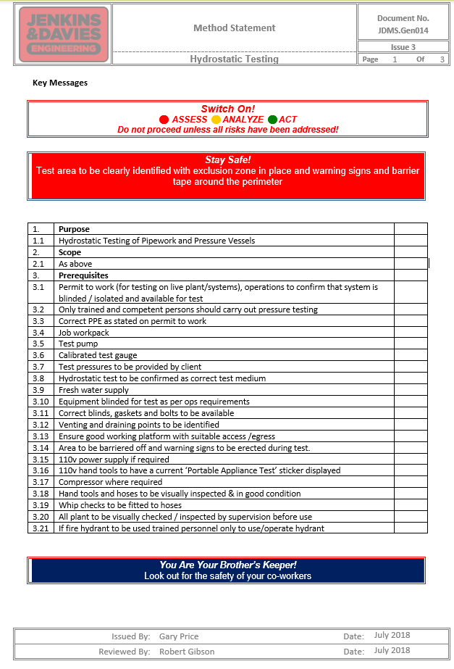
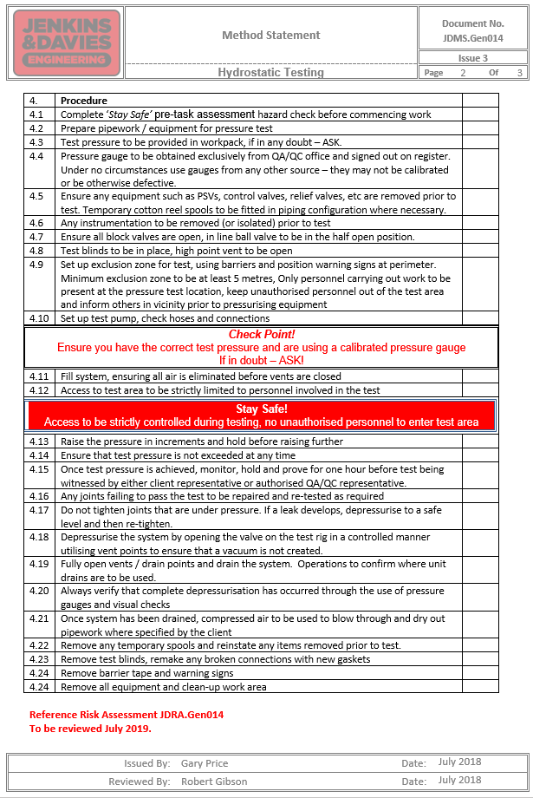
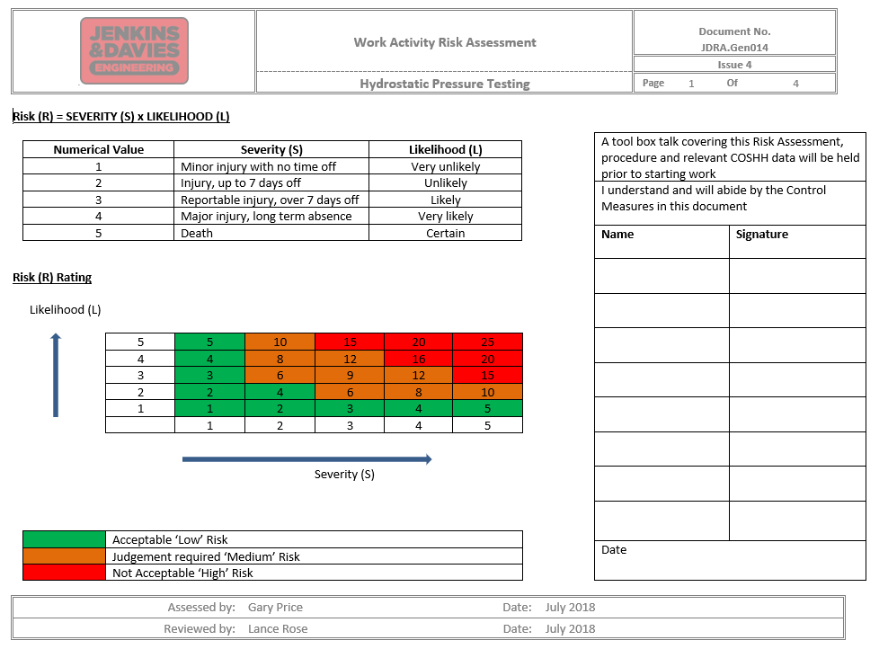
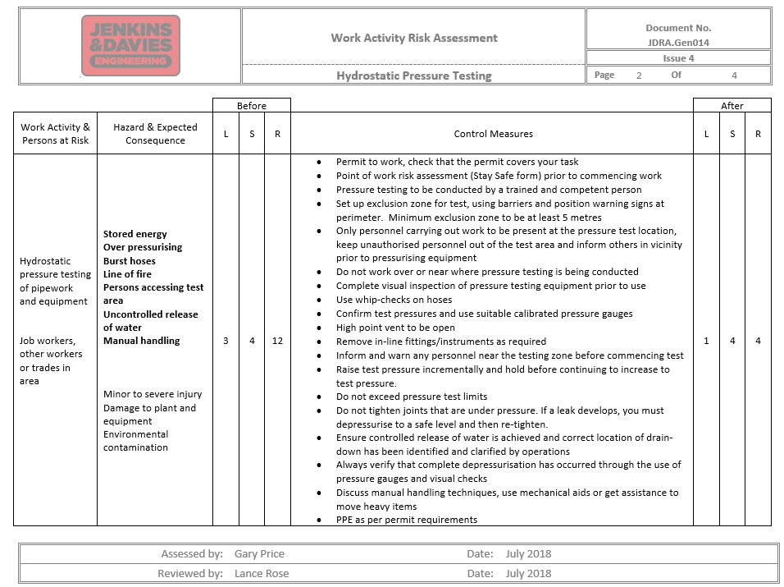
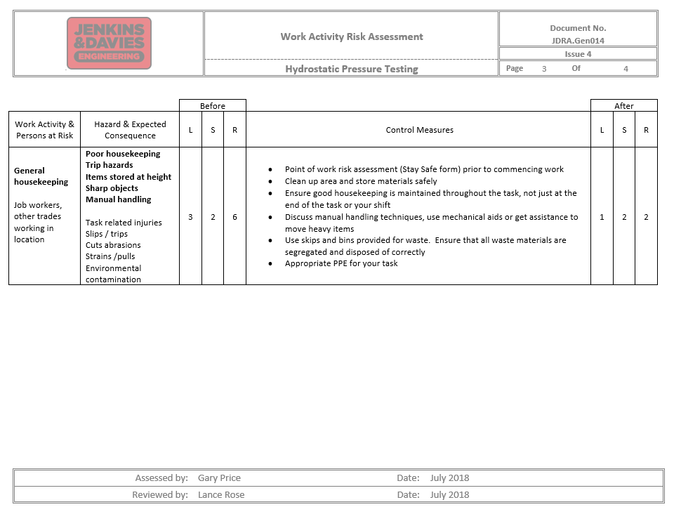

Appendix C


