

University of Wales Trinity Saint David
UWTSD

BEng Energy and Environmental Engineering

Oliver R D Turner
1805585

Environmental Engineering and Sustainable Energy
Application of Computer Aided Engineering Processes
ACMA6010

January 2024

Contents
Introduction 3
The CAE Process 3
Validation 4
Validation Example 5
Main Experiment 9
Outline 9
Engineering Data 9
Rigid Dynamics 10
Steady-State Thermal 11
Static Structural 12
References 14

Figure 1: Composition of a Bimetallic Strip. 5
Figure 2: Properties of example Bimetallic strip. 5
Figure 3: Basic assembly of Bimetallic Strip. 6
Figure 4: Constraints and Meshing for Bimetallic strip. 6
Figure 5: Validation example at 100C. 7
Figure 6: Validation example at 122C. 7
Figure 7: ANSYS Workflow 9
Figure 8: Engine Assembly. 10
Figure 9: Piston Thermal Boundary Conditions 11
Figure 10: Thermal results with large unit error. 11
Figure 11: Thermal results as used. 11
Figure 12: Deformation of Piston. 12
Figure 13: Equivalent Stress of piston. 12
Figure 14: Custom mesh sizing for more precise results. 13
Figure 15: Around Gudgeon. 13
Figure 16Around oil ring 13

Introduction
Computer aided Engineering (CAE), is a method of computer driven analysis, employed for refining 3D objects typically created via Computer aided Design (CAD). CAE allows evaluation and testing of parts within computer simulations in order to predict their physical performance without needing to spend the time, resources and money to create them in real life, in order to conduct the same tests on prototypes.
There are two main fields of CAE. Finite Element Analysis (FEA) and Computational Fluid Dynamics (CFD).
According to (Belegundu and Chandrupatla, 2022), FEA is a simulation method for analysing and calculating changes in stress, heat and fluid flow and resonance, among others. There are many different approaches to solving FEA simulations, as there are many different things it can do. Some examples of these methods are Energy and Galerkin approaches, where elasticity and heat conduction can be calculated; Gaussian Elimination, for matrix transformation of linear equations (simplified equations via estimation); One dimensional Elasticity, which simulates the linear elastic behaviour in single dimensions by using Hooke’s Law. These methods among many others are applied to different solvers depending on the information given and required. These solvers can then be combined together, by feeding results into the set up of the next test, to ascertain a picture of a wider system, either linearly or non-linearly.
CFD operates in a similar way, however the Navier Stokes equations are generally used in order to predict fluid flow around objects. This enables simulations to approximate interactions between solids and gases, preliminary fluid flow characteristics.
The examples in this report will focus on FEA.
This report will discuss the advantages and disadvantages of CAE, as well as go through one validation example, which will compare software (“ANSYS”) performance to a known analytical solution in order to show how accurate, or inaccurate the software can be. The report will be cantered around a structural test which uses simulated kinematic and convection data to show how different software solvers can be linked together in one test scenario. As this simulation is completed, the report will discuss some of the pitfalls within the software, how these can affect the results or cause them to fail entirely, and how they can be avoided.

The CAE Process

Validation
If a computational simulation can not be trusted to yield reliable and accurate results, it is not a valid method of testing. In order to be useful, the data must be trustworthy. In the emergence of mainstream CAE software use in the early 2000s, (Babuska, 2004) asks "can computer predictions be used as a reliable bases for crucial decisions? How can one assess the accuracy or validity of a computer prediction? What confidence can be assigned to a computer prediction of a complex event?" and then states that the Validation and Verification process is that in which these questions, among many others are answered. Since before this paper right up to the present day, academics and engineers have been working to give definitive answers to these questions and with increasing computational power, the simulations become more accurate as more and more nodes can be calculated to more and more decimal places.
As more nodes and calculations are included in a simulation, it would seem obvious that the Accuracy would improve due to the fact that the simulation is more precise. This however is not always the case. This is due to the fact that millions of equations have to be completed for each simulation. It is not possible to complete these equations to an unlimited number of decimal places as for now at least, computational power is limited. Due to this, each equation may have its own slight rounding error. Over millions of equations, these tiny errors can compound, causing a much larger error. This can be seen often when using extremely small mesh sizes. This will be discussed further during the meshing section of the simulation example. The following is an example of a validation experiment, comparing a result on ANSYS with a known analytical problem. When comparing the simulated result to the analytical result, some influences will be discussed about how a result may be influenced.

Validation Example
In order to prove that Simulated results computed by ANSYS are a true representation of real-world physics, a validation example has been conducted and documented. A validation example is a known experiment with analytical results to compare the simulation results with. This will result in showing a percentage error which will show the actual difference between the results.
An analytical experiment was conducted by (Young, 2011) in which the maximum deflection (u) of a bimetallic strip was calculated from base principles.
A bimetallic strip is a simple mechanical device consisting of two materials with different thermal expansion properties. They are bonded together so when subjected to a thermal load, the two materials expand at different rates meaning the object will flex in a predictable direction. An example of where this is useful is in a kettle, when the water boils, the steam causes a bimetallic strip to deflect, hitting a switch and cutting power to the heating element.
For this experiment, a bimetallic strip is said to be comprised of half copper, half Invar, and fixed on the left side as shown in figure 1.
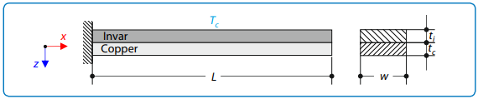
Figure 1: Composition of a Bimetallic Strip.
The material properties and material dimensions are shown in figure 2. Self-weight is neglected.
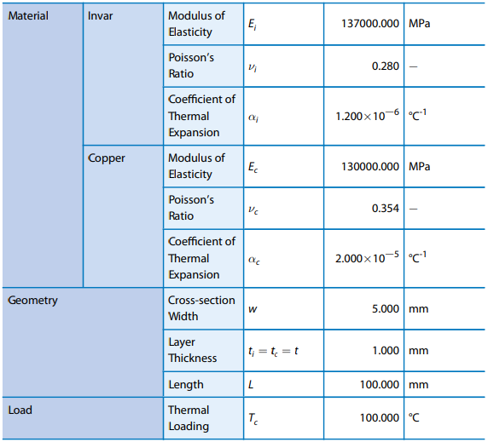
Figure 2: Properties of example Bimetallic strip.
As shown under “Load” in the last row, the bimetallic strip is subjected to a temperature rise of 100C. The deflection is then calculated by Young with the following equation and solution.
$$\text{u=}\frac{\text{6(}\text{α}\text{i}\text{ - }\text{α}\text{c )(t }\text{i}\text{ + t c )Tc}}{t_{s}^{2}\text{ K}}\frac{ {\text{L}}^{\text{2}}}{\text{2}}\text{≈ -7.049 mm. }$$

The experiment was then repeated in ANSYS by first modelling the bimetallic strip in the Solidworks CAD platform. A simple rectangle was extruded to the required dimensions and mated to another the same. No materials are allocated as this can be done more accurately in ANSYS. Some part and assembly files can cause issues with certain CAE Solvers, so all files are saved in the .STEP format as these are usable with the majority of FEA Solvers within ANSYS.
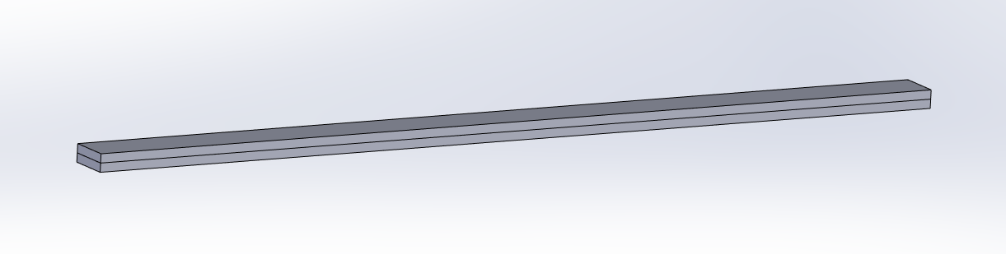
Figure 3: Basic assembly of Bimetallic Strip.
For this example, a static structural study is adequate as we only want to apply one temperature and analyse deflection. If more than one temperature was required, it was to be applied linearly or the temperature was not to be applied to the entire part, a static structural study would not be suitable and would first need to be subjected to a thermal study. This will be shown in the main experiment.
As material properties are provided for the experiment and are not extensive, the materials were created rather than imported, to ensure they match the exact material properties of the analytical solution. This is done in the engineering data Solver in ANSYS, there is an engineering data section of the Static Structural Solver which may be used in this case. If more than one Solver is used in conjunction, this may cause data input issues (See Engineering data section of main Experiment).
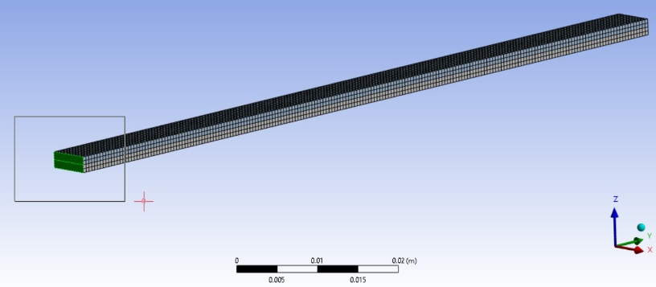
Once the assembly has been imported into ANSYS Mechanical it is important to ensure that the part is adequately constrained, is set to flexible or no deflection will be possible, and material choices are allocated correctly. Automatic contacts are generated between the two parts as they were imported as an assembly. In this case it has the two materials bonded together correctly; this should, however, always be checked as the software does not always guess the user’s intentions correctly. In order to constrain the part, a fixed joint is allocated on the left end. This joint will then be treated as solidly fixed, and the rest of the model will deform about this point. If the model is not confined in some way once any load is applied the forces can just move the part rather than subjecting them to deformation. This can cause a result that is magnitudes larger or smaller than the analytical solution as the part simply moves through free space. it must be discretized. This means it is broken down into a series of nodes. The more nodes, the more data points. This works like a coordinate system where each data point can be compared with the ones around it in order to calculate deflection from point to point. For a simple shape such as this, a square mesh used as it is capable of representing this simple shape fully. For more complicated shapes, objects may be broken down into triangles to better represent the shape. For this particular object, a mesh size of 0.5mm is set as this is half the thickness of each part in the assembly. This will give a reasonable information density while not taking too long to calculate. In figure 4, the mesh can be seen as well as the fixed constraint in green on the left.
Figure 4: Constraints and Meshing for Bimetallic strip.

A thermal condition is set at 122C. Here lies one of the main pitfalls of CAE software. They have default setting built into them which must be considered to produce valid and accurate results. In this case, ANSYS has a default temperature setting of 22C. Therefore, 100C must be added to this figure. If the temperature for the experiment is set at 100C, the temperature step is only 78C. Figure 5 shows the simulation when ran at 100C and figure 6, on the right, shows the simulation ran at 122C. This is a clear example of the massive affect that operator error can have on the outcome of an experiment. The experience of an operator is one of the most important variables to the accuracy of a simulation, as with experience, comes knowledge of what has gone wrong in the past, and how it is accounted for.
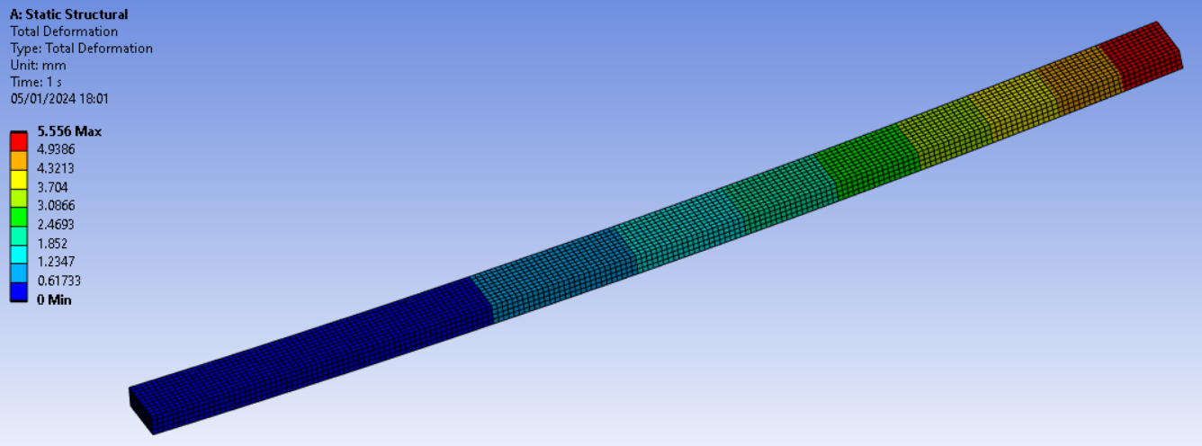
Figure 5: Validation example at 100C.

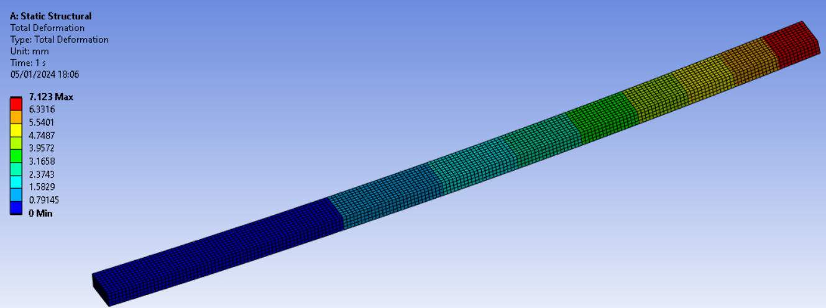
Figure 6: Validation example at 122C.
When the simulation is conducted at 100C, the deflection is calculated at 5.556mm. This is a percentage error of 26.87%. Luckily, when the mistake is this considerable, it is quite easy to spot. When errors are smaller, it can be hard to work out why the variance is present.
When the simulation is conducted at 100C, the deflection is calculated at 7.123mm. Note that the deformation is given as a positive, not a negative figure. The deflection is still accurate but without a negative deflection defined. The percentage error is now 1.04% which is much smaller but still notable at over 1%. With a larger mesh size of 1mm, the error became slightly worse and when the mesh size is reduced to 0.25mm, the error drops to 1.02% which shows that mesh independence has not been reached. This is the point at which mesh size stops having an effect on the results or begins to make them worse due to compounding rounding errors. On the setup available in this experiment, a mesh size mush smaller than this caused the computer to crash, showing that smaller mesh size has a large affect on computational power demand.
There are many factors that could influence this result, it is also hard to verify percentage error. More experienced operators are likely to be able to achieve considerably more accurate results. For the sake of this experiment, barely outside of 1% error can be considered a success. The reasons for this error could be attributed to the mesh, they could be to do with the solver type, it may be that a more accurate result could be ascertained via sequential temperature and structural solvers. It may be simply something not considered. In this ANSYS simulation, the self-weight of the object may be considered without the operator realising or simply, the compounded rounding errors may just be too high to obtain 100% accurate results.

Main Experiment

Outline
A Piston within an internal combustion engine is subjected to multiple forces, pressures and temperatures. Calculating the interactions between these by hand would take an incredibly long time. Using ANSYS, piston performance can be estimated so it can be very close to its desired performance characteristics before it is manufactured/ prototyped. In this Simulation we will use a Kinematic Solver to model the rotation of the engine, convective heat will be mapped through a Steady-State Thermal Solver and then the results of these are to be combined with cylinder pressures in a Static Structural Solver. Figure 7 shows the ANSYS workflow that will be used, with the 3 solvers (B, C and D) as well as separate engineering data that will be used for all 3.
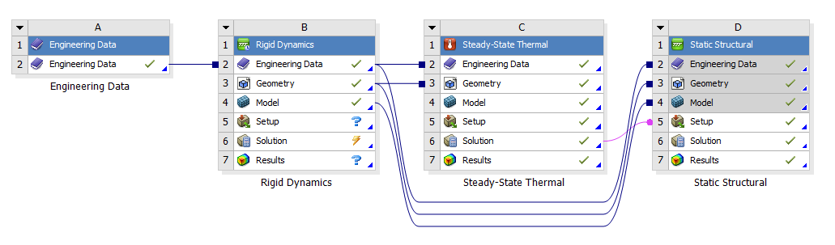
Figure 7: ANSYS Workflow

Engineering Data
Separate Engineering Data is useful when using multiple Solvers in Conjunction. This is because in Solver specific Engineering Data, only material properties which that specific solver can use, can be stored. By using a separate Engineering Data, all material properties can be stored. Once they are linked to a solver, the useful ones will then be extracted for use.
The relevant material for this experiment (6061 Aluminium T6) is taken from a materials database called Granta. The default material for ANSYS is structural steel. It is still possible to make custom materials when linking multiple Solvers, when material properties are well known, they can be brought in from a 3rd party source. However, when doing this, other issues can be caused by any discrepancy in Data or format. An issue occurred during this experiment where non-linear material properties were included in the material package. As these were included, non-linear effects were automatically enabled in the static structural study, which means inertia relief was not able to be activated within the analysis settings. This means the experiment would not run or crashed.
Components other than the piston were left as structural steel as they are not being analysed. It is important to ensure the material is correct within the components section of every Solver going forward.

Rigid Dynamics
A rigid dynamics study is used to model the Kinematics of an engine and apply loads to the piston. A crankshaft, Connecting Rod, Gudgeon Pin and the Piston itself were connected with revolute joints, as they would operate within an engine, to constrain them in all but one axis. The assembly must be constrained to the ground, this was done with a revolute joint to a Crankshaft Journal. To allow the piston to reciprocate, a general join was creating allowing it free movement in one axis, if this was not constrained with whole piston would spin with the crankshaft. Using the Crankshaft to Ground Revolute joint, a rotational velocity is applied. A joint probe is taken within the Pison/ Gudgeon Pin Joint and the maximum force is logged for use in the Static Structural test.
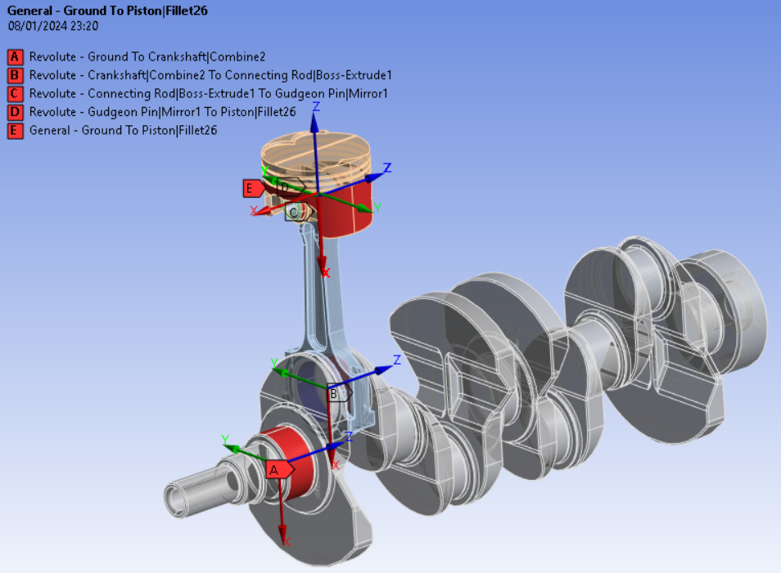
Figure 8: Engine Assembly.

Steady-State Thermal
Only the piston is needed going forward, the other components are supressed. Convection values are applied to the piston as follows.
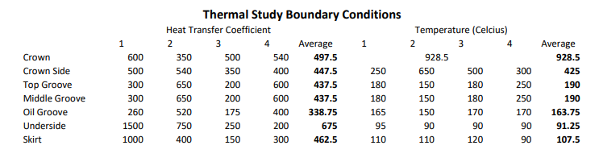
Figure 9: Piston Thermal Boundary Conditions
For thermal studies, the part must me discretised. In the mesh settings, a size of 4mm (4e-003) is selected. Depending on the results, it may be advantageous to alter this size, ensuring all transitions are smooth.
Another pitfall to watch out for are units. ANSYS was set to use mm rather than M. In doing this the heat transfer coefficient units were also changed. The following example shows the importance of the operator ensuring accurate units. Due to the change of units, 497.5 W/M^2 became 497500000 W/M^2. Figure 10 shows the results of the error, while Figure 11 shows the actual result. In figure 10, it is clear that a maximum temperature of 3770C is not possible from an input of less than 1000C.
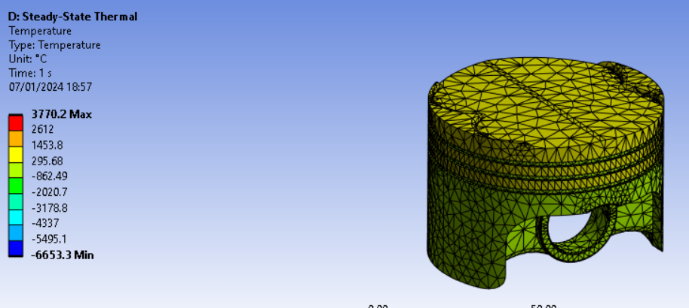
Figure 10: Thermal results with large unit error.
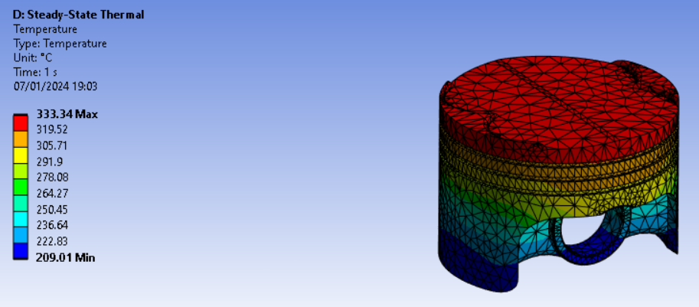
Figure 11: Thermal results as used.

Static Structural
The final part of the simulation is the static structural study. The Joint probe from the Rigid Dynamics study and the temperature data from the Steady State Thermal are inserted as imported loads to be used. The Piston must be set as a flexible part for this Solver in order to calculate Deformation and Strain.
The Mesh is set to the same as the previous at 4mm. In analysis settings, weak springs are enabled. These hold the object in place, so solid constraints aren’t needed. With Kinematics however, the forces cannot be contained by the weak springs, so inertia relief is needed. As inertia relief had been disabled due to the issue defined in the Engineering data section, the experiment failed. Without Inertia relief the part did not stay still enough for the experiment to complete. This is not needed when a part is fully constrained, however. To constrain the piston, the place its constrained in the real world is by the Gudgeon Pin. If it is constrained here then this area will experience no deformation, rendering the experiment pointless.
Shown are the final results for Deformation and Equivalent Stress.
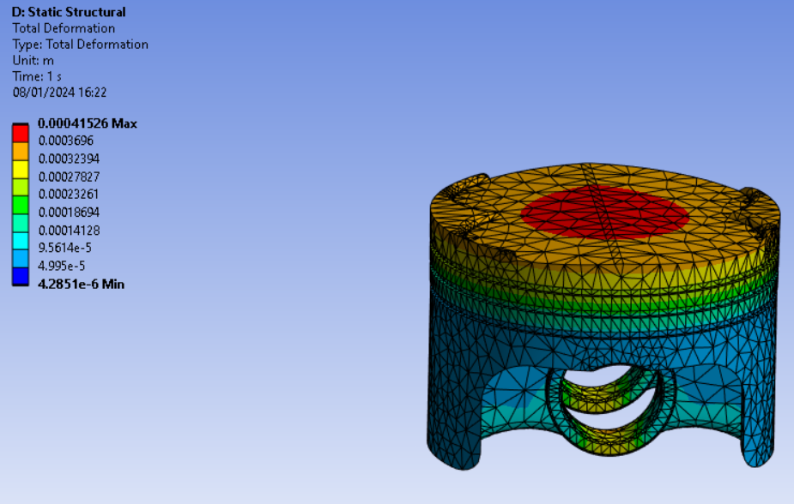
Figure 12: Deformation of Piston.
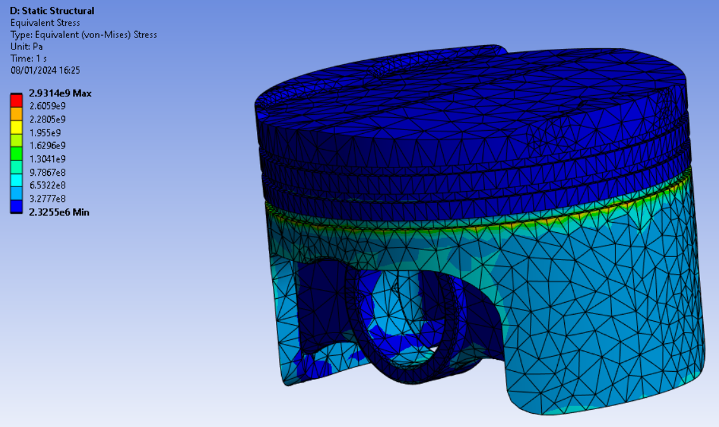
Figure 13: Equivalent Stress of piston.

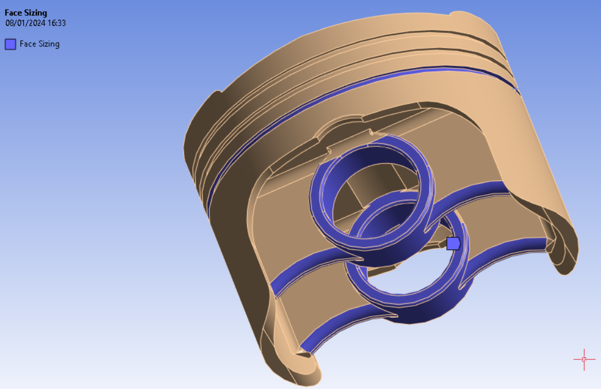
Figure 14: Custom mesh sizing for more precise results.
(0.5mm on stress points around Gudgeon Pin)
It was obvious that the results were jagged so a second run was completed with finer mesh around key areas.
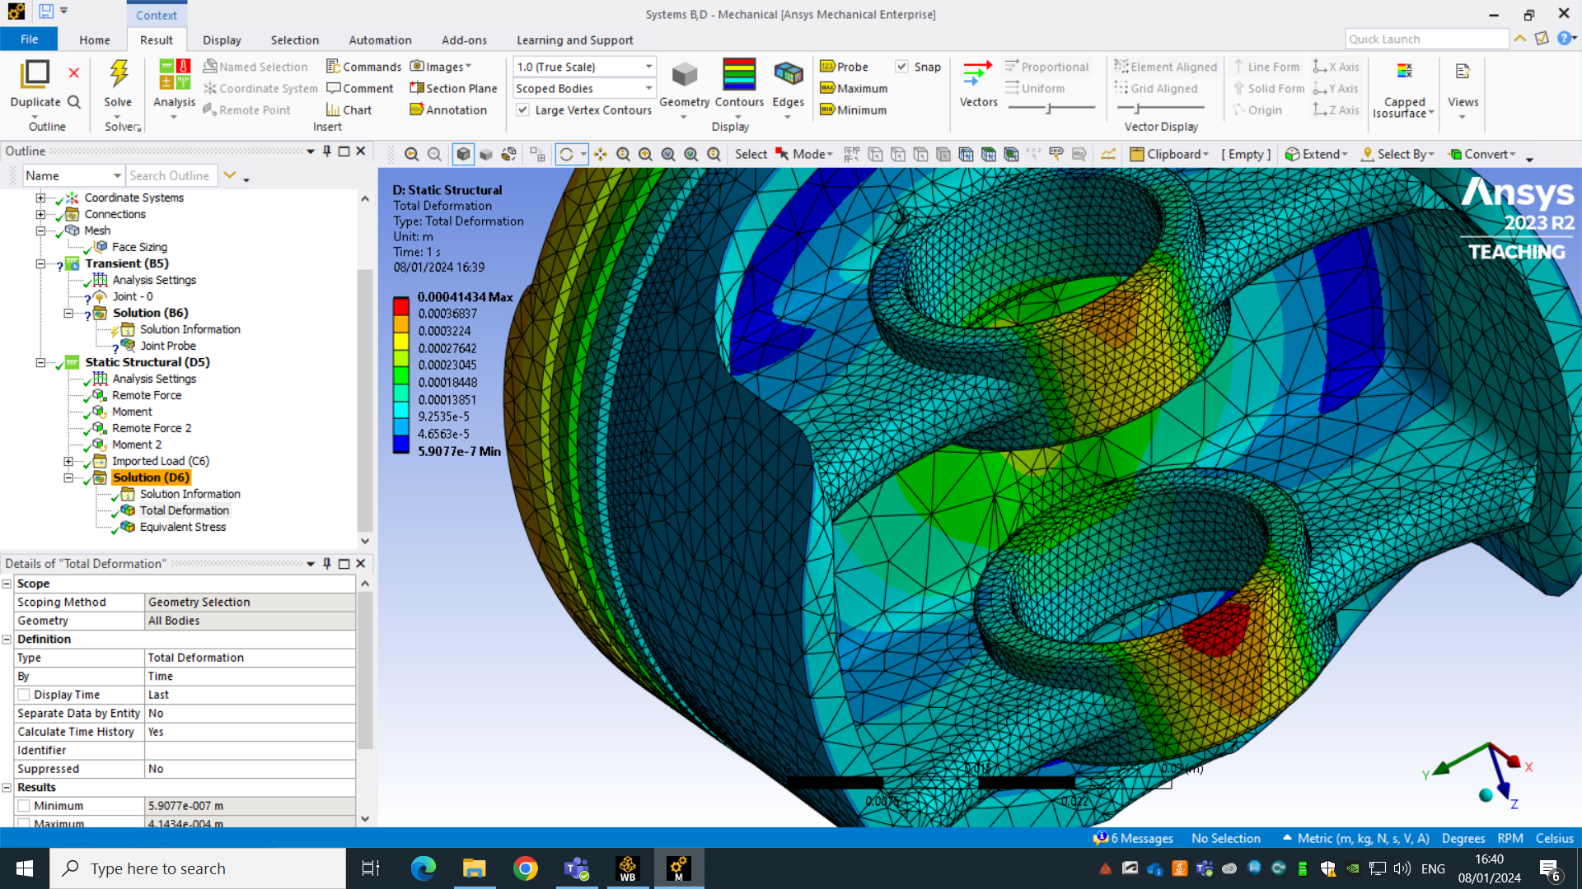
Figure 15: Around Gudgeon.
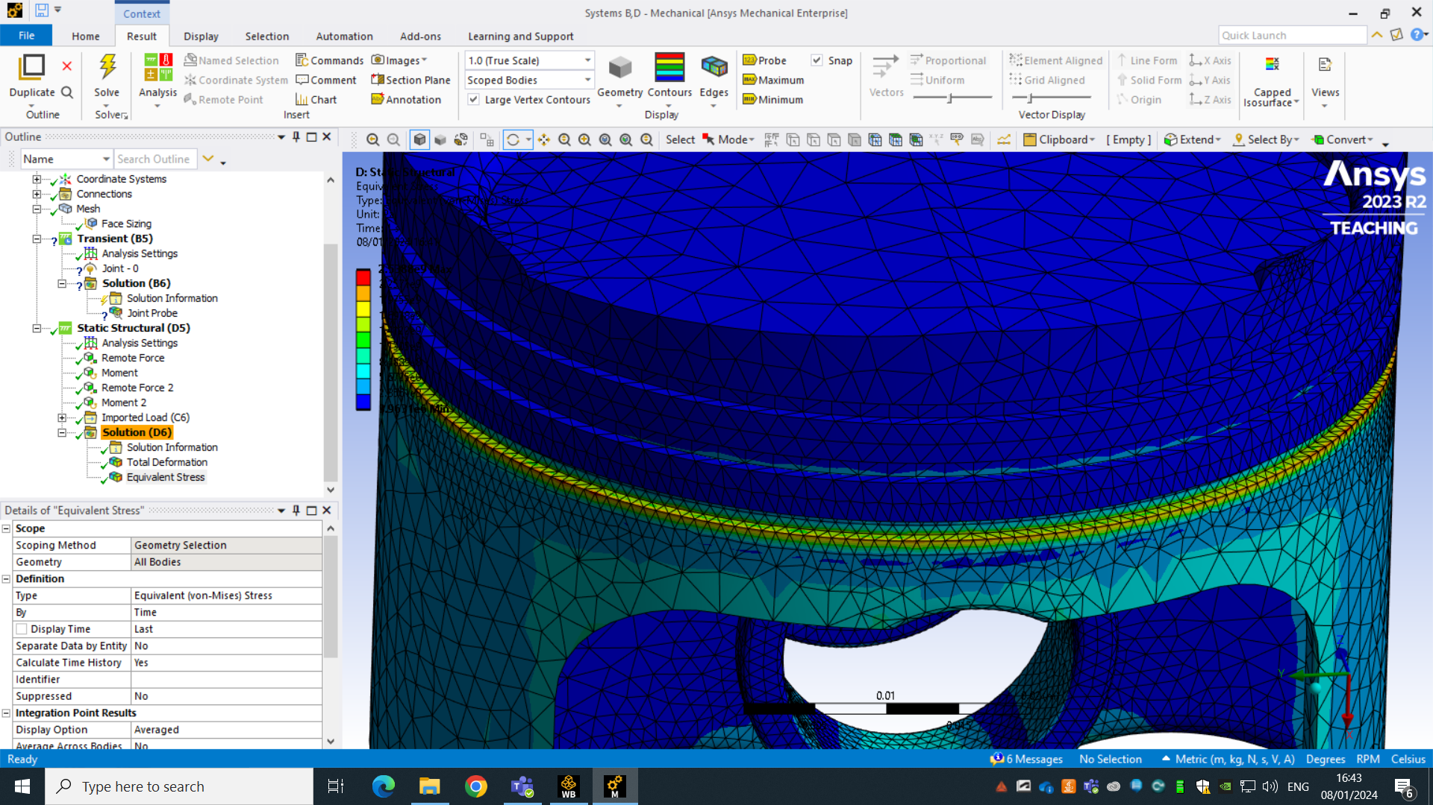
Figure 16Around oil ring

References
Babuska, I., & Oden, J. T. (2004) 'Verification and validation in computational engineering and science: basic concepts.' Computer Methods in Applied Mechanics and Engineering.
Belegundu, A.D. and Chandrupatla, T.R. (2022) Introduction to Finite Elements in Engineering, 5th ed. Cambridge: Cambridge University Press.
Young, W., Budynas, R., & Sadegh, A. (2011) Roark's Formulas for Stress and Strain, 8th Edition. McGraw-Hill Education.

