Developing Workplace Critical Thinking
TASK 3
A Critical Evaluation Report of McGregor's X and Y Theory

Lecturer Name: Dr Ehsan Khajeh
Student Name: Elena Mihaela Radu (2126383)
Module Code: BMSW5101

Abstract

This report critically evaluates McGregor's X and Y Theory of management and its relevance in the modern workplace. McGregor's theory, developed in the 1960s, provides insights into managerial assumptions about employee motivation and behavior. The report analyzes the benefits and disadvantages of the theory, explores its applicability in different workplace contexts, and identifies its limitations.
The analysis of McGregor's X and Y Theory reveals several benefits. The theory highlights the impact of managerial assumptions on employee behavior and emphasizes the need for managers to reflect on their beliefs. Theory Y assumptions promote employee empowerment, engagement, and collaborative decision-making. However, the theory also has disadvantages, including an oversimplification of human behavior and a neglect of external factors and context.
The report provides examples to illustrate the relevance and irrelevance of McGregor's theory in different workplace contexts. It demonstrates that Theory Y assumptions align well with innovative and collaborative environments, while Theory X assumptions may be more applicable in regulated and safety-critical industries.
To effectively manage employees in the modern workplace, it is crucial for managers to adopt a flexible and adaptive approach. While McGregor's theory serves as a foundation for understanding employee motivation, it should be complemented with other management theories that consider contextual factors and individual differences. Integrating contingency theory, transformational leadership, and situational leadership can enhance management practices and create positive work environments.
By critically evaluating and integrating diverse management theories, organizations can foster employee engagement, motivation, and organizational success. Managers should tailor their approaches to the specific needs of the organization and its workforce, considering the complex nature of human behavior. This comprehensive approach will enable organizations to adapt and thrive in the dynamic and competitive business landscape.

Table of Contents

Abstract 2
Introduction 4
McGregor's X and Y Management Theory 4
Theory X: 5
Theory Y: 5
Critical Analysis of McGregor's X and Y Theory 6
Benefits of McGregor's X and Y Theory: 6
Disadvantages of McGregor's X and Y Theory: 7
Example of Relevance in a Workplace Context: 7
Example of Irrelevance in a Workplace Context: 7
Conclusion 8
References 9

Introduction

The report assesses the applicability of McGregor's X and Y Theory of Management in modern workplaces. Developed in the 1960s, McGregor's theory sheds light on managerial presumptions regarding employee behaviour and motivation. This report's objectives are to evaluate the theory's advantages and disadvantages, look at workplace environments where it can be useful, and pinpoint circumstances where it would not be applicable.
According to McGregor's X and Y Theory, managers' presumptions can be divided into two groups: Theory X, which holds that people are naturally lazy and need strict supervision, and Theory Y, which holds that employees are self-motivated and accountable. Managers can modify their leadership styles to promote employee engagement and organisational performance by being aware of these presumptions and their implications (Locke & Latham, 2002).
McGregor's X and Y Theory was chosen as the management theory for this report. It provides a framework for comprehending how management practises are impacted by attitudes about employee motivation. It is crucial to evaluate this theory's advantages, disadvantages, and applicability in the contemporary dynamic working environment (Kanfer, 1990). This theory has influenced the development of managerial practises.
This work intends to offer useful insights for managers and organisations looking to maximise employee motivation, engagement, and performance by undertaking a thorough review of McGregor's X and Y Theory (Deci & Ryan, 2000; Latham & Pinder, 2005). Modern companies can implement efficient management techniques that cater to the various requirements and motivations of their employees by being aware of the application and constraints of this theory.

McGregor's X and Y Management Theory

The McGregor X and Y Theory, created in the 1960s, offers a psychological framework for comprehending and controlling employee behaviour within organisations (McGregor, 1960). It focuses on the beliefs managers have about their workers and how those beliefs influence their management style and strategy. Theory X and Theory Y are two opposing sets of presumptions put out by McGregor.

Theory X:

Theory X is characterized by a pessimistic view of employees. According to Theory X, managers believe that workers are innately unmotivated, sluggish, and disinterested in their jobs. They contend that for people to efficiently carry out their work duties, there must be strong control, constant supervision, and outside motivation in the form of rewards or penalties. According to McGregor (1960), Theory X managers frequently utilise a command-and-control leadership style in which employees are given minimal autonomy or input into the decision-making process.

Theory Y:

Theory Y offers a more optimistic evaluation of workers. Managers that embrace Theory Y assumptions think that workers are accountable, self-directed, and motivated by their own interests. They view employment as a normal and rewarding activity for people. Managers who adhere to Theory Y promote a participative leadership style that fosters employee engagement, independence, and empowerment. They support the development of employees' potential and give them chances for advancement, education, and personal improvement (McGregor, 1960).
According to McGregor's theory (McGregor, 1960), assumptions held by managers have a substantial impact on employee behaviour and assumptions from Theory Y are more suited to fostering a happy work environment and achieving organisational success. He emphasised the significance of integrating Theory Y ideas into management practises to maximise employee potential, improve employee satisfaction, and promote higher performance.
It is crucial to remember that McGregor's X and Y Theory shouldn't be seen as fixed categories or ones that are mutually exclusive. Instead, they represent opposite extremes of a continuum, and depending on the situation and organisational environment, a person may display traits from either theory.
Contingency theory, transformational leadership, and situational leadership are significant management theories that enhance or add to McGregor's work (Fiedler, 1967; Bass & Riggio, 2006; Hersey, Blanchard, & Johnson, 2008). By taking into account elements like situational variables and the significance of inspiring and motivating followers, these theories provide fresh perspectives on effective leadership and management practises.
In general, management theories offer frameworks and insights to aid managers in comprehending employee behaviour, customising their leadership styles, and fostering productive work environments that encourage engagement. According to the unique setting and the various needs of their employees, managers must evaluate and modify their presumptions and practises (Mintzberg, 1979).

Critical Analysis of McGregor's X and Y Theory

While McGregor's X and Y Theory has made significant contributions to the understanding of employee motivation and management practices (McGregor, 1960), it is essential to critically analyse the theory to assess its strengths and weaknesses. The following points outline the benefits and disadvantages of McGregor's X and Y Theory:

Benefits of McGregor's X and Y Theory:

Recognition of Managerial Assumptions: McGregor's theory places a strong emphasis on the influence of managerial preconceptions on employee behaviour, which is one of its main advantages. It highlights how managers' perceptions of their staff might influence their management style and strategy (Hackman & Oldham, 1976). Managers can examine their own viewpoints and modify their behaviours by being aware of these presumptions.
Empowerment and Engagement: According to Deci and Ryan (2000), Theory Y principles encourage employee empowerment, engagement, and self-motivation. Managers may create a productive workplace that promotes initiative, creativity, and greater levels of job satisfaction by giving employees autonomy, responsibility, and opportunity for advancement (Pinder, 1998).
Collaborative Decision-Making: The presumptions of theory Y encourage employee participation in decision-making processes so that the direction of the organisation can be shaped (Hackman & Oldham, 1976). As employees feel valued and their ideas are taken into consideration, this strategy can promote increased dedication, ownership, and innovation.

Disadvantages of McGregor's X and Y Theory:

Oversimplification of Human Behavior: The simplifying of human behaviour by classifying people into rigid X or Y kinds is one criticism of McGregor's approach. In reality, a wide range of variables, such as individual variations, cultural origins, and the particular environment in which they work, affect employee motivations and behaviours (Rousseau, 1985). If these subtleties aren't taken into consideration, we risk having a limited knowledge of employee behaviour.
Contextual Limitations: The significance of context in influencing management practises is not fully addressed by McGregor's theory. When working in more regulated and safety-critical workplaces where standard operating procedures and stringent monitoring are required, Theory Y assumptions may not be as effective as they are in contexts where knowledge-based or creative sectors are involved (McGregor, 1960).
Neglect of External Factors: McGregor's theory largely ignores the influence of external factors on employee behaviour and concentrates instead on the function of managers and their preconceptions. Along with managerial techniques, factors including organisational culture, the state of the economy, and outside influences should be taken into account as they have a substantial impact on employee motivation and performance (Rousseau, 1990; Pfeffer, 1997).

Example of Relevance in a Workplace Context:

A technology startup that values invention, creativity, and cooperation is an example of an environment at work where McGregor's theory would be applicable. In such a setting, the requirements and goals of highly trained and self-driven workers are well matched with Theory Y assumptions. Employers can be encouraged to take chances, experiment with new ideas, and contribute to the expansion and development of an organisation by adopting Theory Y concepts (Hofstede, 2001; Warr, 2007).

Example of Irrelevance in a Workplace Context:

In contrast, McGregor's Theory Y presumptions might not be as relevant in a production facility that follows tight safety rules and standardised operations. To ensure safety and quality, the nature of the work demands a high level of control, adherence to protocols, and careful supervision. With a focus on stringent compliance and performance monitoring, Theory X assumptions may be more applicable in this situation (McGregor, 1960).

Applying McGregor's X and Y Theory to management procedures in the contemporary workplace has both advantages and disadvantages. It oversimplifies human behaviour and ignores the impact of context and outside influences while highlighting the significance of managerial assumptions and employee involvement. The application of the theory depends on the particular workplace setting, corporate objectives, and personnel characteristics. It is essential for managers to use a flexible and adaptive strategy, taking into account the complexity of human behaviour and adjusting their practises to the particular needs of the organisation and their workforce, in order to manage employees effectively.

Conclusion

McGregor's X and Y Theory provides insightful analysis of managerial presumptions regarding employee behaviour and motivation. The notion acknowledges the need of fostering a supportive work environment and giving people the freedom they need to achieve organisational success. The theory's drawbacks, such as its simplicity of human behaviour and disregard for exogenous variables and contextual impacts, must be acknowledged.
In order to appreciate how managerial beliefs affect employee engagement and performance, it is important to comprehend McGregor's theory as a starting point. Managers must, however, employ a flexible and adaptive strategy that takes into account the diversity of people's motives and behaviours.
Management practises should be context-specific and adjusted to fit the specific needs of the organisation and its workers in today's diverse and dynamic settings. The varied character of employee motivation and behaviour may not be adequately addressed by a one-size-fits-all strategy based only on McGregor's X and Y Theory.
Managers should use a variety of management theories and frameworks, combining components of McGregor's theory with other strategies including contingency theory, transformational leadership, and situational leadership, to negotiate the complexity of the modern workplace. With the help of this all-encompassing strategy, managers will be able to combine the best aspects of several theories and modify their management techniques to build productive workplaces that encourage employee engagement, motivation, and organisational success.

References

- Bass, B. M., & Riggio, R. E. (2006). Transformational leadership. Psychology Press.
- Deci, E. L., & Ryan, R. M. (2000). The" what" and" why" of goal pursuits: Human needs and the self-determination of behavior. Psychological Inquiry, 11(4), 227-268.
- Deci, E. L., & Ryan, R. M. (2000). The" what" and" why" of goal pursuits: Human needs and the self-determination of behavior. Psychological Inquiry, 11(4), 227-268.
- Fiedler, F. E. (1967). A theory of leadership effectiveness. McGraw-Hill.
- Hackman, J. R., & Oldham, G. R. (1976). Motivation through the design of work: Test of a theory. Organizational Behavior and Human Performance, 16(2), 250-279.
- Hersey, P., Blanchard, K. H., & Johnson, D. E. (2008). Management of Organizational Behavior: Leading Human Resources. Pearson/Prentice Hall.
- Hofstede, G. (2001). Culture's consequences: Comparing values, behaviors, institutions and organisations across nations. Sage Publications.
- Kanfer, R. (1990). Motivation theory and industrial and organizational psychology. Handbook of Industrial and Organizational Psychology, 1, 75-130.
- Latham, G. P., & Pinder, C. C. (2005). Work motivation theory and research at the dawn of the twenty-first century. Annual Review of Psychology, 56, 485-516.
- Locke, E. A., & Latham, G. P. (2002). Building a practically useful theory of goal setting and task motivation: A 35-year odyssey. American Psychologist, 57(9), 705-717.
- McGregor, D. (1960). The Human Side of Enterprise. McGraw-Hill.
- Mintzberg, H. (1979). The structuring of organizations. Prentice-Hall.
- Pfeffer, J. (1997). New directions for organization theory: Problems and prospects. Oxford University Press.
- Pinder, C. C. (1998). Work motivation in organizational behavior. Psychology Press.
- Rousseau, D. M. (1985). Issues of level in organizational research: Multi-level and cross-level perspectives. Research in Organizational Behavior, 7, 1-37.
- Rousseau, D. M. (1990). Assessing organizational culture: The case for multiple methods. In B. Schneider (Ed.), Organizational Climate and Culture (pp. 153-192). Jossey-Bass.
- Warr, P. (2007). Work, happiness, and unhappiness. Routledge.

Developing Workplace Critical Thinking
TASK 4
Reflective Report on Critical Thinking and Management in the Workplace

Lecturer Name: Dr Ehsan Khajeh
Student Name: Elena Mihaela Radu (2126383)
Module Code: BMSW5101

Table of Contents

Introduction…………………………………………………………………………………………………………..……..12
Gibbs Reflective Cycle…………………………………………………………………………………………………..…12
Description: ………………………………………………………………………………………………..….…13
Experience of Learning on the Module:…………………………………………………...…………13
Feelings During the Assessment of the Module…………………………………………..……...13
Utilizing Critical Thinking Skills in the Future: ………………………………………..…….…..13
Future Professional Development in Management: …………………………….……………..14
Conclusion…………………………………………………………………………………………………….…….…...……14
References……………………………………………………………………………………………………………………….15

Introduction

I will present my understanding of critical thinking and management in the workplace in this reflective report using the Gibbs Reflective Model. In today's complicated and dynamic business environment, the ability to think critically allows people to analyse information, weigh their options, and make well-informed decisions (Facione, 2015). Contrarily, management includes coordinating resources, people, and processes in order to accomplish organisational goals (Drucker, 2017). This report will shed light on the value of critical thinking and management for personal and professional growth by reflecting on my learning experience, assessment feelings, and future aspirations.

Gibbs Reflective Cycle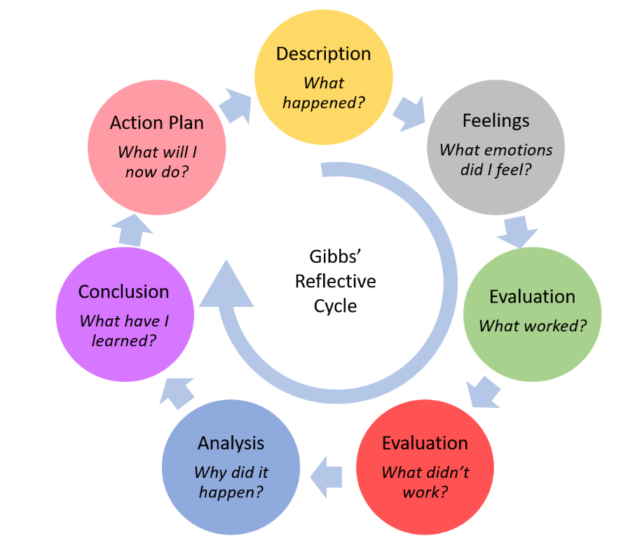
Adapted Gibbs' Reflective Cycle
Description:
I studied the theoretical foundations and practical applications of critical thinking and management during the module. In order to make wise decisions and solve problems effectively, critical thinking entails the methodical investigation and assessment of information (Halpern, 2014). I learned about critical thinking strategies like root cause analysis, SWOT analysis, and decision matrices through a variety of activities and case studies (Paul & Elder, 2018). These resources have given me the framework I need to tackle problems and come to wise judgements at work.

Experience of Learning on the Module:
My understanding of critical thinking and its use in managerial contexts has grown as a result of the module's active discussions, team projects, and practical simulations. The lesson focused on the value of evidence-based decision-making, the understanding of cognitive biases, and the capacity for critical thought under pressure (Kahneman, 2011). I learned how to examine complex situations from several sides by investigating various viewpoints and participating in analytical debates (Cottrell, 2017). I have greatly benefited from this collaborative learning environment in developing my critical thinking abilities.

Feelings During the Assessment of the Module:
As the module assessment approached, a mixture of anticipation, anxiety, and determination filled me. I was both eager to use my critical thinking abilities in a real-world situation and concerned about passing the evaluation. Nevertheless, I understood that the test offered a chance for personal development by letting me demonstrate how well I could use the concepts of critical thinking in a workplace simulation. Despite the pressure, I took the evaluation head-on, concentrating on leveraging my knowledge and showcasing my critical-thinking and managerial skills.

Utilizing Critical Thinking Skills in the Future:
I will use the critical thinking abilities I've developed in the future to improve my decision-making and problem-solving capabilities. I will be better able to negotiate challenging situations in a variety of professional contexts by critically analysing material, taking into account many views, and seeing potential biases (Fisher, 2011). This set of skills will enable me to objectively assess events, make wise decisions, and spot creative ideas that promote organisational success (Kirschner, 2017).
Additionally, it will help me adjust to shifting business contexts where critical thinking is crucial for making strategic decisions and dealing with new problems (Bartlett & Ghoshal, 2015).
Future Professional Development in Management:
I hope to take advantage of upcoming professional development chances to improve my comprehension of management ideas. I want to focus on advanced subjects including leadership styles, conflict resolution techniques, and strategic decision-making procedures (Daft, 2018). I will be better able to lead teams, handle disagreements, and make wise strategic decisions that support organisational goals if I get in-depth expertise in these fields (Kotter, 2012). My ability to succeed in managerial jobs and contribute to the expansion and success of the organisations I work with will depend on my continued professional development in management.

Conclusion

The critical thinking and management module has given me a strong platform on which to grasp and utilise these crucial abilities in the workplace. I reflected on my learning experience, assessment of emotions, and future objectives for using critical thinking and strengthening my management competencies using the Gibbs Reflective Model. With the learned critical thinking abilities, I will be able to handle difficult problems, make informed judgements, and adapt to the changing business environment. My future management professional growth will also enable me to successfully manage teams and propel organisations forward.

References
- Bartlett, C. A., & Ghoshal, S. (2015). Managing across borders: The transnational solution (3rd ed.). Harvard Business Review Press.
- Cottrell, S. (2017). Critical thinking skills: Developing effective analysis and argument (3rd ed.). Palgrave Macmillan.
- Daft, R. L. (2018). The leadership experience (7th ed.). Cengage Learning.
- Drucker, P. F. (2017). The practice of management. Routledge.
- Facione, P. A. (2015). Critical thinking: What it is and why it counts. Insight Assessment.
- Fisher, A. (2011). Critical thinking: An introduction. Cambridge University Press.
- Halpern, D. F. (2014). Thought and knowledge: An introduction to critical thinking (5th ed.). Psychology Press.
- Kahneman, D. (2011). Thinking, fast and slow. Farrar, Straus and Giroux.
- Kirschner, P. A. (2017). Thinking hard about thinking. Educational Psychologist, 52(1), 1-12.
- Kotter, J. P. (2012). Leading change. Harvard Business Review Press.
- Moon, J. A. (2013). Reflection in learning and professional development: Theory and practice. Routledge.
- Paul, R., & Elder, L. (2018). Critical thinking: The nature of critical and creative thought. Journal of Developmental Education, 43(2), 34-35.

