Module: Foreign Languages & Cultural Awareness
Module code: BMIH5003
Student Name: Alexandru alin minea
Student Number: 2215123
Tutor: Lisa Bassler
Word count: 1000 words

Executive Summary
The aim of the report is to analyse and compare two countries culture by utilizing GLOBE project. The countries that have been compared are England and Turkey. The rich traditions and customs of England are well-acknowledged across the globe. English culture is known for its politeness, the British Royal Family, and massive quantities of tea consumption. On the other hand, Turkey has always been a crossroads between the East and the West, fostering a vibrant and multifaceted culture that blends the two. The GLOBE Anglo cluster, which includes the United States, Australia, Canada, New Zealand, Ireland, England, South Africa, and South Africa, has historically placed a high importance on performance. In Addition, the GLOBE Middle East cluster, comprising Qatar, Egypt, Morocco, Turkey, and Kuwait, has a high grade on both In-Group Collectivism and Power Distance. These societies feature an unequal distribution of authority and prioritise social dynamics above individual accomplishment.
Table of Contents
1 Executive Summary 2
2 Introduction 4
3 Culture overview 4
4 GLOBE Project/country analysis 4
5 Challenges of intercultural leadership in the hospitality industry 7
6 Conclusion 8
7 Recommendations 8
8 References 10

Introduction
The illustration of the report concentrates on the key cultural differences between England and Turkey. The study will further analyze and compare the two using the GLOBE Project's culture and leadership study. In Addition, it will also critically discuss the challenges of intercultural leadership in the hospitality industry, and provide concrete examples of potential conflict in managing a intercultural team. Lastly, the report will provide realistic recommendations for the Hotel Management Team to overcome these challenges.

Culture overview
The rich traditions and customs of England are well-acknowledged across the globe. English culture is known for its politeness, the British Royal Family, and massive quantities of tea consumption. However, English culture is always changing and encompasses much more than these commonly acknowledged characteristics (Baxendale, 2016). However, one common element of highbrow humour in English culture is satire. Shakespeare's hometown and its culinary customs, such as Friday fish and chips, are likewise well-known. Though spoken throughout the United Kingdom in Welsh, Irish Gaelic, Punjabi, French, Portuguese, and Scottish Gaelic, English is the official language. However, the British still have a big influence on the world today (Tullett, 2016).
On the other hand, Turkey has always been a crossroads between the East and the West, fostering a vibrant and multifaceted culture that blends the two (Çalış and Küçükali, 2019). Turkish culture is a synthesis of the various ethnic and religious groups that make up the nation, as well as contemporary ideas and centuries-old customs. A complex and varied fusion of components from several Eastern European, Eastern Mediterranean, Caucasian, Middle Eastern, and Central Asian traditions make up Turkish culture, also known as Türkiye kültürü or Türk kültürü (Shipman and Durmus, 2017).

GLOBE Project/country analysis
The GLOBE Anglo cluster, which includes the United States, Australia, Canada, New Zealand, Ireland, England, South Africa, and South Africa, has historically placed a high importance on performance (England Cluster, 2023). Reliability has been lacking in both families and organisations. The cluster values high performance and competition. On the other hand, its low degree of in-group collectivism points to a tendency towards individualistic conduct. Institutional collectivism is a media that emphasises the importance of resource allocation and social cohesion within a society. Other sociological and cultural elements with minor scores include assertiveness, future orientation, avoiding uncertainty, and humanitarian orientation. Furthermore, Power Distance has a middling rating. The Anglo cluster is in favour of giving more weight to collectivism, performance, humanism, the future, and gender equality within the group. It also aspires to a society that is more compassionate and less sceptical (England Cluster, 2023). Engaging, team-oriented, charismatic, and values-based are characteristics of outstanding leadership in the Anglo cluster. However, this cluster requires highly charismatic, collaborative, and team-oriented leaders who can inspire, motivate, and promote high performance while assembling outstanding teams.

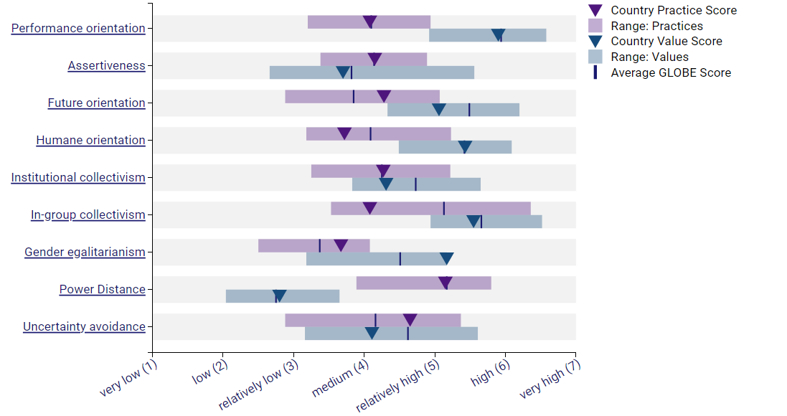
Figure 1: Cultural practices and values in England (Source: England Globe, 2020)
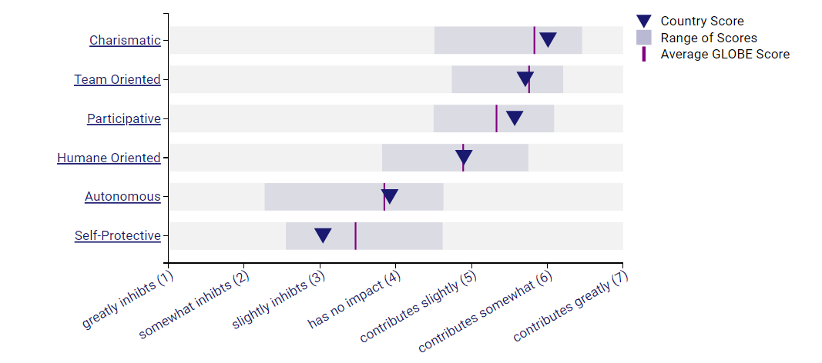
Figure 2: Leadership in England (Source: England Globe, 2020)
In Addition, the GLOBE Middle East cluster, comprising Qatar, Egypt, Morocco, Turkey, and Kuwait, has a high grade on both In-Group Collectivism and Power Distance. These societies feature an unequal distribution of authority and prioritise social dynamics above individual accomplishment (Turkey Cluster, 2023). Their views are very different from their past practices in that they emphasise gender equality, performance and future orientation, and avoiding ambiguity. Additionally, they indicate a willingness to increase the distribution of community resources by expressing a desire to fortify institutional collectivism. The Middle East cluster is characterised by gender discrepancies, strong ties to family and close-knit communities, and an unequal power structure. However, the charismatic and team-oriented dimensions of leadership have the lowest ranks and scores, while the self-protective dimension has the second-highest score (Turkey Cluster, 2023). This leadership profile is distinct from the other eleven clusters, and its additional characteristics demonstrate how Islam has altered our perception of the Arab world.

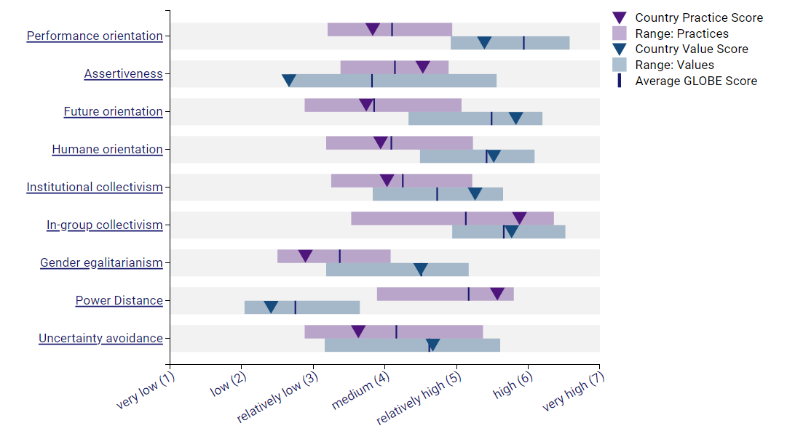
Figure 3: Cultural practices and values in Turkey (Turkey Globe, 2020)
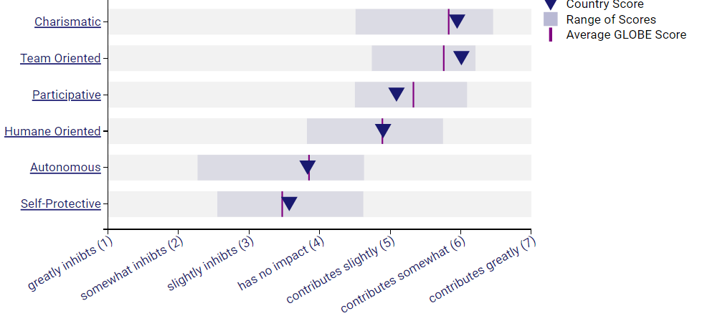
Figure 4: Leadership in Turkey (Source: Turkey Globe, 2020)

Challenges of intercultural leadership in the hospitality industry
Since the hospitality sector is global in scope, businesses need to adjust to the cultural variety of both their clientele and workforce. Employees need to be seen as important resources as well as unique people with their own desires, aspirations, and personal ambitions (Barnett and Carter,2018). Large hospitality organisations understand that their workforce is culturally diverse and that human resources are not the same as other corporate resources. In order to make sure that its staff members feel valued, respected, and acknowledged, hotels such as IHG, Ritz-Carlton, Marriott International, and Hilton Worldwide prioritise understanding and respecting many cultures (Liu et al., 2022). Workers navigating cultural diversity may experience anxiety and confusion if they don't receive enough training or have clear instructions. Customer service, visitor satisfaction, and internal operations may all be impacted by this. In the hotel business, managers' capacity to be both service- and guest-focused is crucial. To ensure that staff members are providing excellent service to clients from different cultural backgrounds, managers can think about conducting intercultural sensitivity tests and providing training to staff members. Culturally sensitive workers are more aware of their client's needs, make more money from each foreign client, have better interpersonal skills in a multicultural setting, and are generally happier at work and while interacting with foreign clients (Ineta, 2023).

Conclusion
In conclusion, a strong grasp of cultural differences and an awareness and respect for ethnic diversity are prerequisites for effectively managing a varied workforce and offering excellent service to a range of guests that enhances their cultural experience. However, hospitality businesses must acknowledge that in order to meet the unique demands of customers from many cultural backgrounds, careful service modification is required. When hotel services engage with guests' cultures and are presented in a way that is appropriate, the quality of the service experience may be greatly enhanced.

Recommendations
Hotel Management can overcome these challenges through the recommendations provided below:
- In an effort to promote and strengthen employees' hotels need to understand cultural diversity. However, many hospitality companies offer training courses, inclusion initiatives, and events that highlight other cultures and customs. Employees who take part in these activities may develop an understanding of and respect for people from different cultural origins as well as the ability to recognise and value the unique viewpoints of others.
- Employees ought to undergo language-based training so they can interact with customers from different cultural backgrounds. Additionally, employees need to be able to modify their communication style to fit the vast range of ethnic contexts they may encounter.
- Success in the international hospitality sector depends on recognising and showcasing the unique qualities of a varied workforce. In order to get a competitive edge based on varied persons (workers) whose performance has a significant influence on the hospitality experience that clients have, it is imperative to adopt culture-oriented managerial methods.

References
Barnett, L. and Carter, E., 2018, May. Challenges to leadership in intercultural settings: intercultural interactions and knowledge management: research From Thailand. In ICMLG 2018 6th International Conference on Management Leadership and Governance (pp. 60-67).
Baxendale, J., 2016. Priestley" s England: JB Priestley and English culture. Priestley" s England, pp.1-228.
Çalış, S. and Küçükali, U.F., 2019. The work safety culture as a subculture: The structure of work safety culture in Turkey. Procedia Computer Science, 158, pp.546-551.
England Cluster, 2023. Anglo. Australia, Canada, England, Ireland, New Zealand, South Africa, USA. [online] Available at: https://globeproject.com/results/clusters/anglo%3Fmenu=list.html#list [Accessed on 23rd Feb’24]
England, 2023. Culture Visualisation. [online] Available at: https://globeproject.com/results/countries/GBR%3Fmenu=list.html#list [Accessed on 23rd Feb’24]
Ineta, L., 2023. Eliminating Intergenerational and Intercultural Communication Problems in Tourism and Hospitality Enterprises. Acta Universitatis Sapientiae, Philologica, 15(2), pp.14-32.
Liu, Y., Liu, J. and King, B., 2022. Intercultural communicative competence: Hospitality industry and education perspectives. Journal of Hospitality, Leisure, Sport & Tourism Education, 30, p.100371.
Shipman, D. and Durmus, B., 2017. The effect of culture on food consumption; a case of special religious days in Turkey. Journal of Food Research, 6(2), pp.92-99.
Tullett, W., 2016. Grease and sweat: race and smell in eighteenth-century English culture. Cultural and Social History, 13(3), pp.307-322.
Turkey Cluster 2023. Middle East. Egypt, Kuwait, Morocco, Qatar, Turkey. [online] Available at: https://globeproject.com/results/clusters/middle-east%3Fmenu=list.html#list [Accessed on 23rd Feb’24]
Turkey, 2023. Culture Visualisation. [online] Available at: https://globeproject.com/results/countries/TUR%3Fmenu=list.html#cluster [Accessed on 23rd Feb’24]

