Assessment
Business Research Proposal Topic: The Influence of Social Media Marketing on Brand Trust and Purchase Intention among Generation Z Customers of Gymshark in the UK
Module Code: BMMB7028
Student Name: Smit Bharatkumar Barot
Student ID: 2526323

Abstract
This study focuses on social media marketing, online brand trust, and purchase intention of UK Gen Zs for the brand Gymshark. The research would explore the impact of social media marketing upon brand trust, purchase intention amongst UK Gen Zs who purchase Gymshark’s products. In the UK, around 97% of Gen Zs use social media platforms, and around 44% of the consumers of this generation purchase products if the same is recommended by their respective influencers. So, the understanding of this influence can boost commercial outcome of the business that continues to increase revenue and decline profit margin. Based upon Theory of Planned Behavior, and Source Credibility theory; research assumes the position of positivism under the deductive philosophical approach and methodology is quantitative. Online questionnaire with close-ended responses will be collected from about 100 Gen-Zs who have purchasing relation with Gymshark with the aid of the online platform ‘Microsoft Forms’ under a non-probability purposive sampling technique. Analysis of collected data would involve descriptive, correlations and regression utilizing SPSS. The research is anticipated to find out key social media marketing influences the brand trust & hence the purchase intention among the Gen-Zs and to impart applicable insights and suggestions for the business to strengthen their brand position.

Table of Contents
1. Introduction 4
1.1 Background 4
1.2 Business Problem Statement 5
1.3 Research Rationale 5
1.4 Research Aim and Objectives 5
1.5 Research Questions 6
1.6 Research Significance 6
1.7 Research Scope 7
1.8 Research Gap 7
2. Literature Review 8
2.1 Social Media Marketing and Generation Z Consumers 8
2.2 Influence of Social Media Marketing on Brand Trust 9
2.3 Social Media Marketing and Purchase Intention 10
2.4 Relationship between Brand Trust and Purchase Intention 12
2.5 Social Media Marketing Factors Influencing Gen Z Consumers 13
2.6 Theoretical Framework 14
2.7 Literature Gaps 15
3. Proposed Methodology 16
3.1 Research Philosophy 16
3.2 Research Approach 17
3.3 Methodological Choice 17
3.4 Research Strategy 18
3.5 Data Collection Tool 18
3.6 Sampling Strategy 18
3.7 Data Analysis Method 19
3.8 Reliability and Validity 19
3.9 Advantages and Disadvantages of the Chosen Methods 20
3.10 Ethical Considerations 20
3.11 Limitations 21
3.12 Resource Implications and Costs 21
4. Expected Outcomes and Timetable 22
4.1 Expected Contribution 22
4.2 Gantt Chart: Research Timetable 22
References 24

1. Introduction

1.1 Background
The rise of social media has revolutionized the way digital marketing works, influencing the brand-audience relationship. Around 97% of Gen Z consumers in the UK use social media, making them the most digitally engaged cohort (EMARKETER, 2026). Such as Instagram and TikTok, social media platforms are no longer just for viewing content, but also a key destination to discover brands, engage with it and eventually made the purchase decision (Dzreke and Dzreke, 2025). UK shoppers learned about brands from influencers, indicating there was a substantial financial reward to be gained (Bartosiak, et al., 2025). UK business Gymshark has seen significant growth as the company has shed a ton of conventional advertising and instead has focused on a variety of influencer-based and digital marketing tactics.
Figure 1 below illustrates that the business made a record turnover of €748.6 million (approximately £646 million) in fiscal year 2025, a 6.4% increase on the previous year (Modaes, 2026). This strategy appeared to be highly effective with the younger consumer segment and the effect of this on their level of trust and purchase intent is therefore both commercial and academic. As an increase in competition within the sportswear sector arises the company must constantly work to enhance customer trust and intent through relevant social media marketing actions. As such, the aim of this study is to investigate the impact of social media marketing on purchase intention and brand trust among the UK Generation Z consumers of Gymshark.

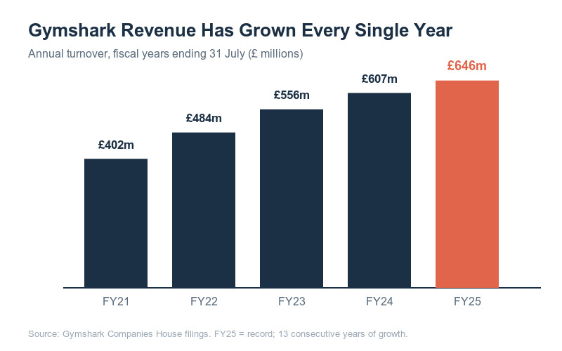
Figure 1: Gymshark Revenues Over the Year
(Source: Pereira, 2026)

1.2 Business Problem Statement
Gymshark has experienced good revenue increase, but its profitability, however, hasn’t experienced a decent growth. Gymshark’s profitability declined for the last 3 years, reporting a pre-tax profit decrease to £7 million, compared with £11.9 million in the previous year (Modaes, 2026). This leads to a primary business issue, as a lot of money invested in social media marketing does not necessarily equate to a proportionate return in financial terms, nor is it known how social media marketing relates to consumer trust and purchasing behavior. This issue is amplified with Gen Z as the result reveals exposure vs skepticism dilemma.
UK’s Gen Z individuals are ardent social media consumers; however, it seems the feelings regarding the use of branded content is ambiguous. People from UK Gen Z favor raw content driven by creators over professionally crafted marketing material. Gymshark need to understand what type of social media marketing tactic is the ones that’s building trust amongst these individuals and thus motivating their purchasing intention rather than awareness.

1.3 Research Rationale
As companies rely more heavily on social media marketing, understanding its effect on consumer behaviour becomes increasingly important. Approximately 44% of Gen Z consumers have purchased a product after an influencer recommendation, a behavioural tendency that a general marketing approach can overlook. Social media is central to Gymshark, yet relatively little research has examined its UK Gen Z audience specifically, where the brand's distinctive strategies may shape psychological responses such as trust and purchase behaviour. Most existing work studies social media marketing and consumer behaviour in general terms rather than at the level of a single brand and generation. This research therefore builds on that literature to generate quantitative primary data and evidence-based recommendations for Gymshark.

1.4 Research Aim and Objectives
Aim: This research primary aim is to examine the influence of social media marketing on brand trust and purchase intention among Generation Z customers of Gymshark in the UK, and to evaluate how social media activities affect consumer purchasing behavior.
Objectives:
- To analyse the influence of social media marketing on brand trust among Generation Z customers of Gymshark in the UK.
- To examine the effect of social media marketing on the purchase intention of Generation Z customers.
- To evaluate the relationship between brand trust and purchase intention among Generation Z customers.
- To explore the social media marketing factors that most influence brand trust and purchase intention.
- To provide strategies for improving Gymshark's social media marketing to enhance brand trust and purchase intention.

1.5 Research Questions
- How does social media marketing influence brand trust among Generation Z customers of Gymshark in the UK?
- How does social media marketing affect the purchase intention of Generation Z customers?
- What is the relationship between brand trust and purchase intention among Generation Z customers?
- Which social media marketing factors have the greatest influence on brand trust and purchase intention?
- What strategies can Gymshark adopt to improve its social media marketing and strengthen brand trust and purchase intention among Generation Z customers?

1.6 Research Significance
The study has both a theoretical and empirical contribution. Theoretically, it contributes to a small amount of research on how theory of trust and behavioral theories are applicable to one single D2C brand in a digital first context and within a UK context focusing on Gen Z.
Practically, it will bring useful marketing recommendations to Gymshark for a selection of social media platforms on how to increase trust and facilitate sales in order to have better marketing budget allocation. Moreover, as the company's revenue reached a record €748.6 million (around £646 million) in fiscal year 2025 while profit margins declined (Modaes, 2026), a brand-based marketing recommendation will bring practical value to the company and is applicable to other D2C clothing brands targeting Generation Z.

1.7 Research Scope
This study focuses on the Generation Z consumers of the United Kingdom who follow or interact with Gymshark's social media accounts on Instagram, TikTok and YouTube. The study aims specifically on the relationship among SMM activities, brand trust and purchase intention rather than on the general brand perception or offline retail experience. Limited to a cross-sectional online survey administered through Microsoft Forms, with the consumer's attitudes being captured at one time in the study, rather than the longitudinal tracking of behaviors. Excluding other Gymshark’s markets and other demographic cohorts, the study was limited to a manageable scope within an MBA dissertation timeframe and budget.

1.8 Research Gap
There have been few studies focus on the relation of social media marketing, brand trust and purchase intention among UK’s Generation Z consumers of sportswear industry. The existing studies that have been carried out focus on influencer marketing, in general, and examine several brands without substantial information on Gymshark specifically. Furthermore, the prior studies paid less attention on discovering factors in social media marketing which have most effect on the purchasing behavior and purchasing decision and the consumers' trust to a brand for UK's generation Z. The aim of this study is to address this gap by employing quantitative methodology that generates empirical results on Gymshark’s customers within UK.

2. Literature Review

2.1 Social Media Marketing and Generation Z Consumers
Social Media marketing (SMM) has evolved as a vital aspect of business strategy as it provides the means to engage and connect with customers, promote products and build lasting customer loyalty and relations through electronic media (Kadam, 2025). According to Chung (2025), social media can be described as internet applications based on Web 2.0 technologies that allow individuals to create and share their own content, echoing the seminal definition of Kaplan and Haenlein (2010). Feng and Ou (2025) suggested that social media is strategic marketing community where a firm creates relationships with its customers for the purpose of retaining their attention, satisfaction and eventually, their loyalty instead of merely broadcasting promotional content. They both agreed that the difference between social media marketing and the traditional marketing lies in interaction, although they put a difference on how the interaction should be valued. Chung puts more weight on technologies which are the platform and interaction with people, while Feng and Ou emphasize the importance of brand community value in SMM.
Figure 2 shows that 97% of Gen Z consumers in the UK use social media and by 2028 the group will outnumber people that engage in video consumption and buying in online platforms. Other brands in other segments should also take into account that Gen Z individuals are more inclined to report influencers driving purchase decisions and they claim almost half, i.e 44% has bought something after reading a review or testimonial from an influencer compared to only 26% in the general population (Alvarez Buylla Lora and Dietz, 2026). When they look for products, consumers from this generation also expect and look for content that mirrors their lives and points of view, rather than generic marketing messages and search online communities for confirmation of buying options. The beginning of evidence that Gymshark must have a social strategy that includes community-centered engagement rather than purely consumption driven communication is starting here.
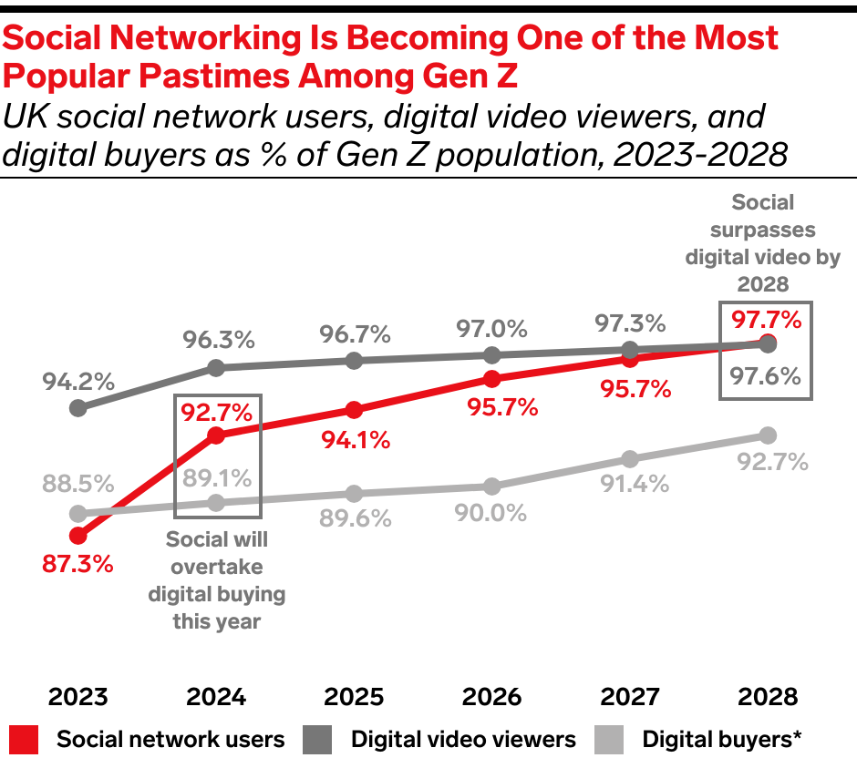
Figure 2: Gen Z Social Media Usage
(Source: EMARKETER, 2026)

2.2 Influence of Social Media Marketing on Brand Trust
Brand trust is the consumer's confidence that a brand will always provide them with a product of quality, effective communication and fulfil their promises (Chaudhuri and Holbrook, 2001; Luthfi et al., 2025). Valmohammadi et al., (2025) said that social media marketing plays a crucial part in building this trust by offering brands a range of opportunities to communicate with consumers and engage them with entertainment, interaction, customization, electronic word of mouth (eWOM) and influencer marketing. Such social media marketing activities help build customers' trust in the brands and engage them, especially in luxury brands (Tafolli et al., 2025). Valmohammadi et al., (2025) highlight direct communication between the brand and consumer to facilitate interaction, while Tafolli et al., (2025) stresses on providing continued, meaningful and high value content on the platforms to facilitate interaction. Although both studies recognize interaction as an integral part in the development of trust, they place varying emphasis on how this occurs.
Likewise, Putro and Aribowo (2026) reported that regular and informative social media communication boosts brand awareness, resulting in improved consumer trust and loyalty. However, Ulfstedt (2025) suggested that the credibility of the influencers is more influential on brand trust than the official brand advertising as consumers think that influencers are more authentic and relatable. Migkos et al., (2025) has discovered that influencers who are seen as trusted media brings a lot better engagement from the customers.
But recent consumer behaviors indicate that not all influencers work. However, Generation Z consumers are well aware of paid posts, and if an influencer's posts seem commercial or misleading, they may wonder if the person is genuine (Jeansson and Hemmingson, 2025). Figure 3 shows, there are vast opportunities to connect and maintain trust with the public on social media channels, as 55.5 million of the UK's population actively uses social media. As a result, Gymshark's efforts to merge fitness influencers, athletes, user-generated content, and community campaigns could prove more successful as it involves actual customer engagement and authenticity.
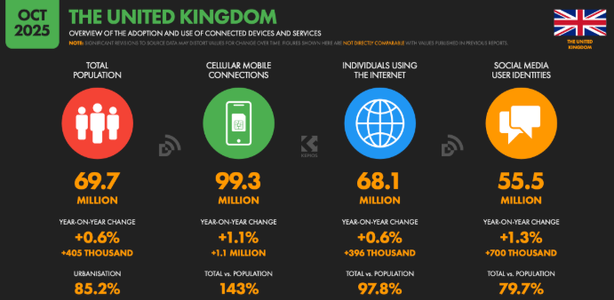
Figure 3: Social Media Usage Statistics in the UK
(Source: Thompson and Thompson, 2025)

2.3 Social Media Marketing and Purchase Intention
Purchase intention is the consumer's willingness to make a purchase once he or she has considered and formed positive attitudes toward a brand in the context of information available. According to Minbale et al., (2025), the Theory of Planned Behavior (Ajzen, 1991) states that purchase intention is a result of attitudes, subjective norms, and perceived behavioral control. These attitudes are established in social media context through customer engagement, influencers marketing, online reviews, and electronic word of mouth (eWOM), which in turn affect the purchasing decisions.
Ismael et al., (2025) concluded that the use of social media advertising, specifically Facebook, has a positive impact on the purchase intention of the consumer due to their increased brand awareness and engagement. Likewise, Bui et al., (2025) indicated that eWOM is one of the most reliable factors influencing online purchase intention as the peer reviews are perceived as more credible than the company reviews. Ghonouei et al. (2025), on the other hand, suggested that the quality and relevance of social media contents are more affecting purchase intention than the frequency of advertisements. Ismael et al., (2025) emphasizes the effectiveness of social media advertising, whereas Bui et al., (2025) and Ghonouei et al. (2025) contend that authentic peer recommendations and valuable content are more persuasive.
Figure 4 shows, social media platforms like Instagram and TikTok were significant platforms for discovering products, with 10.7 million actively using Instagram in 2026, and 9.3 million adult user base in the UK for TikTok and 6.9 million for Facebook. Moreover, 22% of social media users globally follow influencers; this figure is higher for women aged 16-24, at 30.8% (Virtanen, 2025). This approach, which harnesses authentic user-generated content and community engagement, is expected to create a greater sense of purchase intent than traditional advertising methods, as Gymshark aims to foster a community of customers and fitness influencers who will share their workout experiences and product reviews.
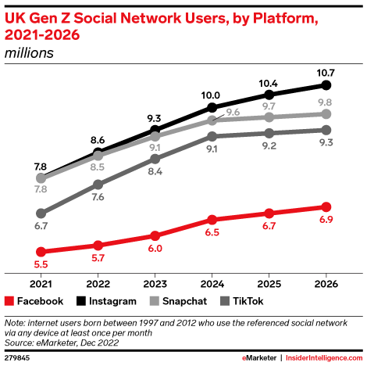
Figure 4: Gen Z social media usage
(Source: EMARKETER, 2026)

2.4 Relationship between Brand Trust and Purchase Intention
Brand trust is known to be one of the key factors that influence consumers' purchase intent as it helps to reduce their perceived risk and boost their trust in the purchasing decision. The Commitment–Trust Theory, state that trust is the main force of successful long-term relationships between the business and customers that results in commitment and repeat purchases (Morgan and Hunt, 1994; Da and Keat, 2025). In like manner, Hipólito et al., (2025) posits that trust is more crucial in the case of online shopping, where the consumer is confronted with a bigger degree of uncertainty, because consumer is unable to physically inspect the product before buying. Shammout et al., (2025) also suggested that the more consumers trust the brands, the more loyal they will be and the more likely they will be to buy the brand. The studies are consistent in finding that trust positively relates to purchase intention, but vary in how much consumer behavior is explained by trust alone.
The researchers agree that trusting does enhance consumer’s intentions, but what they do not agree on is the amount which only trust can account for consumer behavior. Da and Keat (2025) and Hipólito et al., (2025) point towards the fact that trust is the dominant factor influencing on relationship quality and e-purchases whereas Shammout et al., (2025) concur that it does improve the trust which then improves purchases.
Although Widjaja (2025) argued that the purchase intention, however, is influenced by the other factors, such as price, product quality, brand image, and perceived value, apart from trust, according to other researchers. Figure 5 shows that 47% shoppers seek brand website and 24% seek customer reviews before purchasing, even after discovering a trusted brand or product via social media, indicating trust alone rarely triggers immediate purchase. However, even though trust in Gymshark is built on its “real” social media and “real” fitness community, when Generation Z consumers are influenced by other product lines, pricing models, or promotion deals, they will purchase a competitor like Nike or Adidas. Hence, boosting trust in the brand is coupled with value propositions to increase purchase intention.
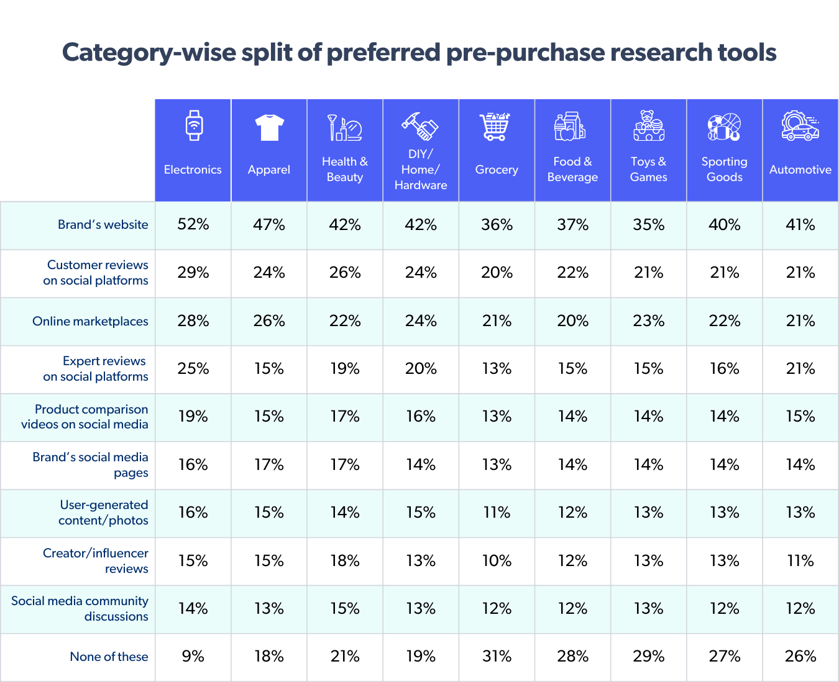
Figure 5: Shopper Trust in Testimonials and Peer Reviews
(Source: Srinidhi Palaparti, 2025)

2.5 Social Media Marketing Factors Influencing Gen Z Consumers
The credibility of the video creator, user-generated content (UGC), entertainment, interaction, information quality, community engagement, electronic word-of-mouth (eWOM), and transparency are among the social media marketing factors that affect the trust and purchasing intention of the Generation Z consumers (Ulfamiyati and Bangsa, 2026). According to Rehman et al., (2025) social media activities that are interactive and entertaining are seen to increase customer engagement and build trust in a brand. Likewise, Yulianto and Fahrudi (2025) observed that consistent and informative social media content helps to build brand awareness, trust and purchase intention by building ongoing interactions.
According to Shaheen et al., (2025), consumers believe that a credible influencer is knowledgeable and trustworthy, which is the most crucial factor in the brand's credibility. On the other hand, Bui et al., (2025) contend that eWOM and customers' reviews have more impact on purchase intention because customers are more likely to trust recommendations from their peers compared to a brand's own recommendations. That means that, although influencer marketing can capture consumers' attention, it's possible that the real experiences the customer has with the product or service could be more important in their decision-making process.
Figure 6 shows that potential advertisement reach is done by YouTube followed by Facebook, Instagram, TikTok. As a result, Generation Z shoppers prefer to see transparency, honest reviews and user-generated content over the heavily commercialized celebrity endorsement. Gymshark takes advantage of these elements by allowing customers, athletes, and fitness influencers to share real-life experiences and customer reviews on social media and online forums.
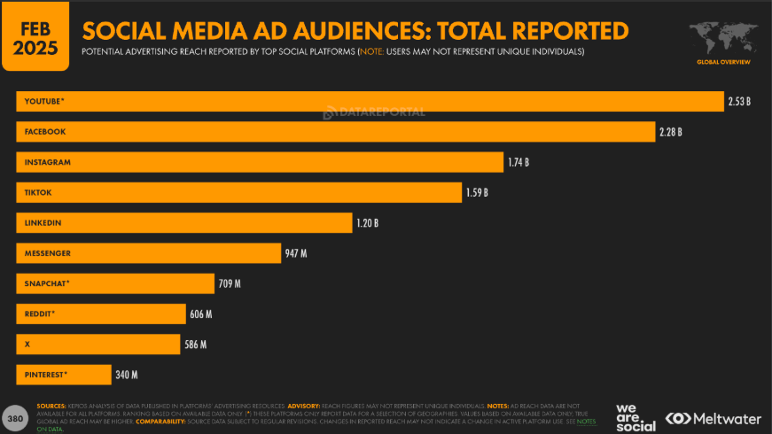
Figure 6: Social media ad audiences
(Source: Chaffey, 2025)

2.6 Theoretical Framework
The Theory of Planned Behavior (TPB) and Source Credibility Theory (SCT) are both appropriate theories that can explain the relationships between social media marketing, brand trust and purchase intention. Ajzen (1991) established, and Jingyi and Ali (2025) confirm, that an individual's behavioral intention is influenced by attitude, subjective norms, and perceived behavior control. In this study, positive attitudes towards Gymshark can be created after engaging in social media marketing activities and the attitudes towards Gymshark can help in reinforcing the intention to buy Gymshark products. But the concept of trust as a factor influencing consumer behavior has received limited attention in TPB. In contrast, Source Credibility Theory suggests that marketing communication effectiveness can be related to the perceived expertise and trustworthiness of the source of the marketing communication (Hovland, Janis and Kelley, 1953; Ohanian, 1990; Yasa et al., 2025). For Gymshark, trust in the brand can be boosted by the presence of legitimate fitness influencers and genuine user-generated content, ultimately leading to higher purchase intentions.
Source Credibility Theory
Theory of Planned Behavior
Social Media Marketing
Brand Trust
Purchase Intention

Figure 7: Theoretical Framework
(Source: Self-created)

2.7 Literature Gaps
Firstly, existing studies on Social Media Marketing and trust intention focus on luxury and general ecommerce contexts and have not been used in D2C activewear brands that are based on influencer culture. Secondly, the research on Gen Z is often generalized, which fails to acknowledge local attitudes towards sponsorship transparency and community-led brand engagement in the UK. Third, none of the reviewed studies test TPB and Source Credibility Theory together in one design, in one brand, in one market, and one generation to see which specific factor (entertainment, customization or credibility) is more important for a fitness-community brand such as Gymshark. This study will rectify these deficiencies by using a quantitative approach, targeted at young people of the ‘Gen Z’ generation and Gymshark within the UK.

3. Proposed Methodology
The research approach will be based on the research onion framework, which starts at the outer level of philosophy and works its way to the inner level of data collection and analysis techniques. The selection of each layer, philosophy, approach, methodological choice, strategy, time horizon and data collection/analysis technique is made to ensure consistency within each layer and that it is directly linked to the study's quantitative and hypothesis-testing objective of looking into relationships between social media marketing, brand trust and purchase intention among Generation Z Gymshark customers in the UK (Saunders, Lewis and Thornhill, 2019).
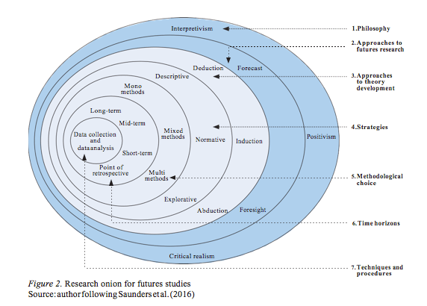
Figure 8: Research Onion Framework
(Source: Melnikovas, 2018)

3.1 Research Philosophy
The positivist philosophy will be used as it assumes that reality is objective, measurable and independent of the researcher and is applied in this study. Positivism is the approach that is appropriate here, because the research tries to test the relationship between the variables that are predetermined and the data that is used is structured data, which is data that can be calculated and has a quantitative approach (Gamage, 2025). This approach will back the idea of relying on uniform questionnaires and statistical analysis, enabling the results to be extrapolated to the wider Gen Z Gymshark customer base and not just interpreted on a case-by-case basis. A positivist approach also allows for the researcher to be value free and not participate in the data collection process, thereby increasing the objectivity and replicability of the research process (Saunders, Lewis and Thornhill, 2019). It is important to ensure that a study can produce actionable and evidence-based marketing recommendations.

3.2 Research Approach
The deductive approach will be used as it allows the existing theory and then formulates testable hypotheses which will be tested with quantitative data (Saunders, Lewis and Thornhill, 2019). This is in contrast to the inductive approach which constructs theory from the patterns found in qualitative data. Considering that this study will start from a framework, which will be extracted from the literature review, that relates social media marketing with brand trust and purchase intention, deduction is the most suitable to choose. The deductive approach also fits in with positivism and quantitative design, allowing the hypotheses formulated from objectives to be statistically analyzed to check their significance and to draw conclusions that are applicable to a wider audience of Gymshark's Gen Z customers.
Consistent with this deductive logic and the conceptual framework presented in Figure 7, the following hypotheses will be tested:
H1: Social media marketing activities have a significant positive influence on brand trust among Generation Z customers of Gymshark in the UK.
H2: Social media marketing activities have a significant positive influence on purchase intention among Generation Z customers of Gymshark in the UK.
H3: Brand trust has a significant positive influence on purchase intention among Generation Z customers of Gymshark in the UK.

3.3 Methodological Choice
This research will be a mono-method of quantitative approach with a structured online survey method to collect numerical data. The quantitative design is suitable when the study's aim is to measure the strength and direction of relationships between variables (e.g., correlation between brand trust and purchase intention) instead of the subjective meanings or lived experiences, which would require a qualitative or mixed methods design (Alford and Teater, 2025). Also, using SPSS tools, quantitative data will be subjected to various statistical analysis, including correlation and regression, which will yield measurable, repeatable results and directly address the research questions and goals.

3.4 Research Strategy
The selected research approach will use an online survey through Microsoft Forms. The positivist-deductive and quantitative research methods will be appropriate for survey research and will gather data within a relatively short period of time from a relatively large sample at a relatively low cost. Microsoft Forms is chosen because it is accessible, can be easily shared via social media and email, automatically gathers responses, and is easily exported to SPSS to analyse (Saunders, Lewis and Thornhill, 2019). Considering the online nature of the target population (Gen Z Gymshark shoppers), conducting an online survey also aligns with how these customers are communicating, which means there is a greater likelihood that they will respond and the data will be of high quality.

3.5 Data Collection Tool
Primary data will be collected by using closed-ended survey with Likert scale questions (using a five-point scale). These items measure constructs that are based on the literature such as social media marketing engagement activities including; entertain, interact, customization, electronic word-of-mouth, credibility of celebrity endorsement. Other constructs are brand trust and purchase intentions. This research will choose close-ended over open ended questions because it will collect enough data that is quantifiable and easy to be coded, and there is less room for interpretations to have impact the results, it would result in standardization of the response. The survey question will have four sections: first is a screening section about the respondent's demographic information; second part is the social media marketing exposure; third section measures the brand trust, and fourth part measures the intention of purchase; the section items used are from reliable previously validated scale to ensure validity of content.

3.6 Sampling Strategy
This study will use a non-probability sampling design combining purposive and convenience elements. The target population is UK residents aged 18-27 who follow or have purchased from Gymshark. Because no complete sampling frame of all UK Generation Z Gymshark customers exists or is accessible to the researcher, probability techniques such as simple random sampling are not feasible; a purposive design with explicit screening criteria (age, UK residence, and Gymshark purchase or follower status) is therefore the most appropriate and transparent choice (Etikan, Musa and Alkassim, 2016; Sharma, 2026). Respondents will be recruited through Gymshark-related social media groups, fitness forums and university networks, with screening questions ensuring that only eligible Gen Z Gymshark customers enter the sample.
The target sample size is approximately 100 respondents. For multiple regression, Green (1991) recommends a minimum of N ≥ 50 + 8m (where m is the number of predictors); with around five social media marketing predictors this implies at least 90 cases, so a sample of 100 satisfies this rule and the common 10-15 cases-per-predictor guidance (Field, 2018). The trade-off of non-probability sampling is reduced statistical generalizability, acknowledged openly in the limitations, while the screening criteria strengthen sample relevance and validity.

3.7 Data Analysis Method
The data obtained will be analyzed with SPSS (Field, 2018), and descriptive statistics will be used to summarize the demographic and response patterns. Then the correlation analysis will be used to test the strength and direction of the social media marketing, brand trust and purchase intention relationship. Multiple regression analysis will be conducted to identify which of the social media marketing factors have the highest influence on brand trust and purchase intention (Ogunleye, 2022). The relative weight of each independent variable (e.g., influencer credibility, UGC, entertainment) will be reflected in the regression coefficient and will directly inform the practical recommendations. In addition, a mediation analysis will be conducted, following the regression-based approach of Baron and Kenny (1986), to test whether brand trust mediates the relationship between social media marketing and purchase intention, consistent with the conceptual framework in Figure 7 and hypotheses H1-H3.

3.8 Reliability and Validity
Criterion | Approach Taken
Reliability | Internal consistency of Likert scale items will be verified with Cronbach’s Alpha for each construct
Content Validity | Survey items adapted from previously validated scales used in peer-reviewed studies
Construct Validity | Confirmed through alignment with the study's theoretical framework
External Validity | Limited by non-probability sampling and the UK-only, single-brand scope; explicit screening criteria enhance sample relevance
Pilot Testing | Prior to a wider distribution, a small pilot study will be conducted to highlight any poorly worded statements or problems with scaling

3.9 Advantages and Disadvantages of the Chosen Methods
Online surveys offer several clear advantages for this study. They are inexpensive, quick to distribute, and well suited to reaching a digitally engaged Generation Z audience, while closed-ended Likert items produce standardised, quantifiable data that can be analysed statistically and coded with little ambiguity (Griffin et al., 2022). SPSS also supports the correlation and regression testing required by the deductive, positivist design, allowing the hypotheses to be assessed efficiently. These strengths are balanced by several disadvantages. Closed-ended questions constrain responses to pre-set options, so they capture the strength of a relationship but not the underlying reasons or context behind a respondent’s attitudes, which reduces the depth and richness of insight compared with qualitative methods (Hadler, 2023). Because recruitment relies on non-probability sampling through online channels, the sample is self-selecting, which introduces the risk of sampling bias and limits how far the findings can be generalised to the wider UK Generation Z population; the modest sample of around 100 further constrains statistical power relative to larger-scale studies. Finally, as the data are self-reported, they are subject to response biases such as social desirability, and stated purchase intentions may not fully reflect actual purchasing behaviour. These limitations are acknowledged transparently and, where possible, mitigated through pilot testing, clear question wording, and anonymity to encourage honest responses.

3.10 Ethical Considerations
This research will follow the principles of ethical research. A mandatory consent statement will be used to ensure informed consent at the beginning of the survey, providing details about the purpose and use of the data in the study. The study will be conducted in accordance with UK GDPR standards, and will ensure that data is collected, stored and processed in lawful, secure and ethical ways. Responses will be kept confidential, anonymous and no personally identifiable information will be collected and all data will be stored on protected university systems and used only in an academic context in accordance with the university's research ethics policy.
Participation will be entirely voluntary and respondents will retain the right to withdraw at any time without giving a reason. Approval will be obtained from the University's research ethics board before any data collection begins (week 3 of the timetable). Although Generation Z includes individuals under the age of 18, this study is explicitly restricted to adults aged 18-27, and an age screening question will exclude any respondent under 18 as an ethical safeguard. Finally, because recruitment takes place through social media groups and online forums, internet-mediated research ethics will be observed: permission will be sought from group administrators before posting the survey link, repeated posting ('spamming') will be avoided, and established netiquette guidelines for online research will be followed (British Psychological Society, 2021).

3.11 Limitations
The nature of the research restricted it to be followed across time, which means only one phase of data collection can be used. A small budget will limit the number of samples and the ability to incentivize recruitment on a larger scale. The study doesn't include the global market and thus is only generalizable to Gymsharks customers. The cross-sectional design has the disadvantage of only being able to detect attitudes at one point in time, which does not allow for the study of changes in consumer behavior over time. Lastly, the use of a self-reported questionnaire can lead to some sources of bias, since reported intentions do not always tell the truth about actual purchasing behavior.

3.12 Resource Implications and Costs
The study is designed to be delivered at minimal direct cost. The principal resource is the researcher's own time across the seven-week schedule, covering questionnaire design, distribution, analysis and writing up. Software costs are effectively zero: Microsoft Forms is available free of charge through the university license, and IBM SPSS is accessed through the university's student license (Field, 2018). No participant incentives will be offered; this keeps the budget at zero but may lower response rates, mitigated by multi-channel recruitment and a short questionnaire. Other needs include secure university cloud storage, library database access, and supervisor time for guidance and ethics sign-off. Because the survey is administered entirely online, no travel, printing or venue costs are anticipated.

4. Expected Outcomes and Timetable

4.1 Expected Contribution
It is anticipated that this study will produce important practical and theoretical implications for future research by experimentally examining the linkage between social media marketing, trust and purchasing intention within the context of a single brand and UK based Gen Z.
Academic contribution: This research adds to the limited body of research that incorporates both the theory of Planned Behavior (TPB) and the Theory of Source Credibility within a single brand within a single generation within the UK. Building on social media marketing models, it empirically tests the mediator of brand trust in the link between marketing and purchase intent of a digitally native activewear brand, engaging in D2C communication. This research provides a replicable methodology for future research looking at Gen Z consumer purchasing behavior on a wide variety of influencer led, D2C brands.
Practical contribution: This study aims to provide the Gymshark marketing team with evidence-based knowledge about what forms of social media marketing, in the form of influencers, UGC, entertainment and interaction that creates customer trust and intention in purchasing among UK based Gen Z user base. Given the growth of the company revenue but the decrease in profit margin, this study may assist in the more efficient allocation of marketing budget for Gymshark to ensure existing and increased satisfaction levels and conversion rate. The study’s recommendations will be practical for Gymshark’s current digital marketing efforts.

4.2 Gantt Chart: Research Timetable
The research will be carried out over 7 weeks. Week 1 will see the finalization of the research question and the proposal. Weeks 1-2 will involve an in-depth and thorough literature review, followed by designing the research methodology and developing the questionnaire in weeks 2-3. The ethical review and pilot testing will be completed in week 3 before data will be collected through an online questionnaire over weeks 4-5. Data analysis will commence with descriptive statistics, correlation and regression on SPSS during weeks 5-6 which will be followed by the drafting of findings, discussion and recommendation over weeks 6-7. Week 7 will see the research being proof read, formatted and finalized for submission. It is acknowledged that seven weeks is a compressed timetable relative to a typical Master's research project; ethics approval is therefore scheduled early (week 3), and the two-week data collection window includes buffer time for participant drop-off and slower-than-expected responses. Should ethics approval or recruitment take longer than planned, the analysis and write-up phases deliberately overlap so that the final deadline can still be met.

Activity | Week 1 | Week 2 | Week 3 | Week 4 | Week 5 | Week 6 | Week 7
Topic finalization & proposal writing
Literature review
Methodology design & questionnaire development
Ethics approval & pilot testing
Data collection
Data analysis
Findings, discussion & recommendations
Final proofreading & submission

References
Ajzen, I., (1991). The theory of planned behavior. Organizational Behavior and Human Decision Processes, 50(2), pp.179-211.
Alford, S. and Teater, B., (2025). Quantitative research. In Handbook of research methods in social work (pp. 156-171). Edward Elgar Publishing.
Alvarez Buylla Lora, M.E. and Dietz, M., (2026). “Let me de-influence you”: How Gen Z reinterprets influencer trust and how this shapes selective consumption. Master’s thesis. Copenhagen Business School.
Baron, R.M. and Kenny, D.A., (1986). The moderator-mediator variable distinction in social psychological research: Conceptual, strategic, and statistical considerations. Journal of Personality and Social Psychology, 51(6), pp.1173-1182.
Bartosiak, A., Lee, J.E. and Loibl, C., (2025). Fear of missing out, social media influencers, and the social, psychological and financial wellbeing of young consumers. PloS one, 20(4), p.e0319034.
British Psychological Society (2021). Ethics Guidelines for Internet-mediated Research. Leicester: British Psychological Society.
Bui, C.T., Ngo, T.T.A., Chau, H.K.L. and Tran, N.P.N., (2025). How perceived eWOM in visual form influences online purchase intention on social media: A research based on the SOR theory. Plos one, 20(7), p.e0328093.
Chaffey, D. (2025). Global Social Media Statistics Research Summary. [online] Smart Insights. Available at: https://www.smartinsights.com/social-media-marketing/social-media-strategy/new-global-social-media-research/ [Accessed 11 July 2026].
Chaudhuri, A. and Holbrook, M.B., (2001). The chain of effects from brand trust and brand affect to brand performance: The role of brand loyalty. Journal of Marketing, 65(2), pp.81-93.
Chung, D.T., (2025). How user-generated content on social media platform can shape consumers’ purchase behavior? An empirical study from the theory of consumption values perspective. Cogent Business & Management, 12(1), p.2471528.
Da, J.Y. and Keat, O.B., (2025). Social Presence and Repurchase Intention in Social Commerce Platforms: Theoretical Review. Journal of Artificial Intelligence and Digital Economy, 2(8), pp.494-512.
Dzreke, S.S. and Dzreke, S., (2025). Influence of social media on consumer behavior: Investigating how social media platforms shape consumer purchasing decisions and loyalty. Open Journal of Business and Management, 13(2), pp.1154-1175.
EMARKETER. (2026). UK Gen Z Social Network Users, by Platform, 2021-2026 (millions). [online] Available at: https://www.emarketer.com/chart/260919/uk-gen-z-social-network-users-by-platform-2021-2026-millions [Accessed 11 July 2026].
Etikan, I., Musa, S.A. and Alkassim, R.S., (2016). Comparison of convenience sampling and purposive sampling. American Journal of Theoretical and Applied Statistics, 5(1), pp.1-4.
Feng, G. and Ou, Y., (2025). The Impact of Marketing Channel Changes on Brand Loyalty in the Digital Era. Economics & Business Management, 1(3), pp.100-107.
Field, A., (2018). Discovering Statistics Using IBM SPSS Statistics. 5th ed. London: Sage.
Gamage, A., (2025). Research design, philosophy, and quantitative approaches in scientific research methodology. Scholars Journal of Engineering and Technology.
Ghonouei, A., Hematinezhad, M. and Hemmatinezhad, M., (2025). The effect of E-Commerce Platforms with the Mediating Role of Customer-related Factors on Sportswear Purchase Intention. Sports Marketing Studies, 6(1), pp.93-108.
Green, S.B., (1991). How many subjects does it take to do a regression analysis? Multivariate Behavioral Research, 26(3), pp.499-510.
Griffin, M., Martino, R.J., LoSchiavo, C., Comer-Carruthers, C., Krause, K.D., Stults, C.B. and Halkitis, P.N., (2022). Ensuring survey research data integrity in the era of internet bots. Quality & quantity, 56(4), pp.2841-2852.
Hadler, J.P., (2023). Context effects in question evaluation via web probing: exploring the interaction of open-ended and closed survey questions. Universitaet Mannheim (Germany).
Hipólito, F., Dias, Á. and Pereira, L., (2025). Influence of consumer trust, return policy, and risk perception on satisfaction with the online shopping experience. Systems, 13(3), p.158.
Hovland, C.I., Janis, I.L. and Kelley, H.H., (1953). Communication and Persuasion: Psychological Studies of Opinion Change. New Haven: Yale University Press.
Ismael, A.S., Amin, M.B., Ali, M.J., Hajdú, Z. and Péter, B., (2025). Relationship between social media marketing and young customers’ purchase intention towards online shopping. Cogent Social Sciences, 11(1), p.2459881.
Jeansson, F. and Hemmingson, K., (2025). Sponsored content, influencers & Gen Z, how are they connected? A study on how the interrelationship between sponsored content and influencers is affected by Gen Z’s relationship with influencers. Bachelor’s thesis. Jönköping University.
Jingyi, W. and Ali, S.K.B.S., (2025). A systematic review of the relationships between attitude, subjective norms, perceived behavioral control, and exercise intention. The Open Public Health Journal, 18(1).
Kadam, P., (2025). Effectiveness of digital marketing strategies. New Dimension In Commerce, Accountancy And Economics, 131.
Kaplan, A.M. and Haenlein, M., (2010). Users of the world, unite! The challenges and opportunities of Social Media. Business Horizons, 53(1), pp.59-68.
Luthfi, A., Bagariang, J.M. and Kurniawati, N., (2025). The influence of brand experience, brand trust, and brand awareness on e-WoM through customer satisfaction. Manajemen Dan Bisnis, 24(2), pp.281-295.
Melnikovas, A., (2018). Towards an explicit research methodology: Adapting research onion model for futures studies. Journal of Futures Studies, 23(2), pp.29-44.
Migkos, S.P., Giannakopoulos, N.T. and Sakas, D.P., (2025). Impact of influencer marketing on consumer behavior and online shopping preferences. Journal of Theoretical and Applied Electronic Commerce Research, 20(2), p.111.
Minbale, E., Bizuneh, B., Seife, W., Sharew, S. and Bitew, K., (2025). Exploring purchasing behavior of Ethiopian consumers towards locally produced apparel products: an extended model of the theory of planned behavior. Cogent Business & Management, 12(1), p.2503420.
Modaes (2026). Gymshark’s Revenue Soars to Record €748.6 Million in 2025, Marking a 6.4% Uptick. [online] Modaes Global. Available at: https://www.modaes.com/global/companies/gymshark-record-turnover-of-7486-million-euros-in-2025-up-64 [Accessed 11 July 2026].
Morgan, R.M. and Hunt, S.D., (1994). The commitment-trust theory of relationship marketing. Journal of Marketing, 58(3), pp.20-38.
Ogunleye, J.O., (2022). Predictive data analysis using linear regression and random forest. In Data integrity and data governance. IntechOpen.
Ohanian, R., (1990). Construction and validation of a scale to measure celebrity endorsers’ perceived expertise, trustworthiness, and attractiveness. Journal of Advertising, 19(3), pp.39-52.
Palaparti, S. (2025). Why customer testimonials and peer reviews are key to shopper trust in 2025. [online] Bazaarvoice. Available at: https://www.bazaarvoice.com/blog/why-customer-testimonials-and-peer-reviews-are-key-to-shopper-trust-in-2025/ [Accessed 11 July 2026].
Pereira, D. (2026). Gymshark Business Model - How Gymshark Makes Money? [online] Business Model Analyst. Available at: https://businessmodelanalyst.com/gymshark-business-model/?srsltid=afmboopmbsjlqzosteyaoeuxxw36hkoi9m5-pxxgqrrwrejpf90mxm7y [Accessed 11 July 2026].
Putro, R.F.E. and Aribowo, A., (2026). Influencer Marketing and Purchase Intention of Local Sportswear: The Mediating Role of Brand Awareness. International Journal of Multidisciplinary Sciences and Arts, 5(1), pp.1-9.
Rehman, F.U., Zahid, H., Qayyum, A. and Jamil, R.A., (2025). Building relationship equity: Role of social media marketing activities, customer engagement, and relational benefits. Journal of Theoretical and Applied Electronic Commerce Research, 20(3), p.223.
Saunders, M., Lewis, P. and Thornhill, A., (2019). Research Methods for Business Students. 8th ed. Harlow: Pearson Education.
Shaheen, A., Khataan, A., Awad, A., Eldin, A.Y.S. and Elnour, A., (2025). The role of influencer content value and credibility in purchase intention. Innovative Marketing, 21(3), p.14.
Shammout, E., Meqdadi, O., Shammout, A.B. and Alshaketheep, K.M.K.I., (2025). Sustainable Marketing’s Impact on Purchase Intentions: The Roles of Brand Image, Trust, and Customer Engagement. Journal of Logistics, Informatics and Service Science, 12(6), pp.31-44.
Sharma, L.R., (2026). Choosing the Right Non-Probability Sampling Design in Research. International Journal of Atharva, 4(1), pp.113-129.
Tafolli, F., Qema, E. and Hameli, K., 2025. The impact of electronic word-of-mouth on purchase intention through brand image and brand trust in the fashion industry: Evidence from a developing country. Research Journal of Textile and Apparel, 29(4), pp.1160-1176.
Thompson, A. and Thompson, A. (2025). New report: The latest Digital and Social Data from the UK - We Are Social UK. [online] We Are Social UK. Available at: https://wearesocial.com/uk/blog/2025/11/new-report-the-latest-digital-and-social-data-from-the-uk/ [Accessed 11 July 2026].
Ulfamiyati, U. and Bangsa, J.R., (2026). The Effect of User-Generated Content, Discount Promotions, and Reviews on Impulsive Buying Among Gen Z on Tiktok Shop. Golden Ratio of Data in Summary, 6(1), pp.376-387.
Ulfstedt, V., (2025). Trust and authenticity in influencer marketing: How sponsored content is perceived and how it affects purchasing decisions in 2025. Bachelor’s thesis. Haaga-Helia University of Applied Sciences.
Valmohammadi, C., Asayesh, F., Mehdikhani, R. and Taraz, R., (2025). Influencer marketing, EWOM, E-brand experience, and retail E-brand loyalty: moderating influence of E-brand love. Journal of Relationship Marketing, 24(1), pp.66-92.
Virtanen, P., (2025). The role of influencer marketing and paid promotions on the buying behaviour of consumers aged 15-35 years old. Bachelor’s thesis. Haaga-Helia University of Applied Sciences.
Widjaja, A.F., (2025). Factors influencing purchase intention in e-commerce: An analysis of brand image, product quality, and price. JUMDER: Jurnal Bisnis Digital dan Ekonomi Kreatif, 1(3), pp.32-47.
Yasa, Y.A., Durmuş, B. and Uslu, A., (2025). Mapping a Decade of Source Credibility Research in Influencer Marketing: A Bibliometric Review. Turkish Journal of Marketing Research, 4(1), pp.49-76.
Yulianto, E. and Fahrudi, A.N.L.I., (2025). The influence of social media marketing activities on purchase intention through brand trust and brand image. Wacana Journal of Social and Humanity Studies, 28(1), pp.51-60.

