

Programme Name: Master of Business Administration
Module Name and Code: International Marketing: Principles and Practices - LCMB7026

Coca-Cola’s International Marketing Strategy in the UK and India

Lecturer: Tushara Balendran
Student Name: SIRAJUL ISLAM
Student ID: 2422222

Table of Contents
1. Introduction 4
2. Overview of Coca-Cola and Its Operation in the UK and India 4
2.1 Company Background and Global Reach 4
2.2 Coca-Cola in the United Kingdom 5
2.3 Coca-Cola in India 5
3. Macro-Environmental Context Using PESTLE (Country Comparison) 6
3.1 Definition of the Macro Environment 6
3.2 Political Factors 7
3.3 Economic Factors 7
3.4 Social Factors 8
3.5 Cultural Factors (Using Hofstede’s Model) 9
3.6 Environmental Factors 11
3.7 Similarities and Differences of PESTLE Analysis 12
4. STP Analysis – Segmentation, Targeting and Positioning 12
4.1 Segmentation Strategy 12
4.2 Targeting Strategy 14
4.3 Positioning Strategy 15
4.4 Differences and similarities of STP 17
5. Marketing Mix Strategy -The 7Ps. 18
5.1 Product 18
5.2 Price 19
5.3 Place 19
5.4 Promotion 21
5.5 People 21
5.6 Process 22
5.7 Physical Evidence 22
5.8 Similarities and Dissimilarities of the 7Ps 22
5.9 Marketing Effectiveness Analysis 23
6. Evaluation of Ethical Issues – United Kingdom 24
7. Overall Recommendation 24
8. Conclusion 25
Reference 27
Appendix 30

1. Introduction
Global fast-moving consumer goods (FMCG) organisations take up a niche of great importance, and international marketing is the main process through which the business organisations grow and stabilise their operations. The success of a brand in a global market environment where consumers have divergent tastes and preferences rooted in cultural and economic factors is possible only when the latter adjusts its products to local needs and maintains a consistent global presence (Huse et al., 2022). In the FMCG industry, international marketing practice means that a brand is not only introduced in new markets, but it is also nurtured in order to be relevant by the use of local knowledge and culture. With over 200 jurisdictions, the company has been able to master standardisation and adaptation and balance its global brand image with local heterogeneous tastes (Penn-Jones et al., 2023). This kind of dual approach has enabled Coca-Cola to compete effectively even in the already developed economies and to grow fast in the emerging markets. The current report is a critical analysis of the International marketing strategy of Coca-Cola in two countries, which exhibit sharp contrasts in culture, economy, and consumer behaviour in the United Kingdom and India. This report will compare macro-environmental factors, segmentation and positioning strategies, and marketing-mix strategies. It will also examine the ethical issues and end with suggestions on how Coca-Cola can improve its international marketing performance in these two opposite markets.

2. Overview of Coca-Cola and Its Operation in the UK and India

2.1 Company Background and Global Reach
Coca-Cola is a soft drink that was established in 1886 in Atlanta, United States, by Dr. John Pemberton. It was originally an initiative that functioned as a local soda fountain elixir, but since then, this has transformed into the largest beverage corporation in the world, with operations still active in over 200 countries (Rogers et al., 2023). The first UK Coca-Cola commercial was in 1900, and the product was imported until 1909, when local bottling began. Coca-Cola entered the Indian market in 1950, but government limitations forced it to close in 1977. The firm returned to the market in 1993 following Indian economic liberalisation (Coca-Cola, 2025). The company has a strong competitive strength due to a diversified portfolio of products that include Coca-Cola Classic, Diet Coke, Coke Zero Sugar, Sprite, Fanta and Minute Maid. With time, Coca-Cola has not only grown to contain carbonated soft drinks, but also bottled water, juices, teas and energy drinks, thus adapting to the changing consumer needs. The company maintains a market leadership in the non-alcoholic drinks industry in the world and has always surpassed its competitors, like PepsiCo (Rogers et al., 2023). The general approach of Coca-Cola is based on the combination of a strong brand image and adaptation to local specifics. Its marketing programmes are based on emotional connectivity, happiness and shared experience-messages that are constant but tailored to the local culture and consumer preference. The company’s mission statement is, “Our purpose is to refresh the world and make a difference” (Coca-Cola, 2025).

2.2 Coca-Cola in the United Kingdom
Coca-Cola was introduced in the United Kingdom in 1900 and gained a household name in no time. Operations of the brand are run under the Coca-Cola Europe Pacific Partners (CCEP), which runs production, bottling and distribution operations. The UK market is both mature and highly competitive, and there is an emerging customer demand for healthier, low-sugar products (Paul, 2020). To this, Coca-Cola provides a wide range of products, especially Diet Coke, Coke Zero Sugar, and low-calorie products. In 2018, the introduction of the UK Sugar Tax boosted the conversion of the company to the reformulated drinks. The marketing of Coca-Cola in the United Kingdom focuses on emotional storytelling and seasonal promotional campaigns like the legendary Coca-Cola Christmas Truck, or the Share a Coke programme, which personalised bottles with the names of consumers (Paul, 2020). The strategy incorporates nostalgia, health awareness, and sustainability - the values of the health-conscious and environmentally conscious consumer base of the UK.

2.3 Coca-Cola in India
Coca-Cola first entered India in 1950 and later pulled out in 1977 following the restrictions on foreign ownership and possession. It re-entered in 1993 after the economy was liberalised, and since then, the brand has built a strong base in the urban and rural markets. Its good performance in India can be attributed to localisation, whereby it provides smaller, affordable packets, and it is also carrying out regional marketing using local languages (Penn-Jones et al., 2023). Through its Indian brands like ThumsUp, Maaza and Limca, Coca-Cola is targeting the different local tastes. The company’s rural approach focuses on low cost, local alliances and a massive delivery channel that would allow it to infiltrate even the most isolated areas in one of the fastest growing drink markets in the world.

3. Macro-Environmental Context Using PESTLE (Country Comparison)

3.1 Definition of the Macro Environment
A company's market performance and strategic decisions depend on the macro-environment. These external factors affect the firm's worldwide operations. Political, economic, social, technical, legal, and environmental issues affect corporate performance (Wang, He and Barnes, 2017). This study explains how varied markets provide possibilities and dangers to global firms like Coca-Cola. The UK-India comparison shows that Coca-Cola's overseas marketing approach relies on economic maturity, regulatory environment, and culture.
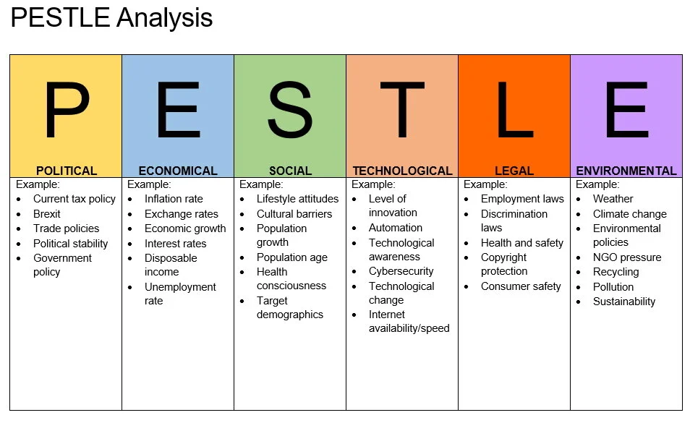
Figure 1: PESTLE Analysis
Source: (Wang, He and Barnes, 2017)

3.2 Political Factors
UK: The United Kingdom boasts of political stability and strong democratic government, coupled with clear trade policies. The introduction of the Soft Drinks Industry Levy (Sugar Tax) in 2018 can be discussed as a bright example of how the government prioritises the health of the population and responsible consumption (Tuominen et al., 2023). Even though this law has posed a threat to the essence of Coca-Cola in the sale of sugary products, it has also propelled the company to innovate low and zero-sugar products. Besides, the current trade agreements and infrastructural policies enable smooth market penetration and distribution (Paul, 2020).

Favourable or Unfavourable: The political environment of the United Kingdom is moderately favourable due to the presence of stability and transparency, and is complicated by strict sugar regulations (Wang, He and Barnes, 2017).

India: The Indian political environment is largely favourable to foreign investments. The foreign direct investment was brought by economic reforms and especially the liberalisation programme of 1991, which allowed Coca-Cola to re-enter the market in 1993. Nevertheless, sometimes bureaucratic means and the complexity of regulations hamper the efficiency of operations (Paul, 2020). Coca-Cola is based on the existing political stability, which is backed by the pro-business administration and the rural infrastructure development.

Favourable or Unfavourable: The environment in India is favourable, as the policies towards foreign direct investment are favourable, and the rural development is growing, despite the presence of long-standing regulatory barriers.

3.3 Economic Factors
United Kingdom: With a GDP of USD 3.4 trillion in 2024 and a GDP per capita of USD 50,000, the United Kingdom is one of the most sophisticated economies in the world. The GNI (Gross National Income, used as a proxy for GNP) was approximately USD 2.70 trillion in 2023. Even though inflation averaged 4.2% economic growth was just 1.1% (Zeqiri et al., 2025). The high cost of living and long-term impacts of Brexit have limited consumer spending on non-essentials like soft drinks. The Soft Drinks Industry Levy, implemented in 2018, has continued to lower Coca-Cola's profit margins (Tuominen et al., 2023). However, Coca-Cola's significant buying power and well-established retail distribution will assist in preserving low- and zero-sugar product demand. Premium pricing techniques still work with health-conscious customers, although standard variations have rather elastic demand.

Favourable or Unfavourable: Economically, the United Kingdom offers a fairly negative situation because of low growth rates and a high cost-based framework.

India: The Indian economy is valued at USD -3.9 trillion in 2024, with a growth rate of above 6% and a GDP per capita of USD -2,800 (Zeqiri et al., 2025). GNP was reported at approximately USD 3.59 trillion in 2023. Rated inflation of 5.4%, and urbanisation has expanded the drink market. The expanding middle class and discretionary money boost low-end and luxury brand consumption (Coca-Cola, 2025). Coca-Cola uses localisation to reach rural regions and provide smaller, cheaper packages to price-sensitive customers.

Favourable or Unfavourable: India is a very favourable location in the long-term growth of volume and market penetration of Coca-Cola (Tuominen et al., 2023).

3.4 Social Factors
UK: The United Kingdom is characterised by an ageing population, but it still has a strong brand loyalty culture. The growing health consciousness has also influenced the reduction of sugar intake and a subsequent move towards water, juices, and zero-sugar products (Wang, He and Barnes, 2017). This is in line with the diversification strategy of Coca-Cola that strengthens the market of products like Coke Zero Sugar and Diet Coke. The use of social media and digital advertising has increased consumer interaction, thus keeping Coca-Cola culturally relevant.

Favourable or Unfavourable: In the United Kingdom, the social conditions favour the social product lines of Coca-Cola, that is, zero-sugar but not soft drinks.

India: The social environment in India is a big opportunity. The country has one of the youngest demographics in the world, with more than 65% of its population being below the age of 35 (Steenkamp, 2020). The introduction of the Western style of life and urbanisation has made them susceptible to foreign brands. Coca-Cola is also positioned as a youthful and festive brand backed up by local festivals and sponsorship of cricket. However, the health awareness rate is relatively low compared to the United Kingdom.

Favourable or Unfavourable: The young and growing population of India makes the social environment of the country highly favourable to long-term market growth (Steenkamp, 2020).

3.5 Cultural Factors (Using Hofstede’s Model)
The basis of cultural differences dictates the way Coca-Cola will interact with consumers in diverse markets. The Hofstede Model identifies six measurable dimensions that explain the influence of culture in marketing communication, consumer behaviour, and brand perception in the United Kingdom and in India (Tuominen et al., 2023).
Dimension | United Kingdom (Score) | India (Score)
Power Distance | 35 – Low | 77 – High
Individualism | 89 – Very High | 48 – Moderate (Collectivist)
Masculinity | 66 – Moderately Masculine | 56 – Balanced
Uncertainty Avoidance | 35 – Low | 40 – Moderate
Long-Term Orientation | 51 – Moderate/Short-Term | 61 – Long-Term Focused
Indulgence | 69 – High | 26 – Restrained
Source: (Panda, 2024)
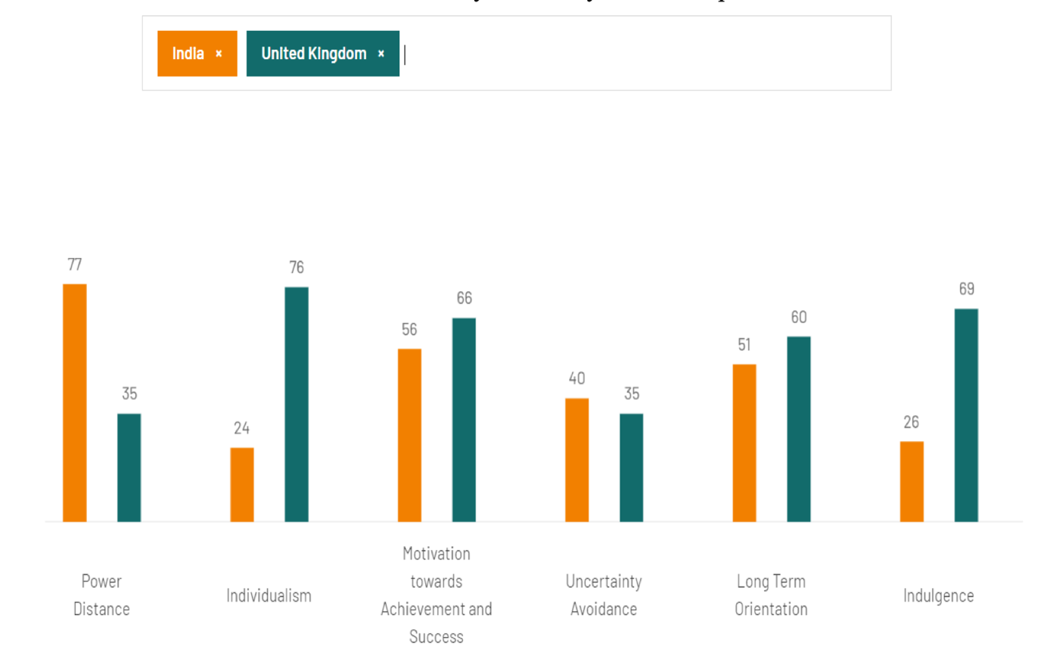
Figure 2: Hofstede’s Cultural Dimensions
Source: (Panda, 2024)
The low power distance score (35) of the United Kingdom shows that the country favours equality and informal communication. The Share a Coke campaign of Coca-Cola creates personal intimacy and inclusivity, which is in line with this cultural paradigm. Moreover, the country is characterised by a high degree of Individualism (89), which implies that the target market is prone to self-expression and autonomy, hence is open to product differentiation like Coke Zero Sugar and Diet Coke (Panda, 2024).

On the other hand, power distance is high in India (77), and the score on Individualism is low (48), which highlights the role of community and family in the decision-making process of purchasing. Coca-Cola has scaled down its messages to avoid the use of group-based advertising and use localised storytelling (Panda, 2024). The high score on Long-Term Orientation (61) of India indicates that the consumers value continuity and tradition, and Coca-Cola can integrate its brand story with the regional festivities and emotionally significant occasions.

Favourable or Unfavourable: The cultural environments in each market support Coca-Cola's strategic aims for different reasons (Safeer et al., 2022). UK social structure fits perfectly into Coca-Cola's global branding strategy and lifestyle advertising campaigns, while India's collectivist culture and prolonged orientation develop emotional loyalty through family and community-focused campaigns.

Advantages and Disadvantages of Hofstede’s Model
Advantages: The Hofstede model's quantitative, comparative explanation of culture's impact on marketing decision-making is its key strength. The approach lets Coca-Cola adapt to market-specific communication techniques and campaign topics, making it a useful analytical tool (Zeqiri et al., 2025).
Disadvantages: The model's antiquity, constant structure, and cultural generalisation are drawbacks. The Indian country is too heterogeneous to be characterised with one aggregate score. Although limited, Hofstede's approach may be used to assess cross-cultural marketing contrasts between the UK and India (Zeqiri et al., 2025).

3.6 Environmental Factors
UK: Environmental sustainability is one of the key areas of public policy. There are strong recycling laws in place, and the government targets high volumes of carbon-cutting (Panda, 2024). Coca-Cola is responsive to the sustainability agenda of the United Kingdom in its World Without Waste campaign, which aims to get a 100% bottle recycling rate by 2030 (Safeer et al., 2022). However, the demand for plastic-free options among consumers is constantly growing, thus increasing the cost of production.
Favourable or Unfavourable: The environmental situation of the United Kingdom is generally favourable to those brands that invest in sustainability. Though it is not as favourable to products that heavily use plastic packaging (Panda, 2024).

India: There is a growing awareness of the environment, but it is not spread uniformly over the regions. Coca-Cola has been criticised for the amount of groundwater it consumes and the amount of plastic waste it produces. The company has, in turn, invested in rainwater collection efforts and community-based recycling programmes in response. However, waste management infrastructural weaknesses still exist and are a major challenge in operations.

Favourable or Unfavourable: The environmental factors in India are rather unfavourable, partly because of the lack of infrastructure. But Coca-Cola has improved its local image through its sustainability efforts.

3.7 Similarities and Differences of PESTLE Analysis
Similarities: Both the UK and India have strong brand image and customer loyalty for Coca-Cola. The company makes profit from the young, digitally active population through global advertising like “Taste the Feeling” (Safeer et al., 2022). These two countries are politically stable, which promotes business growth. The environmental sustainability of these countries pushes Coca-Cola to prioritise its sustainability initiatives. The social and cultural trends, like health awareness, encourage Coca-Cola to expand its low- and zero-sugar product lines.

Differences: The UK market is highly developed, highly regulated and becoming health-aware, which means that it requires a constant stream of low-calorie products. India, on the other hand, has a high growth rate, multiculturalism and a growing consumer base (Safeer et al., 2022). India is a better place to expand both politically and economically, whereas the United Kingdom is stable, but with few growth opportunities. The United Kingdom is the most compliant with sustainability. But India has prospects to make a change on a large scale in the context of changing ecological consciousness.

4. STP Analysis – Segmentation, Targeting and Positioning

4.1 Segmentation Strategy
Coca-Cola divides its consumers into geographic, demographic, psychographic, and behavioural levels to suit the differences between the United Kingdom and India.
Geographic Segmentation:
Geographic segmentation defines the markets as urban and rural. The United Kingdom is a highly urbanised country where Coca-Cola focuses on targeting cities and towns where the consumption patterns are determined by supermarkets, convenience stores and vending machines (Ma, Pu and Wang, 2021). The company has a wide network of distribution, local bottlers and wholesalers in India because of the large and diverse rural population to provide the product even in far-flung areas.
Demographic Segmentation:
Demographic segmentation focuses on consumers aged between 15 and 45, such as students, young professionals and middle-income families. The population of the United Kingdom is health-conscious and likes low or zero-sugar drinks like Diet Coke and Coke Zero Sugar. In India, the age bracket is young, aspirational and open to foreign cultural influences (Helmold, 2022). The Coca-Cola company targets the middle- and upper-class family segment with mainstream products, and the lower-income segment with a 200-ml pack that is affordable.

Psychographic Segmentation:
The psychographic segmentation is based on those who are brand-conscious, lifestyle-oriented and socially active. The UK Coca-Cola consumers, according to VALS, are likely to be the Achievers or Experiencers with their preference to the established brands and the developed image. Indian consumers, especially those in the emerging markets, on the other hand, are oriented towards the Striver segment, which asserts and status, or show a heterogeneous blend of all of the segments due to the mass-market nature of the product.

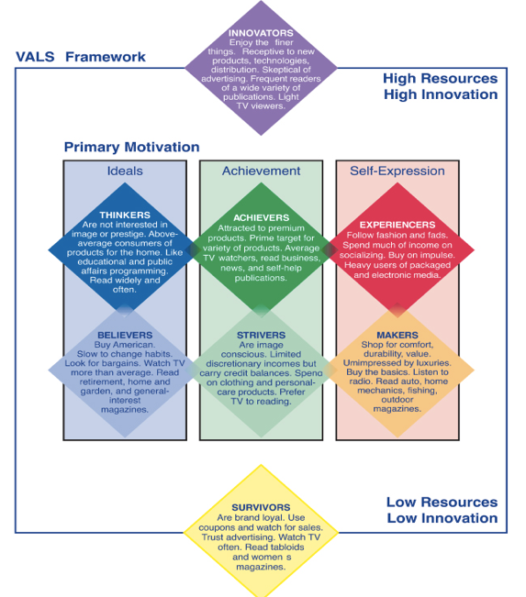
Figure 3: VALS Framework
Source: (Moh. Miftahul Arief et al., 2024)
The UK consumers are more mindful of their health and environment, but the Indian consumers relate Coca-Cola with fun, festivity, and civilisation (Moh. Miftahul Arief et al., 2024).

Behavioural Segmentation:
Behavioural segmentation refers to the regular consumers of soft drinks in need of refreshment and convenience (Ma, Pu and Wang, 2021). The UK consumers prefer healthier versions, whereas the consumption has the highest number during festivals, social events as well as outdoor activities in India. Coca-Cola reinforces these trends with the help of promotions and seasonal campaigns.

4.2 Targeting Strategy
Coca-Cola uses a differentiated targeting approach to position its marketing to the needs of particular consumers in any market.
United Kingdom:
In the United Kingdom, Coca-Cola has one more adult and millennial market with the focus on sugar-free and low-calorie drinks. It focuses on marketing the lifestyle and not on product promotion. Diet Coke and Coke Zero Sugar are brands that are targeted at people who consider pleasure and health at the same time. Emotional storytelling is employed in campaigns like Open Happiness and Real Magic as an emphasis on positivity and inclusivity (Helmold, 2022). The extensive digital landscape of the United Kingdom enables accurate social media targeting, and collaboration with football clubs, summer festivals, and the Premier League enhances work with the community.

India:
In India, Coca-Cola is focused on young and aspirational customers aged between 15 and 35 and mostly the middle classes in the city. The strategy is informed by affordability and international popularity (Moh. Miftahul Arief et al., 2024). Coca-Cola original taste, Thums Up, Maaza, and Sprite are some of the sub-brands that satisfy the various tastes. The IPL and cultural festivals are sponsored, and this creates good connections with the young generation and national identity.

4.3 Positioning Strategy
The positioning of Coca-Cola throughout the world revolves around happiness, togetherness, and emotional attachment. The Real Magic and Taste the Feeling slogans strengthen the common experiences and ensure keeping the brand identity on the international level (Luick et al., 2024). Nonetheless, the positioning is modified to fit the cultural and economic settings.

United Kingdom:
In the United Kingdom, the strategy is differentiated with a strong focus on premiumization and catering to health trends (heavy promotion of Coke Zero/Diet Coke) for an affluent, health-aware consumer base. Coca-Cola will be marketed as a refreshing, nostalgic and lifestyle beverage. Emotional appeal is enhanced by heritage campaigns like the Christmas Truck and Share a Coke (Helmold, 2022). The focus on zero-sugar will fit the high health awareness of the United Kingdom. The highlights of the messaging are moderation, active living, and sustainability, establishing a premium but responsible image.

India:
In India, the strategy is differentiated but focuses heavily on affordability and widespread distribution (small, low-cost packs) to target a mass-market consumer base with diverse income levels and strong local product loyalty. Coca-Cola is positioned as something affordable and a social bonding agent. Thanda Matlab Coca-Cola are campaigns using local language and culture (Forde et al., 2022). The brand narrative is determined by celebration, friendship, and diversity. Given the affordable prices, Coca-Cola can be used as an accompaniment in everyday experiences.

Positioning Illustration (Perceptual Map)
The perceptual logic used in the visual map is given below. It contrasts brands according to the level of price and the image of perceived quality/lifestyle:
- Coca-Cola: Mid-high price, high lifestyle image.
- Pepsi: Average price, average lifestyle image (Forde et al., 2022).
- Diet Coke/Coke Zero: Mid-market, good health lifestyle image.
- Thums Up (India): Low to mid-price, brash style of living image (Forde et al., 2022).
- Local/ private labels: Low price, low perceived quality.
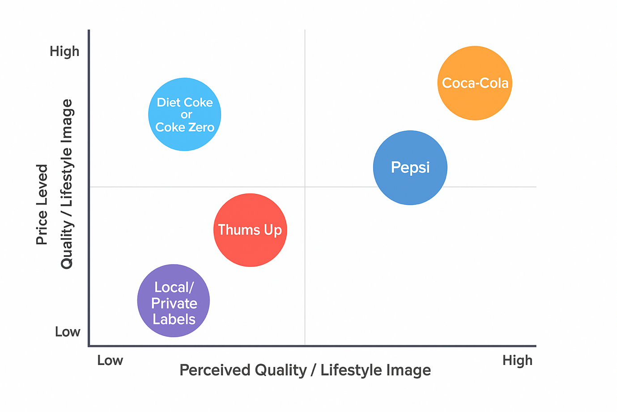
Figure 4: Perceptual Map
Source: (Forde et al., 2022)

This map sustains Coca-Cola's two-fold strategy: in the United Kingdom, and the premium and responsible, and in India and accessible and emotional.

4.4 Differences and similarities of STP
Similarities:
Coca-Cola works with the youth-oriented segment and chooses to use emotive positioning that highlights the feelings of happiness and collective experience in both the United Kingdom and India (Forde et al., 2022). The brand applies the psychographic segmentation in terms of lifestyle choices and maintains a consistent global identity with the help of campaigns like Share a Coke. The business strategy in both markets is based on online marketing and wide distribution.

Differences:
Segmentation is different as in the United Kingdom, the focus will be on health-conscious consumers interested in low- or no-sugar drinks, and in India, the segment will be the aspirational and price-sensitive young people (Helmold, 2022). Positioning difference is also noticeable: the segments with high lifestyle dominate in the United Kingdom, but in India is based on the affordability of the masses. The image of the brand is no longer the responsible, nostalgic calls in the United Kingdom but the available, socially connected messages in India.

5. Marketing Mix Strategy -The 7Ps.

5.1 Product
Coke Zero Sugar, Diet Coke, Coca-Cola Original, Fanta, Sprite, and Dr Pepper are widely available in the UK. On the other hand, India sells Coca-Cola Original, Thums Up, Sprite, Fanta, Limca, and Maaza Mango Drink. Coca-Cola UK extends into functional drinks through Powerade and premium hydration via Smartwater. On the other hand, India features strong brand extensions with Thums Up Charged, Maaza Gold, and Sprite Lemon+ (Batat, 2024). In its operation in the United Kingdom and India, Coca-Cola uses a dual approach of standardisation and adaptation. Although the basic beverage formula is a worldwide standard, underpinning a strong brand image, other peripheral factors like packaging, flavour, and bottle capacities are adjusted in accordance with the local consumer tastes (Batat, 2024). The brand has developed its sugar-free range of products in the United Kingdom by launching Coke Zero Sugar and Diet Coke as part of its gamma, which allows it to meet the current health demand. In India, on the other hand, the company sells domestically resonant versions, such as Thums Up, Maaza, and price-appropriate smaller packs, and replaces packaging materials with sustainability in the UK and durability, cost-effectiveness, and linguistic factors in India (Batat, 2024). This is a hybrid model that will enable the company to be relevant in the two different markets. Product image shown in the appendix.

5.2 Price
Coca-Cola also deploys market-based pricing that is responsive to region-based incomes and competitive forces. The United Kingdom is a country where the premium pricing strategy is used because of the high brand equity, consumer buying power, and preference towards innovative products with zero sugar content (Elgarhy and Mohamed, 2023). The sugar tax also affects the prices; the company sets the low-calorie products at favourable prices to survive the regulatory forces. A penetration pricing model is preferred in India to appeal to the very price-sensitive customers. Low prices, SKUs, the availability of returnable glass bottles, and the 200 ml packs allow the companies to penetrate the market widely. There are minor price differences between rural and urban segments, which are due to differences in the cost of logistics and distributor margins (Elgarhy and Mohamed, 2023). Altogether, the economically differentiating pricing mechanisms outline the economic differences: high pricing in the United Kingdom and inclusivity on the grounds of value in India.

5.3 Place
Although Coca-Cola has a long network of distribution in different countries, each country requires a tailor-made channel strategy. The brand is dependent on supermarkets, convenience stores, online grocery sites, restaurants, pubs, and vending machines in the United Kingdom, and has an advanced e-commerce fulfilment service, which is reinforced by well-developed logistics (Jewel and Kalam, 2020). The distribution into deep rural market penetration is achieved by the use of local bottlers, wholesalers, kirana stores, as well as cold-chain systems adjusted to the hot climates in India. Last-mile delivery, pushcarts, and collaboration with regional distributors are overinvested to cover all areas, and digital ordering provided through food-delivery applications will expand the market in the city. All these mechanisms ensure the product’s availability in a variety of consumption situations. The store’s image is shown in the appendix.
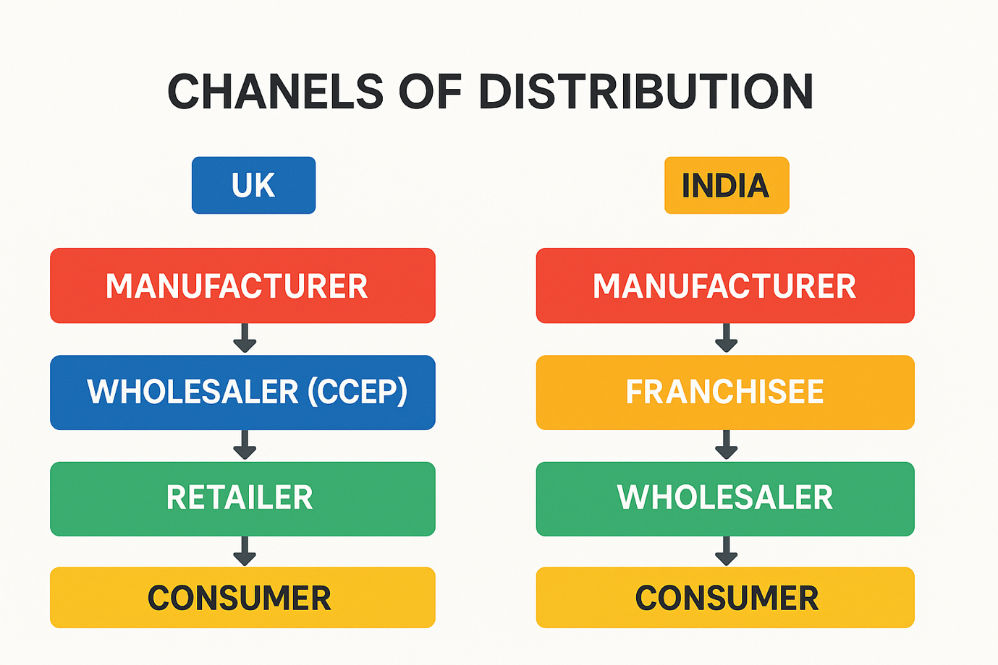
Figure 5: Channels of Distribution for the UK and India
Source:(Jewel and Kalam, 2020)
In the UK, Coca-Cola uses an indirect distribution system through Coca-Cola Europacific Partners, while in India, it also uses indirect distribution through franchise bottlers and extensive wholesaler networks (Jewel and Kalam, 2020).

Market Entry Method
Coca-Cola was introduced in the United Kingdom as a direct investment, which is a wholly owned subsidiary of Coca-Cola Europacific Partners (CCEP). This solution grants complete oversight of manufacturing, branding, quality, intellectual property and supply-chain administration, hence enabling speedy innovation. But it comes with a heavy investment and regulation compliance costs and exposure to taxation, such as a sugar surcharge (Batat, 2024). Coca-Cola uses the franchise and partnership system in India with the help of local bottlers like Hindustan Coca-Cola Beverages. This is a risk-reducing strategy, which helps in market penetration, phased entry, and allows local adaptation of flavours and packaging. The operational control and increased reliance on partner efficiency are reduced, which is viewed as acceptable because of the size and diversity of India.
The franchise-partnership approach allows Coca-Cola to experience rapid growth at minimal financial risk and capitalise on the market experience of the local bottlers. However, the approach involves a loss of control over operations, which makes Coca-Cola rely on the success and efficiency of the local partners (Elgarhy and Mohamed, 2023). Coca-Cola chose this strategy since the market in India is large, heterogeneous and price-sensitive. It requires flexible and locally-focused production and distribution, which can only be offered effectively through a franchise system.

5.4 Promotion
Promotional tactics are localised in terms of culture, social and economic differences. The campaigns in the United Kingdom resonate with emotions and health orientation with themes of togetherness, nostalgia, sustainability, active living, and reduced-sugar lifestyles using digital media, television advertising, outdoor placements, and experiential marketing like the Christmas Truck Tour. Football club sponsorships strengthen the sense of community (Jewel and Kalam, 2020). Promotions in India are made through the use of celebrity endorsements, partnerships with Bollywood, festival campaigns and Indian Premier League sponsorships. The advertising in a regional language, culturally specific storytelling, and colourful aesthetic elements keep them relevant, and the promotions focus on happiness, friendship, low cost, and refreshment.

5.5 People
Coca-Cola India has 25,000 direct employees, and Coca-Cola Great Britain has around 32,700 employees according to recent data (Coca-Cola, 2025). Coca-Cola’s service experience revolves around human resources. To achieve uniformity in the quality of service delivery, the company trains its staff, develops leaders, and provides frontline support in both countries. Influencers, event promoters and brand ambassadors influence the perception of the masses Kusdiana and Yulita, 2024). Here, the local youth ambassadors, sports heroes and hosts of the festivals increase the cultural context in India, whereas in the United Kingdom, workers are involved in sustainability programmes, communal activities, and CSR-related campaigns. Such interactions support the value of relationships and brand loyalty. Coca-Cola Stuff’s image is shown in the appendix.

5.6 Process
Coca-Cola maintains effective business practices based on supply-chain management, production and quality, and online technology. The company uses sophisticated logistics, automated warehousing, and data-based forecasting in the United Kingdom to ensure fast replacement, and the integration of digital technology helps to process the orders through e-commerce and track sustainability (Elgarhy and Mohamed, 2023). In India, operation priorities are made around agility and reach, where cold-chain provisions, rural distribution model, and flexible production plants allow the company to deal with climatic variability and demographic diversity. Mobile ordering systems and tracking route algorithms also increase the efficiency of delivery, which guarantees the stable availability of products in both regions.

5.7 Physical Evidence
There is physical evidence that supports the brand experience of Coca-Cola. Worldwide factors encompass the unique design of the red logo, the rounded shape of bottles, typography and uniform packaging. In the UK, quality and sustainability are emphasised in clean designs, recyclable packaging, event installations and digital displays (Komari et al., 2020). Visibility in India is in the form of store signs, festival stands, branded coolers, kiosks and delivery carts. Branding, particularly physical branding, is transferred to the virtual sphere using digital platforms as well as mobile advertising and social media. These touchpoints enhance recognition and trust. Coca-Cola’s store image is shown in the appendix.

5.8 Similarities and Dissimilarities of the 7Ps
Similarities: The two markets are dependent on emotional branding, large distribution, digital interaction, and robust visual identity. Coca-Cola has a steady worldwide message that is based on happiness, oneness, and rejuvenation (Kusdiana and Yulita, 2024). The quality of the products and branding are also the same in both countries.
Dissimilarities: The United Kingdom is using high-end pricing, sugar-free innovation, sustainability-based promotion, and India is using mass-market pricing, cultural orientation, and deep rural distribution. Market entry is different: wholly owned subsidiary in the United Kingdom and franchise partnerships in India (Kusdiana and Yulita, 2024). Processes, packaging and tone of promotion are responsive to local expectations. These differences represent how global strategy and local responsiveness can interact.

5.9 Marketing Effectiveness Analysis
In the United Kingdom, Coca-Cola is doing well due to a high brand loyalty, a wide distribution network and a high level of social interaction. Coca-Cola India Pvt. Ltd. reported a net profit of ₹420.29 crore (≈ USD 51 million) in FY2024. On the other hand, Coca‑Cola Europacific Partners (bottler for the UK) posted an operating profit of €1.4 billion in H1 2025 (Coca-Cola Annual Report, 2025). Coca-Cola India’s Instagram account has about 247,000 followers as of December 2025. Coca-Cola UK (global profile) holds around 3.24 million Instagram followers, with a growth of ~0.31% over the past month (Coca-Cola Annual Report, 2025). In the United Kingdom, the overall customer reviews are favourable, and the customers are satisfied with the taste and the wide range of the Coca-Cola product; however, they tend to dislike the sugar content and environmental issues. Overall, customer reviews in India are mostly positive because of the affordability, excellent domestic brands such as Thums Up and Maaza, and emotional advertising, which is occasionally accompanied by the issue of water usage and plastic waste. The problem of market saturation is still present; however, the ability to reformulate repeatedly and maintain long-term relations with the partners is helpful in terms of long-term competitiveness.
Similarities: Coca-Cola has been very effective in its marketing efforts in both the UK and India, with high brand awareness, a wide spread and high emotional appeal in the digital and offline channels (Kusdiana and Yulita, 2024).
Differences: The UK is being affected by brand loyalty, the zero-sugar innovation and high positioning in marketing, whereas India is affected by the high sales volume, affordability, rural penetration, and culturally localised campaigns (Kusdiana and Yulita, 2024).

6. Evaluation of Ethical Issues – United Kingdom
Coca-Cola is faced with a range of ethical issues in the United Kingdom, especially the ones related to population health, sugar consumption and the advertisements that are aimed at children. Such as Coca-Cola’s promotion of Coke Zero Sugar targets health-conscious adults (STP) and supports responsible product reformulation under the Product and Promotion elements of the marketing mix. The British market is becoming health-conscious, and the prevalence of obesity and diabetes is putting great moral pressure on beverage manufacturers (Komari et al., 2020). The strong visibility of Coca-Cola branding near family events can indirectly influence younger audiences, raising concerns about targeting ethics and the promotion of high-sugar products, which is an unethical marketing practice. As a can of Coca-Cola contains 7 teaspoons of sugar and an adult can consume only 8 a day, it’s quite alarming. The Soft Drinks Industry Levy is a concrete effect of this nationwide issue that makes companies more accountable in terms of responsible corporate behaviour.
Coca-Cola attempts to reduce the harm ethically by reformulating its products and providing clear nutritional information, but it also has ethical conflicts, particularly with regard to serving sizes and the accessibility of high-sugar-density drinks in young-oriented venues. The corporation also has a social value by investing in recycling programs, local sports programs, and sustainability programs that create social value. In a utilitarian perspective, ethical propriety depends on the actions that lead to the maximisation of the overall well-being. Coca-Cola’s repositioning to zero-sugar products has the potential to increase the health outcomes of the health-conscious consumers; however, when traditional sugary beverages continue to be promoted on a large scale, the net negative effect could surpass the net positive one UK, steering their segmentation, targeting and positioning. Other ethical issues are associated with children’s advertising. Despite the limit that UK legislation places on direct solicitation, younger audiences can still be affected by indirect exposure through the use of social media, in-store displays, and sponsorships.

7. Overall Recommendation
United Kingdom:
Coca-Cola must maintain its presence in the United Kingdom by enhancing the pace of innovation of its low- and non-sugar drinks. Considering the high health awareness of the market, an increase in the product range with the inclusion of natural sweeteners and minimisation of sugar addition to the existing product ranges will lead to long-term acceptance by the consumers (Komari et al., 2020). Sustainability should be a visible one; the business ought to increase investment in recyclable packs, refillable products, and carbon-cutting efforts because UK consumers expect to see action on sustainability. Professional communication is also obligatory. The company must avoid indirect advertising to children, provide clear nutritional data and promote a balanced intake through responsible advertisements (Batat, 2024). Increasing the use of digital interaction by sending wellness-oriented and personalised messages will build trust and maintain relevance.
India:
Market penetration in India is where Coca-Cola needs to put the high gear, through the spread of its rural distribution network, which remains the most substantial growth area. Low price packs, glass bottles (neggable) and flavours that would be region-specific should be at the core of the strategy (Helmold, 2022). Since water consumption is one of the most common ethical issues, the company should focus on the water-stewardship projects, including rainwater harvesting, water access in the community, and sustainability alliances. The regional-language campaigns and the festival-based promotion should be carried out to maintain the cultural localisation. The expansion of partnerships with regional bottlers, small stores, and online delivery will promote coverage and effectiveness (Jewel and Kalam, 2020). Such combined attention to the cost, availability, and ethical water UKge will support the image of Coca-Cola in India.

8. Conclusion
This report has discussed the international marketing practices of Coca-Cola in the United Kingdom and India with a focus on how the environmental variables affected strategic decisions. The key result highlights the necessity to balance the uniformity of the brand with the responsiveness to the local markets. Coca-Cola maintains an emotional brand image but uses country-specific pricing, distribution and promotion strategies in various countries based on unique cultural, economic and regulatory environments (Ma, Pu and Wang, 2021). In the United Kingdom, the priority is on health-focused innovation and sustainability, compared to India, where the priorities are affordability and cultural appeal. Finally, Coca-Cola can excel in the markets due to its ethical responsibility, diversification of its products, and adjustment to the market based on the real conditions in developed and emerging markets.

Reference
Asif Ali Safeer et al. (2022) ‘Consumer Perceptions of Brand Localness and Globalness in Emerging Markets: A Cross-Cultural Context’, Frontiers in psychology, 13. Available at: https://doi.org/10.3389/fpsyg.2022.919020. (Accessed: 12 November 2025).
Batat, W. (2024) ‘Why is the traditional marketing mix dead? Towards the “experiential marketing mix” (7E), a strategic framework for business experience design in the phygital age’, Journal of strategic marketing, 32(2), pp. 101–113. Available at: https://doi.org/10.1080/0965254X.2022.2129745. (Accessed: 19 November 2025)
Coca-Cola (2025) About the Coca-Cola Company, The Coca-Cola Company. The Coca-Cola Company. Available at: https://investors.coca-colacompany.com/about (Accessed: 27 October 2025).
Coca-Cola Annual Report (2025) Financial Information, The Coca-Cola Company. Available at: https://investors.coca-colacompany.com/financial-information. (Accessed: 27 October 2025).
Elgarhy, S.D. and Mohamed, L.M. (2023) ‘The Influences of Services Marketing Mix (7ps) on Loyalty, Intentions, and Profitability in the Egyptian Travel Agencies: The Mediating Role of Customer Satisfaction’, Journal of quality assurance in hospitality & tourism, 24(6), pp. 782–805. Available at: https://doi.org/10.1080/1528008X.2022.2080148. (Accessed: 19 November 2025)
Forde, H. et al. (2022) ‘Understanding Marketing Responses to a Tax on Sugary Drinks: A Qualitative Interview Study in the United Kingdom, 2019’, International Journal of Health Policy and Management, 11(11). Available at: https://doi.org/10.34172/ijhpm.2022.5465. (Accessed: 27 October 2025).
Helmold, M. (2022) 'Marketing Mix'Performance Excellence in Marketing, Sales and Pricing: Leveraging Change, Lean and Innovation ManagementSpringer, pp. 95–103. https://doi.org/10.1007/978-3-031-10097-0_9 (Accessed: 12 November 2025)
Huse, O. et al. (2022) ‘Strategies Used by the Soft Drink Industry to Grow and Sustain sales: a case-study of the Coca-Cola Company in East Asia’, BMJ Global Health, 7(12), p. e010386. Available at: https://doi.org/10.1136/bmjgh-2022-010386 (Accessed: 27 October 2025).
Jewel, Md.M.H. and Kalam, K.K. (2020) ‘The Importance and Level of Adaptation of STP Strategies for Growth in Foreign Markets: in the Case of Soft Drinks Company’, Asian Journal of Economics, Business and Accounting, 19(2), pp. 13–23. https://doi.org/10.9734/ajeba/2020/v19i230299. (Accessed: 12 November 2025)
Komari, A. et al. (2020) ‘Analysis of SWOT Marketing Strategies and 7P Influence on Purchasing Decision’, Journal of physics. Conference series, 1569(3), p. 32002. Available at: https://doi.org/10.1088/1742-6596/1569/3/032002. (Accessed: 27 October 2025).
Kusdiana, Y. and Yulita, R. (2024) 'The Role of marketing mix (7P) Strategy Towards Customer Satisfaction,' INVEST Jurnal Inovasi Bisnis Dan Akuntansi, 5(1), pp. 9–16. https://doi.org/10.55583/invest.v5i1.797. (Accessed: 19 November 2025)
Kwan, Y.K.C., Chan, M.W. and Chiu, D.K.W. (2024) 'Youth marketing development of special libraries in the digital era: viewpoint from the Taste Library with 7Ps marketing mix,' Library Hi Tech, 42(6), pp. 1740–1759. https://doi.org/10.1108/lht-03-2023-0129. (Accessed: 27 October 2025).
Luick, M. et al. (2024) ‘The impact of the UK soft drink industry levy on the soft drink marketplace, 2017–2020: An interrupted time series analysis with comparator series’, PloS one, 19(6), pp. e0301890–e0301890. Available at: https://doi.org/10.1371/journal.pone.0301890. (Accessed: 12 November 2025)
Ma, Y., Pu, L. and Wang, G. (2021) A Business Analysis for the Taier Company Based on STP Model and Market Forecasting. Atlantis Press, pp. 1282. https://doi.org/10.2991/assehr.k.211209.208. (Accessed: 27 October 2025).
Moh. Miftahul Arief et al. (2024) ‘STP-Based Marketing and Public Perception Shift of Urban Islamic Primary Schools: Introducing the Demand Surplus Indicator’, Jurnal Pendidikan Islam, 13(2), pp. 183–192. Available at: https://doi.org/10.14421/jpi.2024.132.183-192. (Accessed: 12 November 2025)
Panda, G. (2024) ‘Exploring the Keys to Successful Cross-Cultural Partnerships: Uncovering the Essential Components that Enhance or Hinder Fruitful Joint Ventures and Collaborations Between Entrepreneurs from the Uk and India’, IJFMR240215949, 6(2). Available at: https://www.ijfmr.com/papers/2024/2/15949.pdf. (Accessed: 12 November 2025)
Paul, J. (2020) ‘Marketing in emerging markets: a review, theoretical synthesis and extension’, International journal of emerging Markets, 15(3), pp. 446–468. Available at: https://doi.org/10.1108/IJOEM-04-2017-0130. (Accessed: 12 November 2025)
Penn-Jones, C.P. et al. (2023) ‘Industry views of the UK Soft Drinks Industry Levy: a thematic analysis of elite interviews with food and drink industry professionals, 2018–2020’, BMJ Open, 13(8), pp. e072223–e072223. Available at: https://doi.org/10.1136/bmjopen-2023-072223 (Accessed: 12 November 2025)
Rogers, N.T. et al. (2023) ‘Changes in soft drinks purchased by British households associated with the UK soft drinks industry levy: a controlled interrupted time series analysis’, BMJ Open, 13(12), p. e077059. Available at: https://doi.org/10.1136/bmjopen-2023-077059 (Accessed: 12 November 2025)
Steenkamp, J.-B.E.M. (2020) ‘Global Brand Building and Management in the Digital Age’, Journal of international marketing (East Lansing, Mich.), 28(1), pp. 13–27. Available at: https://doi.org/10.1177/1069031X19894946. (Accessed: 19 November 2025)
Tuominen, S. et al. (2023) ‘Customer-centric strategy driving innovativeness and business growth in international markets’, International marketing review, 40(3), pp. 479–496. Available at: https://doi.org/10.1108/IMR-09-2020-0215. (Accessed: 19 November 2025)
Wang, C.L., He, J. and Barnes, B.R. (2017) ‘Brand management and consumer experience in emerging markets: directions for future research’, International marketing review, 34(4), pp. 458–462. Available at: https://doi.org/10.1108/IMR-01-2016-0009. (Accessed: 19 November 2025)
Zeqiri, J. et al. (2025) ‘The Impact of Social Media Marketing on Brand awareness, Brand Engagement and Purchase Intention in Emerging Economies’, Marketing Intelligence & Planning, 43(1). Available at: https://doi.org/10.1108/mip-06-2023-0248. (Accessed: 19 November 2025)

Appendix
Hofstede's cultural comparison of India versus the UK

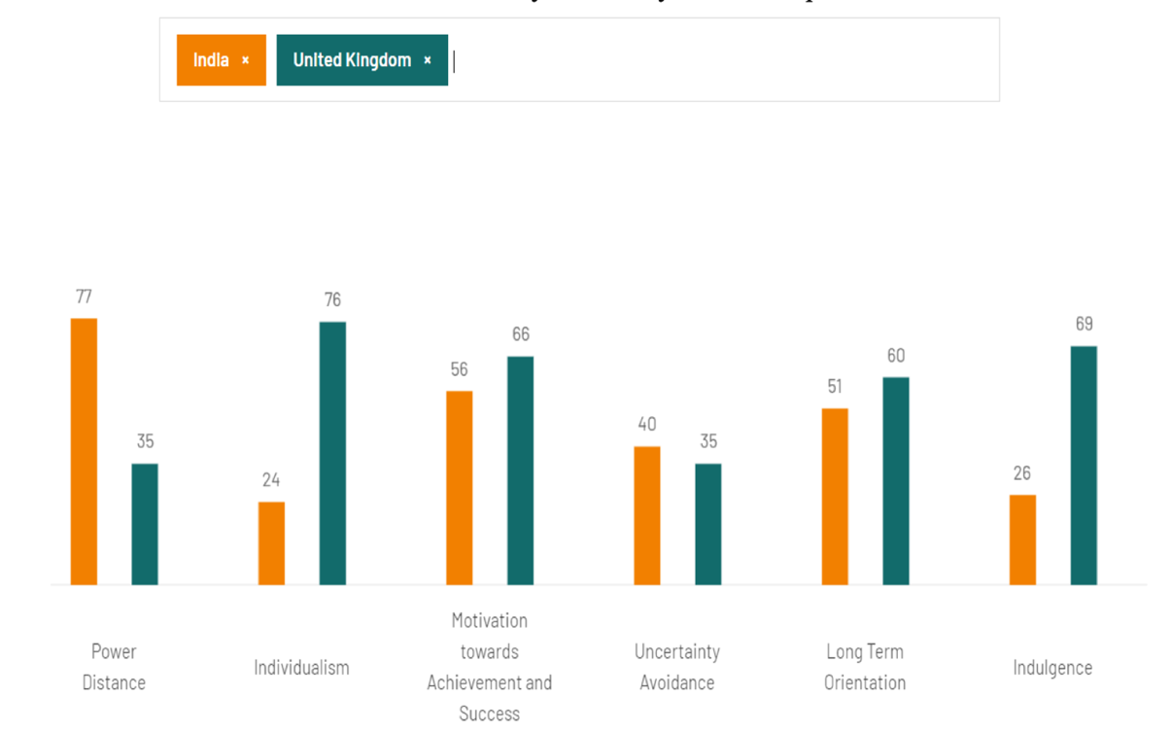
Figure 6: Hofstede’s Cultural Dimensions
Source: (Panda, 2024)
Website: https://www.ijfmr.com/papers/2024/2/15949.pdf

Coca-Cola’s Perceptual Map
Figure 7: perceptual map Coca-Cola ’s
Source: (Forde et al., 2022)

Coca-Cola India product
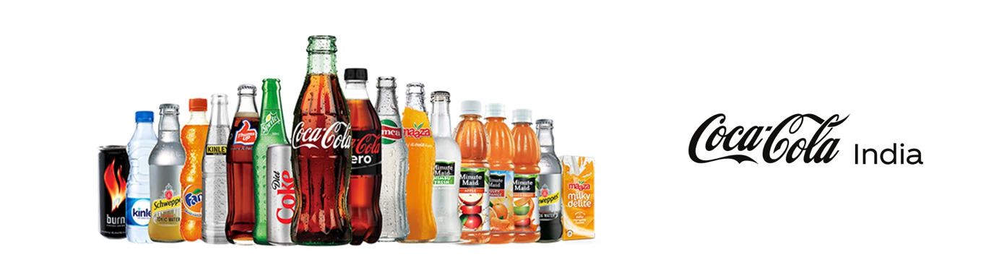
Figure 8: Coca-Cola ’s India product
https://www.in-beverage.org/member/coca-cola-india/

Coca-Cola’s UK product
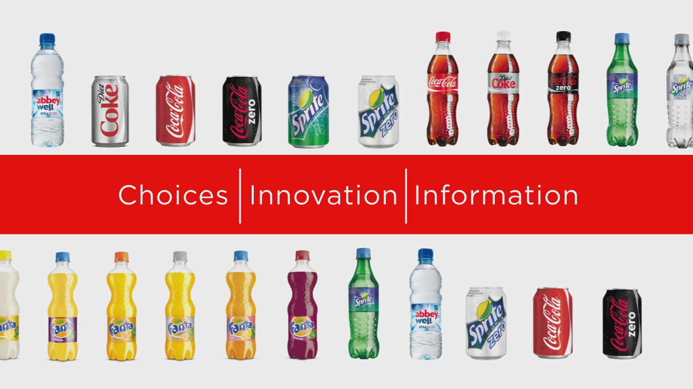
Figure 9: Coca-Cola’s UK product
https://www.slrmag.co.uk/coca-cola-pledges-to-help-solve-obesity-crisis/
Coca-Cola India packaging

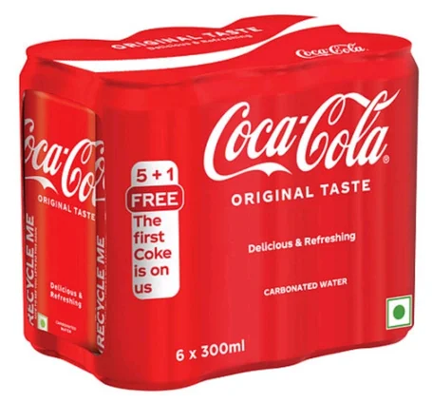
Figure 10: India Coca-Cola packaging
https://www.indiamart.com/proddetail/coca-cola-300ml-26554999162.html

Coca-Cola UK package design
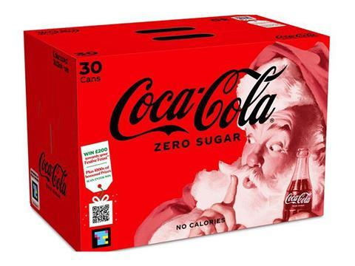
Figure 11: UK Coca-Cola packaging
https://packagingeurope.com/news/coca-cola-uk-becomes-first-beverage-brand-to-pilot-navilens-technology-for-visually-impaired/9183.article
Coca-Cola UK Store
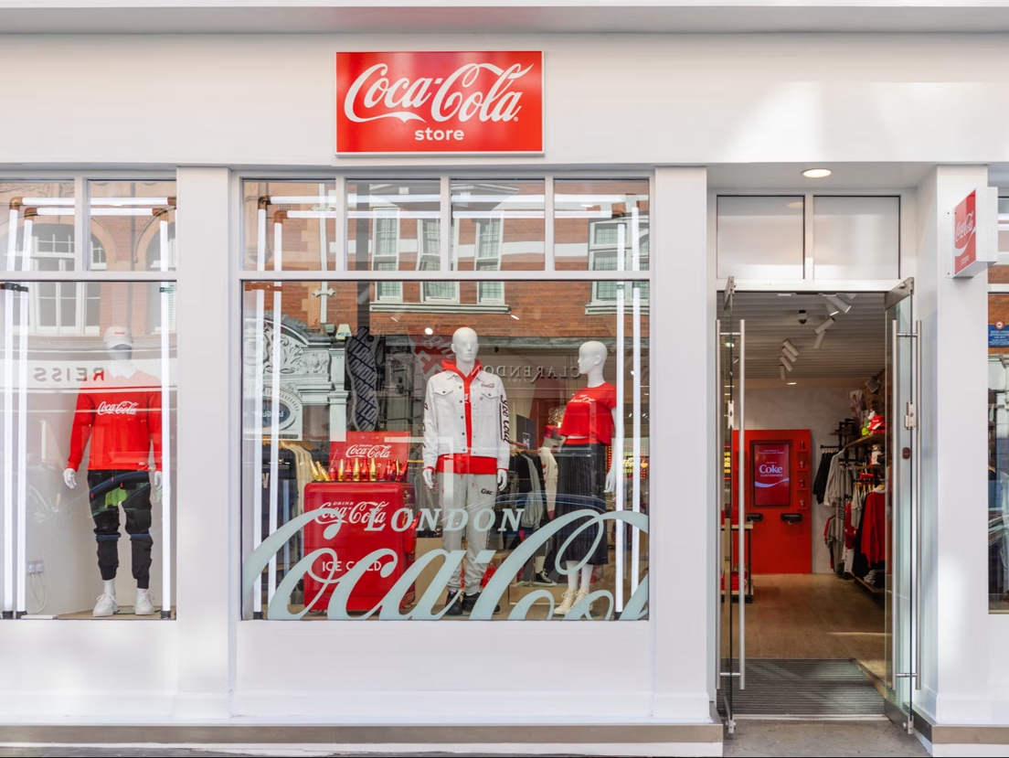
Figure 12: UK Coca-Cola Store
https://www.independent.co.uk/life-style/fashion/coca-cola-fashion-store-london-b2067384.html
Coca-Cola India Store
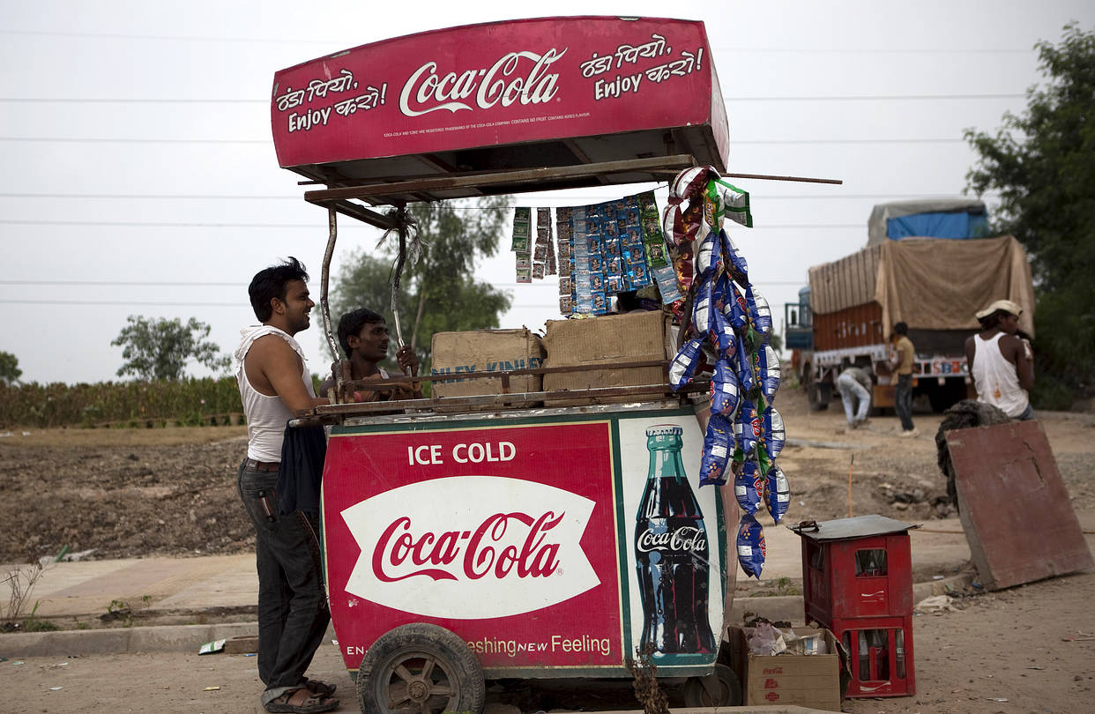
Figure 13: India Coca-Cola’s Store
https://www.wsj.com/articles/coca-cola-closes-plant-in-india-1455122537

Coca-Cola India staff
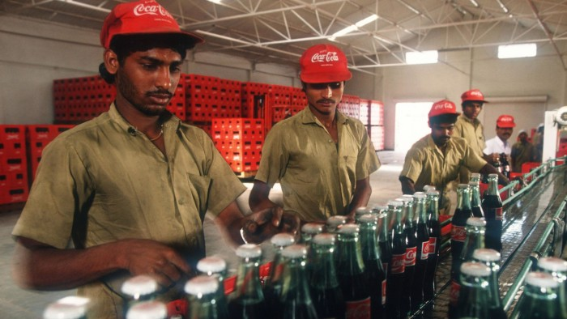
Figure 14: India Coca-Cola’s staff
https://www.ft.com/content/9e7d36da-e8e5-11e4-87fe-00144feab7de

Coca-Cola UK staff
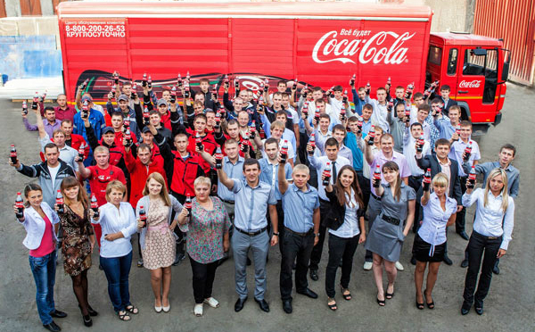
Figure 15: UK Coca-Cola’s staff
https://www.packagingnews.co.uk/news/environment/coca-cola-hbc-announces-new-carbon-and-water-commitments-05-11-2015

