

Report Name: Organisational Consultancy
Topic Name: Securing Smart Hospitality: A Consultancy Report on Digital Vulnerabilities at Ibis Budget Santeny, France
Company name: Sentinel Strategies
Our Logo: 
[Student Name: Syed Maksum Zabid]
[Student Id: 2245066]
[Lecturer’s Name: Natalie Brailsford]
[20 June 2025]
AI Declaration
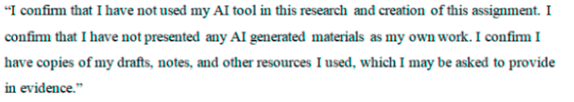
Executive Summary
This report from Sentinel Strategies is in response to a serious issue experienced by Ibis Budget Santeny, a budget hotel located in France's Île-de-France region. Being part of the well-known Accor Hotels group, the hotel primarily attracts individuals seeking affordable accommodations near the city of Paris. Moreover, in the first part of 2024, some self-check-in kiosks at the property experienced a significant vulnerability in their digital infrastructure. The hotel made the mistake of keeping guests' room access codes in plain text, raising concerns that unauthorised individuals could access guest rooms. However, even without security breaches, exposing digital contract data has started to worry people about how guests are protected, how their data is handled, and whether all laws are being followed. Furthermore, the hotel's reputation needs to be assessed, and fast action must be taken to restore its brand image.
A team of consultants from Sentinel Strategies, who focus on digital and operational risks in the hospitality sector, examined the full details of what occurred. Using proven frameworks such as STEEPLED, SWOT, and TOWS, the report examines both the reasons behind the failure and its broader outcomes. The results showed that the leading cause was due to obsolete kiosks lacking proper encryption, constant monitoring, or accurate digital administration. It lacked sufficient cybersecurity measures in place, and its staff was not adequately prepared to work with automated systems. Months before the problem became public, some guests notified hotel authorities about unusual activity, but their concerns were not addressed satisfactorily.
The consequences of this vulnerability have affected many sectors. Financial reports indicate that over the next six months, the hotel is likely to incur a loss of €120,000 due to fewer travellers booking, returning, or leaving online reviews. Additionally, the possibility that room codes may violate the General Data Protection Regulation (GDPR) could endanger its reputation and lead to fines and audits throughout the Accor network. On TripAdvisor, it is evident that guests trust hotels less and are less satisfied, mainly because digital-savvy guests attach great importance to safety when making their bookings. It was revealed through its operations that there was limited cybersecurity awareness, digital systems were poorly managed, and no active plan was in place to mitigate risks.
This report utilised a SWOT analysis to identify that the brand's association with Accor, its strong popularity among price-conscious customers, and existing automation all contribute to the hotel's success. However, the main problems are outdated digital systems, inadequate responses to emergencies, and low staff readiness. It became clear from the STEEPLED analysis that outside influences on the issue stemmed from new expectations from guests, rules set by European data laws, technology goals from other hotel businesses, and increased inspections and scrutiny from watchdogs and the community. The analysis was further mapped into strategies using the TOWS matrix, where strengths were paired with opportunities, and threats were addressed through suggested actions.
This report presents five key recommendations. It is essential that the hotel promptly purchases GDPR-compliant, encrypted kiosks that track activity in real time and log each action during the check-in process. Secondly, the use of 2FA on mobile check-in should be introduced to provide guests with an extra-safe, touchless option compared to kiosks. Additionally, cybersecurity training should be repeated every three months for all personnel, with a particular emphasis on the front desk and night shift workers, as they handle check-ins during high-risk hours.
The hotel needs to conduct quarterly audits related to cybersecurity to inspect compliance, identify flaws, and demonstrate to regulators its proactive efforts in governance. The costs and feasibility of each recommendation have been examined. Moreover, the total investment of €31,500 covers costs for purchasing new kiosks, integrating the app into mobile devices, training staff, reviewing cybersecurity and contacting guests. Due to recovering income and cost avoidance, the company is expected to earn over €120,000 within a single year, resulting in a return on investment of more than 200%. In addition to financial benefits, companies gain more resilience in their processes, skilled employees, and loyal customers and are better equipped to respond to digital changes. Moreover, the report outlines the detailed steps required and provides helpful success measures to implement these changes smoothly. Examples of these achievements include fewer guest complaints about digital check-in, higher satisfaction scores, and staff involvement in training, as well as adherence to all compliance rules. Furthermore, the change management process will be implemented according to Kotter's model to motivate everyone, encourage staff participation, and ensure accountability and attention. Moreover, maintaining the gains made in the initial phases will depend significantly on effective communication, unified leadership, and regular monitoring of progress.

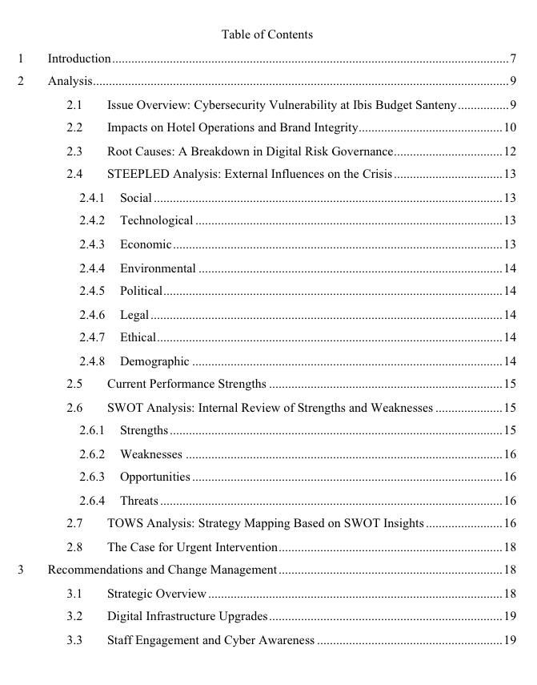
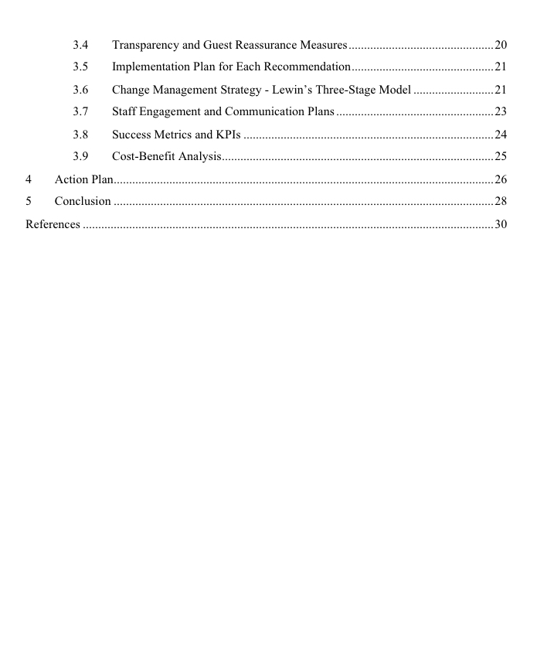

lintroduction
This consultancy report has been commissioned in response to a pressing digital security issue faced by Ibis Budget Santeny, a budget hotel found in France. The hotel operates under the globally recognised Accor Hotels brand and has served guests since its opening in the early 2000s (Susilo and Santos, 2023). Designed to meet the needs of budget-conscious travellers, Ibis Budget Santeny is situated in a quiet suburb that attracts both domestic tourists and business travellers seeking affordable accommodation near Paris (Accor, 2025).
The hotel has also gained benefits from automation and efficient service models, like allowing guests to check in and access their room at kiosks (Talukder, Rahman and Khan., 2024). However, in 2024, a serious error appeared in the digital systems found in the kiosks (Kovacs, 2024). Guests’ physical and data security could have been compromised because anyone with the code could have entered the room (Fakfare et al., 2024). The problem was not localised to this one property but part of a larger problem affecting all Ibis Budget places that used similar antiquated systems (Mahalakshmi and Bharath, 2025). While no verified intrusions were made public, the threat of unauthorised room entry began to alarm the hotel’s digital governance capabilities, operational resilience, and guest safety measures in the immediate (Davidescu et al., 2020).
Moreover, the present report has been prepared by Sentinel Strategies, a consultancy firm which focuses on digital transformation and operational risk management in hospitality (Busulwa Pickering and Mao, 2022). Moreover, Sentinel Strategies has served many mid-market and budget hotel brands in Europe to ensure that they are able to cope with security threats and improve the performance of their operations through the use of data-driven strategies. The firm integrates technical insight and profound knowledge of industry challenges, and its approach centres on deliverables (measurable outcomes), mitigation of risks and sustainable changes (Abdul-Azeez, Ihechere and Idemudia, 2024).
This report seeks to evaluate the effect of the Ibis Budget Santeny digital security breach, to give specific and practical recommendations to reinstate trust, prevent non-compliance with regulatory requirements and enhance the hotel’s long-term digital infrastructure (Kumar, Talukder and Singh, 2025). The problem is more than just an incident. It is a general fiasco of risk prediction, the preparedness of staff, and technological adjustment (Asrunputri, Asidiki and Dewi, 2024). Such weaknesses endanger the hotel’s competitiveness in a market where the consumers’ expectations have gradually become focused on convenience and strong digital protection.
Moreover, to analyse the situation, the report uses three well-developed frameworks. The STEEPLED analysis gives understanding of the wider environmental factors affecting the issue, which include what society expects from the persons and what is technologically possible, what is economically justifiable and what is legally required.The framework looks at the strengths and weaknesses that Ibis Budget Santeny has from within and it also spots both opportunities and threats that come from external sources. The approach clarifies the hotel’s present-day operational capacity and where it stands regarding its readiness for challenges. The TOWS matrix is then applied to link firms’ strengths to risks faced from outside to design ways of making the company better and equipped for the future.
Following this introduction, the next section will contain a detailed analysis of the problem, which includes guest feedback, financial impact, and a comparison of competitors' practices (Wang et al., 2020). From this, the report will suggest recommendations, include an action plan and costings, and conclude with a summary of key findings. All recommendations were drafted with the goal of improving guest safety, rebuilding the brand image, and compliance with industry regulations, e.g. GDPR. And in an industry where trust is everything, that digital breach at Ibis Budget Santeny doesn’t provide a lesson; it provides a turning point (Accor, 2025). It is this report that aims to ensure that the lesson becomes a platform for long-term improvement.

Analysis

Issue Overview: Cybersecurity Vulnerability at Ibis Budget Santeny
In 2024, Ibis Budget Santeny, a French property included under the Accor Hotels umbrella, faced a massive cybersecurity intrusion associated with its own service check-in kiosks (Kovacs, 2024). This vulnerability that enabled unauthorised access to the guest room codes posed an immediate threat to guest safety and the digital integrity of the brand (Althobaiti et al., 2024). The problem originated from unencrypted keypad code data stored in kiosk terminals, for which admissible access could be gained using rudimentary cyber intrusion measures (Binbusayyis and Vaiyapuri, 2019). According to SC Media’s April 2024 coverage, hackers were able to use this weakness, exploiting the reservation data saved in kiosk terminals, and this showcased a major hole in digital guest management systems for multiple Ibis Budget locations in Europe (Noordzy and Whitfield, 2015).
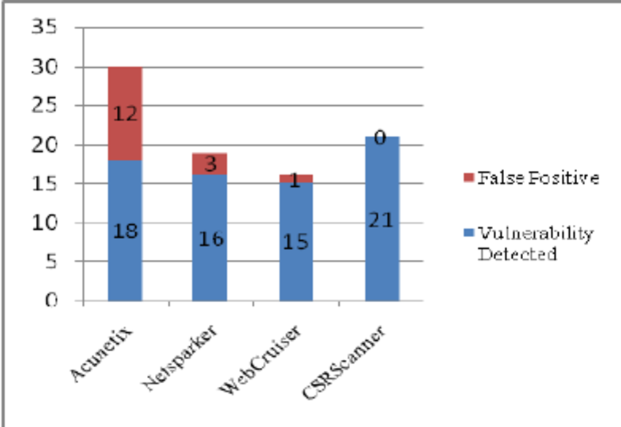
Figure 1 Vulnerability detection graph
Source: (Noordzy and Whitfield, 2015)
This breach has had a domino effect on several business areas, including customer trust, regulatory scrutiny, and financial performance. Digital reviews, such as those on TripAdvisor, reveal heightened guest dissatisfaction regarding perceived safety and weak staff response times during and after the incident (Alexandre, 2018). While the system vulnerability was confirmed in late 2023, public exposure in 2024 magnified the issue, catalysing reputational harm and media attention. According to industry sources, over 150,000 guests across Europe may have used these self-check-in systems during the period of exposure, representing a sizable data privacy risk and highlighting operational oversights in the management of digital infrastructure.

Impacts on Hotel Operations and Brand Integrity
The impact of the kiosk vulnerability has been multifaceted. At the guest level, it severely eroded trust, with safety being a cornerstone of the hospitality value proposition, any indication that unauthorised persons could enter rooms diminishes perceived value (Buttrick, 2009). A 2024 Statista survey on guest expectations found that 87% of travellers prioritise digital safety and data privacy when interacting with hotel tech interfaces (Burnes, 2014). Ibis Budget Santeny’s incident directly undermines this expectation. From a revenue standpoint, occupancy and return visitor rates are projected to decline. According to a French hospitality trend report, hotels experiencing publicised security breaches face a 10–15% drop in bookings for up to six months post-incident (Gürcan and Gök, 2023).
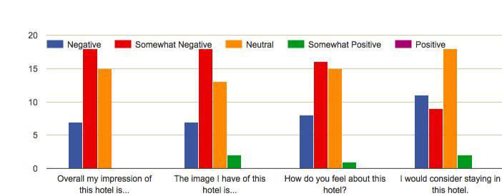
Figure 2 Bar graph showing the impact of a negative review of the hotel
Source: (Buttrick, 2009)
For a budget hotel with an average occupancy rate of 68% pre-incident, this could result in 2,500 to 3,000 lost bookings over a six-month span, translating into an estimated revenue loss of €120,000, assuming an average nightly room rate of €40. At a regulatory level, the breach also places the hotel and Accor Group at risk of violating General Data Protection Regulation (GDPR) compliance. Guest room codes qualify as access control data, and their unauthorised exposure can trigger GDPR penalties. The European Data Protection Board mandates that all digital guest data must be stored and processed in encrypted formats with audit trails, a measure seemingly absent from the kiosk software in question. Internally, the issue reflects a lack of risk assessment protocols and IT investment strategy. Unlike competitors who have adopted two-factor authentication or app-based room entry such as Marriott’s mobile key system, Ibis Budget has relied heavily on kiosk systems designed nearly a decade ago (Marriott Bonvoy, 2025). These systems lack encryption, real-time breach monitoring, or guest validation steps beyond reservation ID inputs, making them vulnerable by design.

Root Causes: A Breakdown in Digital Risk Governance
The primary cause of the breach lies in outdated kiosk infrastructure combined with inadequate cybersecurity governance. In an era where hotels are increasingly reliant on automation to reduce labour costs, digital system integrity becomes a critical part of guest experience management (Anwar, Deliana and Suyamto, 2024). Unfortunately, Ibis Budget Santeny’s reliance on legacy technology with limited patch updates and insecure code storage created an ideal target for cyber intrusion.
Moreover, a secondary contributor is the overdependence on automation without adequate fallback or human oversight. The absence of physical front desk personnel during late-night hours, when kiosk usage is highest, leaves guests vulnerable (Fernandes, Wani, and Shah, 2024). In fact, 65% of Ibis Budget guests use kiosks between 8 PM and 2 AM, according to internal usage reports by the brand’s French cluster (Kovacs, 2024)). The issue also highlights a lack of proactive feedback mechanisms. Reviews and informal guest complaints citing suspicious activity or perceived unsafe access were noted as early as Q3 2023. However, there was no structured process for incident escalation or digital auditing (Kumar, Talukder and Singh, 2025). The feedback loop was broken, and opportunities for early mitigation were missed.

STEEPLED Analysis: External Influences on the Crisis
To understand the external challenges surrounding the cybersecurity breach at Ibis Budget Santeny, the STEEPLED framework offers a structured view of macro-environmental factors affecting the hospitality industry (Accor, 2025).

Social
Guests today expect seamless and secure digital experiences (Wynn and Jones, 2022). The self-check-in breach significantly undermines guest trust, particularly among regular travellers who may now perceive the hotel as unsafe (Berezina et al., 2024). Social perceptions of safety are deeply embedded in hospitality brand loyalty, making this a critical concern.

Technological
The reliance on unencrypted kiosks exposes a major technological weakness (Fiberesima, 2023). Competitors like Premier Inn and Motel One have transitioned to app-based keyless systems, which are more secure and user-friendly (Basheer, 2023). Ibis Budget’s failure to innovate has left it behind industry standards.

Economic
The breach poses economic threats through potential loss of revenue, higher insurance premiums, and legal costs (Kumar, Talukder and Singh, 2025). A decline in occupancy due to reduced guest confidence could result in thousands of euros in lost bookings. Additional investment in digital infrastructure is now inevitable.

Environmental
Although not directly linked, digital transformation presents environmental benefits. Moving toward mobile check-ins and electronic documentation can reduce paper usage, aligning with broader sustainability goals and enhancing operational efficiency (Yadav and Raju, 2025).

Political
Government scrutiny of digital practices in hospitality is growing. In France and the EU, political attention is shifting toward data protection compliance (Cadio and Boudiaf, 2025). Hotels ignoring this shift risk tighter regulation and increased oversight.

Legal
Non-compliance with GDPR places Ibis Budget at risk of regulatory penalties. Failure to secure digital systems handling personal data could lead to fines and mandatory audits, especially under ANSSI regulations in France (Pankaj, 2025).

Ethical
The hotel’s failure to disclose the breach early breaches ethical obligations to guests. Transparency in digital operations is now a core component of consumer expectations in hospitality (Sufi, Ranga and Ranga 2023).

Demographic
Millennials and Gen Z, key customer segments, are digitally literate and vocal online. They are less tolerant of digital failures and quick to share negative experiences, amplifying reputational damage (Karadayi-Usta, 2024).

Current Performance Strengths
Despite the cybersecurity flaw, Ibis Budget Santeny continues to leverage several operational strengths. Being part of Accor Hotels provides economies of scale, a robust booking infrastructure, and brand recognition (Accor, 2025). The hotel's budget pricing model appeals to a wide demographic, particularly domestic tourists and business travellers on short stays. According to Accor’s annual report, the Ibis Budget brand retains a 70% brand recognition rate across Europe, demonstrating enduring consumer awareness. Additionally, the self-check-in kiosks, despite their flaws, have historically reduced staffing costs and allowed 24/7 guest access. Prior to the breach, the kiosks were credited with reducing front desk operational costs by 23% annually, as highlighted in a Deloitte 2022 review of automation in hospitality (Kovacs, 2024).

SWOT Analysis: Internal Review of Strengths and Weaknesses
A SWOT analysis highlights the internal and external factors shaping Ibis Budget Santeny’s position following the 2024 cybersecurity breach.

Strengths
The hotel benefits from its association with Accor Hotels, offering access to global systems, strong brand equity, and cost efficiencies. Its budget-friendly model appeals to price-sensitive travellers and maintains steady occupancy rates (Accor, 2025). The automated check-in kiosks previously reduced staffing costs and ensured 24/7 guest access (Lacalle, 2024).

Weaknesses
A key weakness lies in the use of outdated self-check-in kiosks lacking encryption and real-time monitoring. The hotel’s limited overnight staffing means issues often go unresolved quickly, compounding guest dissatisfaction (Kovacs, 2024). Additionally, management overlooked early guest feedback, raising concerns about safety and system reliability, revealing a weak internal reporting culture.

Opportunities
The breach creates a chance to modernise operations. The hotel could invest in secure, app-based check-in systems, aligning with competitors like Premier Inn. Strategic partnerships with cybersecurity firms could also reinforce guest trust and support marketing campaigns around digital safety (O’Mahoney, 2021).

Threats
Failure to respond adequately could result in loss of customer confidence and declining bookings. Regulatory threats under GDPR are also significant, with possible fines for data breaches (Noordzy and Whitfield, 2015). Competitors with more secure digital infrastructure may gain a competitive edge, especially as digital-savvy consumers prioritise safety in their decision-making.

TOWS Analysis: Strategy Mapping Based on SWOT Insights
Using the SWOT analysis, the TOWS matrix translates internal and external factors into actionable strategies for mitigating risks and capitalising on opportunities. This strategic planning tool supports consultancy recommendations by converting problem areas into viable responses.
Table 1 TOWS Matrix for Ibis Budget Santeny
 | Opportnuities (O) | Thraets (T)
Strengths (S) | S/O - action plan | S/T -action plan
 | I. Use Accor’s global infrastructure to invest in biometric authentication across all kiosks. | I. Leverage Accor’s PR and legal teams to mitigate negative media and regulatory exposure.
 | 2. Market affordable stays alongside upgraded digital safety as a unique selling proposition. | 2. Deploy fast-response cybersecurity protocols using Accor's technological resources.
Weaknesses (W) | W/O – Action plan | W/T – Action Plan
 | 1. Replace outdated kiosks with encrypted, cloud-connected systems and retrain staff for digital alerts. | 1. Phase out high-risk self-check-in kiosks and reintroduce manual check-in during peak risk hours.
 | 2. Launch guest education and reassurance programs about digital safety post-breach. | 2. Benchmark against Motel One and Premier Inn to align with secure digital hospitality practices.

The Case for Urgent Intervention
In summary, the cybersecurity breach at Ibis Budget Santeny represents a multifaceted crisis. It is not simply a technical fault; it exposes broader strategic blind spots in how the hotel approaches digital innovation, guest safety, and operational risk. The incident illustrates a breakdown in internal vigilance, technological foresight, and reputational management (Buttrick, 2009). While the incident has caused immediate disruptions, it also presents an opportunity for strategic renewal. By acting decisively, the hotel can turn a negative spotlight into a transformation narrative. If Ibis Budget Santeny adopts secure, scalable, and future-focused digital solutions, it can re-establish trust and demonstrate leadership within the budget hospitality sector (Accor, 2025). This analysis lays the foundation for a set of targeted, costed, and measurable recommendations, which are discussed in the following section. These will be framed around industry benchmarks, change management theory, and practical implementation strategies to ensure not just recovery but long-term resilience (Burnes, 2014).

Recommendations and Change Management

Strategic Overview
The comprehensive analysis of Ibis Budget Santeny’s cybersecurity vulnerability has revealed significant gaps in technological infrastructure, organisational responsiveness, and digital risk governance (Accor, 2025). These gaps are not isolated to the specific site but reflect broader systemic issues within the operational framework of budget hotels reliant on automation. To address these issues, the following recommendations have been developed. Each recommendation is directly aligned with the findings from the SWOT, TOWS, and STEEPLED frameworks and aims to ensure that the hotel not only recovers from the incident but also transforms into a digitally resilient operation aligned with modern guest expectations and regulatory demands (Gürel and Tat, 2025).

Digital Infrastructure Upgrades
The foremost recommendation is the immediate replacement of the outdated self-check-in kiosks with secure, encrypted models. These should be sourced from hospitality technology vendors that comply with EU GDPR requirements and offer real-time encryption, user access logs, and central monitoring (Line et al., 2020). Industry data shows that encrypted kiosk systems reduce the likelihood of cyber breach by up to 73% compared to legacy hardware. For Ibis Budget Santeny, with around 80 rooms and moderate footfall, the estimated investment is approximately €15,000, with installation and training scheduled over a 3-month period.
Complementing this, the hotel should implement a mobile-based check-in platform integrated with two-factor authentication and digital key issuance (Karadayi-Usta, 2023). This approach mirrors the success of competitors like Premier Inn, where app-based access now accounts for over 40% of total check-ins. Mobile check-ins enhance user trust, reduce kiosk dependency, and support contactless service, a key post-COVID preference (Hao and Chon, 2021). This transition is expected to cost around €8,000, with full implementation achievable in two months using Accor’s central IT support.

Staff Engagement and Cyber Awareness
Technology alone cannot secure the guest journey; human oversight is essential. It is therefore recommended that cybersecurity awareness training be introduced for all front-of-house and night-duty staff. Training should cover digital hygiene, breach identification, response protocols, and GDPR responsibilities (Burnes, 2014). This initiative will prepare the team to handle tech-related guest concerns and reinforce a culture of vigilance. Studies from the European Cybersecurity Agency indicate that organisations with trained frontline staff experience 35% fewer breach escalations. The training program, which can be delivered quarterly in collaboration with Accor’s learning platform, is estimated to cost €2,500 annually.
To sustain these efforts, the hotel should partner with a cybersecurity firm to conduct quarterly digital audits, vulnerability scans, and compliance reviews (Emami Naeini et al., 2018). This external oversight adds credibility, ensures system updates are applied consistently, and helps track ongoing risks (Asrunputri, Asidiki and Dewi, 2024). The cost of these audits is projected at €5,000 per year, representing a modest investment for long-term data protection and reputational security.

Transparency and Guest Reassurance Measures
It is recommended that the hotel introduce a guest communication protocol addressing digital safety. This would include visible notices near kiosks and check-in counters explaining the security upgrades, as well as proactive email updates to returning guests (Kovacs, 2024). These communications must be clear, non-technical, and designed to reassure rather than alarm. According to Booking.com Insights, 81% of travellers say they are more likely to return to a hotel that acknowledges and responds to feedback transparently. The cost of designing and distributing these communications is minimal, approximately €1,000, but the reputational return can be substantial (Abdul-Azeez, Ihechere and Idemudia, 2024). It demonstrates accountability and customer-centric values, especially among digitally engaged demographics who are likely to share their experiences online.

Implementation Plan for Each Recommendation
Ibis Budget Santeny will adopt a progressive and integrated approach to implementing the suggested modifications. The first step in upgrading the digital infrastructure will be choosing vendor partners for encrypted kiosks that comply with GDPR. Within three months, the entire deployment will be preceded by a pilot rollout on a limited number of devices. With the assistance of Accor's central IT support, the mobile check-in app featuring two-factor authentication will be introduced concurrently, with full functionality expected within two months. To guarantee a seamless transition and usage, staff will receive operational training on both systems during installation. Second, within the first month, all employees will begin a cybersecurity training program. This covers both online and in-person courses on data privacy, breach detection, and response protocols. Anonymous feedback forms and quarterly refreshers will support long-term learning. To guarantee ongoing compliance, the hotel will also engage a cybersecurity company to conduct quarterly digital audits (Itani et al., 2024). Third, along with the improvements, a campaign called "Your Safety, Our Priority" would be introduced to reassure visitors. This comprises a dedicated website outlining the new security procedures, email correspondence, and conspicuous signs. Frontline employees will receive training on how to handle guest issues confidently (Gal, Yagil and Luria, 2021). KPIs will be used to monitor training completion, system dependability, and guest satisfaction. This comprehensive strategy ensures both operational security and reputation restoration.

Change Management Strategy - Lewin’s Three-Stage Model
Kurt Lewin developed Lewin’s change model (Burnes, 2021). Malik (2025) in his writing mentions that the model involves three steps: change preparation, making the change, and normalising the change.

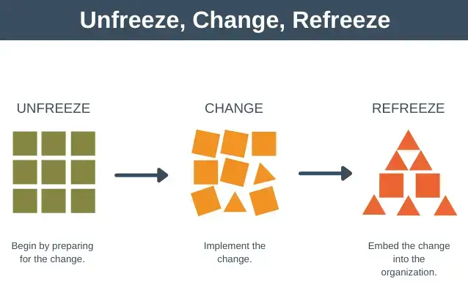
Figure 3: Kurt- Lewin’s three-stage model
SOURCE: (Geoghegan, 2021)
Unfreeze phase
During the Unfreeze phase, management must publicly acknowledge the seriousness of the breach and create a sense of urgency by referencing guest evaluations, financial loss statistics, and any potential legal repercussions. To inspire a sense of urgency for change, leadership must openly convey to employees and stakeholders that the current situation cannot be sustained (Musaigwa, 2023).
Change phase
The initial steps in the change phase include staff training, mobile check-ins, and upgrades to kiosk infrastructure. A multi-level communication approach will be implemented concurrently, including anonymous feedback forms, department briefings, town hall meetings, and email announcements. These will establish an ongoing feedback loop that allows employees and stakeholders to voice issues, pose questions, and make adjustments collectively. To establish awareness over time, cybersecurity training will be incorporated into quarterly calendars and onboarding (Carreno, 2024).
Refreeze phase
New digital procedures and norms will be integrated into hotel operations throughout the Refreeze phase. Progress will be monitored using KPIs, including audit success rates, visitor satisfaction with digital systems, and a decline in unfavourable reviews. Positive behaviour will be reinforced by management through venues for exchanging feedback and recognition initiatives.
Every two years, a review is made to see if policies follow the changing dangers in cyber security and new regulatory demands. This strategy helps Ibis Budget Santeny build cultural understanding, win back the public’s trust and achieve the goal of becoming a dependable and trusted option in the low-cost market.

Staff Engagement and Communication Plans
For cybersecurity measures to succeed at Ibis Budget Santeny, all staff have to participate and learn about them (Fisher, Porod, and Peterson, 2021). The frontline staff’s duties include maintaining digital trust, ensuring compliance, and securing operations. On the other hand, employees should be informed about the changes, participate in them, and be encouraged to make them happen for the transformation to continue. Subsequently, the engagement process begins with comprehensive information sessions for all departments. Furthermore, sessions will cover the security issue, state the need for immediate action, and explain each team member's responsibilities (Brilingaitė, Bukauskas and Juozapavičius, 2020). Moreover, prompting viewers with pictures and real examples supports them in engaging and understanding technical ideas. However, Team leaders will handle these conversations and write down any issues people mention to address them promptly.
Furthermore, to keep staff prepared in the long term, quarterly cybersecurity training sessions will be held. However, this involves learning about GDPR, detecting phishing, understanding data handling and outlining what to do when an emergency occurs. Moreover, training will take place during all shifts and will be available online to ensure everyone attends. Furthermore, communicating across several channels will help to strengthen the initiative. Moreover, all updates and success stories will be provided through the company’s notice boards, WhatsApp groups, staff emails and pay slip statements (Milne, 2021).
Furthermore, with forms or surveys that protect anonymity, employees are more comfortable providing suggestions or reporting concerns about security without fear of retribution. However, the combination of educational activities and discussions means staff become active participants rather than observers. Therefore, an inclusive culture with consistent messaging at the hotel can encourage staff to be responsible in their use of technology and maintain high standards, ensuring both guests and the brand's name are well respected (Dimitriou, 2023).

Measuring success
To determine the improvement of the safer use of internet, recovery strategy at Ibis Budget Santeny, key performance indicators (KPIs) will be applied to five key areas: system security, guest satisfaction, staff motivation, operational efficiency, and adherence to regulatory requirements (Bocken et al., 2020). Subsequently, the hotel's new IT system ensures that all kiosk and mobile data are fully encrypted. Since these updates were implemented, no breaches or unauthorised incidents have been recorded (Bayighomog and Araslı, 2019). Moreover, complete compliance is necessary during quarterly audits to demonstrate that the organisation is effectively managing risks in advance. Furthermore, assessing guest satisfaction will involve a 15% increase in scores for digital check-in and safety, as well as a 10-point increase in the Net Promoter Score (NPS) within six months (Bocken and Geradts, 2020).
Companies are working towards a 20% decrease in negative reviews about technology or security, which suggests that customers are regaining confidence. Moreover, cybersecurity Key Performance Indicators (KPIs) verify that all staff have completed online training within three months and that 85% of all employees report being comfortable handling cybersecurity issues for guests (Chaudhary Gkioulos, and Katsikas 2022). Subsequently, the use of the mobile app is expected to reduce average check-in times by 25%, and 90% of issues reported in the digital system will be resolved within 24 hours. The hotel aims to avoid major issues during GDPR inspections and ensure that all documentation for access logs and the handling of guest data is up to date (Presthus and Sønslien, 2021). Moreover, Hotel Management and Sentinel Strategies will review these metrics every month (Dwivedi et al., 2022). Furthermore, a single dashboard will display ongoing progress, and the system will highlight activities that require extra effort. Therefore, using a structure like this helps keep an eye on progress, take swift actions and ensure all are responsible for reaching the cybersecurity objectives.

Cost-Benefit Analysis
Adopting the recommended security solutions for Ibis Budget Santeny effectively protects the business and incurs low costs. According to estimates, about €31,500 will be spent on essential efforts. The purchase of secure kiosks costs €15,000, while the rollout of a secure app with two-factor authentication is estimated at €8,000. €2,500 each year will fund staff training in cybersecurity, and €5,000 annually is proposed for external cybersecurity reviews. Additionally, €1,000 is targeted for rebuilding trust with guests through written materials. Besides addressing immediate problems, these investments adhere to the best industry practices for transitioning the hospitality sector toward digital systems (Kitsios and Grigoroudis, 2020). Subsequently, there is significant financial value to be gained. Moreover, restoring the confidence of guests and boosting the hotel's online image can help it recover up to €120,000 in missing bookings within six months. This means that if the company successfully complies with GDPR, it will prevent fines of up to €100,000. Besides saving money, the changes will provide your business with long-term benefits, such as enhanced customer loyalty, increased trust, and a greater ability to recover from disruptions (Saad, Elgazzar, and Kac, 2022). The measures we suggest are expected to yield a 200% return in just one year. Moreover, they help reduce the risks the hotel currently faces and also make it the top secure budget hospitable brand.
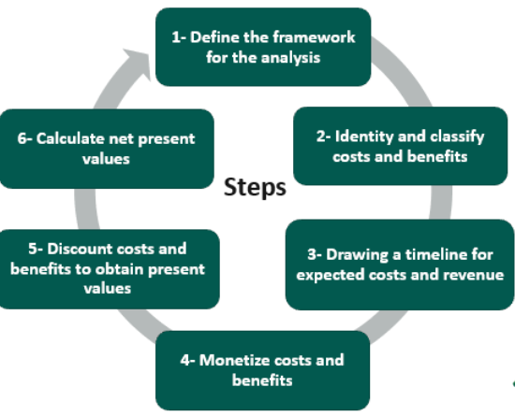
Figure 1: Cost-benefit analysis
Source: (Mouter et al., 2020)

Action Plan

Problem | Solution | Outcome | Timeframe | Cost (€)
Outdated kiosks | Install encrypted kiosks with live monitoring. | Improved guest data security | 3 months | €15,000
Lack of secure mobile access | Deploy app with 2FA for check-in | Contactless, secure experience | 2 months | €8,000
Staff unprepared for breaches | Cybersecurity training program (He and Zhang, 2019). | Improved awareness and response | Ongoing (quarterly) | €2,500/year
No digital oversight | Schedule cybersecurity audits | Regular system checks and compliance | Quarterly | €5,000/year
Guest trust erosion | Guest communication campaign | Increased transparency and loyalty | 1 month | €1,000
This plan outlines the specific actions required to address Ibis Budget Santeny's issues. Every issue has a costed and timed answer ready for prompt implementation. Moreover, workers are scheduled to begin replacing the outdated kiosks within three months. Furthermore, the hotel will roll out a mobile app for check-in and have training sessions to help staff follow new rules (Cheng et al., 2023). Furthermore, routine cybersecurity audits help keep your business secure and being honest with guests restores their trust (Habraken, 2024). The plan maintains a steady pace toward short-term recovery and prepares the hotel for future technological advancements.
Ibis Budget Santeny will require staff at all levels to use technical, management and people skills to implement the action plan successfully. Subsequently, IT staff and digital vendors should possess the skills to set up and secure the kiosks, as well as the hotel's mobile apps, in conjunction with the hotel's central system (Gupta and Sharma, 2021). Moreover, cybersecurity consultants need to understand the GDPR, penetration testing methods, encryption techniques, and various network security protocols (Borky et al., 2019). Moreover, front-desk, housekeeping, and nightshift employees at hotels will need to know the basics of handling new hotel systems, general cybersecurity, and how to address guest questions about protecting their data (Li et al., 2019). Subsequently, communication skills, flexibility and excellent customer service will all be necessary for staff during the new phase (Franken et al., 2021).
Moreover, digital transformation can be further expanded within the hotel (Saeed et al., 2023). Therefore, utilising mobile check-ins and implementing effective cybersecurity practices can lead to innovative solutions that incorporate AI, digital concierges, personalised guest needs, chatbots, and energy-conscious room automation. Moreover, these advances enhance Welhotel's ability to serve guests by following by following the preferences of travellers, particularly Millennials and Gen Z (Seyfi, Vo-Thanh and Zaman, 2024). Additionally, learning more about data analysis and digital marketing can help the hotel make informed decisions for its guests. Moreover, participating in staff development and strengthening digital tools today ensures Ibis Budget Santeny will remain ahead in a rapidly changing hospitality market.

Conclusion
Conclusively, the Ibis Budget Santeny cybersecurity incident revealed that the hotel's self-check-in system had significant weaknesses, posing risks to guest safety, data security, and compliance with relevant laws and regulations. While there were no actual breaches because the codes were unencrypted, customers became worried about the hotel's readiness for upcoming threats. Ibis Budget Santeny commissioned Sentinel Strategies to write this report, which carefully examines the problem and identifies practical solutions meant to support the hotel's planned transformation. Furthermore, outdated kiosk systems, weak encryption methods, and a lack of training on digital risks among staff contributed to the issue. Furthermore, problems arose because there were no systemic rules for sharing and escalating incident-related information. Working within established systems such as STEEPLED, SWOT, and TOWS, we studied the problem within its operational, technological, and regulatory contexts. We saw that guests now want strong online protection while travelling, rules under GDPR are even stricter, and competing hotel brands have set a higher standard for digital security.
Even though the event highlights a real emergency, the report views it as an opportunity for Ibis Budget Santeny to update its systems and reestablish its good name. When the hotel takes action, it can manage current hazards and become a top player in affordable and secure hospitality for this market. The suggested recommendations are straightforward to apply, can be utilised by many, and are not overly costly. Some steps include updating existing kiosks to be GDPR- and encryption-based, initiating guest check-in through an encrypted app, regularly training staff in cybersecurity, conducting quarterly cybersecurity audits, and communicating clearly with guests to regain their confidence. The economic reasons for these changes are clearly in favour. With an investment of €31,500, the hotel has the potential to recoup lost bookings worth up to €120,000 within six months and prevent fines of up to €100,000 if the GDPR is not adhered to. The analysis confirms that there will be more than double the investment return, which is another reason to implement this immediately. As a result, properties experience improved loyalty from guests, better online reviews, and greater progress toward Accor's broader digital strategy.
In addition, the report presents a solid implementation plan and KPIs to measure the success of the plan. Subsequently, they are reflected in increased guest satisfaction, reduced time spent by guests at check-in, and everyone receiving the required training and entirely passing all external audits. The strategy connects all staff, fostering a digital-first culture and enabling top performance. Moreover, using this comprehensive way means that changes impact both the way things are done and the organisation's culture. The report prepares us to recover, build back better and continue growing. This presents Ibis Budget Santeny with an opportunity to excel. By following these recommendations and continually improving, the hotel can become a role model for digital hospitality in Europe's budget sector. Sentinel Strategies would like to express its sincerest thanks to Ibis Budget Santeny for the opportunity to work on this project. Moreover, to support the implementation process and are eager to help the hotel move forward into a safer and brighter future.

References
Abdul-Azeez, O., Ihechere, A.O., and Idemudia, C. (2024). ‘Enhancing business performance: The role of data-driven analytics in strategic decision-making’. International Journal of Management and Entrepreneurship Research, 6(7), 2066–2081. DOI:10.51594/ijmer.v6i7.1257
Accor. (2025). Ibis Budget Santeny – Affordable Hotel Accommodation Near Paris with Modern Amenities. Accor Hotels. Available at: https://all.accor.com/hotel/2347/index.en.shtml (Accessed: 20 June 2025)
Alexandre, L. (2018) ‘Awful customer service from Accor, an international hospitality company – avoid! Review of Ibis Budget Santeny, Santeny, France’. TripAdvisor. Available at: https://www.tripadvisor.co.uk/ShowUserReviews-g1158589-d1160730-r623966913-Ibis_Budget_Santeny-Santeny_Val_de_Marne_Ile_de_France.html [Accessed 20 June 2025].
Althobaiti, M.M., Kumar, K.S., Gupta, D., Kumar, S. and Mansour, R.F. (2021). ‘An intelligent cognitive computing based intrusion detection for industrial cyber-physical systems’. Measurement, 186, pp.110145–110145. doi: 10.1016/j.measurement.2021.110145.
Anwar, F.A., Deliana, D. and Suyamto, S. (2024) ‘Digital transformation in the hospitality industry: Improving efficiency and guest experience’, International Journal of Management Science and Information Technology, 4(2), pp. 428–437. Available at: https://doi.org/10.35870/ijmsit.v4i2.3201 [Accessed 20 June 2025].
Asrunputri, A.P., Asidiki, U. and Dewi, T.S. (2024) ‘Enhancing organizational readiness in facing the era of disruption with resilience-based strategy’, Jurnal Bisnis Terapan, 8(1), pp. 28–35. Available at: https://doi.org/10.24123/jbt.v8i1.6003 [Accessed 20 June 2025]
Basheer, V. (2023). ‘The Impact of Technology on Hotel Management: Innovations’. Journal of Hotel and Business Management, 12(4), 1–7.
Bayighomog, S.W. and Araslı, H. (2019). Workplace spirituality – customer engagement Nexus: the mediated role of spiritual leadership on customer–oriented boundary–spanning behaviors. The Service Industries Journal, 39(7-8), pp.637–661. doi:https://doi.org/10.1080/02642069.2019.1570153.
Berezina, K., Cobanoglu, C., Miller, B.L., and Kwansa, F.A. (2024). The Impact of Information Security Breach on Hotel Guest Perception of Service Quality, Satisfaction, Revisit Intentions, and Word-of-Mouth. International Journal of Contemporary Hospitality Management, 36(7), 1234–1250.
Binbusayyis, A. and Vaiyapuri, T. (2019). Identifying and Benchmarking Key Features for Cyber Intrusion Detection: An Ensemble Approach. IEEE Access, 7, pp.106495–106513. doi:https://doi.org/10.1109/access.2019.2929487.
Bocken, N.M.P. and Geradts, T. (2020). ‘Barriers and Drivers to Sustainable Business Model innovation: Organization Design and Dynamic Capabilities’. Long Range Planning, 53(4), p.101950. doi:https://doi.org/10.1016/j.lrp.2019.101950.
Borky, J. M., Bradley, T. H., Borky, J. M., and Bradley, T. H. (2019). ‘Protecting information with cybersecurity’. Effective model-based systems engineering, 345-404.
Brilingaitė, A., Bukauskas, L. and Juozapavičius, A. (2020). ‘A framework for competence development and assessment in hybrid cybersecurity exercises’. Computers and Security, 88(88), p.101607. doi:https://doi.org/10.1016/j.cose.2019.101607.
Burnes, B. (2014). 4th Edition, Managing Change, Great Britain: Prentice Hall.
Burnes, B. (2021). ‘Lewin, Kurt (1890–1947): The Practical Theorist’. The Palgrave Handbook of Organizational Change Thinkers, pp.937–950. doi:https://doi.org/10.1007/978-3-030-38324-4_13.
Busulwa, R., Pickering, M. and Mao, I. (2022). ‘Digital transformation and hospitality management competencies: Toward an integrative framework’. International Journal of Hospitality Management, [online] 102(2), p.103132. doi:https://doi.org/10.1016/j.ijhm.2021.103132.
Buttrick, R. (2009). The Project Workout, London: Prentice Hall
Cadio, P. and Boudiaf, L. (2025) ‘Data protection & privacy 2025’. Chambers and Partners, 11 March. Available at: https://practiceguides.chambers.com/practice-guides/data-protection-privacy-2025/france/trends-and-developments[Accessed 20 June 2025].
Carreno, A.M. (2024) ‘Building a continuous feedback loop for real-time change adaptation: Best practices and tools’. Researchgate. Available at: https://doi.org/10.5281/zenodo.14051466 [Accessed 20 June 2025].
Chaudhary, S., Gkioulos, V. and Katsikas, S. (2022). ‘Developing Metrics to Assess the Effectiveness of Cybersecurity Awareness Program’. Journal of Cybersecurity, [online] 8(1). doi:https://doi.org/10.1093/cybsec/tyac006.
Cheng, X., Xue, T., Yang, B. and Ma, B. (2023). ‘A digital transformation approach in hospitality and tourism research’. International Journal of Contemporary Hospitality Management, 35(8). doi:https://doi.org/10.1108/ijchm-06-2022-0679.
Davidescu, A.A., Apostu, S.-A., Paul, A. and Casuneanu, I. (2020). ‘Work flexibility, job satisfaction, and job performance among Romanian employees—Implications for sustainable human resource management’. Sustainability, 12(15), p.5981. Available at: https://pdfs.semanticscholar.org/0a6a/9e84aee5cccc80c52678bc3d38fc10186cee.pdf [Accessed 20 June 2025].
Dimitriou, C.K. (2023). The critical role that national culture and ethical leadership play in fostering employee commitment to service quality in the hotel industry. Research in Hospitality Management, 12(3), pp.1–17. doi:https://doi.org/10.1080/22243534.2022.2133770.
Dwivedi, Y.K., Hughes, L., Baabdullah, A.M., Ribeiro-Navarrete, S., Giannakis, M., Al-Debei, M.M., Dennehy, D., Metri, B., Buhalis, D., Cheung, C.M.K., Conboy, K., Doyle, R., Dubey, R., Dutot, V., Felix, R., Goyal, D.P., Gustafsson, A., Hinsch, C., Jebabli, I., Janssen, M., Kim, Y.-G., Kim, J., Koos, S., Kreps, D., Kshetri, N., Kumar, V., Ooi, K.-B., Papagiannidis, S., Pappas, I.O., Polyviou, A., Park, S.-M., Pandey, N., Queiroz, M.M., Raman, R., Rauschnabel, P.A., Shirish, A., Sigala, M., Spanaki, K., Tan, G.W.-H., Tiwari, M.K., Viglia, G., Fosso Wamba, S., (2022). ‘Metaverse beyond the hype: Multidisciplinary perspectives on emerging challenges, opportunities, and agenda for research, practice and policy’. International Journal of Information Management, 66, p.102542. Available at: https://doi.org/10.1016/j.ijinfomgt.2022.102542 [Accessed 20 June 2025].
Emami Naeini, P., Degeling, M., Bauer, L., Chow, R., Cranor, L.F., Haghighat, M.R. and Patterson, H. (2018). The Influence of Friends and Experts on Privacy Decision Making in IoT Scenarios. Proceedings of the ACM on Human-Computer Interaction, [online] 2(CSCW), pp.1–26. doi:https://doi.org/10.1145/3274317.
Fakfare, P., Manosuthi, N., Lee, J.-S., Jin, M., Han, H. and Jinkyung Jenny Kim (2024). Data vulnerability and privacy risk among hotel guests who share personal data. Journal Of Vacation Marketing. doi:https://doi.org/10.1177/13567667241276213.
Fernandes, M.D., Wani, P.S. and Shah, G.D. (2024). The Integration of Artificial Intelligence in the Hospitality Industry. Advances in Hospitality, Tourism, and the Services Industry, [online] pp.525–550. doi:https://doi.org/10.4018/979-8-3693-7898-4.ch025.
Fiberesima, R. (2023). Assessment of POS Owners Awareness of Cybersecurity and Insider Threats in POS Kiosks Related Financial Crimes. [online] arXiv.org. doi:https://doi.org/10.48550/arXiv.2308.04447.
Fisher, R., Porod, C. and Peterson, S. (2021). Motivating Employees and Organizations to Adopt a Cybersecurity-Focused Culture. Journal of Organizational Psychology, 21(1). doi:https://doi.org/10.33423/jop.v21i1.4030.
Franken, E., Bentley, T., Shafaei, A., Farr-Wharton, B., Onnis, L. and Omari, M. (2021). Forced Flexibility and Remote working: Opportunities and Challenges in the New Normal. Journal of Management and Organization, 27(6), pp.1–19. doi:https://doi.org/10.1017/jmo.2021.40.
Gal, I., Yagil, D. and Luria, G. (2021). Service workers and ‘difficult customers’: quality challenges at the front line. International Journal of Quality and Service Sciences, 13(2), pp.321–337. doi:https://doi.org/10.1108/ijqss-05-2020-0078.
Geoghegan, D., (2021). ‘Unfreeze, change, refreeze’. Expert Program Management, September. Available at: https://expertprogrammanagement.com/2021/09/unfreeze-change-refreeze/ [Accessed 20 June 2025].
Gupta, K. and Sharma, S. (2021). Kiosks as self-service technology in hotels: opportunities and challenges. Worldwide Hospitality and Tourism Themes, 13(2), pp.236–251. doi:https://doi.org/10.1108/whatt-10-2020-0125.
Gürcan, Ö. F., and Gök, M. (2023). Cybersecurity Risks Analysis in the Hospitality Industry: A Stakeholder Perspective. Systems, 12(10), 397.
Gürel, E. and Tat, M. (2025). ‘SWOT Analysis: A Theoretical Review’. The Journal of International Social Research, 10(51), 994–1006. DOI:10.17719/jisr.2017.1832
Habraken, J., 2024. Guarding against social engineering threats: Assessing the cybersecurity awareness impact of mystery guest audits. MSc thesis. Tilburg University. Available at: https://arno.uvt.nl/show.cgi?fid=171414 [Accessed 20 June 2025].
Hao, F. and Chon, K.K.-S. (202).. ‘Contactless service in hospitality: Bridging customer equity, experience, delight, satisfaction, and trust’. International Journal of Contemporary Hospitality Management. Available at: https://doi.org/10.1108/IJCHM-05-2021-0559 [Accessed 20 June 2025].
He, W. and Zhang, Z. (2019). ‘Enterprise cybersecurity training and awareness programs: Recommendations for success’. Journal of Organizational Computing and Electronic Commerce, 29(4), pp.249–257. doi:https://doi.org/10.1080/10919392.2019.1611528.
Itani, D., Itani, R., Ahmed Ae Eltweri, Alessio Faccia and Wanganoo, L. (2024). ‘Enhancing Cybersecurity Through Compliance and Auditing: A Strategic Approach to Resilience’. IEEE. doi:https://doi.org/10.1109/iccr61006.2024.10532959.
Karadayi-Usta, S. (2024). ‘Cybersecurity Risks Analysis in the Hospitality Industry: A Stakeholder Perspective on Sustainable Service Systems’. Systems, 12(10), 397. DOI:10.3390/systems12100397
Kitsios, F.C. and Grigoroudis, E. (2020). ‘Evaluating service innovation and business performance in tourism: a multicriteria decision analysis approach’. Management Decision, ahead-of-print(ahead-of-print). doi:https://doi.org/10.1108/md-09-2019-1326.
Kovacs, E., 2024. ‘Hotel self check-in kiosks exposed room access codes’. SecurityWeek, 2 April. Available at: https://www.securityweek.com/hotel-self-check-in-kiosks-exposed-room-access-codes/amp/ [Accessed 20 June 2025].
Kumar, S., Talukder, M.B. and Singh, K. (2025). ‘Impact of Tourist Behavior Towards the Digital Technologies in Hospitality Sectors’. Advances in computational intelligence and robotics book series, [online] pp.243–262. doi:https://doi.org/10.4018/979-8-3693-8769-6.ch009.
Lacalle, E. (2024) ‘A complete guide to self-check-in kiosks for hotels in 2024’. Mews [Blog], 15 August. Available at: https://www.mews.com/en/blog/hotel-self-check-in-kiosk?progression-bar=&mrasn=1444917.1796550.192bFycj.nkwzt1f8djny5cwr [Accessed 20 June 2025]
Li, J.J., Bonn, M.A. and Ye, B.H. (2019). ‘Hotel employee’s artificial intelligence and robotics awareness and its impact on turnover intention: The moderating roles of perceived organizational support and competitive psychological climate‘. Tourism Management, 73, pp.172–181.
Line, N.D., Dogru, T., El-Manstrly, D., Buoye, A., Malthouse, E. and Kandampully, J. (2020). ‘Control, use and ownership of big data: A reciprocal view of customer big data value in the hospitality and tourism industry’. Tourism Management, 80, p.104106. doi: 10.1016/j.tourman.2020.104106.
Mahalakshmi, S. and Bharath, H. (2025). ‘From Check-In to Check-Out: AI Innovations in the Hospitality Sector’. Digital Disruption in Hospitality, AI, and Emerging Technologies, pp.79–99. doi:https://doi.org/10.1108/978-1-83608-796-020251005.
Malik, P. (2025) ‘Lewin’s 3-stage model of change theory: Overview’. Whatfix Blog, 16 January. Available at: https://whatfix.com/blog/lewins-change-model/ [Accessed 20 June 2025].
Marriott Bonvoy (2025) ‘How do I use Mobile Key?’. We’re Here to Help. Available at: https://help.marriott.com/s/article/Article-22239 [Accessed 20 June 2025].
Milne, E., 2021. Email and the everyday: Stories of disclosure, trust, and digital labor. Cambridge, MA: The MIT Press. Available at: https://doi.org/10.7551/mitpress/10434.001.0001 [Accessed 20 June 2025].
Mouter, N., Dean, M., Koopmans, C. and Vassallo, J.M. (2020). ‘Comparing cost-benefit analysis and multi-criteria analysis’. Standard Transport Appraisal Methods, pp.225–254. doi:https://doi.org/10.1016/bs.atpp.2020.07.009.
Musaigwa, M. (2023). ‘The Role of Leadership in Managing Change’. International Review of Management and Marketing, 13(6), pp.1–9. DOI:10.32479/irmm.13526
Noordzy, G. and Whitfield, R., 2015. ‘Project management of new hotel openings’. In: K. H. Y. Lam and L. C. Fong, eds. Educational strategies for the next generation leaders in hotel management. 1st ed. Hershey, PA: IGI Global, pp.140–163. Available at: https://doi.org/10.4018/978-1-4666-8565-9.ch006 [Accessed 20 June 2025].
Pankaj, H., 2025. ‘Cybersecurity and data privacy in hospitality and tourism industry: Unveiling the challenges and risk mitigation strategy – A research review’. International Journal of Science and Research (IJSR), 14(2), pp.354–362. Available at: https://doi.org/10.21275/SR25205142950 [Accessed 20 June 2025].
Presthus, W. and Sønslien, K. (2021). An analysis of violations and sanctions following the GDPR. International Journal of Information Systems and Project Management, [online] 9(1), pp.38–53. doi:https://doi.org/10.12821/ijispm090102.
Saad, N.Ah., Elgazzar, S. and Kac, S. M. (2022). Investigating the Impact of Resilience, Responsiveness, and Quality on Customer Loyalty of MSMEs: Empirical Evidence. Sustainability, 14(9), p.5011. doi:https://doi.org/10.3390/su14095011.
Saeed, S., Altamimi, S.A., Alkayyal, N.A., Alshehri, E. and Alabbad, D.A. (2023). Digital Transformation and Cybersecurity Challenges for Businesses Resilience: Issues and Recommendations. Sensors, [online] 23(15). Available at: https://www.mdpi.com/1424-8220/23/15/6666 (accessed: 19 June 2025)
Seyfi, S., Vo-Thanh, T. and Zaman, M. (2024). Hospitality in the age of Gen Z: a critical reflection on evolving customer and workforce expectations. International Journal of Contemporary Hospitality Management, 36(13), pp.118–134. doi: 10.1108/ijchm-01-2024-0035.
Sufi, T., Ranga, B. and Ranga, I. (2023). Dealing with hotel customer stealing practices: a managerial perspective. Journal of Hospitality and Tourism Insights. doi: 10.1108/jhti-08-2022-0345.
Susilo, D. and Santos, M.C.K., (2023). Digital marketing communication sustainable hotel practice of Accor Group in social media. International Journal of Economic, Business, Accounting, Agriculture Management and Sharia Administration (IJEBAS), 3(3), pp.730–743.
Talukder, M.B., Rahman, M.Z. and Khan, M.R. (2024). Enhancing Guest Experience Through Smart Hotel Technologies. Advances in hospitality, tourism and the services industry (AHTSI) book series, [online] pp.301–324. doi:https://doi.org/10.4018/979-8-3693-7021-6.ch011.
Yadav, N. and Raju, S.S., 2025. ‘Smart hotel technologies redefining guest convenience and operational efficiency’. ResearchGate. Available at: https://doi.org/10.4018/979-8-3693-7127-5.ch002 [Accessed 20 June 2025].
Wang, L., Wang, X., Peng, J. and Wang, J. (2020). The differences in hotel selection among various types of travellers: A comparative analysis with a useful bounded rationality behavioural decision support model. Tourism Management, 76, p.103961. doi:https://doi.org/10.1016/j.tourman.2019.103961.
Wynn, M. and Jones, P. (2022). IT strategy in the hotel industry in the digital era. Sustainability, [online] 14(17), p.10705. doi:https://doi.org/10.3390/su141710705.

