Dakshesh Raval

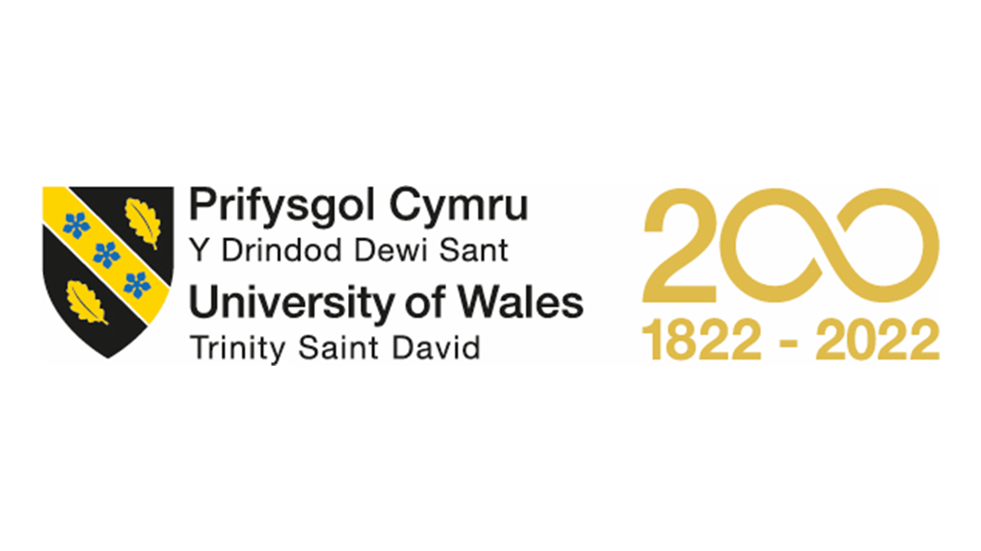

Module: Human Resource Management [LCMB7000]
Assessment: GROUP PRESENTATION INDIVIDUAL
WORK
Professor: Mushfiqur Rahman
Group no 5
Student Name and Id: Dakshesh Raval (2217673)

Table of content:
- Introduction
- Aims and Objectives
- Policies and Procedure
- What is Learning and Development
- Outcome

Dakshesh Raval

Introduction:
Human resource management (HRM), which focuses on improving employees' knowledge and abilities, includes learning and development (L&D) as a key component. Organizations may boost employee performance, job satisfaction, and retention rates by providing necessary training and information. A highly trained workforce that can adapt to changing conditions and maintain market competitiveness may be developed by investing in L&D programs, which can assist organizations in achieving their business objectives.
The difficulties ADIDAS faces with HRM and International HRM (IHRM) are crucial to its development as a worldwide brand. In this presentation, we will look at these problems in further detail and offer a critical assessment of how they affect the operation of the organization. We will also make suggestions for dealing with these concerns and emphasize the significance of L&D programs in preventing HRM and IHRM problems in a globalized company environment.

Aims and Objectives:
Aim:
One cannot overestimate the significance of growth and learning. Adidas does, however, have difficulties in putting into practice successful programs on a global and national scale. For learning and development projects to be improved, a critical understanding of these obstacles, such as cultural and linguistic disparities and resource limitations, is required and the aim of this study.

Objectives:
- According to Noe (2018), the main purpose of learning and development programs is to provide employees with the skills and information they need to do their present jobs well as well as to get them ready for their future career objectives. These programs provide workers with the chance to develop their abilities, learn new things, and keep up with the most recent developments in their field.
- By putting money into employee learning and development, businesses can show how committed they are to their staff members. Also, it can create opportunities for the employees to learn various skills and knowledge. This will increase the engagement of employees and increase work satisfaction. (Kramar,2014)
- The organization may experience improved earnings by investing in the appropriate learning and development for all levels of personnel. When workers have the requisite knowledge and abilities, they can carry out their tasks more successfully and effectively. This leads to increased output, quality, and client happiness, which eventually boosts an organization's profitability.
- Through different training programs, human resource management is essential in raising staff productivity. Giving workers the chance to learn project management, time management, and good communication techniques may greatly increase their engagement and productivity at work. Such initiatives improve outcomes for the business as well as the participants, who are the employees. The success of the organization may be achieved through HRM by making investments in employee development that result in a more knowledgeable and effective staff. (Kohn,1993)
- By ensuring that employees have the skills and training necessary to deliver first-rate customer service, HRM can boost customer satisfaction and loyalty. This may result in enhanced client relationships, higher rates of client retention, and fruitful word-of-mouth advertising. (Parasuraman, Zeithaml, & Berry, 1985

Dakshesh Raval
Policies and procedure:
- Noe et al. (2002) state that "HRM should carry out a thorough needs assessment to identify skill and knowledge shortages within the business." To ascertain their needs for learning and development, this might entail conducting focus groups, surveys, or interviews with management and staff.
- The organization's goals and objectives as well as the unique requirements of each employee should be taken into consideration when HR departments create specialized plans. The training courses, seminars, or programs that workers will take, as well as the anticipated outcomes, should be covered in these plans. HRM may make sure that workers receive the training they require to do their jobs well and advance their careers by creating specialized training programs.
- The learning and development of HRM include performance assessment. Making choices on promotions, transfers, and chances for training and development entails systematically evaluating an employee's work performance, including their strengths and shortcomings. (Aguinis,2019)
- Feedback is used by HR departments to pinpoint areas that require development, check that training is in line with employee requirements, and determine whether programs are meeting organizational objectives. When employees' perspectives are taken into consideration, they feel respected and empowered, which increases employee engagement and happiness. HR departments may enhance training and development initiatives, which boosts performance and increases employee retention, by routinely receiving employee input and acting on it.
- According to Noe et al. (2002), HR departments can encourage cross-functional training and development by giving employees the chance to work in different departments or business units, and by offering training programs that help employees develop the necessary skills and knowledge for these roles.

What are Learning and Development:
To increase employee performance on the job and position them for future career prospects, Noe (2018) defines learning and development as the process of strengthening an employee's skills, knowledge, and capacities. This covers both official and informal educational possibilities, such as coaching, mentoring, and on-the-job training. The main objectives of learning and development are to promote employee growth and development, raise work satisfaction and engagement levels, and enhance overall organizational performance. Learning and development initiatives may be tailored to the precise requirements and objectives of the company and its personnel, and they should be frequently assessed to guarantee their efficacy. Employee motivation and feelings of worth are boosted when there are possibilities for professional growth, which can improve output and work satisfaction. Higher client satisfaction and loyalty may result from this, which will eventually help the business succeed. Implementing successful learning and development programs is therefore essential for HRM if it is to boost staff productivity and expand organizational success.

Outcome: I have done deep research in finding data related to this topic, which is essential for me to complete my assessment properly. I have learned various skills by working with my team members and they have also performed well in this activity. This will help us in the future to complete our goals and work efficiently with any organization.

References:
- Noe, R. A., Hollenbeck, J. R., Gerhart, B., & Wright, P. M. (2002). Human resource management: Gaining a competitive advantage. McGraw-Hill Education.
- Aguinis, H. (2019). Performance management (4th ed.). Pearson.
- Noe, R. A. (2018). Employee Training and Development (7th ed.). McGraw-Hill Education.
- Kramar, R. (2014). Beyond strategic human resource management: is sustainable human resource management the next approach? The International Journal of Human Resource Management, 25(8), 1069-1089
- Kohn, A. (1993). Punished by rewards: The trouble with gold stars, incentive plans, A's, praise, and other bribes. Houghton Mifflin Harcourt.
- Parasuraman, A., Zeithaml, V. A., & Berry, L. L. (1985). A conceptual model of service quality and its implications for future research. Journal of Marketing, 49(4), 41-50.

