
Programme of Study: Computer Networking / Cyber Security
Module Name and Code: ACCA5023 – Network Operating Systems
Assignment Title:
Implementation of a Virtualised Enterprise Network Infrastructure
Student Name: Adil Rahim
Student ID: 2419107


Table of Contents
1. Introduction 2
2. Network Design and Architecture 3
3. Implementation of core services 6
3.1 Routing 7
3.2 Domain Server and DNS 9
3.3 Encrypted Connection (VPN) 11
3.4 Users 13
3.5 Domain Membership 14
3.6 DHCP Server 15
3.7 Testing and Troubleshooting 17
3.8 Disk Drive 18
3.9 IIS Server 19
3.10 Remote Desktop Services (RDS) 20
4. Conclusion 21
References 22

Introduction
The essay critically describes the implementation of a virtualised enterprise network across Birmingham and London. Additionally, it focuses on the core network services required for business functionality, security, and centralised management.
The main problem addressed is the coordination of several interdependent services like routing, Active Directory, DNS, and VPN into a working whole. Enterprise networks are at risk of fragmentation, lack of proper authentication, and insecure communication channels without adequate integration [1].
To solve this problem, the network was configured with Active Directory Domain Services, Domain Name System, Dynamic Host Configuration Protocol, Routing and Remote Access Services, and a site-to-site Virtual Private Network. These services enable key enterprise functions, such as centralised identity management, automatic IP allocation, and secure inter-site connectivity [2].
Nonetheless, it is essential to understand that functionality alone is not enough. The efficiency and security of these services’ interactions directly impact overall network performance. Thus, this report documents the implementation and evaluation of key configuration choices and their impact on the performance and reliability of the network.

Network Design and Architecture
The network design uses a client-server architecture distributed between Birmingham and London. The Birmingham network is the main network and Windows Server is configured as a Domain Controller. This server provides Active Directory, DNS, and DHCP services, thereby enabling centralised authentication and automatic IP allocation on the network [1].
The Debian server, which is mainly used for routing and DHCP relay, is used to set up the London network. This arrangement enables communication between the two networks, while still maintaining a structured separation. It is important to note that different operating systems are used, reflecting real-world enterprise environments where Windows and Linux systems are frequently used together.
Network segmentation that separates Birmingham from London improves security, as the systems are not directly exposed. Nevertheless, this also requires proper routing as well as secure communication, which is handled by static routes and a site-to-site VPN [2].
In addition, DNS is used instead of IP addressing, which makes it easier to use and manage. This approach is generally considered scalable and efficient in enterprise environments.
Still, the design is fairly simple and may not scale well in bigger environments. For instance, static routing is not as flexible as dynamic routing protocols like OSPF, which can adapt to a changing topology. This shows that although the design functions, there is a lack of scalability and fault tolerance.
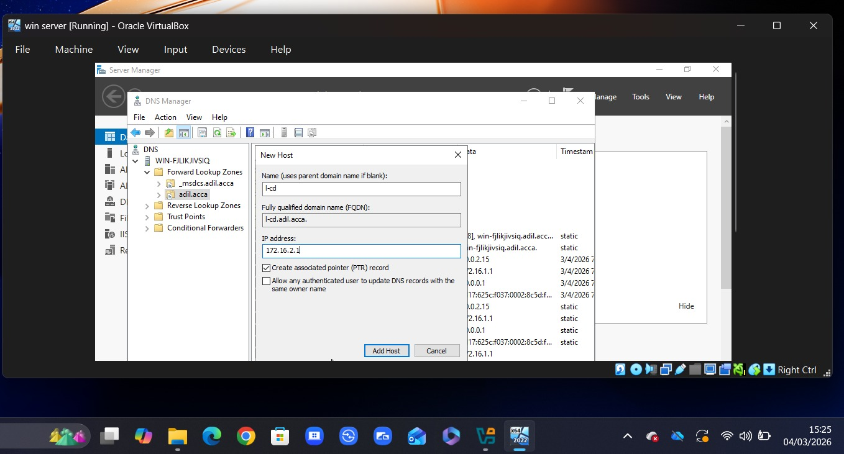
Figure 1: Network topology showing Birmingham and London infrastructure
This figure shows how the network is split between Birmingham and London, with Birmingham acting as the main site where most services are hosted. The two networks are connected through routing and VPN, allowing communication between them.
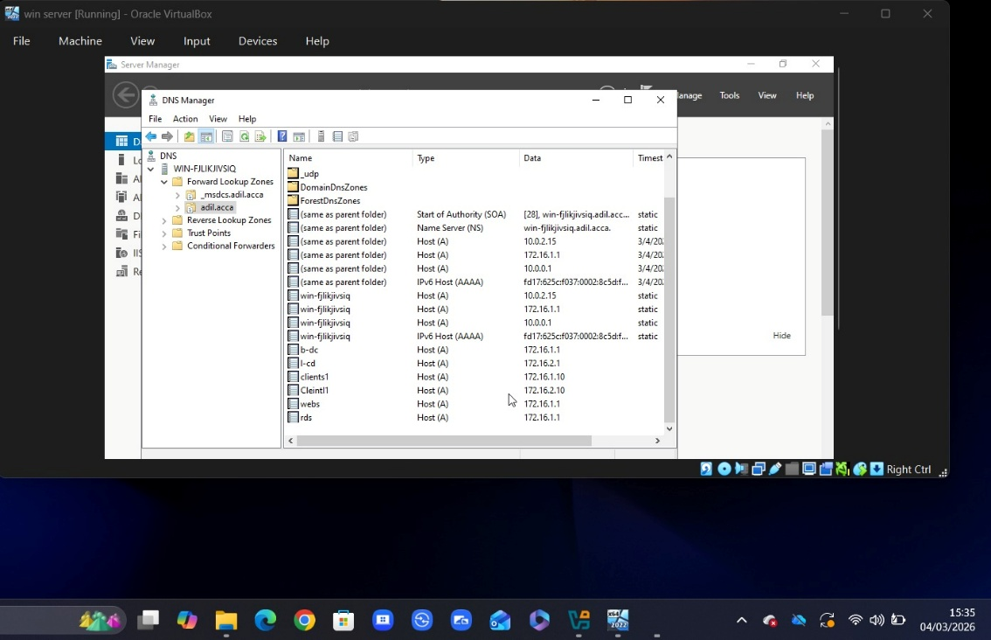
Figure 2: Configuration of core services on Birmingham Domain ControllerThis figure shows the Windows Server configured as a Domain Controller, where services like Active Directory, DNS, and DHCP are running. These are important because they allow centralised login, name resolution, and automatic IP assignment.

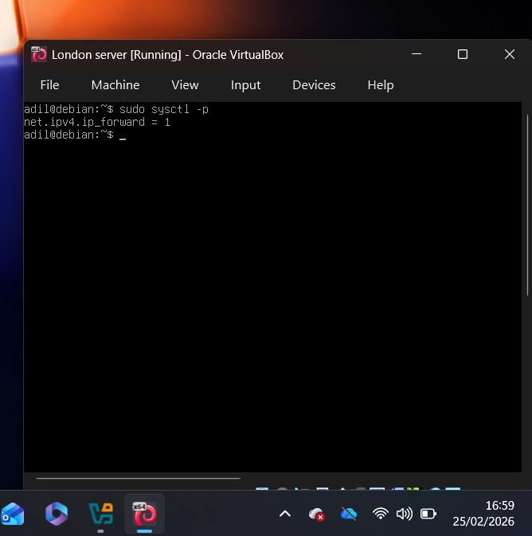
Figure 3: Routing configuration on Debian server in London network
This figure shows the routing setup on the Debian server in London, where IP forwarding and routes are configured. This is needed so that traffic can move between the London and Birmingham networks.

Implementation of core services
Upon implementation of the main network services, the enterprise setup is presented in this section. Each service is configured so that the network is operational, secure, and managed appropriately across Birmingham and London.
The deployment consists of routing, domain services, DNS, DHCP, VPN, file sharing, and remote access. Because these services are interrelated, one misconfiguration can degrade the performance and reliability of the overall network [1].
It is important to note that this implementation was not only focused on functionality, but also ensured that real-world enterprise practices were followed, including centralised authentication, secure communication, and controlled access to resources [2].
The following sections will elaborate on each configuration, providing screenshots for reference that illustrate both the configuration process and the final result.

Routing
The communication between the Birmingham and London networks is established through routing and is critical to the operation of the setup. Without routing, both networks would remain isolated and unable to access shared services.
In the Birmingham network, RRAS was configured on the Windows Server to forward traffic between networks. Firewall rules were modified to allow ICMP traffic for connectivity checks. These configurations enable communication between the two sites, as illustrated in Figure 6.
In the London network, IP forwarding was configured on the Debian server, and static routes were added to control traffic. This ensures that data can travel correctly between Birmingham and London, as shown in Figure 4 and Figure 5.
Nonetheless, static routing has limitations in larger environments, as it does not automatically adapt to network changes, unlike dynamic protocols such as OSPF [3].
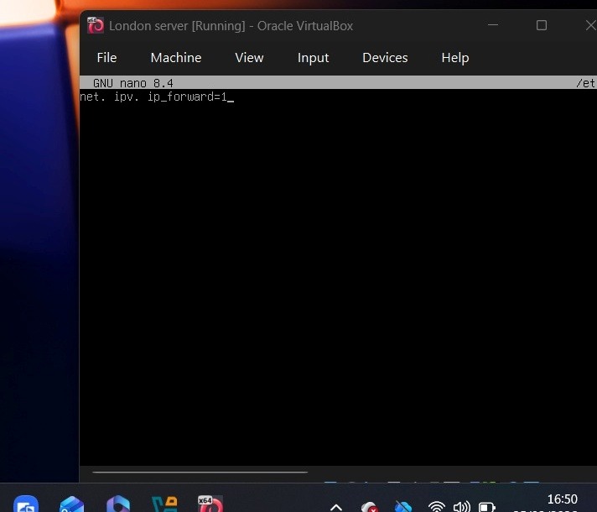
Figure 4: IP forwarding enabled on Debian server
This figure shows that IP forwarding is enabled on the Debian server, allowing the system to pass traffic between networks instead of acting as a normal host.
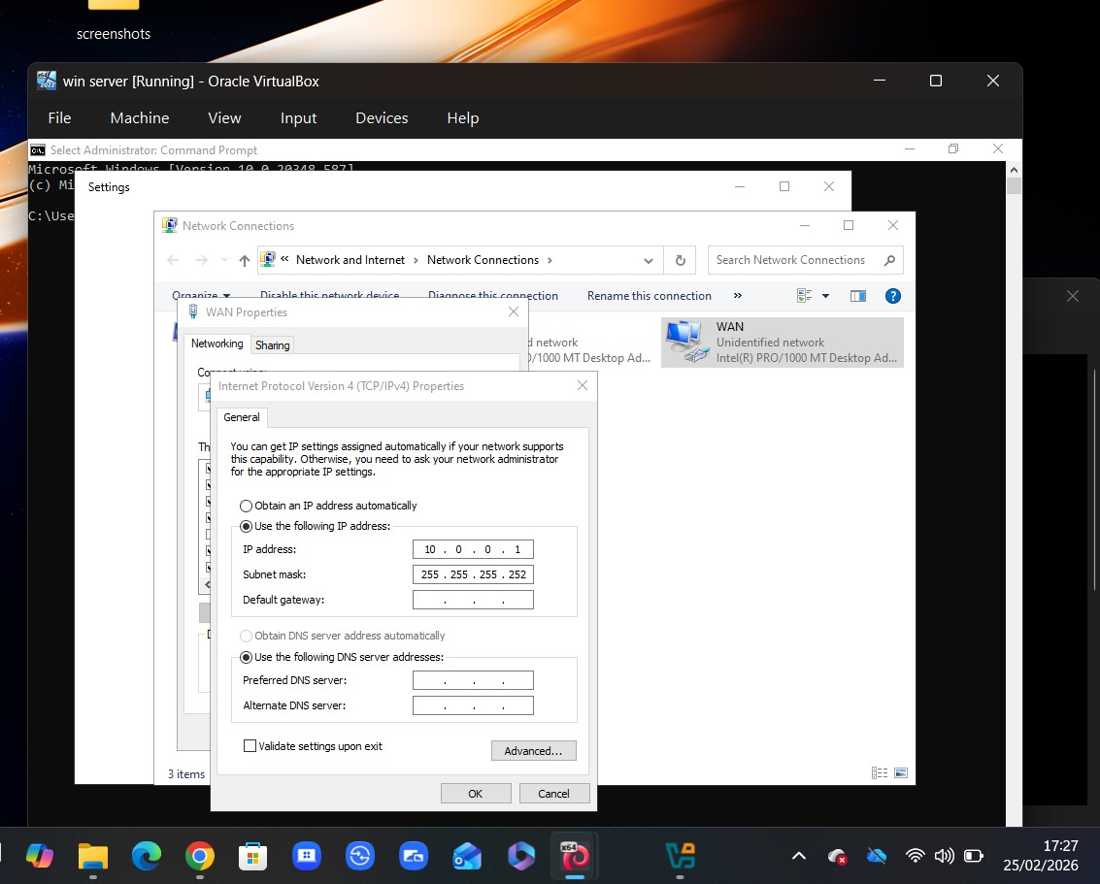
Figure 5: Static routing configuration between Birmingham and London networks
This figure shows the static routes configured on the system, defining how traffic is directed between the Birmingham and London networks.
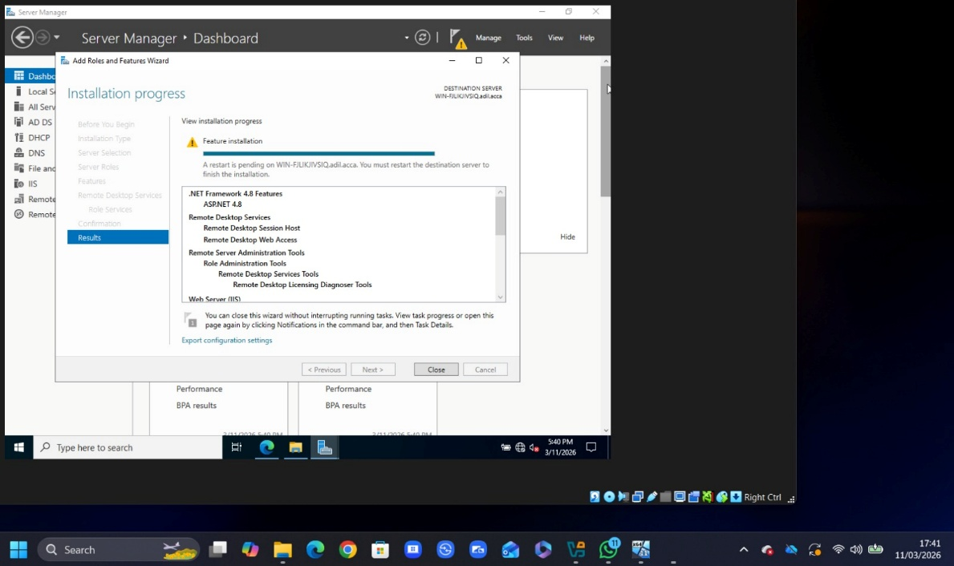
Figure 6: RRAS configuration and firewall rules on Windows Server
This figure shows the RRAS configuration on the Windows Server, along with firewall settings that allow communication between the two networks.

Domain Server and DNS
The Domain Controller was configured in the Birmingham network to manage users, authentication, and network resources. A forest domain called yourname.acca was created to allow centralised control over the network.
The same server was also configured with DNS to support name resolution across both Birmingham and London networks. Records were created for all servers so that devices can be accessed using domain names instead of IP addresses. In addition, a reverse lookup zone was set up with PTR records, allowing IP addresses to be linked back to hostnames.
Figures 7 and 8 show how DNS and domain services were configured to support communication and management across the network.
However, if DNS is not configured correctly, it can cause issues such as failed authentication or loss of access to services. This shows how important DNS is in keeping the network stable and functional [4].
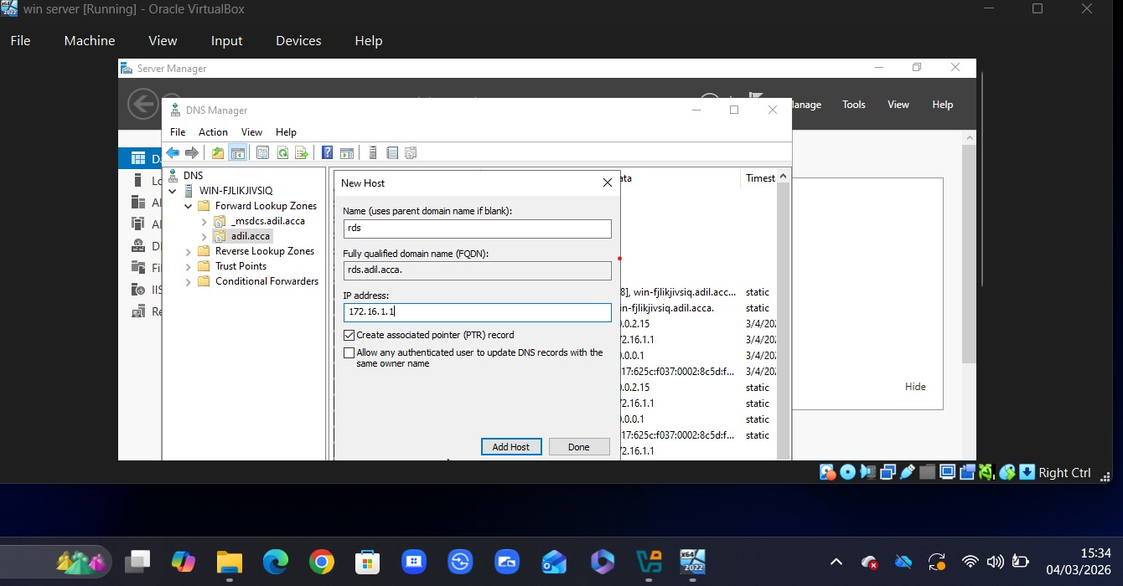
Figure 7: Domain Controller and DNS configuration on Windows Server
This figure shows the Windows Server configured as a Domain Controller, including Active Directory and DNS services used for managing users and network resources.

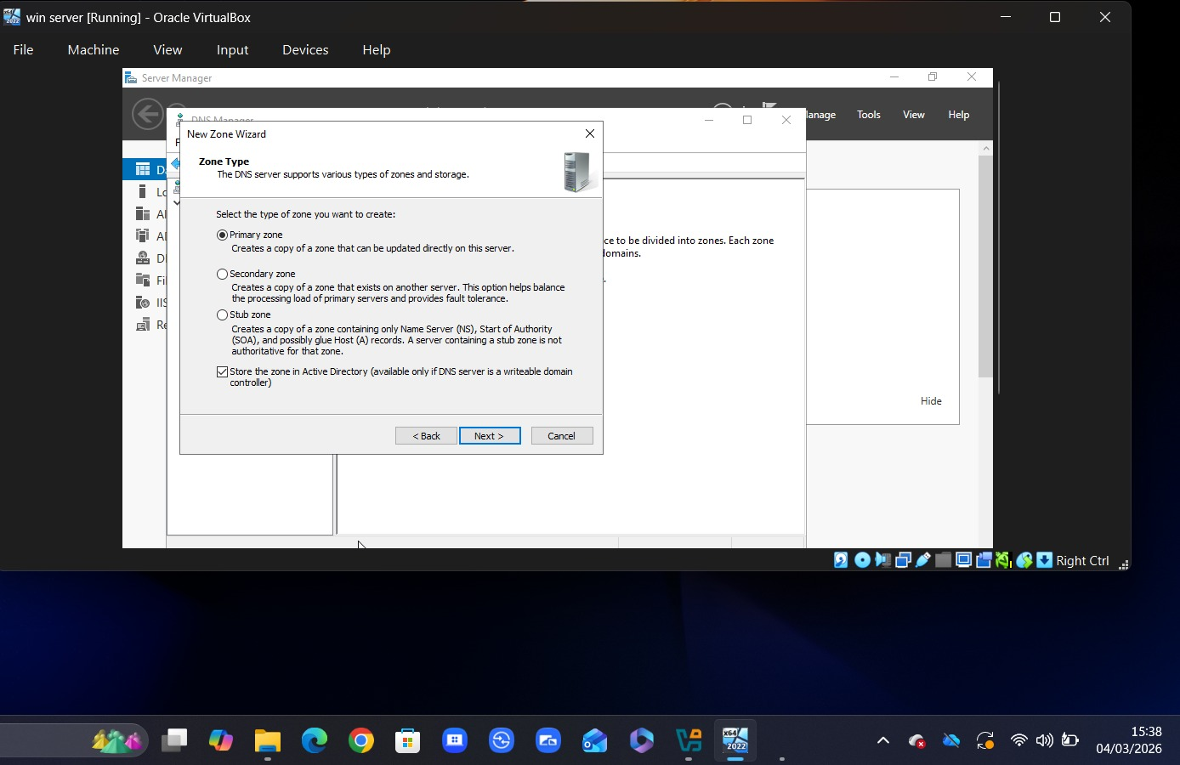
Figure 8: DNS records and zone configuration
This figure shows the DNS setup, including records and zones used for resolving domain names and linking IP addresses to hostnames.

Encrypted Connection (VPN)
A VPN connection was created for the Birmingham and London sites so they can communicate securely. A virtual private network helps protect data during transmission.
IPSec was used to configure the VPN so that both networks act as if they are on the same internal network. In business environments, different locations must be able to communicate securely.
As shown in Figure 9 and Figure 10, the VPN configuration includes key exchange and authentication, enabling a stable connection between the two networks.
Still, weak encryption or misconfiguration can expose the network to security risks. Data needs to be encrypted at all times to prevent unauthorised access [5].
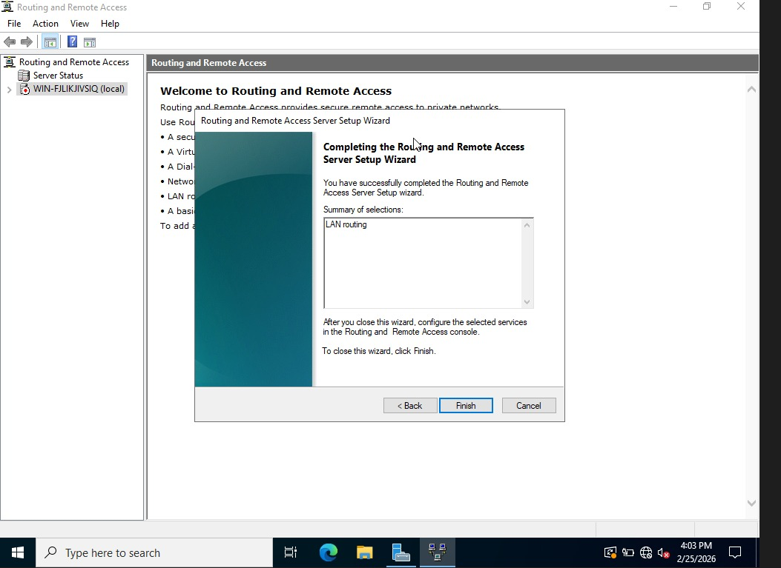
Figure 9: IPSec VPN configuration between Birmingham and London
This figure shows the VPN configuration used to establish a secure connection between the two networks.

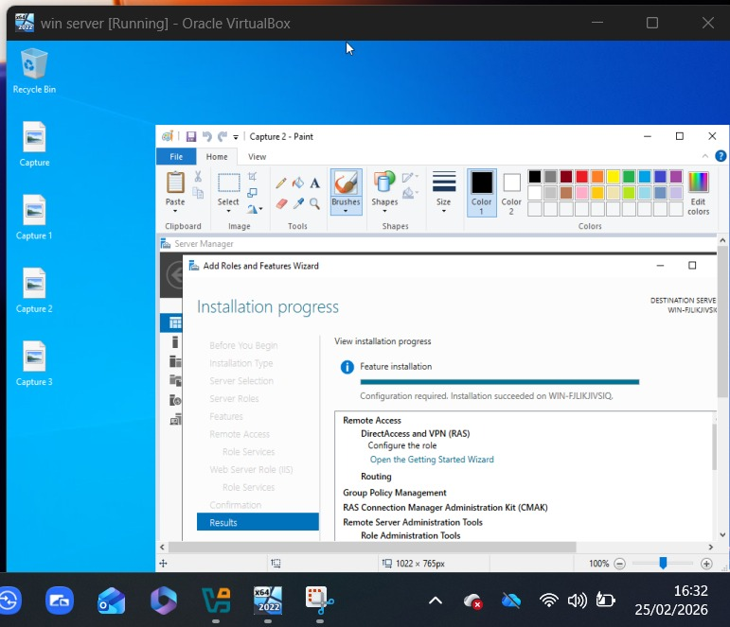
Figure 10: Active VPN connection between Birmingham and London networks
This figure shows the active VPN connection, confirming that secure communication between the two sites is established.

Users
User accounts were created in the yourname.acca domain to allow access to network resources. All users were created following the required naming convention, using the first letter of the first name followed by the surname.
Creating users manually can be time-consuming. PowerShell can be used to automate this process, making it easier and reducing the chances of mistakes when creating multiple accounts. This approach reflects how companies automate tasks in real-world environments.
As shown in Figure 11, user accounts were created and managed successfully in Active Directory.
Incorrect user configuration or weak password settings can lead to security risks. Therefore, appropriate policies must be applied to ensure secure access to the network [6].
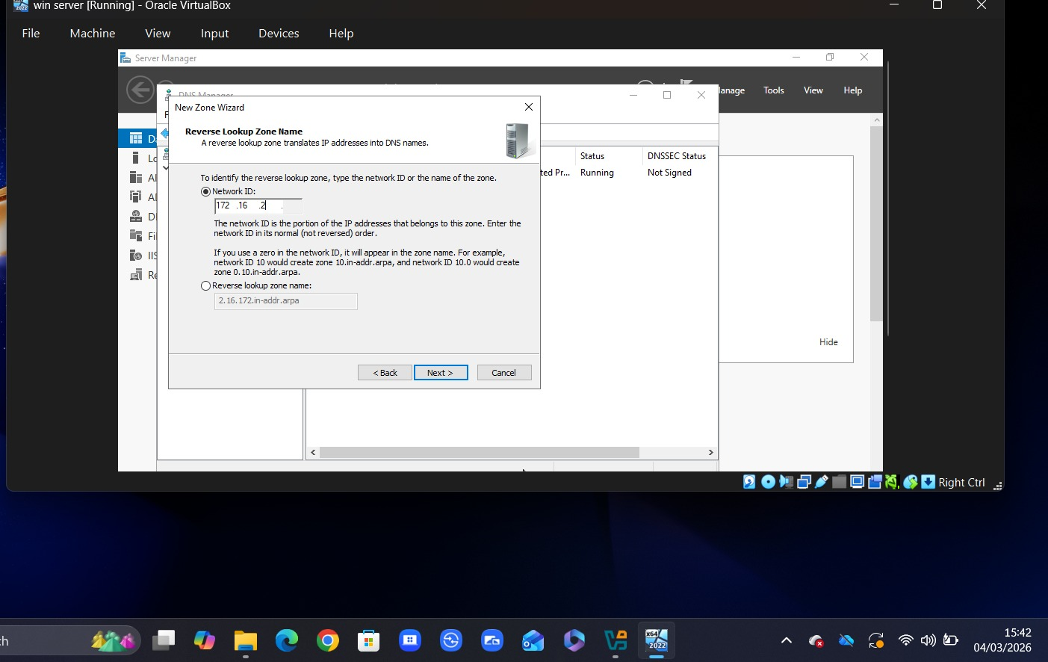
Figure 11: User accounts created in Active Directory
This figure shows the user accounts created in the domain, following the required naming convention.

Domain Membership
The L-CD, ClientS1, and ClientL1 client machines were joined to the yourname.acca domain for centralised authentication to the network. This allows users to log in using domain credentials rather than local credentials.
Adding devices to the domain provides better control over user accounts, security settings, and resources. It also allows all systems to be managed consistently from the Domain Controller.
As illustrated in Figure 12, the machines were successfully joined to the domain and are identifiable in Active Directory.
However, users may encounter login problems or limited access to resources if systems are not properly configured. Therefore, correct domain integration is essential for maintaining a stable and secure network [7].
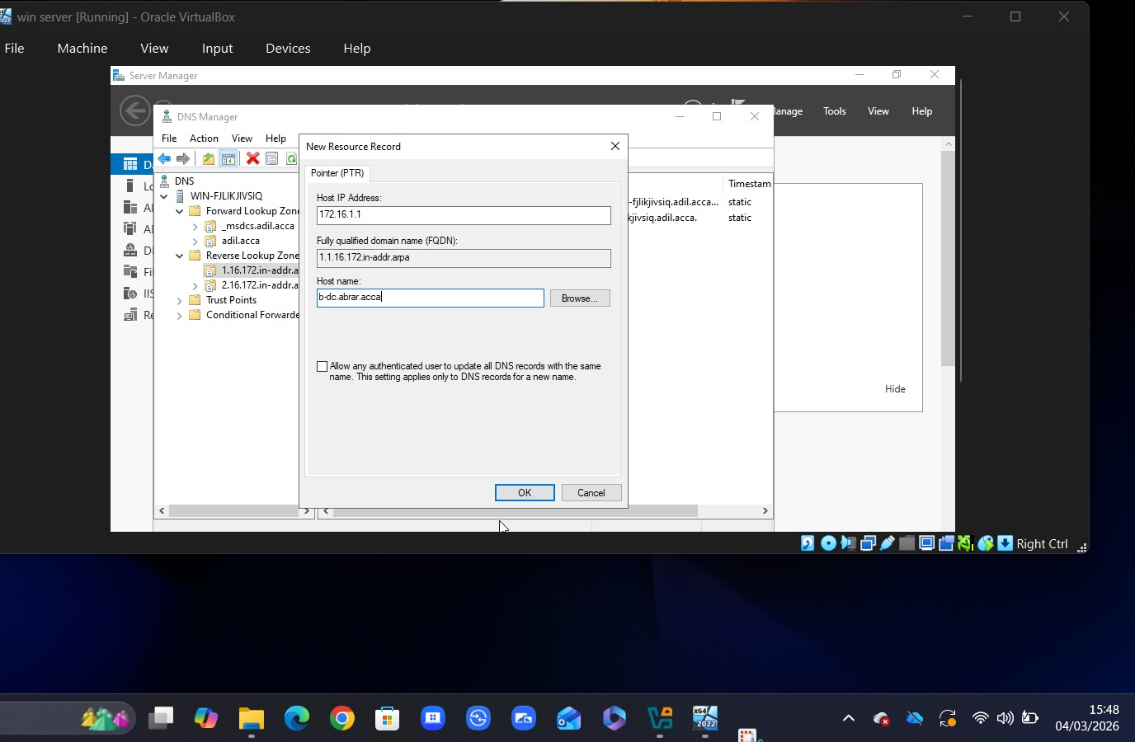
Figure 12: Client machines joined to the domain
This figure shows that the client systems have been successfully joined to the domain and are managed through Active Directory.

DHCP Server
The Birmingham Domain Controller was configured as the DHCP server to automatically assign IP addresses to clients. A scope was defined with a specific IP range so that devices could receive network configuration without manual setup.
Moreover, the London server was configured as a DHCP relay to forward client requests to the DHCP server in Birmingham. This ensures that devices in both networks can obtain IP addresses automatically.
As shown in Figure 13 and Figure 14, DHCP configuration and IP allocation were successfully implemented.
Incorrect DHCP configuration can result in issues such as IP conflicts or devices failing to connect to the network. Therefore, correct scope and relay configuration are essential for maintaining network stability [8].
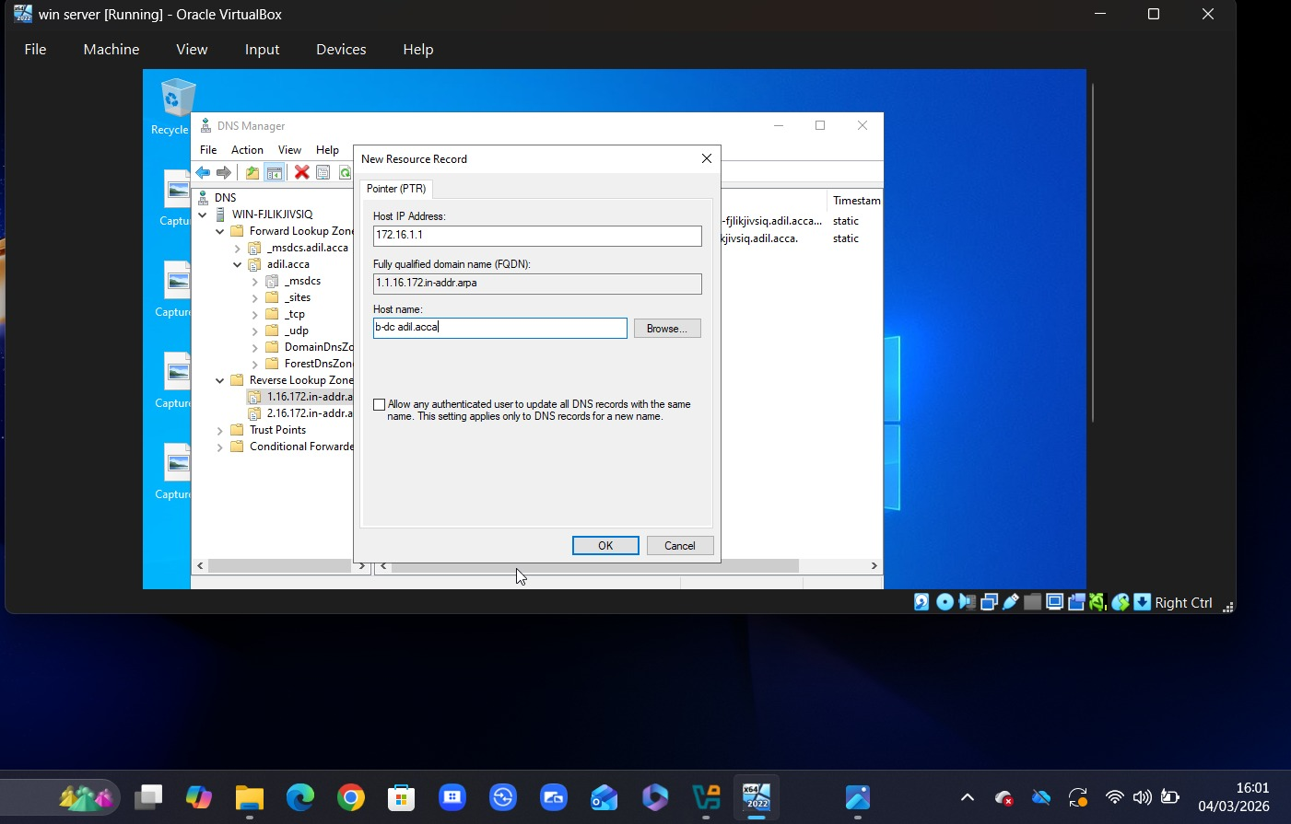
Figure 13: DHCP scope configuration on Domain Controller
This figure shows the DHCP scope used to assign IP addresses automatically to devices in the network.

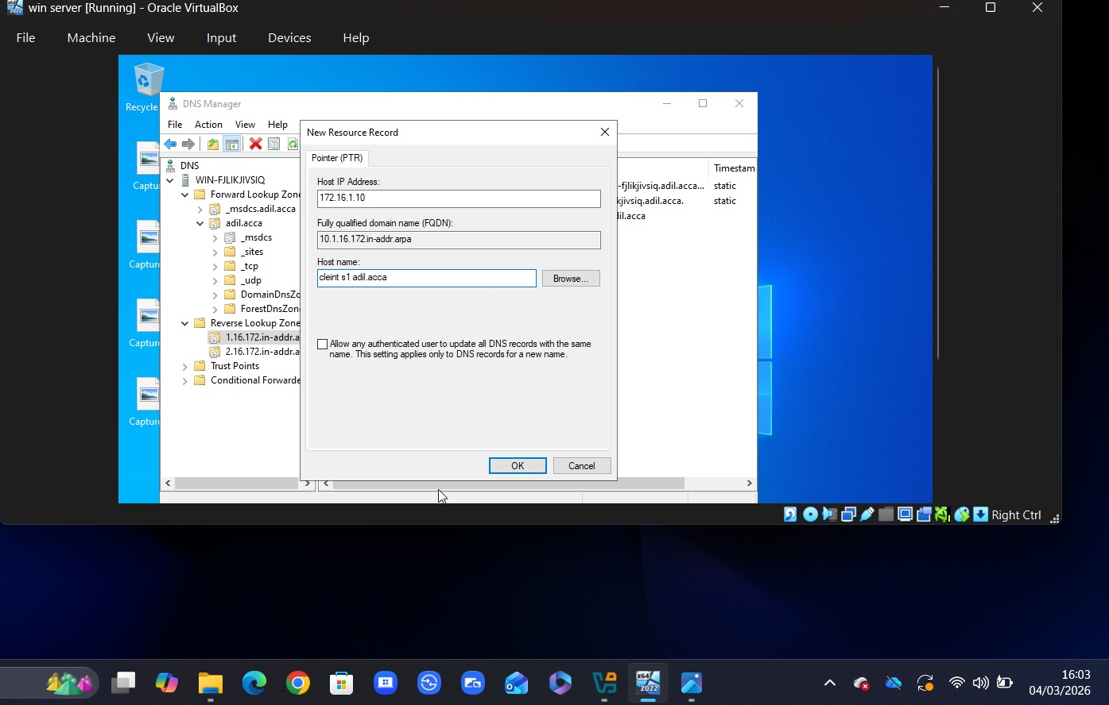
Figure 14: Automatic IP address assignment via DHCP
This figure shows that client devices receive IP addresses automatically from the DHCP server.

Testing and Troubleshooting
Once the entire configuration was completed, the network was tested to check if everything was working properly. Tools such as ping were used to confirm that communication was possible across both networks between Birmingham and London.
Domain login, DNS resolution, and DHCP IP allocation tests were also performed. These checks confirmed that services were functioning correctly and that users were able to access network resources.
As shown in Figure 15, connectivity tests were successful, and the network is operational.
During testing, issues such as failed connections or incorrect configurations may occur. To identify and resolve these issues, it is necessary to check routing, DNS, and firewall settings [9].
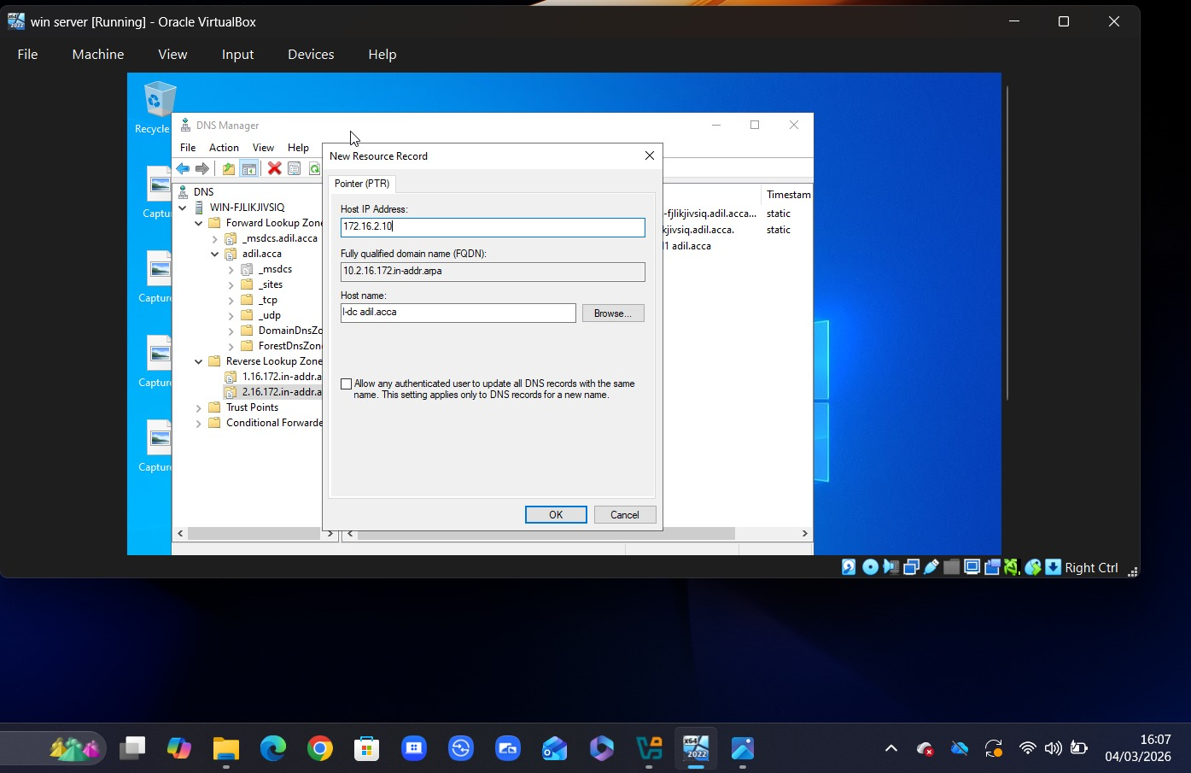
Figure 15: Successful connectivity test between Birmingham and London networks
This figure shows a successful ping test, confirming communication between the two networks.

Disk Drive
An extra disk drive was mounted on the Birmingham server and assigned the path E:\BirminghamFiles. Once shared across the network, both Birmingham and London were able to access the drive.
Permissions were configured to allow domain users full control, while other users were given read-only access. This ensures that files are managed securely while still being accessible where needed.
As shown in Figure 16, the shared drive is accessible across the network with appropriate permissions applied.
However, incorrect permission settings can lead to unauthorised access or data loss. Therefore, it is important to configure access rights properly to ensure data security [10].
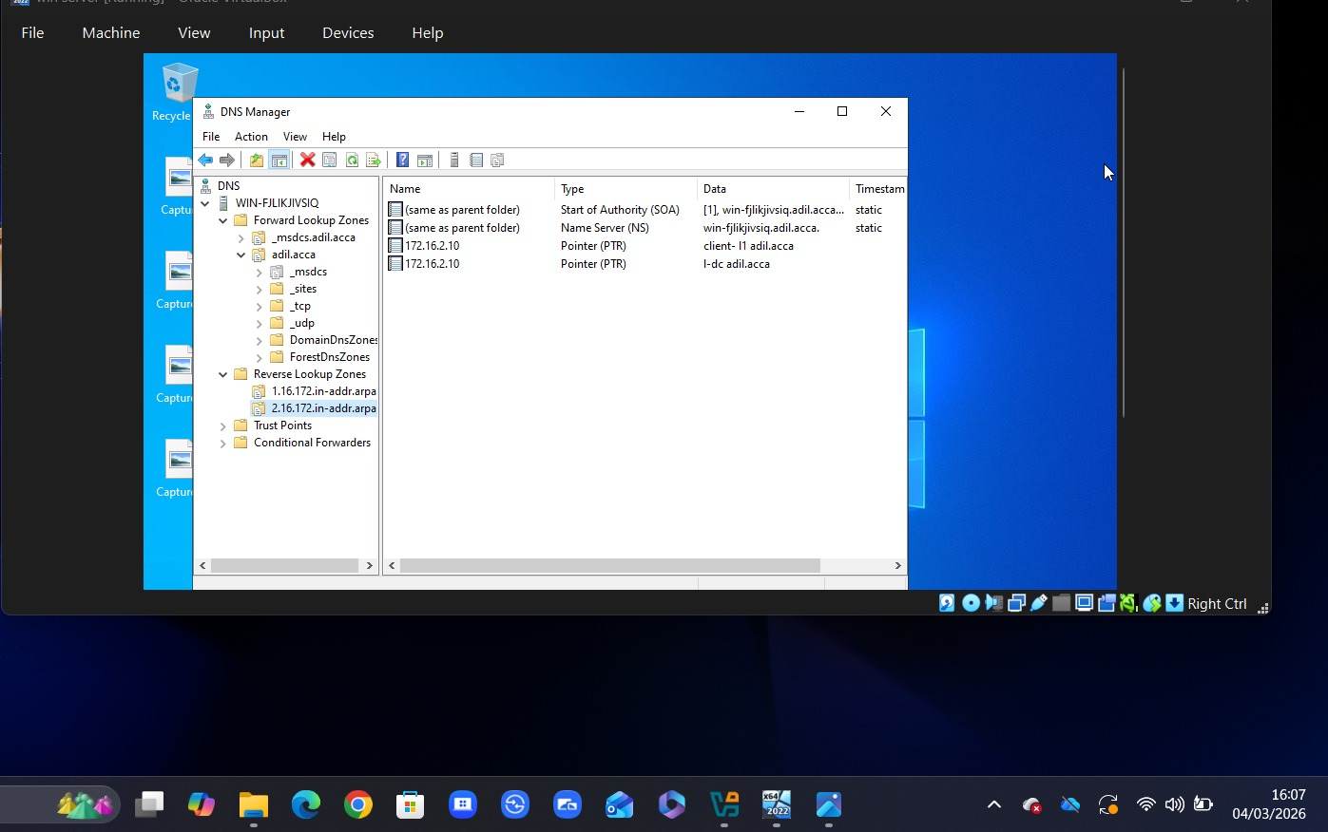
Figure 16: Shared disk drive with configured permissions
This figure shows the shared drive and the permissions applied to control access across the network.

IIS Server
The IIS server was configured on the Birmingham network to host a website for internal access. A website named webs.yourname.acca was created and configured within the domain.
The website was set to allow access only to domain users using Windows authentication. By requiring domain credentials to log in, the security of the website is improved.
The website is accessible and displays the required message, as shown in Figure 17, confirming that the configuration was successful.
However, incorrect IIS configuration or weak authentication settings can lead to unauthorised access. Therefore, proper configuration and security settings are necessary to protect web-based resources [11].
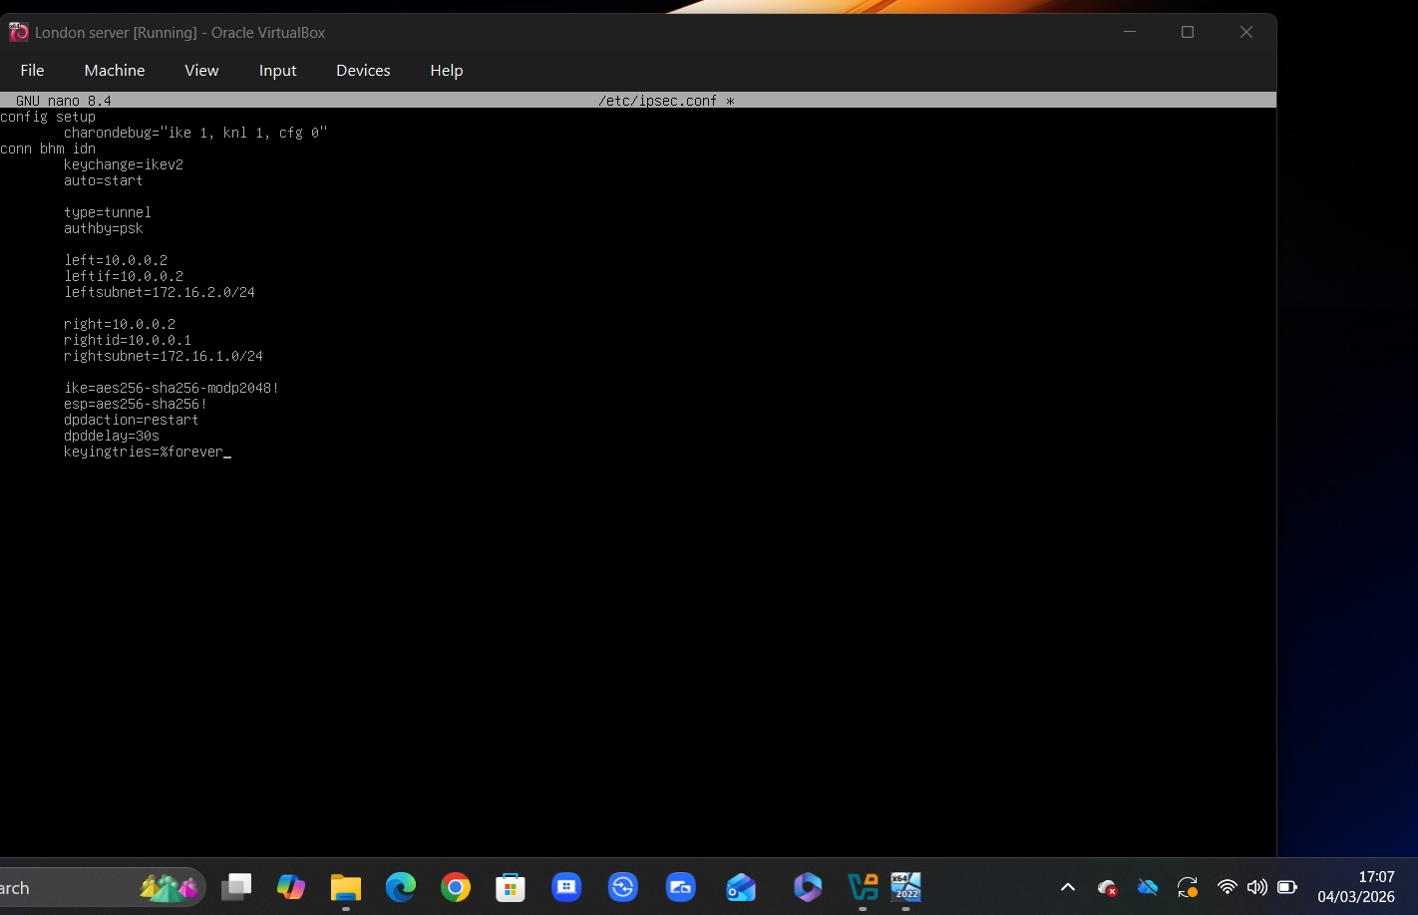
Figure 17: IIS website hosted on Birmingham server
This figure shows the configured website, confirming that it is accessible to authorised users within the network.

Remote Desktop Services (RDS)
The Birmingham server was configured to allow access from other machines on the network through Remote Desktop Services. This allows users to manage the server without physical access.
Using a web-based access point, a secure connection was created to allow users to connect to the domain. This makes remote management more flexible and accessible.
Figure 18 shows the RDS login page, and its availability indicates that remote access is configured successfully.
Weak or misconfigured security settings can lead to unauthorised access risks. Therefore, it is necessary to ensure secure configuration and proper authentication of remote access services [12].
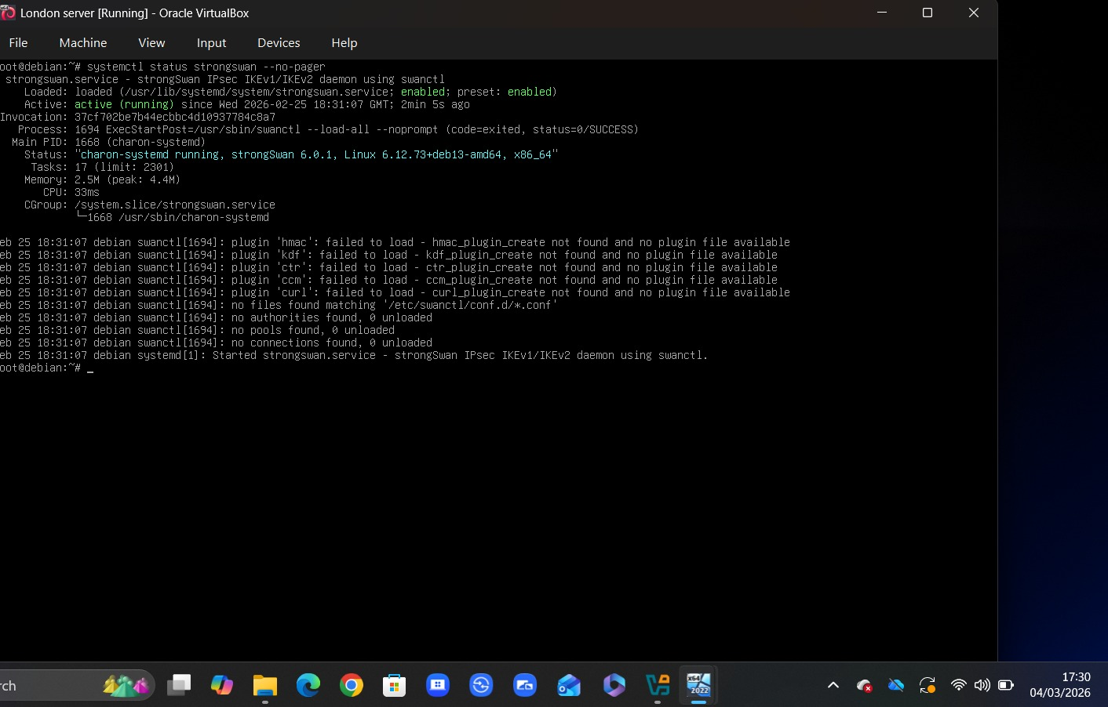
Figure 18: Remote Desktop Services login interface
This figure shows the RDS login page, confirming that remote access to the server is available.

Conclusion
The report outlines the implementation of a virtualised enterprise network in London and Birmingham. It includes a range of services such as routing, domain configuration, DNS, DHCP, VPN, file sharing, and more. Each component was configured so that the network is manageable, functional, and secure at both sites. In summary, the sites can communicate, user authentication is centralised, and users can access shared resources, similar to a real corporate network.
Nonetheless, certain limitations were identified during the process. In larger environments, the use of static routing can reduce flexibility. Additionally, incorrect configuration of DNS, DHCP, or security settings may lead to connectivity or access issues. This shows the importance of proper configuration and strong security measures to keep the network stable.

References
[1] A. S. Tanenbaum and D. J. Wetherall, Computer Networks, 5th ed. Pearson, 2011.
[2] Microsoft, “Active Directory Domain Services Overview,” Microsoft Learn, 2023. [Online]. Available: https://learn.microsoft.com/en-us/windows-server/identity/ad-ds/get-started/virtual-dc/active-directory-domain-services-overview
[3] Cisco, “IP Routing Basics,” Cisco Networking Academy, 2022. [Online]. Available: https://www.netacad.com/courses/networking-basics
[4] Microsoft, “DNS Overview,” Microsoft Learn, 2023. [Online]. Available: https://learn.microsoft.com/en-us/windows-server/networking/dns/dns-top
[5] W. Stallings, Cryptography and Network Security, 7th ed. Pearson, 2017.
[6] Microsoft, “Active Directory Users and Computers,” Microsoft Learn, 2023.
[7] Microsoft, “Join a Computer to a Domain,” Microsoft Learn, 2023. [Online]. Available: https://learn.microsoft.com/en-us/windows-server/identity/ad-ds/manage/join-computer-to-domain
[8] Microsoft, “DHCP Overview,” Microsoft Learn, 2023. [Online]. Available: https://learn.microsoft.com/en-us/windows-server/networking/technologies/dhcp/dhcp-top
[9] Cisco, “Network Troubleshooting Basics,” Cisco Networking Academy, 2022. [Online]. Available: https://www.netacad.com/courses/networking-basics
[10] Microsoft, “File and Folder Permissions,” Microsoft Learn, 2023.
[11] Microsoft, “IIS Web Server Overview,” Microsoft Learn, 2023. [Online]. Available: https://learn.microsoft.com/en-us/iis/get-started/introduction-to-iis/iis-web-server-overview
[12] Microsoft, “Remote Desktop Services Overview,” Microsoft Learn, 2023.

