Component 1 – Website Redesign for Online Business Presence
Module code: ACCA5019
Lecturer: Dr Mobolanle Bello
Submission deadline: 26/06/2026
Name – Guilherme Yporti Gutuzzo
Student Number - 2415327

Table of Contents
Introduction ----------------------------------------------------------------- 2
2.0 Healthy/harvest Website Redesign ----------------------------------- 3
2.1 Current Issue ------------------------------------------------------------ 3
2.1 Current Issue ------------------------------------------------------------ 3
2.1 Current Issue ------------------------------------------------------------4,5
2.2 Propose Solutions ------------------------------------------------------- 5
2.2 Propose Solutions ------------------------------------------------------- 6
3.0 Responsive Design Implementation ------------------------------------7
3.1 Implications for improving User Experience ---------------------------7
3.2 Implications for improving Mobile Sales -------------------------------8
4.0 Implementation Moodborard------------------------------------------- 9
Wireframe ---------------------------------------------------------------- 10,11,12
Web Design --------------------------------------------------------------- 13,14,15
4.1 Moodboard and Wireframe Design ---------------------------------16,17
5.0 Conclusion --------------------------------------------------------------- 18
References ------------------------------------------------------------------- 19
1.0 Introduction
This report presents the redesign process of the HealthyHarvest website, an online organic grocery business that offers fresh produce, pantry products, prepared meals and subscription boxes. The main purpose of the project is to improve the website’s usability, visual identity and overall customer experience [1]. The redesign also aims to support the company’s sustainable values, increase customer trust and encourage more online purchases and subscription sign-ups [2].
The scope of the report includes an analysis of the main problems found in the current website, such as confusing navigation, outdated visual design, limited product information, poor mobile responsiveness, accessibility concerns and an inefficient checkout process. It also explains the proposed design solutions and discusses the importance of responsive design in e-commerce.
The methodology followed a structured UI/UX design process. First, a mood board was created to define the colours, typography, imagery and sustainable visual direction of the brand. Wireframes were then developed to organise the layout, content and navigation of the key pages. Finally, an interactive prototype was produced to demonstrate how users would move between the Home, Shop, Subscription, About Us and Contact pages.
This report is significant because it shows how effective design decisions can improve usability, customer satisfaction, mobile accessibility and business performance [3].

HealthyHarvest website redesign
2.0 HealthyHarvest Website Redesign
The current HealthyHarvest website presents several usability and design problems that may reduce customer satisfaction and limit business growth. As an online organic grocery company, HealthyHarvest needs a website that is easy to use, visually attractive and reliable.
Customers should be able to find products easier, understand the company’s values and complete purchases without unnecessary difficulty. The redesign therefore focuses on identifying the main weaknesses of the existing website and proposing suitable solutions to improve the overall user experience.
2.1 Current Issues
Confusing Navigation
One of the main issues is confusing navigation and information architecture. If products, subscription plans and company information are not organised clearly, users may struggle to find the content they need. A complicated menu can increase frustration and cause customers to leave the website before completing a purchase [1].
Outdated Visual Designs
The visual design is also outdated and does not communicate the organic and sustainable identity of HealthyHarvest effectively. A website for an organic grocery business should create a natural, fresh and trustworthy impression. However, inconsistent colours, weak visual hierarchy and poor-quality imagery can make the business appear less professional [2].
Limited Mobile Experience
Another important problem is the limited mobile experience. Many customers access e-commerce websites using smartphones, so a non-responsive layout can create serious usability difficulties. Text may appear too small, buttons may be difficult to select, and product information may not fit correctly on the screen. These issues can discourage mobile users and reduce sale [4], [5].
Limited Product Information
The current website also provides limited product information and does not offer enough transparency about ingredients or product sourcing. Customers buying organic food may want to know where products come from, whether they are certified organic and what ingredients are included. Without this information, users may have less confidence in the company [3].
Low-Quality Image
Low-quality or poorly optimised images create additional problems. Images are important in online grocery shopping because customers cannot physically inspect the products. If photographs are unclear, inconsistent or slow to load, users may find it difficult to judge product quality. Large image files may also reduce website performance.
Inefficient Checkout Process
The checkout process is another area of concern. A long or complicated checkout may require customers to complete too many steps or enter unnecessary information. This can increase cart abandonment, particularly for users who want a quick and convenient shopping experience.
Lack of Personalised Recommendations
The website also lacks personalised recommendations. Without suggestions based on product categories, previous choices or popular items, the business may miss opportunities to increase the average order value. Customers may also find the shopping experience less engaging.
Accessibility Issues
Accessibility is another significant issue. Weak colour contrast, small text, unclear buttons and missing labels may make the website difficult to use for people with visual or physical impairments. Accessibility problems can exclude potential customers and reduce the overall quality of the website [6], [7].
Limited Trust Signals
Finally, the site has limited trust signals and social proof. Customers may hesitate to purchase if they cannot see reviews, secure payment information, delivery details or evidence of the company’s commitment to sustainability. Ineffective calls-to-action may also make it unclear what users should do next [2], [3].

2.2 Proposed Solutions
Improved Navigation
The redesigned HealthyHarvest website uses a simple and consistent navigation menu with the main pages: Home, Shop, Subscription, About Us and Contact. This structure helps users understand where information is located and allows them to move easily between pages [1]. A search bar, account icon and shopping cart are also placed in the header to support common customer actions.
Stronger Visual Identity
The new visual identity uses green, beige, grey and natural brown tones to reflect health, freshness and sustainability. The moodboard guided the choice of colours, typography, imagery and icons. High-quality photographs of vegetables, farms and organic products support the brand message and create a stronger emotional connection with users.
Clear Calls-to-Action
The Home Page includes a large hero banner with the message “Fresh Organic Groceries Delivered to Your Door”. Two clear buttons, “Shop Now” and “View Subscription Plan”, guide users towards the most important actions. This improves the visibility of key services and supports higher conversion rates [2].
Product Organisation and Filtering
The product section is organised into clear categories such as fruits and vegetables, pantry staples, beverages, snacks and personal care. The Shop Page also includes filters for price, dietary needs and organic products. These features help customers reduce the number of results and find suitable items more efficiently.
Product Information and Transparency
Product cards include images, names, prices, ratings and “Add to Cart” buttons. More detailed product pages could also provide ingredient lists, nutritional information, sourcing details and organic certification. This would improve transparency and help customers make informed purchasing decisions.
Subscription Plans
The subscription section presents three simple choices: Starter Box, Family Box and Premium Box. Each plan clearly shows the price, number of items, delivery benefits and cancellation options. The “Choose Plan” buttons provide a direct and understandable call-to-action.
Trust and Social Proof
To improve trust, the Home Page includes customer reviews, secure payment information, delivery benefits and sustainable packaging messages. These elements demonstrate reliability and show that other customers have had positive experiences with the company [2], [3].
Accessibility Improvements
The redesign also considers accessibility by using clear headings, readable text sizes, recognisable icons and stronger contrast between text and backgrounds. Buttons are large enough to select easily, and the layout can be adapted for different screen sizes [6], [7].
Checkout and Website Performance
Finally, image sizes should be optimised to improve loading speed without reducing visual quality. A simplified checkout process should request only essential information and provide clear delivery and payment options. Together, these solutions create a more professional, accessible and user-friendly website that supports HealthyHarvest business objectives and sustainable brand value.

3.0 Responsive Design Implementation
Responsive web design is an accordance that allows a website’s layout, content and interactive elements to adjust automatically to different screen sizes and devices [ ]. It aims to provide a consistent and usable experience across desktop computers, tablets and smartphones by adapting elements such as images, navigation menus, text and page structure. Responsive design is especially important for e-commerce because customers may begin or complete their shopping journey using different devices [4].
3.1 Implications for Improving User Experience
Responsive design has important implications for improving user experience in e-commerce websites. The literature suggests that users expect websites to work effectively across different devices, including desktops, tablets and smartphones [4], [5]. When a website adapts correctly to different screen sizes, users can access information, browse products and interact with key functions more easily [4].
A responsive interface can reduce common usability issues such as small text, misplaced buttons, horizontal scrolling and poor image display. These problems can make the website harder to understand and may interrupt the user journey. In contrast, responsive layouts support clearer navigation, better readability and more comfortable interaction [4]. This is particularly important in e-commerce because users need to compare products, read information and make decisions quickly [2], [3].
Consistency is also an important aspect of user experience. When the same branding, layout structure and main functions are maintained across devices, users can move between platforms with less confusion [4]. For example, a customer who browses a website on a laptop should still recognise the same menu, product categories and checkout process on a mobile phone.
Responsive design can also improve accessibility. Larger touch-friendly buttons, readable font sizes, suitable spacing and clear content hierarchy can make websites easier to use for a wider range of users [5], [6]. Therefore, responsive design supports a smoother, more inclusive and more satisfying online shopping experience.
3.2 Implications for Improving Mobile Sales
Responsive design also has significant implications for improving mobile sales in e-commerce. Mobile devices are widely used for online shopping, so businesses need websites that perform well on smaller screens [5]. If a mobile website is difficult to use, customers may leave before completing a purchase [2], [3].
A responsive website can support mobile sales by making the shopping process faster and more convenient. Product images, descriptions, prices and call-to-action buttons need to be clearly visible and easy to interact with [4], [5]. When users can browse products, add items to the cart and complete checkout without difficulty, they are more likely to continue with the purchase [2].
Mobile usability can also influence customer trust and purchase intention. A professional and well-organised mobile interface can make users feel more confident about the business [2]. However, a poorly designed mobile website may create doubts about reliability, security and service quality [2], [3].
Checkout design is another important factor. Long forms, unclear payment options and small input fields can increase cart abandonment on mobile devices [3], [5]. Responsive design can reduce these barriers by simplifying forms, improving button placement and presenting payment and delivery information clearly. Overall, responsive design can improve mobile sales by creating a more efficient, trustworthy and user-friendly shopping experience [2], [3].

4.0 IMPLEMENTATION SECTION
Moodboard
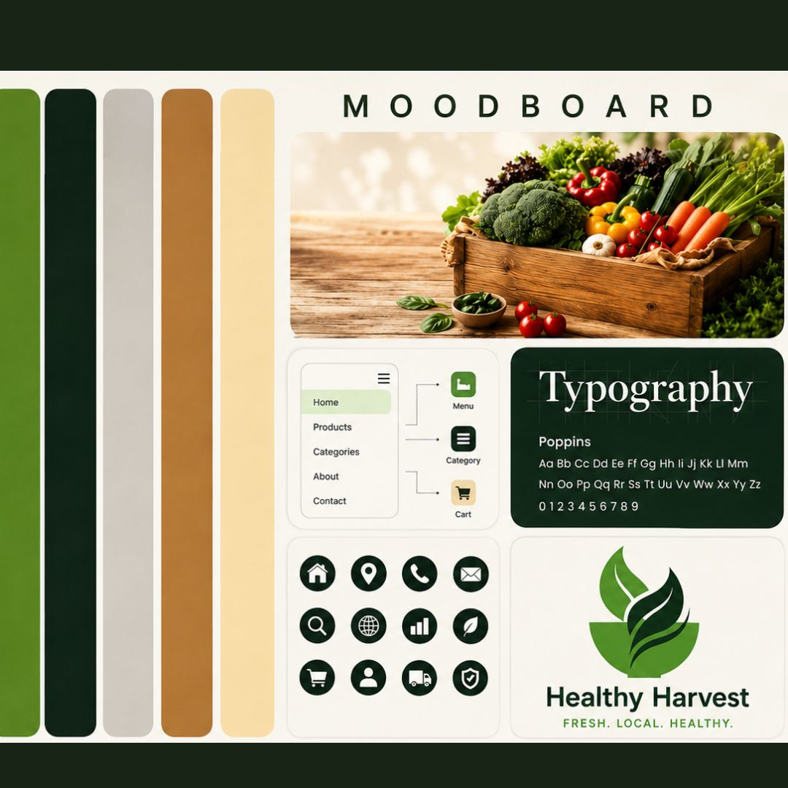
Wireframe
Homepage Wireframe
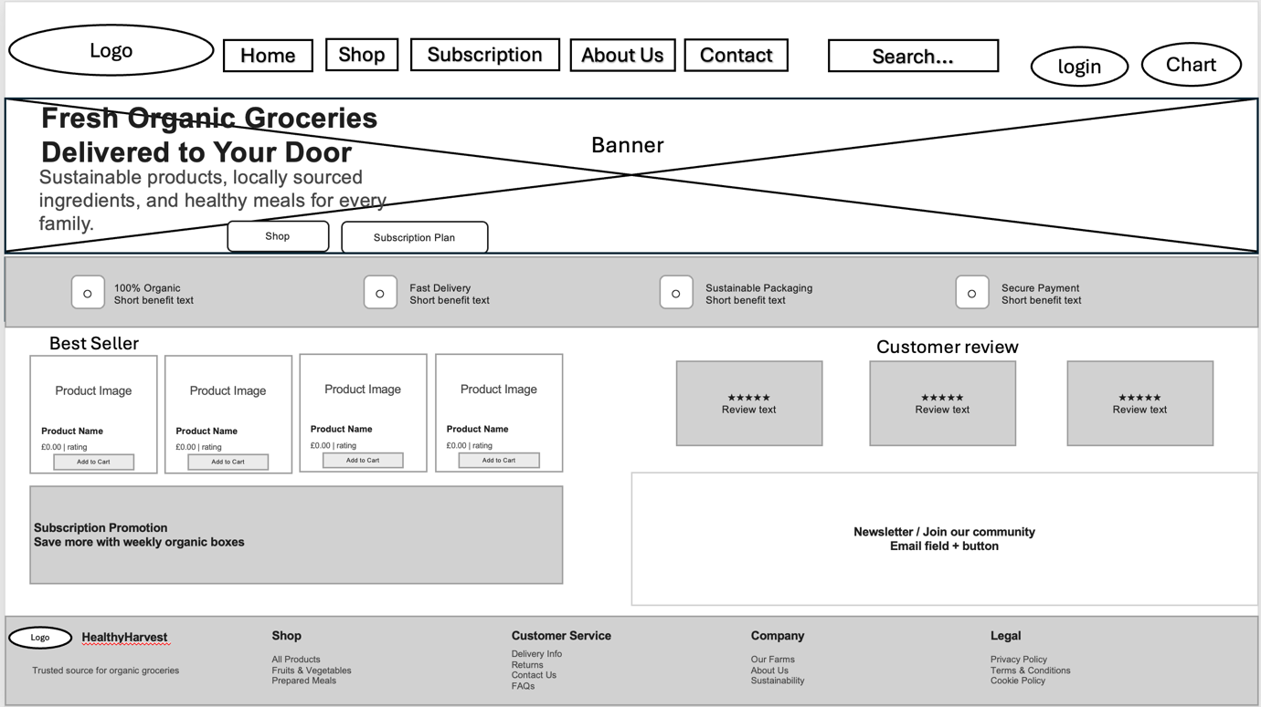
Shop Page Wireframe
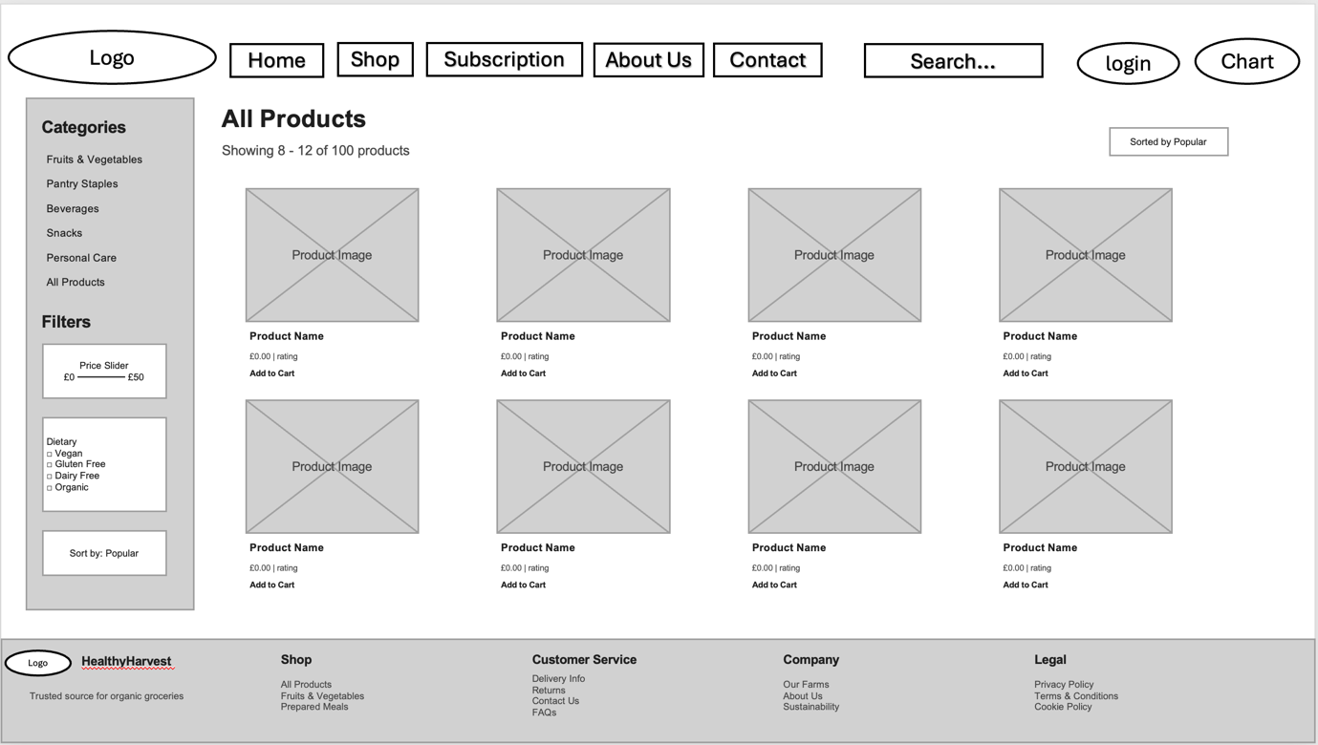
Subscription Wireframe Screenshot
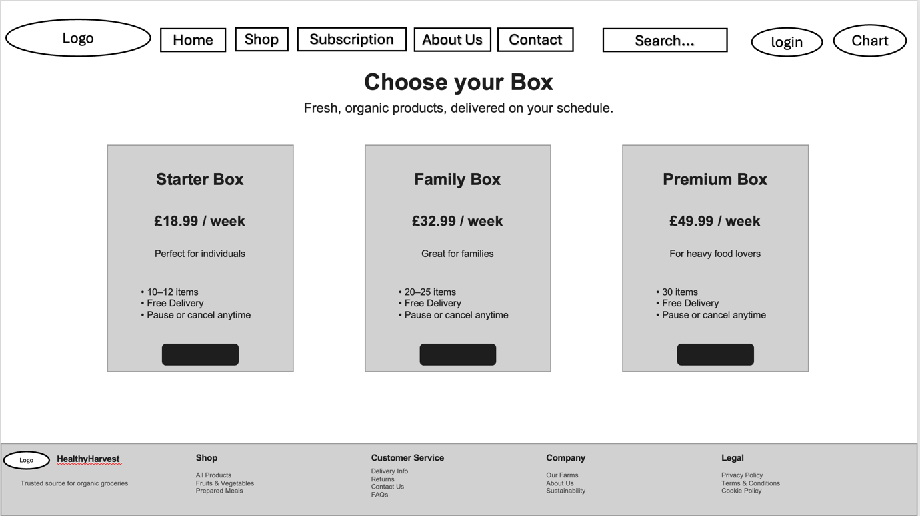
Page About Wireframe
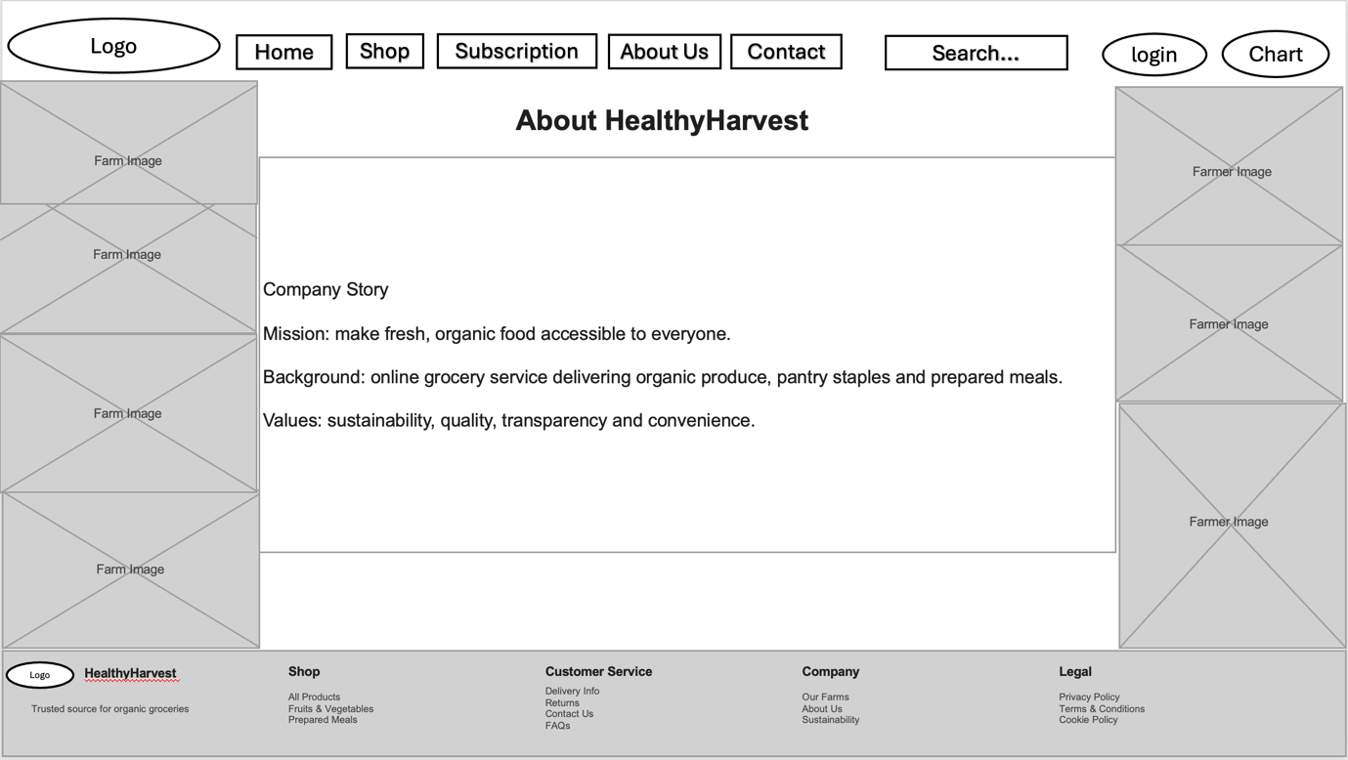
Page Contact Us Wireframe
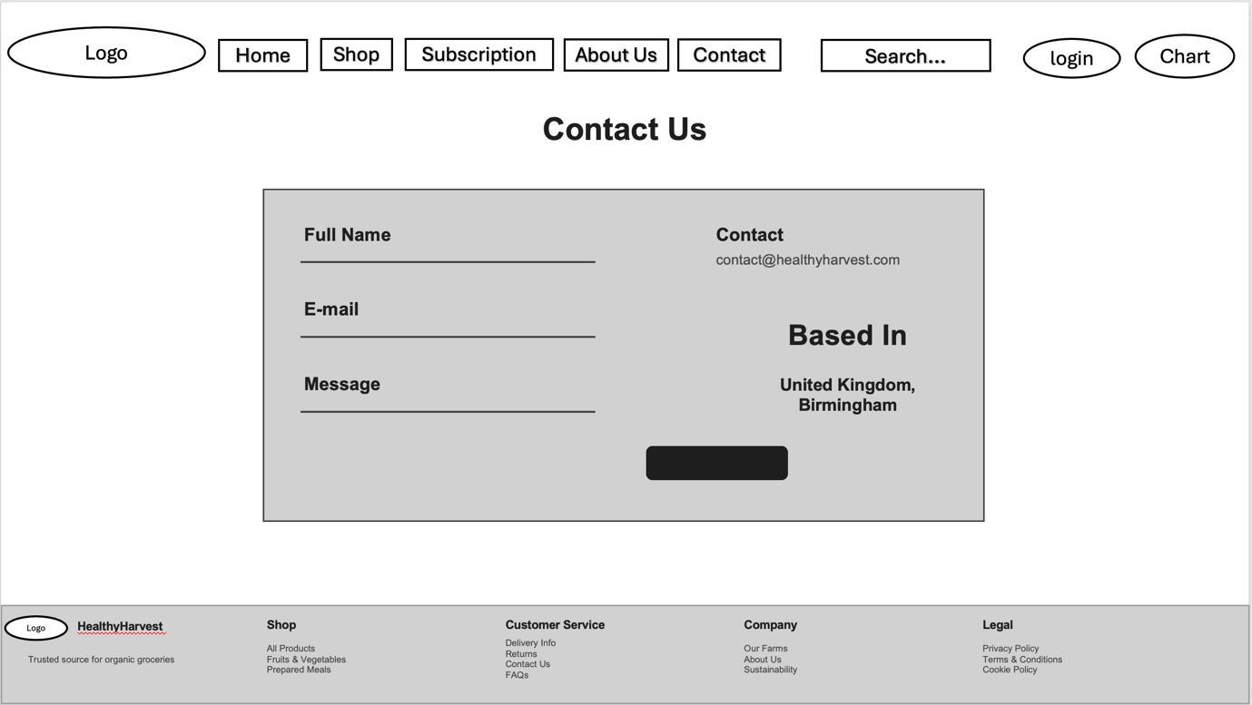
Web Design
Homepage
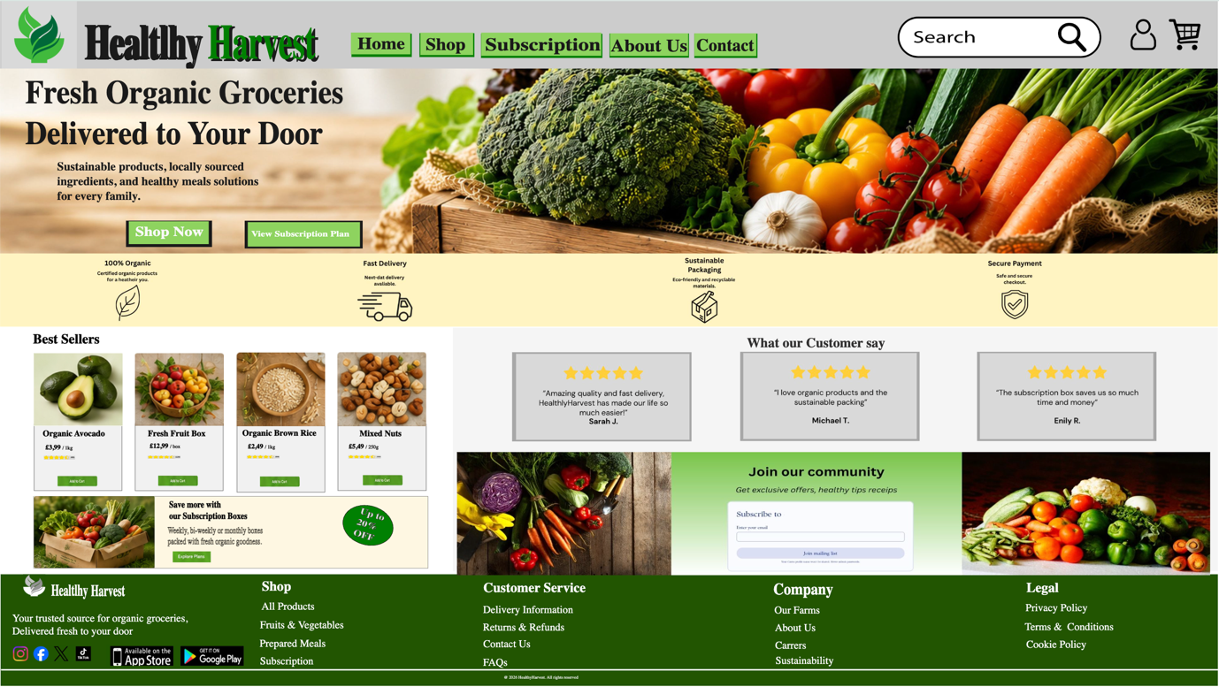
Page Shop Web Design
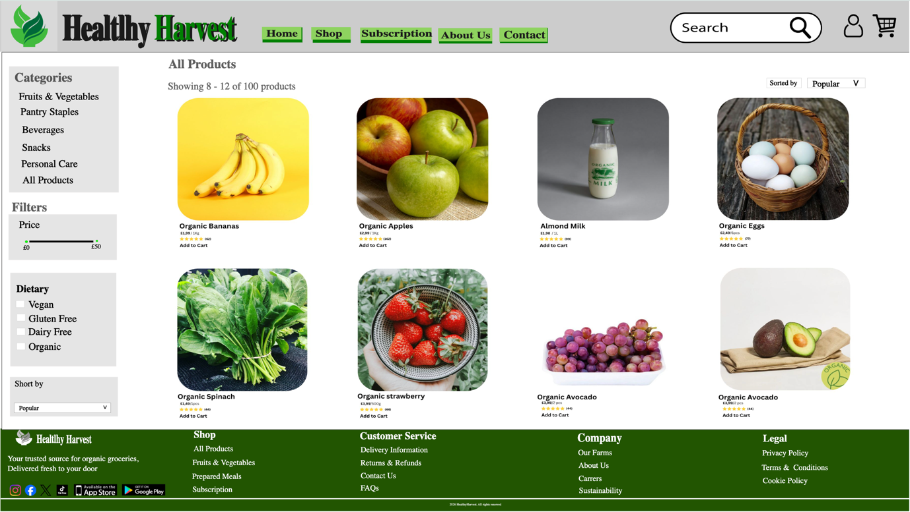
Page Subscription Web Design
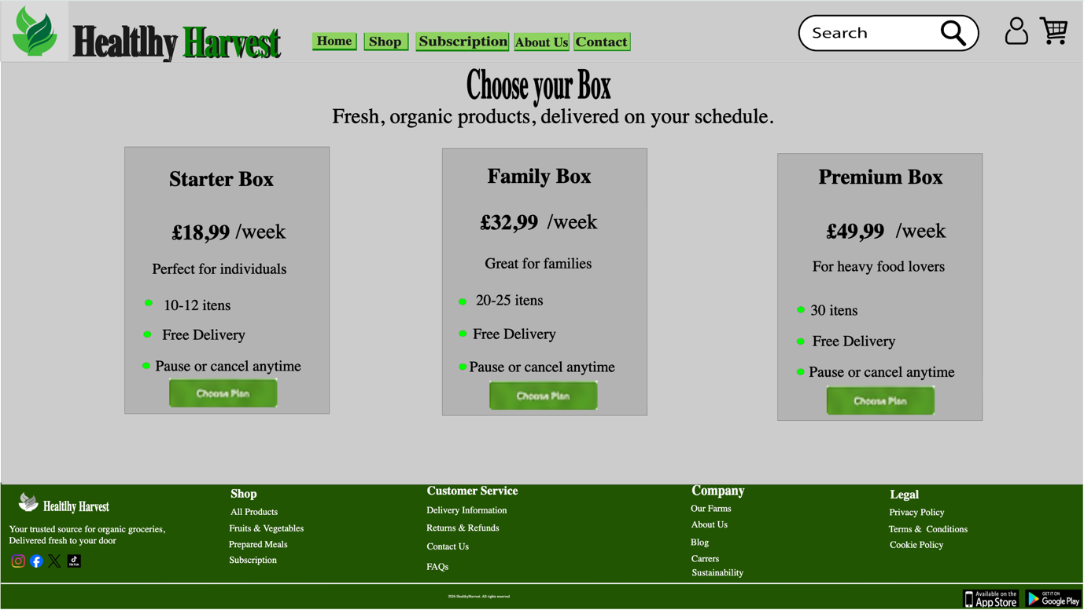
Page About Web Design
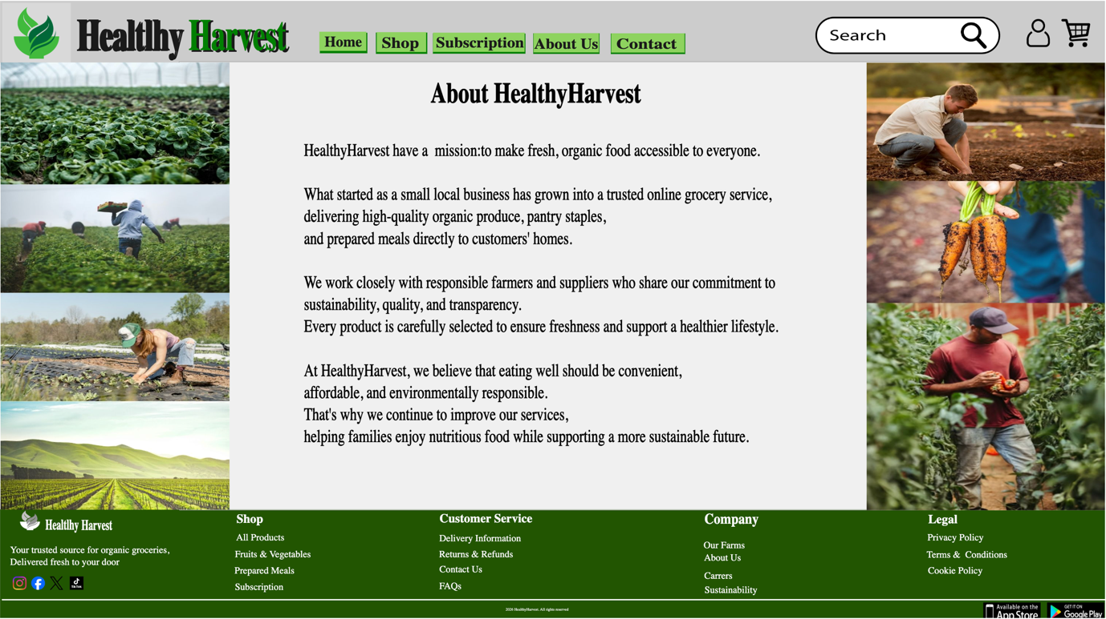
Page Contact Us Web Design
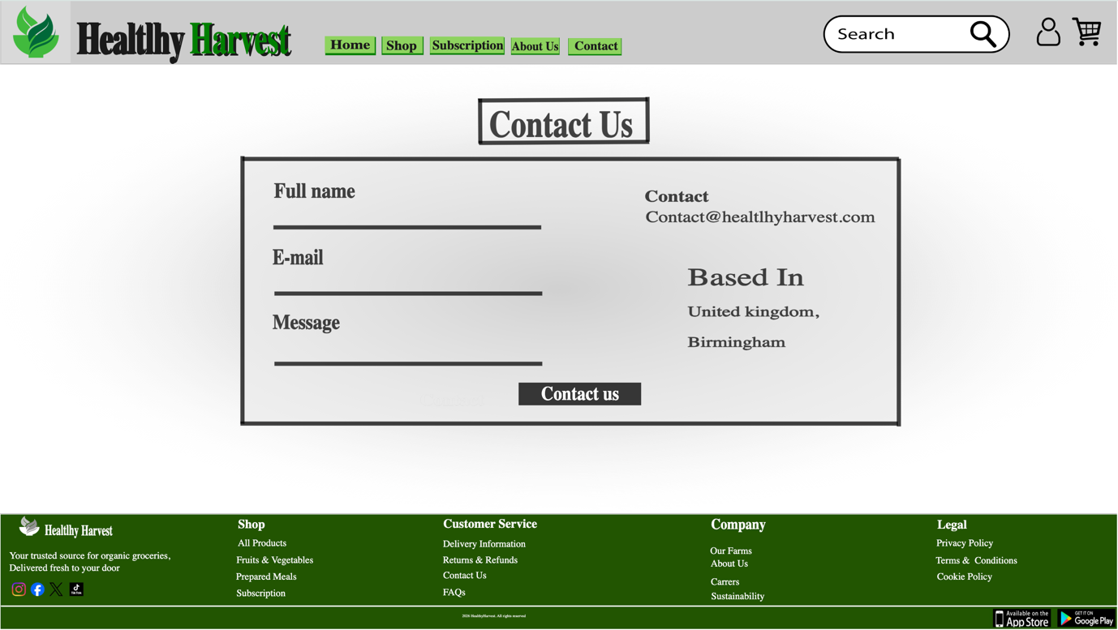

4.1 Moodboard and Wireframe Design
Moodboard
A moodboard is a visual collection of colours, images, typography, icons and other design elements used to communicate the intended style and atmosphere of a project [8]. It helps designers establish a clear visual direction before creating the final interface [9]. The moodboard developed for HealthyHarvest focused on natural colours, organic food imagery, simple icons and a sustainable visual identity.
The HealthyHarvest moodboard influenced the design by creating consistency across the website. The selected colour palette included different shades of green, beige, grey, brown and black. Green was used as the main brand colour because it represents nature, freshness, health and sustainability. Beige and brown supported the natural theme by creating a connection with farming, wooden packaging and organic products. Grey and black were used to provide contrast and improve the visibility of text and interface elements.
The moodboard also included photographs of fresh vegetables, farmers and organic produce. These images influenced the website’s hero banner, product cards and About Us page. The main banner uses a wooden box filled with vegetables, which communicates freshness and supports the company’s grocery delivery service. Images of farms and farmers were used to strengthen the message of responsible sourcing and transparency. The logo, leaf symbols and simple black icons also helped to create a recognisable visual identity throughout the pages.
Wireframe
A wireframe is a basic visual representation of a webpage that shows the position of content, navigation and interactive elements before the final colours and images are applied [10]. It normally uses simple boxes, lines, labels and placeholders to focus on structure and functionality. Wireframes help designers test the organisation of information and understand how users will move through the website [10].
The wireframe influenced the HealthyHarvest design by defining the structure of each key page. The Home Page wireframe established the position of the header, navigation menu, search bar, hero banner, call-to-action buttons, benefits, best-selling products, customer reviews, newsletter and footer. The Shop Page wireframe organised the categories, price filter, dietary preferences, sorting menu and product grid.
The Subscription Page wireframe created a clear three-column layout for the Starter, Family and Premium boxes. The About Us wireframe balanced company information with farming images, while the Contact Page wireframe separated the contact form from the business information.
By using wireframes before completing the final prototype, the design process became more organised. It was easier to identify the most important content, maintain consistency between pages and create a clear navigation structure [10]. however, both the moodboard and wireframes had an important influence on the final HealthyHarvest website design.
5.0 Conclusion
This project demonstrated the importance of following a structured UI/UX design process when redesigning an e-commerce website. The HealthyHarvest project began with the identification of usability, visual and technical problems affecting the existing website. These included confusing navigation, limited product information, weak mobile responsiveness, low-quality imagery, accessibility concerns and an inefficient shopping experience.

The moodboard helped establish a clear visual identity based on natural colours, organic food photography, sustainable values and consistent branding. The wireframes then supported the organisation of content and functions across the Home, Shop, Subscription, About Us and Contact pages. This made it easier to define the position of key elements before developing the final prototype.

The completed design provides clearer navigation, stronger calls-to-action, improved product presentation and more visible trust signals. Features such as customer reviews, delivery benefits, secure payment information and subscription options support customer confidence and encourage purchasing decisions. The responsive design approach also improves accessibility and usability for customers using mobile devices.

Overall, the project showed that effective design is not only about visual appearance. It also involves understanding user needs, organising information clearly and supporting business objectives. The final HealthyHarvest design creates a more professional, accessible and user-friendly experience while supporting the company’s values and future growth.

Reference
[1] B. Kumar, S. Roy, A. Sinha, C. Iwendi and Ľ. Strážovská, “E-Commerce Website Usability Analysis Using the Association Rule Mining and Machine Learning Algorithm,” Mathematics, vol. 11, no. 1, Art. no. 25, 2023, doi: 10.3390/math11010025.
[2] J. Guo, W. Zhang and T. Xia, “Impact of Shopping Website Design on Customer Satisfaction and Loyalty: The Mediating Role of Usability and the Moderating Role of Trust,” Sustainability, vol. 15, no. 8, Art. no. 6347, 2023, doi: 10.3390/su15086347.
[3] P. B. Pires, M. Prisco, C. Delgado and J. D. Santos, “A Conceptual Approach to Understanding the Customer Experience in E-Commerce: An Empirical Study,” Journal of Theoretical and Applied Electronic Commerce Research, vol. 19, no. 3, pp. 1943–1983, 2024, doi: 10.3390/jtaer19030096.
[4] W. Li, Y. Zhou, S. Luo and Y. Dong, “Design Factors to Improve the Consistency and Sustainable User Experience of Responsive Interface Design,” Sustainability, vol. 14, no. 15, Art. no. 9131, 2022, doi: 10.3390/su14159131.
[5] M. Sandesara, U. Bodkhe, S. Tanwar, M. D. Alshehri, R. Sharma, B.-C. Neagu, G. Grigoras and M. S. Raboaca, “Design and Experience of Mobile Applications: A Pilot Survey,” Mathematics, vol. 10, no. 14, Art. no. 2380, 2022, doi: 10.3390/math10142380.
[6] C. Moreno Martínez, J. Recas Piorno, J. J. Escribano Otero et al., “Responsive Inclusive Design (RiD): A New Model for Inclusive Software Development,” Universal Access in the Information Society, vol. 22, pp. 893–902, 2023, doi: 10.1007/s10209-022-00893-9.
[7] G. Bogdanova, T. Todorov, J. Dochkova-Todorova, N. Noev and N. Sabev, “Design and Development Model of a Web Accessibility Ecosystem,” Information, vol. 15, no. 10, Art. no. 613, 2024, doi: 10.3390/info15100613.
[8] M. R. dos Reis and E. A. D. Merino, “Image Composition Influences on the Mood Board Visual Reading Process Through Eye-Tracking,” Product: Management and Development, vol. 19, no. 1, Art. no. e20210010, 2021, doi: 10.4322/pmd.2021.005.
[9] A. Omwami, H. Lahti and P. Seitamaa-Hakkarainen, “Creating Inspiration by Developing Digital Mood Boards in Student Teams,” Techne Serien—Forskning i Slöjdpedagogik och Slöjdvetenskap, vol. 31, no. 1, pp. 65–81, 2024, doi: 10.7577/TechneA.5361.
[10] D. Gudoniene, E. Staneviciene, V. Buksnaitis and N. Daley, “The Scenarios of Artificial Intelligence and Wireframes Implementation in Engineering Education,” Sustainability, vol. 15, no. 8, Art. no. 6850, 2023, doi: 10.3390/su15086850.

