WBGP Report – Using Systems Engineering Tools to Present a Solution

Thomas Appleby (2217664)

Work Based Group Project (ACDA5022)

Wales Institute for Science and Art
University of Wales Trinity Saint David



Table of Contents
Table of Contents 1
Table of Figures 2
Abstract 3
Introduction 4
Disposal and Breakdown 4
Using the Systems Engineering Tools 5
Presentation Planning 7
Conclusion 7
References 8

Table of Figures
Figure 1 - Function Means Analysis 5
Figure 2 - Pugh Matrix 6

Abstract
The aim of this report is to show the authors experiences from working in a team and how they worked in order to complete the brief given to them and as such the author decided that writing the report from the perspective of them selves made most sense, so the majority of this report will be written in the first person to better encapsulate the authors thoughts and experiences.

This report goes through how the team and I worked though each section together and used a systems engineering mindset throughout the tasking. How through the use of both in person and online meetings the work load was shared to produce both individual and collaborative elements to a presentation.

Introduction
This report focuses on the way my team and I worked together on the task we were given by our lecturers. It shows how through the use of collaboration the team and I developed solutions with help from the systems engineering tools that we were given. The tools required judgment decisions to be made about the design of the solution we were developing to meet the brief as well as the ranking of each component to each other to get an idea of a structure of importances.

The report will also go over the specific area that I was given to research and present during the presentation given to the lecturers and other industry professionals from various companies within the sector. The report also goes over how this specific area is connected to the others and how I spoke with the other members of my team so that we could get an idea of how our sections were going to work together and what information they can get from each other to streamline the way that processes would be conducted.

Disposal and Breakdown

Disposal is defined as ‘Disposal is the act of getting rid of something that is no longer wanted or needed’[1] and breakdown is defined as ‘an act, instance or result of decomposition’[2]. In the case for this brief it constituted the disposal or breakdown of waste product in the manufacturing process as well as the disposal of any live munitions the case of a miss fire or failed detonation.

When we as a team were deciding which roles each of us should take, I had initially wanted to take on the role of looking into the testing and evaluation of the solution but as another member of the team was deemed to have greater experience within that role it fell to them as the team felt that they would be able to produce a better section for the presentation. I was then given the role of disposal and breakdown as I had completed some work previously similar to that of disposals.

My original plan was to discuss the use of EOD techniques and how they can be used to breakdown the explosive element of our solution after a firing had resulted in no result from the system. But after discussing with my team as well as the lecturers that set the task a conclusion was met that, what I had intended on doing is not quite what the task was asking so would fall outside the scope of the report. I then focused my efforts on working out what regulations and standards would have to be used for safe disposal of excess materials made during the manufacturing process. As I was inexperienced with the manufacturing side of explosives I spoke with the member of my team that was dealing with manufacturing and they suggest that I look at various STANAGs (Standardisation Agreements) that they adhere to when completing the manufacturing process. STANAG 4518 : SAFE DISPOSAL OF MUNITIONS, DESIGN PRINICPLES, REQUIREMENTS, AND SAFETY ASSESSMENTS [3] gives a description on the process that must be taken when disposing of munitions and other explosive matter. If I were to take this report further I would develop a step by step guide for this process explaining why each step is significant and way that if not disposed of in that manor issues could occur. I also spoke with the member of the team in charge of the testing and evaluation as during this process there would be then need for disposal of the excess test material.

Using the Systems Engineering Tools
Throughout the time during my systems engineering lectures the lecturer gave us power point presentations [4] though the use of an excel spreadsheet of systems engineering tools. We used these tools to develop a solution for the assignment brief given to us at the start of the course. As a team we worked through the different steps of the spreadsheet using in person meetings so that we could easily combine our thoughts and include everyone in the decision making process. We made sure everyone had input into the design process as there were a lot of different specialisms within the team so became crucial that we all inputted with what we had experienced with our different back grounds.

During the meetings with the team I made sure that I was giving my thoughts and opinions when making decisions, I also was heavily involved with the functions means analysis (FMA) and Pugh matrix as I suggested a lot of the solutions that we could have employed for the solution to the design brief. The function means analysis has a list of all the contrasting functions that the solution has to complete and then next to that there is a list of different means that can be used to complete those functions, as a team we had to think of those functions. Once we had thought of as many different means for each of the functions as we were happy with then we decided to develop three concept ideas that used different elements from what we had thought of in the function means table.

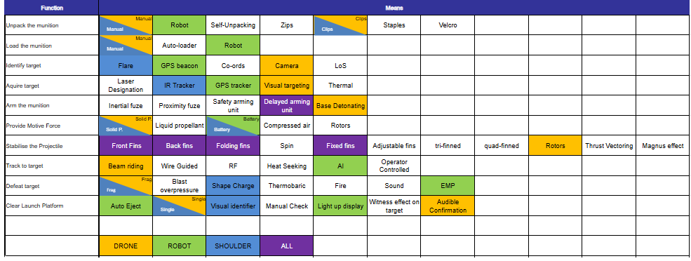
Our theme throughout was ‘Past, Present and Future’ we wanted each of our solutions to fit one these, We decided to have one solution that we would base off of a shoulder launched variant, as that sort of technology has been around for a long time and is what would typically be used in that sort of scenario, so focused the means on creating a solution which would work for that, we also decided that with the way that technology is currently being used in live theatres that a drone based solution should be involved. For the future we decided to use technology that we can see has the potential to be used in active theatre but for some reason or another isn’t currently being used. For this we discussed the use of a small electromagnetic pulse (EMP) grenade launched of a ground based ROV, something like the wheelbarrow that is used for EOD tasks, we wanted it to be controlled by an AI as that is an area that is gaining a lot of traction that could be used in a number of instances but is as f yet not reliable or secure enough to be used in active theatre. We thought of using electromagnetic pulse as we wanted our blue skies thinking future solution to be able to complete the stretch goals such as defeat the communications towers without harming the users inside.
Figure 1 - Function Means Analysis

We then used a tool called a Pugh matrix to score the individual solutions [5]. The solutions were scored against the requirements and were given a score from -2 to 2 depending on how well each solution fulfilled the requirements, the better the solution scored against the criteria the higher the score it received. The results of this Pugh matrix showed that as predicted the drone solution was the most effective solution.

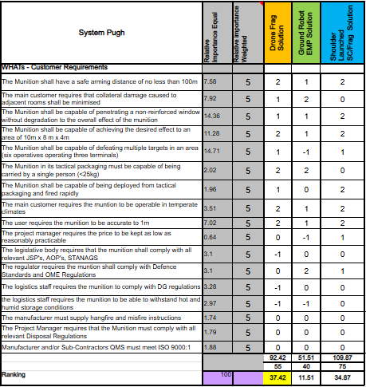
Figure 2 - Pugh Matrix

Presentation Planning
One of the main points of this module is the presentation equating for 50% of the total marks. The presentation had to be split by the team into two distinct sections. The first section was a group section going through the teams’ use of the systems engineering tools and how we used them to develop a solution to the brief given to us at the start of the module. The other section of the presentation was full of individual sections; each member of the team had to present their individual sections. We were given a total of 40 minutes for the presentation which worked out as 20 mins for each section but only around 4 minutes for each of our sections. My approach for my section of the presentation was to develop 4 slides with a lot of pictures and minimal words as I have experienced that the less words on each slide of a presentation the more the audience focuses on what you as the presenter is saying. When making my slides I consulted with my team to see if my slides got my point across without saying too much, they also helped me format my slides so that they were in keeping with the overall theme of the presentation. From when I have presented previously I have struggled with remembering all of my points that I wanted to talk about and with the reduced words on my slides I made the executive decision to make prompt cards that I would use to help me when presenting, I did not use them as a script as that would mean I would be spending more time looking at my cards than at my audience, as my section of the presentation was last I was also given the role of opening up the floor for questions. For the team section of the presentation I was given the role of explaining how the function means analysis flows into the Pugh matrix and how that gives us a solution from a list of functions. The slides for the team section of the presentation we made as a team taking screen shots from the spreadsheet with the systems engineering tools and formatting them to have the same theme throughout the whole presentation. Each member of the team was given the role of writing their script for their section of the group run through of the systems engineering tools.

During the presentation we elected to gather chairs and sit at the front of the room as only a few of us had done any presenting in the past so sat down to help with nerves and to reduce the amount of fidgeting when not talking. During the presentation we also used a clicker to switch the slides to improve the flow of the presentation as we would not have to stop and use the computer to change the slide.

Conclusion
The aim of the group project area of this module was to assess our ability to work in a team in a collaborative manner and to see if we can complete a task given to us. I believe that my team and I showed a good ability to interact with each other in a constructive manner, allowing us to methodically complete the systems engineering tools given to us.

My team and I were able to develop a coherent presentation that flowed through the all of the points that we were trying to get across. We developed a design for our slides that aimed to look sleek and professional, we also made sure to have a constant format so that when showing graph they amalgamated themselves together with the slide pack and so that if we were to put any graphs with our personal sections there would be a template to draw from.

If I were to undergo this task again, some aspects for the group element of the activity that I would change is I would develop a rough concept earlier as when we were given feedback from the lecturers and other industry professionals one of the biggest comments they had was the fact that we didn’t present an idea of what our solution looked like or was until the end, so spent most of the time during the presentation confused as they weren’t sure about what we were talking about.

A way I would improve my personal performance would be when presenting my slides to stand forward and project myself more as I was hiding behind the screen slightly which caused me to present the wrong slide to the audience without being aware, this had the affect of making me look ill prepared for the presentation, another was I could improve is if I were to put more effort into learning my script so that I was less reliant on my slide cards that I had in my hand.

References
[1] Collinsdictionary.com. (2024). Definition of disposal. [online] Available at: https://www.collinsdictionary.com/dictionary/english/disposal.
‌
[2] Collinsdictionary.com. (2025). Definition of breakdown. [online] Available at: https://www.collinsdictionary.com/dictionary/english/breakdown.
‌
[3] NSA, NATO Standardisation Agency. (2001). STANAG – 4518: SAFE DISPOSAL OF MUNITIONS, DESIGN PRINCIPLES AND REQUIREMENTS, AND SAFETY ASSESSMENT

[4] Holley, D. (2023). 05 Performing Functional Analysis 2023.

[5] Guler, K. and Petrisor, D.M. (2021). A Pugh Matrix based product development model for increased small design team efficiency. Cogent Engineering, [online] 8(1). Doi: HTTPs://doi.org/10.1080/23311916.2021.1923383.

