University Of Wale Trinity Saint David

Wales Institution of Science and Art



Technical Report Studying Metallic Processing

Materials and Introduction to Processing (ACMA4000)

Kenyon Dale Montana
2123458
December 2023

Introduction

The purpose of this report is to research, analyse, and evaluate one processing method from each of the three main derivation of metal fabrication methods: forming, casting, and miscellaneous. One type of process will be studied from each of these fabrication methods. These being extrusion, sand casting, and welding. An overview, their application, micro structure, mechanical properties, and their defects will be analysed throughout.

Literature review

Throughout the span of this technical report, information regarding each processes’ merits and limitations were explored. Furthermore, the processes’ effect on their respective materials concerning their mechanical properties and micro structures were studied. Applications of which are also stated and highlights their strengths in different industries and compromises in others.

Methodologies

In order to have completed this technical report, a vast number of sources and reports were studied. Numerical data was essential and was displayed in the form of graphs and tables. Reviewing reports, journals, websites, studies and determining their relevancy and reliability proved crucial.

Forming Metallic Fabrication: Extrusion

4.1 Extrusion Overview

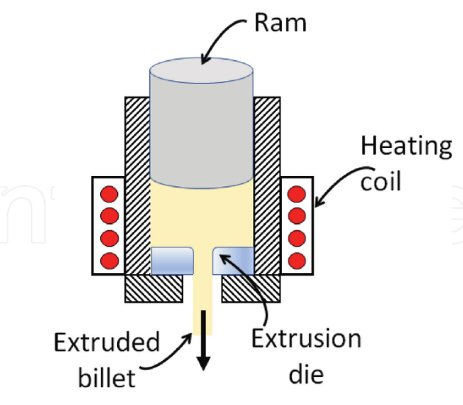
Figure 1 –Schematic representation of direct extrusion process (Murugan, Nguyen, Gupta, 2012)
Extrusion is a forming process in which a material is forced through a singular or multiple series of die in order achieve a desired shape of uniform cross-sectional area (SME, 2012). Figure 1 depicts the process of direct extrusion, a ram applies a force to a billet, forcing it into the die. The shape of the extruded billet is dictated by the die which can generate diverse shapes and sizes. The heating coil then regulates the material’s temperature as it is pressed, depending on the material can be between 90-1,260 degrees Celsius in the case of metal direct extrusion (SME, 2012. There are countless applications in multiple industries for extrusion, examples of which are: pharmaceutical, food processing, and in automotive.
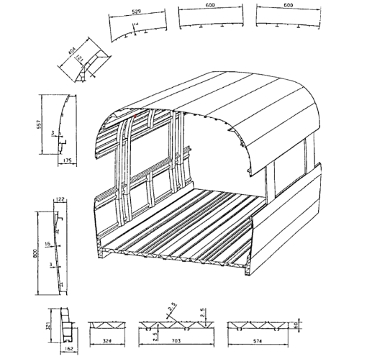
Figure 2- Passenger carrier design on high-speed train ICE1 (Bauser, Sauer, Siegert, 2006)
The automotive industry favours heavily from extrusion due for the theme of long, constant shapes and the ability to produce these consistently and rapidly. This is exemplified in Figure 2, highlighting a train carriage’s profile and how its multiple components are extrusions from aluminium alloys. Vehicle doors, pipes, wires, and window frames are also produced in this manner.
Extrusion is widely common in multiple industries, having both its merits and limitations. Firstly, direct extrusion is highly efficient, being able to continuously produce a product cycle after cycle without interruption. This is essential is high volume industries and in circumstances such as vehicle production lines where production is rapid and constant. Direct Extrusion also minimises on waste and the waste of materials commonly worked through direct extrusions (such as aluminium) can often be recycled with no consequences to its properties (La-plastic, 2023). Furthermore, extrusion increases the strength of a material such as aluminium.
Table 1 - Tensile test results on Al-1050 in initial state and after processing by FALEP. (YS: von Mises equivalent yield strength; UTS: ultimate strength). (Viet et all, 2021)
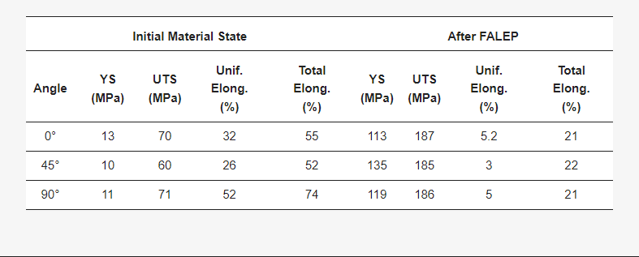
Table 1 displays the mechanical properties of aluminium (AI- 1050) before and after FALEP (and extrusion method). When the die was set to 0 degrees, the material’s ultimate tensile strength increased by approximately 166%.
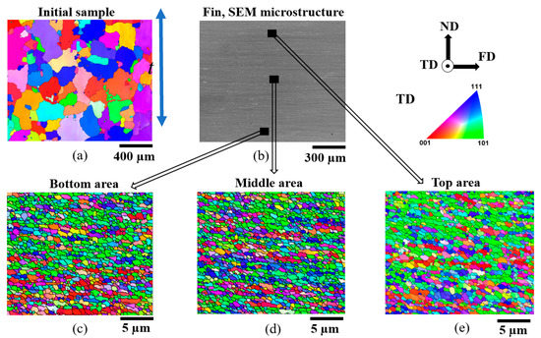
Figure 3- (a) EBSD microstructure of the initial sample; (b) SEM microstructure across the thickness of the produced fin; (c–e) EBSD microstructures of the bottom, middle, and top areas of the Al-1050 produced fin, respectively. (Viet et all, 2021)
The increase in strength is attributed to the change in grain structure. Figure 3 exhibits the grain structure of Al – 1050 before and after extrusion. Grain size is refined to 160 times smaller in comparison to its initial state with the grains being in a much more uniform arrangement. (Viet et all, 2021).

4.2 Defects and Remedies for Extrusion.

Extrusion methods do have their restrictions and defects with one being the large amount of excess heat produced within the press and the cylinder walls (Howard Precision Metals Inc, 2014). This in turn increases operation cost as it increases energy consumption. The most common defect in aluminium extrusion is surface defects, where there are blemishes or scratches within the surface of the extruded aluminium. A remedy to this would be to apply the sufficient amount of correct lubrication between the billet and die.

Figure 4 - Image of blistering within an aluminium extrusion (Machen, 2016)
Figure 4 displays an image of blistering found in extruded aluminium, which occurs when moisture or gasses are trapped within the material. To mitigate this, store billet in less humid environments and pre heat before process. Another example of a defect within aluminium extrusions are die lines. These are raised or recessed lines cause by imperfections in the die. Regular die inspections, cleaning, and maintenance can remedy this.

Casting Metallic Fabrication: Sand Casting

5.1 Casting Overview

Casting is the process in which a material is molten and fed into a mold to harden into a specified form (Xometry, 2023). Multiple different processes come under casting such as gravity die casting, pressure die casting, sand casting, and investment casting.

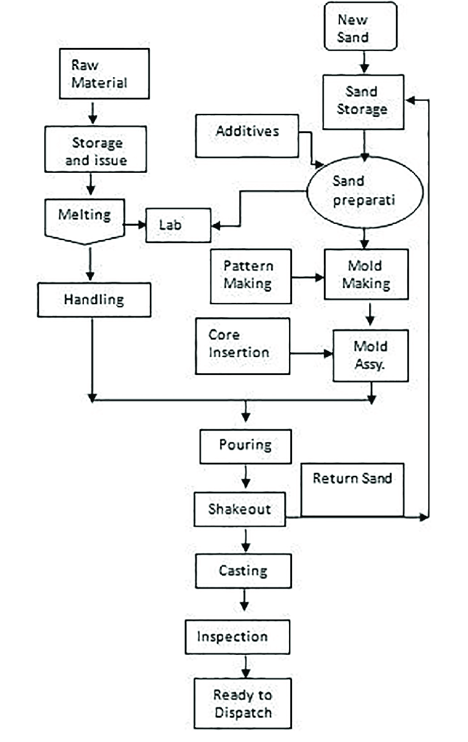
Figure 5 - Flow chart for sand casting (Vante, Naik, 2015)
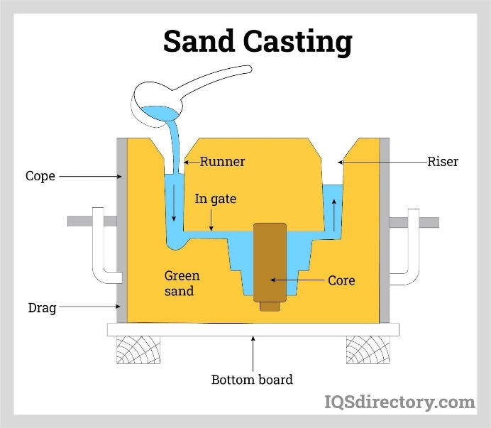
Figure 6 - Visual illustration of sand casting (IQS Directory, n.d)
Sand Casting is a method of casting which involves compacting sand into a desired shape using a mold, preparing the pathway which the liquid flows through, pouring the molten material into the mold, and extracting the product out the mold. Figure 5 depicts the various stages involved within the process from the melting of the material to the preparation for dispatch. The process is also illustrated in Figure 5. To generate the mold, the sand is pressed into a mold pattern which has the form desired for the product to generate a cavity with those features. The sand must then be bound using binding agents in the case of green casting where the cast can be reused. The riser and runner pin are then inserted to allow for the free flow of liquid and gases. The material is then poured into the cavity, allowing to cool for some time and then extracted (IQS directory, n.d)
This process is widely used numerous sectors as it can be used to produced small products such as jewellery to large scale implications such as engine blocks. Casting is immensely popular as it is a very low-cost production, yet very versatile. As mentioned before, sand casting can be used for very small products to extremely large products. The tooling is extremely cheap but can still generate complex designs. On the other hand, automation of this process is extremely costly and turn around for un-automated sand casting can be much slower in comparison to other processes. Surface finish and dimension accuracy also degrades throughout as the mold slowly degrades (Xometry, 2023). It is also to be considered that high skilled labour is required which could add further cost in staff training etc.
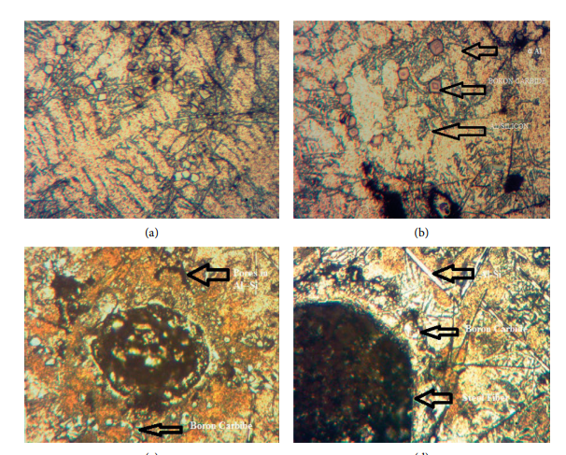
Figure 7 - (a, b) Optical micrographs of LM6 Al alloy hybrid composites with 5% of B4C. (c, d) Optical micrographs of LM6 Al alloy with 5% (Gnaneswaran et all, 2022)
Figure 7 highlights the micro structures of aluminium composites (LM6) and clearly depicts the lack of significant structure. This is due to the lack of control within the cooling process in sand casting. This causes variation in the grain structure of the aluminium.
Table 2- Cast aluminium properties (Matmatch, n.d)
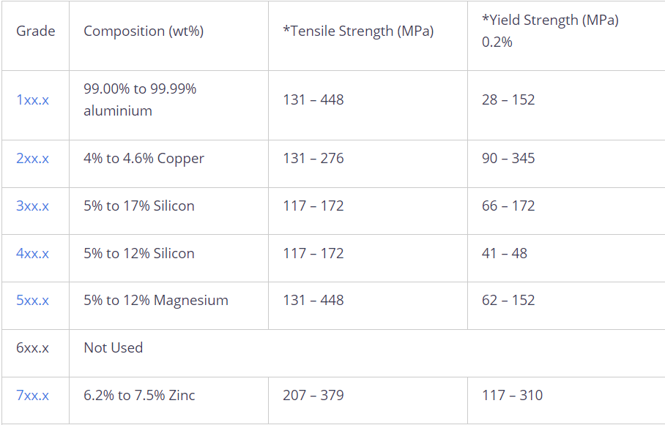
Table 3 - Wrought aluminium properties (Matmatch, n.d)
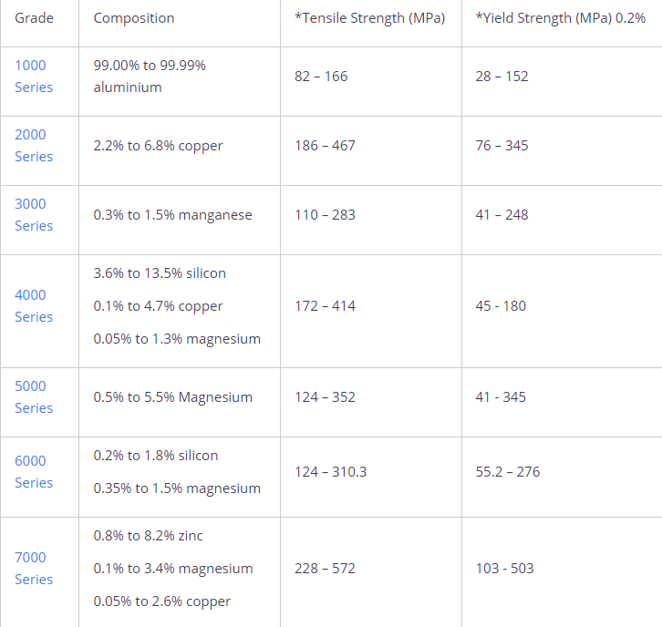
Table 2 and Table 3 provide comparative information between cast aluminium and wrought aluminium. Wrought aluminium has overall a greater tensile strength with the highest ultimate tensile strength being 572 MPa in comparison to the cast aluminium’s maximum UTS only being 379 MPa. This can be attributed to the variance in the casted aluminium’s micro structure.

Casting Defects and Remedies.

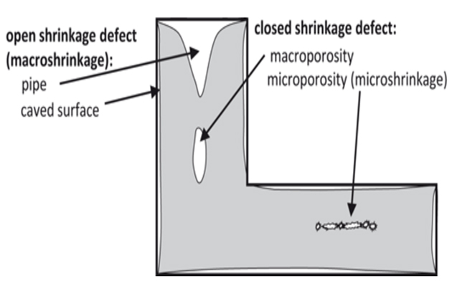
Figure 8 - Illustration of shrinkage defects (Tien, 2020)

Shrinkage is a defect found in sand casting and can manifest in either closed or open form. Open shrinkage occurs when air is drawn into the mold whilst closed shrinkage when certain pools of the molten metal turn solid later than its surroundings. To remedy this, ensure that the riser system takes into consideration the contraction during solidification. An open hole is another defect in sand casting. Open holes are holes found on the surface of the casted parts that are visible to the naked eye. This can be due to multiple factors: inadequate venting, too much moisture in either the tools or the mold, or the molten metal’s temperature is too high. Remedies to these would be to ensure that the tools are dry in storage/before usage, apply adequate venting in the riser and runner, and follow closely and carefully the melting and pouring process. Finally, cold shuts are cracks in the surface of the metal that are visible by the naked eye. This causes a weak point in the part and are therefore often rejected. It is commonly caused by the molten material being too viscous. Increasing the temperature in which the material is poured into the cast can prevent this (Tien, 2020).

Miscellaneous Metal Fabrication: Welding

6.1 Welding Overview

Welding is the process in which two materials (commonly metal) are joined together using heat. There is a wide plethora of different welding methods, ranging from using different gases, electricity, or with friction. These methods all have their uses and the variety in welding methods are highlighted in Figure 9
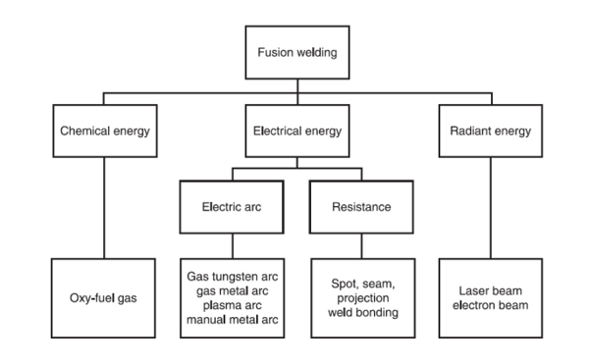
Figure 9 - Flow Chart for different welding methods
Tungsten inert gas (TIG) welding is a form of arc welding alongside MIG and multiple others. TIG welding can be one of the most difficult methods of welding to learn but has a great range of benefits. The electrode of the torch consists of tungsten and is inconsumable with the welding possible with or without a filler material. TIG welding is used within the automotive industry as it requires no post-weld clean up and has a clean and attractive finish in comparison to other welding methods. Body panel repairing, joining of structural frames, and even finer work such as welding small bracketry are just some of the applications of welding. TIG welding offer the welder an abundance of control when welding hence its favourability with finer work. This method of welding can also be used for larger structural parts. Unlike MIG, TIG welding can copper and requires little to no clean up after the weld unlike other welding methods (Eziil, 2022).
On the other hand, TIG is skill intensive and requires a great deal of experience in order to have presentable welds. Naturally, TIG is also less time efficient than other less intricate welding methods. Furthermore, TIG is very inefficient at thicker materials whilst methods are much more favoured for heavier welding such as those on large vessels.
Table 4 - Mechanical Properties of T welded joints welded using TIG (Pan et all, 2022)
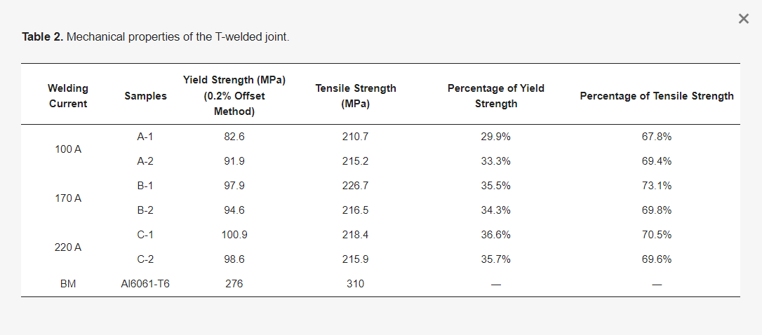
Table 4 depicts the results of stress-strain test carried out on a T-welded joints of aluminium alloy Al6061-T6, and filler material ER4043 using TIG. The maximum value displayed for the ultimate tensile strength is shown to be 310 MPa, considerably high for the surface area in which the t bone was welded. This could be in relation to the weld’s micro structure and how it alters after due to TIG welding.
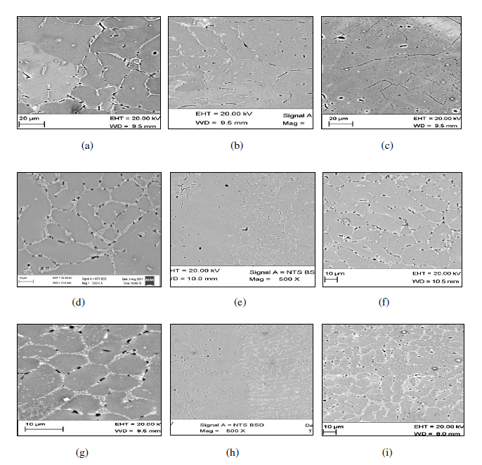
Figure 10 - Optical micrographs; (a, b, c): HAZ, transition zone (at 100 μm), weld metal at 180A; (d, e, f): HAZ, transition zone, weld metal at 190A; (g, h, i): HAZ, transition zone, weld metal at 200A. (Shete, Powar, 2023)
Figure 10 displays the results of an experiment where the micro structures of TIG welded of aluminium alloy AA4043. Figure 10 (b,e,h) indicate how approaching the heat affected zone, the grain boundaries elongate and become smaller. This becomes more prominent as temperature increases (Shete, Powar, 2023). The increased tensile and yield strength as temperature rises can be attributed to this change in microstructure.

6.2 Defects and Remedies

Porosities are bubbles or holes that weaken the structure of the weld. These are commonly caused by contamination in the metal such as painting a bracket before welding or improper cleaning. A solution to this is to follow proper fabrication process (i.e ensure cosmetic painting of a part is done after welding) and to also thoroughly clean the material. Lack of penetration is another prominent defect from TIG welding and is apparent when the weld does not properly penetrate the work piece and compromises the weld strength. The heat is not high enough in this scenario and must be adjusted accordingly. Finally, distortion is the counterpart to lack of penetration. Distortion is when the material warps or deforms, and occurs when the output temperature is too high and must be decreased accordingly (Welding & Welder, 2010).

Conclusion

As targeted, three processes each from forming, casting, and miscellaneous metallic fabrications were analysed. Their advantages and disadvantages were carefully considered and their application in industry explored. Researching their defects and concluding effective solutions to each was also achieved alongside the study of their micro structures along-side their mechanical properties.

Appendix

- Murugan, S., Nguyen, B. and Gupta, M. (2019). Synthesis of Magnesium Based Nano-composites. [online] Research Gate. Available at: https://www.researchgate.net/publication/330913034_Synthesis_of_Magnesium_Based_Nano-composites [Accessed 29 Dec. 2023].
- M. Bauser , M., Sauer , g. and Siegert , K. (2006). Extrusion Second Edition - [PDF Document]. [online] vdocuments.mx. Aluminium-Verlag, Du ¨sseldorf, Germany : ASM International. Available at: https://vdocuments.mx/extrusion-second-edition-586e0ff4bdf83.html?page=573 [Accessed 3 Jan. 2024].
- Paul MurphyPlastics (2023). Extrusion Process : Working, Types, Application, Advantages and Disadvantages. [online] Paul Murphy Plastics. Available at: https://paulmurphyplastics.com/2019/09/25/extrusion-process-working-types-application-advantages-and-disadvantages/#:~:text=Extrusion%20is%20widely%20used%20in [Accessed 4 Jan. 2024].
- Vu, V.Q., Toth, L.S., Beygelzimer, Y. and Zhao, Y. (2021). Microstructure, Texture and Mechanical Properties in Aluminum Produced by Friction-Assisted Lateral Extrusion. Materials, 14(9), p.2465. doi:https://doi.org/10.3390/ma14092465.
- Howard Precision Metals. (2021). Advantages and Disadvantages of Direct Extrusion. [online] Available at: https://www.howardprecision.com/advantages-and-disadvantages-of-direct-extrusion/ [Accessed 12 Jan. 2024].
- ‌ jmadmin (2023). Understanding Extrusion Surface Defects. [online] jm blogs. Available at: https://jmaluminium.com/blogs/understanding-extrusion-surface-defects/ [Accessed 12 Jan. 2024].
- KTA-Tator. (2016). Common Causes of Blistering and Bubbling in Industrial Coatings. [online] Available at: https://kta.com/kta-university/blistering-bubbling-coatings/ [Accessed 12 Jan. 2024].
- Naik, G.N. and Vante, A. (2015). Quality Improvement for Dimensional Variations in sand Casting Using Quality Control Tools. [online] Research Gate. Available at: https://www.researchgate.net/publication/282391639_Quality_Improvement_for_Dimensional_Variations_in_sand_Casting_Using_Quality_Control_Tools [Accessed 16 Jan. 2024].
- Xometry, T. (2003). Casting: Definition, Importance, Types, and How It Works. [online] www.xometry.com. Available at: https://www.xometry.com/resources/casting/what-is-casting/ [Accessed 17 Jan. 2024].
- Directory, I. (n.d.). Sand Casting: Construction, Types, Applications, and Advantages. [online] www.iqsdirectory.com. Available at: https://www.iqsdirectory.com/articles/die-casting/sand-casting.html [Accessed 18 Jan. 2024].
- Xometry, T. (2023). Sand Casting: Definition, How It Works, Advantages, Disadvantages, and Examples. [online] www.xometry.com. Available at: https://www.xometry.com/resources/casting/sand-casting/ [Accessed 18 Jan. 2024].
- Gnaneswaran, P., Hariharan, V., Chelladurai, S.J.S., Rajeshkumar, G., Gnanasekaran, S., Sivananthan, S. and Debtera, B. (2022). Investigation on Mechanical and Wear Behaviors of LM6 Aluminium Alloy-Based Hybrid Metal Matrix Composites Using Stir Casting Process. Advances in Materials Science and Engineering, [online] 2022, pp.1–10. doi:https://doi.org/10.1155/2022/4116843.
- Match, M. (n.d.). Cast vs. Wrought Aluminium - Matmatch. [online] matmatch.com. Available at: https://matmatch.com/learn/material/cast-wrought-aluminium [Accessed 24 Jan. 2024].
- Vu, D.T. (2020). 5 types of Sand casting defects and how to prevent to improve cast quality. [online] Vietnam Cast Iron. Available at: https://vietnamcastiron.com/sand-casting-defects/ [Accessed 24 Jan. 2024].
- Eziil (2010). 13 Different Types of Welding and Their Uses Explained! [online] eziil.com. Available at: https://eziil.com/types-of-welding [Accessed 25 Jan. 2024].
- Norsemen (2023). 5 Advantages And Disadvantages Of TIG Welding? | Welders Choice. [online] Available at: https://norsemensafety.co.uk/5-advantages-and-disadvantages-of-tig-welding/ [Accessed 25 Jan. 2024].
- Mao, P., Li, Y., Sun, S., Liao, W., Yan, X. and Tang, W. (2022). A Study on Welding Characteristics, Mechanical Properties, and Penetration Depth of T-Joint Thin-Walled Parts for Different TIG Welding Currents: FE Simulation and Experimental Analysis. Metals, [online] 12(7), pp.1157–1157. doi:https://doi.org/10.3390/met12071157.
- Hanmant Shete and Powar, V. (2023). Academia.edu - Share research. Journal of Physics.
- Welding and Welder (2023). Common TIG Welding Defects, Problems and Prevention - Welding & Welder. [online] www.weldingandwelder.com. Available at: https://www.weldingandwelder.com/help-and-advice/common-tig-welding-defects-problems-and-prevention/ [Accessed 26 Jan. 2024].

