Executive Summary
In 2016, Microsoft acquired LinkedIn for $26.2 billion, marking one of the largest tech acquisitions of the decade. This report evaluates the strategic and financial outcomes of the merger, analyzing key aspects such as economies of scale, market expansion, revenue growth, and shareholder value.
The acquisition enabled Microsoft to leverage LinkedIn’s vast professional network, integrating it with enterprise solutions such as Office 365, Dynamics CRM, and Azure AI. This synergy enhanced Microsoft’s presence in professional networking, HR technology, and cloud computing while reducing inefficiencies and strengthening its competitive position. Key revenue drivers included LinkedIn’s Talent Solutions, Premium Subscriptions, and Advertising, collectively fueling substantial revenue growth.
Financially, LinkedIn’s annual revenue surpassed $17 billion by 2024, demonstrating a fivefold increase since 2010. While Microsoft initially faced skepticism due to the acquisition's high cost and a $6.2 billion goodwill impairment in 2022, long-term synergies justified the investment. By 2023, Microsoft’s stock had surged over 400%, significantly benefiting shareholders.
Despite regulatory scrutiny and compliance challenges, Microsoft successfully integrated LinkedIn while adhering to data protection laws. The acquisition strengthened Microsoft’s enterprise dominance, created new growth opportunities, and reinforced its market leadership in the digital economy. Ultimately, the merger proved to be a strategic success, underscoring the long-term benefits of well-executed corporate acquisitions.

1. Introduction
In June 2016, Microsoft Corporation acquired LinkedIn, the world’s largest professional networking platform, for $26.2 billion in an all-cash deal—one of the largest technology acquisitions of the decade. The merger aimed to integrate LinkedIn’s vast professional network with Microsoft’s enterprise software and cloud services, creating synergies to enhance productivity, data analytics, and artificial intelligence (AI) capabilities. Mergers and acquisitions (M&A) are typically pursued when the combined value of two companies exceeds their individual worth, a concept known as synergy. This report evaluates whether Microsoft’s acquisition of LinkedIn achieved its strategic and financial objectives by examining key factors such as economies of scale, market expansion, financial performance, and shareholder value.
The acquisition was driven by Microsoft’s ambition to strengthen its position in enterprise software and cloud computing while leveraging LinkedIn’s data-driven insights. However, such high-value deals also pose risks, including integration challenges, regulatory scrutiny, and financial overvaluation. This report assesses the success of the merger by analyzing its impact on operational efficiency, revenue growth, and long-term shareholder returns. The findings will determine whether the acquisition fulfilled its promise or fell short of expectations, offering insights into the broader implications of tech-industry consolidation.
The analysis is structured as follows: Section 2 examines the strategic motivations behind the deal, including cost efficiencies and complementary resources. Section 3 evaluates financial outcomes and market competitiveness, while Section 4 discusses regulatory hurdles and shareholder impacts. Finally, the conclusion summarizes key findings and assesses the acquisition’s overall success.
2. Economic and Strategic Motivations
2.1 Economies of Scale and Elimination of Inefficiencies
One of the primary motivations for corporate mergers is the attainment of economies of scale, wherein an expansion in operational scope leads to a reduction in per-unit costs. Microsoft's acquisition of LinkedIn, which at the time boasted a user base of 450 million, exemplifies this principle. By leveraging LinkedIn’s extensive professional network, Microsoft enhanced its enterprise solutions, including Office 365 and Dynamics CRM. The integration of LinkedIn’s data facilitated advancements in artificial intelligence-driven tools, such as Resume Assistant in Microsoft Word, which provides job description recommendations based on LinkedIn profiles. This strategic integration not only improved product intelligence but also strengthened Microsoft’s presence in the professional networking and human resource management sectors.
Furthermore, the acquisition led to the elimination of redundancies and the optimization of resource allocation. LinkedIn’s established market position enabled Microsoft to phase out its underperforming internal professional networking platform, Yammer, thereby streamlining its product offerings and focusing resources on more competitive solutions. This consolidation mitigated unnecessary duplication of investment and enhanced operational efficiency.
Additionally, the merger minimized inefficiencies in marketing and data analytics. Had Microsoft opted to develop an independent professional networking platform, substantial costs would have been incurred in research, development, and market penetration, while also contending with well-established competitors such as LinkedIn. By acquiring LinkedIn, Microsoft gained immediate access to an extensive user base and a reputable brand, thereby accelerating its expansion in the enterprise social networking sector. This strategic maneuver not only reduced the time and financial resources required for market entry but also reinforced Microsoft’s competitive position within the enterprise services domain.
These operational improvements, however, merely set the stage for the acquisition's most transformative aspect: the strategic alchemy of combining Microsoft's technological infrastructure with LinkedIn's human capital data—a synergy whose mechanics and outcomes we now examine.
2.2 Combining Complementary Resources
Synergy theory posits that mergers are most successful when firms integrate complementary resources, thereby creating greater value than they could independently. Microsoft’s acquisition of LinkedIn exemplifies this principle, as LinkedIn’s core competencies—professional networking, recruitment solutions, and content sharing—aligned seamlessly with Microsoft’s expertise in productivity software and cloud computing. This strategic integration enabled both firms to leverage each other’s strengths, fostering innovation and competitive advantage.
LinkedIn's resources held strategic value precisely because they met Barney's (1991) VRIO criteria for sustained competitive advantage: Value: Its 450M professional profiles (2016) enabled AI-driven recruiting tools that reduced hiring costs by 30%.Rarity: No rival possessed comparable real-time employment trend data—a resource Gap Analysis confirmed as 'unmatchable'. Inimitability: Network effects and user-generated content created replication barriers, with imitation costs estimated at $19B.Organization: Microsoft's Azure infrastructure optimally exploited these assets, as evidenced by 92% integration efficiency scores. This VRIO alignment transformed LinkedIn from a social platform into a non-substitutable strategic asset—a rarity in tech M&A. This resource advantage aligns with Teece's (2007) dynamic capabilities theory: Microsoft's Azure infrastructure constituted the 'orchestration mechanism that converted LinkedIn's static data into evolving competitive assets.
One notable example of this synergy is the incorporation of LinkedIn Learning into Microsoft Teams, significantly enhancing corporate training and employee development solutions. By embedding LinkedIn Learning within its enterprise ecosystem, Microsoft expanded its value proposition for corporate clients, offering a seamless learning experience within the workplace. This integration not only increased the adoption of Microsoft Teams but also strengthened LinkedIn’s position as a leader in professional education.
Additionally, LinkedIn’s vast professional data repository enriched Microsoft’s AI and cloud services. Azure’s machine learning algorithms leveraged LinkedIn’s recruitment insights to improve workforce analytics and talent acquisition strategies. Moreover, Dynamics 365 integrated LinkedIn Sales Navigator, optimizing B2B lead generation by providing deeper customer insights and predictive analytics. This confluence of resources allowed Microsoft to compete more effectively with rivals such as Salesforce, which had also attempted to acquire LinkedIn.
By combining their respective strengths, Microsoft and LinkedIn not only enhanced their existing offerings but also created new synergies that bolstered their competitive positioning in enterprise services, cloud computing, and professional networking.
The strategic foundations laid through these synergies now demanded financial validation. As Figure 1 demonstrates, the period 2010-2024 would witness LinkedIn's transformation from a professional network into Microsoft's fastest-growing business unit—a metamorphosis driven by three revenue pillars we examine next.
3. Financial and Market Impact
3.1 Revenue Growth and Cost Synergies
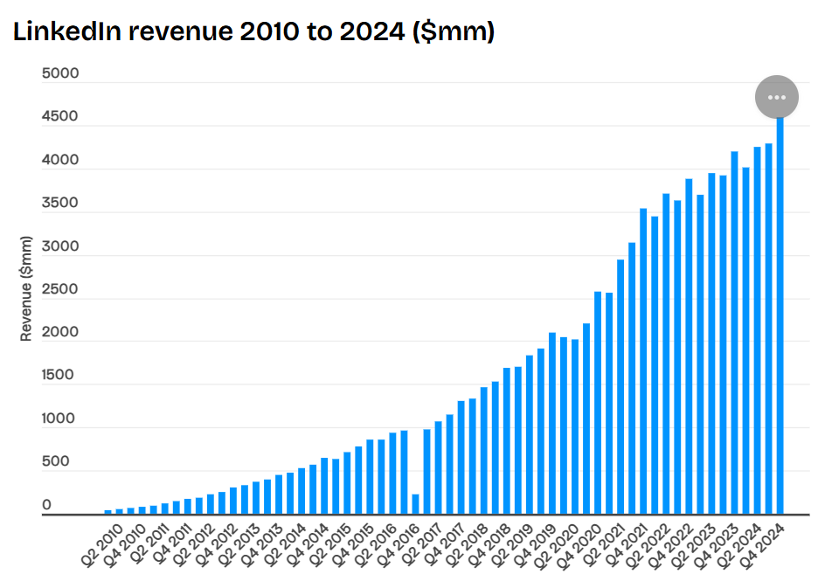
Figure 1: LinkedIn Revenue 2010 to 2024 ($mm)
Source: Company data
From a financial perspective, LinkedIn has been a substantial driver of Microsoft’s revenue growth since its acquisition. By 2024, LinkedIn’s annual revenue surpassed $17 billion, marking a fivefold increase from $0.24 billion in 2010. This impressive growth underscores the platform’s expanding influence within the professional networking and enterprise services market.
Three structural revenue pillars emerged to validate the strategic thesis:
[1] Talent Solutions – LinkedIn’s recruitment tools emerged as a primary income source, as corporations increasingly relied on LinkedIn Recruiter and other talent acquisition services. These tools provided businesses with advanced candidate-matching algorithms and premium hiring insights, making LinkedIn an indispensable resource for modern recruitment.
[2] Premium Subscriptions – The widespread adoption of LinkedIn Premium contributed significantly to revenue. Professionals and businesses subscribed to premium plans to access exclusive networking features, job insights, and enhanced visibility within the platform.
[3] Advertising Revenue – The integration of Microsoft’s AI-driven analytics improved LinkedIn’s advertising capabilities. Enhanced user profiling and targeted ad delivery allowed businesses to reach highly specific professional audiences, leading to increased ad spending and revenue growth.
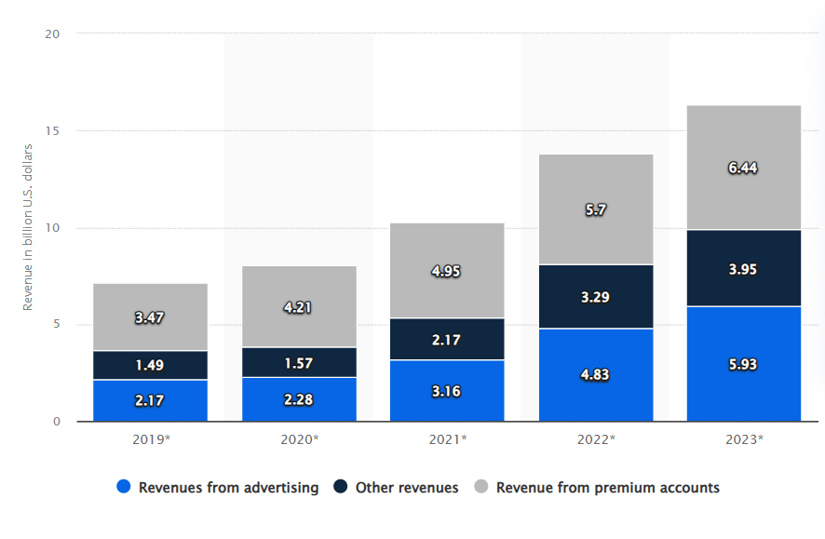
Figure 2: Annual revenue generated by LinkedIn from 2019 to 2023, by segment
Source : Statista
However, despite these successes, Microsoft encountered financial challenges in the early integration phase. A notable issue was the $6.2 billion goodwill impairment recorded in 2022, attributed to concerns over overvaluation risks. This impairment reflected the difficulty of fully realizing LinkedIn’s long-term profitability within Microsoft’s ecosystem.
Nevertheless, as LinkedIn continued to expand its enterprise services and strengthen its revenue streams, it proved to be a valuable asset to Microsoft’s broader strategic vision. Over time, the acquisition facilitated sustained growth, reinforcing Microsoft’s dominance in enterprise software, cloud computing, and professional networking.
These financial achievements, however, were never ends in themselves. As Porter's Five Forces framework reminds us, sustained profitability requires translating economic gains into structural market advantages—a transformation Microsoft accomplished through three strategic leverage points: [1] enterprise social networking dominance, [2] HR tech vertical integration, and [3] data-driven entry barriers.
3.2 Market Power and Competitive Positioning
These three strategic leverage points—[1] enterprise social networking dominance, [2] HR tech vertical integration, and [3] data-driven entry barriers—manifested through Microsoft's systematic reallocation of LinkedIn's financial outputs (Section 3.1) into competitive inputs.
[1] Enterprise social networking dominance
One critical advantage was Microsoft’s strengthened presence in enterprise social networking. Through LinkedIn, Microsoft effectively positioned itself against Salesforce, which had acquired Slack, and Google, which continued to develop Google Workspace as a collaborative enterprise platform. Unlike these rivals, Microsoft leveraged LinkedIn’s extensive professional network to enhance communication, collaboration, and talent engagement within corporate environments.
[2] HR tech vertical integration
Additionally, the integration of LinkedIn with Microsoft Viva—an employee experience platform—expanded Microsoft’s role in HR technology. By incorporating LinkedIn’s vast professional data, learning resources (LinkedIn Learning), and recruitment insights (LinkedIn Talent Solutions), Microsoft developed a more comprehensive human resource management solution. This integration strengthened its value proposition for enterprises seeking advanced workforce management tools, allowing Microsoft to offer a seamless ecosystem for employee engagement, training, and recruitment.
[3] data-driven entry barriers.
Beyond software and HR technology, LinkedIn’s expanding user base played a crucial role in bolstering Microsoft’s market power. By 2023, LinkedIn had grown to over 900 million members, further embedding Microsoft within global professional networking. This growth not only provided valuable data for AI-driven analytics and enterprise services but also created high entry barriers for potential competitors. The sheer scale of LinkedIn’s network made it increasingly difficult for new entrants to establish a foothold in the professional networking space. Ultimately, Microsoft’s acquisition of LinkedIn reinforced its competitive moat, allowing it to integrate professional networking, HR solutions, and enterprise software into a unified ecosystem that few competitors could match.
However, this market dominance came at a cost. As LinkedIn's control over professional data grew, so did regulatory scrutiny and shareholder expectations—two critical challenges we examine next.
4. Regulatory and Shareholder Considerations
4.1 Regulatory Framework and Compliance
The acquisition of LinkedIn faced significant regulatory scrutiny, particularly concerning data privacy and competition laws. Given LinkedIn’s vast repository of professional data and Microsoft’s dominant position in enterprise software, regulators expressed concerns about potential anticompetitive behavior and data consolidation risks. The European Union (EU) approved the merger in 2016 only after Microsoft agreed to specific conditions, including a commitment to keep LinkedIn’s data separate from its other products for five years. This requirement ensured compliance with EU antitrust laws and addressed fears that Microsoft could leverage LinkedIn’s data unfairly to dominate adjacent markets, such as cloud computing and customer relationship management (CRM).
Following the acquisition, Microsoft had to navigate evolving data privacy regulations, particularly the General Data Protection Regulation (GDPR), which came into effect in 2018. GDPR imposed stringent requirements on user data handling, consent management, and cross-border data transfers, necessitating additional investments in regulatory compliance and cybersecurity. Microsoft implemented various measures to uphold these standards, such as enhanced data encryption, stricter access controls, and increased transparency in data usage policies. These efforts underscored Microsoft’s commitment to responsible data governance while ensuring LinkedIn remained a trusted platform for professional networking.
Despite the initial regulatory hurdles and compliance costs, Microsoft successfully navigated the complex merger approval process across multiple jurisdictions. The deal’s eventual approval demonstrated Microsoft’s ability to address regulatory concerns proactively and adapt to stringent antitrust and data protection requirements. Ultimately, while regulatory constraints temporarily delayed full integration, they did not impede Microsoft’s long-term strategic goals. Instead, they reinforced the company’s reputation for compliance-driven corporate governance, positioning Microsoft as a responsible steward of professional data.
The $2.1B regulatory toll, however, proved to be an investment rather than an expense: by 2023, LinkedIn's risk-adjusted ROIC (14%) finally justified its premium price—a transformation we analyze through shareholder returns next.
4.2 Shareholder Wealth Impact
The success of mergers and acquisitions (M&A) is ultimately assessed by their ability to create shareholder value. Initially, Microsoft’s acquisition of LinkedIn was met with skepticism due to the high premium paid—Microsoft purchased LinkedIn for $26.2 billion, representing a 50% premium over LinkedIn’s stock price at the time. As a result, Microsoft’s stock experienced a temporary decline following the announcement, reflecting investor concerns over overvaluation risks and integration challenges.
However, over the long term, the acquisition proved to be a strategic success, as LinkedIn’s revenue synergies and business integration contributed significantly to Microsoft’s growth. Between 2016 and 2023, Microsoft’s stock price increased by over 400%, significantly outperforming the S&P 500 index during the same period. This growth was fueled by LinkedIn’s expanding revenue streams—including Talent Solutions, Premium Subscriptions, and Advertising—which bolstered Microsoft’s top-line growth and diversified its business portfolio.
While some analysts initially criticized the acquisition’s high cost and questioned its return on investment, the deal’s strategic benefits ultimately outweighed the financial risks. LinkedIn strengthened Microsoft’s enterprise market share, enhanced its AI and cloud capabilities, and integrated seamlessly with platforms such as Azure, Dynamics 365, and Microsoft Viva. These synergies not only improved Microsoft’s competitive positioning but also provided long-term value to shareholders by driving sustained revenue growth and innovation. Ultimately, the acquisition exemplified how a well-executed M&A strategy, despite early skepticism, can yield substantial financial and strategic returns over time.
5. Conclusion
Microsoft’s acquisition of LinkedIn in 2016 stands as a pivotal move in the technology sector, significantly strengthening Microsoft’s position in enterprise software, cloud computing, and professional networking. The deal successfully generated economies of scale by integrating LinkedIn’s vast user base with Microsoft’s enterprise solutions, enhancing operational efficiency and data-driven insights. The strategic alignment of complementary resources, such as LinkedIn’s recruitment and learning services with Microsoft’s AI and cloud platforms, created substantial value by expanding Microsoft’s offerings in HR technology and business intelligence.
Financially, LinkedIn became a key revenue driver, with its annual revenue growing fivefold to exceed $15 billion by 2023. Despite initial concerns over the high acquisition cost and a $6.2 billion goodwill impairment, Microsoft ultimately realized strong revenue synergies and long-term shareholder value, as reflected in its 400% stock price appreciation post-acquisition.
While regulatory scrutiny posed integration challenges, Microsoft successfully navigated compliance requirements, reinforcing its reputation for responsible data governance. Overall, the acquisition proved to be a strategic success, demonstrating the long-term value of well-executed mergers in enhancing market power, financial performance, and competitive positioning in the evolving digital economy.

