BSc Cloud Computing
Module: Cloud Computing Administration
Lecturer: Renuga Jayakumar
date 24/04/2024
Andrian Gontea (2114820)
Contents
Introduction 2
1.Azure Total Cost of Ownership 2
2.Azure File Storage and its associated features, security measure 4
3.Azure database options and recommend the most suitable one for storing user profiles 11
4.Azure Backup options for file shares and databases 18
5.Evaluation of how azure site recovery would assist GLI 23
References 26

Introduction
This proposal outlines a calculated transition strategy for GLI's file storage and database systems, aiming to transfer them to Azure's cloud platform. The primary objective of the migration process is to demonstrate the possibility and benefits of transitioning to Azure File storage and Azure Databases through the utilisation of Azure's range of complimentary services.
This document provides a thorough examination of the challenges currently faced by GLI in data infrastructure management, while also introducing Azure as a pragmatic solution. By leveraging Azure's complimentary services, GLI can begin a gradual transfer process, starting with the transfer of file storage and databases. The proposal highlights the key features and benefits of Azure File storage and Azure Databases, with a particular focus on their scalability, reliability, and security.
Additionally, the document outlines a methodical approach for migrating GLI's file storage and databases to Azure, ensuring minimal disruption to existing operations and maximising financial advantages. Through careful records and demonstration, the management staff of GLI can gain a comprehensive understanding of the migration process. This will improve the process of making informed decisions and guarantee that they are in line with the goals and objectives of the organisation.
The main goal of this proposal is to help GLI's implementation of cloud technology, optimise resource allocation and improve precision in data management processes, all while complying with limited financial resources.

1.Azure Total Cost of Ownership
The total cost of ownership for Azure is affected by a number of factors. These include the direct costs of infrastructure and computation, as well as indirect costs like training and maintenance. Another factor is the potential benefits, such as scalability. By understanding these aspects, organisations can make informed decisions about Azure adoption, which can help them optimise spending and m aximise return on investment .
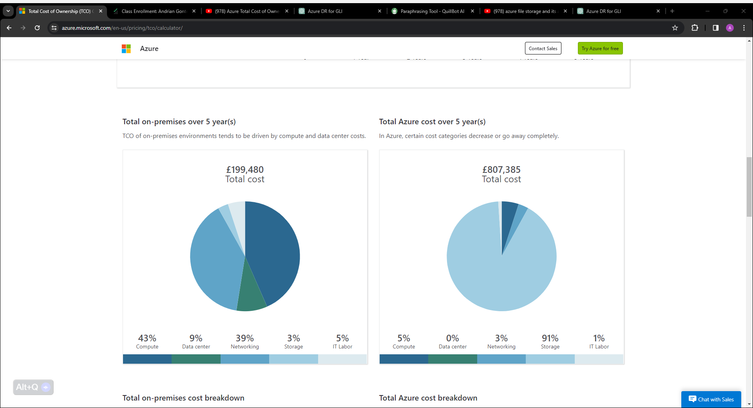

Figure.1
Figure.2
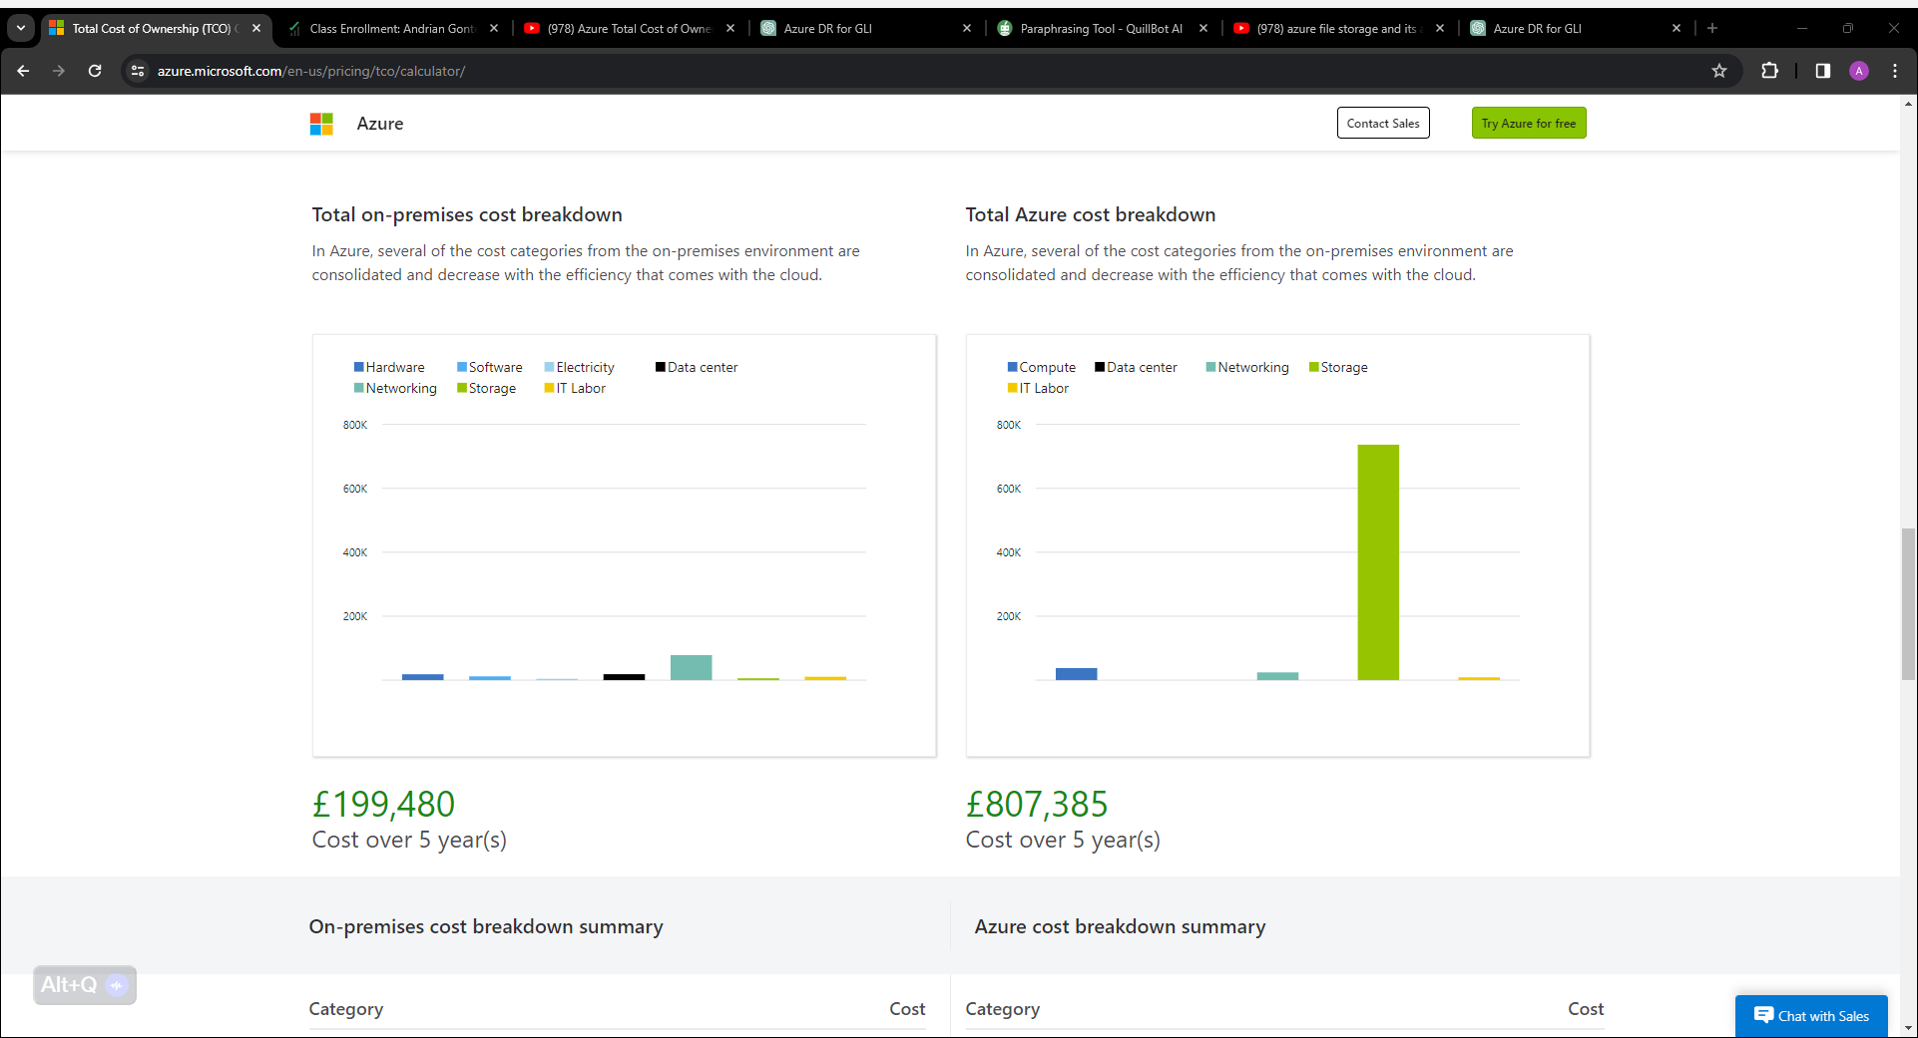

Figure.3
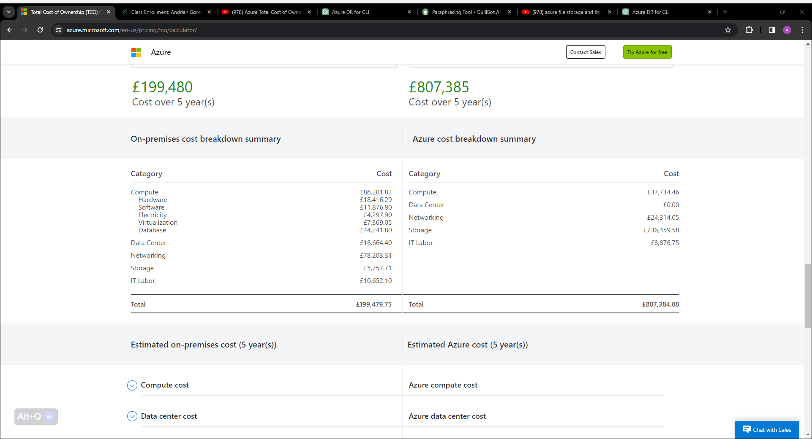

2.Azure File Storage and its associated features, security measure
Microsoft Azure offers a cloud-based storage solution known as the Azure File Storage service. This service is supplied by Microsoft Azure [1]. By utilising established protocols such as Server Message Block and Representational State Transfer , it provides file shares that are both highly accessible and scalable. These file shares can be accessed from any location. Azure File Storage is becoming an increasingly crucial component for storing and sharing files across a wide variety of apps and platforms as organisations continue to move more and more towards cloud-based solutions. Organisations are moving towards cloud-based solutions. We will focus on its capabilities, advantages and the safety steps that have been taken to secure the data that is stored within Azure File Storage as part of our examination. This will be done in order to ensure that the data is protected.

The Azure File Storage Service's Capabilities and Performance

Microsoft Azure File Storage offers scalable file shares, which enable organisations to grow their storage capacity as needed without having to worry about the administration of their infrastructure. Scalability is a feature that is offered by Microsoft Azure File Storage. [2]

By utilising the standard Smtp protocols, users are able to access files that have been saved in Azure File Storage from a wide range of operating systems, including Windows, Linux, macOS and others. Universal access is the name given to this particular capability.

Integration with Azure Services: Azure File Storage is able to integrate well with other Azure services, including Virtual Machines, App Services and Azure Linux Service, without causing any issues. The ability to easily collaborate and share files among the many Azure resources is made possible as a result of this. [3]

Azure File Storage ensures both the redundancy and high availability of data by replicating it across multiple data centres located within a region. This ensures that the data is always accessible. This reduces the possibility that data will be lost as a consequence of malfunctioning hardware or other natural disasters that may occur.
Figure.4
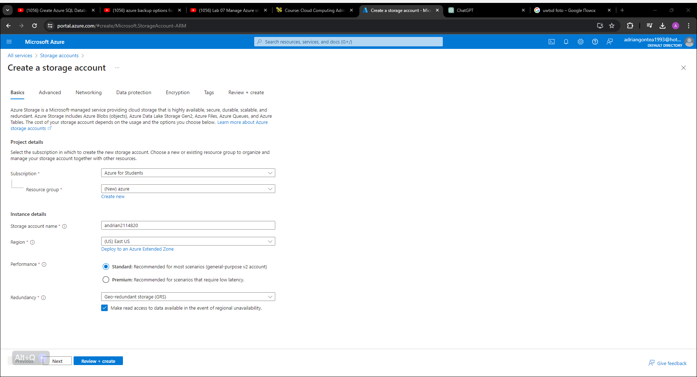

Encryption of Data: Azure File Storage provides encryption while the data is at rest in order to protect data that is stored in file shares. When this occurs, it guarantees that the data will remain to be encrypted and inaccessible, even in the event that unauthorised access is acquired.

Figure.5

As a result of the built-in backup and restoration features that Azure File Storage offers, businesses are able to create snapshots of file shares and, if necessary, restore them to a previous state. The backup and restore functionality that is available with Azure File Storage is the name of this feature.
Figure.6
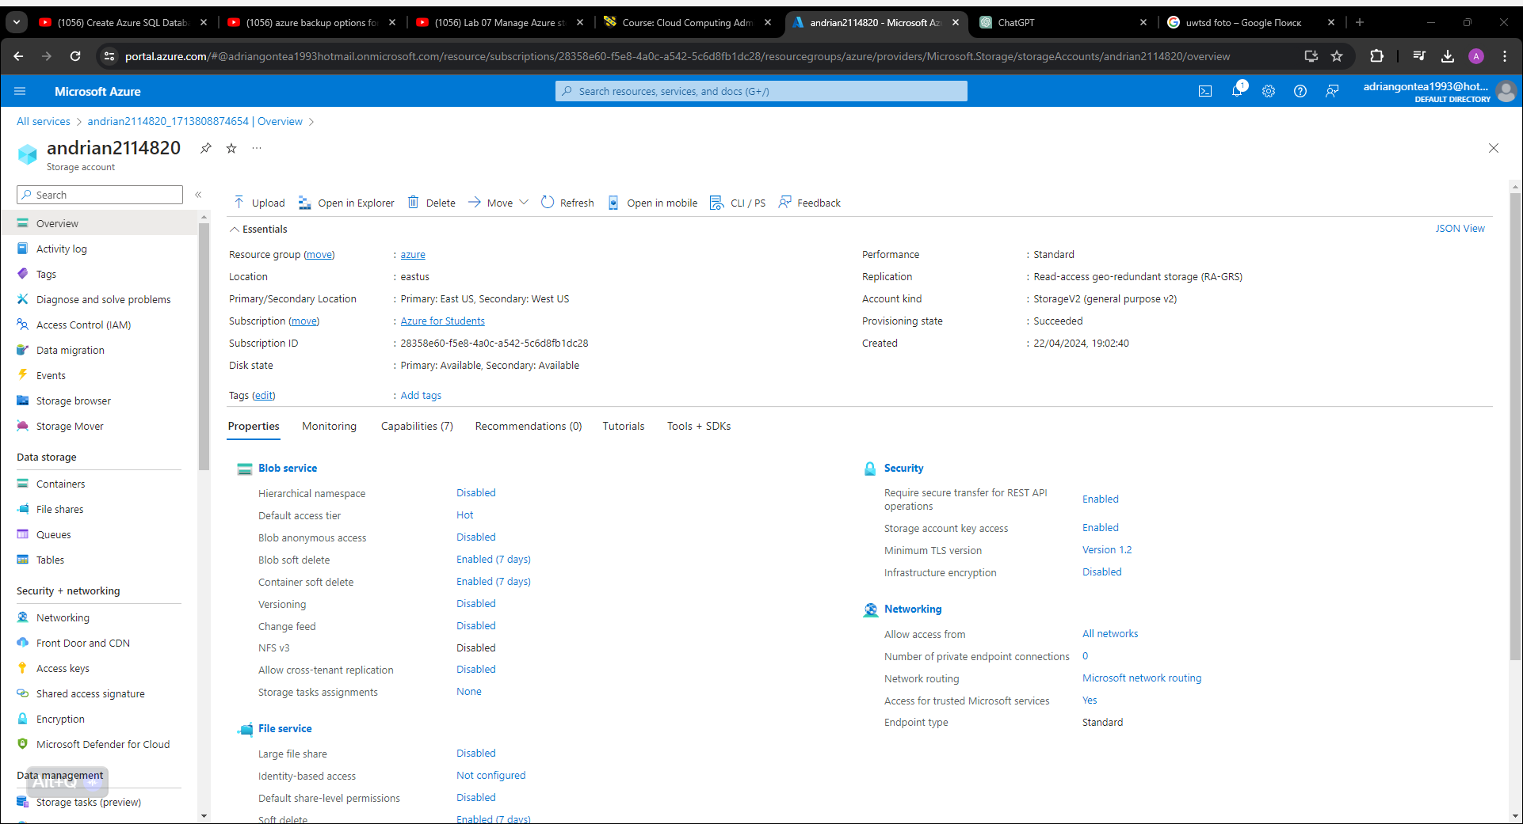
Performance Tiering: Because Azure File Storage offers a number of different performance tiers, including Standard and Premium tiers, it provides organisations with the flexibility to select the appropriate tier based on the performance and availability requirements that they have.

Measures and precautions taken to ensure the safety of Azure File Storage

Microsoft Azure File Storage employs server-side encryption to encrypt data while it is stored in the Azure File Storage service. on the event that the physical storage media is compromised, this guarantees that the data that is kept on file shares will continue to be protected. Client-side encryption is a means of encrypting data before it is submitted to a storage account and Microsoft Azure offers options for client-side encryption as well.
Figure.7
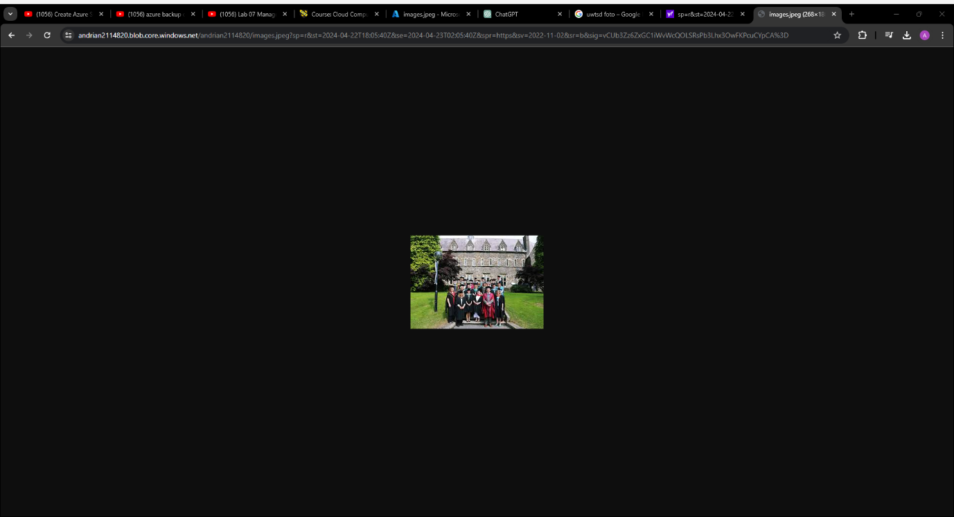

Figure.8
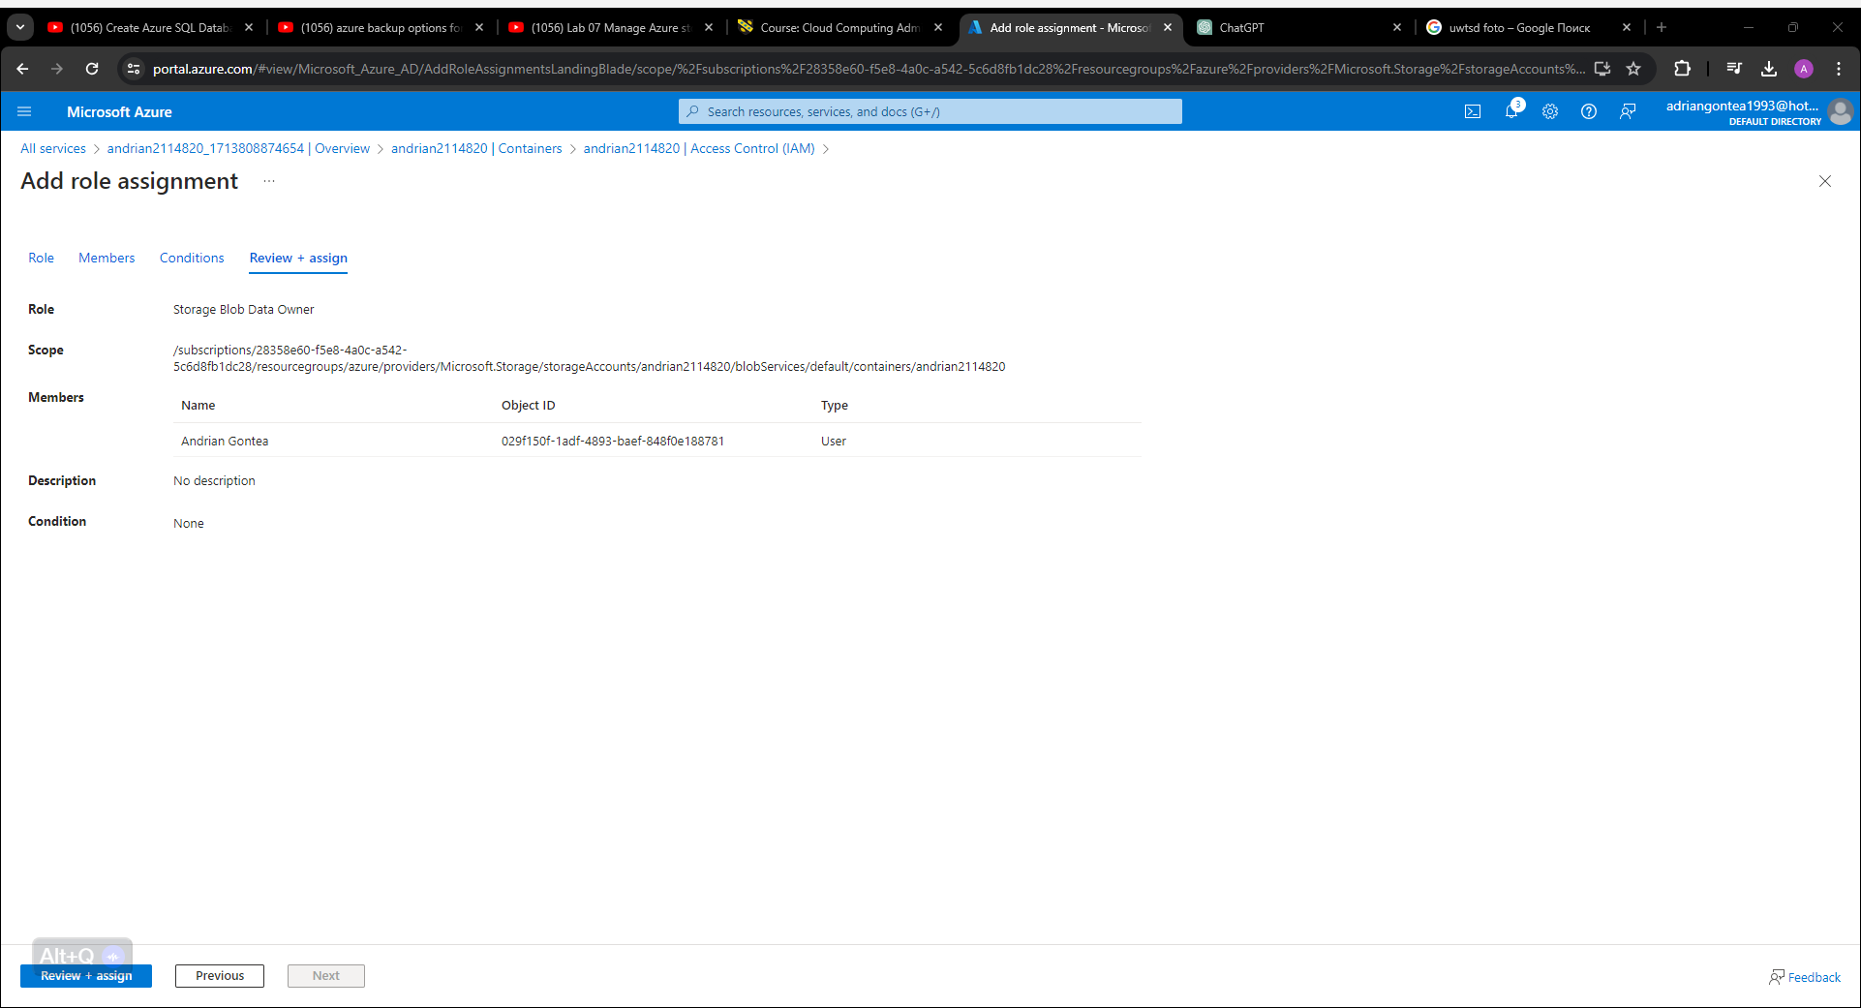
Figure.9
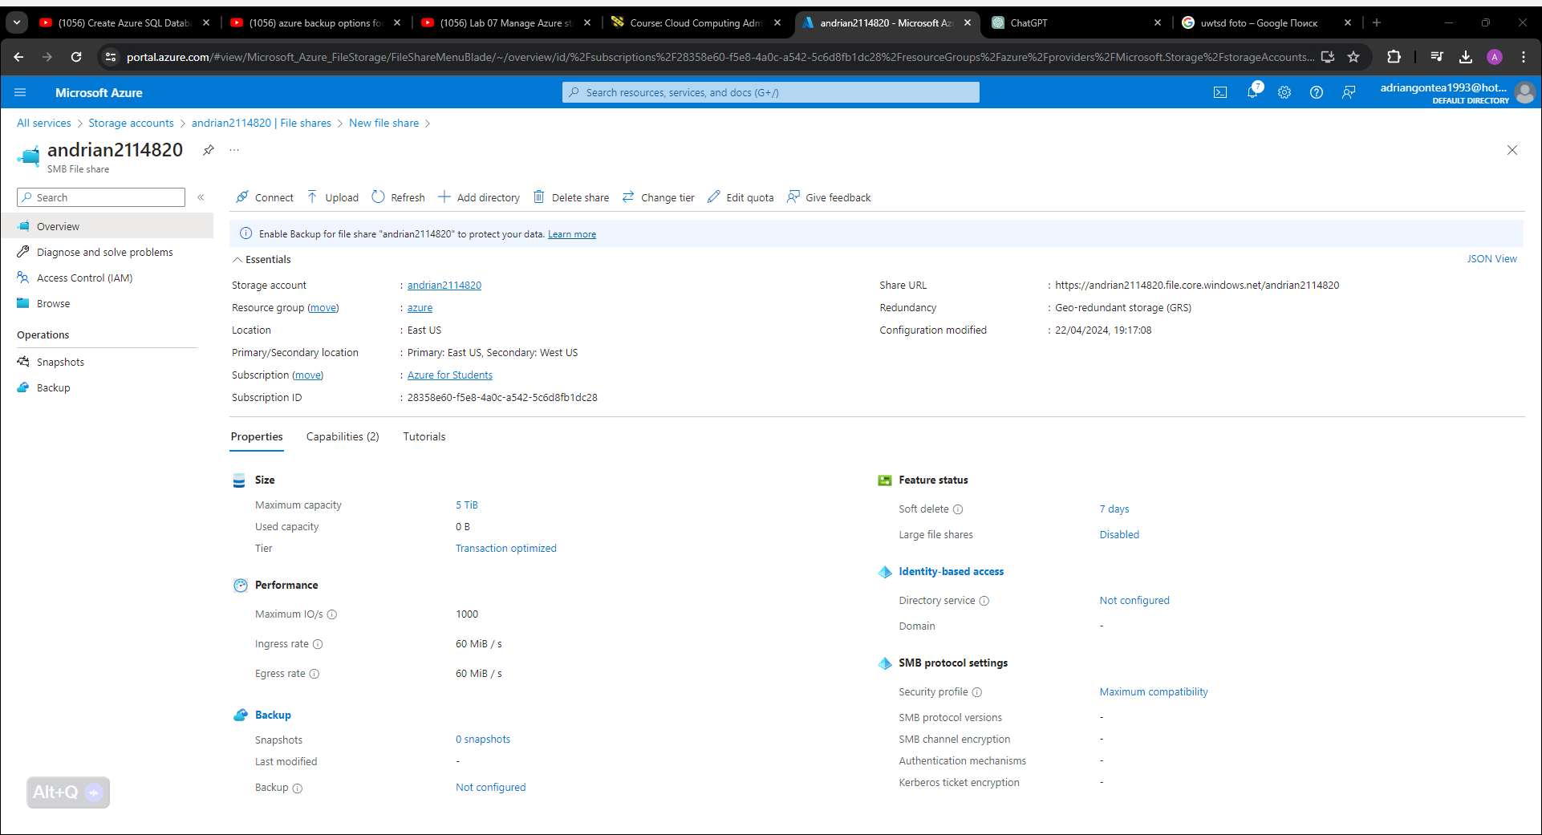

Azure Active Directory integration allows for granular access controls to be implemented, which is one of the features offered by Azure File Storage. Organisations are able to determine who is allowed to access file shares and what actions they are allowed to carry out with the use of these controls. The ability to restrict access based on user identities, groups or roles ensures that only approved users will be able to access sensitive data. This is made possible by the fact that it is feasible to restrict access.

Figure.10
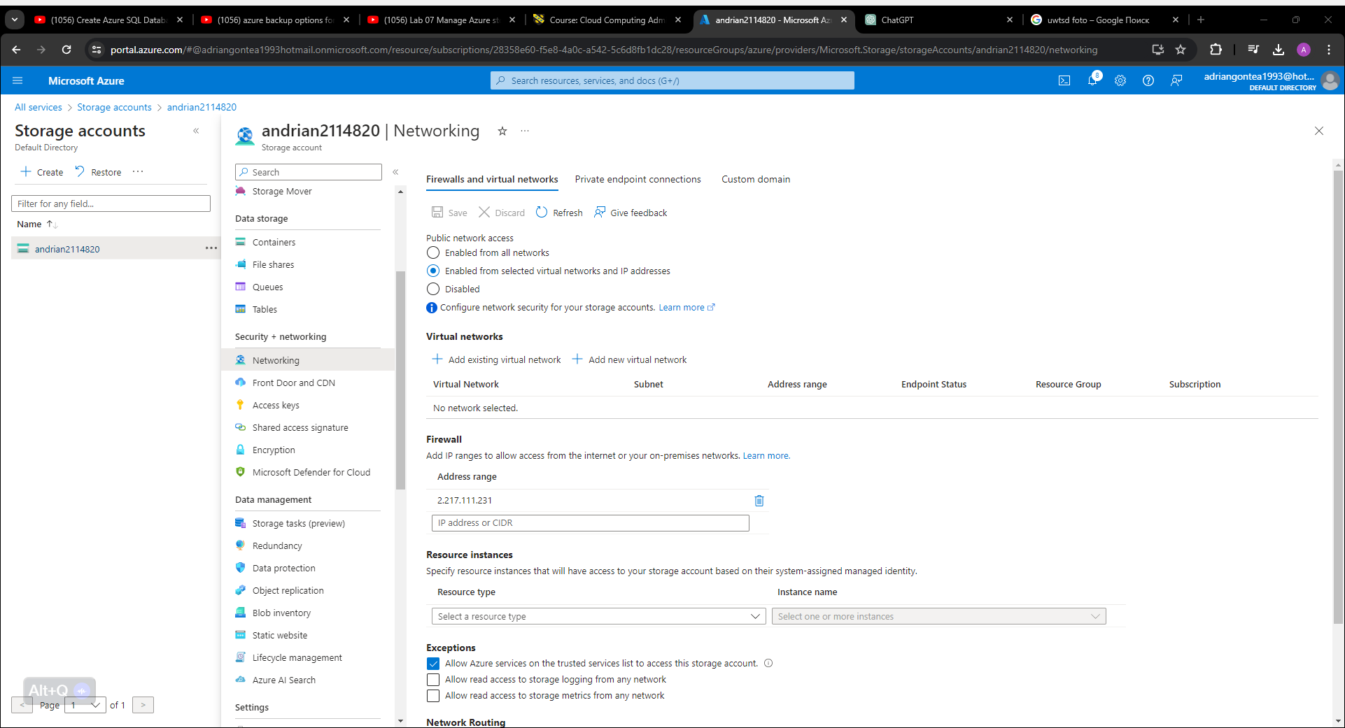

Security for Networks: Azure File Storage provides organisations with the ability to configure network security settings, such as network access control lists and virtual networks, in order to restrict access to file shares from specific IP addresses or virtual networks. This allows businesses to better protect their networks. The prevention of unauthorised access from threats originating from the internet or from networks that are external to the system is facilitated by this measure.

Auditing and Monitoring: Azure File Storage offers auditing and monitoring capabilities through platforms such as Azure Monitor and Azure Security Centre. For the sake of compliance and security, these capabilities make it possible for companies to monitor and keep track of activities such as accessing files, making modifications, and other activities. The audit logs provide information about who accessed files, when those files were accessed, and what actions were carried out upon accessing those files. This enables companies to detect security events and respond to them in a manner that is both effective and efficient. [4]

Data Protection: Azure File Storage makes use of data protection measures such as replication and redundancy to ensure that the data that has been collected is both accessible and will remain accessible for an extended period of time. Through the process of replicating data across a number of data centres that are located within a region, Azure File Storage is able to lessen the risk of data loss that may occur as a consequence of hardware failures or natural disasters.

Compliance Certifications: Azure File Storage is in accordance with a wide range of compliance certifications and standards, such as ISO, SOC, and GDPR Certifications. This guarantees that the data that is stored in file sharing satisfies the statutory standards for the protection of data, the privacy of users, and the security of the data.

Conclusion:

There are a number of features that are included in Azure File Storage, which offers a robust and safe solution for storing and sharing files in the cloud. Some of these features include scalability, access across several platforms, connectivity with Azure services, and built-in security measures. Microsoft Azure File Storage provides assistance to businesses in the process of protecting their data from unauthorised access, data breaches and compliance violations on their end. Encryption, access limitations, network security, audits and compliance certifications are the means by which this objective is accomplished. Despite this, companies are required to implement extra security best practices, like as robust authentication, data classification and frequent security assessments, in order to improve the overall security posture of their Azure File Storage deployments. This is done in order to ensure that their applications are protected from potential threats. Generally speaking, Azure File Storage offers a stable and secure platform for storing and managing files in the cloud. This platform enables businesses to take advantage of the benefits of cloud computing while maintaining the confidentiality, integrity, and availability of their data.

3.Azure database options and recommend the most suitable one for storing user profiles
A wide range of database services are available through Azure, and these services can be customised to satisfy the requirements of a wide variety of use cases. Solutions for relational databases, NoSQL databases, and data centres are included in these offerings. When it comes to the storage of user profiles, there are a number of factors that need to be properly taken into mind. Data structure, scalability, performance, and cost-effectiveness are some of the features that fall under this category. We will analyse the various Azure database options as part of our analysis, and then we will provide a suggestion for which of these alternatives is the best suitable for storing user profiles. [5]

Azure SQL Database, the most popular option

Figure.11
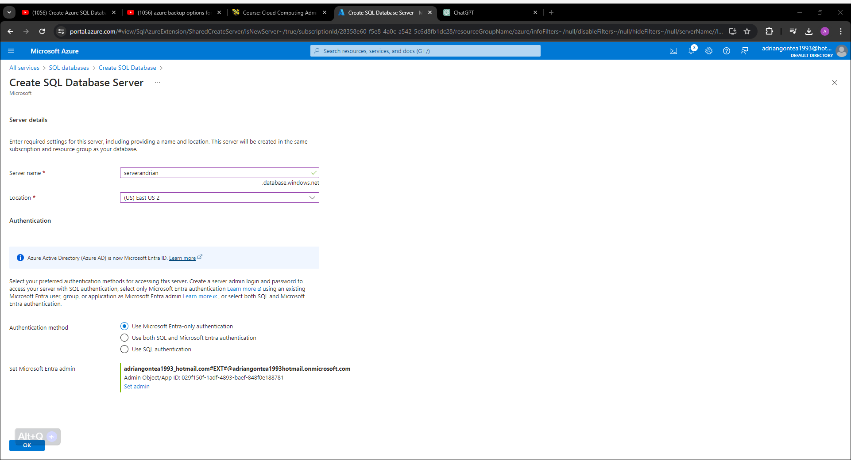
Figure.12
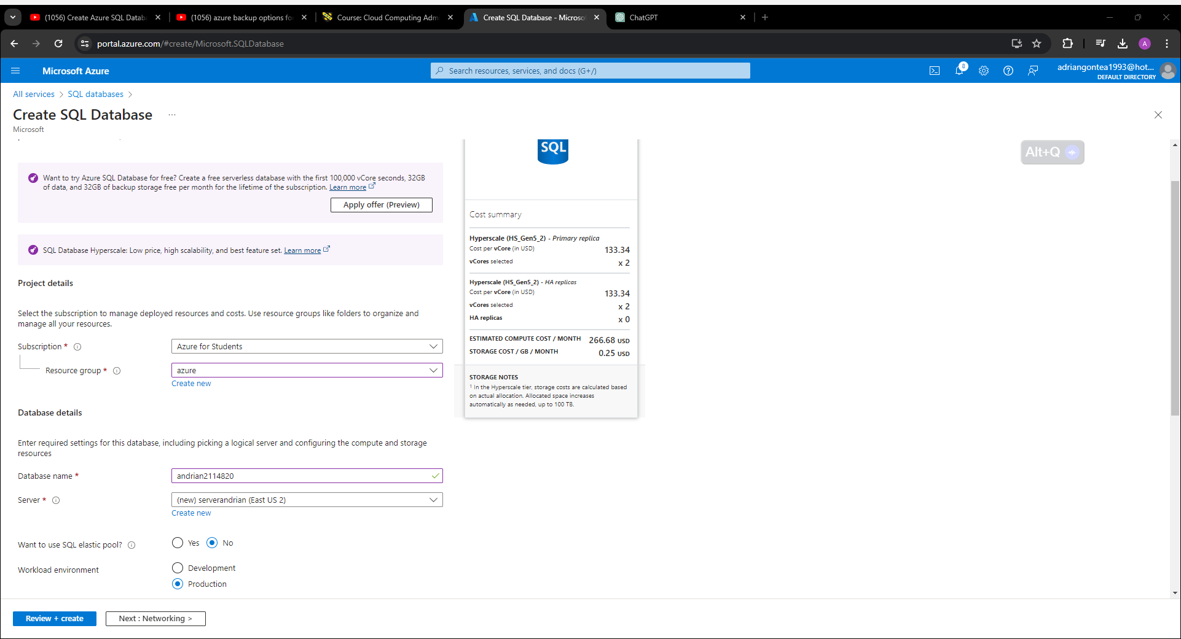

Figure.13
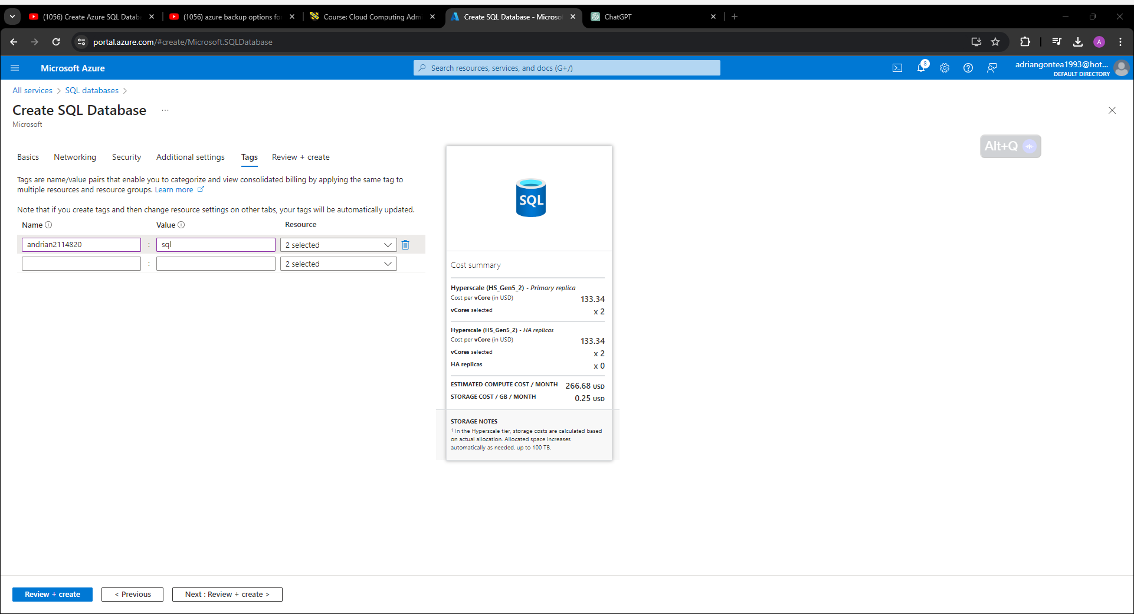
Figure.14
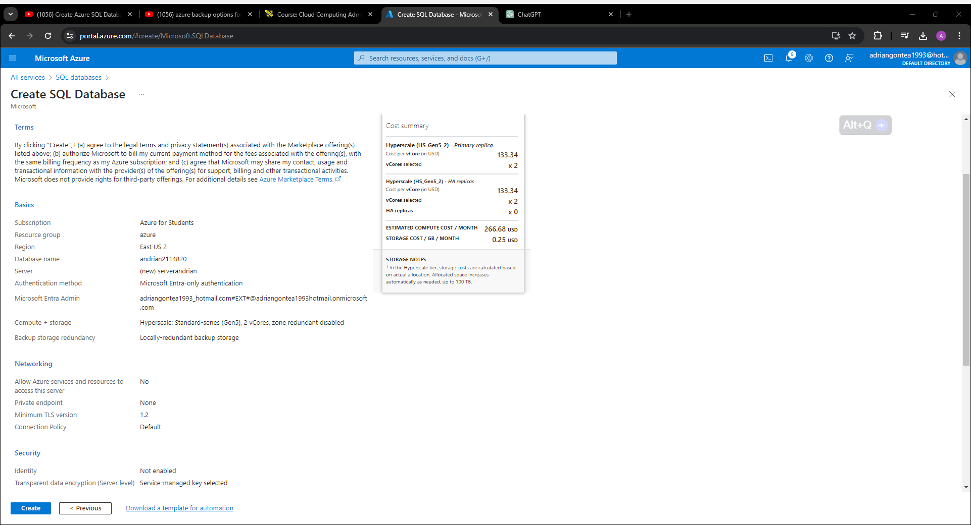

Figure.15
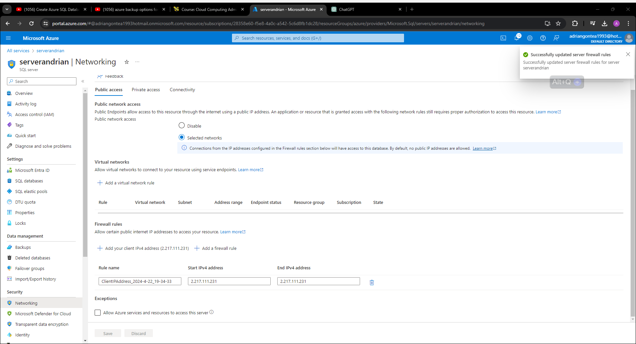
Figure.16
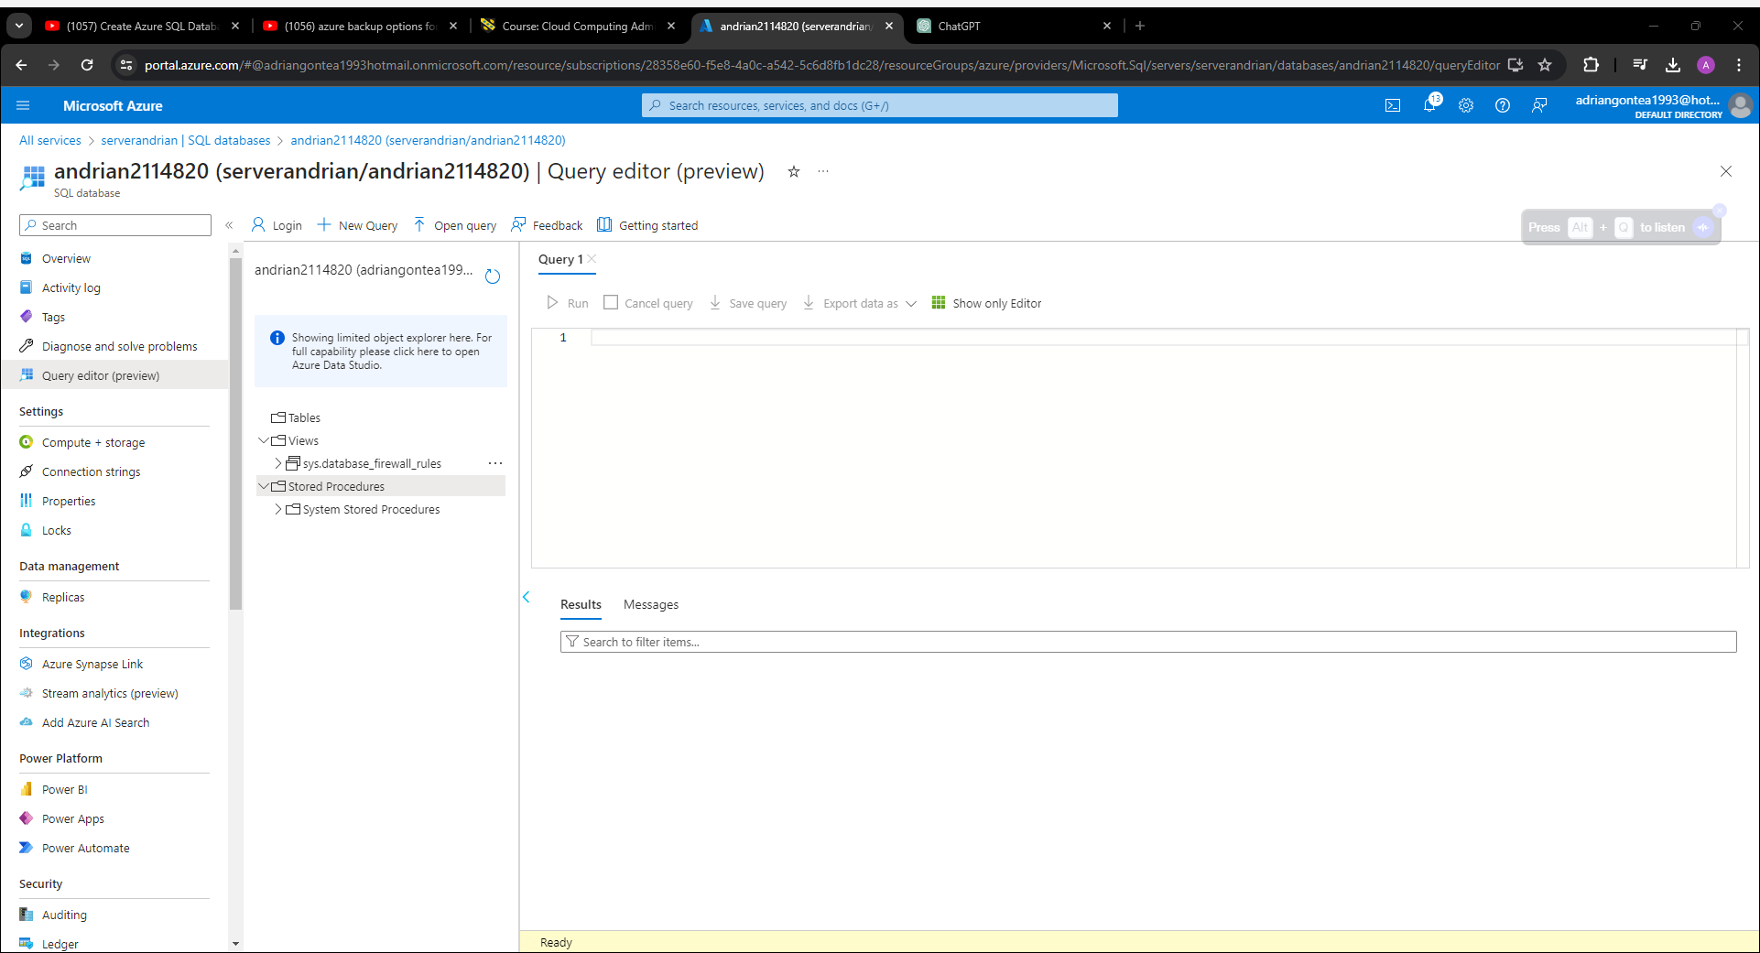

An entirely managed relational database service known as Azure SQL Database is built on top of the Microsoft SQL Server engine, which serves as the service's foundation. There are a number of characteristics that it offers, like high availability, automatic backups, and built-in intelligence that is specifically designed to optimise performance. When it comes to applications and structured data that are required to adhere to the ACID (Atomicity, Consistency, Isolation, and Durability) requirements, the Azure SQL Database is a fantastic option to consider. [6]

An advantage:

The security of the data is ensured by compliance with the ACID standard.
With a completely managed service, it is possible to reduce the overhead costs associated with operations.
T-SQL is supported in addition to the well-known SQL Server functions while using this software.
The system incorporates built-in security procedures, such as encryption and the identification of potential threats.
Both automatic backups and point-in-time recovery are two options that are available.
Disadvantages:

The scalability of NoSQL databases is far higher than that of relational databases.
Large datasets demand a larger price tag than smaller datasets.
It is essential to have understanding of SQL in order to successfully complete administrative and optimising tasks.
2. Amazon Web Services' Cosmos.

Microsoft Azure Cosmos DB is a NoSQL database service that is distributed throughout the entire world. It was developed with the intention of facilitating the development of applications that are not only highly responsive but also highly scalable. It is appropriate for a wide number of use cases since it supports a wide variety of data models, including document, key-value, graph, and column-family data models, among others. In addition to offering assured low latency and high availability, Azure Cosmos DB also enables multi-region replication options. These features are an additional benefit.

An advantage:

Due to the fact that it is distributed across the globe, users are able to access data from any location in the world with far less delay.
Many different data models are supported, which makes it possible to have flexibility in the environment of the data schema.
In addition to horizontal scalability, there is also functionality for automated sharding.
a service level agreement (SLA) that guarantees both high availability and throughput.
Integrated with Azure Active Directory for the aim of providing security and regulating access to the system.
Disadvantages:

The price is higher in contrast to the prices of other database systems that are offered through Azure.
A steeper learning curve exists as a consequence of the fact that its design is composed of numerous models.
It is possible that this is an unnecessary investment for use cases that are less complicated and include data that is arranged.
The Table Storage service offered by Azure

Azure Table Storage is a NoSQL key-value store that has the capability to provide schemaless storage for semi-structured data. Specifically, it is a database management system of some kind. It provides a high level of scalability and a low level of latency for read and write operations, which makes it perfect for storing enormous volumes of data with clear access patterns. [7]

An advantage:

The storage capacity is not limited in any way that is realistically applicable, and the system is extremely expandable.
In contrast to the costs of other Azure database options, this one is actually pretty affordable.
A straightforward data model supported by key-value pairs, which simplifies the development process.
Equipped with the capacity to store a significant amount of data pertaining to user profiles.
The integration with Azure Blob Storage makes it easy to back up and archive data using the cloud storage service.
Disadvantages:

Comparable to relational databases, relational databases offer restricted querying capabilities just as relational databases.
The failure to provide already-built functionality for transactions that are very complicated.
The native availability of support for ACID compliance is not accessible.
Consult or make a suggestion

It is recommended that the Azure Cosmos DB model be used as the Azure database option for the purpose of storing user profiles. To be more specific:

In addition to providing automatic splitting, Azure Cosmos DB also offers simple horizontal scalability, which ensures that scalability is maintained. This guarantees that the database will be able to handle increasing quantities of user profile data without seeing a decrease in speed.

As a result of its highly adaptable nature, Azure Cosmos DB is able to accommodate a diverse range of user profile data structures and access patterns. A wide variety of data models, including as document, key-value, and graph data models, are accessible through its support.

global Distribution: The characteristics of Azure Cosmos DB's worldwide distribution make it possible to view user profiles with a minimum amount of latency from any location in the world. A smooth experience is provided for users who are located in different geographic locations as a result of this capability.

Azure Cosmos DB provides high availability, which is supported by service level agreements and multi-region replication. This feature is referred to as availability. Consequently, this guarantees that user profiles are constantly available and safeguarded against any faults or outages that may occur.

When it comes to the protection of data, Azure Cosmos DB communicates with Azure Active Directory in order to perform authentication and access control. Therefore, organisations now have the option to set fine-grained security restrictions for the data associated with user profiles.

Azure Cosmos DB offers the most advantageous combination of scalability, flexibility, and worldwide availability for the purpose of storing user profiles in a contemporary context that is focused on cloud computing. Azure SQL Database and Azure Table Storage are two additional alternatives that could be considered depending on the needs that are being met; nevertheless, Azure Cosmos DB provides the most optimal combination of these three essential properties.

Conclusion:

Azure provides a wide variety of database solutions, each of which is appropriate for a certain set of operational situations. In conclusion, Azure offers a wide range of database solutions. It would appear that Azure Cosmos DB is the most suitable solution for storing user profiles. This is due to the fact that it is scalable, flexible, distributed globally, has high availability, and has security features. This is due to an overlap of both of these qualities. Using Azure Cosmos DB, businesses are able to effectively manage and recover user profile data, all while ensuring that their apps are functioning at optimal speed and that they are reliable. This is made possible by the fact that the user profile data can be retrieved and maintained.

4.Azure Backup options for file shares and databases
The cloud-based service known as Azure Backup, which is provided by Microsoft Azure, makes it easy to create backups of files, folders, programmes, and databases. This particular service is given by Microsoft Azure. This solution gives companies the ability to protect their data while it is stored in the cloud. Plans for the protection of data should always include the execution of backup schedules and retention regulations as an essential component. In order to satisfy the objectives of both business and compliance, these rules and schedules make certain that backups are performed on a consistent basis and that they are stored for the appropriate period of time. In this section, we will discuss backup schedules and storage policies for both file shares and databases that make use of the Azure Backup choices. During the sections that follow, this discussion is going to take place. [8]
Figure.17
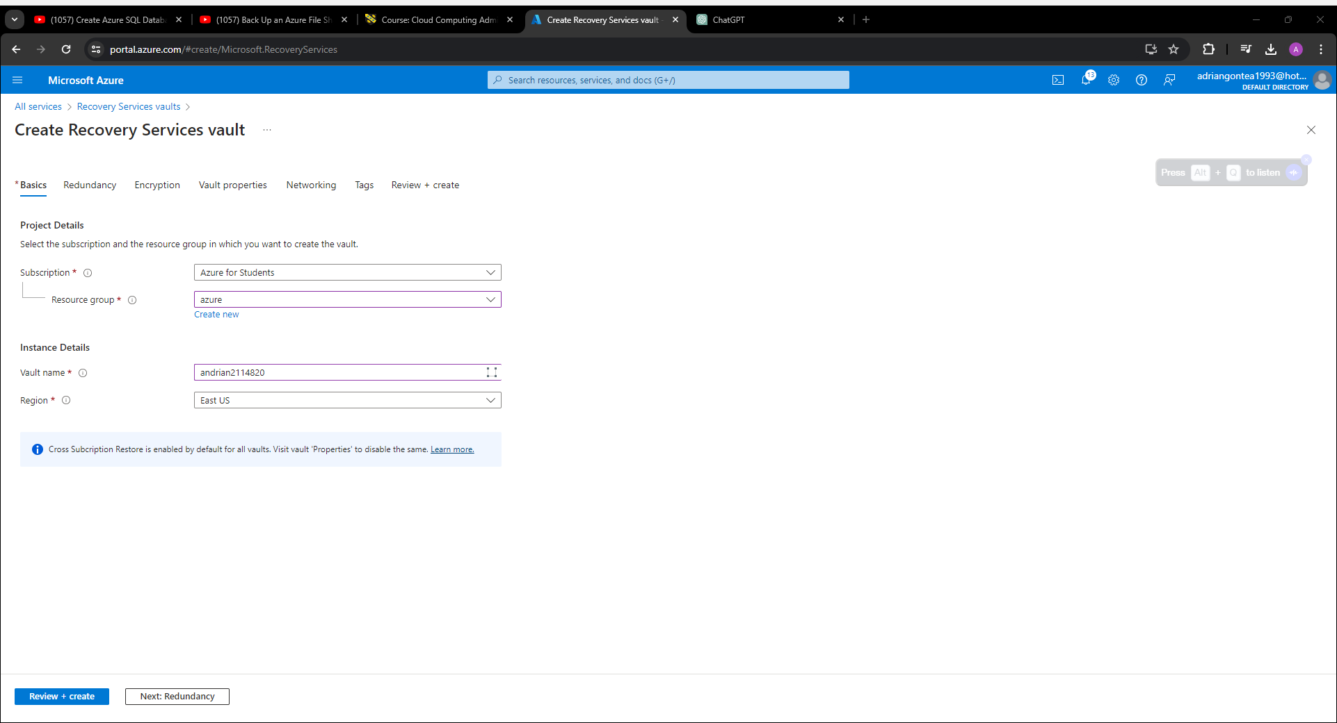

Figure.18
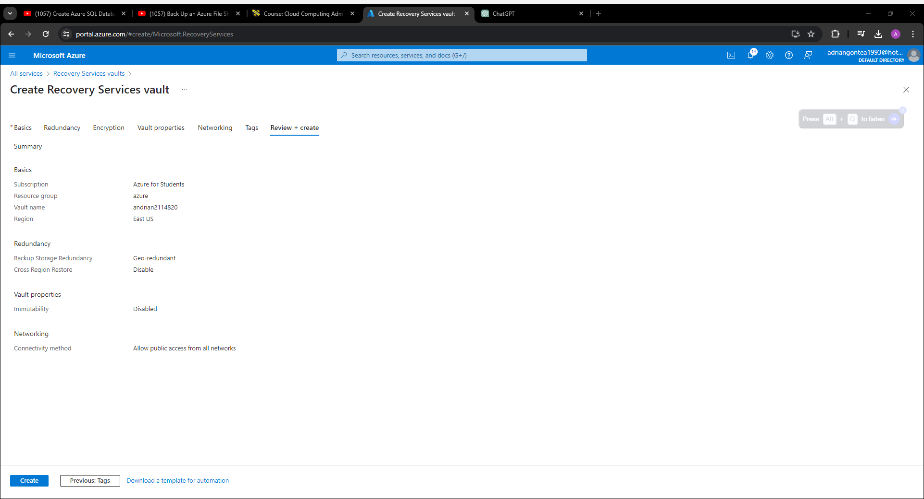
Figure.19
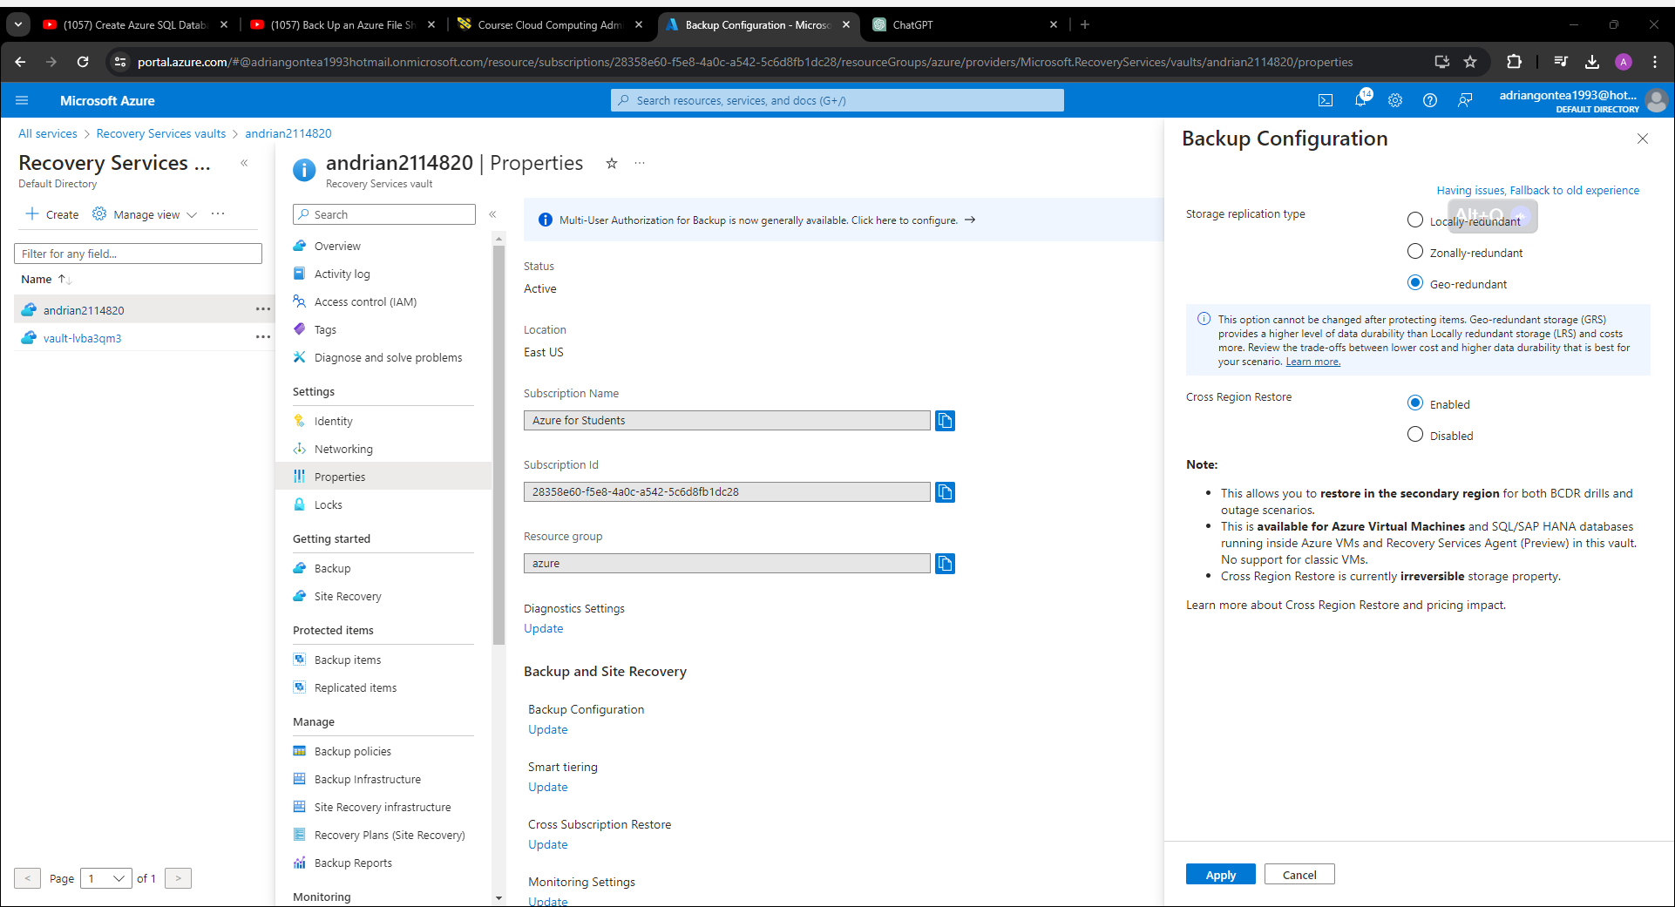

Figure.20
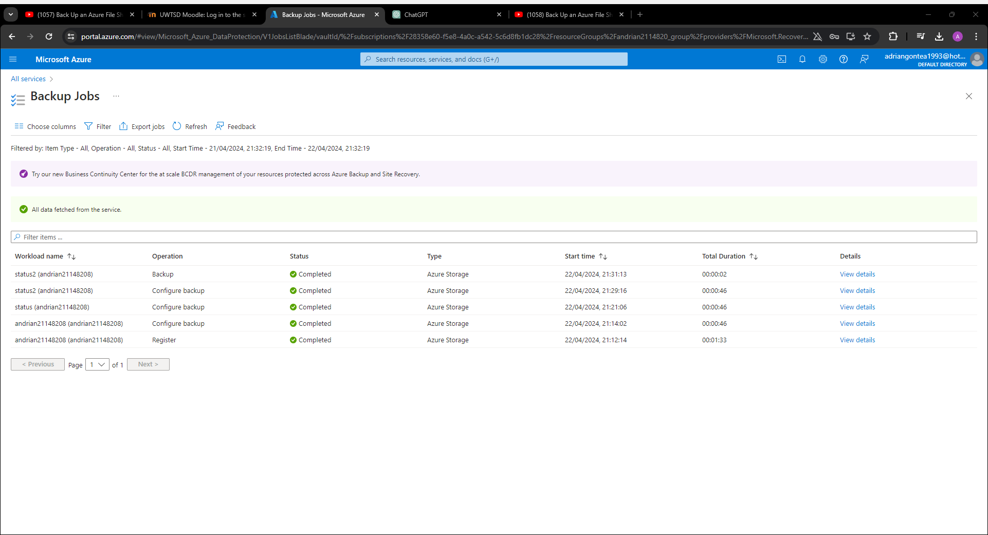
1. timetables and timetables for the transfer and backup of files
The Azure Backup service offers two primary options for backing up file shares. These options are offered to users via the service. These choices include Azure Backup for Azure Files as well as Azure Backup for file servers that are located on-premises.
Azure's Backup Service for Files Stored in Azure Service:
Microsoft Azure Files is a cloud-based service that enables fully managed file shares in addition to enabling access to files through the use of SMB and NFS. Businesses are able to create backups of file shares that are kept in Azure with the assistance of Azure Backup for Azure Files. This will allow businesses to protect their data. [9]
Choices available for the Backup Schedule:
The backups ought to be scheduled to run on a daily basis at a time that has been decided upon in advance. By doing this, you will ensure that the data that is saved in file shares is backed up on a regular basis, which will protect against the loss of data.
Keep regular backups: In order to produce additional backup copies and to enable various recovery points for data that is shared in a file, it is advised that backups be performed on a weekly basis.
It is possible to configure individualised backup schedules according to the specific needs of the business, such as backing up key file sharing on a more consistent basis. It is possible to accomplish this by examining the configuration choices for the backup schedule.
An Assortment of Policies Regarding Retention:
Define the storage range for backups, which sets the period of time that backup data should be maintained. This definition is referred to as the retention range. Microsoft Azure Backup allows for retention periods that can span anywhere from a few days to several years, depending on the requirements of the organisation and the rules that are in place.
Keeping backup copies for a predetermined period of time on a daily, weekly, and monthly basis can be accomplished by configuring retention rules. This can be done on a daily, weekly, and monthly basis. A comprehensive backup history will be maintained for file sharing as a result of this action.
When it comes to file servers that are located on the premises, Azure Backup:
For on-premises file servers, Azure Backup provides either the Azure Backup Server or the System Centre Data Protection Manager for the purpose of backing up files and folders to Azure. Both of these options are considered to be backup solutions.
Choices available for the Backup Schedule:
Partial Backups: Set up incremental backups so that they pick up only the files that have been modified or added since the last backup. Both the length of time necessary for backups and the amount of storage space that is required will be reduced as a result of this.
Full backups of the full system: Regular full backups are suggested in order to capture the whole file system and provide thorough recovery points for file shares. This is because full backups capture all of the data in the system.
When it comes to the frequency of backups, it is important to customise them in accordance with the requirements of the business. This may include settings for daily, weekly, or personalised plans. [10]
An Assortment of Policies Regarding Retention:
Define a duration range for backups, which describes the amount of time that backup data should be maintained in Azure Backup vaults. This range indicates the length of time that backups should be stored.
Through the implementation of the Grandfather-Father-Son Retention Policy, it is recommended that backup copies be kept on a daily, weekly, monthly, and yearly basis for varied durations of time. You can rest assured that a comprehensive backup history will be preserved that way.
Secondly, databases with regard to the backup schedules they have
There are a number of various options available for backing up databases that are hosted on Azure services. Some of these options include Azure SQL Database, Azure Database for PostgreSQL, Azure Database for MySQL, and a great deal of other options. These choices are made available via Azure Backup.
Azure's SQL Database, which includes:
With the built-in backup and restoration tools that are given by Azure SQL Database, organisations are able to simply create backups of databases via the Azure portal or by using PowerShell commands. This is made possible by the fact that these services are supplied by Azure SQL Database.
Choices available for the Backup Schedule:
Automatic Backup: Enable automated backups to generate backups of Azure SQL databases on a regular basis in accordance with a schedule that you have already defined. This will ensure that backups are produced correctly. Azure SQL Database will automatically perform entire backups, differential backups, and transaction log backups from the database. These backups will be based on the database recovery model.
Manual Backup: This feature enables you to produce backup copies whenever you require them by enabling you to perform ad hoc backups at any time. Such backups can be performed through the Azure interface or with PowerShell commands.
An Assortment of Policies Regarding Retention:
For the purpose of ensuring compliance with regulatory requirements and data retention standards, it is required to design long-term retention policies in order to store backup copies for extended periods of time. This is done in order to ensure that the company is in accordance with these regulations.
Point-in-Time restoration: Make use of the capabilities of point-in-time restoration in order to recover databases to specific points in time that occurred within the retention period. For the goal of data preservation, this will make it possible to have specific recovery options and alternatives.
a database hosted on Azure that is compatible with both PostgreSQL and MySQL:
Utilising Azure Backup for Azure Database for PostgreSQL and Azure Database for MySQL, businesses are able to generate backups of PostgreSQL and MySQL databases that are hosted on Azure. This is made possible by the availability of these backup tools.
Choices available for the Backup Schedule:
Through the use of the planned backup tool, you are able to set up periodic backups to execute in accordance with a schedule that you have previously established. This guarantees that PostgreSQL and MySQL databases are backed up on a consistent basis to maintain their safety.
The ability to create backup copies for specific database instances with greater flexibility is made possible by the availability of backups that are performed on demand. Backups that are performed on demand can be carried out whenever they are need to be.
An Assortment of Policies Regarding Retention:
Define the retention period for backup copies, which sets the amount of time that backup data should be maintained in Azure Backup vaults. This is referred to as the retention period.
Encryption of Backups: Encryption of backups ought to be enabled in order to protect backup data while it is stored safely. That the backups of the database are both secure and confidential will be ensured by this.
Remarks to Conclude
When it comes to data protection strategies, crucial components include backup schedules for data as well as policies for the retention of data. The presence of these components guarantees that organisations will be able to retrieve data in the event that it is lost, corrupted, or destroyed as a result of natural disasters. When organisations utilise Azure Backup, they are able to set backup schedules that are flexible and define retention policies that are tailored to their unique requirements for file sharing and databases. This allows for these organisations to better protect their data. Businesses have the ability to effectively protect their data assets, decrease risks, and ensure the continuity of their corporate operations in the event of unanticipated disasters by making use of the numerous backup alternatives that are made available by Azure.
In a word, file shares and databases may both benefit from the extensive backup and recovery solutions that Azure Backup provides. Additionally, it provides a wide range of scheduling and retention options, which may be tailored to meet the specific needs of commercial enterprises. Whether it's protecting Azure Files, on-premises file servers, Azure SQL databases, or any other Azure service, Azure Backup makes it possible for organisations to develop strong data protection plans and retain their key data assets in the cloud. This is true regardless of the type of Azure service being protected.

5.Evaluation of how azure site recovery would assist GLI
Data security is of the utmost importance in today's digital world for any company but especially for GLI that deals with large amounts of storage and vital databases. Natural or artificial catastrophes, they may all play chaos on businesses, causing data loss, downtime, and financial consequences. With its comprehensive set of capabilities designed to safeguard storage and databases, Azure Site Recovery stands out as a strong disaster recovery solution. How ASR might help GLI strengthen its DR approach is the subject of this essay.
The purpose of Azure Site Recovery, a service offered by Microsoft, is to facilitate the automation and orchestration of the replication and failure of virtual machines, regardless of their location—in the cloud or on-premises. By facilitating the rapid restoration of workloads in the case of a catastrophe, it guarantees the continuance of corporate operations. Virtual machines are not the only things that ASR can handle; storage and databases are also part of its purview.
Securing Storage with Azure Site Recovery: GLI, like many other organisations, relies on storage to store vital data needed for daily operations. ASR's replication and failover procedures are critical in protecting this priceless asset.
Data redundancy is assured by ASR's replication capabilities, which allow for the transfer of data from on-premises storage to Azure. To achieve certain Recovery Point Objectives, GLI may adjust the replication settings to synchronise data between on-premises and Azure at certain intervals. Because of this adaptability, GLI is able to find a happy medium between operational overhead and data currency.
Failover: With ASR, you can easily switch from your local storage to Azure in case of a catastrophe. Depending on predetermined criteria such as performance limits or identified outages, GLI may activate failover either manually or automatically. With this fast backups, GLI can go back to business as soon as possible with little interruption.
With ASR's powerful orchestration features, GLI can design recovery plans specifically for its storage system. The recovery process may be made more organised and effective with the help of these plans, which detail the steps to be taken during failover. GLI may modify recovery methods to handle complex storage arrangements, guaranteeing dependability and consistency in any situation.
Azure Site Recovery for Database Security: Many corporate applications rely on databases, which store mission-critical data that is crucial for running the company. By adding database DR capabilities to ASR, organisations like GLI are able to better safeguard their database assets.
Data Corruption and Inconsistency Mitigation: Application Consistency: ASR makes sure that applications are consistent when databases are replicated and when failure occurs. This is made possible by integrating with Azure Backup, which offers recovery and backup solutions that are application-aware and designed for common database systems like Oracle and SQL Server. By using these features, GLI can ensure that data remains safe during the whole disaster recovery process.
Databases may be restored to a particular instant in time using GLI's point-in-time recovery feature made possible by ASR which minimises data loss. For GLI to confidently and precisely roll back to a known good state in the event of data corruption or human mistake, this granular recovery capability is crucial.
Compatible with Multiple Platforms: GLI can safeguard databases that are operating on different platforms and technologies thanks to ASR, which enables diverse database settings. With ASR's unified DR solution, you can accommodate multiple database environments, whether it SQL Server on Windows or Oracle on Linux. Due to its adaptability, GLI's DR administration is made easier, which optimises operational processes and gets rid of the need for separate solutions.
Critical parts of GLI's IT infrastructure, storage and databases, may be adequately protected using Azure Site Recovery. The replication, failover, and orchestration features of ASR will help GLI strengthen its DR plan, which will guarantee data resilience and business continuity in the event of a catastrophe. When it comes to safeguarding vital data and preventing storage asset hardware failures or database data corruption, ASR has you covered with all the features and capabilities you need. Azure Site Recovery is a trustworthy companion on GLI's journey towards operational excellence and resilience within the ever-changing digital ecosystem.

References

[1] | T. L. Warner, Managing Storage in Azure, Wiley Data and Cybersecurity, 2020.
[2] | H. Dewan and R. Hansdah, A Survey of Cloud Storage Facilities, IEEE, 08 September 2011.
[3] | Y. Mansouri and A. Erradi, Cost Optimization Algorithms for Hot and Cool Tiers Cloud Storage Services, IEEE, 11 September 2018.
[4] | P. Matri, A. Costan, G. Antoniu, J. Montes and M. S. Pérez, Blob Storage Meets Built-In Transactions, IEEE, 16 March 2017.
[5] | D. Dundjerski, S. Lazić, M. Tomašević and D. Bojić, Improving schema issue advisor in the Azure SQL database, IEEE, 08 January 2018.
[6] | M. T. Dejan Dundjerski, Automatic Database Troubleshooting of Azure SQL Databases, IEEE, 03 July 2020 .
[7] | E. Baralis, A. D. Valle, P. Garza, C. Rossi and F. Scullino, SQL versus NoSQL databases for applications, IEEE, 15 January 2018.
[8] | T. L. Warner, Backing Up and Restoring Your Azure Data, Wiley Data and Cybersecurity, 2020.
[9] | S. Brathwaite, Securing Data and Applications, Wiley Data and Cybersecurity, 2023.
[10] | M. Z. Hasan, M. Z. Hussain, Z. Kamran, M. Asif, S. Nosheen, A. M. Qureshi and A. Ahmed, Cloud data Management, a challenge to security, IEEE, 09 February 2024.

